**ECP3004: Summer 2024**

* **Final Project -**

***Written by: Joshua Singh, Christian Ortiz, and Gianluca David***

**Executive Summary**

* The pandemic-induced recession and inflation had negative impacts on the stock and bond markets. Investors began to pull out of certain markets as prices and interest rates fluctuated throughout the years. Bond prices fell too low which forced bonds to maturity prematurely, causing serious loss in returns/yields. Inflation forced many people to withdraw their funds from unstable and uncertain markets overseas causing international market failures.
* Standard deviation is an extremely valuable tool that can be used to measure volatility or “worthiness” of investing in a fund. Funds with higher STDs are more risky to invest in and oftentimes result in higher losses on assets.
* Sharpe’s Ratio is consistent with the mean. Funds with higher mean returns will have higher Sharpe’s ratio values, meaning that they are the most “profitable” or will provide the highest return when assuming risk.
* The annualized mean returns and standard deviations were calculated by scaling the monthly values, providing a yearly perspective on returns and volatility. The returns ranged from 0.90% (VBISX) to 13.75% (VFINX), while the volatility varied from 2.72% (VBISX) to 21.24% (VEURX).
* The Sharpe ratios, which measure risk-adjusted returns, showed that the VFINX fund offered the best return per unit of risk, with a ratio of 0.74.
* The scatterplots and covariance matrix of the returns showed strong positive correlations between certain funds (VFINX and VEURX, VFINX and VPACX), but weaker correlations involving the VBISX fund, indicating potential diversification benefits.
* The Value-at-Risk (VaR) analysis provided an estimate of the potential loss over a one-month and one-year period, with the VEURX fund showing the highest potential loss and the VBISX fund showing the lowest.
* The global minimum variance portfolio aims to minimize standard deviation by investing different weights in the assets in its portfolio.
* The tangency portfolio aims to capitalize on the highest Sharpe Ratio attainable by investing different weights in the assets in its portfolio.

**Stock & Bond Profiles**

**VFINX**: The Vanguard 500 Index Fund tracks the performance of the stocks that make up the S&P 500 index (which is an extremely popular benchmark of big U.S. companies) by mimicking similar investments. The fund is non-diversified meaning that it’s assets only go to a specific set of stocks and nothing else. It has been around since 2010 and continues to do well, with a total of 1.18 trillion dollars in assets currently.

**VEURX**: The Vanguard FTSE Europe ETF fund is similar to the VFINX. It is also an indexing approach where all assets are invested in specific stocks. In this case, most assets will go towards the FTSE Developed Europe All Cap Index. This fund is older than the VFINX by 5 years. It has a sustainability rating of 2 stars, which might be a sign of volatility/risk.

**VEIEX**: The Vanguard Emerging Markets Stock Index is a little different from the previous two funds. This index measures the return on investments for stocks from companies in countries with emerging markets. This indexing approach tracks stock performance from the FTSE Emerging Markets All Cap China A Inclusion Index. This fund functions by sampling a variety of stocks that will provide similar characteristics of the observed index. Since the year 2006, it has been a diversified fund and still remains that way today.

**VBISX**: The Vanguard Short-Term Bond Index Fund is an index for U.S government, corporate, and international bonds. These bonds must have maturities between 1 and 5 years to be included. Also, they must be issued to the public. Similar to VEIEX, there is a sampling process that must occur. In this case, most assets will be invested in bonds included in this index. The year of inception is 2007. Its assets are 57.8 billion which is low when compared to VFINX.

**VPACX**: The Vanguard Pacific Stock Index also uses an indexing approach to invest most assets in common stocks. The stocks for this fund are included in the FTSE Developed Asia Pacific All Cap Index. This fund is diversified but only for the pacific region and parts of Asia. The year of inception is 2005 and the net assets are very low for a fund that has been around so long. It should also be mentioned that the sustainability rating for this fund is 2 stars, which indicates high market volatility.

**Return Calculations and Sample Statistics**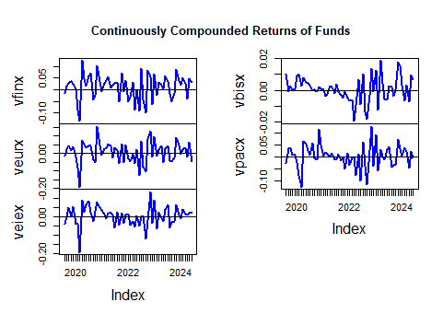

*Figure 1: Continuously Compounded Returns of Funds*

The VBISX fund experienced extremely low returns during the beginning and mid-section of 2022. The recession caused by the pandemic and rising inflation rates forced interest rates to rise. This eventually led to the crash of the bond market, which the VBISX primarily operates in. Bond prices began to fall drastically, which forced bonds to maturity way ahead of time. Thus, in turn providing lower yields/returns. The fund’s return shoots back up in early 2023 after the market begins to restabilize. The VBISX fund wasn’t the only fund that fell victim to the recession. Just like VBISX, VPACX suffered large losses in returns due to consumer/investor behavior that occurred during the recessionary period. Many domestic investors stopped investing in overseas portfolios and began to pull out of foreign markets. This happened because people were uncertain of the direction in which things would go and they wanted to protect their assets. Many people felt that the risk of not withdrawing their investments would result in serious losses that might never be gained back. The VFINX fund seemed to do better than VBISX and VPACX and had larger positive spikes in their return in 2020 than any other fund. This can be attributed to government relief bills and stimulus checks which restimulated the economy for a few months.

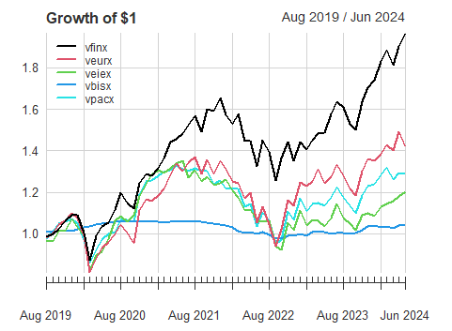

*Figure 2: Growth of $1*

After computing an equity curve, I concluded that VFINX will have the highest future value at the end of this 5-year period. This is not very surprising because the VFINX fund is not very risky and does not exhibit signs of volatility. In fact, this fund’s returns have been consistently greater than 0 during most of the months in each year. The price-time plot that was created also indicated this. It showed a somewhat steady increase in stock price since 2019, which means that is the most valuable (or will provide the greatest future return). Also, when considering that it is an index of a multitude of different stocks, it is reasonable to assume that its price will be the highest and most stable.

**Histograms and Boxplots**

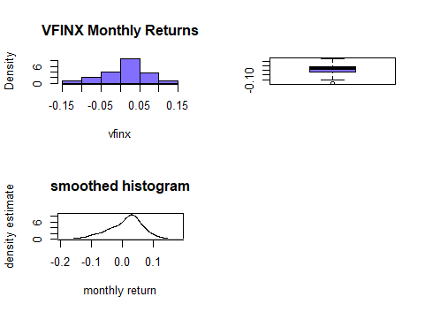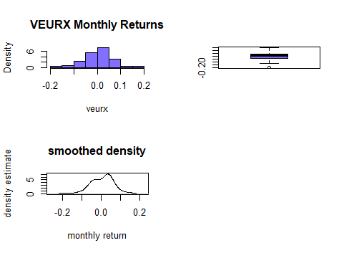

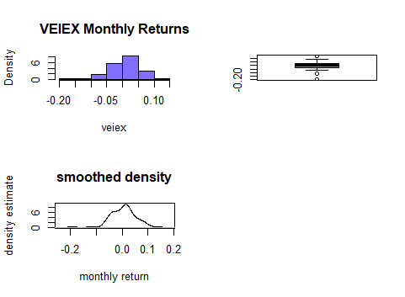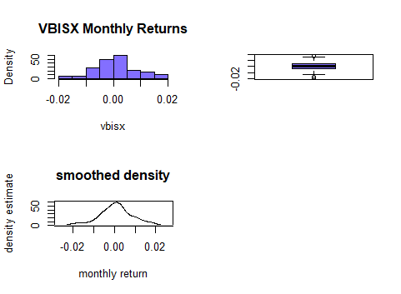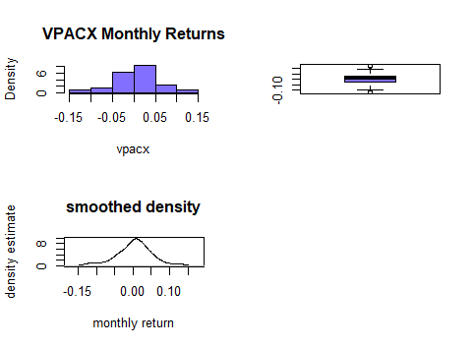

*Figures 3-8: Monthly Returns per Each Stock / Bond Fund.*

The histograms and boxplots are pretty decent indicators of normal distribution. Three out of the five funds’ returns are not normally distributed. Returns for VFINX and VEURX are not normally distributed. VEURX seems to be less normally distributed than VFINX. There appear to be no outliers on either distribution. VEIEX’s returns are also not normally distributed, similar to the other two. However, there is a very noticeable outlier on the left tail. There is a blank space on the plot which can mean that there was an issue/error during the data recollection period. The VBISX and VPACX funds are the only two that seem to adhere to the rules of normal distribution. There are no outliers visible for these two either.

**Descriptive Statistics and Sharpe’s Ratio/Slope**

The descriptive statistics calculations for each fund reinforce some of the assumptions that we made from the graphs and plots. The VFINX fund had the highest mean/average return of 0.01146 meanwhile VBISX had the lowest return of 0.00754. This matches up with the price-time plot which showed steady growth for VFINX. The fund with the highest standard deviation is VEURX. According to the graphs, it looks the most volatile, so it makes sense that it has the highest standard deviation. VBISX ended up having the lowest standard deviation. This is consistent with “low risk, low reward”. It is the least volatile of the five funds, but it also has the lowest return. With that being said, it is safe to say that its returns have the most normal distribution. This observation was made by observing the skewness values. VBISX had the lowest skewness value on its left tail; this can also be observed in the density graph for this fund. On the other end of the spectrum is the VEIEX fund. This fund has the highest skewness value which is consistent with the outlier that was observed on the left tail. Yet another calculation that can tell you more about a fund's profitability is Sharpe’s ratio/slope (SR). The funds with the highest and lowest SRs are VFINX and VBISX, respectively. This is not surprising given what we concluded from the mean calculations. Sharpe’s ratio is a very efficient metric that is used to assess the excess return gained per unit of risk that is assumed when making an investment. In this case, VFINX provides the highest excess return per unit of risk that is taken on, while VBISX provides the lowest.

The annual means were obtained by multiplying the monthly means by 12, which essentially scales up the monthly returns to reflect a full year. Similarly, the annual standard deviations were calculated by multiplying the monthly standard deviations by the square root of 12.

The annualized mean returns for the funds range from approximately 0.90% (for VBISX) to 13.75% (for VFINX). These figures represent the average return an investor would have received each year if they had invested in the fund. Higher numbers are better.

|  |  |  |  |  |
| --- | --- | --- | --- | --- |
| VFINX | VEURX | VEIEX | VBISX | VPACZ |
| 0.137490 | 0.071625 | 0.037467 | 0.009049 | 0.051780 |
| ~14% | ~7% | ~4% | ~1% | ~5% |

*Figure 9: Annualized Means per Fund*

The annualized standard deviations, which indicate the level of risk or volatility associated with each fund, vary from approximately 2.72% (for VBISX) to 21.24% (for VEURX). A higher standard deviation indicates a higher level of risk and volatility. Higher returns are very clearly more desirable, but they often come with higher risk.

|  |  |  |  |  |
| --- | --- | --- | --- | --- |
| VFINX | VEURX | VEIEX | VBISX | VPACZ |
| 0.18531 | 0.21241 | 0.18302 | 0.02724 | 0.17128 |
| ~19% | ~21% | ~18% | ~3% | ~17% |

*Figure 10: Annualized Standard Deviations per Fund*

The annualized Sharpe ratios for the funds range from approximately 0.20 (for VEIEX) to 0.74 (for VFINX). Based on the Sharpe ratio calculations, the VFINX fund appears to be the best investment among the five funds, as stated above.

|  |  |  |  |  |
| --- | --- | --- | --- | --- |
| VFINX | VEURX | VEIEX | VBISX | VPACZ |
| 0.7397 | 0.3352 | 0.2024 | 0.3169 | 0.2999 |
| ~74% | ~34% | ~20% | ~32% | ~30% |

*Figure 11: Annualized Sharpe Ratios*

When comparing the rankings of the funds based on the monthly Sharpe ratios and the annualized Sharpe ratios, it was found that the rankings are not the same. This shows that one must consider the time period when evaluating investment performance, and that different measures of performance can lead to different conclusions about how good an investment is.

Assuming the average annual return is received every year for 5 years, the growth of $1 invested in each fund was calculated and showed that $1 invested in the VFINX fund would grow to approximately $1.99 after 5 years, while $1 invested in the VBISX fund would grow to approximately $1.05. These calculations assume a continuously compounded annual return, which means that the returns are reinvested at the end of each year and earn returns in the subsequent years.

|  |  |  |  |  |
| --- | --- | --- | --- | --- |
| VFINX | VEURX | VEIEX | VBISX | VPACZ |
| 1.989 | 1.431 | 1.206 | 1.046 | 1.296 |

*Figure 12: Growth of $1 after 5 years ($)*

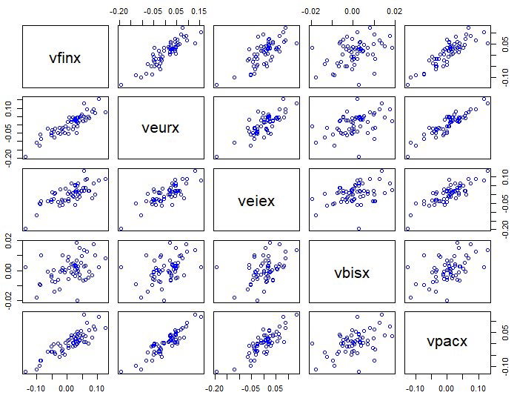

*Figure 13: Pair-wise Scatterplots*

The pair-wise scatter plots above show several interesting relationships. Each scatterplot provides a visual representation of the relationship between two funds, with the x-axis representing the returns of one fund and the y-axis representing the returns of another.

From the scatterplots, we can observe that the returns of VFINX and VEURX show a strong positive correlation. Similarly, the scatterplots between VFINX and VPACX, as well as VEURX and VPACX, also show a positive correlation, though slightly less obvious than the VFINX**/**VEURX relationship.

In contrast, the scatterplots involving VBISX show a different pattern. The returns of VBISX appear to have a weaker and less consistent relationship with the other funds. This shows that the returns of the short-term bond index are less correlated with the returns of the equity funds, which is normal and shows the typical behavior of bonds compared to stocks.

The sample covariance matrix of the returns on these assets further supports these observations. The covariance values between VFINX and VEURX, as well as between VFINX and VPACX, are positive, indicating a positive linear association between these. On the other hand, the covariance values involving VBISX are relatively lower, indicating a weaker linear association with the other funds. This shows that the short-term bond index provides diversification benefits when included in a portfolio with the equity funds, as its returns are less correlated with the returns of the stocks.

**Value-at-Risk Calculations and Analysis**

Value-at-Risk (VaR) is a statistical measure that shows the level of financial risk within a firm or investment portfolio over a specific time frame. It is commonly used by investment and commercial banks to gauge the potential losses in their portfolios. Specifically, the 1% VaR represents the maximum loss that one can expect to incur on the worst 1% of days, i.e. there is a 1% chance that losses will exceed this value. Similarly, the 5% VaR represents the maximum loss expected on the worst 5% of days, i.e. there is a 5% chance that losses will exceed this value. The 1% and 5% VaR in this analysis were calculated for a $100,000 investment over a one-month investment horizon. These calculations were based on the normal distribution using the estimated means and variances of the assets.

The 5% monthly VaR values for the asset losses ranged from -1211 (for VBISX) to -9053 (for VEURX). These figures represent the maximum loss that is not expected to be exceeded with a 95% confidence level over a one-month period. The asset with the highest potential loss was VEURX, while the asset with the lowest potential loss was VBISX.

|  |  |  |  |  |
| --- | --- | --- | --- | --- |
| VFINX | VEURX | VEIEX | VBISX | VPACZ |
| -7368 | -9053 | -8037 | -1211 | -7412 |

*Figure 14: 5% Monthly VaR ($)*

The 1% monthly VaR values for the assets ranged from -1739 (for VBISX) to -12775 (for VEURX). These figures represent the maximum loss that is not expected to be exceeded with a 99% confidence level over a one-month period. Again, the asset with the highest potential loss was VEURX, while the asset with the lowest potential loss was VBISX.

|  |  |  |  |  |
| --- | --- | --- | --- | --- |
| VFINX | VEURX | VEIEX | VBISX | VPACZ |
| -10684 | -12775 | -11289 | -1739 | -10480 |

*Figure 15: 1% Monthly VaR ($)*

Annual VaR values were calculated using the annualized mean and standard deviation. These were found by scaling the mean by a factor of 12 (to account for 12 months in a year) and the standard deviation by the square root of 12 (since standard deviation scales with the square root of time), and then recalculating VaR using these annualized values. The annualized VaR provides a sense of the potential loss over a one-year period.

|  |  |  |  |  |
| --- | --- | --- | --- | --- |
|  | Annualized Mean | Annualized SD | VaR 1% Annual | VaR 5% Annual |
| VFINX | 0.13749 | 0.18531 | -25442 | -15407 |
| VEURX | 0.071625 | 0.21241 | -34461 | -24253 |
| VEIEX | 0.037467 | 0.18302 | -32179 | -23170 |
| VBISX | 0.009049 | 0.02724 | -5287 | -3513 |
| VPACX | 0.05178 | 0.17128 | -29296 | -20542 |

*Figure 16: Table of Annualized Values*

**Portfolio Theory**

After computing the global minimum variance portfolio, the expected return of the portfolio was calculated at .0007647 and the standard deviation of the portfolio calculated at .007249. Comparing the portfolio’s SD to the SD of the 5 funds, the portfolio’s SD is significantly lower than the funds as is by design of the portfolio. The portfolio’s Sharpe Ratio, calculated by taking the expected return of the portfolio minus the risk-free rate of return divided by the volatility of the portfolio, also known as reward per unit of risk getting by investing is .04801.

|  |  |  |  |  |
| --- | --- | --- | --- | --- |
| VFINX | VEURX | VEIEX | VBISX | VPACX |
| 0.0377 | -0.0253 | 0.0217 | 1.0537 | -0.0879 |

*Figure 17: Global minimum variance portfolio weights*

In the portfolio, VEURX and VPACX have negative weights in the global minimum variance portfolio. This indicated that the more volatile or riskier funds are being shorted. The portfolio has a leveraged position in the bond fund VBISX, as it is the most stable of the 5 funds.

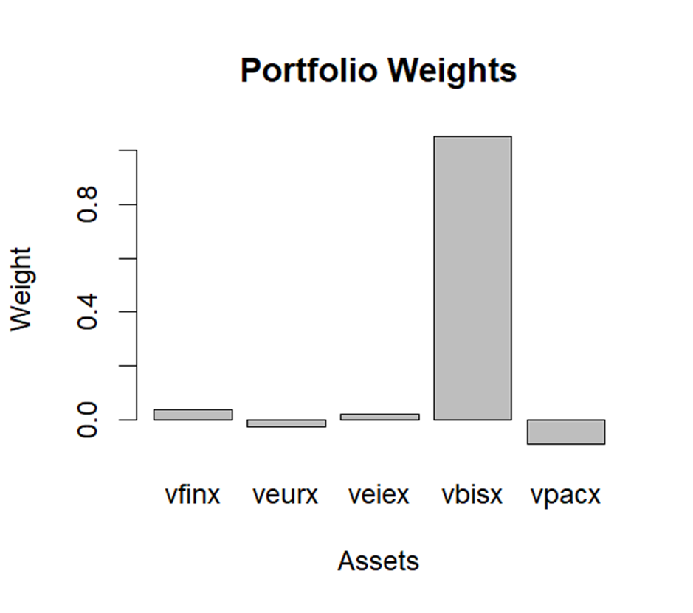

*Figure 18: Bar Chart of GMV Portfolio Weights*

After calculating the 5 individual funds VaR’s, the global minimum variance portfolio 1% VaR of the $100,000 investment is calculated at -$389.80. The global minimum variance portfolio 5% VaR of the $100,000 investment is calculated at -$274.55. This comparatively much less than that of the 5 individual assets.

|  |  |  |  |  |
| --- | --- | --- | --- | --- |
| VFINX | VEURX | VEIEX | VBISX | VPACX |
| -25442 | -34461 | -32179 | -5287 | -29296 |

*Figure 19: Individual asset VaR’s*

After computing the tangency portfolio, the portfolio that invests in combination on the 5 funds with the highest Sharpe Ratio, the expected return of the portfolio was calculated at .01455, the standard deviation of the portfolio calculated at 0.04619, and the Sharpe Ratio was calculated at 0.306. The Sharpe Ratio of the tangency portfolio is naturally higher than that of the individual 5 funds due to the design of the portfolio.

|  |  |  |  |  |
| --- | --- | --- | --- | --- |
| VFINX | VEURX | VEIEX | VBISX | VPACX |
| 1.8777 | -0.6773 | -0.1085 | 0.6138 | -0.7057 |

*Figure 20: Tangency portfolio weights*

In the portfolio, VEURX and VPACX have negative weights in the tangency portfolio. This indicated that the funds with lower Sharpe Ratio are being shorted. The portfolio has a leveraged position in the bond fund VFINX, as it has the highest Sharpe Ratio of the 5 funds.

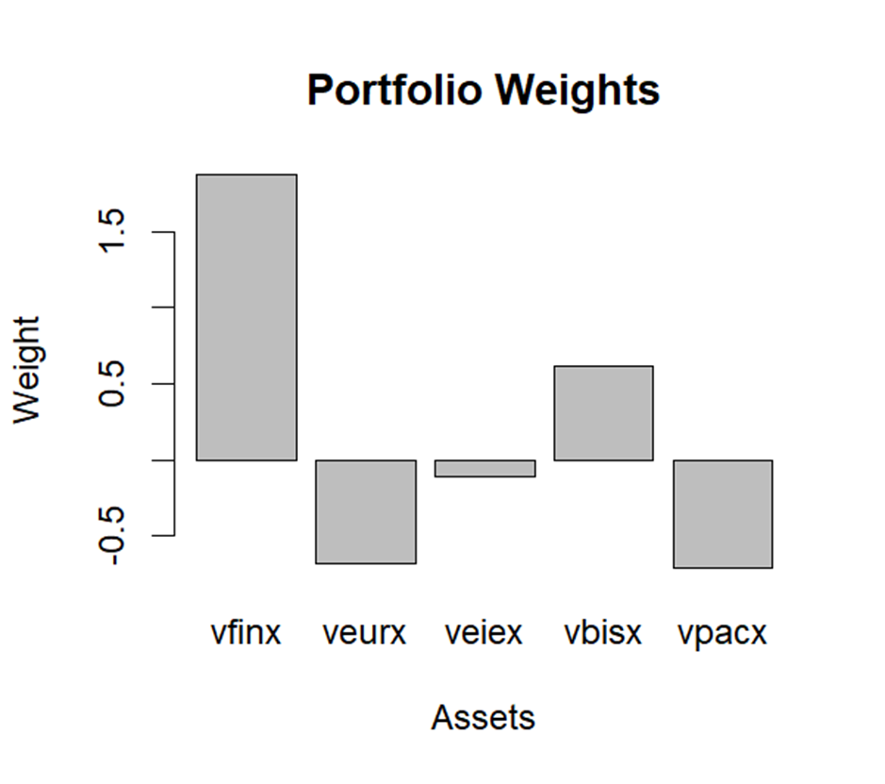

*Figure 21: Bar Chart of Tangency portfolio weights*

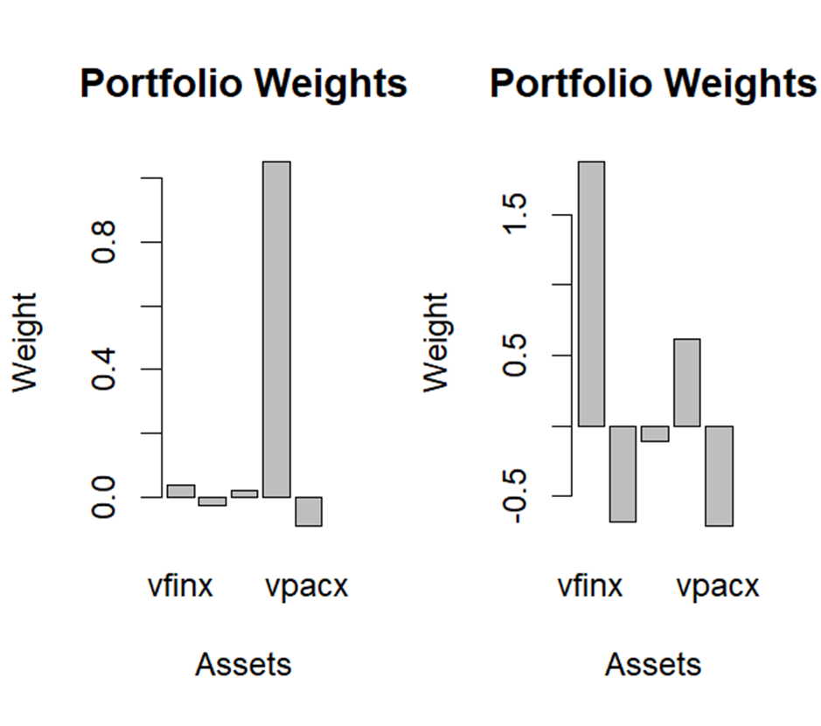

*Figure 22: Bar Chart of GMV and Tangency portfolio weights*

The weights differ based on the goal of the portfolio. The GMV portfolio has a leveraged position in VBISX due to its stability while shorting the more volatile funds. The tangency portfolio has a levered position in VFINX due it having the highest Sharpe Ratio while shorting the funds with lower Sharpe Ratios.

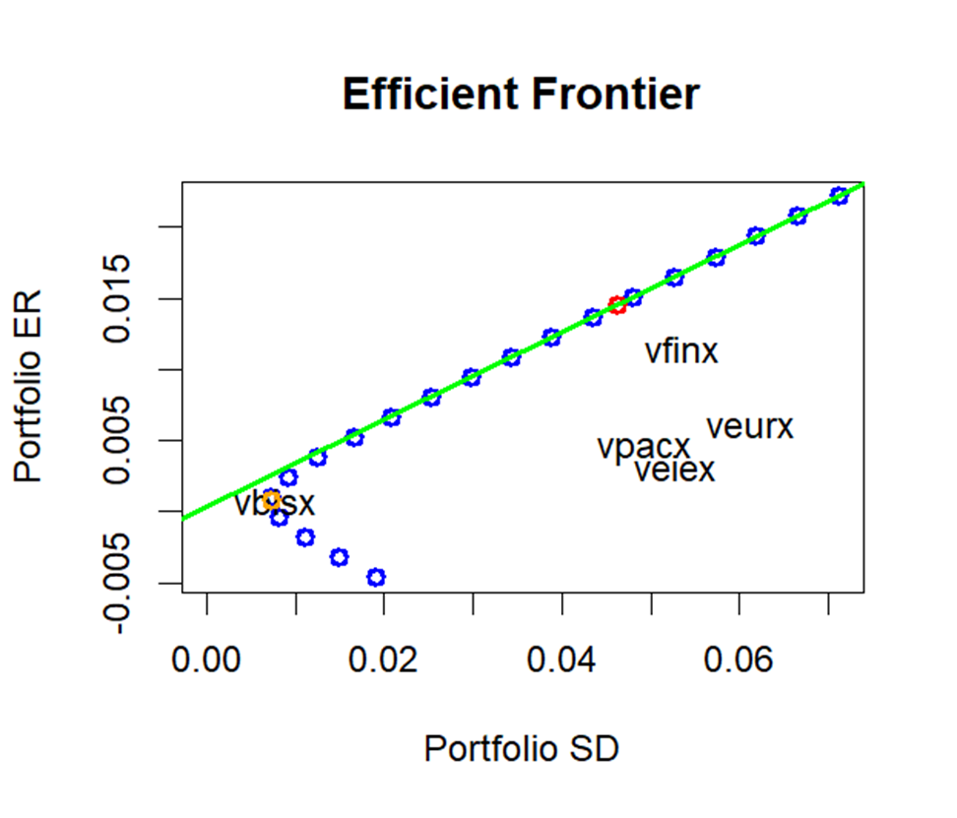

*Figure 23: Efficient Portfolio Frontier Graph*

The graph indicates the efficient portfolio frontier of the 5 funds, which describes the risk and return characteristics of all the portfolios possible by investing in the 5 funds and T-bills. The red is 100% in the tangency portfolio. To the left of the red dot on the efficient frontier are efficient portfolios investing in T-bills and the tangency portfolio. To the right of the red dot are efficient portfolios borrowing at the T-bill rate of return and have a leveraged position on the tangency portfolio. If you’re more risk averse, investing in T-bills and not in the tangency portfolio is optimal and will be on the left side of the portfolio frontier. If you’re riskier, shorting T-bills and having a leveraged position in the tangency portfolio is optimal and will be on the right side of the portfolio frontier.