Complexities

Two way synchronization

Two way synchronization between model and the file structure creates some level of complexity. The ideal simplicity can be achieved by supporting changes made in the model thru tiger views and ignoring any direct resource changes. Since the tool depends on file based configuration management, ignoring resource changes will kill the main purpose of multi file persistence. Therefore we shall need to look at the complexity at deeper level. The complexity increases especially where a resource change causes further resource changes. Let’s take a look at types of resource changes and their effec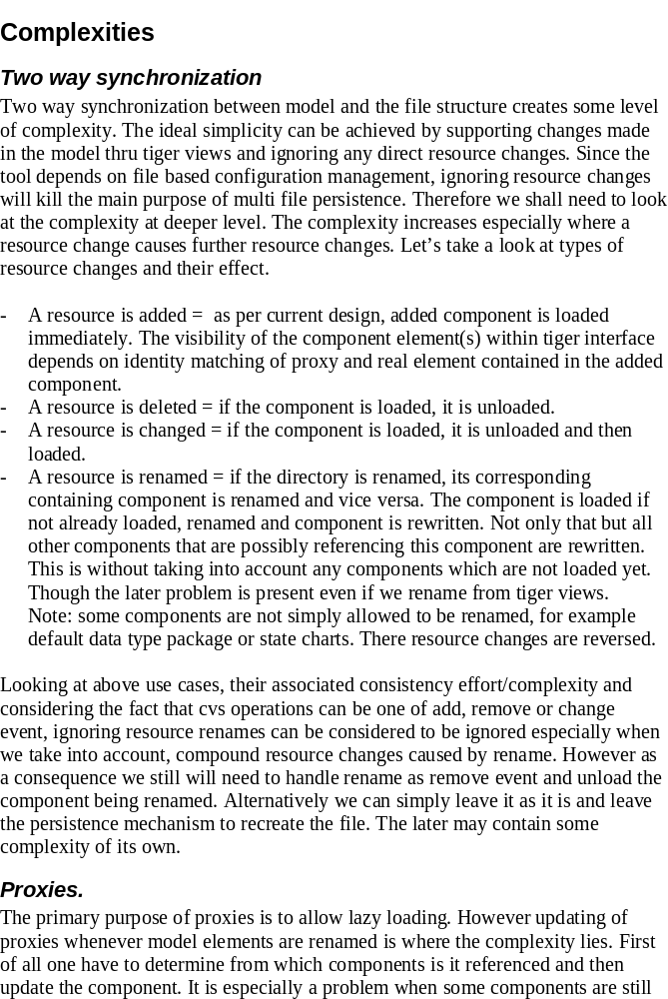t.

- A resource is added = as per current design, added component is loaded immediately. The visibility of the component element(s) within tiger interface depends on identity matching of proxy and real element contained in the added component.
- A resource is deleted = if the component is loaded, it is unloaded.
- A resource is changed = if the component is loaded, it is unloaded and then loaded.
- A resource is renamed = if the directory is renamed, its corresponding containing component is renamed and vice versa. The component is loaded if not already loaded, renamed and component is rewritten. Not only that but all other components that are possibly referencing this component are rewritten. This is without taking into account any components which are not loaded yet. Though the later problem is present even if we rename from tiger views.
Note: some components are not simply allowed to be renamed, for example default data type package or state charts. There resource changes are reversed.

Looking at above use cases, their associated consistency effort/complexity and considering the fact that cvs operations can be one of add, remove or change event, ignoring resource renames can be considered to be ignored especially when we take into account, compound resource changes caused by rename. However as a consequence we still will need to handle rename as remove event and unload the component being renamed. Alternatively we can simply leave it as it is and leave the persistence mechanism to recreate the file. The later may contain some complexity of its own.

Proxies.
The primary purpose of proxies is to allow lazy loading. However updating of proxies whenever model elements are renamed is where the complexity lies. First of all one have to determine from which components is it referenced and then update the component. It is especially a problem when some components are still not loaded. In the first attempt to reduce the complexity relative paths were used instead of full paths. Following are some of possibilities that can reduce this area of complexity.

- Our proxies rely on named path for lookup, thus creating the requirement to update the path on renames. If we develop a mechanism of UID or (UUID) preferably derivative instead of names of components, with the help of UID look up table, we could still locate the component and get rid of requirement of updating the named proxy paths.
- Don’t store the proxies at all. If we look carefully, our meta model is already using relational database concepts for establishing relations. If we have a mechanism of creating indexes for each of the component, we can use this mechanism to locate the component location of queried model element. However this would require synchronization between index files and the components file. Overall developing this mechanism is not trivial unless we use some third party library for indexing and BTrees for look up mechanism. Please note that we are already using some kind of lookup mechanism already i-e., instance lists.

Complex unloads because of proxies
When a component is loaded, the model elements being loaded replace their proxies (if any). In practical terms these are simple turned into real elements. While this provides simplicity, it also requires that when component is unloaded, its cross referrals are turned back into proxies again. The determination of referrals is done by literally evaluating all links of each model element, which triggers heterogeneous loading of components. There are some complex scenarios where components are reloaded even after their unloading procedure.

While the proposal of removing proxies seem difficult but the removal of proxies remove this complexity as well.

Not using resource structure as primary model rather then relying on cross boundary relations for containment relationship.
In many of the tools that I reviewed, I made following observations:

- Their design revolves around the resources and directly resources. Even if they have view similar to model explorer, its primary model is directory structure itself not the model relations. They use the model relations for second level detail within the model explorer. To better understand this concept, consider Package explorer, which shows java files whose internal structure is only showed when the node is expanded. This particularly means that parent child or more precisely containment relationship is defined by their directory structure and physical and file based containment. In our case we require proxy 2 real ME identity match. All these tools sacrifice some visible inconsistency such as visibility of model element in model explorer but not its container diagram, but its logical when you take resource tree as primary model for model explorer.
- Once you do that, you gain the ability to isolate a single component as much as possible. That is key design aspect that brings lot of benefits. For example if package diagram is open with another package shape in it. It is totally independent of its physical existence. The shape and its cached text (as a part of graphical attributes) are not affected until it is double clicked. Another example is data types. They only keep a reference with no relation with original data type object. A reference is however resolvable based on its applicable scope. In other words, direction relational links are not established rather unlinked references are created wherever possible through out the cross component relations. These references can however be resolved on a common design pattern. You can call these soft links provided if we call explicit relations as hard links. This also allowed them
- All of the tools use the similar terms from standard eclipse environment such as refactoring that is used to keep the model in sync, so that user would know that normal operations may not update the references. This sequence particularly loads the files,

Please note that above observations cannot apparently considered at this point because it appears to be a radical change but it does tell us that some requirements must be taken into consideration right from the start. This also reminds me how a language compiler and linker works, it treats the file under consideration as independent as possible from others and reply on external resolvable symbols.

Proposed design with respect to above proposal
- Addition of following elements to the header of component
UUID, name (Type is already there).
A component shall be considered as valid only if all following conditions are true.
- The type of parent component is valid according to relationships.
- The name of file is same as header.
- Maintain a UUID 2 Component Path(s) map for all component files in the resource tree. An entry is going to be considered as valid if there is only one file is present with same UUID. For any duplicates warnings markers will be added and all invalid components or duplicate components will not be loaded in any case.
- If the resource is removed, perform unload.
- If the resource is added, register component, load only if it was recently unloaded.
- If the resource is renamed, perform unload.
- If the resource is changed, perform unload followed by load.

General comments
- The property editor should provide readonly view for proxy model elements.
- ….

Overall Strategy
Pre-planning
- Evaluate the proposed design with respect to all mfp issues to see if it will work fine.
- On a parallel side, go thru the open issues and see which ones are unrelated to resolution provided by proposed design changes.

Planning.
- There are about 22 issues open in mfp database. We are going to calculate time for each one of them.
- We shall first perform quick general code review and identify areas where code is not harmonious. Evaluate and determine necessary list of changes (if any).
- Calculate the time to implement approved refactoring.

Generally our first attempt will be to close any issues that are not related to any refactoring effort. Depending on the stability of the MFP after handling these issues, we shall do the necessary refactoring and test the implementation.

As far as the test code is concerned it is over all complete.

Disadvantages of UUID
---------------------
The purpose of this section is to question the odds of using UUID before we
really decide to use it.

While UUID gives us an advantange to become independent from names and the path
where they exits. There are some model elements where name is more vital then
its ids. Examples are

Data types
Class names\key letters

One of the example where the odd of using UUID becomes more visible is where
some user deletes a data type and recreates it again with same name and same
core type, he would not understand from his stand point that something
internally has changed.

Proxies and their role overlapping with real instances.
------------------------------------------------------
This area requires more research.

EMF
---
Note: Following findings are based on the study done so far on the subject and
does not mark its authenticity. However it does provide a warning and guideline
for further study.

While we are considering to use EMF, it is important to realize that using EMF
is not going to help us at all in multi-file scenarios if we take along the same
set of requirements today and use EMF to implement it. While EMF do provide the
basic concepts of lazy loading and multi-file persistence, but they are still
far away from where we stand today.

One example is reference updating and resource synchronization. EMF uses XMI
and for external references it uses xlink compatible mechanism. However it is
totally up to the implementation about how to use it. For example one might use
relative location, absolute location, UUID or nameID based references.
Practically speaking, I have seen tools not using location based xlinks, instead
a mixture of UUIDs and name based references. There they use another concept of
reference resolver which is very important and if we look closely, we are
actually doing it but implicitly; without a formal realization and design
pattern based mechanism as seen in other tools. But it is important to realize
here that none of UUID, Name or Path based references provide complete coverage
of scenarios when taken individually or separately. It is probably the reason
why XSD support all types of references.

Coming back to EMF, let me remind that EMF does not provide resource
synchronization and model integrity. Upon investigation it is found that a new
project is there which is still in incubation. The name of project is EMF
Transaction API and it is done under EMFT (EMF Technology). This project brings
most of the concepts that we have today and surprisingly both have same name,
"Transaction". They are also implementing undo/redo based on this API and
similarly resource synchronization falls under the same project. According to
the implementation done under emft/transaction/org.eclipse.emf.workspace, they
are just beginning to implement resource synchronization. A lot of code reminds
me of early implementation that we did in early phases but at the same time
their implementation is lot better and follows common grounds and logic. As an
examples see what do people think about resource synchronization upon delete [6]
comment 2 by Christian W. Damus and following discussion.

Symbol look up mechanism
------------------------

As discussed earlier, name based (do not confuse name based references with path
based references as in our case both are same i.e, name of file is same as name
of model element) references play an important role when a given model spans
over multiple file. One of another important component that EMF have, addresses
the symbol look up mechanism. It provides the ability to locate a model resource
against the name of the model element within it. OCL is one example which
utilizes this API. EMFT have another project called OCL which implements OCL
parser and interpreter. This project relies heavily on Query project and some of
classes from emf core. This mechanism is also used for resolving name based
references.

Proxy Policy Discussion (Used to help define Proxy Policy section in the analysis note)
> -----Original Message-----
> From: McCausland, Campbell
> Sent: Monday, February 06, 2006 12:29 PM
> To: Ali, Babar; Mulvey, Robert
> Cc: Raza, Asif; Rochford, Gregory
> Subject: RE: PLCM design principles
>
> As requested, please find my comments embedded.
>
> > -----Original Message-----
> > From: Ali, Babar
> > Sent: Monday, February 06, 2006 5:04 AM
> > To: Mulvey, Robert; McCausland, Campbell
> > Cc: Raza, Asif
> > Subject: RE: PLCM design principles
> >
> > Guys, please review and embed your comments.
> >
> > - Current Policy for Proxy
> > 1- If relation is between two component root model elements
> then proxy
> > will be created for RGO in the component that contains the RTO.
> > 2- If relation is between two cross component model elements where
> > both can be non root or one of them can be root model element, then
> > the proxy will be generated for RTO in the component containing the
> > RGO.
> > 3- In case of domain to subsystem relation R43, first rule
> is ignored
> > (special handling) and proxy is generated against 2nd rule
> and proxy
> > is created for RGO.
> >
> > Relation iteration under above rules which does not cause lazy
> > loading.
> >
> > DataType ->[R20]-> Bridge and all similar navigations.
> > Example Usage: DataType.dispose();
> >
> > - Generalization of above observation
> > All navigations in which rule # 2 applies, only one way navigation
> > will cause component to be lazy loaded and that will be
> from RGO->RTO.
> > RTO to RGO will not be loaded.
> >
> > If we implement special code for this, this may have performance
> > compromise. The special code will result in loading of all
> components
> > that can possibly contain the RGOs of given type whether or not
> > related.
> >
> >
> > Alternatives
> > ------------
> >
> > 1. Two way proxy generation
> >
> > This has following consequences.
> >
> > - double the instances of all proxies
> > - double the effect of model driven changes in resource
> > synchronization and hence the complexity. Consider delete operation
> > from tiger view.
>
> Unfortunately, the above is not an option. It violates the
> requirement that we only write the files the user expects.
>
> >
> >
> > 2. Keeping only one way proxy.
> >
> > RTO alone.
> > - Parents cannot determine the number of children without loading
> > them.
> >
> > An alternative is to create special relationships rather
> then direct
> > relationships just like removing R1 and using R43 for all
> parent child
> > relationships. Although it is more of a hack and requires more
> > investigation.
>
> This is an example of complexity/asymmetry we need to remove.
> We cannot remove R1 without breaking all the model compilers
> including third party and customer's m/c's. R1, R43? It
> should be all the same to the ooaofooa analyst and the model
> compiler architect, they must not be required to know about
> RGO vs. RTO.
>
> >
> > RGO alone.
> > - For parent child relationship, child utilizes
> ensureParentAvailable
> > but reverse scenario will be problematic
>
> In what way? Please specify.
>
> > - For other relations, there is no way to determine without special
> > handling code as specified earlier
> >
>
> I have specify generic rules elsewhere. Do they not apply to
> all these scenarios?
>
> >
> >
> > Use of proxy as a method for caching data from other component.
> > ---------------------------------------------------------------
> >
> > One of the reason why proxy was introduced is to facilitate
> caching of
> > data or attributes that the proxy holds, so that views show
> the proxy
> > model elements without loading the containing proxy but practically
> > speaking attributes of proxy alone is of no usage until other
> > relations are browsed. For example:
> >
> > 1. Parent child relationships in model explorer Whenever a
> proxy model
> > element becomes visible, the model explorer inquires about the
> > children of the proxy from the proxy, which causes component
> > represented by the proxy to be loaded.
> > This is done in order to show +/- sign
>
> Unlike Microsoft, I am not content for the +/- sign to be
> buggy. I think it is OK for loading to occur a little earlier
> so that this is shown correctly. In other words, I don't
> understand the problem here.
>
> >
> > 2. data type
> > The use of Data Type without any of its specialization such as
> > Enumeration, CoreDT, UserDT is apparently not used anywhere
> >
> > 3. canvas
> > In case of canvas, DTP and FPk graphical elements are
> display with use
> > of proxy alone but if properties view is visible(which is
> visible most
> > of time), with advance properties off, loads the children as well
> > because it get property descriptors (needs investigation why).
>
> I'm not so worried about occasions when additional data is
> loaded. I am concerned about situations where loading is
> _not_ occurring when it should.
>
> >
> > But the experience has showed that there are very few places where
> > data contained in a single proxy alone have any use.
> > Therefore it is assumed in general that proxy is not an effective
> > method of caching the data.
>
> We only expect naming data to be available. In most cases
> (events being a notable exeception), this is available in the
> proxy. Whether this data is ever used without loading other
> data is actually not the issue. If we take this information
> away and the user causes dangling references, there is no
> information to help him understand what he did and how to fix it.
>
> >
> >
> > > - We shall not write files except those the user
> associates with a
> > > given change.
> >
> > With proxies and delete operation, this is not possible.
>
> As Greg has already noted. The user must expect widespread
> changes when deleting some types of model element.
>
> >
> > > -----Original Message-----
> > > From: Mulvey, Robert
> > > Sent: Saturday, February 04, 2006 5:07 AM
> > > To: McCausland, Campbell; Ali, Babar
> > > Subject: RE: PLCM design principles
> > >
> > > Thank you,
> > >
> > > I will incorporate this into the document along with
> > Babar's Analysis
> > > of Proxy policy and my Listener state machine results.
> > Perhaps the 3
> > > of us can get together earlier to mid-week and look over the new
> > > portions of the document.
> > > Then we'll make more modifications and review with the
> whole group
> > > again around Thursday or Friday morning.
> > >
> > > Bob
> > >
> > > > -----Original Message-----
> > > > From: McCausland, Campbell
> > > > Sent: Friday, February 03, 2006 6:46 PM
> > > > To: Mulvey, Robert
> > > > Subject: PLCM design principles
> > > >
> > > > Hi Bob,
> > > >
> > > > As promised here are the high level design principles I
> > think should
> > > > apply to PLCM:
> > > >
> > > > - We shall not write files except those the user
> > associates with a
> > > > given change.
> > > > - The loading behavior shall be uniform across all
> associations,
> > > > regardless of direction.
> > > > - Neither metamodel analysts, nor writers of custom
> > transactions and
> > > > queries on the model,
> > > > shall have to know anything about the underlying
> > construction of
> > > > the model (so long as hand
> > > > written code uses the generated traversal mechanisms).
> > > > - Model data shall be loaded just before it is needed.
> > > >
> > > > This implies the following lower level consequences:
> > > >
> > > > - The 'select any from instances of' statement needs to
> > keep loading
> > > > components until one instance is found
> > > > - In the above case with a where clause, loading proceeds
> > until an
> > > > instance is found that passes the filter
> > > > - The 'select many from instances of' statement needs
> to load all
> > > > components that could contain an instance of the target class
> > > > - The above rules apply equally to 'select related by'
> > > > statements traversing in the Referred To -> Referrring Class
> > > > direction. (e.g. Data Type -> Attribute)
> > > >
> > > > Let me know if you were expecting more/something else :)
> > > >
> > > > best,
> > > >
> > > > C.
> > > >
> > > >
> > > >
> > >
> >

