

Model Transformations for
xtUML/SystemC

Modified Date: January 20, 2010
Document Revision: 1.0 Draft 1
Project ID: N/A
Direct comments, questions to the author(s) listed below:

Mentor Graphics Company Confidential
Copyright © Mentor Graphics Corporation <2007>
All Rights Reserved
This document contains unpublished information that is confidential and proprietary to Mentor Graphics Corporation, 8005 SW Boeckman Road, Wilsonville, Oregon 97070. It is supplied for identification, maintenance, evaluation, engineering, and inspection purposes only, and shall not be duplicated or disclosed without prior written permission from an authorized representative of Mentor Graphics. This document and any other confidential information shall not be released to any third party without a valid Confidential Information Exchange agreement signed by the third party and an authorized Mentor Graphics representative. In accepting this document, the recipient agrees to make every reasonable effort to prevent the unauthorized use of this information.

Table of Contents
1 Introduction 2
1.1 Definitions, Acronyms, and Abbreviations 2
1.2 References 3
1.3 Conventions 3
2 Example – xtUML Inter-Component Messaging 4
2.1 An xtUML Model 4
2.1.1 Interface and Message 4
2.1.2 Components and Ports 4
2.1.3 Send Message 4
2.1.4 Receive Message 5
2.1.5 Timer 5
2.2 SystemC Implementation 6
2.2.1 Interface and Message 6
2.2.2 Components and Ports 7
2.2.2.1 SC_MODULE 7
2.2.2.2 sc_signal < > 7
2.2.2.3 SC_CTOR 7
2.2.2.4 Send Message 7
2.2.2.5 Receive Message 7
2.2.3 Module Behavior 8
2.2.3.1 SC_METHOD 8
2.2.3.2 SC_THREAD 8
2.2.3.3 SC_CTHREAD 8
2.2.4 Timer 8
2.2.5 xtUML Event Dispatcher 8
3 Formal Mapping 8
4 Transformation Status 12
5 Open Issues 13
6 Attachments 14

xtUML/SystemC Model Transformations for

CAIRO Matrix
C  Consult | A  Approve | I  Inform | R  Responsible | O  Omit
Director of Engineering  General Manager | Responsible for Marketing |  | <anyone>

Responsible: <name>
Approved by:
<Name> <Title>, on <Approval Date>

Change Record
Rev | Description of Change | Date Released | Authored By
1.0 Draft 1 | Initial Draft |  | Yasser Shoukry

Introduction
This document specifies how xtUML and SystemC models are transformed

Definitions, Acronyms, and Abbreviations
Term | Meaning

References

Table 1: Referenced Documents
Document Title | Version | Date | Author

Conventions
Within this document the following blue italic font is used to indicate quotes from external sources:
“This is a quote.”

Within this document the following fonts are used to indicate AUTOSAR, xtUML, and transformation script substitution variables:

SystemC element
xtUML element
Transformation substitution variable

Example – xtUML Inter-Component Messaging

An xtUML Model

Interface and Message
An entity can use the Tick interface to send a tick message to another entity.
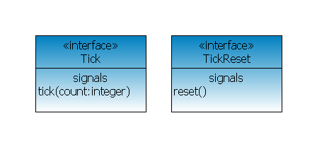

Components and Ports
An entity inside a Ticker component sends a tick message to an entity inside a Tickee component. It does so through a port; without the entity inside Ticker having any explicit knowledge of the entity inside Tickee (and vice versa).
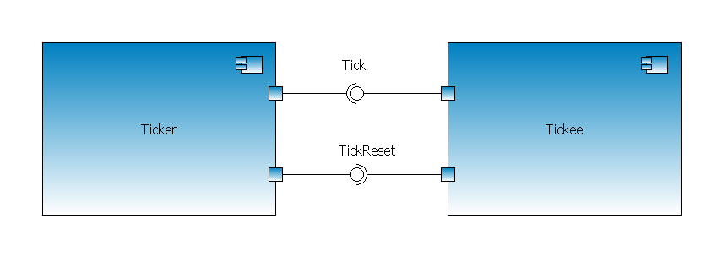
The Tickee component “provides” a Tick interface (the name of the port on the Tickee component is TickProv) for the Ticker component to “use” in order to send the tick message; the Ticker component thus “requires” a Tick interface (the name of the port on the Ticker component is TickReq).

Send Message
The name of the port on the Ticker component is TickReq. The Ticker component implementation has a TickReq class. The TickReq class has an operation that is used within the component to send the tick message through the TickReq port using a send statement:

Ticker::TickReq::tick(count:integer):void
{
send TickReq::tick(count:param.count);
}

Receive Message
The name of the port on the on the Tickee component is TickProv. The Tickee component implementation has a TickProv class. The TickProv class has a class-based state machine. There is a signal assigned to a transition in the state machine that is mapped to the receipt of the tick message through the port.
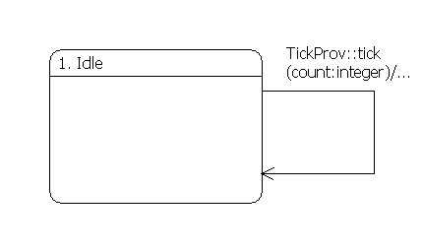
The OAL for the transition handles the tick message coming in.

Tickee::TickProv::tick(count:integer):void
{
// handle the tick message

[SNIP]
}

Timer
The implementation of the Ticker component contains a Ticker class with a startRecurringTimer operation.

Ticker::Ticker::startRecurringTimer():void
{
ts = 1000000;
create event instance timerEvent of Ticker1:tick to \
self;
ts = 1000000;
ts = ts*param.periodSeconds;
self.timerHandle = TIM::timer_start_recurring(microseconds:ts, \
event_inst:timerEvent);
}
The Ticker::Ticker class instance state machine has an event on a transition mapped to the arrival of the timer expiration event.
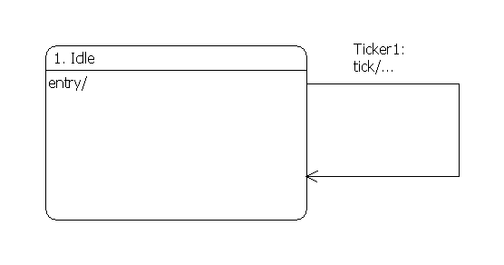

SystemC Implementation
SystemC main component is modules. A typical design consists of a large number of communicating modules. Some modules represent hardware that needs to be synthesized while others are only used for verification. The former case modules should be described using a subset of SystemC defined archetypes with proper considerations of RTL modeling. The latter case modules can contain ordinary C/C++ code. To support both we need two different approaches while generating output.
A SystemC module declaration contains both structural information and behavioral information. In contrast, xtUML separates structure declaration out from behavioral ones. A defined merging between two different models is needed.

Each module header file contains
• Port declarations (from UML Structural Description)
• Internal signal variable declarations (from UML Structural Description)
• Internal data variable declarations (from UML Behavioral Description)
• Process declarations (from UML Behavioral Description)
• Member function declarations (from UML Behavioral Description)
• Module constructor (both UML Structural and Behavioral Description)

Interface and Message
A separate file called “interfaces.h” is used to separate the declaration of the interfaces and allow assigning different implementation types to them. For each interface MC-SystemC generates three typedef statements for <interface_name>_in, <interface_name>_out and <interface_name>_channel. The first two statements are used to define in/out port types for this interface, while the third one is used to define the channel connecting between in/out port pair. The default values for these definitions are sc_in<datatype>, sc_out<datatype> and sc_signal<datatype>.

For interfaces holding more than one signal/operation, a separate interface/channel definitions are generated for each signal/operation.

For interfaces holding parameters of array type, the generated interface/channel is for only one element. A port of the array size should be generated.

Components and Ports
For each xtUML component a SystemC SC_MODULE is created in a separate header file. This file will contain all information about the structural part of the component.
For each component, the following actions should be taken inside SC_CTOR
- Instantiation of nested components
- Binding nested component ports using the generated signals
- Registering processes to its sensitivity list

Components
Instantiation of nested components is done inside the definition of each component.
The top module should be instantiated inside the “main” function of the program. Clock and reset signals are also generated for the top module and connected to its ports.

Ports and Channels
For each required port, an output port is added to the SC_MODULE using the generated <interface_name>_out generated in 2.2.1
For each satisfaction (component connection) between provided and required ports of nested components, the generated <interface_name>_channel is used to bind the ports.
Delegated ports do not need a generation of a <interface_name>_channel; binding of delegated ports is done using the name of the port on the outer component.

Two default ports are defined for all components, namely “clk” and “reset” ports.

Send Message
Class functions will be mapped into regular functions within an SC_MODULE. These functions should be called from a function which is registered as SC_METHOD, SC_THREAD or SC_CTHREAD. Typically, any OAL inside a state machine will be mapped into one of these process types.

The send function will call the “write” function inside the port instance of the component. However, this function will not be fired unless called from OAL in the state machine.

Receive Message
Each state inside a class based state machine will be mapped into a separate no-arg function and then registered into SC_METHOD with a sensitivity list generated from the events assigned to the state transitions which leads to this state.
This will result into an SC_METHOD with tick signal inside the sensitivity list. The SystemC simulation engine will fire this process whenever the value of tick signal is changed.
The generated no-arg function should contain the OAL code written inside the state plus that written inside the state transition.

Timer
There is as yet no clear mapping between Timers in xtUML and SystemC. By definition, SC_METHOD, SC_THREAD and SC_CTHREAD derive their timing behavior by assigning a clock signal to their sensitivity list.

xtUML Event Dispatcher
xtUML event dispatcher will not be used. Instead the SystemC simulation kernel dispatches edge and level change events to the appropriate registered processes inside various SystemC modules.

Formal Mapping Of Component Diagram
Below is the one-to-one mapping of symbols that can appear in the component diagram and its equivalent archetype in SystemC.

xtUML element | SystemC element
Component, ${ComponentName} | SC_MODULE ${ComponentName}
Interface, ${InterfaceName}, with possibly multiple Signal(s) with Server-to-Client Message Direction and possibly multiple Signal(s) regardless Message Direction, ${signalName(s)}, with parameter(s) ${parameterName(s)} of type ${UMLTypeName(s)} | For each of the xtUML Interface(s), Three typedef statements are generated inside the “interfaces.h”:  typedef sc_in<interfaceType> ${interfaceName}_in  typedef sc_out<interfaceType> ${interfaceName}_out  typedef sc_signal<interfaceType> ${interfaceName}_channel  The later one is used to connect between ports of different components.
xtUML Port, ${portName}, on Component, ${ComponentName}, with provided interface, ${InterfaceName}, regardless message direction and interface type | For each Port a port definition of the following syntax should be declared inside the module definition file:  ${ interfaceName }_in ${portName}  Where the ${ interfaceName }_in was previously defined inside the “interfaces.h” file.
xtUML Port, ${portName}, on Component, ${ComponentName}, with required interface, ${InterfaceName}, regardless message direction and interface type | For each Port a port definition of the following syntax should be declared inside the module definition file:  ${ interfaceName }_out ${portName}  Where the ${ interfaceName }_out was previously defined inside the “interfaces.h” file.
xtUML Primitive Types, boolean, real, integer, string | bool, UMLBoolean.  double, UMLReal.  [Note: double variables are not synthesizable]  String, UMLString.  [Note: string is not a synthesizable]  SystemC defined datatypes are packaged into a user defined datatype package. This package should be marked as direct types (“type:direct”) before it is used.  This typically can be performed by editing the “datatype.mark” file and adding the following line  .invoke AssignDirectToUDTPackage( "SystemC Datatypes" )  Where “SystemC Datatypes” is the name of the package containing the direct types.
xtUML Enumeration Data Type, ${DataTypeName} | enum, ${DataTypeName }

Transformation Status
This section provides an update on the generation of SystemC description from the xtUML models.

xtUML | SystemC Code gen.
Signals (no parameters) | Not Supported yet
Signals (Single parameter) | Supported
Signals (multiple parameters) | Split into multiple separate signals
Operations (no arguments) | Not Supported yet
Operations (Single argument) | Supported
Operations (multiple arguments) | Split into multiple separate signals
Multiple signals per interface | Not Supported yet
System Component package representing a root composition | Not Supported yet
Nested Components | Supported
Imported Components | Supported
Multiple Component Packages | Supported
Multiple interface references per port | Supported
Event queue interrogation | Not Supported yet
Initialization functions | Not Supported yet

Open Issues
This section lists either UML modeling of SystemC components or xtUML-SystemC mapping questions that need to be answered and resolved. Some of these questions may result in the promotion of a new mapping feature.
- No one-to-one mapping for xtUML “Timers” into SystemC. For HW purposes, time is calculated as number of clock ticks.
- Multiple sources for the same event. Since events on the state transitions are mapped into sensitivity lists for SC_METHOD, multiple sources for this event can cause a “multiple drivers” error while synthesizing the module.
- Class attributes should be mapped into variables. These variables should be updated only inside SC_METHOD which is sensitive only to clock and reset edges. Current behavioral modeling scheme does not allow to model sequential logic inside xtUML.
- While generating the structural description, operations and signals are treated in the same manner. However, Behavioral modeling of operations needs the ports to be declared as TLM ports.
- Synthesis Tool: Generated code should be tested against current capabilities of Catapult-C in order to check the behavior of the post-synthesis modules.

Attachments

