To distribute our PGP public key to the Wachovia Bank customer:
****** NOTE USE https://dataweb.wachovia.com/test ******

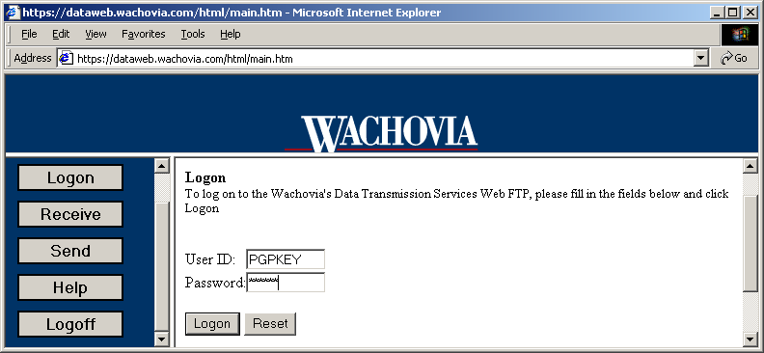

- Point your browser to the Wachovia website at https://dataweb.wachovia.com
  - ID is PGPKEY and Password is PUBKEY * case sensitive, uppercase only
- Click Logon
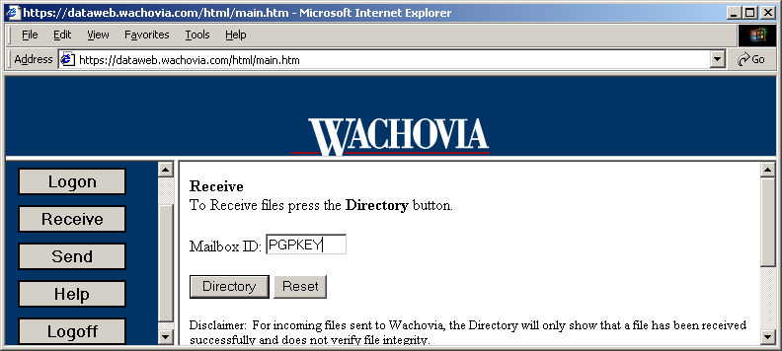
- Click on Receive
- Enter PGPKEY for Mailbox.
- Click on Directory

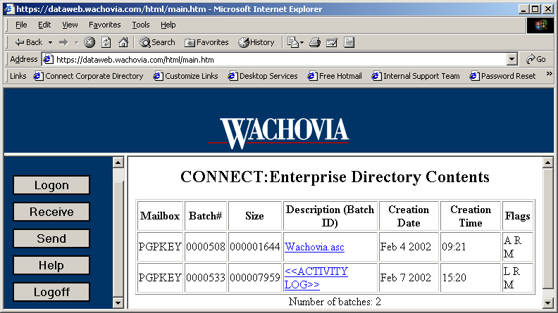
- Then click on the file 'Wachovia.asc'

This will start the download of the Wachovia Bank public key to the customer.
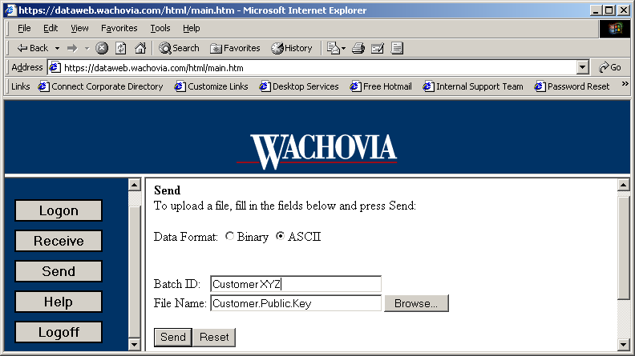
- The customer can then send their public key to Wachovia by selecting Send.
- Notify the Data Transmission Services Architecture group when the key is received from the customer.

