1. Introduction
   1. Give an overall intro of your project.  Why you did it? What are the factors of interest

Introduction

Our goal was to determine how to make a paper airplane that would fly a long distance. The design of the plane can greatly affect lift and air resistance (drag), so our first factor of interest was plane design. For this project we chose three basic designs which we called “snub-nosed”, “delta”, and “weighted.” Another consideration in the design of an airplane is how air will behave at the ends of the wings. In the middle of the wings, air moves a longer distance over the top of the wing than under the wing. This causes the air to move faster over the top of the wing in order to meet the air that went under the wing on the other side. The higher speed decreases the pressure on the top of the wing generating lift. At the ends of the wings, air can slip out from under the wing to join the air above. This generates vortices at the end of the wing that create drag. Winglets are extensions at the end of the wing that help to block the generation of vortices and decrease the drag they create. Modern commercial aircraft use winglets to increase efficiency by up to 6.5%. Accordingly, our second factor was to modify each design by either bending the ends of the wings up or down or leaving them as is.

Factors:

Plane design: (Snub, Delta, Weighted)

Winglets: (Up, Down, Center)

* 1. What are the null and alternative hypotheses

H0: Mean flight distance is the same for all designs.

Ha: Mean flight distance is different for at least one of our designs.

H0: Mean flight distance is the same for all winglets.

Ha: Mean flight distance is different for at least one of our winglets.

HO: There is no interaction between plane design and winglets.

Ha: There is at least some interaction between plane design and winglets.

1. Data Collection

We anticipated that small variations in the folding of the plane could lead to variation in performance; we controlled for this factor by having one member of the group (Corum) fold all nine of the planes used. We also controlled for variations in the skill of the thrower by having the same person (Johnson) execute all of the throws. Because we worried that the performance of the thrower might decrease with time, we randomized the throwing order. This was done by numbering each plane from 1 to 9, and rolling a 10-sided die (numbered 0-9 where 0 was always ignored) to determine the throwing order until all planes had been assigned 10 throws. (Once a treatment had been rolled its allotted number of times, its number was ignored and rerolled) We threw the planes in an enclosed gym to ensure a windless environment.

The two factors were plane design (Dart, Weighted, Snubnose) and winglets (Up, Flat, Down.) The response was the distance from plane to thrower measured in inches to the nearest half inch.

One problem we encountered was that winglets tended to cause the “Dart” plane to curve in flight which meant that its true flight distance was longer than the distance measured from the thrower to the plane.

Our overall sample size was 90, 10 for each combination of design/winglets. We used R to calculate that with this sample size and an estimate of the variance from our previous work that we would have a power of over 80% to detect a difference of 3 feet in the mean flight distance of the planes.

1. Descriptive Statistics
   1. Numerical Descriptive Statistics

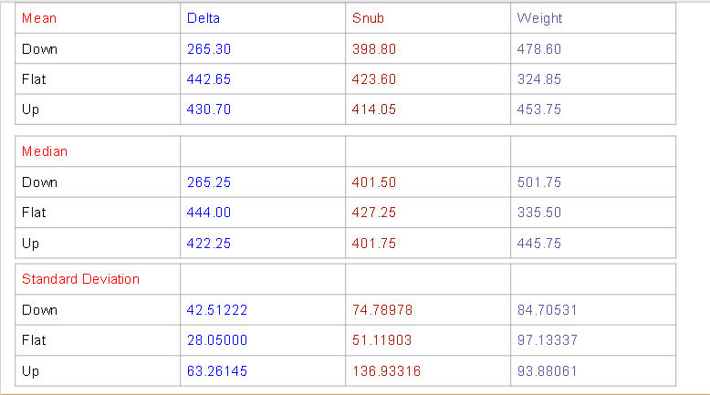

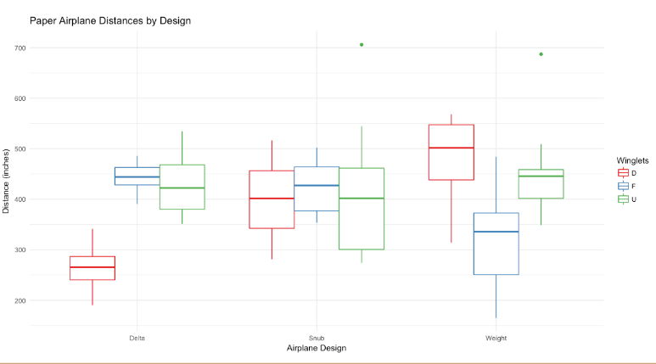

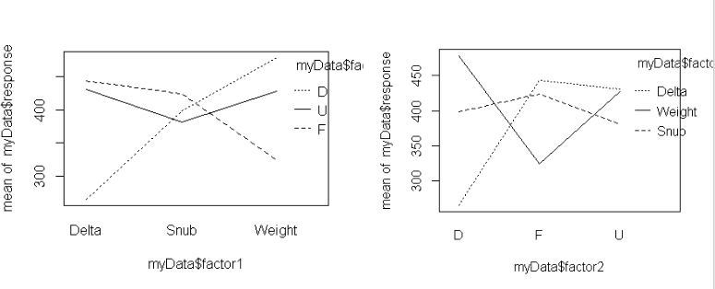

* 1. “Tell a story” based on what you see in your descriptive statistics

All designs seem to have the same mean, but there appears to be definite evidence of interaction and possible evidence of winglet effect. Notice that the winglets didn’t make much of a difference for the snub-nosed design, but the folded down winglets had a negative effect on the delta design (we noticed that this plane tended to circle the thrower more than others) while the folded down winglets appeared to increase the mean distance of the weighted design.

We also had two outliers, but as we considered these flights, there was not a good reason to believe the measurements were flawed. Sometimes everything just comes to together for a long flight.

1. Inferential Statistics
   1. Checking Requirements

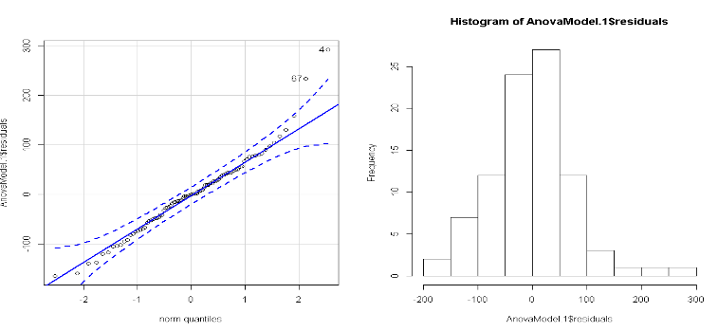

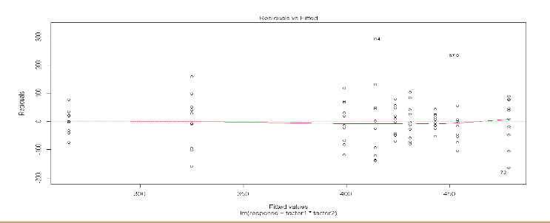

Residuals are normally distributed, but variance appears to be unequal. In particular, the p-value for Levene’s test of homogeneity of variance was below 2%, indicating that there is good evidence that the variances were unequal among the groups. Unfortunately, there was not a clear pattern between the variance and the mean of the response for the groups, so we didn’t try to transform the response variable.

* 1. ANOVA table, df,SS, MS, F, p-value

Sum Sq Df F value Pr(>F)

Design 26578 2 2.0279 0.13824

Winglets 42351 2 3.2314 0.04465 \*

Interaction 293907 4 11.2127 2.741e-07 \*

Residuals 530792 81

* 1. Decision rule (level of significance)

α = .05

* 1. Any mean differences or mean treatment combinations that stand out?

Plane design did not have a significant effect, but winglets did. There was also a significant interaction between plane design and winglets. Winglets of either type positively affected the weighted design, while winglets made no noticeable difference in snub -nosed design. The delta design performed similarly with up winglets and no winglets, but performed worse with down winglets which we believe was due to circling as described above.

1. Conclusion
   1. General Conclusion of your results based on decision rule

Design didn’t have a significant effect on distance

Winglets had a significant effect

There was a significant interaction between winglets and design

* 1. Why do you think you got the results you did?

Winglets have been shown to improve efficiency by a modest amount in full-size aircraft, so we were not surprised to see that they had a significant effect on paper planes.

Measurements between treatment combinations may have been somewhat more spread than they ought to have been as some design/winglet combinations had a tendency to spiral around the thrower rather than fly directly away from him, leading to planes that had a long flight time landing only a short distance a measured along a straight line from the thrower .

* 1. What would you have done differently?

More replications would have increased our power to discern smaller difference is flight length and we wished that we would have used multiple copies of the same plane to prevent degradation. Finally, we wished we had a better way to measure distance for planes that travel in an arc or a reliable way to eliminate curvature in the flight path.

* 1. Any follow up studies that you would have done?

We would have liked to have tested winglets with more plane designs and to have tried different sizes of winglets.

1. Three references of Peer-reviewed articles in APA formatting

Sobieszczanski-Sobieski, J and Haftka, R. T. (1997). Multidisciplinary aerospace design optimization: survey of recent developments. Structural optimization, 14(1), 1-23

Maughmer, Mark D. and Swan, Timothy S.(2002) Design and Testing of a Winglet Airfoil for Low-Speed Aircraft Journal of Aircraft, 39(4), 654-661

Dees, Paul. (2010) Hang Glider Design and Performance, 10th AIAA Aviation Technology, Integration, and Operations (ATIO) Conference, Aviation Technology, Integration, and Operations (ATIO) Conferences.

Parenteau, M., Laurendeau, É., & Carrier, G. (2018). Combined high-speed and high-lift wing aerodynamic optimization using a coupled VLM-2.5D RANS approach. Aerospace Science And Technology, 76, 484-496. doi:10.1016/j.ast.2018.02.023