Spotlight: Systematic Multi-Asset Funds with News-Sentiment Analytics
Nuo Chen (z5640476)
FINS5545 Financial Market Data Literacy - Part B

Abstract
Spotlight offers twelve systematically managed funds built from 50 US equities and 10 cryptocurrencies. Over a three-year out-of-sample backtest the best fund, Combined Maximum-Sharpe, earns a Sharpe ratio of 0.98, but the more durable result is that equal weighting beats every optimised equity fund (0.82 against 0.72 for the closest optimised rival). The methods that lean hardest on estimated inputs hold the most concentrated portfolios and rewrite them most often, and they lose the most out of sample. A sector news-sentiment index built from 146,830 headlines tracks tone convincingly but does not predict returns: sentiment correlates with same-day sector returns in seven of ten sectors and with next-day returns in one. A sentiment tilt therefore reduces the Sharpe ratio of both equity funds. Making the tilt direction an estimate rather than an assumption recovers the loss and more, though bootstrap intervals for that improvement span zero. The funds, fact sheets and analytics are delivered as a deployed Streamlit application reading precomputed results.

Contents
1
Right-click and choose Update Field in Word to populate this.

1. The funds and the backtest design
Spotlight offers 12 funds. Each is one asset family - the 50 US equities, the 10 cryptocurrencies, or the two combined - run through one optimisation method, because a family-method pair is what an investor buys and what a fact sheet covers. The four methods are equal weight, minimum variance, maximum Sharpe (mean-variance tangency), and risk parity. All are long only and fully invested, so weights are non-negative and sum to one.
Weights come from a walk-forward backtest. At each rebalance the optimiser sees a rolling window of the previous 252 trading days and nothing after it, and the resulting weights are held until the next rebalance, drifting with prices in between as a real fund does. Rebalancing is monthly, on the first trading day of each month, giving 36 rebalances. The out-of-sample record runs from 2021-01-01 to 2023-12-31 (1095 trading days for the equity and combined funds); it begins after the first full estimation window, not on the first date in the data.
Two conventions are stated rather than assumed. The risk-free rate is zero, so the Sharpe ratio is the annualised mean return divided by annualised volatility. Headline results are gross of transaction costs; a 10 basis point charge on one-way turnover is reported alongside as a robustness layer. Equity and combined funds annualise on 252 days and crypto-only funds on 365, matching each calendar.
The four objectives are stated formally in Appendix A, with every symbol defined.
Three design choices deserve defending. The estimation window rolls rather than expands, so the covariance matrix reflects the most recent year of trading rather than an average of the whole history, which keeps the funds responsive to a change in regime at the cost of a noisier estimate. Rebalancing monthly balances the same tension the other way: often enough to act on a changed covariance estimate, rarely enough not to pay for chasing noise. Long-only weights match what the product is, a fund an ordinary investor can buy, and they bound the damage an extreme estimate can do, because a weight cannot go below zero however attractive the optimiser finds a short position.
The absence of look-ahead is asserted rather than argued. tests/test_no_lookahead.py runs each fund on the full sample and again on a sample truncated at 30 June 2022 and requires the overlapping returns and weights to match exactly; a backtest that used future data could not pass.

How often the funds trade
Monthly rebalancing is a choice, so the alternatives were measured. Weekly, fortnightly, monthly and quarterly schedules were run for each method on the combined universe, gross and net of costs.
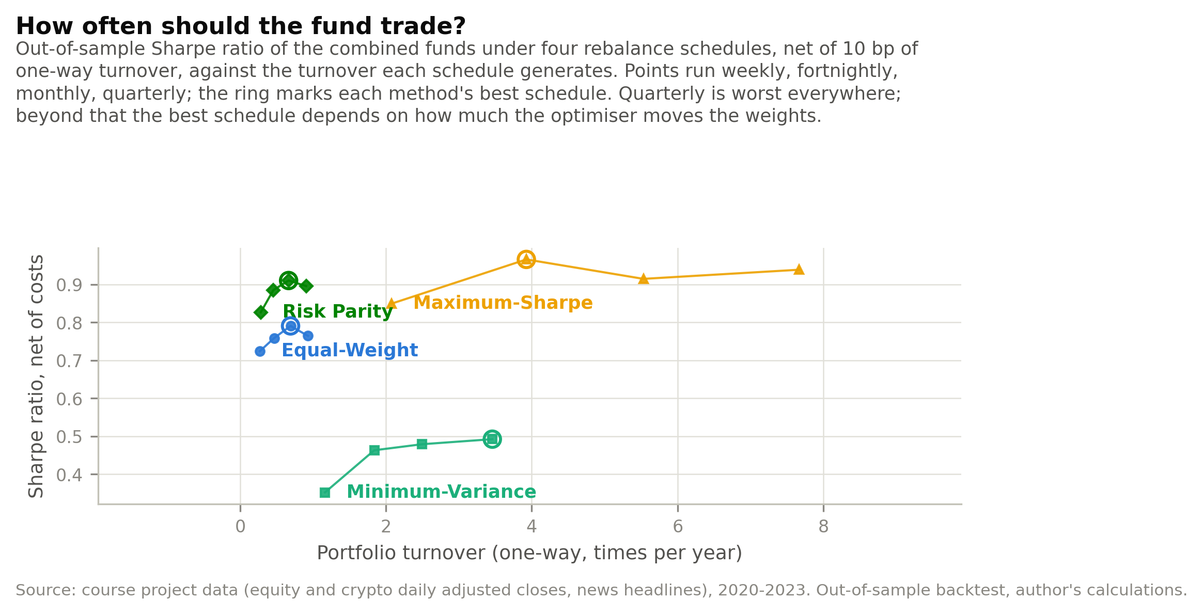
Figure 1: Sharpe ratio net of 10 bp of one-way turnover against annual turnover, for four rebalance schedules across the four combined funds. Out-of-sample, 2021-2023.
Best net-of-cost schedule by method: Equal-Weight fortnightly; Maximum-Sharpe monthly; Minimum-Variance weekly; Risk Parity fortnightly.
Quarterly rebalancing is worst for every method, which says the cost of holding a stale covariance estimate for three months exceeds the trading it saves. Above that floor the schedules separate by how much each method's weights actually move. Equal weight and risk parity barely trade whatever the schedule, so their fortnightly advantage is small. Maximum Sharpe turns over several times a year, so it is the fund where the choice bites, and monthly is its best net-of-cost schedule: weekly gives it a fresher estimate but the extra turnover is not repaid. Monthly is kept as the product schedule because it is the best net outcome for the fund most sensitive to the decision and within a few hundredths of the best for every other fund.

2. Out-of-sample results and fund fact sheets
Table 1: Out-of-sample performance of all twelve funds. Annualised return is geometric; the Sharpe ratio uses the arithmetic mean with a zero risk-free rate. Equity and combined funds annualise on 252 days, crypto-only on 365. Sample 2021-2023.
fund | ann return | ann vol | sharpe | max drawdown | growth of 1
Combined Maximum-Sharpe | 0.240 | 0.252 | 0.981 | -0.258 | 1.902
Combined Risk Parity | 0.140 | 0.162 | 0.888 | -0.195 | 1.478
Combined Equal-Weight | 0.151 | 0.216 | 0.761 | -0.279 | 1.524
Combined Minimum-Variance | 0.054 | 0.128 | 0.477 | -0.154 | 1.171
Crypto Risk Parity | 0.443 | 0.799 | 0.862 | -0.799 | 3.004
Crypto Equal-Weight | 0.405 | 0.819 | 0.829 | -0.816 | 2.774
Crypto Minimum-Variance | 0.320 | 0.650 | 0.753 | -0.758 | 2.301
Crypto Maximum-Sharpe | -0.235 | 0.798 | 0.065 | -0.889 | 0.447
Equity Equal-Weight | 0.126 | 0.161 | 0.819 | -0.202 | 1.427
Equity Risk Parity | 0.099 | 0.145 | 0.723 | -0.185 | 1.326
Equity Maximum-Sharpe | 0.092 | 0.182 | 0.573 | -0.256 | 1.299
Equity Minimum-Variance | 0.054 | 0.127 | 0.479 | -0.153 | 1.171
Equal weighting earns the highest Sharpe ratio of the four equity funds at 0.819, ahead of risk parity at 0.723, maximum Sharpe at 0.573 and minimum variance at 0.479. The ordering is not one story but two, and telling them apart matters more than the ranking does.
The first is sample noise. Every rebalance asks 252 days of returns to supply 50 expected returns and a 50-by-50 covariance matrix, and a year of daily data is a thin sample for that many quantities. The estimates move from month to month whether or not the market does, and the funds that read them most closely move with them. Maximum Sharpe holds 6 of the 50 stocks and rewrites 34% of its portfolio at the average rebalance; minimum variance holds 18 and rewrites 15%. Equal weighting estimates nothing and never trades, and risk parity, which needs variances but no expected returns, changes 2% of its weights a month. That turnover and that concentration are therefore not the product of the optimisation; they are a symptom of how noisy its inputs are. The optimiser is doing its job faithfully on a sample too small to support the question being asked of it.
How small is quantified by DeMiguel, Garlappi and Uppal (2009), who evaluate fourteen mean-variance models and their estimation-error corrections against 1/N across seven datasets and find none of them consistently better on Sharpe ratio, certainty-equivalent return or turnover. Calibrating to US equities, they estimate that a sample-based mean-variance strategy needs an estimation window of roughly 6,000 months to beat 1/N on a 50-asset portfolio. This fund holds 50 assets and estimates on 12 months. On their arithmetic the equity results here are not a surprising outcome but the expected one, and the question is less why optimisation lost than why anyone would have expected it to win at this sample size.
The second force is not error at all. Minimum variance ranks last on the Sharpe ratio while achieving exactly what it was built to achieve: its 12.7% annualised volatility is the lowest of the four funds and its 15.3% maximum drawdown the shallowest. The objective never mentions return, so reading its last place as a failure of optimisation would be wrong. The fund solved its problem; the Sharpe ratio scores a different one.
That is a statement about who the fund is for rather than about whether it works. An investor ranking funds on risk-adjusted return should not hold it - at +5.4% a year it is the weakest equity fund on offer. An investor who will sell in a drawdown should, because it is the fund that fell least, and the return an investor keeps is the return they hold through. Spotlight therefore lists all twelve funds rather than only the top of the Sharpe table, and the allocation tool exists so that a user can express which of those two investors they are. A single ranking cannot carry that information, which is why the fact sheet shows the drawdown next to the growth line.
Whether that first force really is sample noise is testable, and Section 5.4 tests it by correcting the covariance estimate and re-running every fund.
One number in the table needs reading carefully. Crypto Maximum-Sharpe reports a positive Sharpe ratio of 0.065 alongside an annualised return of -23.5%. Both are correct. The Sharpe ratio uses the arithmetic mean, +5.2% a year, while the headline return is geometric - what a dollar actually compounds to. The two diverge by roughly half the variance. At 79.8% annualised volatility that is 0.798 squared over two, or 31.9%, against an observed gap of 28.8%; the approximation overshoots by about 3.1% because it drops the higher-order terms that matter at this volatility. The direction is what counts: a fund can average a gain every day and still destroy capital.
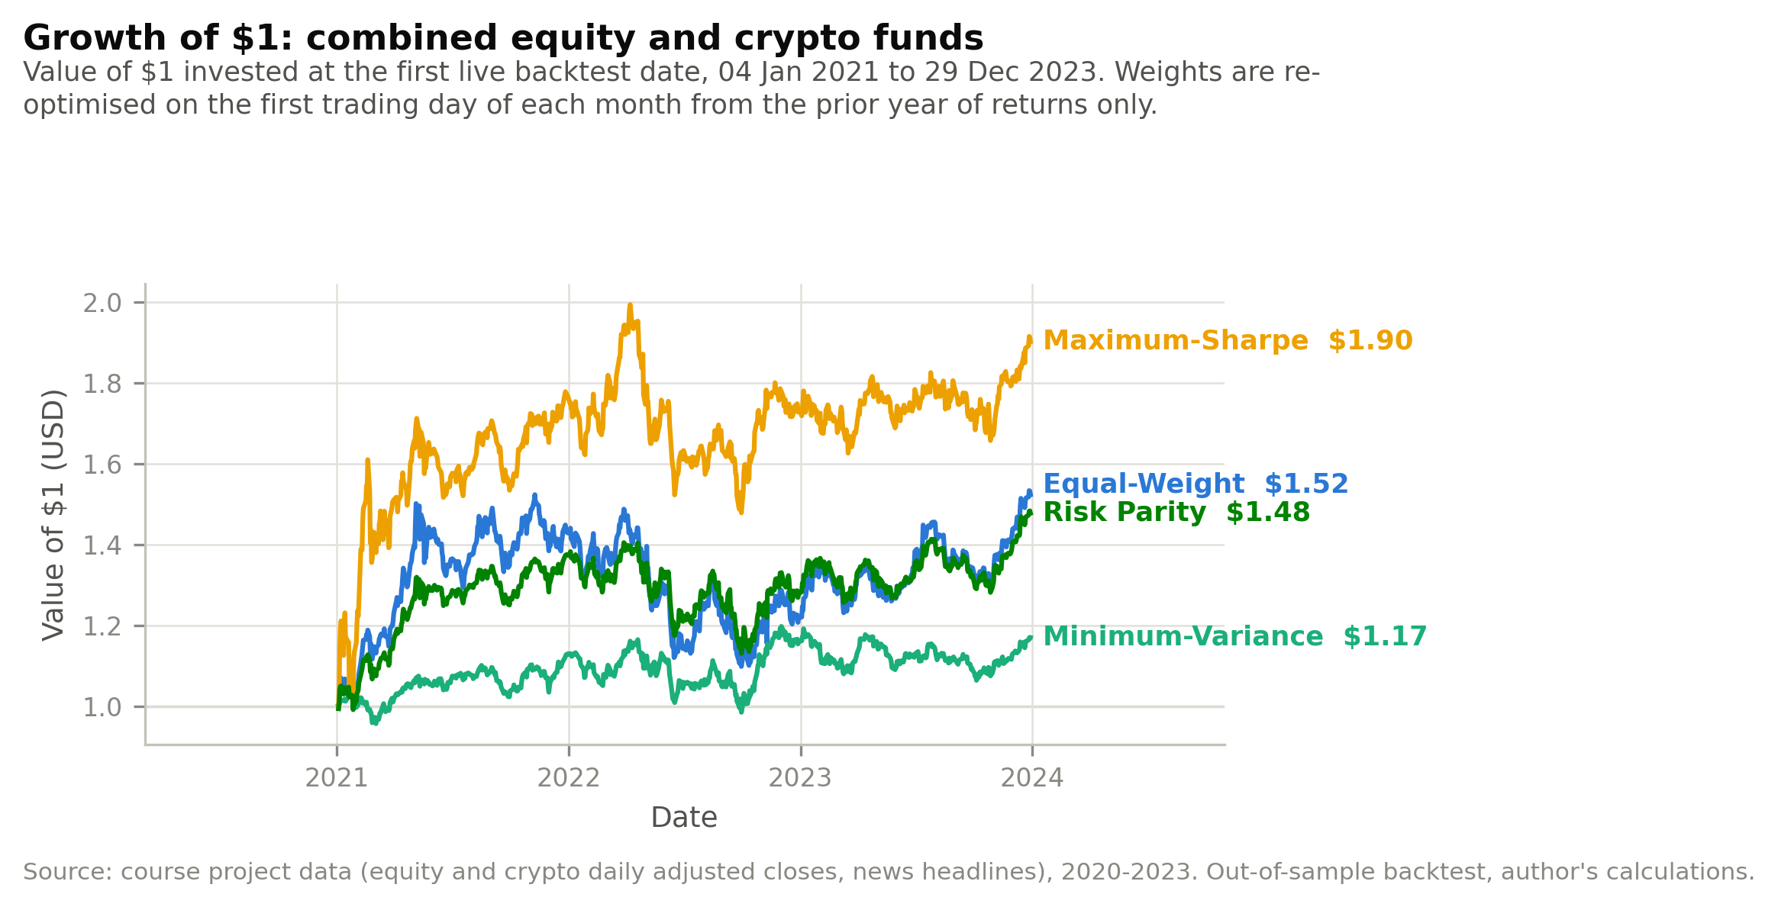
Figure 1: Growth of $1 invested at the first live backtest date in the four combined equity-plus-crypto funds.
The lines separate in the first quarter of 2021 and never reconverge. Maximum Sharpe pulls away early because its concentration paid during the crypto rally, holds most of that lead through the 2022 drawdown, and ends well ahead. An investor would have preferred it on the final value alone, but the path matters: the fund that ends highest is also the one that fell furthest, and the choice between it and risk parity is a choice about tolerance for that path rather than about which manager is better.
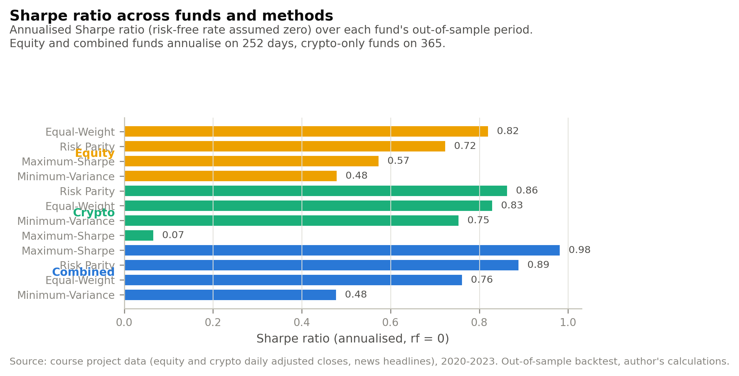
Figure 1: Sharpe ratio across all twelve funds, grouped by asset family.
The crypto funds occupy the top of the risk-adjusted table despite their drawdowns, because 2021 to 2023 was a period in which crypto returns were large enough to compensate for their volatility. That is a statement about this sample, not about the asset class. Within the equity funds the ordering runs the other way from what optimisation theory promises: equal weighting at 0.819 beats every optimised rule. The combined funds sit between the two families, which is what diversification should produce, though it also means that mixing crypto with equities lowered the Sharpe ratio relative to holding crypto alone over this particular window.
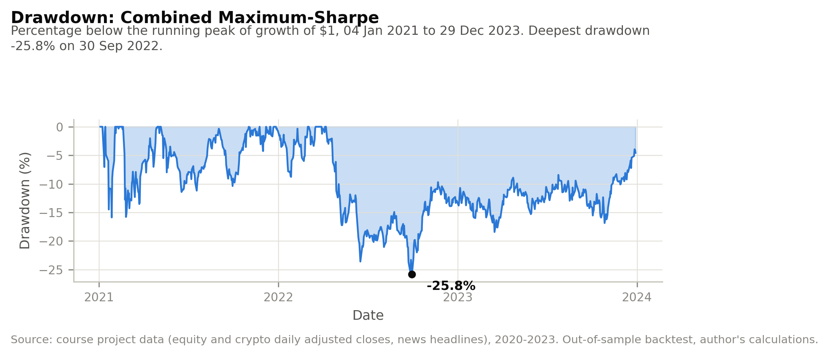
Figure 1: Drawdown of the Combined Maximum-Sharpe fund from its running peak.
The fund lost 25.8% from its peak and took most of a year to recover. An investor who bought at the high would have watched a quarter of their capital disappear before any of the eventual return arrived, which is the experience a Sharpe ratio of 0.98 conceals. This is why the fact sheet in the app shows the drawdown alongside the growth line rather than below it: the two together describe the product, and either alone misleads.
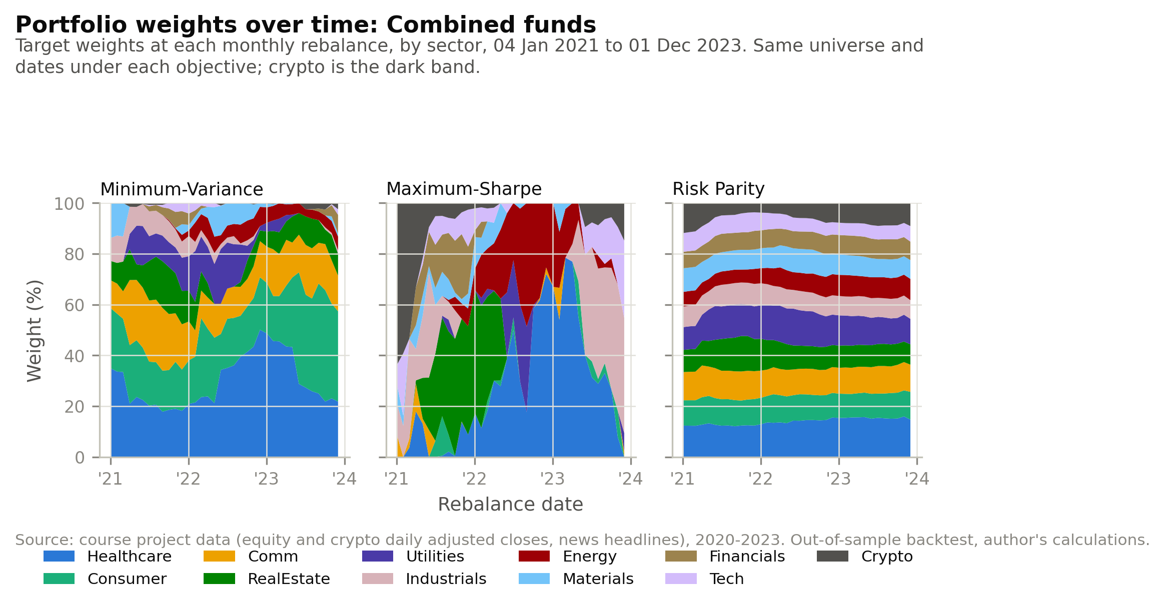
Figure 1: Target weights at each monthly rebalance for three combined funds, aggregated to sector and stacked to 100%. Crypto is the dark band.
The three panels show the same universe and the same dates producing three completely different funds. Minimum variance concentrates in healthcare and consumer staples, which are the sectors whose estimated covariance with everything else is lowest, and its crypto band is almost invisible - minimising variance means avoiding the most volatile assets available, whatever their return. Maximum Sharpe swings violently between sectors and carries a wide crypto band, because it is chasing estimated means and those estimates change sharply from month to month. Risk parity is nearly static: equalising risk contributions produces weights that depend on relative volatilities, and relative volatilities are far more stable than relative means. The visual stability of each panel is a direct picture of how much estimation error each objective admits.

3. The news-sentiment index
Every one of the 146,830 aligned headlines is scored with VADER. The text is scored raw: VADER reads capitalisation, punctuation, degree modifiers and negation, so lower-casing or stripping punctuation would remove the evidence the model is built on. Scores are averaged within a ticker-day, then equally weighted across the five tickers in each sector, so that one heavily covered name cannot speak for its sector.
Ticker-days with no headline are dropped from the sector average rather than scored as zero. A zero would pull the index toward neutral on quiet days and would confuse an absence of news with balanced news, and Part A found multi-month collection blackouts for two tickers that a zero-fill would have turned into fake neutral sentiment. The daily coverage count is published beside the index so thin days are visible.
The index is lagged one trading day after alignment. A decision on day t therefore uses only sentiment from t-1 or earlier: a Saturday or Monday headline, both aligned to Monday, is first usable for Tuesday's trade.
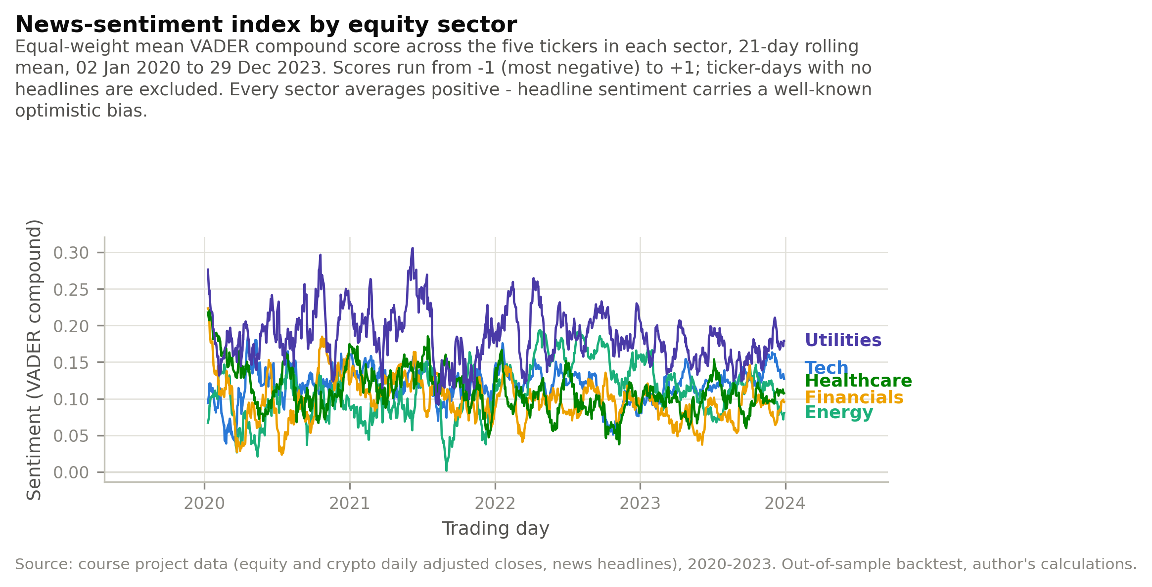
Figure 1: News-sentiment index for five equity sectors: equal-weight mean VADER compound score, 21-day rolling mean, 2020-2023.
Every sector's index sits above zero for most of the sample. That is a property of financial headline writing rather than of the market: coverage is written to attract readers and leans positive, so the level of the index carries little information and only its movement does. Utilities runs highest at +0.179 and financials lowest at +0.090, a difference that reflects the vocabulary of each sector's news - dividends and stability against litigation and rates - more than any difference in performance. Energy is the one sector whose index moves visibly with its fundamentals, rising through 2022 as the sector's returns did.
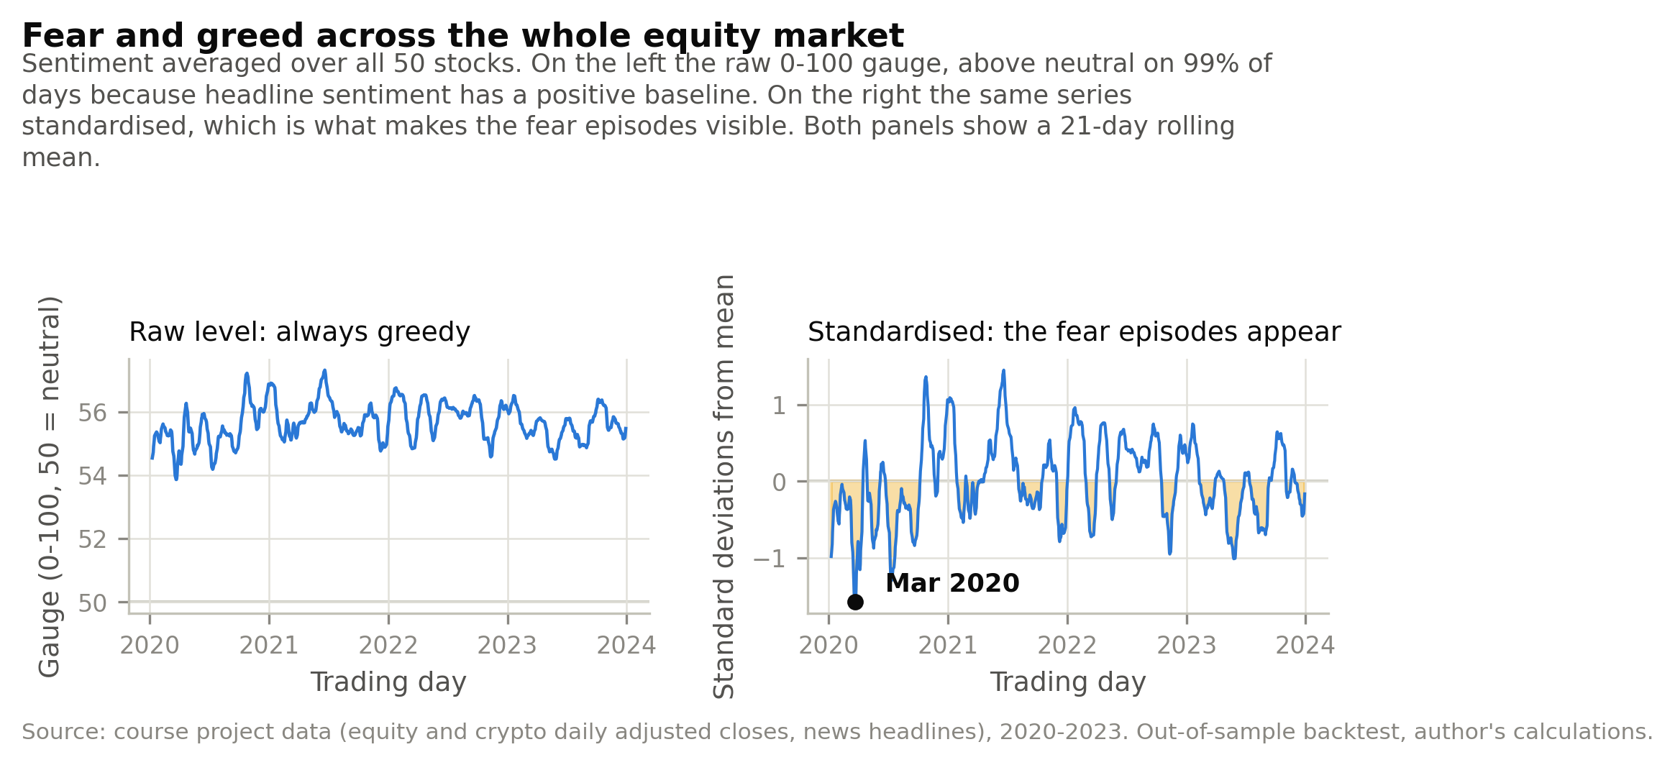
Figure 1: Market-wide fear and greed gauge: sentiment averaged across all 50 equities, shown as the raw 0-100 level and standardised.
The raw gauge sits above neutral on 99% of days, so read as a level it would have called the market greedy throughout the COVID crash. It is uninformative for the same reason the sector indices are: the baseline is positive. Standardising removes that baseline and the episodes appear immediately. The deepest trough is mid-March 2020, the week of the crash itself, and the second is early December 2021, when the Omicron variant was announced. That the two largest negative excursions in a purely textual series line up with the two events a reader would name without seeing the data is the strongest available evidence that the index measures something real.
Table 1: Coverage and neutral share of the sentiment model by sector.
sector | n headlines | n tickers | mean compound | neutral share | n days with news
Comm | 11783 | 5 | 0.099 | 0.523 | 997
Consumer | 25877 | 5 | 0.094 | 0.517 | 998
Energy | 19365 | 5 | 0.106 | 0.438 | 996
Financials | 18269 | 5 | 0.090 | 0.493 | 998
Healthcare | 14697 | 5 | 0.107 | 0.501 | 997
Industrials | 13156 | 5 | 0.090 | 0.498 | 998
Materials | 5393 | 5 | 0.096 | 0.576 | 940
RealEstate | 5339 | 5 | 0.133 | 0.533 | 940
Tech | 26632 | 5 | 0.116 | 0.503 | 1006
Utilities | 6319 | 5 | 0.179 | 0.395 | 962
Between 40% and 58% of headlines score neutral depending on the sector. A neutral score is not a finding of balance; it means the model found no word it recognised. Headlines are also a weaker signal than the articles beneath them - they are short, written to be clicked, and often name a company without saying anything about it. Both limitations point the same way: the index should be read as an indicator of the tone of coverage, and any trading use of it has to survive the fact that half its inputs are silent.

4. Fusion: does sentiment improve the funds?
The baseline fusion is a cross-sectional sector tilt. At each rebalance the lagged sector index is turned into a z-score across the ten sectors, and each equity weight is multiplied by (1 + lambda z) for its sector, then clipped at zero and renormalised so the fund stays long-only and fully invested. The tilt never touches the covariance estimate, so any difference in results comes from the tilt alone. Sentiment applies to equities only, because the cryptocurrencies carry no news.
Table 1: Equity funds before and after the sentiment tilt, out of sample.
fund | ann return | ann vol | sharpe | max drawdown | growth of 1 | avg turnover
Equity Minimum-Variance (base) | 0.054 | 0.127 | 0.479 | -0.153 | 1.171 | 0.151
Equity Minimum-Variance + sentiment | 0.052 | 0.128 | 0.457 | -0.168 | 1.162 | 0.215
difference | -0.003 | 0.001 | -0.022 | -0.016 | -0.009 | 0.064
Equity Maximum-Sharpe (base) | 0.092 | 0.182 | 0.573 | -0.256 | 1.299 | 0.331
Equity Maximum-Sharpe + sentiment | 0.081 | 0.186 | 0.509 | -0.270 | 1.260 | 0.365
difference | -0.011 | 0.004 | -0.064 | -0.013 | -0.039 | 0.034
The tilt makes both funds worse. Minimum variance falls from 0.479 to 0.457 and maximum Sharpe from 0.573 to 0.509, while turnover rises in both. That combination - lower return, higher trading - is what a signal with no predictive content looks like when it is used to move weights: the tilt adds noise to a portfolio that was already as good as its inputs allowed, and charges for the privilege.
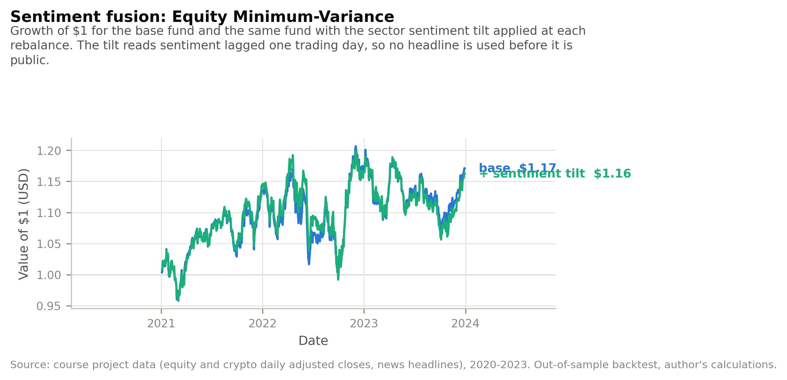
Figure 1: Growth of $1 for the Equity Minimum-Variance fund with and without the sentiment tilt.
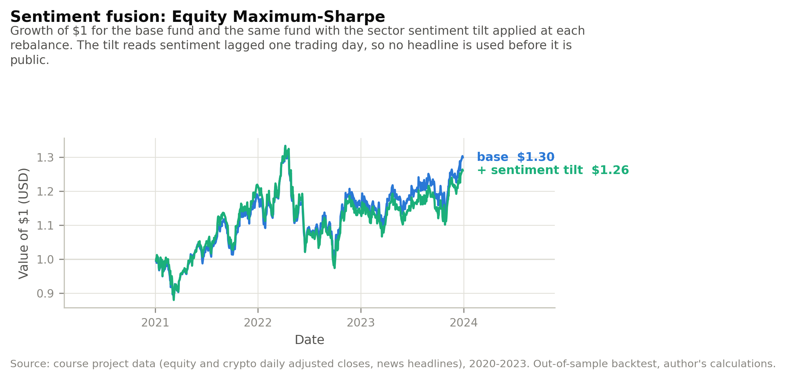
Figure 1: Growth of $1 for the Equity Maximum-Sharpe fund with and without the sentiment tilt.
The diagnostics explain the direction of the result. The correlation between the lagged sector index and the sector return it can be traded on is negative in 8 of the ten sectors, with a mean of -0.0205.
Table 1: Correlation between the lagged sector sentiment index and the equal-weight sector return on the day the signal becomes usable.
sector | n days | corr lagged sentiment vs return | mean return high sentiment | mean return low sentiment | spread bps per day
Consumer | 1002 | 0.028 | 0.001 | -0.000 | 10.118
Materials | 1002 | 0.020 | 0.002 | -0.000 | 17.434
Tech | 1005 | -0.009 | 0.000 | 0.002 | -19.545
Healthcare | 1002 | -0.012 | 0.000 | 0.001 | -9.295
Comm | 1002 | -0.014 | 0.000 | 0.000 | -0.748
Financials | 1002 | -0.021 | 0.001 | 0.001 | 0.048
RealEstate | 1002 | -0.037 | -0.000 | 0.001 | -14.500
Industrials | 1002 | -0.039 | -0.001 | 0.002 | -27.196
Utilities | 1002 | -0.052 | -0.001 | 0.001 | -16.246
Energy | 1002 | -0.071 | -0.001 | 0.003 | -31.842
A negative correlation is consistent with three different stories - a reversal, news already in the price, or noise - so sentiment on day t was correlated against the sector return on the day before, the same day, and the day after, with a p-value for each.
Table 1: Sector sentiment on day t against the sector return on t-1, t and t+1, with Pearson p-values. Raw daily index, 2020-2023.
sector | corr prev day | p prev day | corr same day | p same day | corr next day | p next day
Tech | 0.032 | 0.316 | 0.121 | 0.000 | -0.031 | 0.326
Energy | 0.034 | 0.286 | 0.120 | 0.000 | -0.027 | 0.393
Industrials | 0.113 | 0.000 | 0.119 | 0.000 | -0.020 | 0.523
Financials | 0.076 | 0.017 | 0.118 | 0.000 | 0.048 | 0.128
Utilities | 0.053 | 0.098 | 0.097 | 0.003 | -0.088 | 0.006
Materials | 0.061 | 0.061 | 0.096 | 0.003 | 0.015 | 0.656
Consumer | 0.015 | 0.632 | 0.082 | 0.010 | 0.001 | 0.972
RealEstate | 0.040 | 0.223 | 0.061 | 0.063 | 0.002 | 0.949
Healthcare | -0.002 | 0.958 | 0.053 | 0.097 | -0.023 | 0.466
Comm | -0.014 | 0.656 | 0.018 | 0.578 | -0.003 | 0.924
Mean correlations: +0.0885 same day (7 of 10 significant at 5%), -0.0127 next day (1 of 10), and +0.0408 the day before (2 of 10).
The same-day correlation is the large one. Sentiment moves with the sector return on the day it is published, +0.0885 on average and significant in 7 of ten sectors. The next-day correlation is -0.0127 and significant in 1. The news is real information and it is related to prices, but by the time a headline has been published and a trading day has closed, that information is in the price. This is the 'already priced' reading rather than a reversal: a genuine reversal would show up as a large, significant NEGATIVE next-day coefficient, and it does not. The negative signs reported in the diagnostics above are small and mostly indistinguishable from zero.
That conclusion is the one an efficient market would predict at this horizon, and it explains the fusion result without needing the tilt to be badly built. There is nothing left in daily headline sentiment to trade.

Is the signal there at a slower frequency?
Absorption by the daily close does not rule out a slower effect, so sentiment averaged over the past k trading days was tested against the return over the next k days, for k of 1, 5, 21 and 63. Observations are sampled every k days rather than every day, because overlapping windows share data and would inflate significance badly at the longer horizons. Each horizon is run twice: on raw sector returns, and cross-sectionally with the day's mean across sectors removed from both sides, which is what the tilt actually bets on.
Table 1: Past-k-day sector sentiment against the next-k-day sector return, non-overlapping observations. The corrected column applies a Bonferroni threshold across the eight tests reported here.
horizon days | variant | n obs | correlation | p value | significant 5pct | significant corrected
1 | absolute | 9821 | -0.013 | 0.199 | False | False
1 | cross-sectional | 9821 | -0.022 | 0.029 | True | False
5 | absolute | 1990 | -0.016 | 0.470 | False | False
5 | cross-sectional | 1990 | -0.023 | 0.311 | False | False
21 | absolute | 460 | -0.088 | 0.060 | False | False
21 | cross-sectional | 460 | -0.069 | 0.141 | False | False
63 | absolute | 140 | -0.149 | 0.080 | False | False
63 | cross-sectional | 140 | -0.121 | 0.153 | False | False
The correlation is negative at every horizon and its magnitude grows with the horizon, from -0.0130 at one day to -0.1487 at 63 days, but the number of independent observations falls from 9,821 to 140. 1 of 8 tests clear 5% uncorrected, and 0 survive the correction for having run eight of them.
The correlation is negative at every horizon and grows with the horizon, which is the pattern a slow effect would leave. Nothing else supports that reading. The number of independent observations collapses from 9,821 to 140 as the horizon lengthens, the confidence around each estimate widens accordingly, and after correcting for having run 8 specifications none of them clears the threshold. Eight tests producing one nominal p-value of 0.029 is what chance delivers.
The honest reading is that this is a null result with a suggestive shape, and that separating a weak slow effect from noise would need a longer sample than three years rather than a cleverer test on this one. The search was conducted over eight specifications and that is reported here rather than only the specification that came closest.

5. Extensions

5.1 A finance lexicon for VADER
Only 1,831 of the 33,033 distinct tokens in the headline corpus carry a VADER score, and 49.6% of headlines score neutral. The gaps are not obscure: 'earnings' appears 11,870 times and 'beat' 2,083, and VADER scores neither. 46 finance terms were added, selected by frequency from the headlines themselves rather than from memory, each with a written rationale. Terms whose sign reverses with context - 'cut', 'hike', 'buy' - were deliberately excluded and are listed with their reasons.
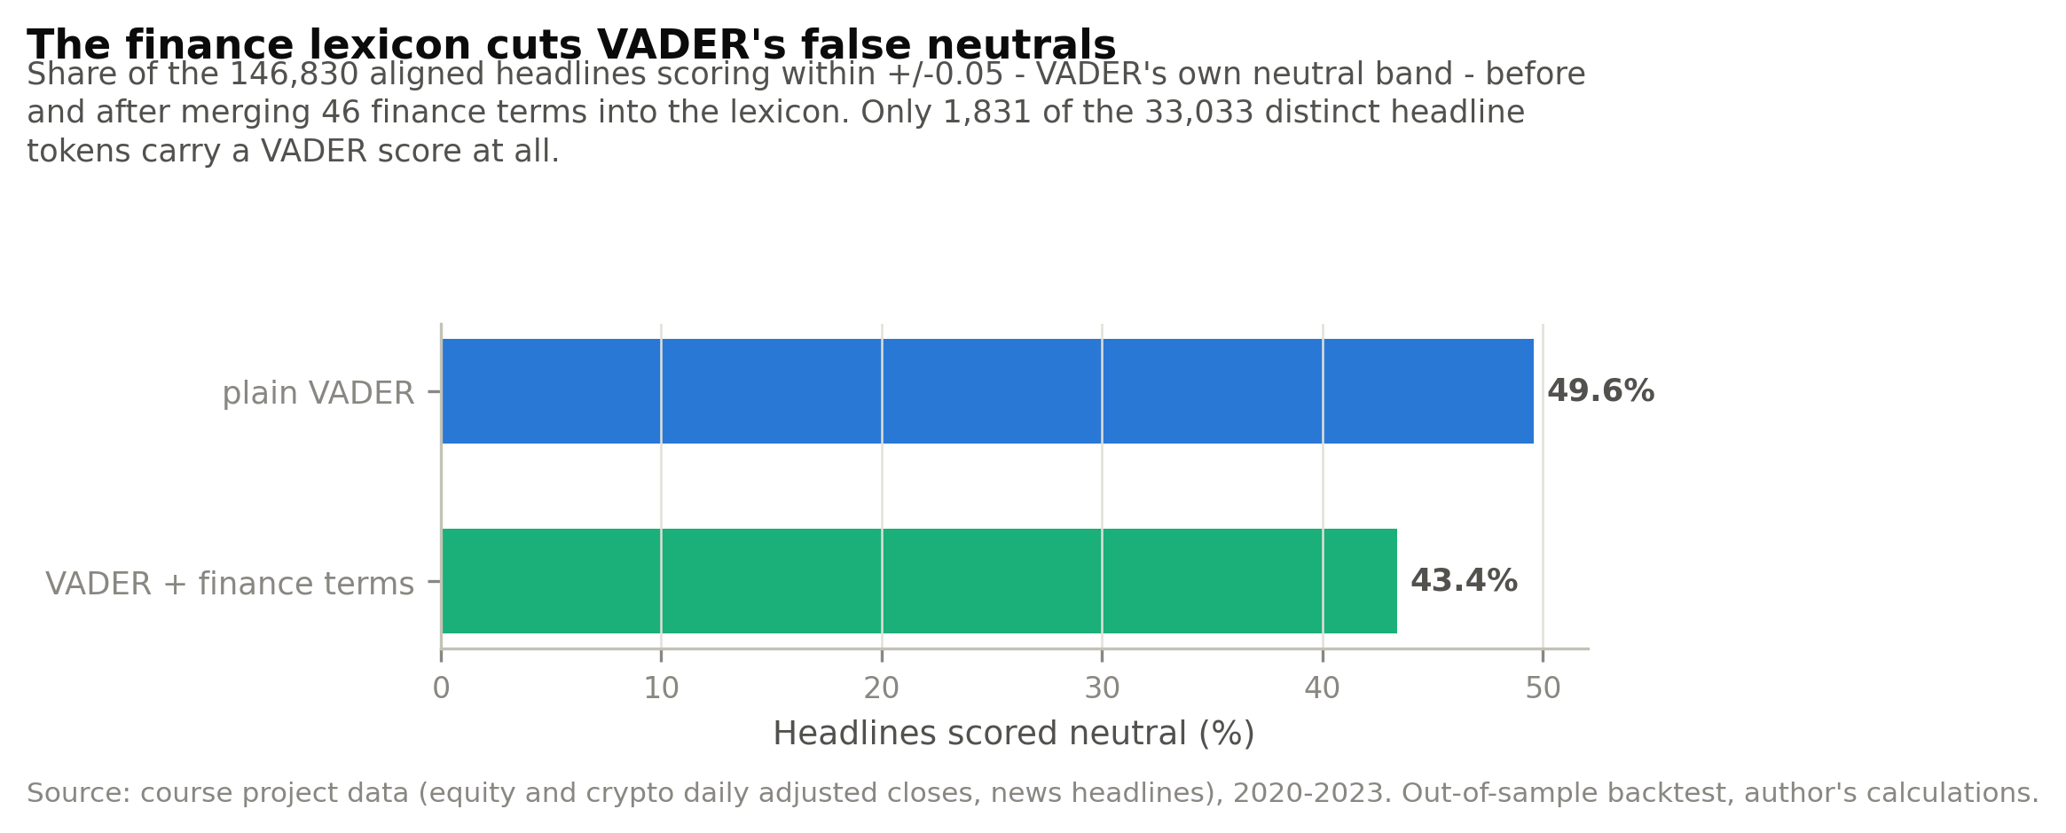
Figure 1: Share of headlines scoring inside VADER's neutral band, before and after adding the finance terms.
The neutral share falls to 43.4% and 16.1% of headlines are rescored.
The headlines being missed are the most informative ones. 'AbbVie Q4 EPS $2.21 Beats $2.19 Estimate' scores exactly zero under plain VADER, because neither 'beats' nor 'estimate' is in a lexicon built for social media. Adding 46 market terms cuts the neutral share from 49.6% to 43.4% and rescores 16.1% of headlines, and the dispersion of scores rises from 0.288 to 0.317.
A lower neutral share is not automatically a better signal. The extension makes the index a more faithful description of tone, which is what it was built for, but it also fires on headlines whose sentiment is not about the company: 'Inovio's Surge on a Coronavirus Vaccine Was Just Speculation' scores positive because 'surge' is now scored, though the sentence is sceptical. Whether the added accuracy helps depends entirely on what the index is used for, and the next section shows that it helps one use and hurts another.

5.2 A tilt that learns its own direction
Because the naive tilt leans the wrong way, the direction is made an estimate rather than an assumption. At each rebalance the pooled correlation between lagged sentiment and sector returns is re-estimated on the previous 252 trading days only, and the tilt leans whichever way that window indicates. Hard-coding the reverse would have fitted the answer to data already seen; this does not, and the truncation test covers it.
Table 1: Every fusion variant against its base fund, gross and net of 10 bp of one-way turnover.
fund | variant | sharpe | sharpe net costs | avg turnover
Equity Minimum-Variance | base (no sentiment) | 0.479 | 0.465 | 0.151
Equity Minimum-Variance | fixed tilt / plain lexicon | 0.457 | 0.437 | 0.215
Equity Minimum-Variance | adaptive tilt / plain lexicon | 0.510 | 0.490 | 0.218
Equity Minimum-Variance | fixed tilt / extended lexicon | 0.501 | 0.482 | 0.212
Equity Minimum-Variance | adaptive tilt / extended lexicon | 0.387 | 0.367 | 0.220
Equity Maximum-Sharpe | base (no sentiment) | 0.573 | 0.552 | 0.331
Equity Maximum-Sharpe | fixed tilt / plain lexicon | 0.509 | 0.487 | 0.365
Equity Maximum-Sharpe | adaptive tilt / plain lexicon | 0.658 | 0.636 | 0.354
Equity Maximum-Sharpe | fixed tilt / extended lexicon | 0.558 | 0.535 | 0.366
Equity Maximum-Sharpe | adaptive tilt / extended lexicon | 0.540 | 0.517 | 0.363
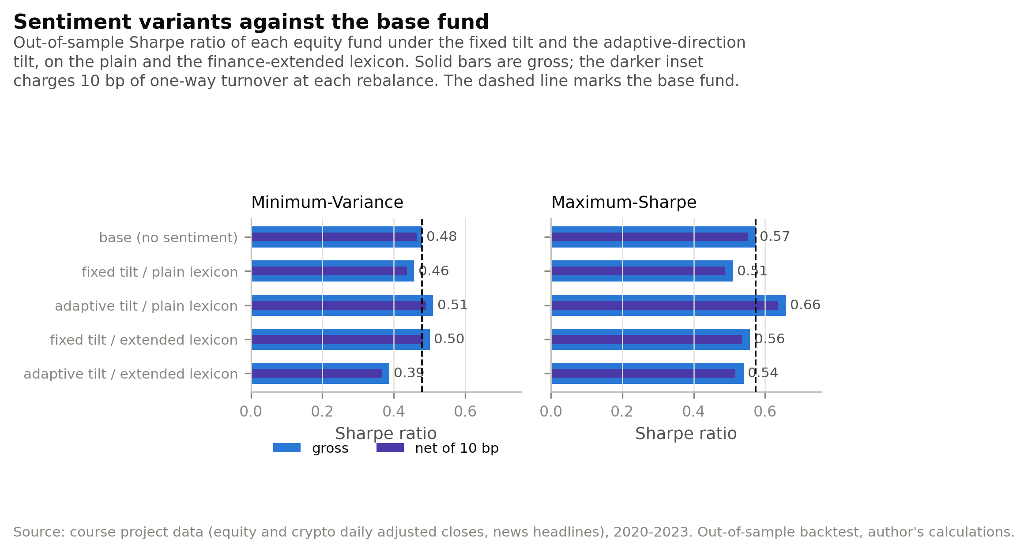
Figure 1: Sharpe ratio of each fusion variant against the base fund, gross and net of transaction costs.
A higher point estimate is not the same as an improvement. The difference in Sharpe ratios between each tilt and its base fund was resampled with a stationary bootstrap of 5,000 draws and a mean block length of 21 trading days, which keeps the two series paired and preserves their autocorrelation.
Table 1: Bootstrap confidence intervals for the change in Sharpe ratio relative to the base fund.
fund | variant | difference | ci low | ci high | p value | significant 5pct
Equity Minimum-Variance | adaptive tilt / plain lexicon | 0.031 | -0.133 | 0.204 | 0.749 | False
Equity Minimum-Variance | fixed tilt / plain lexicon | -0.022 | -0.183 | 0.138 | 0.800 | False
Equity Maximum-Sharpe | adaptive tilt / plain lexicon | 0.085 | -0.081 | 0.254 | 0.311 | False
Equity Maximum-Sharpe | fixed tilt / plain lexicon | -0.064 | -0.208 | 0.087 | 0.408 | False
The adaptive tilt raises the point estimate on both funds, by +0.085 of a Sharpe point at best. Every bootstrap interval spans zero. On three years of daily data the noise around a Sharpe difference is wider than the difference itself, so the improvement is not established, however it looks in the table. Reporting it as a result would be claiming more than the sample supports.
What can be said is narrower: making the direction an estimate rather than an assumption removes the damage the fixed tilt does, without look-ahead. Establishing that it adds value would need a longer sample or a second market.
The two extensions do not stack. The finance lexicon helps the fixed tilt and hurts the adaptive one. The diagnostics explain why: the extended lexicon weakens the very correlation the adaptive tilt trades against, moving the mean from -0.0205 to -0.0156 and the count of negative sectors from eight to seven. Part of what the adaptive tilt was exploiting was VADER's blind spots rather than a property of the news, which is a reason to treat its advantage cautiously even before the confidence intervals are considered.

5.3 Was the winner found or fitted?
Comparing five variants over one period and keeping the best is itself a choice fitted to that period. The variants were therefore re-ranked on a 2021-2022 discovery window alone, and the selected variant's 2023 performance reported, 2023 having played no part in the choice.
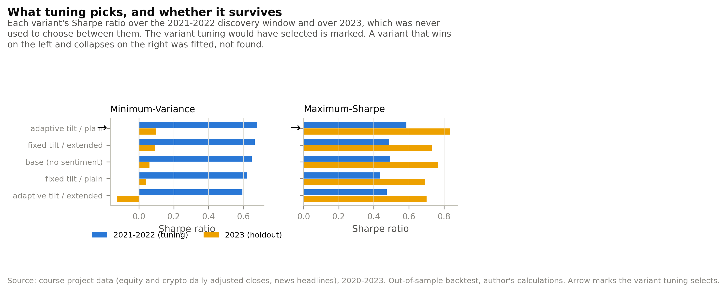
Figure 1: Sharpe ratio in the 2021-2022 tuning window against the untouched 2023 holdout, for each fusion variant.
Table 1: Discovery-window ranking and holdout outcome for each variant.
fund | variant | discovery sharpe | holdout sharpe | selected by tuning
Equity Minimum-Variance | adaptive tilt / plain lexicon | 0.677 | 0.100 | True
Equity Minimum-Variance | fixed tilt / extended lexicon | 0.664 | 0.094 | False
Equity Minimum-Variance | base (no sentiment) | 0.648 | 0.060 | False
Equity Minimum-Variance | fixed tilt / plain lexicon | 0.622 | 0.042 | False
Equity Minimum-Variance | adaptive tilt / extended lexicon | 0.595 | -0.126 | False
Equity Maximum-Sharpe | adaptive tilt / plain lexicon | 0.585 | 0.835 | True
Equity Maximum-Sharpe | base (no sentiment) | 0.494 | 0.765 | False
Equity Maximum-Sharpe | fixed tilt / extended lexicon | 0.488 | 0.731 | False
Equity Maximum-Sharpe | adaptive tilt / extended lexicon | 0.474 | 0.701 | False
Equity Maximum-Sharpe | fixed tilt / plain lexicon | 0.435 | 0.694 | False
Tuning on 2021 and 2022 selects the adaptive tilt on the plain lexicon for both funds, and that choice also ranks first on 2023 - Maximum-Sharpe at 0.835 against 0.765 for the base fund. The ranking survived a period it was not chosen on, which is more than the tuned tilt in the course's own worked example managed.
Three caveats belong with that. The holdout margin over the base fund is a few hundredths of a Sharpe point, consistent with the bootstrap finding that the difference is not established. Every Minimum-Variance variant decays by roughly 0.58 of a Sharpe point into 2023, the base fund included, so the decay is the market regime and not a property of the tilt. And one split of two funds is evidence rather than proof: the exercise shows the selection was not obviously fitted, not that it will hold.

5.4 Does correcting the covariance fix the result?
The sample-noise half of that argument is testable, so it was tested rather than asserted. Ledoit-Wolf shrinkage is the standard correction for a covariance matrix estimated from too few observations, and every fund was re-run with it. The three methods use the covariance differently, which makes the test discriminating: minimum variance is a pure function of the whole matrix, risk parity needs only its diagonal, and maximum Sharpe is dominated by the expected returns that shrinkage leaves untouched.
The results line up with that ordering. Minimum variance gains the most, +0.059 of a Sharpe point on the combined fund and +0.021 on the equity fund, and its holdings spread from 19 names to 27 as the extreme eigenvalues the optimiser had been leaning on are pulled back. Risk parity does not move at all (+0.000), which is what shrinking the off-diagonal terms of a matrix should do to a method that reads only the diagonal. Maximum Sharpe is mixed and small (+0.014 on equities, -0.022 combined), because its problem is the mean estimates and shrinkage does not address them. The correction helps exactly where the diagnosis said the noise was.
It does not, however, change the conclusion. Shrunk minimum variance still reaches only 0.500 against equal weighting's 0.819. Correcting the covariance recovers part of what sample noise costs and leaves the gap intact, which is the same result DeMiguel and co-authors report for the estimation-error corrections they test. The second force in the ordering - an objective that does not price return - is not something a better estimator can fix.
Table 1: Each fund re-run with a Ledoit-Wolf shrunk covariance matrix against the sample covariance. Out-of-sample, 2021-2023.
family | method | shrinkage | sharpe | ann vol | n assets held
Equity | Minimum-Variance | False | 0.479 | 0.127 | 18
Equity | Minimum-Variance | True | 0.500 | 0.126 | 19
Equity | Maximum-Sharpe | False | 0.573 | 0.182 | 6
Equity | Maximum-Sharpe | True | 0.587 | 0.182 | 6
Equity | Risk Parity | False | 0.723 | 0.145 | 50
Equity | Risk Parity | True | 0.723 | 0.145 | 50
Combined | Minimum-Variance | False | 0.477 | 0.128 | 19
Combined | Minimum-Variance | True | 0.536 | 0.126 | 27
Combined | Maximum-Sharpe | False | 0.981 | 0.252 | 8
Combined | Maximum-Sharpe | True | 0.960 | 0.254 | 8
Combined | Risk Parity | False | 0.888 | 0.162 | 60
Combined | Risk Parity | True | 0.888 | 0.162 | 60

5.5 The figure design system
Every exhibit is drawn through one design system rather than styled per figure. Categorical colours occupy fixed slots and are never cycled, so no two series in a chart can share a hue. The twelve-slot palette is validated pair by pair in CIE Lab space under normal, deuteranopic and protanopic vision by tools/check_palette.py; the worst separation is a deltaE of 16.9, identical to the original five-slot palette.
The design system exists because the product is read by someone who will not check the code. A reader who cannot distinguish two bands in a weight chart cannot audit the fund's holdings, and a reader who is colour-blind should not be excluded from that. Fixing the colour slots and validating every pair under simulated colour-blind vision makes the exhibits verifiable rather than merely attractive.

6. The app and the investor journey
Spotlight is a Streamlit application. A visitor compares the twelve funds on one table and chart, opens a fund's fact sheet for its growth of $1, drawdown, current holdings and sector history, sets an allocation across funds with sliders and sees the blended track record, and reads the sentiment analytics including the fear and greed gauge and the sector index.
The application reads only precomputed CSV files committed under results/. It runs no backtest and loads no sentiment model, so cold starts stay fast on Streamlit Community Cloud's free tier. scripts/run_part_b.py rebuilds every artifact end to end.
The target user is someone with savings and no time: a working professional or an early-career investor who wants a rules-based portfolio and will not read a covariance matrix. The journey is built around the decision that user actually makes, which is not which stock to buy but how much risk to carry. They compare twelve funds and see at once that the crypto funds returned most and fell furthest; they open a fact sheet for the four numbers a fund provider publishes, the growth line, the drawdown and the holdings; and they set an allocation with sliders and watch the blend update, which is where diversification stops being a word and becomes a visibly shallower drawdown. The analytics sit apart from the funds on purpose: the report shows that they do not predict returns, so presenting them beside an allocation control would imply a link the evidence does not support.
The business model is a management fee on assets, shown explicitly in the allocation tab so the user can see what the product costs them.

7. Critical reflection and recommendations
What worked was the machinery for being wrong safely. The truncation test caught nothing because there was nothing to catch, but it is the reason the out-of-sample claims can be made at all, and the same test is what made the adaptive tilt defensible rather than suspicious. The identity checks on the backtest found a real error: weights had been applied as fixed targets on every day between rebalances, which is arithmetically a fund that trades back to target daily and which had inflated the best fund's Sharpe ratio from 0.98 to 1.03.
What did not work was the sentiment fusion, and the interesting part is why. The index itself is sound: it moves with same-day returns, its extremes line up with the events a reader would name, and extending the lexicon makes it measurably more faithful. It simply has no predictive content at the horizon a monthly-rebalanced fund can trade, and no amount of better text processing changes that. The adaptive tilt recovers the loss, but its advantage is not statistically established and part of it traces to VADER's blind spots rather than to the news.
The broader lesson is about where the risk in this kind of project sits. None of the errors found here were errors of finance; they were errors of accounting and of inference - a rebalancing assumption, a colour palette too small for its data, a ranking chosen on the same sample it was evaluated on. The modelling was the easy part.
First, ship the funds without the sentiment tilt and keep the sentiment index as a standalone analytic. The evidence in section 4 does not support a link between the index and future returns, and a product that tilts on it would be charging a fee for turnover it cannot justify. The index earns its place as context a user reads, not as an input to their money.
Second, offer risk parity rather than maximum Sharpe as the default combined fund. Maximum Sharpe wins on the headline number, but it holds 8 of 60 assets, rewrites a third of its portfolio a month, and fell 26% at its worst. Risk parity gives up 0.09 of a Sharpe point for a drawdown six percentage points shallower and weights that barely move. For a user who cannot monitor the fund, the second is the more honest default, and the first should be available to those who choose it.
Third, re-estimate the tilt's value on a longer sample before any version of it reaches a live product. The bootstrap intervals show three years of daily data cannot separate a 0.09 Sharpe improvement from zero. The specific test worth running is the same walk-forward design on a decade of data, or on a second market, with the number of specifications searched declared in advance.

References
Add sources through Word's References tab, then insert the bibliography here and update fields.
Sources are cited where the method originates: Markowitz (1952) for mean-variance portfolio selection, Sharpe (1966) for the ratio, Maillard, Roncalli and Teiletche (2010) for risk parity, and Hutto and Gilbert (2014) for VADER. DeMiguel, Garlappi and Uppal (2009), 'Optimal Versus Naive Diversification: How Inefficient is the 1/N Portfolio Strategy?', Review of Financial Studies 22(5), 1915-1953, supplies the estimation-window result quoted in Section 2.

Appendix

Appendix A - The four objectives
Each fund solves for a weight vector w over N assets from two estimated inputs: the vector of expected returns m and the covariance matrix S, both computed on the estimation window and annualised. Every fund is long-only and fully invested, so 1'w = 1 and w >= 0.
(1) Equal weight: w_i = 1 / N for every asset i. No estimation.
(2) Minimum variance: minimise w'Sw subject to 1'w = 1, w >= 0.
(3) Maximum Sharpe (tangency): maximise (w'm - r_f) / sqrt(w'Sw) subject to 1'w = 1, w >= 0, with the risk-free rate r_f set to zero.
(4) Risk parity: find w such that every asset contributes an equal share of portfolio risk, RC_i = w_i (Sw)_i / (w'Sw) = 1/N for all i, solved by minimising the sum of squared deviations from that target subject to 1'w = 1, w >= 0.
Here N is the number of assets in the family (50 equities, 10 cryptocurrencies, or 60 combined), w_i is the weight on asset i, (Sw)_i is the i-th element of Sw, RC_i is asset i's risk contribution, and 1 is a vector of ones. Only equations (3) and (4) are affected by the choice of expected-return estimator; equation (2) uses S alone, which is why Section 5.4 can separate covariance noise from mean noise.

Appendix B - Supporting exhibits
Exhibits not needed in the main narrative.
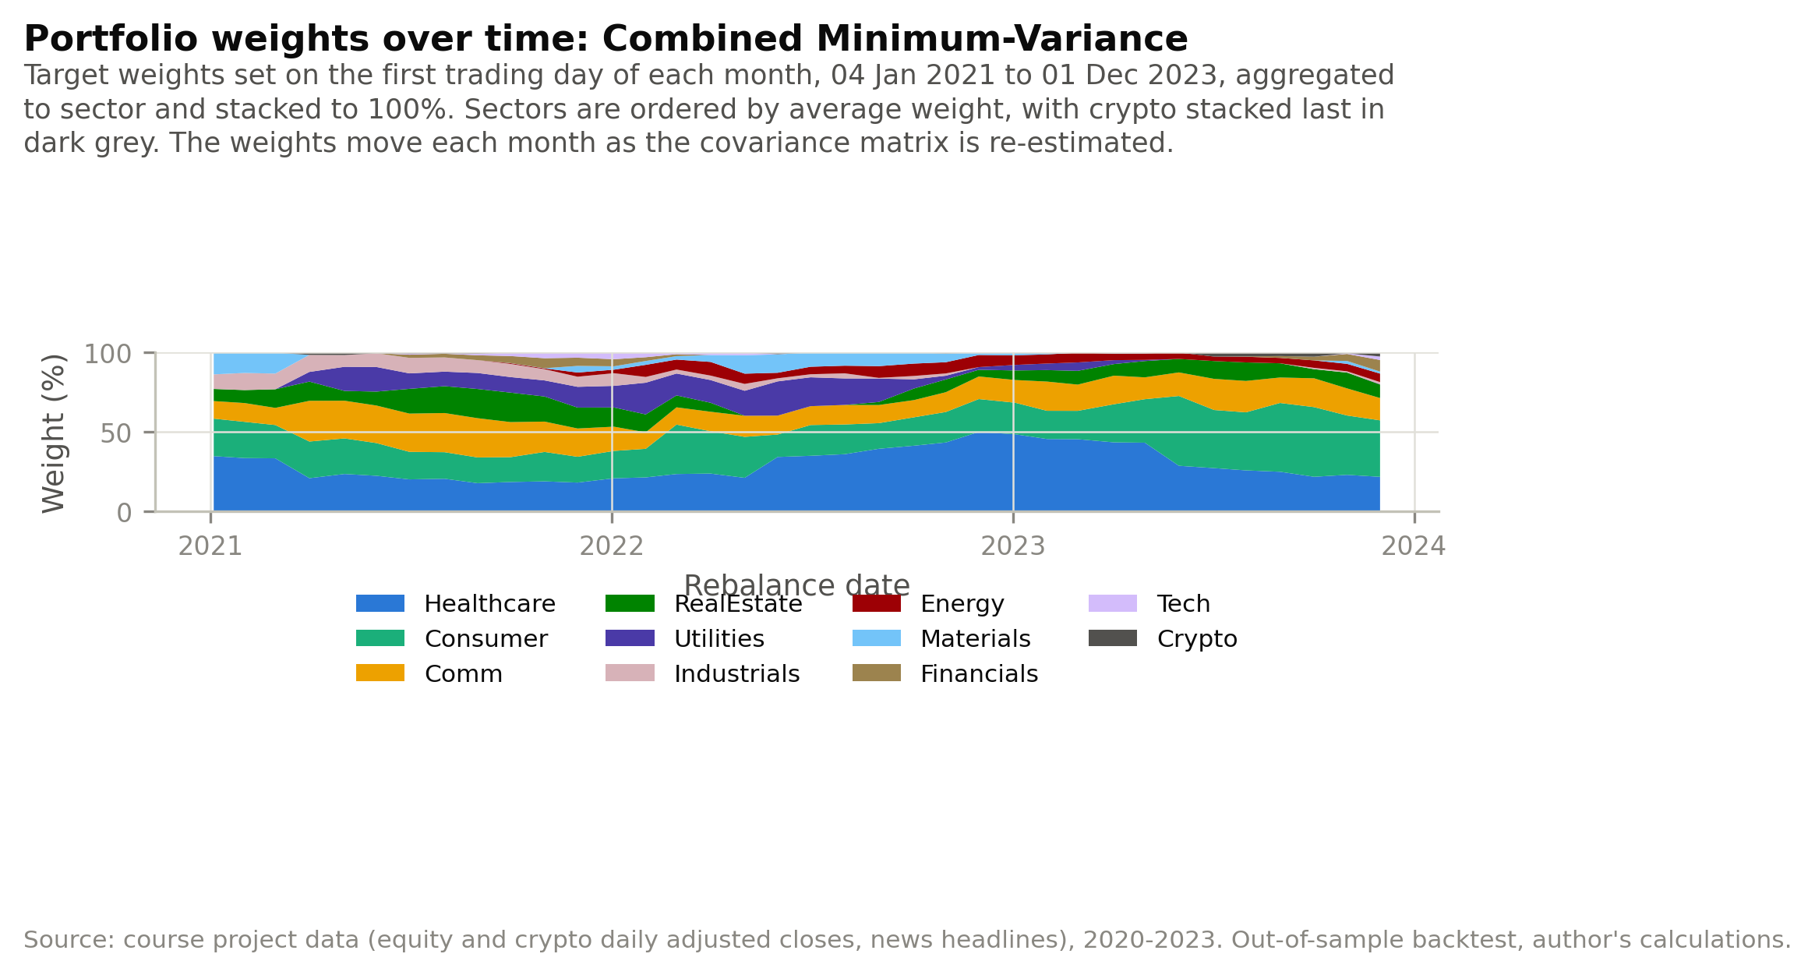
Figure 1: Sector weights over time for the Combined Minimum-Variance fund, the single-fund version of the across-methods exhibit.
Table 1: Full rebalance-frequency study: four schedules across the four combined funds, gross and net of 10 bp of one-way turnover.
method | frequency | n rebalances | sharpe | sharpe net costs | annual turnover
Equal-Weight | weekly | 156 | 0.769 | 0.765 | 0.930
Equal-Weight | fortnightly | 78 | 0.794 | 0.791 | 0.692
Equal-Weight | monthly | 36 | 0.761 | 0.759 | 0.465
Equal-Weight | quarterly | 12 | 0.725 | 0.724 | 0.270
Minimum-Variance | weekly | 156 | 0.520 | 0.492 | 3.459
Minimum-Variance | fortnightly | 78 | 0.499 | 0.479 | 2.497
Minimum-Variance | monthly | 36 | 0.477 | 0.463 | 1.840
Minimum-Variance | quarterly | 12 | 0.360 | 0.352 | 1.164
Maximum-Sharpe | weekly | 156 | 0.971 | 0.939 | 7.669
Maximum-Sharpe | fortnightly | 78 | 0.937 | 0.915 | 5.531
Maximum-Sharpe | monthly | 36 | 0.981 | 0.966 | 3.926
Maximum-Sharpe | quarterly | 12 | 0.857 | 0.850 | 2.078
Risk Parity | weekly | 156 | 0.902 | 0.896 | 0.905
Risk Parity | fortnightly | 78 | 0.915 | 0.911 | 0.665
Risk Parity | monthly | 36 | 0.888 | 0.885 | 0.456
Risk Parity | quarterly | 12 | 0.828 | 0.827 | 0.283

