

**CSUSB Mobile Application**

**Bomb threat or suspicious object design**

**Version: 1.0**

**Date: 03/20/2012**

**By: Francisco Ron**

Table of Contents

1) Emergency manual subsystem decomposition 3

2) Source code 4

3) Unit testing results 9

4) Comments 11

# Emergency manual subsystem decomposition

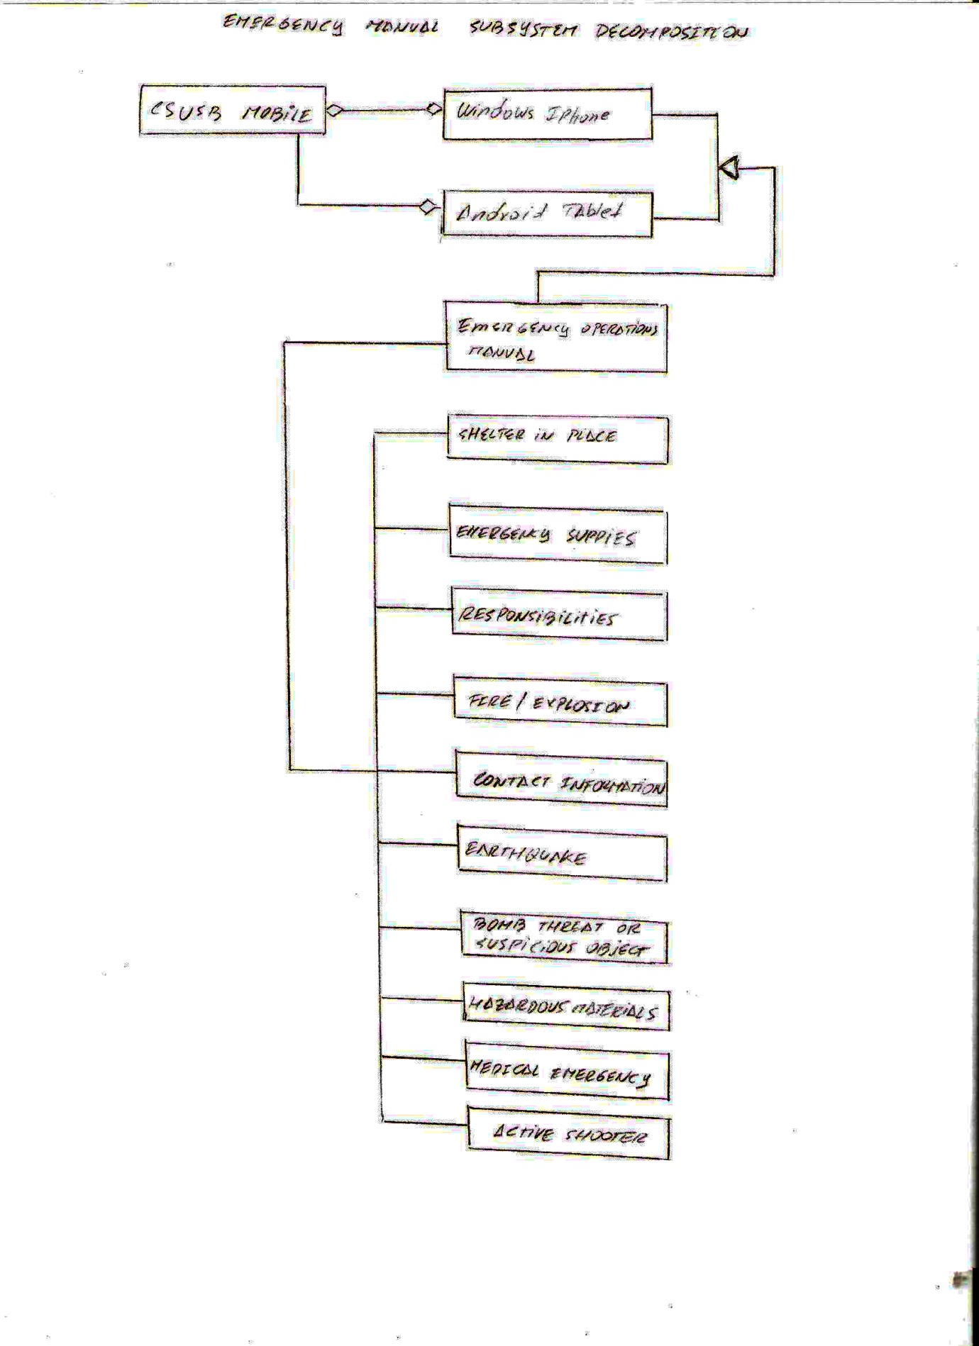

# Source code

<!DOCTYPE html>

<html>

# <!—This page was created with [www.codiqa.com/](http://www.codiqa.com/) After an initial design using plane HTML the results were not the expected, so we decided to use the above mentioned service that points to an CSS used by the CSUSB Mobile system -->

<head>

# <!—This instruction allows the program to acces the CSS file that controls the whole system, if taken off the results will be different than the ones you see on a regular browser -->

<?php include "header.php" ?>

<meta charset="utf-8" />

<meta name="viewport" content="width=device-width, initial-scale=1" />

<title>

</title>

<link rel="stylesheet" href="http://code.jquery.com/mobile/1.0.1/jquery.mobile-1.0.1.min.css" />

<style>

/* App custom styles */

</style>

<script src="http://ajax.googleapis.com/ajax/libs/jquery/1.6.4/jquery.min.js">

</script>

<script src="http://code.jquery.com/mobile/1.0.1/jquery.mobile-1.0.1.min.js">

</script>

</head>

<body>

<div data-role="page" id="page1">

<div data-role="content">

<p>

Report<b> ALL</b>

bomb threat calls to the University Police at<b> 911</b>

from a campus phone or<b> 537-7777</b>

from a cell phone.

</p>

<p>Don’t ever make a threat as a “joke.”</p>

<p>

Have a healthy suspicion that causes you to alert faculty or staff when something doesn’t seem right.</p>

<p><b>Any person receiving a phone call that a bomb or other explosive device has been placed on campus is to ask the caller:

</b>

</p>

<div data-role="fieldcontain">

<fieldset data-role="controlgroup" data-type="vertical">

<legend>

</legend>

<input name="checkbox1" id="checkbox1" type="checkbox" />

<label for="checkbox1">

When is the bomb going to explode?

</label>

<input name="checkbox4" id="checkbox4" type="checkbox" />

<label for="checkbox4">

Where is the bomb located?

</label>

<input name="checkbox5" id="checkbox5"type="checkbox" />

<label for="checkbox5">

What kind of bomb is it?

</label>

<input name="checkbox6" id="checkbox6" type="checkbox" />

<label for="checkbox6">

What does it look like?</label>

<input name="checkbox9" id="checkbox9" type="checkbox" />

<label for="checkbox9">

Why did you place the bomb?

</label>

</fieldset>

</div>

<p>

Keep the caller on the phone as long as possible. Listen carefuly to the caller and try to determine and record the following:</p>

<div data-role="fieldcontain">

<fieldset data-role="controlgroup" data-type="vertical">

<legend> </legend>

<input name="checkbox10" id="checkbox10" type="checkbox" />

<label for="checkbox10">Date and time of the call</label>

<input name="checkbox11" id="checkbox11" type="checkbox" />

<label for="checkbox11">

Exact words of the caller</label>

<input name="checkbox12" id="checkbox12" type="checkbox" />

<label for="checkbox12">

Age and sex of the caller</label>

<input name="checkbox13" id="checkbox13" type="checkbox" />

<label for="checkbox13">Speech pattern and/or accent

</label>

<input name="checkbox14" id="checkbox14" type="checkbox" />

<label for="checkbox14">

Emotional state</label>

<input name="checkbox16" id="checkbox16" type="checkbox" />

<label for="checkbox16">Background noises (i.e. traffic)</label>

</fieldset>

</div>

<p>University Police Officers will conduct a detailed bomb search.

</p>

<p> <b>IF YOU FIND A SUSPICIOUS OBJECT: DO NOT TOUCH THE OBJECT:

</b>

</p>

<div data-role="fieldcontain">

<fieldset data-role="controlgroup" data-type="vertical">

<legend> </legend>

<input name="checkbox17" id="checkbox17" type="checkbox"/>

<label for="checkbox17">

CLEAR THE AREA IMMEDIATELY

</label>

<input name="checkbox18" id="checkbox18" type="checkbox" />

<label for="checkbox18">CALL 911 (537-7777 from a cell phone)

</label>

<input name="checkbox19" id="checkbox19" type="checkbox" />

<label for="checkbox19">

REPORT THE LOCATION</label>

</fieldset>

</div>

<p>

</p>

</div>

</div>

<script>

//App custom javascript

</script>

<?php include "footer.php" ?>

</body>

</html>

# Unit testing results

First we designed a plain HTML page that look as the User required. It was tested on several browsers and it worked perfectly fine. It, however, showed some unexpected results when it was integrated to the system. The page presented paragraphs with blue bold text. That happened because the system’s CSS page took control over the code and applied the general format.

After the first testing, we decided to design it with [www.codiqa.com/](http://www.codiqa.com/) and we also formatted the source code to make it visually easier for the programmer. The results of the testing were as expected:

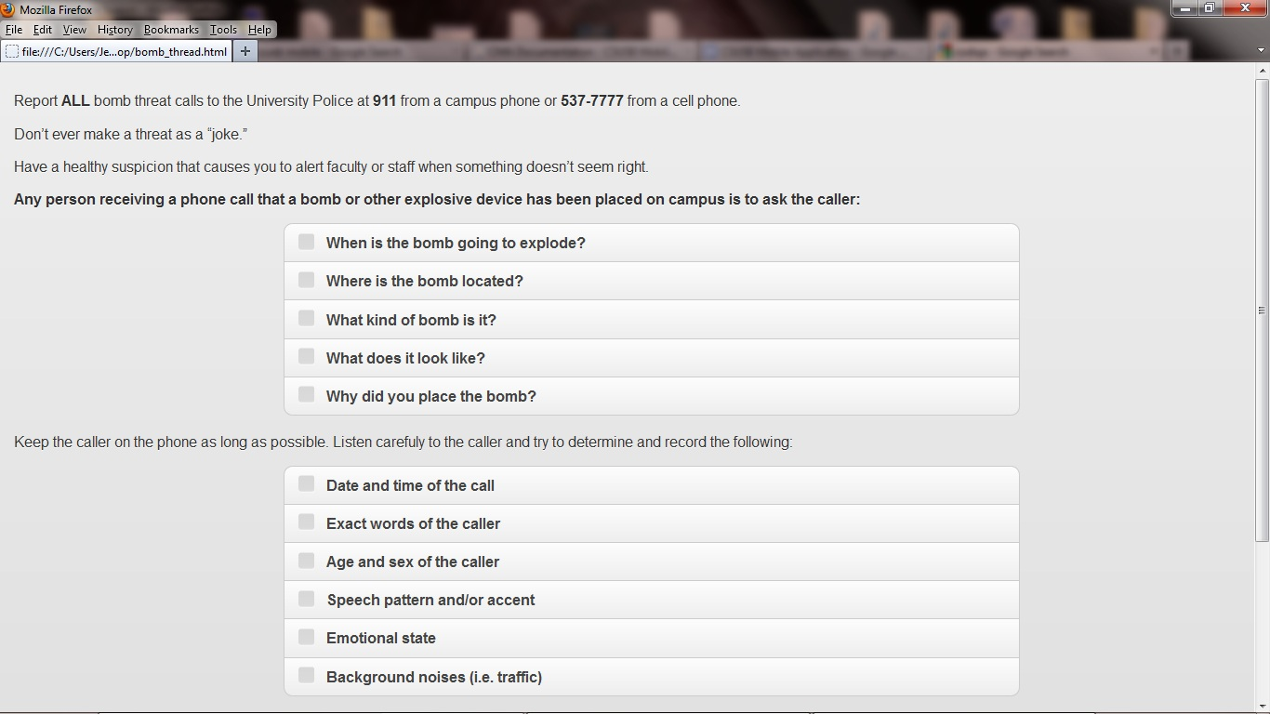

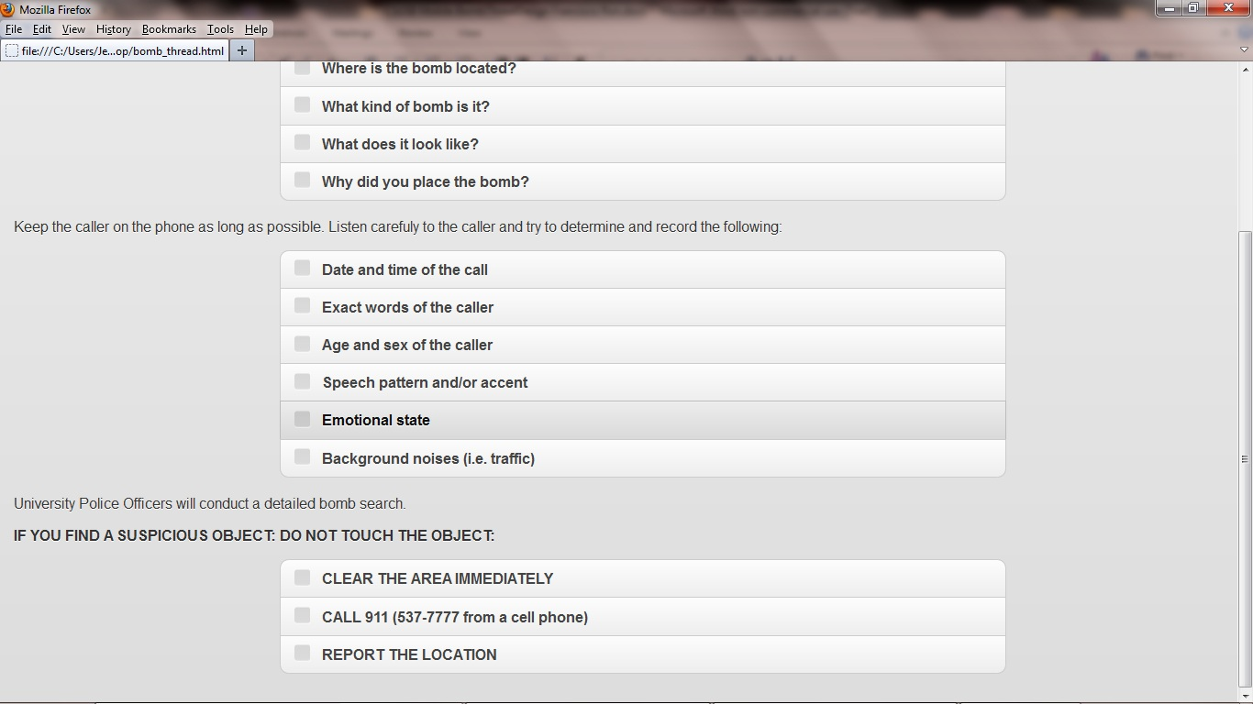

# Comments

I’m including this picture that might want to be used in the future.

### 