
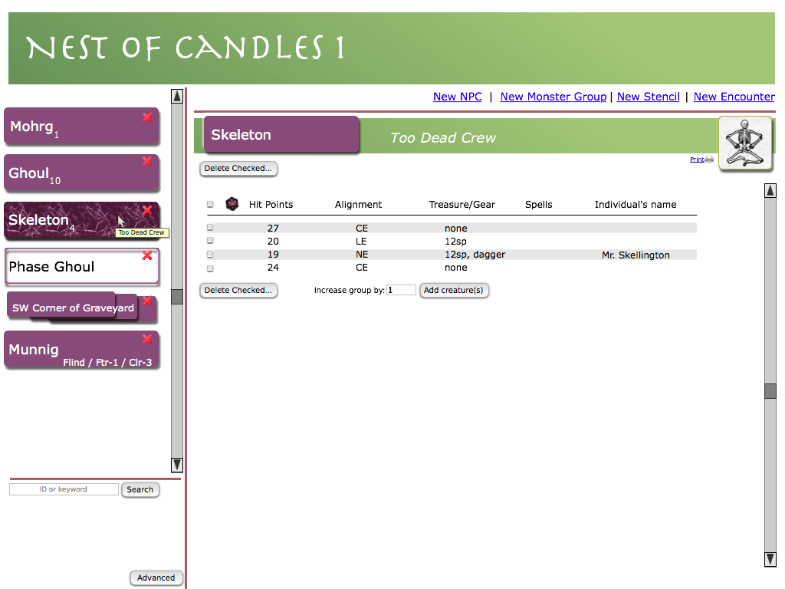
General:
- Workgroup name is click editable. So is the monster name on any purple button, the label of the monster group (“Too Dead Crew”), and a few other things that you see
- The X icons in the corner of the workspace items (on the left) remove the thing in a context-sensitive way. Tooltip displays “Remove from this workspace” if the thing is in the user's library (and thus deletion is not permanent) or “Delete” if a monster group or encounter, which exist only on one workspace
- New NPC and New Monster Group display the advanced search dialog (these should have “...” appended to the label). After a selection is made from Advanced search, the thing you chose is created immediately.
- New Stencil and New Encounter just create a new blank item, immediately, with a default name such as “Unnamed creature [n]”
- The search button searches for the terms entered. Advanced search syntax can be used for field search, such as cr:12 and cr:>12
- The advanced search button brings up the same dialog as New NPC and New Monster Group. Unlike those links, you must then choose either monster group or npc after searching.
Monster Group Space:
- The image is editable. This is true any time you see an image in a box like this. Click it to get an image upload dialog.
- In the monster group, the default image is inherited from the stencil, and blank if the stencil had no image.
- “Delete Checked...” does what it says. Button is grayed if there is nothing checked. Button is gone if there are no items in the list.
- Hit points are click-to-edit, alignment is click-to-pick-dropdown, treasure/gear, spells, and name are click-to-edit (freeform text)
- Add Creatures instantly adds more creature rows, rolled immediately. If no creatures are in the list, this is the only thing visible.
- The d20 (tooltip “click to reroll checked”) can be clicked to reroll all checked creatures, with a confirm box.
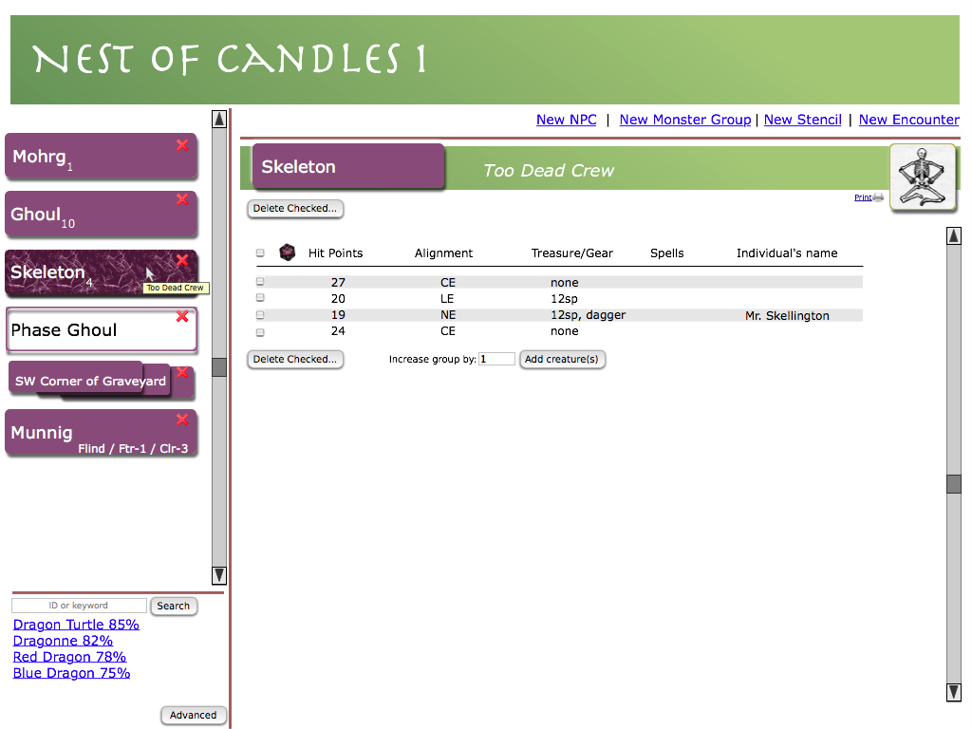
Search:
- after clicking a search result, you get a lightbox question to choose either monster group or NPC

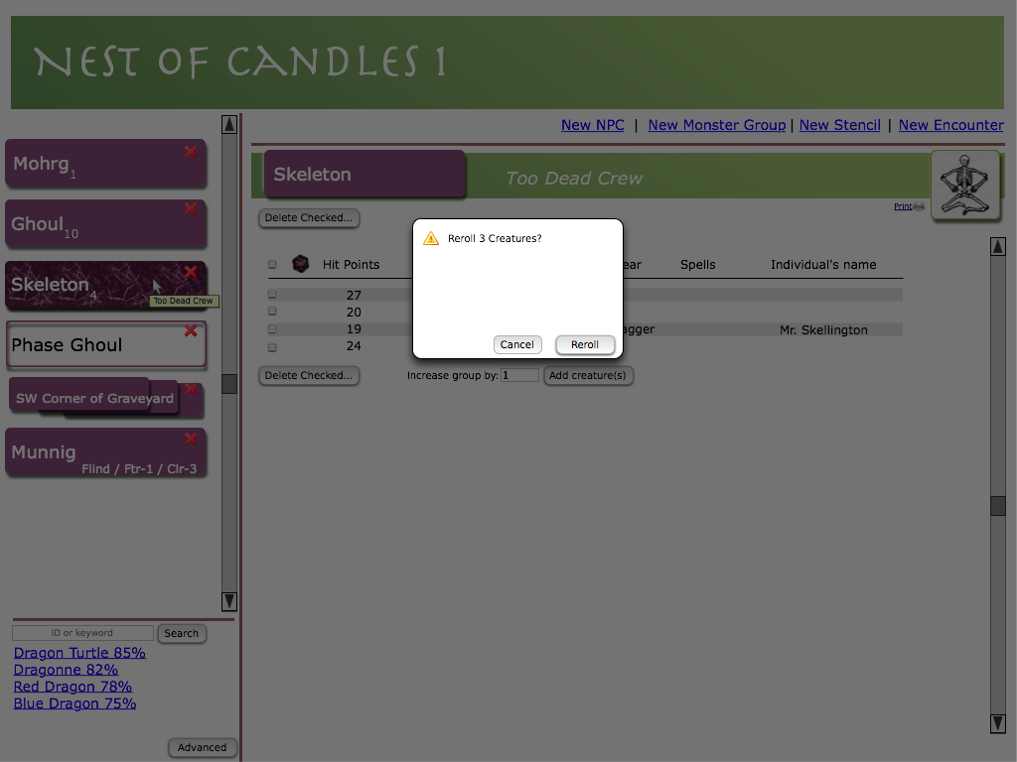
Confirm Reroll:
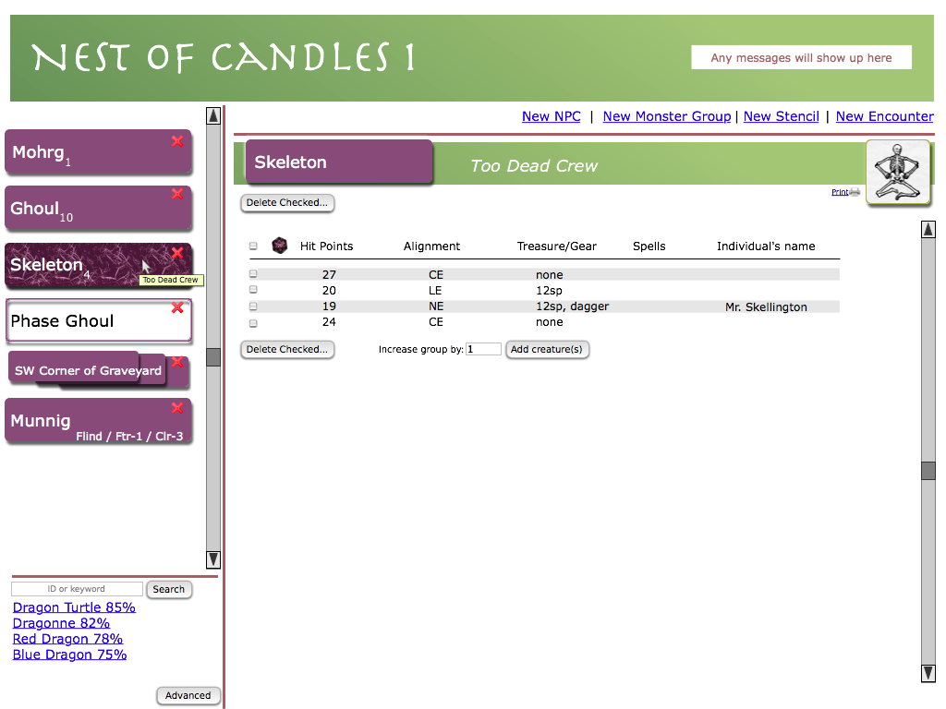
Messages:
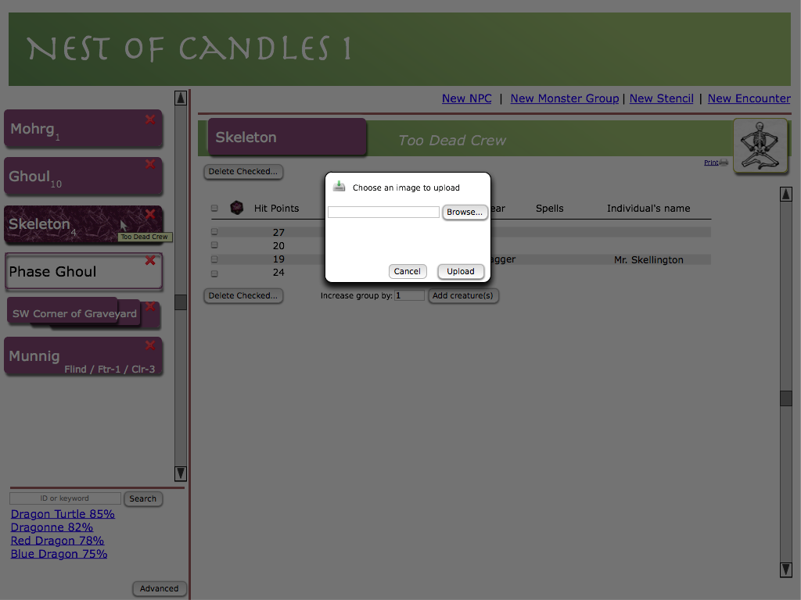
Image Upload:
- Uploading an image replaces (overrides) the image in the box. It is stored with the specific monster group.

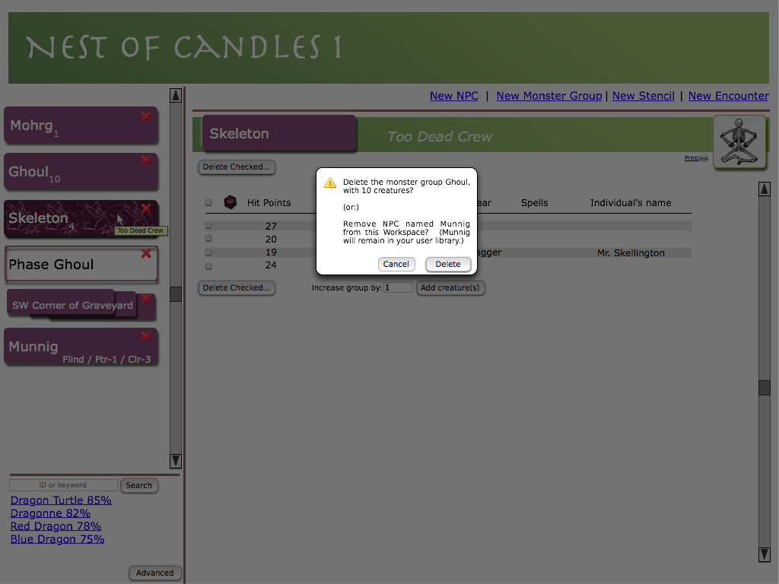
Confirm Delete:
- Deleting a thing from the sidebar has context-specific consequences. Buttons and message will say “delete” for monster groups and encounters, “remove from worksapce” otherwise.

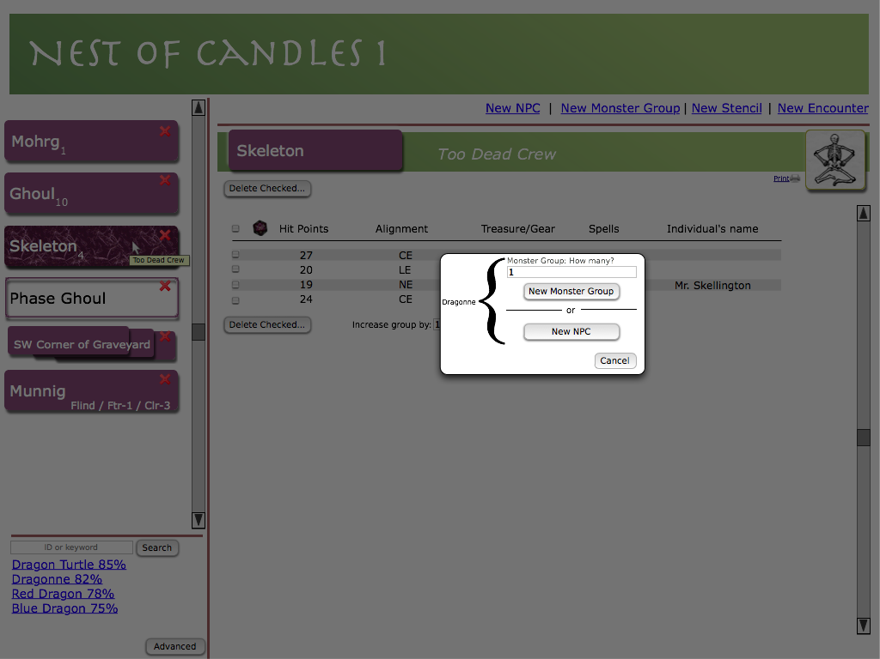
Choose Monster Group or NPC:

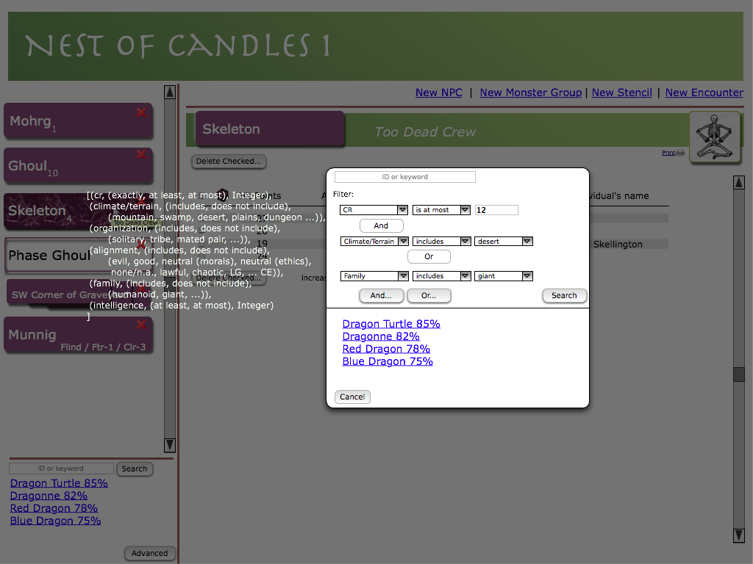
Advanced Search:
- as with basic search, when you click a search result, you get asked next whether you want a monster group or NPC. Exception: if you arrive at advanced search by clicking New NPC or New Monster Group, clicking a result gives you a new one of those immediately.

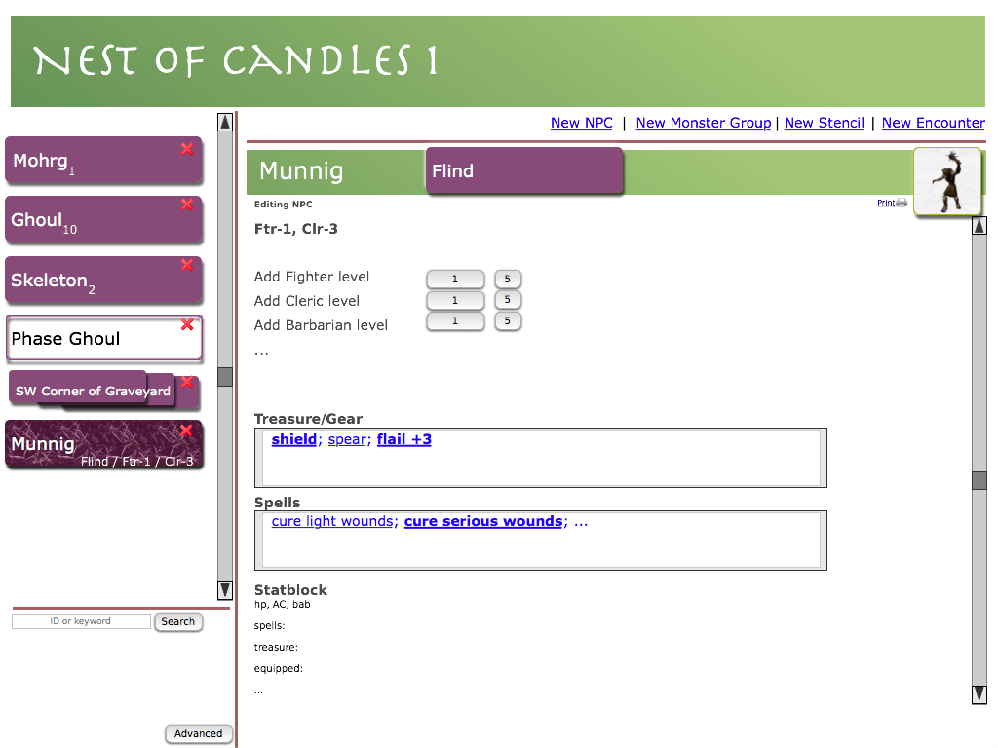
NPC:
- typing into the treasure/gear, separate items with semicolons to get a new link.
- Clicking a link gets a context-sensitive menu.

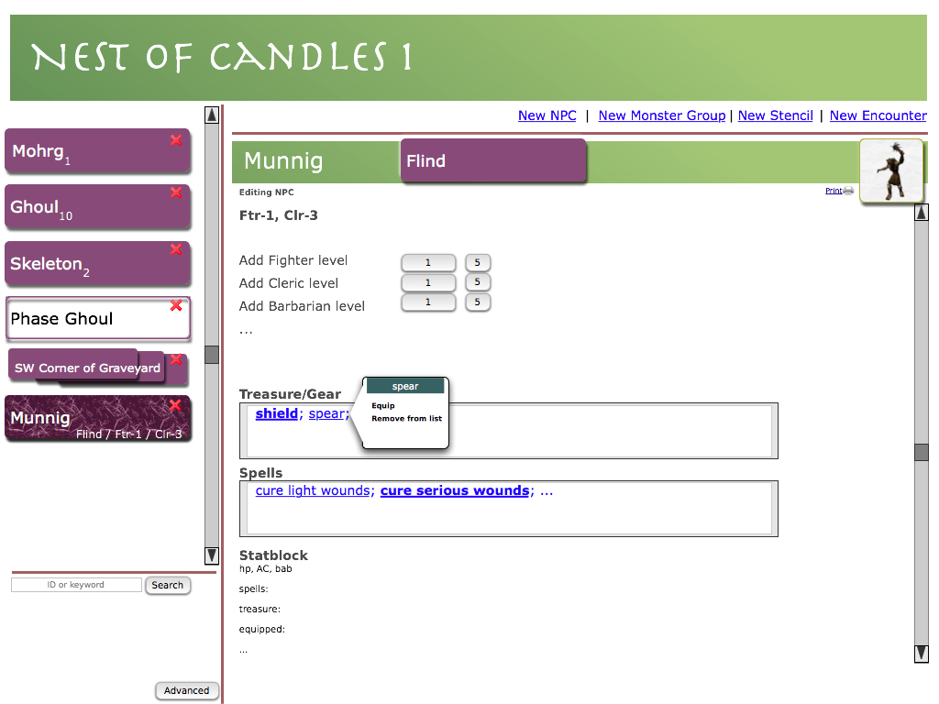
Equip menu:
- equipped items say “unequip/unready” and unequipped items say “equip/ready”

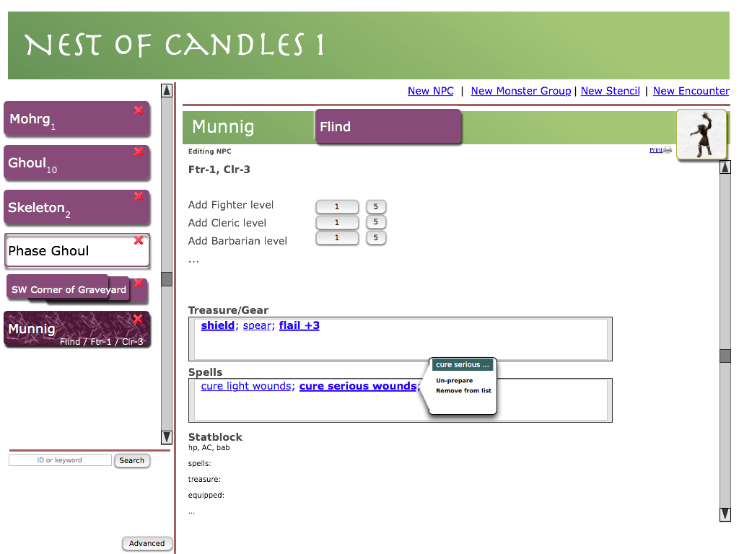
Spell menu:
- as with equip, prepared spells say “unprepare/unmemorize” and unprepared spells say “prepare/memorize”

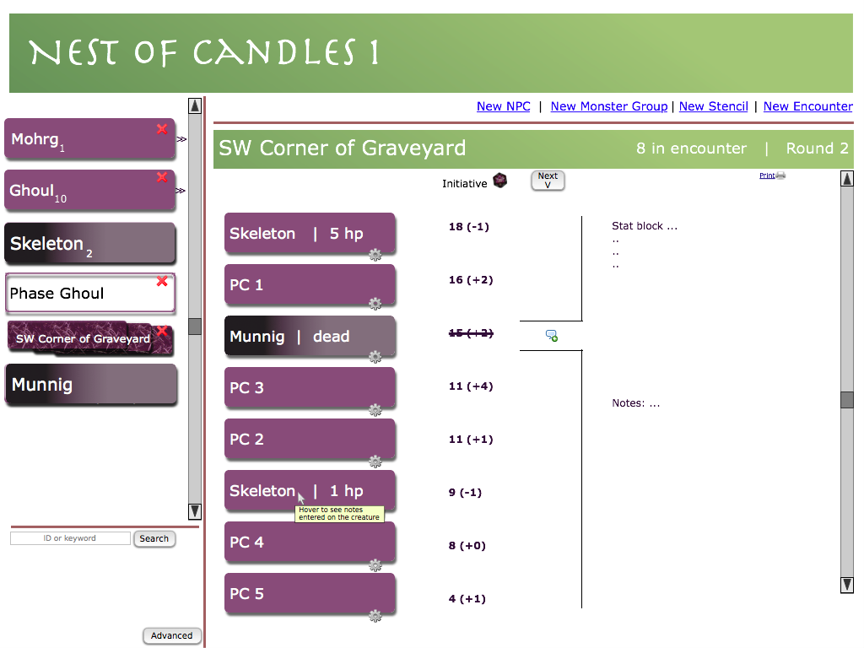
Encounter:
- Click a combatant to get a menu
- Chevrons next to sidebar items flash/fade in when an encounter is on the desktop
- Click a chevron to add a thing to the encounter
- Things that cannot be added (either they are already in the encounter, or they are stencils or other encounters) are ghosted out, with no chevron.
- The gears are drag handles, for rearranging monsters in the initiative. A monster thus dragged has its initiative replaced with an opaque gray box.
- Dead combatants are shown grayed. Their inits are crossed out, and their turns are skipped init.
- The bubble near the center shows whose turn it is. Clicking “Next V” moves it to the next turn. As it moves, the statblock on the right displays the new current monster.
- Clicking the d20 by Initiative rerolls all inits. (Tooltip: “Reroll all inits”)

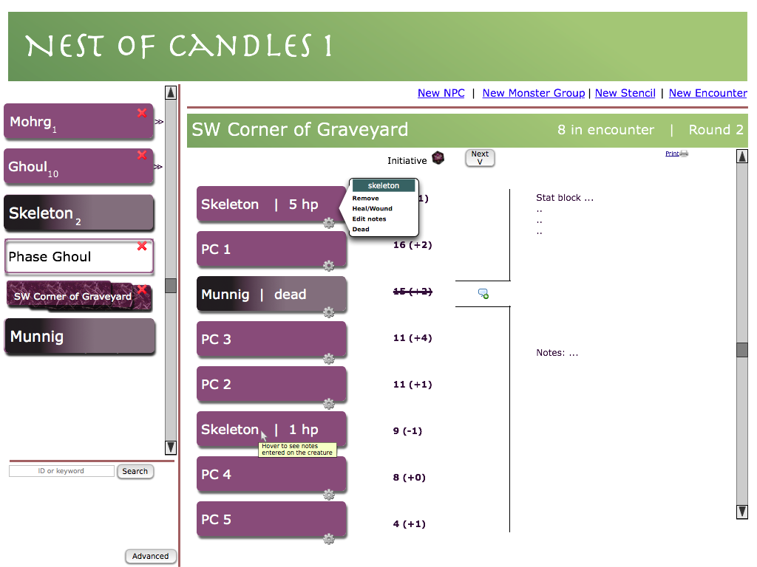
Combatant menu:

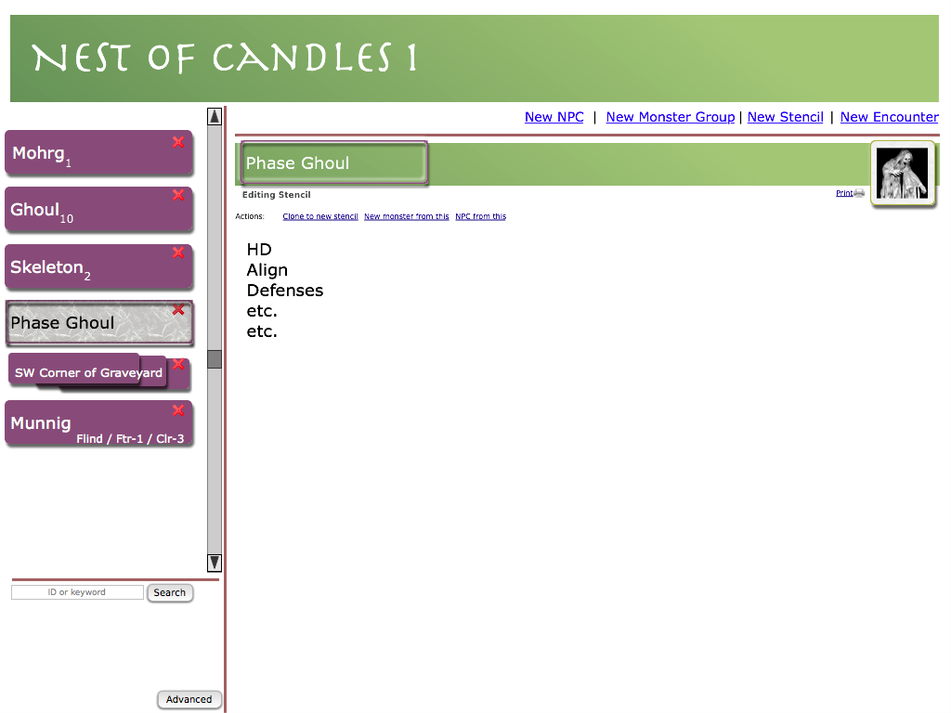
Stencil:
- Art is editable. Editing this art automatically updates all monster groups which use this stencil, unless they have already overridden the art.

