Generating an RSA Key Pair in Windows 10

Step 1. Download OpenSSH
We will be using a trusted 3rd-party binary package (installer) created by MLS Software. This will work with both 32 bit and 64 bit Windows architectures.

Download Link: http://www.mls-software.com/opensshd.html

Choose the .exe file under the “New Version” table.

Example: setupssh-<#.##-#>.exe

OpenSSH also includes the cryptography libraries provided by OpenSSL, so we won’t need to install these packages separately.

Step 2. Install OpenSSH
To install OpenSSH, double-click the downloaded executable file and follow the tutorial below...

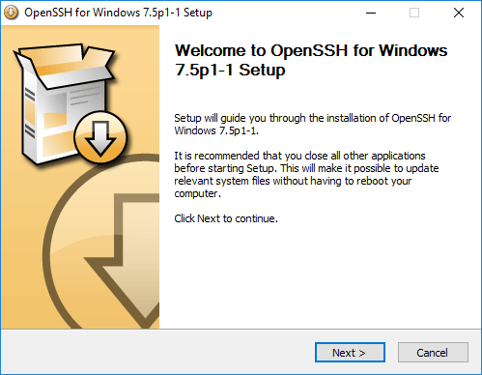  To begin installation, click Next | 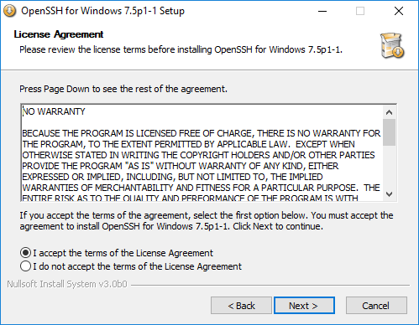  Accept the EULA, click Next | 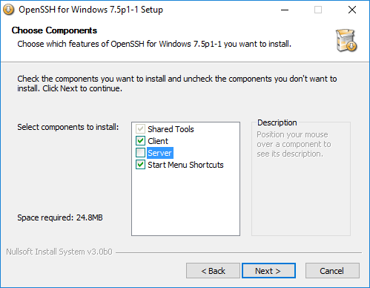  Since we won’t be needing incoming connections, uncheck Server, click Next

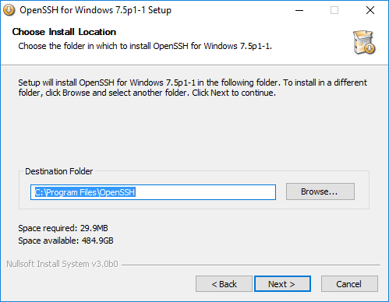  Accept the defaults, click Next | 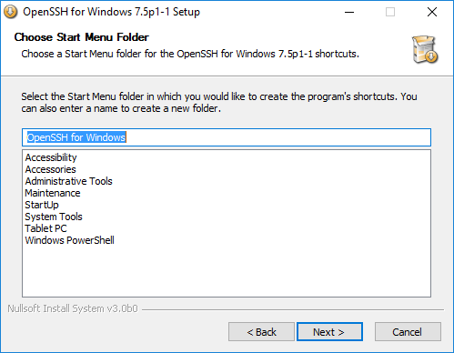  Accept the defaults, click Next | 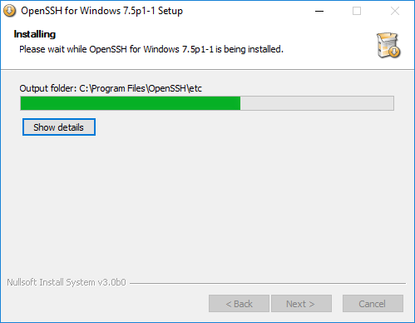  Wait for the installer to finish...

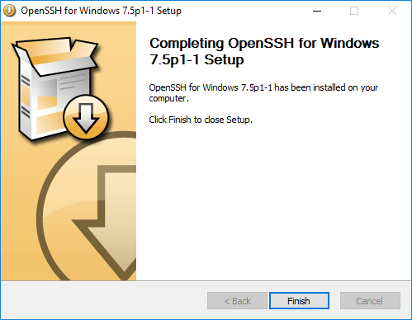
To finish the installation, click Finish

You may need to reboot Windows at this point.

Step 3. Generate an RSA Key-Pair
Now that we’ve installed OpenSSH and OpenSSL, we can generate an RSA key-pair.

Open Windows Command Prompt and type
ssh-keygen -t rsa

It will ask you to enter a file in shich to save the key, by default it will use “id_rsa”.
Press Enter to use the default names “id_rsa” and “id_rsa.pub”.
These files will be created in: C:\Users\<username>\.ssh\
Enter your passphrase (password) and confirm it by entering it again. Remember this password.

You will have successfully created
Generating public/private rsa key pair.
Enter file in which to save the key (/home/<username>/.ssh/id_rsa):
Created directory '/home/<username>/.ssh'.
Enter passphrase (empty for no passphrase):
Enter same passphrase again:
Your identification has been saved in /home/<username>/.ssh/id_rsa.
Your public key has been saved in /home/<username>/.ssh/id_rsa.pub.
The key fingerprint is:
SHA256:1lP+hk2C2Dnh61+EYdmvZfAoQ7fSYAs9EnYKusAVniU <username>@<laptopname>
The key's randomart image is:
+---[RSA 2048]----+
| E.o o . |
| . o = o = o |
| o + = @ + |
| . . = % O * |
| . S O O * =|
| . + @ + |
| . . * |
| . o |
| ... |
+----[SHA256]-----+

Please remember, these files will be created in: C:\Users\<username>\.ssh\

