ECCLES MBA
General Management & Rotational Leadership Program
Interview Playbook — User Manual
David Eccles School of Business · Full-Time MBA Program
Version 2.0 · August 2026

Contents
1. Overview & Purpose
2. Getting Started
3. Navigating the Tool
4. Using the Question Bank
5. Practice Mode
6. Readiness Dashboard
7. Frameworks Section
8. Battlecard Section
9. Red Flags Section
10. Suggested Study Approach
11. Troubleshooting

1. Overview & Purpose
This tool helps Eccles MBA students prepare for General Management (GM) and Rotational Leadership Development Program (LDP) interviews. It's built around programs like those at P&G, Target, and PepsiCo.
It includes 100 interview questions, 10 business frameworks, an interview cheat sheet, and a list of common mistakes to avoid.
It also has a practice mode where you can speak or type an answer and get instant feedback.
Everything runs from one file. There is nothing to install. Open the file in any modern web browser and it works right away — no internet connection needed after the page loads.
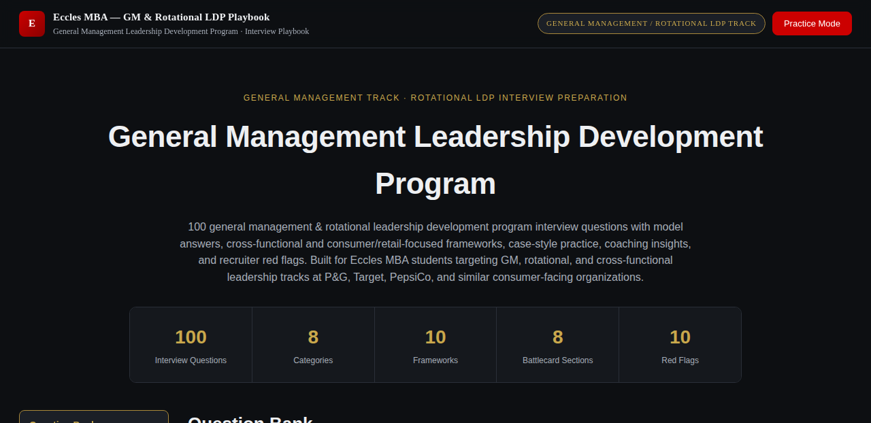
The top of the tool: title, quick stats, and the Practice Mode button.

2. Getting Started

2.1 Opening the Tool
Double-click the file (named something like Eccles_GM_LDP_Interview_Playbook.html) to open it in your web browser. Or right-click it and choose "Open with" to pick a specific browser.
Note: For the best experience — especially for the voice practice feature — use Google Chrome or Microsoft Edge. Safari and Firefox will show all the content correctly, but their built-in speech recognition is limited or unavailable.

2.2 What You'll Need
- Any modern desktop or mobile web browser (Chrome, Edge, Safari, or Firefox).
- A microphone — only if you want to speak your answers out loud. Typing works everywhere.
- No account, login, or internet connection is required once the file is open.

3. Navigating the Tool
The sidebar on the left (or the tab bar at the top, on a phone) gives you four sections:
- Question Bank — the full set of 100 questions, with search and filters.
- Frameworks — 10 business frameworks worth knowing for these interviews.
- Battlecard — a short, focused cheat sheet for last-minute review.
- Red Flags — 10 specific mistakes that hurt GM candidates in interviews.
The header also has a "Practice Mode" button. This opens the practice screen without picking a question first — useful if you just want to rehearse freely.

4. Using the Question Bank

4.1 Searching and Filtering
Type in the search box to find questions by keyword. Use the category buttons to narrow the list to one of the 8 GM categories. Use the difficulty buttons to filter by Foundational, Core, or Advanced.

4.2 Expanding a Question
Click anywhere on a question to open it. Each question has four tabs:
- Conversational — a model answer, written the way a strong candidate would actually say it out loud.
- Deep-Dive — the same answer, expanded with more detail, numbers, and business reasoning.
- Coaching — tips on how to deliver the answer and what to emphasize.
- Red Flag — the specific mistake to avoid on this question.
Note: Clicking a tab does not close the question. You can move freely between all four tabs before closing it.
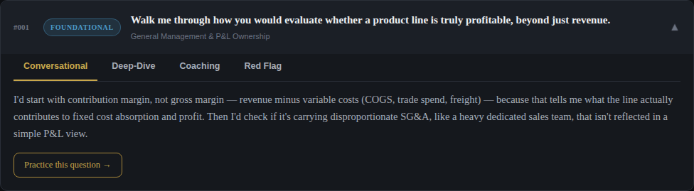
An open question, showing the four tabs and the "Practice this question" link.

4.3 Practicing a Specific Question
Inside any open question, click "Practice this question →". This opens the practice screen with that exact question loaded, so your practice and feedback are tied to it.

5. Practice Mode

5.1 Recording or Typing Your Answer
Click the microphone button to start. Speak your answer naturally, and it will appear as text in real time. Click the microphone again to stop. You can also type or edit your answer directly, whether or not you used the microphone.
Note: The microphone needs your browser's permission and works best in Chrome or Edge. If your browser doesn't support it, the tool will let you know on-screen — just type your answer instead.

5.2 Live Metrics
As soon as you start typing or speaking, three numbers start tracking automatically — no AI needed for these, since they're just measured directly:
- Duration — how long you've been answering, timed from your first keystroke or the moment you start recording.
- Pace — your words per minute, calculated from your actual answer length and elapsed time.
- Filler Words — a live count of words like "um," "uh," "like," and "you know."

Duration, Pace, and Filler Words update live as you speak or type.

5.3 Getting Your Answer Evaluated
This tool doesn't connect to a live AI model, so it can't grade your answer by itself. Instead, it writes the evaluation prompt for you — you just copy it, paste it into Claude or ChatGPT, and read back the scores it gives you.
- Type or speak your answer as usual.
- Click "Copy Prompt." This copies a ready-made request that already includes your question, your answer, and your delivery metrics.
- Paste it into Claude, ChatGPT, or any AI chat tool you have access to.
- Read the five scores in its response, and enter each one in the matching dropdown below the prompt box.
- Click "Save to Dashboard" to log this attempt. All five scores must be filled in first.
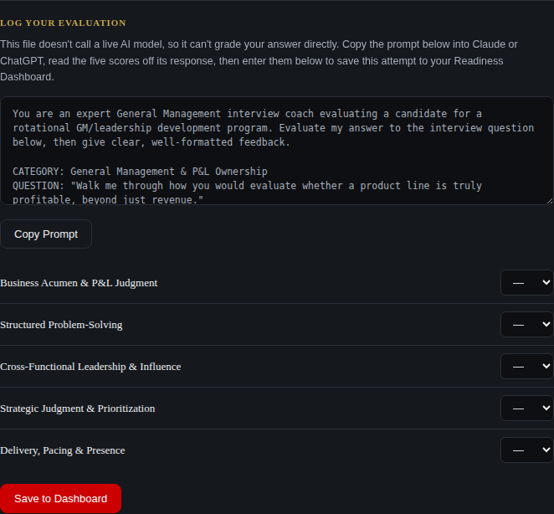
The Log Your Evaluation section: copy the prompt, get scored by a real AI, then enter the five scores here.
Note: Nothing stops you from entering scores without actually running the prompt — this tool trusts you to use it honestly, the same as a paper self-assessment would. The value only comes through if you actually get real feedback first.

5.4 The Five Scores
Every evaluation is scored on the same five dimensions, each from 1 to 5:
- Business Acumen & P&L Judgment
- Structured Problem-Solving
- Cross-Functional Leadership & Influence
- Strategic Judgment & Prioritization
- Delivery, Pacing & Presence
These five combine into one Overall score out of 100, which is what feeds your Readiness Dashboard — see the next section.

5.5 Readiness Tracker
The Question Bank page shows a short readiness bar with a running count of how many of the 100 questions you've evaluated at least once. For the full breakdown — your Overall Readiness, category-by-category strength, and your progress over time — see the next section.

6. Readiness Dashboard
Every evaluation you save builds out this dashboard — so you can see your progress across all eight categories, not just how one practice session went.

6.1 Overall Readiness
A ring in the top-left of the dashboard shows your Overall Readiness as a single percentage, averaged across every question you've evaluated at least once. It's labeled with one of four stages: Needs Work, Developing, Solid Progress, or Interview Ready.
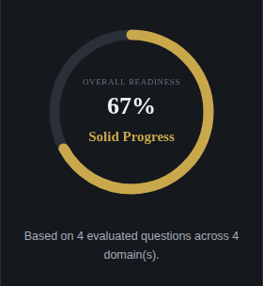
The Overall Readiness ring, with your current stage and a short summary underneath.

6.2 Domain Mastery
Next to the ring, a bar for each of the 8 categories shows your average score there and how many of that category's questions you've evaluated. This is the fastest way to see which categories still need work.
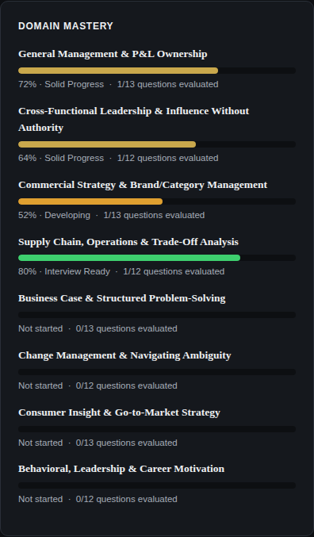
Domain Mastery: one bar per category, color-coded from red (needs work) to green (interview ready).

6.3 Score Progress Over Time
Below Domain Mastery, a line chart plots your last 30 saved evaluations in order, so you can see whether your scores are actually trending up as you practice more.

6.4 Export, Import, and Reset
Three buttons sit at the top of the Readiness Dashboard:
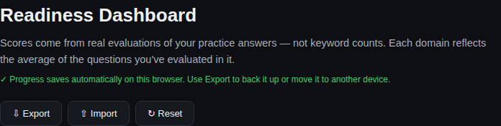
Export, Import, and Reset — at the top of the Readiness Dashboard.
- Export — downloads all your saved progress as a single file. Use this to back up your progress, or to move it to a different computer or browser.
- Import — loads a previously exported file back in. This replaces whatever progress is currently saved on this device, so use it to restore a backup or bring progress over from another device.
- Reset — permanently clears all saved progress on this device. It will ask you to confirm first, since this can't be undone — export a backup first if you're not sure.

6.5 Your Progress Is Saved On This Device
Your practice history is saved in your browser, so it's still there the next time you open the file — even after closing the tab or restarting your computer.
Note: This only saves on the device and browser you practiced in. It doesn't sync across devices automatically, doesn't use an account, and is never sent anywhere — it stays entirely on your computer. Use Export and Import (Section 6.4) to move your progress to another device.

7. Frameworks Section
This section covers 10 business frameworks that come up often in GM and rotational leadership interviews:
- P&L / Contribution Margin Waterfall
- Kotter's 8-Step Change Model
- Porter's Five Forces
- RACI (Responsible, Accountable, Consulted, Informed)
- Impact/Effort Prioritization Matrix
- MECE Issue-Tree Structuring
- 4Ps Marketing Mix
- S&OP Demand-Supply-Financial Reconciliation
- Stakeholder Influence Mapping
- Root Cause Analysis
Each one includes a short summary of when to use it, plus 3-4 specific points. Review these before case-style or strategy interview rounds.

8. Battlecard Section
The battlecard is built for last-minute review, ideally in the hour before an interview. It has 8 parts: Must-Know Concepts, Cross-Functional Leadership Phrases, Business Metrics to Know Cold, General Management Principles, Common Interview Mistakes, Strong Candidate Signals, Executive Differentiators, and a Last-Minute Review checklist.

9. Red Flags Section
This section lists 10 specific habits that weaken GM candidates — from reciting data with no clear point, to poor structure in your answers.
Compare this list against your own practice answers. It's one of the fastest ways to catch weak spots before a real interview.

10. Suggested Study Approach
- Start with "Foundational" questions in the Question Bank to build core vocabulary and confidence.
- Move to "Core" questions. Practice at least 2-3 per category using the voice feature.
- Review the Frameworks and Battlecard sections once you're comfortable with about half the question bank.
- Save "Advanced" questions for your final week. Focus on the categories most relevant to your target company.
- Use the Readiness Dashboard to check you've practiced all 8 categories — not just your strongest ones — and to see whether your scores are trending up.

11. Troubleshooting

11.1 The Microphone Isn't Working
- Make sure you're using Chrome or Edge — Safari and Firefox have limited voice support.
- Check that you granted microphone permission when your browser asked.
- If typing works but voice doesn't, just type your answer instead — coaching feedback works the same either way.

11.2 The Page Looks Broken or Unstyled
- Make sure you're opening the actual .html file in a web browser, not a plain-text preview.

11.3 My Practice Progress Didn't Save
- Make sure you're opening the tool the same way each time (same browser, same computer) — progress is saved to that specific browser.
- If you're in a private/incognito window, some browsers block the saving feature entirely. The Readiness tab will tell you if this happened.
Note: If neither applies and progress still isn't saving, treat each session as a fresh practice sprint in the meantime, and keep your own notes as a backup.

Developed by Cory Burk, Senior Manager, Program Management · Full-Time MBA Program · David Eccles School of Business.
© 2026 University of Utah, David Eccles School of Business. All rights reserved.

