Client: Tom Tom Club Tomato Farmers

System Requirement Specification document
Version 1.0
By: Cory J. Quirk

Purpose of this document
This SRS document will set expectations for all aspects of design of the application to meet the client’s needs. The details provided here, including the entity relationship diagram (showing database structure) and workflow diagram will help guide the work of the developer and define the amount of work involved.

We will provide a product perspective and user stories to provide background that illustrates the business’s needs. Functional requirements (usable features of the app that will fill the business’s needs) will be defined first, followed by non-functional requirements.

Product perspective
This product is fulfilling organization needs for a medium sized tomato farm. The farm is decentralized and each farmer (or “steward”) is responsible for overseeing their respective plots. Tomato plants which are currently growing will be located by plot and then more specifically the row within the plot. In actuality there is additional labor performed under the coordination of each farmer, but those workers are outside the scope of the intended audience for this application. The app must be functional in the most popular modern web browsers but need not be mobile-compatible. There are a variety of tomatoes being grown on this farm, from heirloom varieties, to classic styles, to cherry and grape tomatoes.

User stories
As a farmer, I want to keep track of available seeds so that I may plan my planting accordingly.
As a farmer, I want insights about the tomato varieties we sell, so that we may play the market better.
As a farmer, I want information about disease in our crops, so that we may mitigate the spread of disease.
As a farmer, I want to see information about my coworkers’ plots to gain insight about farming techniques as they relate to disease management or cultivation styles like hydroponics.
As a farmer, I want to know how many of our seeds make it to sellable produce, so that we may account for this in our budgeting.

Functional requirements
Ability for the user to create an account, provide a secure password and valid email, so that they may add or edit farm inventory items.
A superuser may readily add or remove users as well as farm plots. A superuser may grant or revoke superuser permissions for standard users.
Ability for a user to quickly access their plots and active crops, as well as seeds purchased and produce harvested.
Ability for a user to access plots, crops, seeds, and produce of the entire farm, including those managed by other stewards.

Non-functional requirements
Security:
User authentication, encryption for passwords, and secure session management provided via Spring Boot.
Performance:
The app needs to meet certain performance standards for speed as requested by the client.
Reliability:
The app needs to be readily accessible at any time without any sort of regular interruptions of service.
Localization:
The app will use U.S. time and currency standards but measurements (weight, distance, area, etc.) will use the metric system. The app will be entirely in American English in its first iteration.
Usability:
This app is meant for internal usage for farm staff only.
Maintainability:
This site will require little maintenance after deployment, but the code will be easily approachable and reusable for any future developers.

Future development
We want to expand the app beyond just crops to other aspects of the farm operation such as equipment, tools, or vehicles.
We want to expand the scope of crops past only tomatoes and include other crops as our farm expands.
We want to continue adding new ways to visualize and analyze the data in the app.
We will make the website mobile friendly and/or transport the app to a platform such as Android or iOS for usage away from a desktop computer.
We will provide more language options under which to use the app beyond just English.

Workflow diagram (logic for the app)

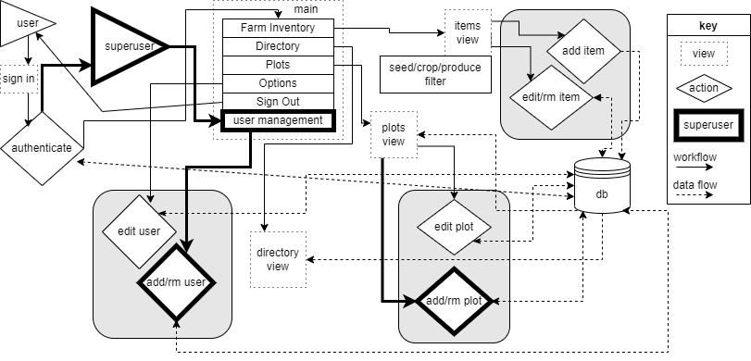

Data model

