Application Definition Statement

A concise, concrete declaration of the app’s main purpose and its intended audience

Purpose or Main Intent

A web and mobile application that allows users to search for local bands playing near them.

Description of Intended Audience

Music and local band enthusiasts who are interested in seeing local artists/bands. Age groups leans more towards the ages of 16-40. Target audience also includes people who aren’t willing to travel long distances or spend an excess amount of money.

Core Functionality

Allows users to easily have access to all nearby artists/bands show times and locations. Users can also filter search fort the artists they are searching for and purchase tickets at supporting locations.

Feature Set

* Search for local artists/bands
* Filter search results by:
* Genre
* Location
* Show times
* View details of listed artist'
* Purchase tickets
* User login/ User sign up / Forgot Sign up

Nice to Have

* Share artist profile on social networks
* “Follow” artist to get future notifications for show times
* Artist profile pictures and biography

Primary Persona

|  |  |
| --- | --- |
| Emma Anderson | “I want the application to be as accurate as possible. If my favorite local band is playing nearby, I need to know exactly when and where. It needs to let me filter out the genres I don’t like.”  Emma is a full time college student with very little extra free time. She enjoys most types of music genres but also likes to support the local talent when her favorite artists aren’t playing nearby. She usually only has the time and money to drive short distances to see live shows. Using the internet to search for nearby artists playing has deemed almost useless for her. All other sites don’t provide her with results specific to her location, only the artists. |

|  |  |  |
| --- | --- | --- |
| Characteristics | Influencers | Pain Points |
| **Age**: 21  **Education**: College Undergraduate  **Job Title**: Record store clerk  **Tech Familiarity**: High  **Tech Usage**: Daily  **Platform**: OSX Mavericks/  MacBook Pro, iPhone 5 | * A way to filter out unwanted genres * Location-based service for better results * Ability to follow artists for future notifications. | * Lack of ability to follow local artists * Lack of location-specific search results |

|  |  |
| --- | --- |
| Scenarios | |
| **Goal:**  Searches for any  Local band of possible interest (any time) | Emma uses her laptop or iPhone to search for artists playing near her. She opens up Google and searches for “local artists in ______”. She usually finds an occasional Craigslist ad that is promoting a band or artist playing on a specific night. If artist of interest is not found there, she clicks all other search links, usually an artist promotional site that displays a show time and location for the band. She sets a reminder on her phone for the date and time of the event. |
| **Goal:**  Searches for local band playing that night | (On a Friday or Saturday night) Uses iPhone to search for bands playing the night of. Opens the safari browser to Google search “Artists playing in ______ tonight”. Usually she will find links directing her to a bar’s or club’s website promoting the artist that night. She then takes note of it and attends the event that night. |

Secondary Persona

|  |  |
| --- | --- |
| Jack McComb | “The app needs to be simple, I don’t have time to fiddle with it all day. If I’m buying tickets for a show, the process better be easy or I’m out.”  Jack is a manager in the Music and Instruments section at Best Buy. Because of his job and interest in music, he finds shows artists mainly through word of mouth from locals. He is open to a new way to find local artists and is willing to driving a little further out of town if the artist has a good reputation. He owns a smartphone but is not very tech savvy and has a past of giving up on websites/apps if they are too complicated/annoying for him. |

|  |  |  |
| --- | --- | --- |
| Characteristics | Influencers | Pain Points |
| Age: 32  Education:  Job Title: Music Section Manager at Best Buy  Tech Familiarity: Basic  Tech Usage: Daily  Platform: Windows 8/ iPhone 4 | *In this section, outline the personas concerns and why they would use this web service.*   * Able to have list of show times in organized manor * Able to follow artists for future shows * Get notifications when artists are playing near him | *In this section, outline any major issues or problems with current workflow.*   * Often forgets artists when being told by word of mouth * Show times not always accurate * Lack of ability to follow artist of interest in the future |

|  |  |
| --- | --- |
| Scenarios | |
| **Goal:**  Get show times/location for local bands playing live | Jack always asks friends or acquaintances if they have heard of and bands playing in the nearby area. If none heard of, he calls the local bars/clubs to see which bands are playing and when. He then Google searches the band to see what genre they are under. If the genre is in his interest, he attends the show and purchases the ticket at the door.  Use Case Diagram |
|  |  |

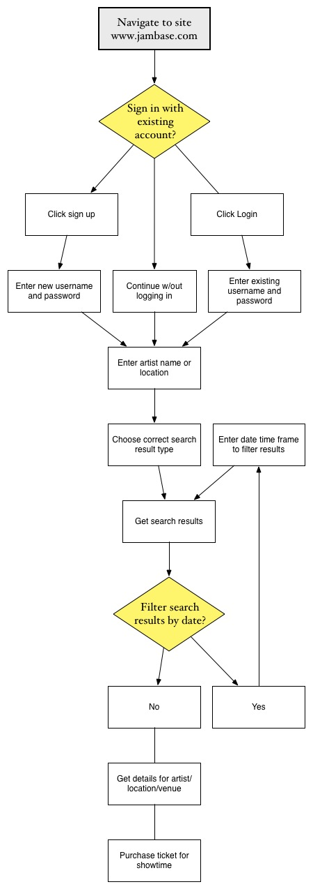

Heuristics Evaluation Sheet

Pick a similar web app and evaluate the design.

|  |  |
| --- | --- |
| Heuristic |  |
| **Visibility of app status**  Does the app keep users informed about what is going on, through appropriate feedback? | There are no progress indicators when searching or loading search results. When searching for an artist they cannot find, it displays a message indicating they could not find your search results. |
| **User control & freedom**  Users often choose app functions by mistake and will need a clearly marked “emergency exit.” Does the app contain safe exploration features? (back, cancel, undo) | Yes, the navigation at the top of the page displays the home button and other navigational elements that serve the user as an escape hatch. When searching for anything on the websites, it displays a message at the top of the search suggesting another page if this is not the expected page to land on. |
| **Error prevention**  Does the app eliminate error-prone conditions and present users with a confirmation option? | All buttons or links with an icon display an appropriate, relevant, and familiar icon so the users will have no confusion. All affordances are in an appropriate area and within close proximity of what they may relate to. Also, a bottom border separates all the search results. However, when choosing a start and end date to narrow results, both were simply a text field allowing me to write any characters in the text field. Also, I am able to choose a end date earlier than a start date, causing an error. |
| **Consistency & Standards**  Users should not have to wonder whether different words, situations, or actions mean the same thing. | All affordances on the application are styled and shaped relatively the same. Ex. All links are underlined and become non-underlined when hovered over. |
| **Recognition rather than recall**  Minimize the user’s memory load by making objects, actions, and options visible. | Titles and headings are not very distinctive from any other text of lesser importance. Some elements are the same size of others, when they should be smaller/bigger. However, a border at the bottom of each result distinctively separates each search result. |
| **Flexibility & efficiency of use**  Reduce the number of steps required by anticipating user needs and enabling customization. | Yes. Users can choose to display all search results on one page and choose the start and end date to display show times for. Users can also choose the distance in miles to search for show times. |
| **Aesthetics & screen design**  Screens should not contain information which is irrelevant or rarely needed | Aesthetics were not very pleasing and sometimes were hard to see what I was looking at/where to find something. No irrelevant information was displayed. |
| **Help users recognize, diagnose, & recover from errors**  Error messages should be expressed in plain language precisely indicating the problem and solution | When searching for results that cannot be found, the site suggests adding a new artist to the database, or trying the advanced search method. When filtering the search results by dates that conflict each other, it simply displays the error message on the results page saying exactly what error you have made, and suggests how to fix it. |

Heuristics Evaluation Sheet

A method for conducting quick and easy, low cost evaluations of user interface designs. Pick a similar service and evaluate its design.

|  |  |
| --- | --- |
| Heuristic |  |
| **Add your own Heuristic**  If the App can be evaluated using another heuristic, feel free to add to this list. |  |
| **Add your own Heuristic**  If the App can be evaluated using another heuristic, feel free to add to this list. |  |
| **Add your own Heuristic**  If the App can be evaluated using another heuristic, feel free to add to this list. |  |
| **Add your own Heuristic**  If the App can be evaluated using another heuristic, feel free to add to this list. |  |
| **Add your own Heuristic**  If the App can be evaluated using another heuristic, feel free to add to this list. |  |