**DSP Equalizer**

Documentation and Instruction Manual

by: Cory Pisano and Minh Pham

*Welcome to our DSP Equalizer Program!* While the program is fairly straightforward to use, we aim to ensure that the proper usage of our program is completely understood.

**Initializing the Program**

1. Ensure that main_program_gui.m, main_program.fig, and equalizer.m are all within your current working MATLAB directory.

2. Close all unneeded MATLAB windows. Be sure to close any prior instances of the program to allow it to run from a fresh state. Enter clear and clc in the MATLAB command line to clear any previous variables and command line output.

3. Run main_program_gui.m. This will launch the GUI, and allow you to use the main program.

**The Program Interface:**

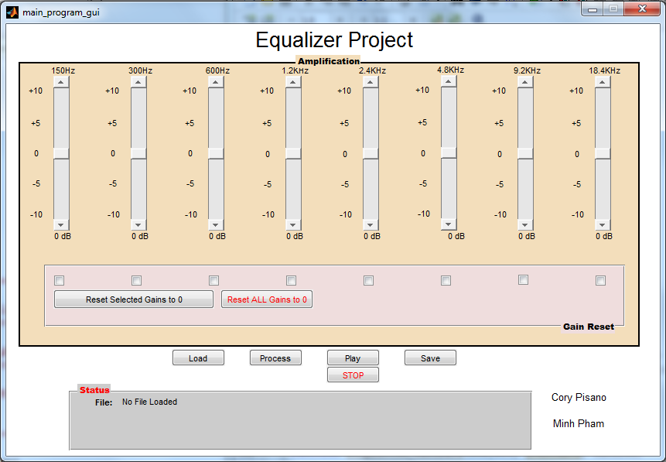

The program can be broken up into 3 main sections:

*Amplification:* This section allows you to vary the gain for one of 8 frequency bands. There are 8 sliders. Clicking the arrow button on the slider will vary the gain by 1dB. Clicking the trough of the slider (the track in which the slider resides) will vary the gain by 2dB. Each slider has an indicator at the bottom that details the gain in dB

*Gain Reset:* Under amplification is a Gain Reset partition. This contains 8

checkboxes. Each checkbox corresponds to the slider above. When one or more

checkboxes are selected, one can press Reset Selected Gains to 0 to change

the gains of the selected sliders to 0. This is especially useful if the slider was

accidentally manipulated to have a decimal gain. You may also hit the red

Reset ALL Gains to 0 button to change ALL gains to 0.

*Control:* There are 5 main buttons: Load, Process, Play, STOP, and Save.

Load: Opens a dialog box to allow you to choose a WAV file.

Process: Applies the given gain to the file.

Play: Plays the processed audio.

STOP: Stops the currently playing audio.

Save: Saves the processed audio as a new WAV file.

*Status:* Shows the file, processing and save status. When the program is initially started, the processing and save statuses are not visible until a file is loaded. Once a file is loaded, they will appear, along with the file name, such as below:

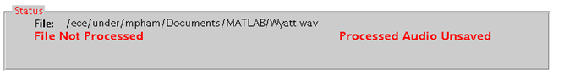

The filename and path is listed at the top of the panel. The left side of the panel shows File Status, whereas the right shows Save Status. Both can have several states, which will be discussed next.

*File Statuses:*

1.Shown when the file is loaded, but no processing applied and no gains changed.

2.Shown when the file is loaded, and the currently set gains have been applied. The audio is ready to be played or saved.

3.Shown when a slider is manipulated after loading or processing a file. Indicates that the shown gains **have not been applied**. If the Process button was not yet pushed, pushing Play will not result in any audio. If it had been pushed, the resulting audio will not represent the currently shown gains until Process is pushed again, and File Status 2 is shown.

4.Indicates that the Gain Reset function was used on either some or all of the gains. The same warning from File Status 3 applies: the Process button must be pushed, and File Status 2 shown before the resulting audio represents the currently shown gains.

*Save Statuses:*

1.The processed audio is unsaved. Push Save to save it.

2.The processed audio has been saved. Note that the saved audio only reflects the current audio settings **only when File Status 2 and Save Status 2 are both showing.**

**Basic Instructions:**

1. Push the Load button. A file open window will be presented. The window will only show WAVs. This program will only load 44.1 KHz, PCM encoded monaural WAV files. Once a file is loaded, File Status 1 and Save Status 1 should show.

2. Set the gains as desired. File Status 3 or 4 should appear, depending on how the gains are set.

3. Push Process. **WAIT for File Status 2 before proceeding to Step 4.**

4. Push Play or Save as desired.

**NOTE:** To listen to the original sound file, you must set all gains to zero, then push Process. This includes freshly loaded files! Pushing Play without pushing Process will play the last processed audio file.