**XPendit Use Case Descriptions**

**Developers: P.A.L.S.S.**

**In this document, we lay out and explain the use cases for our group expense sharing app, XPendit. The Use Case Diagrams are split into two main categories: Interface and Financial. The descriptions are split similarly, and are presented below.**

**Interface Use Case Models**

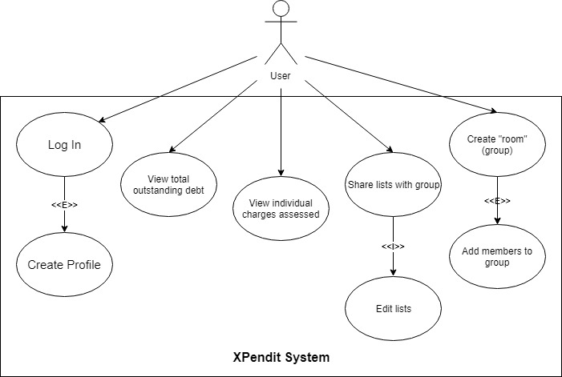

**Use Case:** Log In

**User Story IDs Addressed:** 012

**Related Use Cases:** Includes “Create Account”

**Steps:**

|  |  |
| --- | --- |
| **Pre-Conditions: User has opened application without being logged in.** | |
| Actor actions (User) | System response |
| 1. Select login option |  |
| 2.1 Enter username  2.2 Enter password  Alternative: User does not have account  2.1 “Create Account” |  |
| 6. Submits information | 7. Checks if information is correct |
|  | 8. Logs user in |
| **Post-Conditions: User has been logged into their account.** | |

**Use Case:** Create Account

**User Story IDs Addressed:** 012

**Related Use Cases:** Included in “Log In”

**Steps:**

|  |  |
| --- | --- |
| **Pre-Conditions: User has not created an account and has selected create an account.** | |
| Actor actions (User) | System response |
| 1. Select text field for username |  |
| 2. Enters desired username |  |
| 3. Select text field for password |  |
| 4. Enter desired password |  |
| 5. Submits information | 6. Checks if information meets minimum system requirements |
|  | 7. Saves user to database |
| **Post-Conditions: User has created an account.** | |

**Use Case:** View total outstanding debt

**User Story IDs Addressed:** 002

**Related Use Cases:** N/A

**Steps:**

|  |  |
| --- | --- |
| **Pre-Conditions: User is logged in.** | |
| Actor actions (User) | System response |
| 1. Select “Home” | 2. Displays home screen |
| 3. Selects “Total Owed” | 4. Displays total balance owed to all individuals |
| **Post-Conditions: N/A** | |

**Use Case:** View individual charges assessed

**User Story IDs Addressed:** 003, 005

**Related Use Cases:**

**Steps:**

|  |  |
| --- | --- |
| **Pre-Conditions: User is logged in and has selected to look at monthly charges** | |
| Actor actions (User) | System response |
| 1. User selects “History” | 2. Displays the charges |
| 2. User views charges |  |
| 3. User exits dialog | 4. Return to previous menu |
| **Post-Conditions: N/A** | |

**Use Case:** Share lists with groups

**User Story IDs Addressed:** 009, 010

**Related Use Cases:** Includes “Edit Lists”

**Steps:**

|  |  |
| --- | --- |
| **Pre-Conditions: User is logged in and is in a sub-menu for the desired group.** | |
| Actor actions (User) | System response |
| 1. Selects option to create a list | 2. Open dialogue box |
| 3. Give list a name |  |
| 4. Add items  (via Include: “Edit list”) |  |
| 5. Save and submits list | 6. Save list to database; exit |
| **Post-Conditions: List has been created and shared with everyone in group.** | |

**Use Case:** Edit List

**User Story IDs Addressed:** 009, 010

**Related Use Cases:** Included in “Share lists with group”

**Steps:**

|  |  |
| --- | --- |
| **Pre-Conditions: User is logged in and is in a sub menu for the desired group** | |
| Actor actions (User) | System response |
| 1. Selects list to edit | 2. Show dialogue box |
| 3. Select edit list option |  |
| 4. Add or remove item from list |  |
| 5. Save and submit list | 6. Save list to database |
| **Post-Conditions: List has been edited and shared with everyone in group** | |

**Use Case:** Create room

**User Story IDs Addressed:** 011

**Related Use Cases:** Includes “Add members to group”

**Steps:**

|  |  |
| --- | --- |
| **Pre-Conditions: User is logged into system and has selected create new group option.** | |
| Actor actions (User) | System response |
| 1. Select new group |  |
| 2. Give name to group | 3. Save group |
| 4. Add members  (via Include: Add members to group) | 5. Return dialog to select members |
| **Post-Conditions: User has successfully created a group.** | |

**Use Case:** Add members to group

**User Story IDs Addressed:** 011

**Related Use Cases:** Included in “Create room”

**Steps:**

|  |  |
| --- | --- |
| **Pre-Conditions: User has successfully created a group, is logged in, and in add member to group menu.** | |
| Actor actions (User) | System response |
|  | 1. Give dialog |
| 2. Select text field |  |
| 3. Type user email |  |
| 4. Click submit | 5. Check if user exists |
|  | 6. Add user to group |
| **Post-Conditions: User has successfully added member to the group.** | |

**Financial Use Case Models**

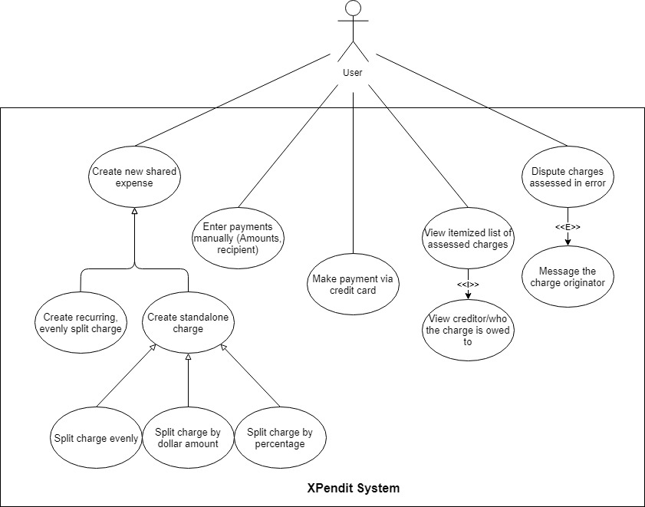

**Use Case:** Create new shared expense

**User Story IDs Addressed:** 001, 003

**Related Use Cases:** Generalizes “Create recurring, evenly split charge”; “Create standalone charge”

**Steps:**

|  |  |
| --- | --- |
| Pre-Conditions: Assumes the user has logged into the app, is viewing the group of interest, and has incurred an expense that needs to be shared with the group. | |
| Actor actions (User) | System response |
| 1. Select “Create new charge” | 2. Dialogue box appears |
| 3. Input charge details  Alternative: “Create recurring, evenly split charge”  Alternative: “Create standalone charge” |  |
| 4. Select “Confirm” or enter | 5. Dialogue box disappears |
| Post-Conditions: All included group members may see the new charge on their account. | |

**Use Case:** Create recurring, evenly split charge

**User Story IDs Addressed:** 001, 002, 003

**Related Use Cases:** Generalization of “Create new shared expense”

**Steps:**

|  |  |
| --- | --- |
| Pre-Conditions: Assumes there is a recurring charge that group members will be responsible for on a regular basis. | |
| Actor actions (User) | System response |
| 1. Select “Create new charge” | 2. Dialogue box appears |
| 3. Input charge details  a. Select “Recurring Charge”; describe it  b. Select interval  c. Select group members to be charged  d. Enter total amount of bill |  |
| 4. Select “Confirm” or enter | 5. Dialogue box disappears |
| Post-Conditions: Each included group member will be assessed the same charge on the selected interval. | |

**Use Case:** Create standalone charge

**User Story IDs Addressed:** 001, 004

**Related Use Cases:** Generalization of “Create new shared expense”; generalizes “Split charge evenly”, “Split charge by dollar amount”, “Split charge by percentage”

**Steps:**

|  |  |
| --- | --- |
| Pre-Conditions: Assumes the user wishes to split a single charge incurred with group members. | |
| Actor actions (User) | System response |
| 1. Select “Create new charge” | 2. Dialogue box appears |
| 3. Input charge details  a. Select “One-time Charge”; describe it  b. Select group members to be charged  c. Enter total amount of bill | 4. Display three choices for how the bill should be split: “Charge Evenly”, “Charge by Dollar Amount”, “Charge by Percentage” |
| 5. Three choices:  Default path: Use case “Split charge evenly”  Alternative: Use case “Split by dollar amount”  Alternative: Use case “Split charge by percentage” | 6. Assess charges |
| 7. Select “Confirm” or enter | 8. Dialogue box disappears |
| Post-Conditions: Each included group member will be assessed the chosen amount. | |

**Use Case:** Split charge evenly

**User Story IDs Addressed:** 001, 004

**Related Use Cases:** Generalization of “Create standalone charge”

**Steps:**

|  |  |
| --- | --- |
| Pre-Conditions: Assumes that the user is creating a standalone charge, and wishes it to be split evenly among all included group members. | |
| Actor actions (User) | System response |
| 1. Select “Create new charge” | 2. Dialogue box appears |
| 3. Input charge details  a. Select “One-time Charge”; describe it  b. Select group members to be charged  c. Enter total amount of bill | 4. Display three choices for how the bill should be split: “Charge Evenly”, “Charge by Dollar Amount”, “Charge by Percentage” |
| 5. Select “Charge Evenly” | 6. Assess charges |
| 7. Select “Confirm” or enter | 8. Dialogue box disappears |
| Post-Conditions: Each included group member is assessed the same charge within a penny (to account for amounts that aren’t exactly divisible). | |

**Use Case:** Split charge by dollar amount

**User Story IDs Addressed:** 001, 004

**Related Use Cases:** Generalization of “Create standalone charge”

**Steps:**

|  |  |
| --- | --- |
| Pre-Conditions: Assumes the user is creating a standalone charge, and wishes to assess a specific dollar amount to each individual involved. | |
| Actor actions (User) | System response |
| 1. Select “Create new charge” | 2. Dialogue box appears |
| 3. Input charge details  a. Select “One-time Charge”; describe it  b. Select group members to be charged  c. Enter total amount of bill | 4. Display three choices for how the bill should be split: “Charge Evenly”, “Charge by Dollar Amount”, “Charge by Percentage” |
| 5. a. Select “Charge by Dollar Amount”  b. Input dollar amounts to be assessed | 6. Assess charges |
| 7. Select “Confirm” or enter | 8. Dialogue box disappears |
| Post-Conditions: User retains responsibility for any part of the charge not divided among other group members. Each included group member is assessed their respective charge. | |

**Use Case:** Split by percentage

**User Story IDs Addressed:** 001, 004

**Related Use Cases:** Generalization of “Create standalone charge”

**Steps:**

|  |  |
| --- | --- |
| Pre-Conditions: Assumes the user is creating a standalone charge, and wishes to assess a specific percentage of the bill to involved group members. | |
| Actor actions (User) | System response |
| 1. Select “Create new charge” | 2. Dialogue box appears |
| 3. Input charge details  a. Select “One-time Charge”; describe it  b. Select group members to be charged  c. Enter total amount of bill | 4. Display three choices for how the bill should be split: “Charge Evenly”, “Charge by Dollar Amount”, “Charge by Percentage” |
| 5. a. Select “Charge by Percentage”  b. Input percentages to be assessed | 6. Assess charges |
| 7. Select “Confirm” or enter | 8. Dialogue box disappears |
| Post-Conditions: User retains responsibility for any percentage of the charge not assessed to other group members. Each included group member is assessed their respective charge. | |

**Use Case:** Enter Payments Manually (Amount, Recipient)

**User Story IDs Addressed:** 006, 007

**Related Use Cases:** N/A

**Steps:**

|  |  |
| --- | --- |
| Pre-Conditions: Assumes the user has logged into the app, is viewing the group of interest, and has made a payment to another group member for a portion of their outstanding debt. | |
| Actor actions (User) | System response |
| 1. Select “Enter Payment” | 2. Display dialogue box |
| 3. Select group member that was paid; enter | 4. Ask for payment amount |
| 5. Enter dollar amount paid | 6. Dialogue box disappears |
| Post-Conditions: The input dollar amount is subtracted from total debt and debt owed to selected user. The payment recipient is notified that they have received a payment, and their credit to the individual is reduced by the paid amount. | |

**Use Case:** View itemized list of assessed charges

**User Story IDs Addressed:** 003, 005

**Related Use Cases:** Includes “View creditor/who the charge is owed to”

**Steps:**

|  |  |
| --- | --- |
| **Pre-Conditions: User is logged in and has selected to look at monthly charges** | |
| Actor actions (User) | System response |
| 1. User selects “History” | 2. Displays the charges |
| 2. User views charges and initiator  (via Include: View creditor/who the charge is owed to”) |  |
| 3. User exits dialog | 4. Return to previous menu |
| **Post-Conditions: N/A** | |

**Use Case:** View Creditor/who the charge is owed to

**User Story IDs Addressed:** 003, 005

**Related Use Cases:** Included in “View itemized list of assessed charges”

**Steps:**

|  |  |
| --- | --- |
| Pre-Conditions: Assumes the user has logged into the app, is viewing the group of interest, and wishes to see the specifics of a particular charge assessed. | |
| Actor actions (User) | System response |
| 1. Select “History” | 2. Display list of charges in reverse chronological order, including description of charge, charge amount. |
| 3. Select individual charge from list | 4. Display all individual details, including:  Person assessing charge;  Date of charge;  Description of charge;  Charge amount. |
| Post-Conditions: N/A | |

**Use Case:** Dispute charges assessed in error

**User Story IDs Addressed:** 008

**Related Use Cases:** Extends to “Message the charge originator”

**Steps:**

|  |  |
| --- | --- |
| Pre-Conditions: Assumes the user has logged into the app, is viewing the group of interest, and wishes to dispute a charge they were wrongly assessed by a group member. | |
| Actor actions (User) | System response |
| 1. Select “History” | 2. Display list of charges in reverse chronological order. |
| 3. Select individual charge from list | 4. Display all individual details. |
| 5. Select “Dispute This Charge”  Optional: “Message the charge originator” | 6. Mark charge as “Pending Dispute” |
| Post-Conditions: Charge originator is notified that their charge is not accepted by the recipient. | |

**Use Case:** Message the charge originator

**User Story IDs Addressed:** 008

**Related Use Cases:** Extends “Dispute charges assessed in error”

**Steps:**

|  |  |
| --- | --- |
| Pre-Conditions: Assumes the user has logged into the app, is viewing the group of interest, and wishes to contact a group member explaining why they disputed a charge. | |
| Actor actions (User) | System response |
| 1. Select “History” | 2. Display list of charges in reverse chronological order. |
| 3. Select individual charge from list | 4. Display all individual details. |
| 5. Select “Dispute This Charge” | 6. Mark charge as “Pending Dispute” |
| 7. Select “Message Originator” | 8. Display text box |
| 9. Type message; enter | 10. Text box disappears |
| Post-Conditions: Charge originator receives message from the group member disputing a charge. | |