**Use Case:** Add members to group

**User Story IDs Addressed:** 011

**Related Use Cases:** Included in “Create room”

**Steps:**

| **Pre-Conditions: User has successfully created a group, is logged in, and in add member to group menu.** | |
| --- | --- |
| Actor actions (User) | System response |
|  | 1. Give dialog |
| 2. Select text field |  |
| 3. Type user email |  |
| 4. Click submit | 5. Check if user is there* |
|  | 6. Add user to group* |

1. Member addition GUI queries the user database with the inputted email
2. If the user database returns a user
   1. Member addition GUI sends user to group manager
   2. Group manager adds user to group manager
   3. Member addition GUI displays success message
3. Else:
   1. Member addition GUI displays error message to User

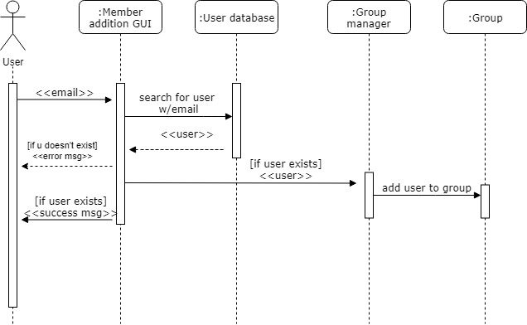

**Use Case:** Create room

**User Story IDs Addressed:** 011

**Related Use Cases:** Includes “Add members to group”

**Steps:**

| **Pre-Conditions: User is logged into system and has selected create new group option.** | |
| --- | --- |
| Actor actions (User) | System response |
| 1. Select new group |  |
| 2. Give name to group | 3. Save group* |
|  | 4. Return dialog to select members |

**Post-Conditions: User has successfully created a group.**

**Use Case:** Create new shared expense

**User Story IDs Addressed:** 001, 003

**Related Use Cases:** Generalizes “Create recurring, evenly split charge”; “Create standalone charge”

**Steps:**

| Pre-Conditions: Assumes the user has logged into the app, is viewing the group of interest, and has incurred an expense that needs to be shared with the group. | |
| --- | --- |
| Actor actions (User) | System response |
| 1. Select “Create new charge” | 2. Dialogue box appears |
| 3. Input charge details |  |
| 4. Select “Confirm” or enter | 5. Dialogue box disappears |
| Post-Conditions: All included group members may see the new charge on their account. | |