**XPendit Use Case Descriptions**

**Developers: P.A.L.S.S.**

**In this document, we lay out and explain the use cases for our group expense sharing app, XPendit. The Use Case Diagrams are split into two main categories: Interface and Financial. The descriptions are split similarly, and are presented below.**

**Interface Use Case Models**

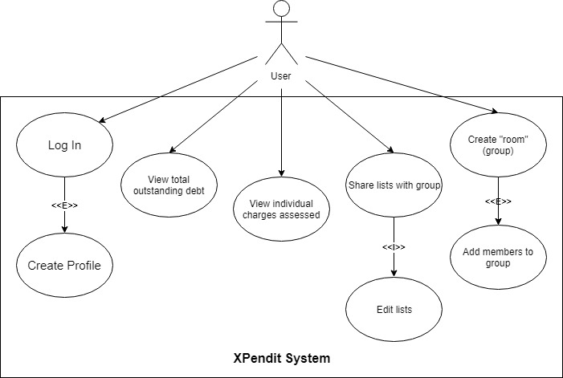

**Use Case:** Log In

**User Story IDs Addressed:** 012

**Related Use Cases:** Includes “Create Account”

**Steps:**

|  |  |
| --- | --- |
| **Pre-Conditions: User has opened application without being logged in.** | |
| Actor actions (User) | System response |
| 1. Select login option |  |
| 2.1 Enter username  2.2 Enter password  Alternative: User does not have account  2.1 “Create Account” |  |
| 6. Submits information | 7. Checks if information is correct |
|  | 8. Logs user in |
| **Post-Conditions: User has been logged into their account.** | |

**Use Case:** Create Account

**User Story IDs Addressed:** 012

**Related Use Cases:** Included in “Log In”

**Steps:**

|  |  |
| --- | --- |
| **Pre-Conditions: User has not created an account and has selected create an account.** | |
| Actor actions (User) | System response |
| 1. Select text field for username |  |
| 2. Enters desired username |  |
| 3. Select text field for password |  |
| 4. Enter desired password |  |
| 5. Submits information | 6. Checks if information meets minimum system requirements |
|  | 7. Saves user to database |
| **Post-Conditions: User has created an account.** | |

**Use Case:** View total outstanding debt

**User Story IDs Addressed:** 002

**Related Use Cases:** N/A

**Steps:**

|  |  |
| --- | --- |
| **Pre-Conditions: User is logged in.** | |
| Actor actions (User) | System response |
| 1. Select “Home” | 2. Displays home screen |
| 3. Selects “Total Owed” | 4. Displays total balance owed to all individuals |
| **Post-Conditions: N/A** | |

**Use Case:** View individual charges assessed

**User Story IDs Addressed:** 003, 005

**Related Use Cases:**

**Steps:**

|  |  |
| --- | --- |
| **Pre-Conditions: User is logged in and has selected to look at monthly charges** | |
| Actor actions (User) | System response |
| 1. User selects “History” | 2. Displays the charges |
| 2. User views charges |  |
| 3. User exits dialog | 4. Return to previous menu |
| **Post-Conditions: N/A** | |

**Use Case:** Share lists with groups

**User Story IDs Addressed:** 009, 010

**Related Use Cases:** Includes “Edit Lists”

**Steps:**

|  |  |
| --- | --- |
| **Pre-Conditions: User is logged in and is in a sub-menu for the desired group.** | |
| Actor actions (User) | System response |
| 1. Selects option to create a list | 2. Open dialogue box |
| 3. Give list a name |  |
| 4. Add items  (via Include: “Edit list”) |  |
| 5. Save and submits list | 6. Save list to database; exit |
| **Post-Conditions: List has been created and shared with everyone in group.** | |

**Use Case:** Edit List

**User Story IDs Addressed:** 009, 010

**Related Use Cases:** Included in “Share lists with group”

**Steps:**

|  |  |
| --- | --- |
| **Pre-Conditions: User is logged in and is in a sub menu for the desired group** | |
| Actor actions (User) | System response |
| 1. Selects list to edit | 2. Show dialogue box |
| 3. Select edit list option |  |
| 4. Add or remove item from list |  |
| 5. Save and submit list | 6. Save list to database |
| **Post-Conditions: List has been edited and shared with everyone in group** | |

**Use Case:** Create room

**User Story IDs Addressed:** 011

**Related Use Cases:** Includes “Add members to group”

**Steps:**

|  |  |
| --- | --- |
| **Pre-Conditions: User is logged into system and has selected create new group option.** | |
| Actor actions (User) | System response |
| 1. Select new group |  |
| 2. Give name to group | 3. Save group |
| 4. Add members  (via Include: Add members to group) | 5. Return dialog to select members |
| **Post-Conditions: User has successfully created a group.** | |

**Use Case:** Add members to group

**User Story IDs Addressed:** 011

**Related Use Cases:** Included in “Create room”

**Steps:**

|  |  |
| --- | --- |
| **Pre-Conditions: User has successfully created a group, is logged in, and in add member to group menu.** | |
| Actor actions (User) | System response |
|  | 1. Give dialog |
| 2. Select text field |  |
| 3. Type user email |  |
| 4. Click submit | 5. Check if user exists |
|  | 6. Add user to group |
| **Post-Conditions: User has successfully added member to the group.** | |

**Financial Use Case Models**

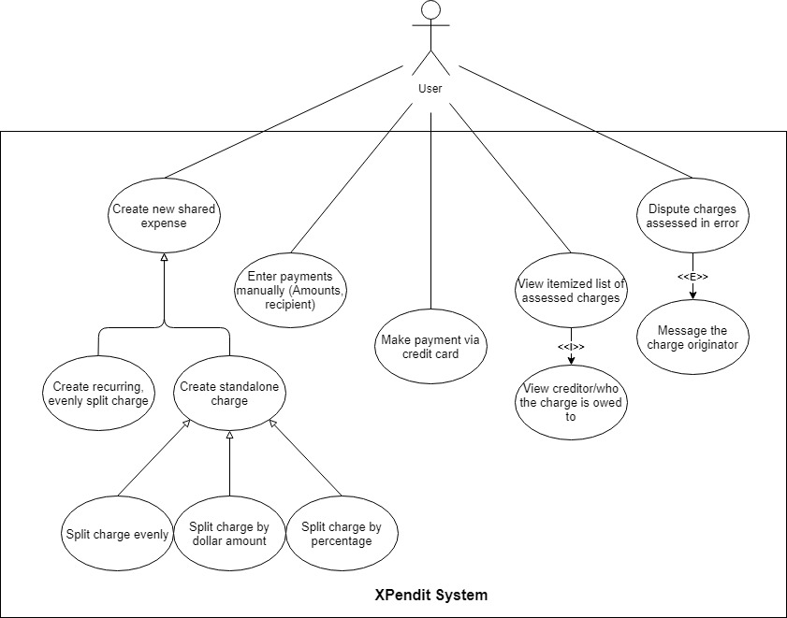

**Use Case:** Create new shared expense

**User Story IDs Addressed:** 001, 003

**Related Use Cases:** Generalizes “Create recurring, evenly split charge”; “Create standalone charge”

**Steps:**

|  |  |
| --- | --- |
| Pre-Conditions: Assumes the user has logged into the app, is viewing the group of interest, and has incurred an expense that needs to be shared with the group. | |
| Actor actions (User) | System response |
| 1. Select “Create new charge” | 2. Dialogue box appears |
| 3. Input charge details  Alternative: “Create recurring, evenly split charge”  Alternative: “Create standalone charge” |  |
| 4. Select “Confirm” or enter | 5. Dialogue box disappears |
| Post-Conditions: All included group members may see the new charge on their account. | |

**Use Case:** Create recurring, evenly split charge

**User Story IDs Addressed:** 001, 002, 003

**Related Use Cases:** Generalization of “Create new shared expense”

**Steps:**

|  |  |
| --- | --- |
| Pre-Conditions: Assumes there is a recurring charge that group members will be responsible for on a regular basis. | |
| Actor actions (User) | System response |
| 1. Select “Create new charge” | 2. Dialogue box appears |
| 3. Input charge details  a. Select “Recurring Charge”; describe it  b. Select interval  c. Select group members to be charged  d. Enter total amount of bill |  |
| 4. Select “Confirm” or enter | 5. Dialogue box disappears |
| Post-Conditions: Each included group member will be assessed the same charge on the selected interval. | |

**Use Case:** Create standalone charge

**User Story IDs Addressed:** 001, 004

**Related Use Cases:** Generalization of “Create new shared expense”; generalizes “Split charge evenly”, “Split charge by dollar amount”, “Split charge by percentage”

**Steps:**

|  |  |
| --- | --- |
| Pre-Conditions: Assumes the user wishes to split a single charge incurred with group members. | |
| Actor actions (User) | System response |
| 1. Select “Create new charge” | 2. Dialogue box appears |
| 3. Input charge details  a. Select “One-time Charge”; describe it  b. Select group members to be charged  c. Enter total amount of bill | 4. Display three choices for how the bill should be split: “Charge Evenly”, “Charge by Dollar Amount”, “Charge by Percentage” |
| 5. Three choices:  Default path: Use case “Split charge evenly”  Alternative: Use case “Split by dollar amount”  Alternative: Use case “Split charge by percentage” | 6. Assess charges |
| 7. Select “Confirm” or enter | 8. Dialogue box disappears |
| Post-Conditions: Each included group member will be assessed the chosen amount. | |

**Use Case:** Split charge evenly

**User Story IDs Addressed:** 001, 004

**Related Use Cases:** Generalization of “Create standalone charge”

**Steps:**

|  |  |
| --- | --- |
| Pre-Conditions: Assumes that the user is creating a standalone charge, and wishes it to be split evenly among all included group members. | |
| Actor actions (User) | System response |
| 1. Select “Create new charge” | 2. Dialogue box appears |
| 3. Input charge details  a. Select “One-time Charge”; describe it  b. Select group members to be charged  c. Enter total amount of bill | 4. Display three choices for how the bill should be split: “Charge Evenly”, “Charge by Dollar Amount”, “Charge by Percentage” |
| 5. Select “Charge Evenly” | 6. Assess charges |
| 7. Select “Confirm” or enter | 8. Dialogue box disappears |
| Post-Conditions: Each included group member is assessed the same charge within a penny (to account for amounts that aren’t exactly divisible). | |

**Use Case:** Split charge by dollar amount

**User Story IDs Addressed:** 001, 004

**Related Use Cases:** Generalization of “Create standalone charge”

**Steps:**

|  |  |
| --- | --- |
| Pre-Conditions: Assumes the user is creating a standalone charge, and wishes to assess a specific dollar amount to each individual involved. | |
| Actor actions (User) | System response |
| 1. Select “Create new charge” | 2. Dialogue box appears |
| 3. Input charge details  a. Select “One-time Charge”; describe it  b. Select group members to be charged  c. Enter total amount of bill | 4. Display three choices for how the bill should be split: “Charge Evenly”, “Charge by Dollar Amount”, “Charge by Percentage” |
| 5. a. Select “Charge by Dollar Amount”  b. Input dollar amounts to be assessed | 6. Assess charges |
| 7. Select “Confirm” or enter | 8. Dialogue box disappears |
| Post-Conditions: User retains responsibility for any part of the charge not divided among other group members. Each included group member is assessed their respective charge. | |

**Use Case:** Split by percentage

**User Story IDs Addressed:** 001, 004

**Related Use Cases:** Generalization of “Create standalone charge”

**Steps:**

|  |  |
| --- | --- |
| Pre-Conditions: Assumes the user is creating a standalone charge, and wishes to assess a specific percentage of the bill to involved group members. | |
| Actor actions (User) | System response |
| 1. Select “Create new charge” | 2. Dialogue box appears |
| 3. Input charge details  a. Select “One-time Charge”; describe it  b. Select group members to be charged  c. Enter total amount of bill | 4. Display three choices for how the bill should be split: “Charge Evenly”, “Charge by Dollar Amount”, “Charge by Percentage” |
| 5. a. Select “Charge by Percentage”  b. Input percentages to be assessed | 6. Assess charges |
| 7. Select “Confirm” or enter | 8. Dialogue box disappears |
| Post-Conditions: User retains responsibility for any percentage of the charge not assessed to other group members. Each included group member is assessed their respective charge. | |

**Use Case:** Enter Payments Manually (Amount, Recipient)

**User Story IDs Addressed:** 006, 007

**Related Use Cases:** N/A

**Steps:**

|  |  |
| --- | --- |
| Pre-Conditions: Assumes the user has logged into the app, is viewing the group of interest, and has made a payment to another group member for a portion of their outstanding debt. | |
| Actor actions (User) | System response |
| 1. Select “Enter Payment” | 2. Display dialogue box |
| 3. Select group member that was paid; enter | 4. Ask for payment amount |
| 5. Enter dollar amount paid | 6. Dialogue box disappears |
| Post-Conditions: The input dollar amount is subtracted from total debt and debt owed to selected user. The payment recipient is notified that they have received a payment, and their credit to the individual is reduced by the paid amount. | |

**Use Case:** Make payment via credit card

**User Story IDs Addressed:** 006, 007

**Related Use Cases:** N/A

**Steps:**

|  |  |
| --- | --- |
| Pre-Conditions: Assumes the user has logged into the app, is viewing the group of interest, and wishes to make an electronic payment to a user. | |
| Actor actions (User) | System response |
| 1. Select “Enter Payment” | 2. Display dialogue box |
| 3. Select group member to be paid | 4. Display text boxes |
| 5. Enter credit card information | 6. Dialogue box disappears |
| Post-Conditions: The input dollar amount is subtracted from total debt and debt owed to recipient. The user’s credit card is charged their selected amount, and the money is credited to the recipient’s account of choice. | |

**Use Case:** View itemized list of assessed charges

**User Story IDs Addressed:** 003, 005

**Related Use Cases:** Includes “View creditor/who the charge is owed to”

**Steps:**

|  |  |
| --- | --- |
| **Pre-Conditions: User is logged in and has selected to look at monthly charges** | |
| Actor actions (User) | System response |
| 1. User selects “History” | 2. Displays the charges |
| 2. User views charges and initiator  (via Include: View creditor/who the charge is owed to”) |  |
| 3. User exits dialog | 4. Return to previous menu |
| **Post-Conditions: N/A** | |

**Use Case:** View Creditor/who the charge is owed to

**User Story IDs Addressed:** 003, 005

**Related Use Cases:** Included in “View itemized list of assessed charges”

**Steps:**

|  |  |
| --- | --- |
| Pre-Conditions: Assumes the user has logged into the app, is viewing the group of interest, and wishes to see the specifics of a particular charge assessed. | |
| Actor actions (User) | System response |
| 1. Select “History” | 2. Display list of charges in reverse chronological order, including description of charge, charge amount. |
| 3. Select individual charge from list | 4. Display all individual details, including:  Person assessing charge;  Date of charge;  Description of charge;  Charge amount. |
| Post-Conditions: N/A | |

**Use Case:** Dispute charges assessed in error

**User Story IDs Addressed:** 008

**Related Use Cases:** Extends to “Message the charge originator”

**Steps:**

|  |  |
| --- | --- |
| Pre-Conditions: Assumes the user has logged into the app, is viewing the group of interest, and wishes to dispute a charge they were wrongly assessed by a group member. | |
| Actor actions (User) | System response |
| 1. Select “History” | 2. Display list of charges in reverse chronological order. |
| 3. Select individual charge from list | 4. Display all individual details. |
| 5. Select “Dispute This Charge”  Optional: “Message the charge originator” | 6. Mark charge as “Pending Dispute” |
| Post-Conditions: Charge originator is notified that their charge is not accepted by the recipient. | |

**Use Case:** Message the charge originator

**User Story IDs Addressed:** 008

**Related Use Cases:** Extends “Dispute charges assessed in error”

**Steps:**

|  |  |
| --- | --- |
| Pre-Conditions: Assumes the user has logged into the app, is viewing the group of interest, and wishes to contact a group member explaining why they disputed a charge. | |
| Actor actions (User) | System response |
| 1. Select “History” | 2. Display list of charges in reverse chronological order. |
| 3. Select individual charge from list | 4. Display all individual details. |
| 5. Select “Dispute This Charge” | 6. Mark charge as “Pending Dispute” |
| 7. Select “Message Originator” | 8. Display text box |
| 9. Type message; enter | 10. Text box disappears |
| Post-Conditions: Charge originator receives message from the group member disputing a charge. | |