Matplotlib-Challenge Observations on Homework

Observation 1: CAPOMULIN seems to be the only treatment effective in combating tumor growth.

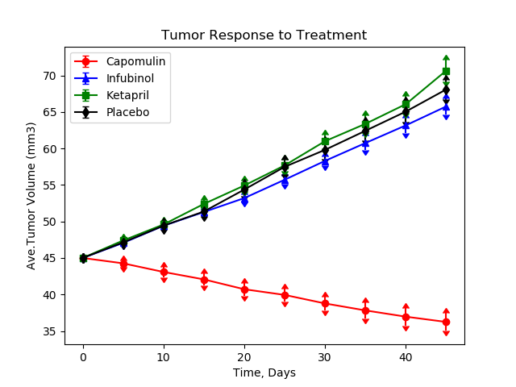

Observation 2: CAPOMULIN is most effective treatment in slowing down metastasis spread on mice (Placebo is worst).

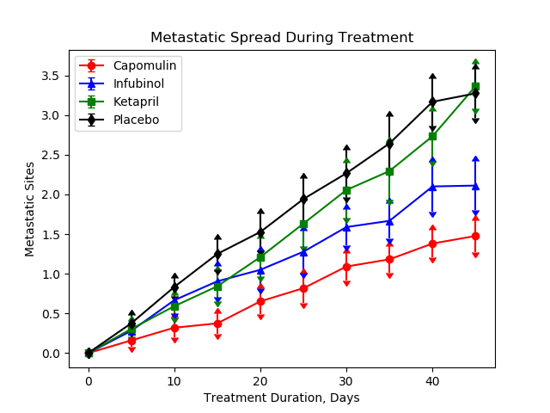

Observation 3: CAPOMULIN shows better than 80% survival rate after 40 days when used to treat tumors on mice.

