# RingsMatter Site Plan

## Connor Sanderson

## WDD 130

## Overview

### Purpose

At RingsMatter we are dedicated to helping others discover the deep significance that rings can hold. Rings come in many different styles and sizes, and we believe that there is a ring out there for everyone!

### Audience

Whether you are looking for a wedding band, more style, or just interested in changing up your look, RingsMatter is the perfect site for you!

## Branding

### Website Logo

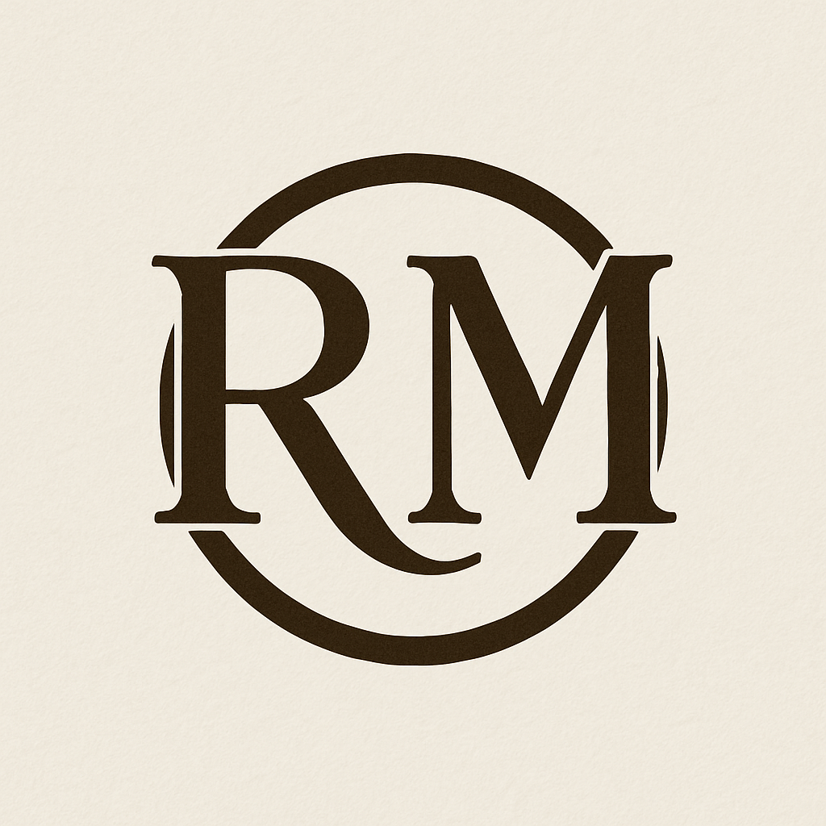

## Style Guide

### Color Palette

|  |  |  |  |
| --- | --- | --- | --- |
| **Primary** | **Secondary** | **Accent 1** | **Accent 2** |
| #32230F | #EEE8DC | #9B287B | #429EA6 |

### Typography

#### Heading Font: Aclonica

#### Paragraph Font: Archivo Narrow

### Navigation

Home Page2 Page3

**Content**

**Home**

RingsMatter is dedicated to exploring the cultural, emotional, and personal significance of rings. More than just fashion accessories, rings have the potential to tell stories which vary from person to person, unique in their own ways. Our site dives into the symbolism behind different ring styles, and how wearing rings can express confidence, commitment, or creativity. Whether you’re curious about wedding bands, signet rings, or modern minimalist styles, RingsMatter shows you why this small accessory carries big meaning. Discover how a simple circle can say everything.

Stories: Like we stated above, rings have the potential to tell an infinite number of unique stories. Two of the same rings can tell two different stories for two different people. That’s what makes them so special. They are applicable to everyone bar none.

Love: Should you be looking for or have already found your significant other, then a wedding band would be perfect for you. From diamonds to sapphire, there are many ways to show your devotion to the one you love through even the simplest of rings. Each wedding band carries with it deep sentiment and the stones we choose to adore them with are just one more lasting testimony to this devotion.

Achievement: All of us have achievements which are very dear to us. Whether it be winning a state championship, learning to play an instrument or doing something you never thought possible. What better way to remember this even than through a ring. Thanks to the variety that they come in you can get it fitted to any need that you may have to represent your achievement.

Identity: Once again, thanks to the variety of rings that exist they are a perfect way to express and explore your identity. Whether you want an extravagant band, or something simple and easy to miss, there is still a ring for your needs. If you’re looking to express your love of nature, or animals or even music, there are rings to help express all these things.

Tradition: Finally, there is tradition. This could easily be one of the largest factors when deciding on a ring to fit your personal needs and interests. Rings are perfect for displaying a mantra to help you remember a purpose. Or maybe they play a part of your culture. Either way it serves as a great reminder not only to you but also to those close to you.

Rings come in all types of materials from steel to wood and even silicone!

To help all of you find the perfect rings all you have to do is answer a few questions! Just follow the link below to find the simple circle that’ll say exactly what you need it to.

**About Us – page 2**

Rings have always played a large role in our lives. Although to some, they can appear insignificant we promise that for us this is not the case. They have always proven such a special part of our lives. From a reminder of how far we’ve come to the simple mantras that keep us pushing forward every day. We have made it our mission to help others find the joy that these simple circles can bring into your lives as they have brought into ours. There are countless stories that need to be told. Rings are the perfect way to tell these stories without having to carry around large keepsakes. We have all found the rings that are perfect for us and the stories we have, and we know there are more out there to discover.

**Where to Begin – page 3**

We know at times it can be difficult to know where to start. With so many options and with so much freedom to choose it can be difficult to know which ring you should buy. There are a lot of factors to consider. You may think that maybe you might not even like wearing a ring. Luckily for you we’ve considered this! The special thing about rings is that they come in all sorts of different materials. You can go in a more traditional type of metal ring, like tungsten or gold. Or you can have one made from wood or even silicone. To help you out even further in selecting a ring we have put together a questionnaire to give you the start you could be looking for! Just answer these quick questions and you’ll have all the information you need to get yourself the perfect storyteller.

**Wireframes**

### Home

Pages 2 & 3

