**Java Server Page (JSP)**

Java Server Page (JSP) is a technology for developing Webpages that supports dynamic content. This helps developers insert java code in HTML pages by making use of special JSP tags, most of which start with <% and end with %>.

A JSP component is a type of Java servlet that is designed to fulfil the role of a user interface for a Java web application. Web developers write JSPs as text files that combine HTML or XHTML code, XML elements, and embedded JSP actions and commands.

Using JSP, you can collect input from users through Webpage forms, present records from a database or another source, and create Webpages dynamically.

JSP tags can be used for a variety of purposes, such as retrieving information from a database or registering user preferences, accessing JavaBeans components, passing control between pages, and sharing information between requests, pages etc.

**Functionalities** of this system:

1. Admin login.

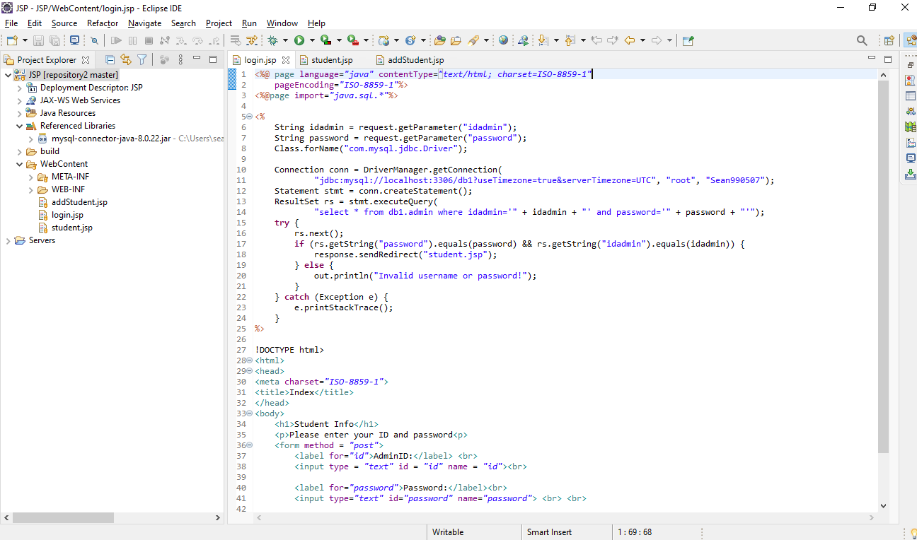

1. View student info.

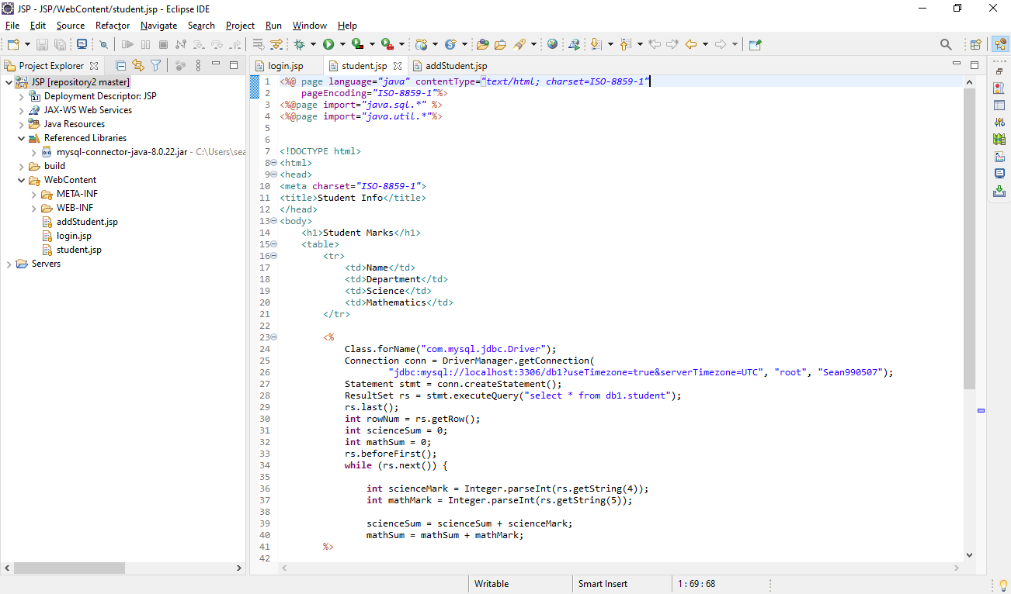

1. Add new student.

