A

Project Report on

“-------------------------------“

At


GIDC RAJJU SROFF ROFEL INSTITUTE OF MANAGEMENT OF STUDIES (BBA) &
ROFEL SHRI G.M BILAKHIA COLLEGE OF APPLIED SCIENCES (BCA), VAPI
[ISO 9001:2015, 29990-2010 Certified College]


Affiliated to
Veer Narmad South Gujarat University, Surat

As a partial fulfilment

For the degree of

Bachelor of Computer Application

(B. C. A.)
2022-2023

Guided By: Submitted By:

------------------- -----------------------

Acknowledgement

We take this opportunity to thank all those who have contributed their support in preparing this seminar. Firstly, we would like to express our deep sense of gratitude towards ROFEL BBA and BCA College, Vapi.
Providing us this opportunity to implement our skills in making Presentations/Project on a topic in our sixth semester course curriculum.
I would not miss the opportunity to thank my guide ----------------------- who has always been providing continuous guidance & support and always been a stepping stone in completing this seminar.
I am also very thankful to Principal Dr. P.H.Ved of our college for their keen interest and for providing all facilities in our project work.
Last but not least, we are also grateful to our parents and friends whose continuous support has always boosted our moral towards working on this seminar.

INDEX
Sr No. | Particulars |  | Page No.
1. | Introduction |  | 05
 | 1.1 | Project profile | 06
2. | Development Environment
 | 2.1 | Development Tools (S/W & H/W Specification) | 07
 | 2.2 | Development Strategy (Process Model) | 24
3. | System Analysis
 | 3.1 | Requirement Gathering & Analysis | 30
 | 3.2 | Scope of the System | 32
4. | Software Requirement specification
 | 4.1 | E-R Diagram | 34
 | 4.2 | System Flow Diagram | 35
 | 4.3 | Data Flow Diagram | 38
 | 4.4 | Process Specification | 40
 | 4.5 | Data Dictionary | 43
5. | Testing |  | 48
6. | User Interface |  | 62
7. | Bibliography/ Webography

Introduction:
The primary use of a chat room is to share information via text with a group of other users.
Generally speaking, the ability to converse with multiple people in the same conversation differentiates chat rooms from instant messaging programs, which are more typically designed for one-to-one communication.
The users in a particular chat room are generally connected via a shared internet or other similar connection, and chat rooms exist catering for a wide range of subjects.

To Join The Chatting Room:
To join a chat room, First you'll need to Sign up with a nickname OR you can use your existing username, Email, Password and Image or you can sign up with an alternate username. Second to enter in chatting room after sign up Login with your Email and Password to come In chatting room.

Security:
One feature that's been around since the earliest chat rooms is the ability to send a private message to an individual user that can't be seen by the whole group.
Second feature that’s Once you sign up with your username No one can use your name to sign up or login.

OBJECTIVES:
The main objective of the Online Chat Application is to manage the details of Chat Application, Online Chat, Smiles Chat Users, Chat History. It manages all the information about Chat Application, Chat Profile, Chat History, Chat Application. The purpose of the project is to build an application program to reduce the manual work for managing the Chat Application, Online Chat, Chat Profile, Smiles Chat. It tracks all the details about the Smiles Chat, Users, Chat History.
Group Members: | Name: Shubham Kumar Yadav  Seat no: 350  Class: TYBCA
Project Title: | Online Chatting Application.
College Guide Name: | Prof. Tanvi Rana.
Hardware Configuration: | PROCESSOR: AMD Ryzen 5 CPU  Radeon Graphics.  HARD DISK: 255GB SSD ITB HDD.  RAM: 8GB.
Software Configuration: | Android Studio (Electric Eel 2022.1.1).  Microsoft Edge.
Operating System: | Windows 11.
Platform: | - Android Studio (Electric Eel | 2022.1.1) .  - Figma.  - Firebase.  - XAMPP Server.
Project Technology: | Kotlin and PHP.
Front End: | Android Studio, XML and Figma.  Html, CSS, JavaScript and Bootstrap.
Back End: | Firebase.
1.1 project profile

DEVELOPMENT ENVIORMENT

DEVLOPMENT TOOLS

HARDWARE SPECIFICATION: -

PROCESSOR: AMD RYZEN5.

DISK: 255gb SSD and 1TB HDD.
RAM: 8GB.

SOFTWARE SPECIFICATION: -

OPERATING SYSTEM: Windows 11.
FRONT-END: Android Studio, XML, Figma, HTML, CSS, JavaScript and Bootstrap.

BACK-END: Firebase.
HELP TOOL: Android Studio, Figma, Visual Studio, Code, XAMPP Server and Firebase.

PROGRAMMING LANGAUGE

- Kotlin:

Kotlin is a modern, trending programming language.
Kotlin is easy to learn, especially if you already know Java (it is 100% compatible with Java).
Kotlin is used to develop Android apps, server side apps, and much more.



What is Kotlin?
Kotlin is a modern, trending programming language that was released in 2016 by JetBrains.
It has become very popular since it is compatible with Java (one of the most popular programming languages out there), which means that Java code (and libraries) can be used in Kotlin programs.
Kotlin is used for:
- Mobile applications (specially Android apps)
- Web development
- Server side applications
- Data science
- And much, much more!

Why Use Kotlin?
Kotlin is designed to run on a Java Virtual Machine and can run side by side with Java. Although Kotlin first started as a language for Android development specifically, it quickly spread through the Java community because of its features and has since been used for many types of applications.
- Kotlin is fully compatible with Java
- Kotlin works on different platforms (Windows, Mac, Linux, Raspberry Pi, etc.)
- Kotlin is concise and safe
- Kotlin is easy to learn, especially if you already know Java
- Kotlin is free to use
- Big community/support.

What are the advantages of Kotlin?

Kotlin’s creation arose after Lead Developer Dmitry Jemerov sought features he couldn’t find in Java. Scala, another language that runs on the Java Virtual Machine (JVM), was close to what he wanted, but it took too long to compile.
- Kotlin is concise, saving time that you’d otherwise spend writing boilerplate code in Java.
- You can convert a Java file into a Kotlin file with just a script.
- Kotlin has no runtime overhead. Sometimes, adding features to a language means it has more overhead, which lowers its performance. Not so with Kotlin.
- Kotlin streamlines asynchronous programming. Making network and database calls asynchronously in Java is clumsy and painful. Kotlin has coroutines that make asynchronous programming simple and efficient.
- Kotlin handles nulls. A null in Java can crash a program if you haven’t prepared for it. In Kotlin, you can add a simple operator to variables that may be null to prevent these crashes.
- Kotlin can run on multiple platforms. Kotlin can run anywhere Java runs, so you can use it to build cross-platform apps.
- It’s easy to switch to Kotlin. Kotlin is fully compatible with Java, so you don’t have to change all your code at once. You can slowly migrate an application to use Kotlin.

- Firebase:
Firebase is a set of backend cloud computing services and application development platforms provided by Google. It hosts databases, services, authentication, and integration for a variety of applications, including Android, iOS, JavaScript, Node.js, Java, Unity, PHP, and C++.


What is Firebase?

Firebase is a Backend-as-a-Service (BaaS) which started as a YC11 startup. It grew up into a next-generation app-development platform on Google Cloud Platform. Firebase (a NoSQL JSON database) is a real-time database that allows storing a list of objects in the form of a tree. We can synchronize data between different devices.

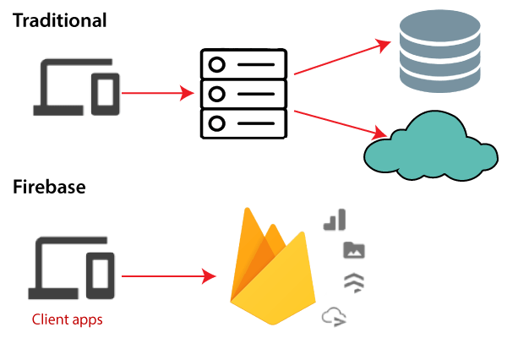

Why use Firebase?

- Firebase manages real-time data in the database. So, it easily and quickly exchanges the data to and from the database. Hence, for developing mobile apps such as live streaming, chat messaging, etc., we can use Firebase.
- Firebase allows syncing real-time data across all devices - iOS, Android, and Web - without refreshing the screen.
- Firebase provides integration to Google Advertising, Ad Mob, Data Studio, Big Query DoubleClick, Play Store, and Slack to develop our apps with efficient and accurate management and maintenance.
- Everything from databases, analytics to crash reports are included in Firebase. So, the app development team can stay focused on improving the user experience.
- Firebase applications can be deployed over a secured connection to the firebase server.
- Firebase offers a simple control dashboard.
- It offers a number of useful services to choose from.

Advantage and Disadvantages of Firebase

Advantage:
- Firebase is a real-time database.
- It has massive storage size potential.
- Firebase is serverless.
- It is highly secure.
- It is the most advanced hosted BaaS solution.
- It has minimal setup.
- It provides three-way data binding via angular fire.
- It provides simple serialization of app state.
- We can easily access data, files, auth, and more.
- There is no server infrastructure required to power apps with data.
- It has JSON storage, which means no barrier between data and objects.

Disadvantages:
- Firebase is not widely used, or battle-tested for enterprises.
- It has very limited querying and indexing.
- It provides no aggregation.
- It has no map-reduce functionality.
- It cannot query or list users or stored files.

Android Studio:

Android Studio is the official Integrated Development Environment (IDE) for android application development. Android Studio provides more features that enhance our productivity while building Android apps.
Android Studio was announced on 16th May 2013 at the Google I/O conference as an official IDE for Android app development. It started its early access preview from version 0.1 in May 2013. The first stable built version was released in December 2014, starts from version 1.0.
Since 7th May 2019, Kotlin is Google's preferred language for Android application development. Besides this, other programming languages are supported by Android Studio.


What is Android?

Android is a software package and Linux based operating system for mobile devices such as tablet computers and smartphones.
It is developed by Google and later the OHA (Open Handset Alliance). Java language is mainly used to write the android code even though other languages can be used.
The goal of android project is to create a successful real-world product that improves the mobile experience for end users.
There are many code names of android such as Lollipop, Kitkat, Jelly Bean, Ice cream Sandwich, Froyo, Ecliar, Donut etc which is covered in next page.

Features of Android:
After learning what is android, let's see the features of android. The important features of android are given below:
1) It is open-source.
2) Anyone can customize the Android Platform.
3) There are a lot of mobile applications that can be chosen by the consumer.
4) It provides many interesting features like weather details, opening screen, live RSS (Really Simple Syndication) feeds etc.

Categories of Android applications:
- There are many android applications in the market. The top categories are:
- Entertainment
- Tools
- Communication
- Productivity
- Personalization
- Music and Audio
- Social
- Media and Video
- Travel and Local etc.

- PHP:
PHP is platform independent application made it can be run on way operation system such as windows8, XP, UNIX.
What is PHP?
PHP is widely used general purpose scripting language that is especially suited for web development and can be embedded into HTML.
    - PHP Stands for PHP: Hypertext Pre-processor
    - PHP is a server-side scripting language, like ASP
    - PHP scripts are executed on the server
    - PHP supports many databases (MySQL, Informix, Oracle, Sybase, solid, PostgreSQL, Generic ODBC, etc.)

PHP is an open source software

PHP is free to download and use

What is PHP File?
    - PHP files can contain text, HTML tags and scripts
    - PHP files are returned to the browser as plain HTML
    - PHP files have a file extension of “.php”,”.php3”, or “.phtml”.

Why PHP?
- PHP runs on different platform (Windows, Linux, Unix, etc.)
- PHP is compatible with almost all servers used today (Apache, IIs, etc.)

PHP is free to download from the official PHP resource: www.php.net PHP is easy to learn and runs efficiently on the server side.

XAMPP
Introduction to XAMP
XAMPP is a cross-platform web server that is free and open-source. XAMPP is a short form for Cross-Platform, Apache, MySQL, PHP, and Perl.

- XAMPP is a popular cross-platform web server that allows programmers to write and test their code on a local webserver.
- It was created by Apache Friends, and the public can revise or modify its native source code.
- It includes Maria DB, Apache HTTP Server, and interpreters for PHP and Perl, among other computer languages. Because of XAMPP’s simplicity of deployment, a developer can quickly and easily install a WAMP or LAMP stack on an operating system, with the added benefit that common add-in apps like WordPress and Joomla can also be loaded.

Need for XAMPP

- XAMPP is simply a local host or server.

- This local server runs on your personal computer, whether it’s a desktop or a laptop.
- It is used to test clients or websites before publishing them to a remote web server.
- On a local computer, the XAMPP server software provides a suitable environment for testing MYSQL, PHP, Apache, and Perl projects. Because most real-world web server deployments share the same components as XAMPP, moving from a local test server to a live server is straightforward.

ADVANTAGES AND DISADVANTAGES OF XAMPP

ADVANTAGE:

- In comparison to other web servers such as WAMP, it is simple to set up.
- It is Multi Cross-Platform, which implies it works on both Windows and Linux.
- With a single command, you may start and stop the entire web server and database stack.
- Both a full and a standard version of XAMPP are available.
- It has a control panel that you can see contains start and stop buttons for specific mechanisms, such as Apache, which is running through its Control Panel.
- It also includes OpenSSL, phpMyAdmin, Media Wiki, Joomla, WordPress, and a lot of additional modules.

DISADVANTAGES:
    - In comparison to the WAMP server, configuration and setting are more difficult.

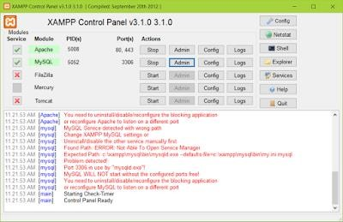
    - PHP MY ADMIN

What is PHP My Admin?
- PHP My Admin is a free software tool written in PHP, intended to handle the administration of MySQL over the worldwide web.
- PHP my admin supports a wide range of operations with MySQL. The most frequently used operations are supported by the user interface (managing database, tables, fields, relation indexes, users, permission etc.)
- While you still have the ability to directly execute any SQL statement.

History
- Tobias Rat schiller, then an IT consultant and later founder of the software company Maguma, started to work on a PHP-based web front-end to MySQL in 1998, inspired by MySQL Web admin. He gave up the project (and php Ads New, of which he was also the original author) in 2000 because of lack of time.

- By that time, phpMyAdmin had already become one of the most popular PHP applications and MySQL administration tools, with a large community of users and contributors. In order to coordinate the growing number of patches, a group of three developers registered the phpMyAdmin Project at Source Forge and took over the development in 2001.
- In July 2015, the main website and the downloads left Source Forge and moved to a content delivery network. At the same time, the releases began to be PGP-signed. Afterwards, issue tracking moved to GitHub and the mailing lists migrated. Before version 4, which uses ajax extensively to enhance usability, the software used HTML frames.

Features:

- Web interface
- MySQL and MariaDB database management
- Import data from CSV and SQL
- Export data to various formats: CSV,SQL,XML,PDF(via the TCPDF library), ISO/IEC 26300 - OpenDocument Text and Spreadsheet, Word, Excel, LaTeX and others
- Administering multiple servers
- Creating PDF graphics of the database layout
- Creating complex queries using query-by-example (QBE)
- Searching globally in a database or a subset of it
- Transforming stored data into any format using a set of predefined functions, like displaying BLOB-data as image or download-link.
- Live charts to monitor MySQL server activity like connections, processes, CPU/memory usage, etc.

JavaScript:

JavaScript is a dynamic computer programming language. It is lightweight and most commonly used as a part of web pages, whose implementations allow client-side script to interact with the user and make dynamic pages. It is an interpreted programming language with object-oriented capabilities.

JavaScript was first known as Live Script, but Netscape changed its name to JavaScript, possibly because of the excitement being generated by Java. JavaScript made its first appearance in Netscape 2.0 in 1995 with the name Live Script. The general-purpose core of the language has been embedded in

Netscape, Internet Explorer, and other web browsers.

The ECMA-262 Specification defined a standard version of the core JavaScript language.

- JavaScript is a lightweight, interpreted programming language.
- Designed for creating network-centric applications.
- Complementary to and integrated with Java.
- Complementary to and integrated with HTML.
- Open and cross-platform

Bootstrap:
Why Use Bootstrap?
  - Mobile first approach − Bootstrap 3, framework consists of Mobile first styles throughout the entire library instead them of in separate files
  - Browser Support − It is supported by all popular browsers.

  - Easy to get started − With just the knowledge of HTML and CSS anyone can get started with Bootstrap. Also the Bootstrap official site has a good documentation.
  - Responsive design − Bootstrap's responsive CSS adjusts to Desktops, Tablets and Mobiles.

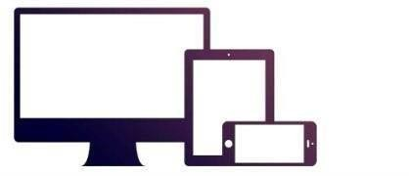
  - Provides a clean and uniform solution for building an interface for developers.
  - It contains beautiful and functional built-in components which are easy to customize.
  - It also provides web based customization.
  - And best of all it is an open source.

Visual Studio Code:

Visual Studio Code is a source-code editor that can be used with a variety of programming languages, including Java, JavaScript, Go, Node.js, Python and C++.
It is based on the Electron framework, which is used to develop Node.js Web applications that run on the Blink layout engine.
Visual Studio Code employs the same editor component (codenamed "Monaco") used in Azure DevOps (formerly called Visual Studio Online and Visual Studio Team Services).

Out of the box, Visual Studio Code includes basic support for most common programming languages. This basic support includes syntax highlighting, bracket matching, code folding, and configurable snippets.
Visual Studio Code also ships with IntelliSense for JavaScript, TypeScript, JSON, CSS,
and HTML, as well as debugging support for Node.js. Support for additional languages can be provided by freely available extensions on the VS Code Marketplace.



Instead of a project system, it allows users to open one or more directories, which can then be
saved in workspaces for future reuse. This allows it to operate as a language-agnostic code editor for any language. It supports many programming languages and a set of features that differs per language.

Unwanted files and folders can be excluded from the project tree via the settings. Many Visual Studio Code features are not exposed through menus or the user interface but can be accessed via the command palette

Here are 5 great reasons why you might want to use Visual Studio Code:

Not Quite a Full IDE, But…

Compared to Gedit, or virtually any editor I’ve used on Linux, VS Code is probably one of the best editors around. If you love VIM, the name “Microsoft” may stick in your craw—but never fear, you can still configure VS Code to be VIM-like via extensions. The editor includes 14
themes, plus there are lots more in the marketplace. It’s highly customizable.

Extensions

This is beyond a doubt the most useful feature. There’s a comprehensive list of extensions available for VS Code in the online marketplace, which has existed since mid-2015.
Installing extensions is as easy as clicking one button. You can manage them easily, including updating and disabling. It’s all very slick and works flawlessly, and the website shows how you can create your own extensions and publish them to the marketplace.

Debugging?

While VS Code isn’t quite a full IDE, you can install and run debuggers (it even comes with one for JavaScript). The marketplace includes 68 free debuggers, including C/C++, Java, PHP, Python, Ruby, C#, Go, Lua, Haxe, Android and others.

Develop for Unity

Unity is the 2D/3D game engine and framework that you can program in C# for free (or with a commercial license). This Article on Microsoft’s website covers developing your first game (though it predates VS Code).

The C# extension includes code colorization, bracket matching, IntelliSense, CodeLens and more. Add in the Unity configuration and you can use it for creating games, but it doesn’t include any tools for image editing.

Highly Configurable

VS Code can be configured with themes, snippets and language support. The list of user and Workspace settings is very comprehensive and contained in a file settings.json. From the quick links menu on the right of the welcome screen, you can go straight to editing it. On the left is the full list of (currently) 294 settings in a read-only file. You just copy the ones you want onto the right, change them, and save the file.

Development strategy

Software Evolution

Over time, software systems, programs as well as applications, continue to develop. These changes will require new laws and theories to be created and justified. Some models as well would require additional aspects in developing future programs. Innovations and improvements do increase unexpected form of software development. The maintenance issues also would probably change as to adapt to the evolution of the future software.
Software process and development are an ongoing experience that has a never-ending cycle. After going through learning and refinements, it is always an arguable issue when it comes to matter of efficiency and effectiveness of the programs

Activates:
System Initiation/Planning: where do systems come from? In most situations, new feasible systems replace or supplement existing information processing mechanisms whether they were previously automated, manual, or informal.

Requirement Analysis and Specification: identifies the problems a new software system is suppose to solve, its operational capabilities, its desired performance characteristics, and the resource infrastructure needed to support system operation and maintenance.

Functional Specification or Prototyping: identifies and potentially formalizes the objects of computation, their attributes and relationships, the operations that transform these objects, the constraints that restrict system behavior, and so forth.

Partition and Selection (Build vs. Buy vs. Reuse): given requirements and functional specifications, divide the system into manageable pieces that denote logical subsystems, then determine whether new, existing, or reusable software systems correspond to the needed pieces.

Architectural Design and Configuration Specification: defines the interconnection and resource interfaces between system subsystems, components, and modules in ways suitable for their detailed design and overall configuration management.

Detailed Component Design Specification: defines the procedural methods through which the data resources within the modules of a component are transformed from required inputs into provided outputs.
Component Implementation and Debugging: codifies the preceding specifications into operational source code implementations and validates their basic operation.

Software Integration and Testing: affirms and sustains the overall integrity of the software system architectural configuration through verifying the consistency and completeness of implemented modules, verifying the resource interfaces and interconnections against their specifications, and validating the performance of the system and subsystems against their requirements.

NORMALIZATION

Normalization is a step by step process for designing relations and relationships. Normalization reduces redundancy using the principle of non-less decomposition is the reduction of the table to smaller table without any loss of information. This enable manipulation of the database in a powerful way, minimizes data anomalies and inconsistencies, improves data independence and helps to create flexible design. A fully normalized record consist of:
A primary key that identifies that entity.
A set attribute that describes that entity.
Normal form:
Normalization result in the formation of tables that satisfy certain specified constraints, and represent certain normal forms.
Several normal forms have been identified, the most important and widely used of this are:
First normal form(1 NF)
Second normal form(2 NF)
Third normal form(3 NF)
Boycee code normal form(BCNF)

Functional dependency

Given that A and B be composite attributes and R is a relation. Attribute A is functionally dependent on B, If each value of A in R is associate with precisely one value of B.

First normal form

This is the lowest level of normalization. It states that data is in first normal form, if the pool of valid values that may appear in attributes contains only atomic values.(atomic values can not be decomposed into smaller unit).each contains only one value in any row of a table.
Second normal form

Data is in second normal form if it is in 1NF and every attribute in the record is functionally depend upon the whole key and not a just a part of the key.(N attribute is a non key if it is not part of the primary key). The purpose of 2NF is to eliminate repeating groups of N to ensure that the remaining attributes belong to this entity. N attribute is functionally parallel depends on a key, if the attribute contains only one value which depends on the key.

Third normal form
Data is in third normal form and only if it is in 2NF and every non key attribute is non transitivity depend on the primary key. The purpose of 3NF is to ensure that the attributes directly to the entity.

Other normal form
The other normal form boycee code normal form (BCNF), 4th normal form and 5th normal form. They are seldom used.
Incremental model:
What is Incremental Model?
Incremental Model is a process of software development where requrements are broken down into multiple standalone modules of software development cycle.
The incremental build model is a method of software development where the product is designed, implemented and tested incrementally (a little more is added each time) until the product is finished. It involves both development and maintenance. The product is defined as finished when it satisfies all of its requirements. This model combines the elements of the waterfall model with the iterative philosophy of prototyping.
The product is decomposed into a number of components, each of which is designed and built separately (termed as builds). Each component is delivered to the client when it is complete. This allows partial utilization of the product and avoids a long development time. It also avoids a large initial capital outlay and subsequent long waiting period. This model of development also helps ease the traumatic effect of introducing a completely new system all at once.
The incremental model applies the waterfall model incrementally.
The series of releases is referred to as “increments”, with each increment providing more functionality to the customers. After the first increment, a core product is delivered, which can already be used by the customer. Based on customer feedback, a plan is developed for the next increments, and modifications are made accordingly. This process continues, with increments being delivered until the complete product is delivered. The incremental philosophy is also used in the agile process model
The Incremental model can be applied to DevOps. In DevOps it centers around the idea of minimizing risk and cost of a DevOps adoption whilst building the necessary in-house skillset and momentum.
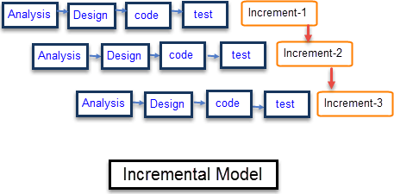
Each iteration passes through the requirements, design, coding and testing phases. And each subsequent release of the system adds function to the previous release until all designed functionality has been implemented.

Requirement Analysis | Requirement and specification of the software are collected
Design | Some high-end function are designed during this stage
Code | Coding of software is done during this stage
Test | Once the system is deployed, it goes through the testing phase

Advantages | Disadvantages
- Software will be generated quickly during the software life cycle | - It requires a good planning designing
- It is flexible and less expensive to change requirements and scope | - Problems might cause due to system architecture as such not all requirements collected up front for the  entire software life cycle
- Though the development stages changes can be done | - Each iteration phase is rigid and does not overlap each other
This model is less costly compared toothers | - Rectifying a problem in one unit requires correction in all the  Units.

3. SYSTEM ANALYSIS

- PRESENCE SYSTEM
- REQUIRMENT GATHERING & ANALYSIS
- SCOPE OF SYSTEM
- OBJECTIVES

PRESENCE SYSTEM:

Software is always part of large system or business work beginnings by establishing requirement for all system elements and then allocating some subset of these requirements to software. This system view is essential when software must interface with other elements such as hardware, people and databases. System engineering and analysis encompasses requirements gathering at the business area level.
System study is most important stag of software development life cycle while attempting to convert the manual process to computerized process. System study can be carefully defined as “a study of the operations or a set of connected elements and of the
inner connection between these elements”.
The process of building a system has been always complex. In recent years, however with the system becoming larger and costlier, the complexities have multiplied. So the need for better method for developing system is widely recognized. An applied model of the system should meet a few basic requirements:
The model should utilize established methods and techniques, for example, concepts such as database designs and structured programming.
The model should be structured and should cover the entire system development process from feasibility study to programming.
The model should consist of “building blocks” which will define task result and interfaces. The models should separate the logical system (the actual needs of the user) from the physical system (the system to be implemented)
Documentation should be a direct result of the development work and should be concise, precise and as non-redundant as possible.
Based on the above requirement of the system of the system model, system study was done. The study covered the overall functionality of the existing system was done by interviewing the personal involved and questionnaires distributed to them were they processed and studied sample document were collected as they would be of use during the design and implementation phases based on the results of system the requirements model was developed.

REQUIRMENT ANALYSIS

User any system when supposed to be developed it is essential that the designer follows the step of software development life cycle (SDLC).
SDLC consists of various integrated steps all levels of software development SRS (System Requirement Analysis) is the first technique step in SDLC.

REQUIREMENTS

User Friendly.
All relevant information should be displayed on the screen.
Should provide easy hard copy.
Easy access to details.
Valuable statistical information should be available.
Timely reports should be generated.
Minimum mouse usage and maximum keyboard should be facilitated. ▪Graphical charts should be available.

SYSTEM REQUIREMENT

System and utility department of Fasttreack shop require a complete solution a computerize their product functionality. For this they want to maintain all details of the product coming for processing.

FUNCTIONAL REQUIREMENTS:

Function requirements meant the process to be performed by the system to achieve the desire output:
Output drives the inputs flow through the system.
Invalid inputs should be avoided and appropriate message will be displayed.
The data should have an easy and smooth flow through the system and the integrity of the data should maintain.

DESIGN CONSTRAINTS

These are the facts present in client’s environment that many restrict the choice of a designer. Such factors include standards that must followed, resource limits, operating environment, reliability and security.
The reliability of the project depicts the extent to which it does not fail. The software should be bug free. Security is a must whenever a larger database is involved.
Some situations should be handled carefully.

Simplified design of the software should be the prime goal:

The design should be easy to understand.
It should be stable.
It should be flexible in nature.

PERFORMANCE REQUIREMENTS:

This part of SRS specifies the performance constraint on the software system.
There are two type of requirement they are:

Static Requirement:
Static requirement is those that do not impose constraint on the execution of the software but on the capability requirements of the system. This software is to be single user software. Terminal needed should be on only one. It should be easy to handle several files and normal sized databases.

Dynamic Requirement:
Dynamic requirement is those they specify constraints on the execution of the system. These include the response time and throughput constraint on the system. The response time should be minimum in order that the through put is high.
faster processing speed.
should support multi-user.
very little response time.

External Interface Requirement:
This refers to the screen design i.e. the user interface. The screen layout Should be attractive with the various controls well- spaced and compact. Standard Pertaining should be simple and attractive having catchy layouts and screen design.

Coding Specifications option:
In maintains and certain there should be for creation, changes and display in the create phase, a new entry is to be added to other. During the change desired and then edit the fields for which changes are inculpated. It will update in the respective table on the saving the information. During the display phase one has to select the key field for which the information is to be displayed. No modification is to be allowed in this phase.
It should be simple and understandable.
Use of modules and functions should be done. The modules, function etc., should be properly named

4. Software Requirement specification:

ER(ENTITY RELATIONSHIP DIAGRAM):-
The Entity-Relationship (ER) model was originally proposed by Peter in 1976 as a way to unify the network and relational database views. Simply stated the ER model is a conceptual data model that views the real world as entities and relationships. A basic component of the model is the Entity-Relationship diagram which is used to visually represent data objects. It is simple and easy to understand with a minimum of training.
Therefore, the model can be used by the database designer to communication the design to the end user.

4.1 ER DIAGRAM:-
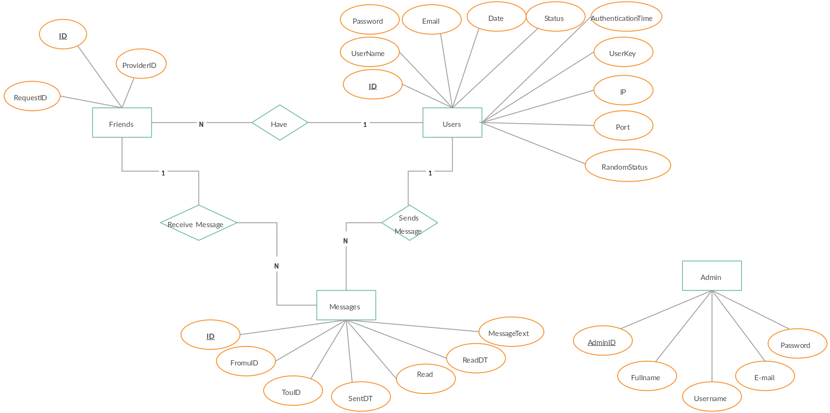
4.2 SYSTEM FLOWCHART DIAGRAM:-

System Flowchart is the graphical representation of the flow of data in the system and represents the work process of the system. Various symbols are used in the flowchart to designate specification.

- Display:

Indicates data that is displayed for people to read such as data on monitor or projector screen
.
- Process:

Indicates any processing function.

- Database:

Indicates a list of information with a standard structure that allows for searching and sorting.

- Document:

Indicates data that can be read by people such as printed output.
SYSTEM FLOW DIAGRAM:-

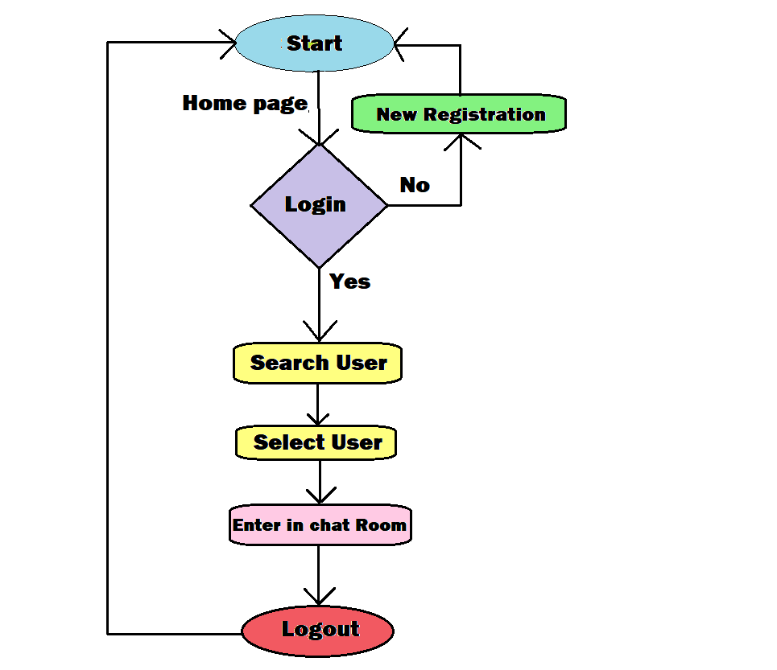

Data Flow Diagram:

Represent Data Flow

Represent a Form

Represent a Form

Represent a Data Table

Represent a Report

Represent a Decision

Represent a Processing

4.3 DFD DIAGRAM:-
A data flow diagram is graphic representation of a system that shows data flows to from and within the system, processing function that change the data in same manner, and the storage of this data. They are networks of related system function that indicated from where information is revived and to where it is sent. An external entry is the originator or receiver of data or information.

Zero Level:
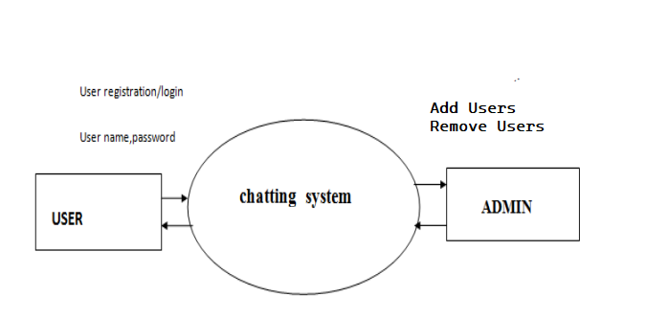

Zero Level DFD.

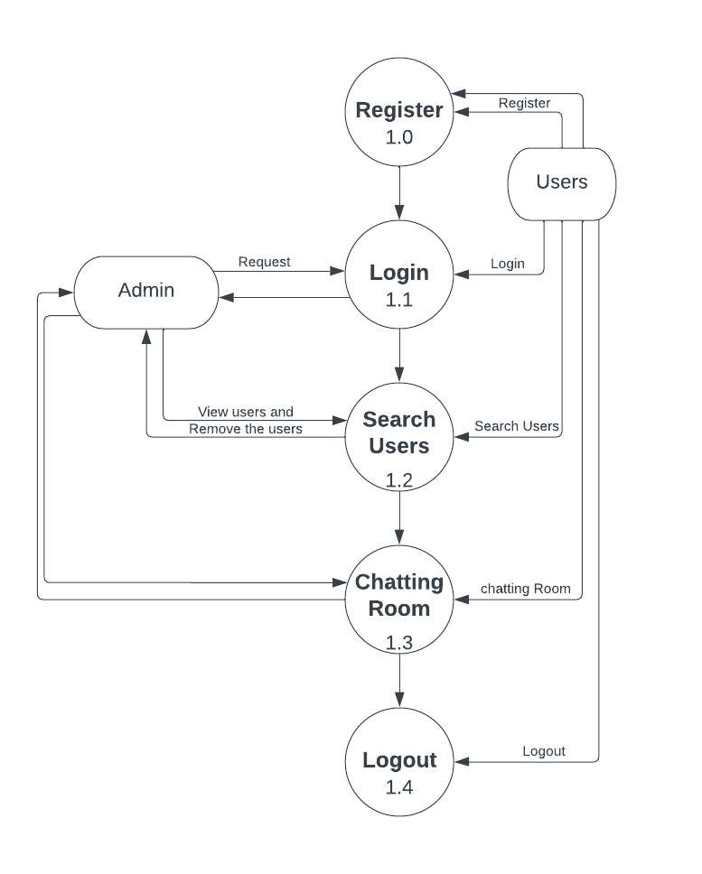
First Level:-
First Level DFD.

4.4PROCESS SPECIFICATION

ADMIN LOGIN PROCESS

1 | Process No. | 1
2 | Process Name | Admin Login Process
3 | Description | Admin can Login
4 | Input | User ID, Password
5 | Output | Operate the System

USER LOGIN PROCESS

1 | Process No. | 2
2 | Process Name | User Login Process
3 | Description | User can Login
4 | Input | User Email ID, Password
5 | Output | Operate the System

USER REGISTRATION

1 | Process No. | 3
2 | Process Name | User registration Process
3 | Description | User can registration
4 | Input | User Details
5 | Output | Register to the system

USER PROFILE SETUP

1 | Process No. | 3
2 | Process Name | Profile Process
3 | Description | User can Setup own profile
4 | Input | User Details
5 | Output | View all user to the system

VIEW USERS

1 | Process No. | 4
2 | Process Name | View Users Process
3 | Description | View the all Users in system
4 | Output | Click any user to chat

SEARCH USERS

1 | Process No. | 4
2 | Process Name | Search Users Process
3 | Description | Search the Users in system
4 | Output | Click on user to chat

CHAT ROOM

1 | Process No. | 4
2 | Process Name | Chat Room Process
3 | Description | Users can chat in system
4 | Output | User can Send and Receive messages with here friends

USER LOGOUT

1 | Process No. | 4
2 | Process Name | Logout Process
3 | Description | Users can logout to the system
4 | Output | User can come out from system

  - Data dictionary:

  - Admin table - This table contains the information of the admins
Column Status | Attribute | Datatype | Size | Description
Not null  Primary key | id | int | 10 | Admin identification number, it consists of unique number
Not null | Username | varchar | 100 | Username of admin
Not null | Password | varchar | 100 | Password of admin

  - User Signup - This table contains the information of the new User

Column Status | Attribute | Datatype | Size | Description
Not null | id | int | 10 | Users identification number, it consists of unique number
Not null  Primary key | Email | varchar | 100 | Email ID of Users
Not null | Password | varchar | 100 | Password of Users and it should be more than 6 digits
Not Null | Confirm Password | varchar | 100 | Same password required or Retype the password

  - User Login - This table contains the information of the User who already Signup or old Users.

Column Status | Attribute | Datatype | Size | Description
Not null | id | int | 10 | Users identification number, it consists of unique number
Not null  Primary key | Email | varchar | 100 | Email ID of Users
Not null | Password | varchar | 100 | Password of Users

  - Profile Setup - This table contains the information of the User Identity.

Column Status | Attribute | Datatype | Size | Description
Not null  Primary key | id | int | 10 | Users identification number, it consists of unique number
Not null | Image | varchar | 100 | Users Photos to identification from face
Not null | Name | varchar | 100 | Users Name
Not Null | Bio | varchar | 100 | User Bio (About Yourself )

  - Users search - This table contains the all users information New and Old.

Column Status | Attribute | Datatype | Size | Description
Not null  Primary key | id | int | 10 | Users identification number, it consists of unique number
Not null | Image | varchar | 100 | Users Photos to identification from face
Not null | Name | varchar | 100 | Users Name
Not Null | Bio | varchar | 100 | User Bio (About Yourself )

  - Chat Room - This table contains the all Messages

Column Status | Attribute | Datatype | Size | Description
Not null  Primary key | id | int | 10 | Users identification number, it consists of unique number.
Not null | Messages | varchar | 100 | Sender and Receiver Messages.
Not null | Sender ID | varchar | 100 | Sender identification number, it consists of unique number.
Not Null | Receiver ID | varchar | 100 | Receiver identification number, it consists of unique number.

TESTING
SYSTEM TESTING AND IMPLEMENTATION

White Box Testing and Black Box Testing in Software Testing

Software testing is one of the best means to affirm the quality of software and deliver an error-free application. Over the years, software testing has matured into a separate discipline giving way to several different testing techniques that have been introduced, analyzed and studied in this area. Black box testing and white box testing are two such testing approaches that are quite commonly used by software testers.

System testing is a critical element of the software quality assurance and represents the ultimate review of specification, design and coding.
The increasing visibility of software as system and the attendant “costs” associated with a software failure forces for well planned, through testing. It is not unusual for a development organization to expand between 30 and 40 percent of total project effort on testing. In the extreme, testing of human-rated software can cost three as much as all other software engineering activates combined.
White box Testing: White box testing sometimes called glass-box testing is a test case design method that to use the control structure of the pal design to derive test case. Using white-box testing methods, the software engineer can derive text case that:
  - Guarantee that all independent paths within a module have been exercised at least once
  - Exercise all logical decisions on their true and false sides.
  - Exercise all loops at their boundaries within their operational bounds. Exercise internal data structure to assure their validity.

What is White Box Testing?

In white box testing methodology, the tester has the knowledge of the internals of a system and knows how the system is implemented. The tester uses this knowledge to develop test cases that will examine the control flow, information flow, data flow, exception and error handling as well as coding practices of the system.
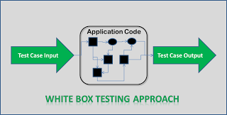

How to write Test Cases for White Box Testing?

  - The tester analyzes and understands the structure of the system by examining its code.
  - The tester understands the weak spots within the code that is most prone to defects.
  - The tester develops test cases to cover individual data/information/ control flows and branches within the code.
  - The tester also develops test cases to test proper working of all the functionalities and error handing of the system.

Techniques of White Box Testing

When it comes to white box testing, the knowledge that the tester possesses about the system is the driving factor, which helps the tester to devise test cases aimed at discovering defects with the internal working of the system.

- Statement Tests: All the statements within the code must have a test case associated with it such that each statement must be executed at least once during the testing cycle.
- Decision Tests: All the decision directions must be executed at least once during the testing life cycle.
- Branch Condition Tests: All the conditions in a specific decision must be tested for proper working at least once.

- Decision/Condition Tests: All the combination of the possible conditions within a specific decision for all the decisions is to be tested.
- Data Flow Tests: This will ensure that all the variables and data that are used within the system are tested by passing the specific variables through each possible calculation.
- Multiple Condition Tests: This will ensure that each point of entry with in the code is tested at least once during the testing life cycle.

Black box Testing: Black box testing focuses on the functional requirement of the software,
i.e. black box testing enables the software engineer to derive sets of input conditions that will fully exercise all functional requirements for a program black box testing not an alternative to white box testing techniques. Rather, it is complementary approach that is likely to uncover a different class of errors than white-box methods.
Black box Testing attempts to find errors in the following categories:

  - Incorrect or missing functions.
  - Interface errors.
  - Error in data structure or external database access.
  - Performances errors.
  - Initialization and terminating errors.

What is Black Box Testing?

- Crudely put, when the tester has no idea of the internal working of the system which he is testing, that approach is called black box testing.
- In this case, the system under test is viewed as a “black box”.

Requirements Document or Functional Specification Document forms the basis of this testing, which requires the user to understand the processes within the software.
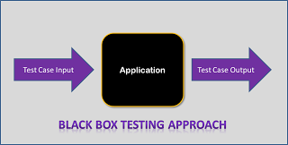

How to write Test Cases for Black Box Testing?

  - The tester examines requirements and specifications of the system.

  - The tester explores the system’s UI and functionality to understand how the processes on the system are expected to work.
  - Tester designs test cases with valid inputs and the corresponding expected outputs.
  - Tester also includes some negative test cases with invalid inputs and expected outputs (error messages/program termination) as applicable.

Techniques of Black Box Testing

In case of black box testing, inputs to the test cases are the driving factor. Any one of the three techniques discussed below can be used to choose the inputs during the black box testing process

  - Boundary Value Analysis: This approach is focused on testing the boundary values associated with the system. This approach aims at testing the boundaries of the input domain that have the highest probability of giving erroneous outputs.
  - Equivalence Class Partitioning: In this approach, a limited set of functions is identified along with its corresponding valid and invalid inputs and expected outputs. This approach aims at identifying classes of errors and therefore reducing the number of test cases required.
  - Error Guessing: An experienced tester most often uses this approach to first identify the defects and then develop corresponding test cases. EXAMPLE: A tester, without knowledge of the internal structures of a website, tests the web pages by using a browser; providing inputs(clicks, keystrokes) and verifying the outputs against the expected outcome.

Debugging: Debugging occurs as a consequence of successful testing. That is when a test. Uncovers an error, debugging is the process that results in the removal of the error. Although debugging can and should be an orderly process, it is still very much an art. A software engineer, evolution the results of test is often confronted with a “symptomatic” indication of software problem. That is, the external manifestation of the error and the internal cause of the error may have no obvious relationship to one another. The poorly understood mental process that connects a symptom to cause is debugging. Debugging is not testing but if always occurs as a consequence of testing.
TEST CASES
LOGIN FOR USER

Serial No | Description | Expected Result | Actual Result | Result
1. | This page contains 2 fields user name and password and a login button to submit the information. User is entering correct information. | User home page should open after successful login. | Respective user home page is opening after successful login by user. | Passed
2. | If either user name or password is filled incorrect or left blank. | An error message should be displayed and user should be asked fill the information again. | When wrong information is entered by user then an error message is displayed. | Passed

USER REGISTRATION PAGE
Serial No | Description | Expected Result | Actual Result | Result
1. | User registration page 1 consist of detail information about User and a submit button to submit the information. Here user is entering correct information. | After submitting information User registration page 2 should be displayed. | After submitting information User registration page 2 is displayed. | Passed
2. | If the information entered by user in incorrect or left somewhere blank. | An error message should be displayed and ask the user to fill the information again. | An error message is occurred if the information is incorrect or left blank. | Passed

IMPLEMENTATION
Implementation is the stage in the project where the theoretical design is turned into the working system and is giving confidence to the new system for the users i.e., will work efficiently and effectively. It involves careful planning, investigation of the current system and its constraints on implementation, design of method to achieve the changeover, an evaluation, of change over methods. A part from planning major task of preparing the implementation is education of users. The more complex system is implemented, the more involved will be the system analysis and design effort required just for implementation. An implementation coordinating committee based on policies of individual organization has been appointed. The implementation process begins with preparing a plan for the implementation for the system. According to this plan, the activities are to be carried out; discussions may regarding the equipment have to be acquired to implement the new system.
Implementation is the final and important phase. The most critical stage is in achieving a successful new system and in giving the users confidence that the new system will work and be effective. The system can be implemented only after thorough testing is done and if it found to working according to the specification. This method also offers the greatest security since the old system can take over if the errors are found or inability to handle certain types of transaction while using the new system.
At the beginning of the development phase a preliminary implementation plan is created to schedule and manage the many different activities that must be integrated into plan. The implementation plan is updated throughout the Development phase, culminating in a changeover plan for the operation phase. The major elements of implementation plan are test plan, training plan, equipment installation plan, and a conversion plan.
There are three types of implementations:
- Implementation of a computer system to replace a manual system.
- Implementation of a new computer system to replace an existing system.
- Implementation of a modified application to replace an existing one, using the same computer.
Successful implementation may not guarantee improvement in the organization using the new system, but improper installation will prevent it. It has been observed that even the best system cannot show good result if the analysts managing the implementation do not attend to every important detail. This is an area where the systems analysts need to work with utmost care.

Conversion Methods
A conversion is the process of changing from the old system to the new one. It must be properly planned and executed. Four methods are common in use. They are Parallel Systems, Direct Conversion, Pilot System and Phase In method.
Parallel systems:
The most secure method of converting from an old to new system is to run both systems in parallel. This method is safest one because it ensures that in case of any problem in using new system, the organization can still fall back to the old system without the loss of time and money.
The disadvantages of parallel systems approach are:
- It doubles operating costs.
- The new system may not get fair trial.
Phase –IN- method:
This method is used when it is not possible to install a new system throughout an organization all at once. The conversion of files, training of personnel or arrival of equipment may force the staging of the implementation over a period of time, ranging from weeks to months.
Post Implementation Review
After the system is implemented and conversion is complete, a review should be conducted to determine whether the system is meeting expectations and where improvements are needed. A post implementation review measures the systems performance against predefined requirement. It determines how well the system continues to meet the performance specifications.

A Database-driven One Shop Multi-vendor ecommerce:

The shopping portal that I have built for our store makes use of several advance features that the cart contain all the selected products until checkout and My Shopping by which user can track their previous shopping on this portal. For doing so shopping portal uses a Database by which all these information stored in this database and when required then it is fetched from it. So, I use MYSQL Database in this project.

So, this shopping portal contains dynamic effects by using this database. Some parts of this project which use database are following:
- Firstly, when user Register an account on this website the user gives their information which are stored in database.
- Then when users want to login on this website then they give their username and password as they choose at registration time, if both are matched with database’s username and password then user can successfully log in the website otherwise Access Denied.
- The Objects which users can see on homepage, after login page, buy products page are also come from database.
- Now after login user can modify their profile and password. The modified profile details and password details altered in the database.
- In Buy Products Section Product and Their Prices also fetched from database’s table. When user select a product and push Add to cart then items added to database’s cart table.
- Then in My Cart section the products displayed which are in the cart table of the database following by user.
- Checkout section takes the carts item and their total price and then payment details are given by the user and these details store in separate database table. After Successful entry in this table users cart empty automatically because all items purchased by him.
- In My Shopping section the products a user purchased are displayed.
ABOUT THE CURRENT SYSTEM

Advantages of the Current System:

The project One Shop ecommerce is GUI based system so that it is easy to handle. It also increases the efficiency of the end user, because it will reduce the redundant job, which is tedious to complete. The Online System also has automated capability to complete job, so it reduces the work manually.

Advantage of One Shop Multi-vendor ecommerce :
- This online program will take less time and gives better results.
- It reduces the tedious jobs Like (Redundant work, long procedures, Up to Date Information).
- It will improve the online shopping system, since all the information is available whenever required.
- It provides quick processing thus helps in transaction and updating in Edit personal view can perform in few seconds.
- It provides accurate Output.
- It gives fast answer of queries.
- The amount of paper work is reduced.
- Better Control.

Deficiencies of the manual system:

1) Lack of immediate retrieval of information
In manual system, lot of time is wasted in retrieving information. Much searching is required before required information is found. This wastes a lot of time of the user as well as the person.

2) Lack of immediate information storage
In manual system, it is difficult to store information at proper place at that very moment. This is because the person is unable to quickly locate the place where the information is to be stored.

3) Prompts updating not possible
Changes are quite natural in all walks of life. Information and stored data also change from time to time. These changes should be incorporated in the working also to keep the information up to date. However, bringing about changes through the manual system is a slow and tedious process because of which inaccurate information storage occurs.

4) Unplanned working
The manual system lacks the element of planned working. Records are not properly maintained. This creates a lot of problems at times like during information retrieval and storage.
5) Insignificant generation of managerial and Strategic reports.
In manual system, reports for management are difficult to be generated and strategic reports are almost impossible. This is because for these reports proper storage of information, its retrieval and it’s filtering (i.e., choosing information that meets criteria are very important and are very tough in manual system.

6) Accuracy
The manual system lacks accuracy in working and a number of operations may be performed incorrectly. The computations that are done in the organization may be incorrect and whatever are generated in the system may be inaccurate.
7) Reliability
The reliability of a manual system is considered to be low because of the above given reasons including the fact that ‘To error is human’. Any task that is performed by men, always contain the risk of errors.
8) Redundancy of information
In manual system, particular information may be stored at a number of places, lending to redundancy. Redundancy of data or information creates a number of problems storage space is wasted; changes at one place are to be made at a number of places and so on.

GOALS OF THE PROPOSED SYSTEM:

1) Immediate retrieval of information
The main objective of the new system is to provide for quick and efficient retrieval of information. Any type of information would be available to the user whenever he requires. Facility would be provided for online query to cut down on the response time greatly.
2) Immediate storage of information
In the proposed system, it will be easy to store information at any given time at the correct places. The location of storage would be easily available and user will face no difficulty.
3) Prompt updating of information
In the proposed system, the information will always remain up to date as the updating will be prompt and without any efforts. This factor will be of great importance in the proposed system as it determines the integrity of the information stored.
4) Fast computation of information
The computation of information will be quite fast in the proposed system. Not only mathematical calculations, but also logical comparisons will be quick in the new system.
5) Planned approach toward working
The working in the service centre information system will be well planned and organized. The data will be stored properly in the data store, which will help in retrieval of information as well as in its storage.
6) Generation of managerial and strategic reports
The new system would provide for regular generation of reports, which would help the management in decisions making work and in controlling the overall working of the organization. The generation, of these reports would be possible only if the system is organized such that retrieval of information can be made on conditions.
7) Accuracy
The level of accuracy in the new proposed system would be higher. All operations and computations would be done correctly and this will ensure that whatever information is coming from the centre, it is accurate.

8) Reliability
The reliability of the proposed system would be high due to the above stated reasons. The reason for the increased reliability of the system is that now there would be proper storage of information, its maintenance would be well managed and retrieval would be possible in the desired manner.
9) Non-Redundant Information
In the new system, utmost care would be taken that no information is repeated, any usage of storage or otherwise. This would assure economic usage of storage or space and consistency in the data stored. This will also help make those changes easily as the change would have to be made only at that very place and nowhere else.

