Twitter Data Extractor

User Manual

Author: Coşkun Deniz <codenineeight@gmail.com>
Created at: September 2022

Table of Contents
Introduction 3
Supported Features 3
How to Setup 4
Installing Dependencies 4
Creating a Project on Google Cloud Platform for Google Sheets Usage 4
MongoDB Installation 8
How to Use 9
Basic Usage 9
Supported Arguments 9
Example Commands 10
Support 11

Introduction
This command-line tool extracts user and tweet data from Twitter and reports the results to CSV, Excel, Google Sheets documents or MongoDB, SQLite databases.

Supported Features
- Extract single/multiple user data.
- Extract user’s friends/followers data.
- Extract tweets data for a user.
- Extract tweets data for a search keyword.
- Report results to CSV, Excel or Google Sheets documents.
- Report results to MongoDB or SQLite databases.

Basic package only contains results in the requested output file/database.
Premium package contains the source code and installation of the script on the user side. User of the tool should have the Twitter API access.

How to Setup

Installing Dependencies
Run the following commands to install required packages in the project directory.
python -m venv env
source env/bin/activate
python -m pip install -r requirements.txt

Creating a Project on Google Cloud Platform for Google Sheets Usage
- Go to Google Developers Console and create a new project (or select the one you already have).
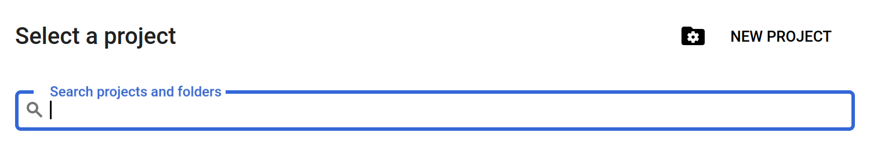
Write a name for your project and click the CREATE button.
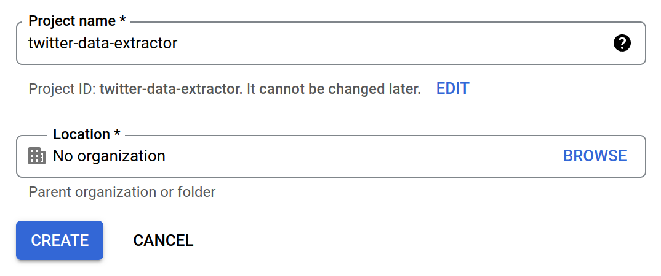
- Select APIs & Services → Library from the side menu. First search for “Google Drive API” and enable it.
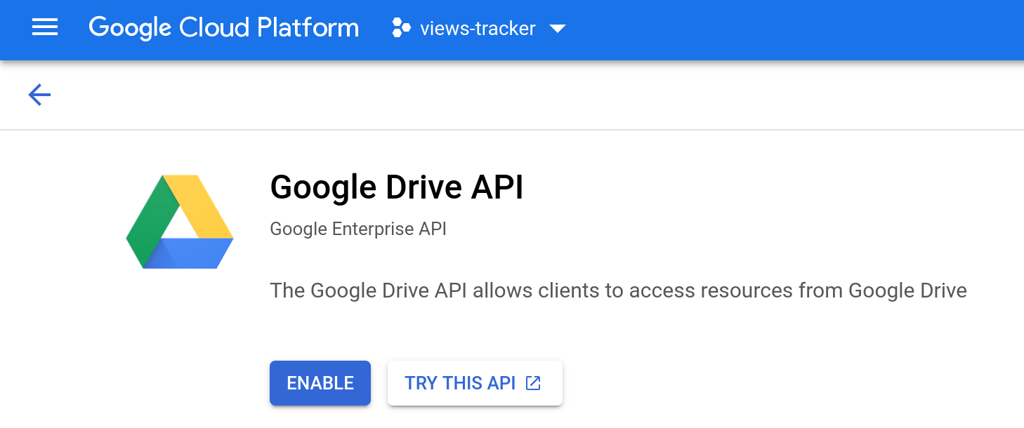
Then search for “Google Sheets API” and enable it.
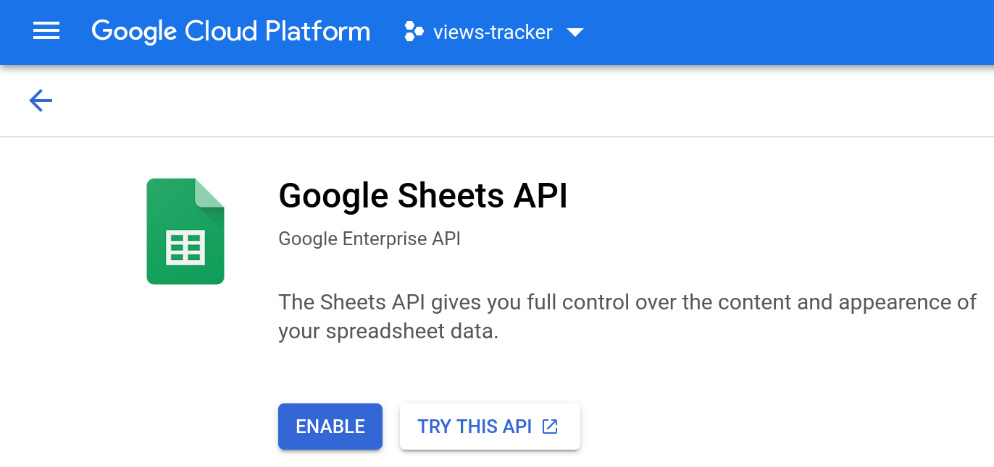
- Create credentials for service account.
Since it’s a separate account, by default it does not have access to any spreadsheet until you share it with this account. Just like any other Google account.
1. Go to APIs & Services → Credentials from the side menu.
2. Choose “CREATE CREDENTIALS > Service account”.
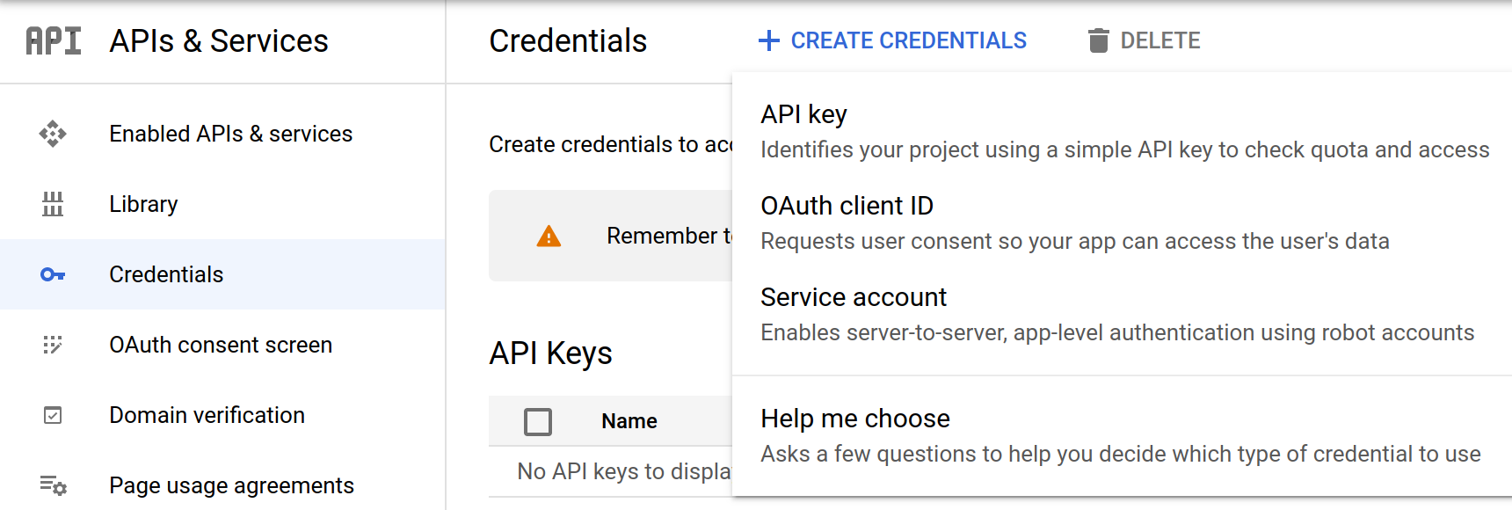
3. Fill out the form.
4. Click “CREATE AND CONTINUE” and “DONE”.
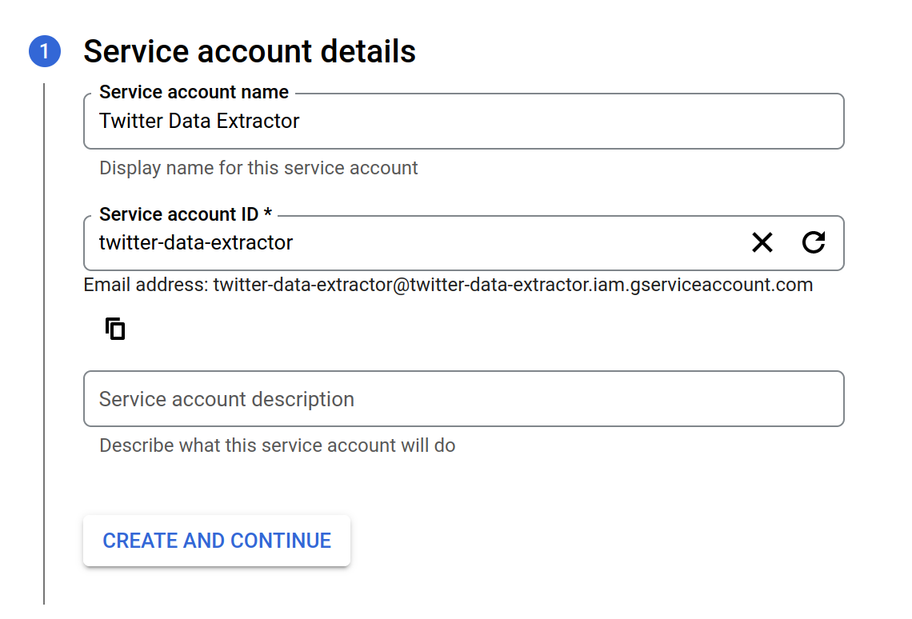
5. Click on the email link under Service Accounts section.
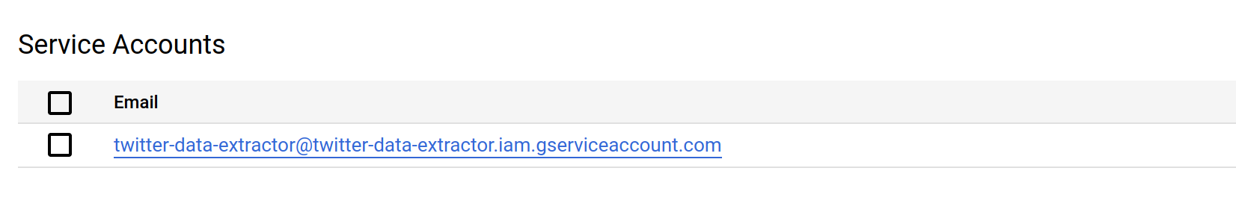
6. Go to KEYS tab and select “Create new key” from “ADD KEY” drop down menu.
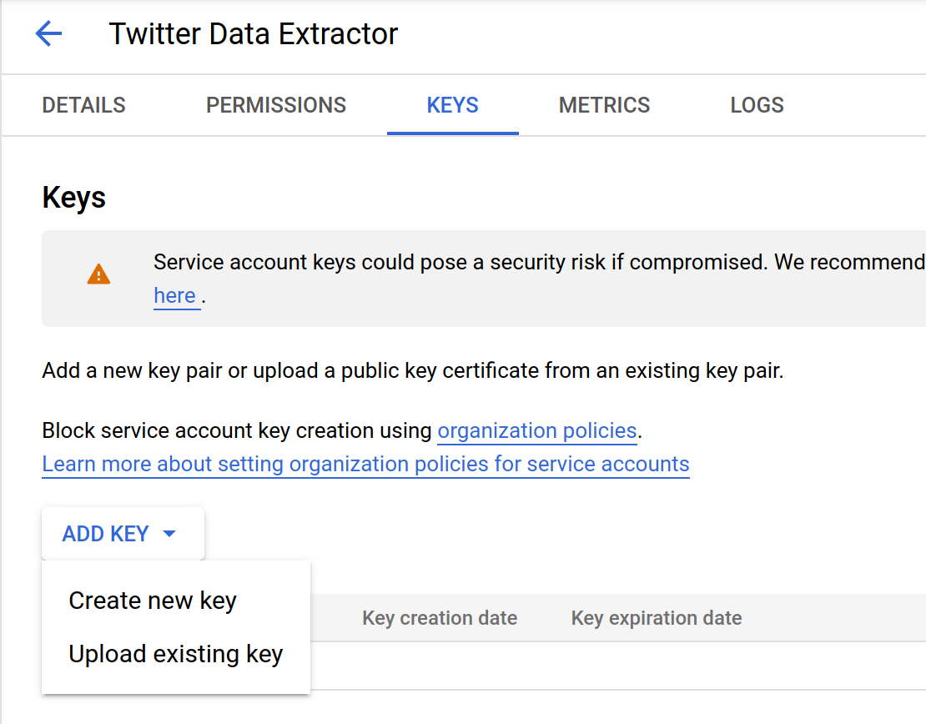
7. Select JSON from the popup menu and click CREATE.
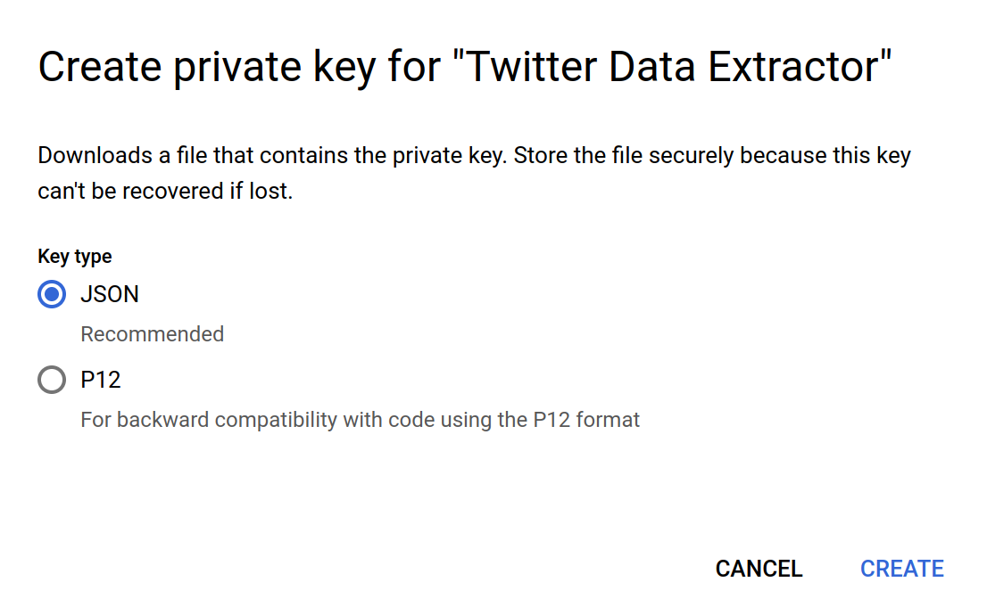
8. JSON file with credentials will be downloaded automatically. It may look like this
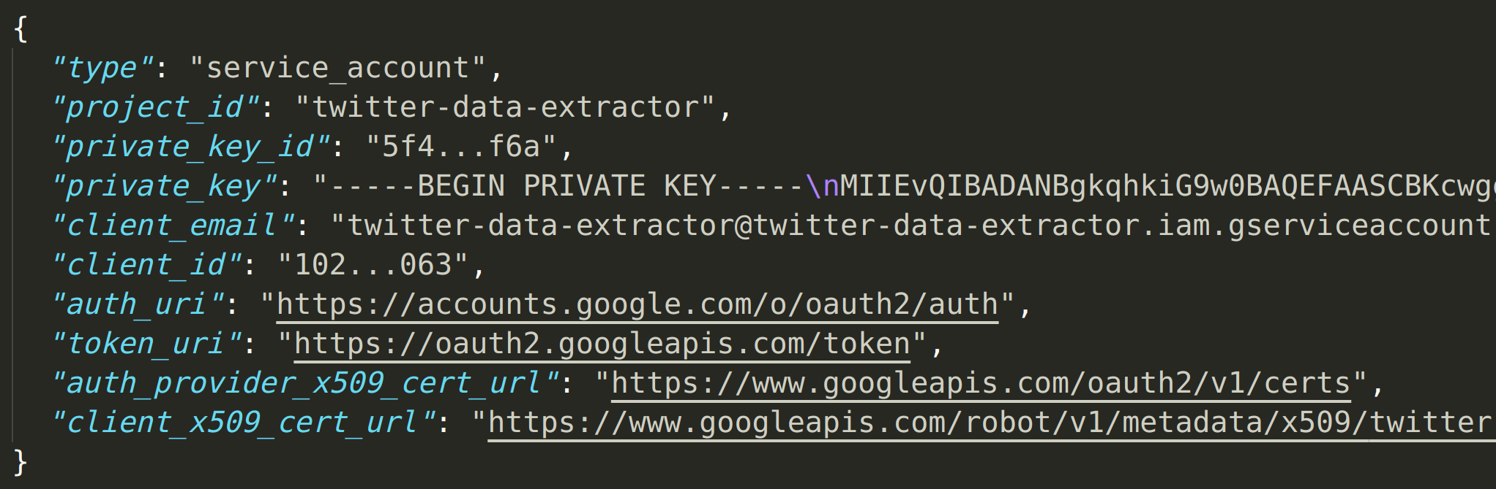
- Rename the downloaded file as “credentials.json” and copy it to the project directory.

MongoDB Installation
If you will use MongoDB to save users/tweets data, install it from here.
You can check the running status after installation and start the database server with the following commands on Linux.
sudo service mongod status

sudo service mongod start

How to Use

Basic Usage
The following commands are a few examples of getting user data, user’s friends, tweets or tweets of a given keyword.
python twitter_data_extractor.py -u gvanrossum
python twitter_data_extractor.py --forme -ul "gvanrossum,nedbat"
python twitter_data_extractor.py -u gvanrossum -fr
python twitter_data_extractor.py --forme -u gvanrossum -ut
python twitter_data_extractor.py -s python

Results are written to results.xlsx file by default. Logs can be seen in the tw_extractor.log file in the project directory.

Supported Arguments

Short Argument | Long Argument | Description | Default Value
-h | --help | Show help message and exit.
-c | --useconfig | Read configuration from json file. | False
-cf | --configfile | Read configuration from given json file. | config.json
- | --forme | Determine API user (account owner or on behalf of a user) | False
-u | --user | Extract user data for the given username
-ul | --users | Extract user data for the given comma separated usernames
-fr | --friends | Extract friends data for the given username | False
-fl | --followers | Extract followers data for the given username | False
-ut | --user_tweets | Extract tweets of user with the given username | False
-s | --search | Extract latest tweets for the given search keyword
-tc | --tweet_count | Limit the number of tweets gathered | 20
-e | --excludes | Fields to exclude from tweets queried as comma separated values (replies,retweets) | retweets
-ot | --output_type | Output file type (csv, xlsx, gsheets, mongodb or sqlite) | xlsx
-of | --output_file | Output file name | results.xlsx
-sm | --share_mail | Mail address to share Google Sheets document

TODO: add config file usage explanations

Example Commands

Support
If you need support, you can contact me by emailing to codenineeight@gmail.com with the “twitter_data_extractor” prefix in the subject. You can also see my Upwork profile here.

