YouTube Views Tracker

User Manual

Author: Coşkun Deniz <codenineeight@gmail.com>
Created at: March 2022

Table of Contents
Introduction 3
Supported Features & Package Levels 3
Basic Package (BP) 3
Standard Package (SP) 3
Premium Package (PP) 3
How to Setup 4
Installing Dependencies 4
Creating Docker Image Manually (PP) 4
Creating a Project on Google Cloud Platform for Google Sheets Usage (SP, PP) 4
How to Use 9
Basic Usage 9
Supported Arguments 10
Example Commands 10
Scheduling (PP) 11
Running Docker Image (PP) 12
Running Tests 12
Screenshots 13
Support 14

Introduction
This tool monitors view counts for YouTube videos and reports the results on Excel or Google Sheets documents. The user can use either video URLs or channel links to track video counts.

Supported Features & Package Levels
There are 3 types of packages: basic(BP), standard(SP), and premium(PP).

Basic Package (BP)
- Read video URLs (up to 1000) from txt, csv, or xlsx files.
- Output results to Excel.
- Chart for the most watched 10 videos on Excel output.

Standard Package (SP)
- Features in BP
- Read video URLs from Google Sheets document.
- Read video URLs from channel links (up to 3).
- Output results to Google Sheets.
- Installation of the script on the user side.
- Test the script on the user side.

Premium Package (PP)
- Features in SP
- Read video URLs from channel links (up to 5).
- Schedule for repeated runs.
- Run as Docker container.

All packages contain the source code and user manual document.

How to Setup

Installing Dependencies
Run the following commands to install required packages in the project directory.
python -m venv env
source env/bin/activate
python -m pip install -r requirements.txt

Creating Docker Image Manually (PP)
Docker image will be provided with the delivered package, but if you want to build it yourself, run the following command in the project directory.
docker build -t yt_views_tracker .
Note that there is a dot at the end.
Install docker from here for your system if you don’t already have it.
If you want to create a tar file from Docker image, run the following command after build.
docker save yt_views_tracker:latest | gzip > yt_views_tracker.tar.gz
You can load the image on another system with the below command.
docker load -i yt_views_tracker.tar.gz
You will see an output like below.
161bb48217a5: Loading layer [==================================================>] 2.048kB/2.048kB
3ab11ff81fc5: Loading layer [==================================================>] 108.5kB/108.5kB
293a28bb0e11: Loading layer [==================================================>] 7.35MB/7.35MB
ae8c8923029b: Loading layer [==================================================>] 9.649MB/9.649MB
Loaded image: yt_views_tracker:latest

If you type docker images, you can see the extracted image.
REPOSITORY TAG IMAGE ID CREATED SIZE
yt_views_tracker latest 907250b0ddd8 8 days ago 62.9MB

Creating a Project on Google Cloud Platform for Google Sheets Usage (SP, PP)
- Go to Google Developers Console and create a new project (or select the one you already have).
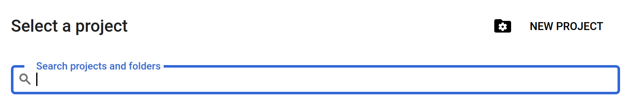
Write a name for your project and click the CREATE button.
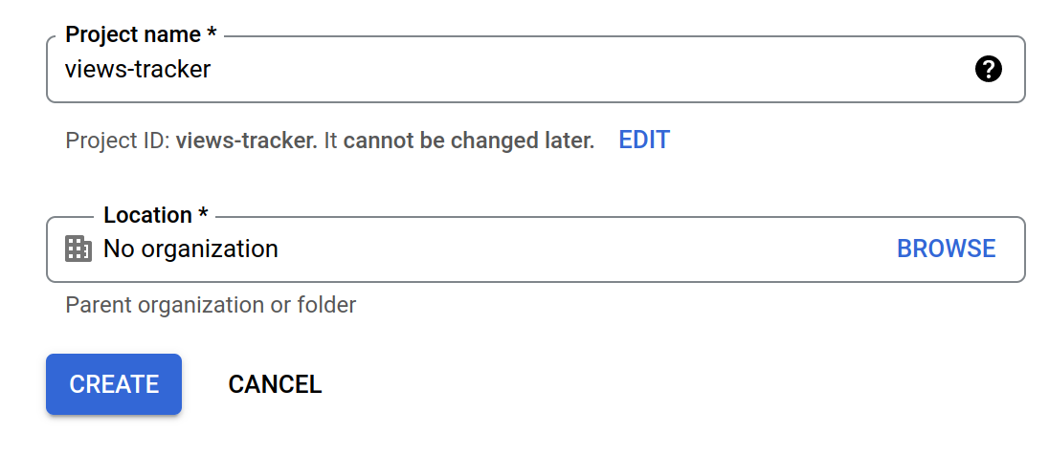
- Select APIs & Services → Library from the side menu. First search for “Google Drive API” and enable it.
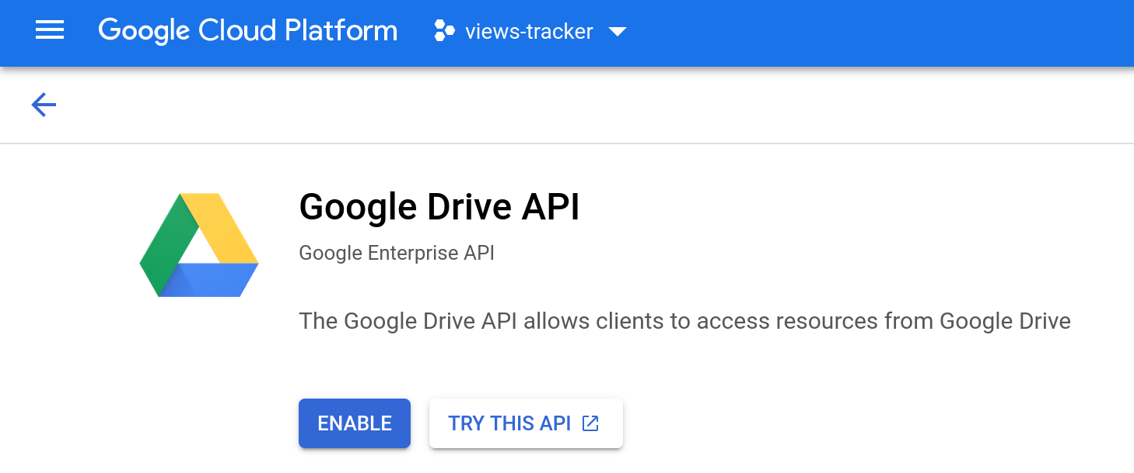

Then search for “Google Sheets API” and enable it.
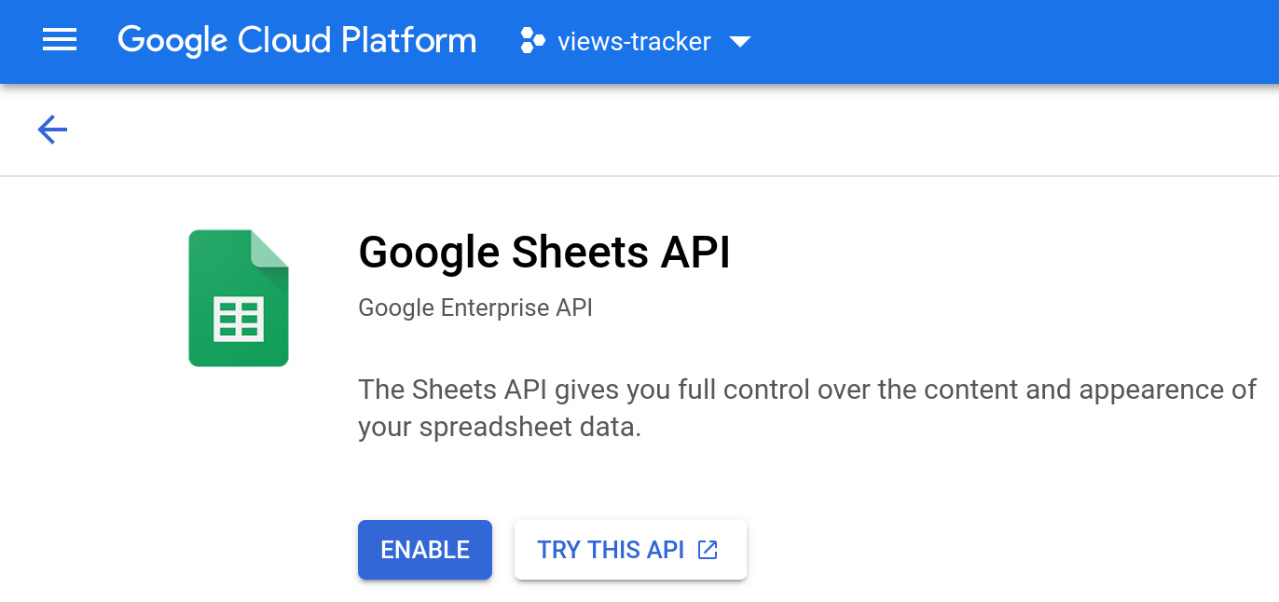
- Create credentials for service account.
Since it’s a separate account, by default it does not have access to any spreadsheet until you share it with this account. Just like any other Google account.

1. Go to APIs & Services → Credentials from the side menu.
2. Choose “CREATE CREDENTIALS > Service account”.
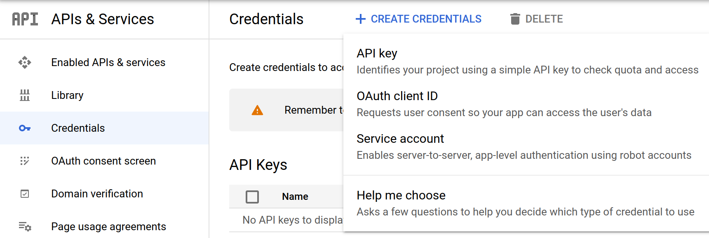

3. Fill out the form.
4. Click “CREATE AND CONTINUE” and “DONE”.
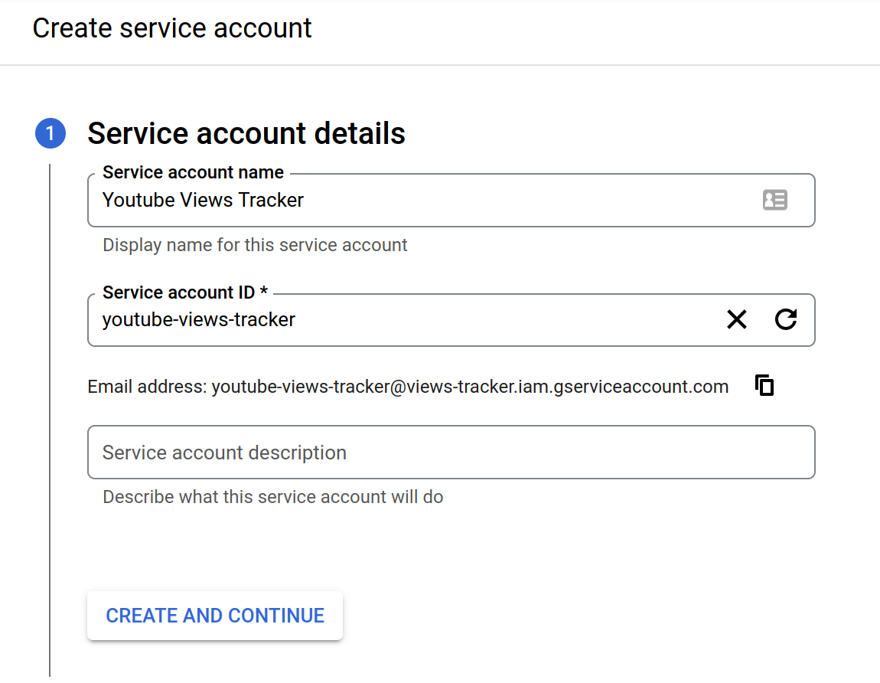
5. Click on the email link under Service Accounts section.
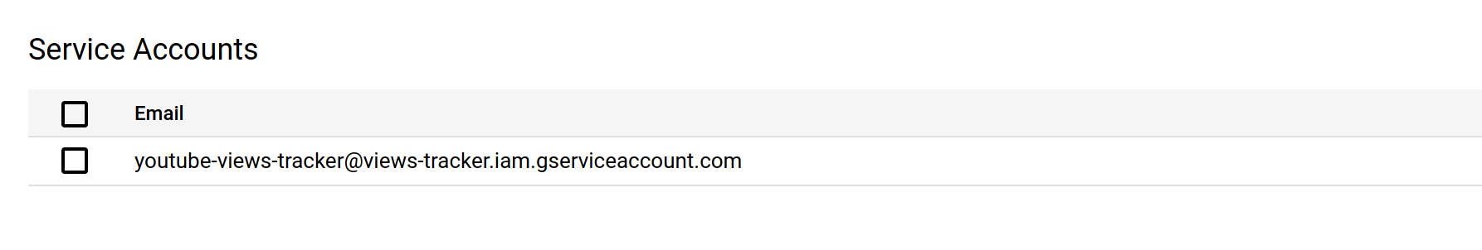

6. Go to KEYS tab and select “Create new key” from “ADD KEY” drop down menu.
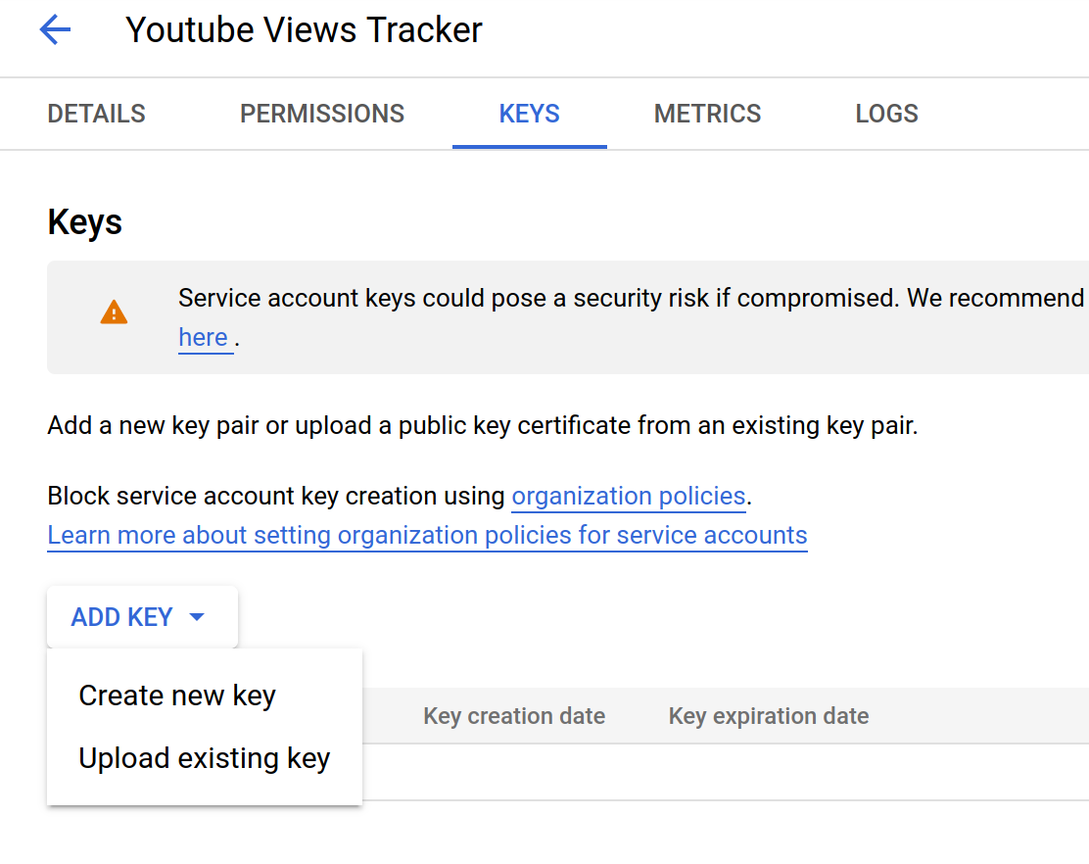
7. Select JSON from the popup menu and click CREATE.
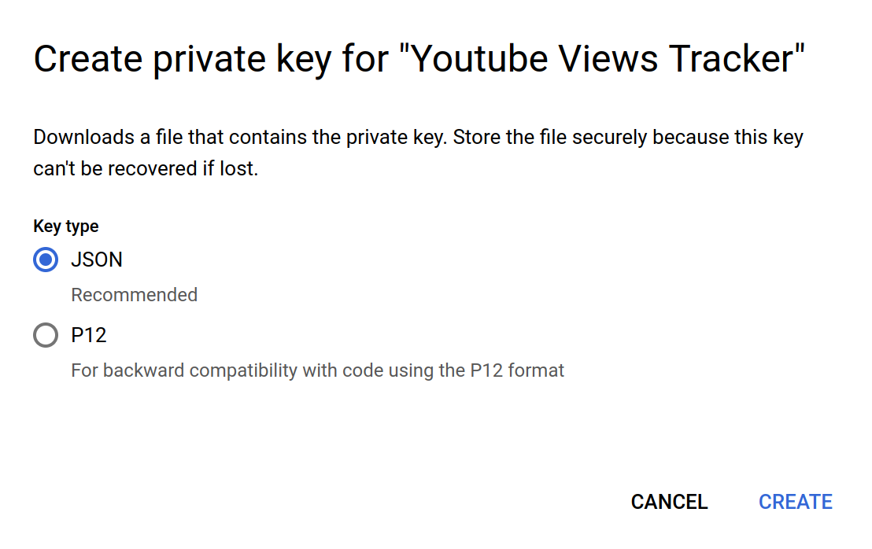

8. JSON file with credentials will be downloaded automatically. It may look like this
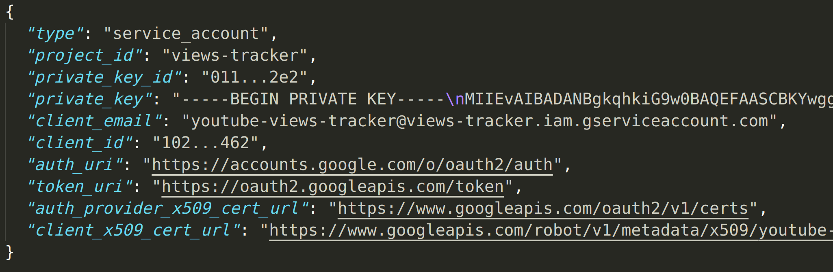
- Rename the downloaded file as “credentials.json” and copy it to the project directory.
- Share your document with the value of “client_email” field if you will read urls from a Google Sheets document.
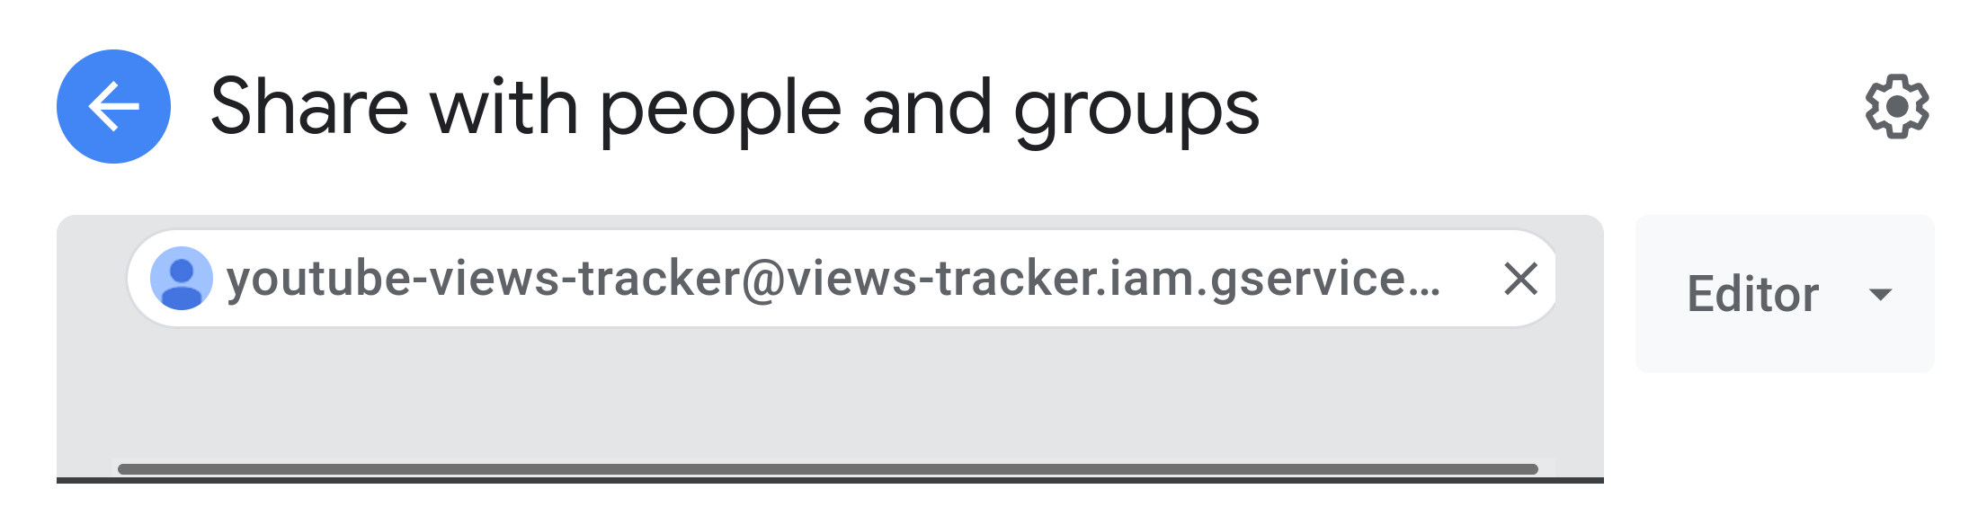

How to Use

Basic Usage
For the most basic usage, the script requires at least one of “-c”, “-f”, or “-ch” options for config file, urls file and channel links respectively.
python yt_views_tracker.py -c
python yt_views_tracker.py -f ~/video_urls.txt
python yt_views_tracker.py -ch “https://www.youtube.com/c/ArjanCodes/”

Results are written to results.xlsx file by default in views, title, url order.
Logs can be seen in the yt_views.log file in the project directory.

Supported Arguments
Short Argument | Long Argument | Description | Default Value
-h | --help | Show help message and exit.
-c | --useconfig | Read configuration from json file. | False
-cf | --configfile | Read configuration from given json file. | config.json
-f | --urlsfile | Read video urls from given file.
-ch | --channels | Channel urls separated by comma.
-ot | --output_type | Output file type (excel or gsheets). | excel
-of | --output_file | Output file name. | results.xlsx
-uc | --url_column | Url column index for csv, xlsx, or Google Sheets input. | 0
-sm | --share_mail | Mail address to share Google Sheets document.
-s | --schedule | Interval to run as scheduled task. | NONE

The above list contains all options that are supported in the Premium Package. If you have other packages, one or more options may not be available for your package. Please see the Supported Features & Package Levels section.

Example Commands
- Read video URLs from video_urls.csv and output results to video_view_counts.xlsx file.
python yt_views_tracker.py -f ~/video_urls.csv -of video_view_counts.xlsx
- Use options from custom_config.json file.
python yt_views_tracker.py -c -cf custom_config.json
- Read video URLs from the third column of video_urls.csv file.
python yt_views_tracker.py -f ~/video_urls.csv -uc 2
- If you will use Google Sheets for getting video URL inputs, add “gsheets-” prefix to the urlsfile(f) parameter.
python yt_views_tracker.py -f gsheets-video_urls
This command will read URLs from Google Sheets document named “video_urls”.
- Read video URLs from Google Sheets document using file link.
python yt_views_tracker.py -f gsheets-https://docs.google.com/spreadsheets/d/1dtFZbg4Gm8mCopO9fpZ-DwJ37uLMopgLePgFdigutuI
- Read video URLs from txt file and output results to Google Sheets document named “view_results”.
python yt_views_tracker.py -f ~/video_urls.txt -ot gsheets -of view_results -sm codenineeight@gmail.com
Share mail parameter is needed, so that you can see the document on your account.
- If you will use config file and read URLs from channel links, you should keep the urlsfile field empty in the json file.
{
"urlsfile": "",
"channels": [
"https://www.youtube.com/c/ArjanCodes/",
"https://www.youtube.com/c/Coreyms"
],
"output_type": "excel",
"output_file": "results.xlsx",
"url_column": 0,
"share_mail": "codenineeight@gmail.com",
"schedule": "NONE"
}

python yt_views_tracker.py -c

Scheduling (PP)
You can run the script in scheduled intervals. Scheduling is not active by default so the script will run only once and exit after completion. You have 9 scheduling options as shown below.
- 10 minutes (MIN10)
- 15 minutes (MIN15)
- 30 minutes (MIN30)
- 1 hour (HOUR1)
- 3 hours (HOUR3)
- 6 hours (HOUR6)
- 8 hours (HOUR8)
- 12 hours (HOUR12)
- Once a day at “HH:MM”

- Run every 30 minutes
python yt_views_tracker.py -f video_urls.csv -s MIN30
- Run once a day at 15:30
python yt_views_tracker.py -f video_urls.csv -s 15:30

Running Docker Image (PP)
- Run the following command first for once.
docker run --rm -it -v view_results_volume:/src yt_views_tracker
view_results_volume is the storage that will be shared with docker container. yt_views_tracker is the name of the image.
- If you will use with Google Sheets, copy your credentials file to the shared directory.
sudo cp /path/to/credentials.json /var/lib/docker/volumes/view_results_volume/_data

- If you will use the urls file, copy urls file to the shared directory.
sudo cp /path/to/video_urls.txt /var/lib/docker/volumes/view_results_volume/_data

- Run the container by passing arguments as usual.
docker run --rm -it -v view_results_volume:/src yt_views_tracker -f video_urls.csv

docker run --rm -it -v view_results_volume:/src yt_views_tracker -ch "https://www.youtube.com/c/ArjanCodes/"

docker run --rm -it -v view_results_volume:/src yt_views_tracker -f video_urls.txt -ot gsheets -of view_results -sm codenineeight@gmail.com

- Copy the results to a different directory on the host device.
sudo cp /var/lib/docker/volumes/view_results_volume/_data/results.xlsx ~/views_output

- If you will use config file, copy your config file to the shared directory, and run the container with "-c" and "-cf" options.
sudo cp /path/to/config_for_docker.json /var/lib/docker/volumes/view_results_volume/_data

docker run --rm -it -v view_results_volume:/src yt_views_tracker -c -cf config_for_docker.json

See here for sharing volumes on Windows.

Running Tests
Install the pytest package.
python -m pip install pytest
Run the following command in the project directory.
pytest -vs

If you want to check coverage report, install the coverage package first.
python -m pip install coverage
Run the tests with the coverage command.
coverage run --omit *dist-packages* -m pytest -vs
Run the following command to see the html report.
coverage html --omit *dist-packages,yt_views_tracker.py*
You can see the report by opening index.html file located under htmlcov folder in the project directory.

Screenshots
Excel Result
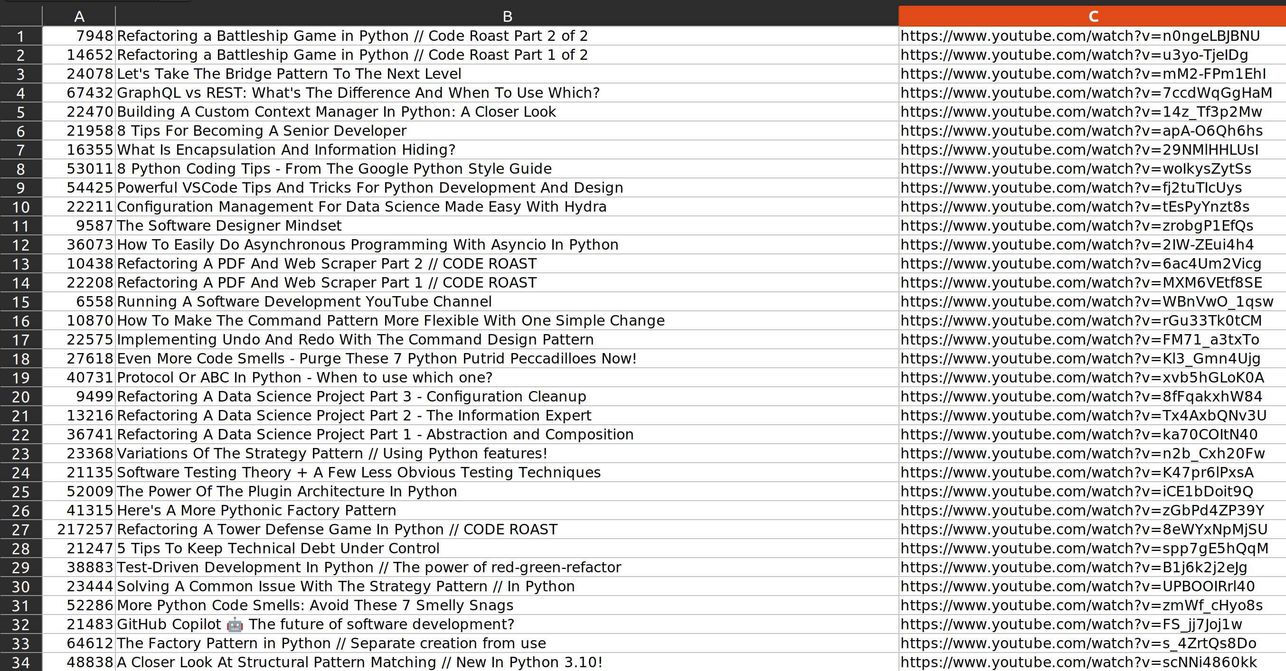

Excel Chart
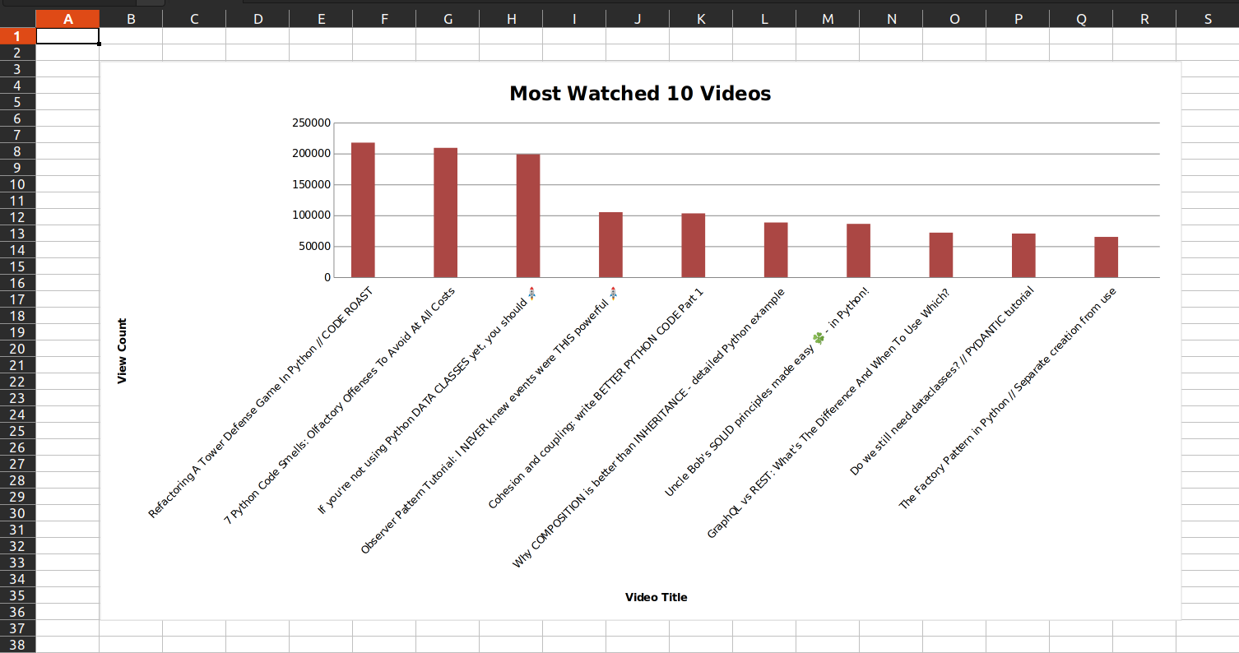

Google Sheets Result
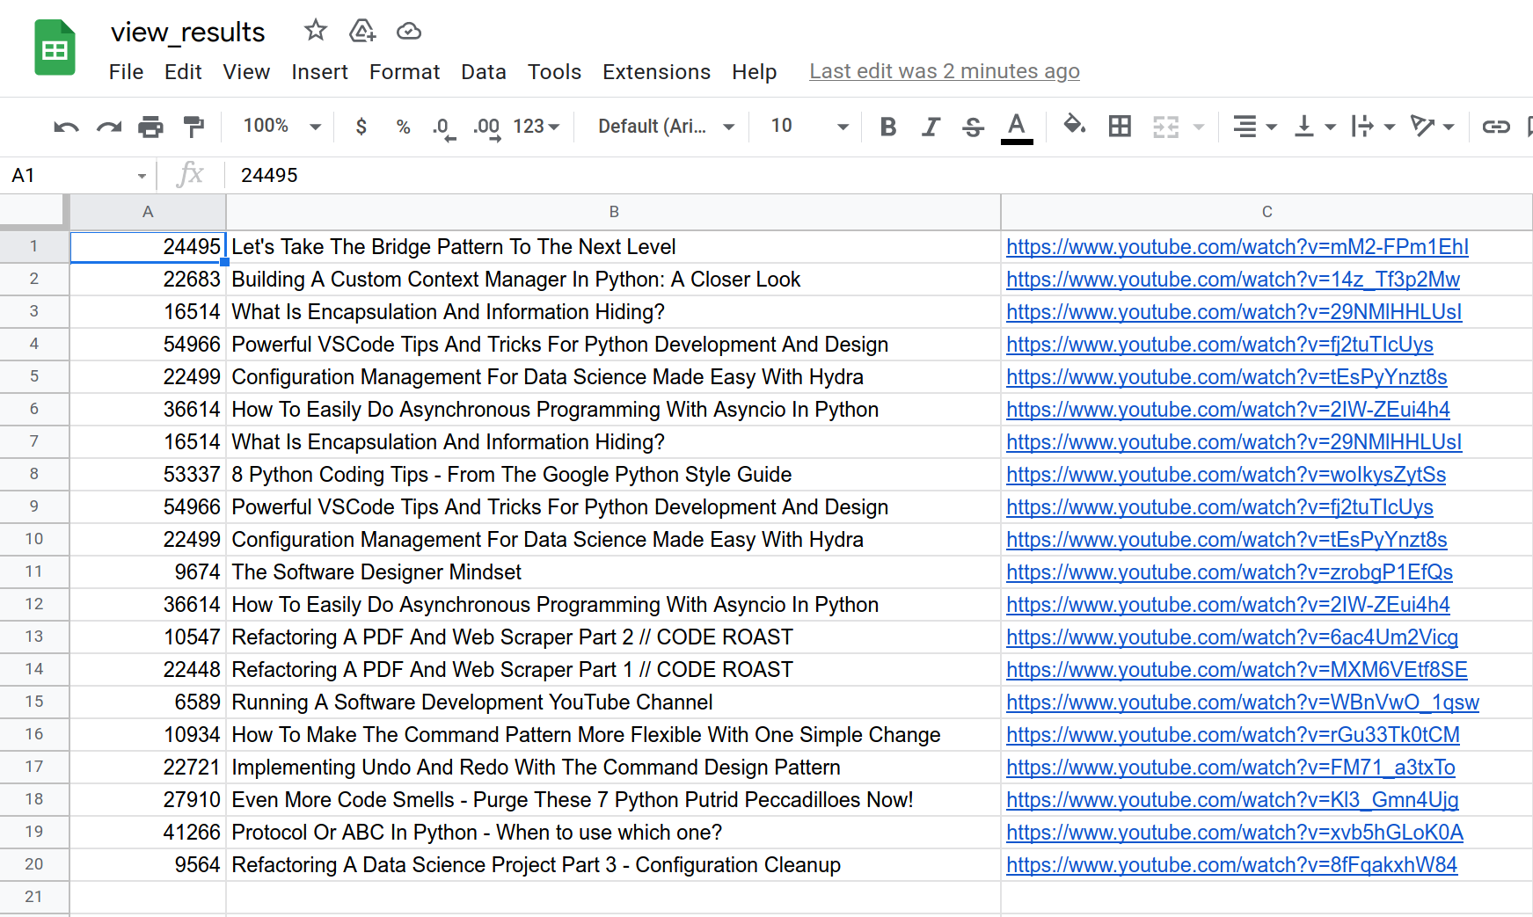

Support
If you need support, you can contact me by emailing to codenineeight@gmail.com with the “yt_views_tracker” prefix in the subject. You can also see my Upwork profile here.

