Copyright WILEY-VCH Verlag GmbH & Co. KGaA, 69469 Weinheim, Germany, 2018.

Supporting Software Code

**Isotopically encoded nanotags for multiplexed ion beam imaging**

**Authors:**

Dr. Stefan Harmsen1,2,*, Dr. Ahmet F. Coskun1,2,3,4,*, #, Shambavi Ganesh4,5

Dr. Garry P. Nolan3, #,, and Dr. Sanjiv S. Gambhir1,2,6,7#

**Affiliations:**

1Department of Radiology, Stanford University School of Medicine,Stanford, CA, USA

2Molecular Imaging Program at Stanford University (MIPS), Bio-X Program, Stanford University School of Medicine, Stanford, USA

3Department of Microbiology and Immunology, Stanford University School of Medicine, Stanford, CA, USA

4Wallace H. Coulter Department of Biomedical Engineering, Georgia Institute of Technology and Emory University, Atlanta, GA, USA

5School of Electrical and Computer Engineering, Georgia institute of Technology and Emory University, Atlanta, GA, USA

6Department of Bioengineering, Stanford University Schools of Medicine and of Engineering, Stanford, USA

7Department of Materials Science & Engineering, At Stanford University, School of Medicine, Stanford, CA, United States.

#Corresponding authors

Ahmet F. Coskun, Ph.D. (ahmet.coskun@bme.gatech.edu)

Sanjiv S. Gambhir, M.D., Ph.D. (sgambhir@stanford.edu)

Garry P. Nolan, Ph.D. (gnolan@stanford.edu)

*These authors contributed equally

**Summary:**

This document contains 2 supporting codes, each of which classifies the nanotags into a chosen number of classes (6 or 7), and plots the results obtained. Supporting Code 1, after preprocessing the data, classifies the nanotag data into 6 classes using SVM and KNN (2 to 4 neighbors) and plots a bar graph comparing the ground truth data with an algorithmic result. Supporting Code 2, after preprocessing the data, classifies the nanotag data into 7 classes using SVM and KNN (2 to 4 neighbors), and plots a bar graph comparing the ground truth data with an algorithmic result, along with a 3-Dimensional Scatter plot of the classified data points obtained. The difference between Supporting code 1 and Supporting code 2 is the desired number of classes the nanotags need to be classified into. It has been divided into 2 versions for ease of implementation.

**Supporting Code 1:**

## Implementing KNN/SVM for 6 classes

**Part 1: Organization and Parsing of Data**

##The following code imports the modules necessary. It is suggested to cross-verify that all ##required modules are installed. In the event it is not, it may give rise to an error.

import numpy as np

import matplotlib.pyplot as plt

import matplotlib.ticker as ticker

from matplotlib.ticker import (MultipleLocator, FormatStrFormatter, AutoMinorLocator)

import pandas as pd

from sklearn.model_selection import train_test_split, StratifiedShuffleSplit, GridSearchCV

from sklearn.svm import SVC

from sklearn.metrics import classification_report, confusion_matrix, accuracy_score

from sklearn import svm ,neighbors

from pylab import *

##Preprocessing of Data, from nanotaglistsortednorm.csv (An excel file which contains the #relevant information about the nanotags. This information is also displayed at the end of the file, #in the form of a table.)

#read csv file

df1 = pd.read_csv("nanotaglistsortednorm.csv")

#assign group numbers to the pre-existing labels

dictLabel = {'b001':1,'b010':2,'b100':3,'b101':4,'b110':5,'b111':6}

df1 = df1.query('code == "b001" or code =="b010" or code == "b100" or code == "b101" or code == "b110" or code == "b111" ')

labels = df1['code']

## Checking the number of datapoints in each class

new_labels = [dictLabel[l] for l in labels]

class_count = { 1: 0, 2: 0, 3:0 , 4:0 , 5:0, 6:0}

for l in new_labels:

class_count[l] += 1

## Splitting it into test and train data which are modified depending on the size of the dataset

X=df1[['F','Br','I']]

y=new_labels

X_train, X_test, y_train, y_test = train_test_split(X, y, test_size = 0.15)

**Part 2: Training of Data**

## Searching over the grid space for the best parameters for the SVM Model.

C_range = np.logspace(-2, 10, 13)

gamma_range = np.logspace(-9, 3, 13)

param_grid = dict(gamma=gamma_range, C=C_range)

cv = StratifiedShuffleSplit(n_splits=5, test_size=0.15, random_state=42)

grid = GridSearchCV(SVC(), param_grid=param_grid, cv=cv)

grid.fit(X, y)

## SVM Model Fit, using the parameters previously obtained that are best fit for the model. The #best parameters can be selected from the train-test split, in order to validate the robustness of the #model and get an unbiased estimate of the algorithm’s performance on a dataset. Once the #parameters are determined, the algorithm can either be implemented on the original dataset, or #the test data.

svclassifier = SVC(kernel='rbf',C = 10.0, gamma = 1.0)

svclassifier.fit(X, y)

#Using the SVM model created, values are predicted for the input chosen.

y_pred = svclassifier.predict(X)

## K-NN Model fit, for different instances of the model, with number of neighbors varying from ##2 to 4.

#Please change n_neighbors using [2,3,4] values to get the desired results and graphs.

#The KNN classifier is created, using the appropriate “n_neighbors” value and can be used on the #whole dataset, or the test dataset as per experimental protocol.

neigh = neighbors.KNeighborsClassifier(n_neighbors=3)

neigh.fit(X, y)

# Using the KNN model created, values are predicted for the input chosen.

y_pred = neigh.predict(X)

acc_test = 100*np.sum(y_pred == y)/len(y)

#Output obtained is printed.

print(confusion_matrix(y, y_pred))

print(classification_report(y, y_pred))

Example output:

Confusion Matrix:

[[21 0 0 0 0 0]

[ 0 14 0 0 0 0]

[ 0 0 13 1 0 0]

[ 0 0 0 8 0 2]

[ 0 0 1 0 5 1]

[ 0 0 0 1 0 15]]

Classification Report:

|  |
| --- |
| Precision recall f1-score support |
|  |
| 1 1.00 1.00 1.00 21 |
| 2 1.00 1.00 1.00 14 |
| 3 0.93 0.93 0.93 14 |
| 4 0.80 0.80 0.80 10 |
| 5 1.00 0.71 0.83 7 |
| 6 0.83 0.94 0.88 16 |
|  |
| avg / total 0.93 0.93 0.93 82 |

**Part 3: Plotting of Data**

## Defining plotting functions

def make_meshgrid(x, y, h=.02):

x_min, x_max = x.min() - 1, x.max() + 1

y_min, y_max = y.min() - 1, y.max() + 1

xx, yy = np.meshgrid(np.arange(x_min, x_max, h), np.arange(y_min, y_max, h))

return xx, yy

def plot_contours(ax, clf, xx, yy, **params):

Z = clf.predict(np.c_[xx.ravel(), yy.ravel()])

Z = Z.reshape(xx.shape)

out = ax.contourf(xx, yy, Z, **params)

return out

## Plotting of data by setting appropriate parameters for the graphs

# data to plot

X = np.array(X)

X0 = X[:, 0]

n_groups = 6

#manual refers to ground truth number of tags in each class

manual = (21,14,14,10,7,16)

# One of the following variables can be chosen depending on which algorithm has to be used.

#This variables are updated after the above code has been run for SVM and KNN(2-4 neighbors)

SVM = (21,14,13,10,3,16)

KNN_2 = (21,12,12,10,5,15)

KNN_3 = (21,14,13,8,5,15)

KNN_4 = (14,20,12,13,8,3,14)

# create plot outline

fig, ax = plt.subplots()

index = np.arange(n_groups)

bar_width = 0.35

opacity = 0.8

#Create Bar plots

rects1 = plt.bar(index, manual, bar_width,

alpha=opacity,

color='magenta',

label='Manual')

rects2 = plt.bar(index + bar_width, kmeans_3, bar_width,

alpha=opacity,

color='blue',

label='Kmeans_3')

#Changing properties of labels and axes

plt.xlabel('Barcode',fontweight = 'bold',fontsize = 18)

plt.ylabel('Counts',fontweight = 'bold',fontsize = 18)

#plt.title('Bar plot')

plt.xticks(index + bar_width, ('001', '010', '100','101','110','111'))

plt.yticks(np.arange(5), ('0', '5','10','15','20' ))

fontsize = 14

ax = gca()

ax.set_xticklabels(['001', '010', '100','101','110','111'], minor=False, rotation=45)

for tick in ax.xaxis.get_major_ticks():

tick.label1.set_fontsize(fontsize)

tick.label1.set_fontweight('bold')

for tick in ax.yaxis.get_major_ticks():

tick.label1.set_fontsize(fontsize)

# tick.label1.set_fontweight('bold')

for axis in [ax.yaxis]:

axis.set_major_locator(plt.MaxNLocator(5))

plt.tight_layout()

plt.show()

#Example plots for SVM and KNN(2-4 neighbours) as compared to ground truth data

#Manual counts vs SVM classification:

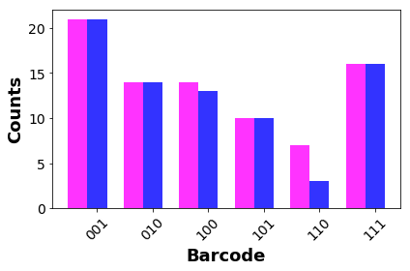

#Manual counts vs KNN-2 classification:

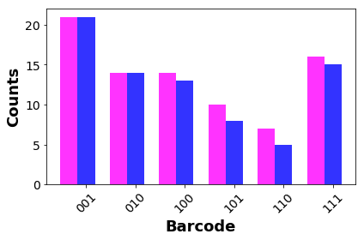

#Manual counts vs KNN-3 classification:

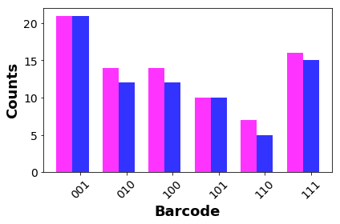

**Supporting Code 2:**

# # Implementing KNN/SVM for 7 classes

**Part 1: Organization and Parsing of Data**

## Importing Modules necessary. It is suggested to cross-verify that all required modules are ##installed. In the event it is not, it may give rise to an error

import numpy as np

import matplotlib.pyplot as plt

import pandas as pd

from sklearn.svm import SVC

from sklearn.metrics import classification_report, confusion_matrix ,accuracy_score

from sklearn import svm, neighbors

from sklearn.model_selection import StratifiedShuffleSplit ,GridSearchCV , train_test_split

from pylab import *

import matplotlib.ticker as ticker

import umap

import seaborn as sns

from sklearn.decomposition import PCA

from mpl_toolkits.mplot3d import axes3d, Axes3D

##Preprocessing of Data, from nanotaglistsortednorm.csv (An excel file which contains the #relevant information about the nanotags. This information is also displayed at the end of the file, #in the form of a table.)

#read csv files

df1 = pd.read_csv("nanotaglistsortednorm.csv")

#assign group numbers to the pre-existing labels

dictLabel = {'b000':0,'b001':1,'b010':2,'b100':3,'b101':4,'b110':5,'b111':6}

#df1 = df1.query('code == "b000" or code == "b001" or code =="b100" or code == "b110" or code == "b111" or code == "b010" or code == "b101"')

labels = df1['code']

# ## Checking the number of datapoints in each class

new_labels = [dictLabel[l] for l in labels]

class_count = {0: 0, 1: 0, 2: 0, 3:0 , 4:0 , 5:0, 6:0}

for l in new_labels:

class_count[l] += 1

print(class_count)

# ## Splitting it into test and train Data (can vary depending on the size of the dataset)

X=df1[['F','Br','I']]

y=new_labels

X_train, X_test, y_train, y_test = train_test_split(X, y, test_size = 0.15)

**Part 2: Training of Data**

##Grid search over the parameter space for SVM model

C_range = np.logspace(-2, 10, 13)

gamma_range = np.logspace(-9, 3, 13)

param_grid = dict(gamma=gamma_range, C=C_range)

cv = StratifiedShuffleSplit(n_splits=5, test_size=0.15, random_state=42)

grid = GridSearchCV(SVC(), param_grid=param_grid, cv=cv)

grid.fit(X_train, y_train)

## SVM Model Fit, using the parameters previously obtained that are best fit for the model. The #best parameters can be selected from the train-test split, in order to validate the robustness of the #model, and get an unbiased estimate of the algorithm’s performance on a dataset. Once the #parameters are determined, the algorithm can either be implemented on the original dataset, or #the test data.

svclassifier = SVC(kernel='rbf',C = 10.0, gamma = 1.0)

svclassifier.fit(X, y)

#Using the SVM model created, values are predicted for the input.

y_pred = svclassifier.predict(X)

## K-NN Model fit, for different instances of the model, with number of neighbors varying from ##2 to 4.

#Please change n_neighbors using [2,3,4] values to get the desired results and graphs.

#The KNN classifier is created, using the appropriate “n_neighbors” value and can be used on the #whole dataset, or the test dataset as per experimental protocol.

neigh = neighbors.KNeighborsClassifier(n_neighbors=4)

neigh.fit(X, y)

#Using the KNN model created, values are predicted for the input.

y_pred = neigh.predict(X)

acc_test = 100*np.sum(y_pred == y)/len(y)

#The output is printed

print(confusion_matrix(y, y_pred))

print(classification_report(y, y_pred))

#Example Output:

#Confusion Matrix:

[[14 1 1 0 1 0 0]

[ 1 20 0 0 0 0 0]

[ 2 0 12 0 0 0 0]

[ 0 0 0 13 1 0 0]

[ 0 0 0 0 8 0 2]

[ 0 0 0 3 0 3 1]

[ 1 0 0 0 1 0 14]]

#Classification matrix:

|  |
| --- |
| precision recall f1-score support |
|  |
| 0 0.78 0.82 0.80 17 |
| 1 0.95 0.95 0.95 21 |
| 2 0.92 0.86 0.89 14 |
| 3 0.81 0.93 0.87 14 |
| 4 0.73 0.80 0.76 10 |
| 5 1.00 0.43 0.60 7 |
| 6 0.82 0.88 0.85 16 |
|  |
| avg / total 0.86 0.85 0.84 99 |

**Part 3: Plotting of Data**

# ## Defining plotting functions

def make_meshgrid(x, y, h=.02):

x_min, x_max = x.min() - 1, x.max() + 1

y_min, y_max = y.min() - 1, y.max() + 1

xx, yy = np.meshgrid(np.arange(x_min, x_max, h), np.arange(y_min, y_max, h))

return xx, yy

def plot_contours(ax, clf, xx, yy, **params):

Z = clf.predict(np.c_[xx.ravel(), yy.ravel()])

Z = Z.reshape(xx.shape)

out = ax.contourf(xx, yy, Z, **params)

return out

## Plotting of data

# data to plot

print(type(X))

X = np.array(X)

X0 = X[:, 0]

n_groups = 7

#manual refers to ground truth number of tags in each class

manual = (17,21,14,14,10,7,16)

# One of the following variables can be chosen depending on which algorithm has to be used.

#This variables are updated after the above code has been run for SVM and KNN(2-4 neighbours)

SVM = (7,21,14,13,10,3,15)

KNN_2 = (17,19,10,14,10,5,4)

KNN_3 = (14,20,12,13,8,5,14)

KNN_4 = (14,20,12,13,8,3,14)

# create plot

fig, ax = plt.subplots()

index = np.arange(n_groups)

bar_width = 0.35

opacity = 0.8

rects1 = plt.bar(index, manual, bar_width,

alpha=opacity,

color='magenta',

label='Manual')

rects2 = plt.bar(index + bar_width, KNN_3, bar_width,

alpha=opacity,

color='blue',

label='kmeans_4')

plt.xlabel('Barcode',fontweight = 'bold',fontsize = 18)

plt.ylabel('Counts',fontweight = 'bold',fontsize = 18)

plt.xticks(index + bar_width, ('000', '001', '010', '100','101','110','111'))

fontsize = 14

ax = gca()

plt.yticks(np.arange(5), ('0', '5','10','15','20' ))

ax.set_xticklabels(['000','001', '010', '100','101','110','111'], minor=False, rotation=45)

for tick in ax.xaxis.get_major_ticks():

tick.label1.set_fontsize(fontsize)

#tick.label1.set_fontweight('bold')

for tick in ax.yaxis.get_major_ticks():

tick.label1.set_fontsize(fontsize)

#tick.label1.set_fontweight('bold')

for axis in [ax.yaxis]:

axis.set_major_locator(ticker.MaxNLocator(5))

plt.tight_layout()

plt.show()

#Example Plots:

#Manual counts vs SVM classification:

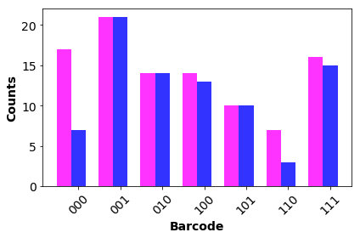

#Manual counts vs KNN-2 classification:

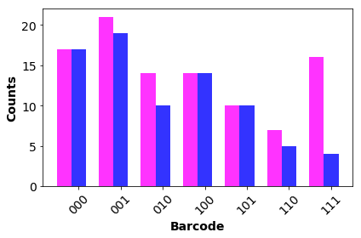

#Manual counts vs KNN-3 classification:

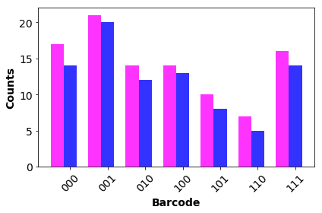

# ## Scatterplot 3D of data

X=df1[['F','Br','I']]

X_F= X[['F']]

X_Br= X[['Br']]

X_I =X[['I']]

N = 7

cmap = plt.cm.jet

cmaplist = [cmap(i) for i in range(cmap.N)]

cmap = cmap.from_list('Custom cmap', cmaplist, cmap.N)

bounds = np.linspace(0,N,N+1)

norm = mpl.colors.BoundaryNorm(bounds, cmap.N)

fig = plt.figure()

ax = Axes3D(fig)

scat = ax.scatter(X_F,X_Br,X_I,c=y,cmap=cmap,norm=norm)

ax.set_xlabel('X-axis')

ax.set_ylabel('Y-axis')

ax.set_zlabel('Z-axis')

ax.set_title("3D Scatterplot")

plt.show()

#Example scatterplots:

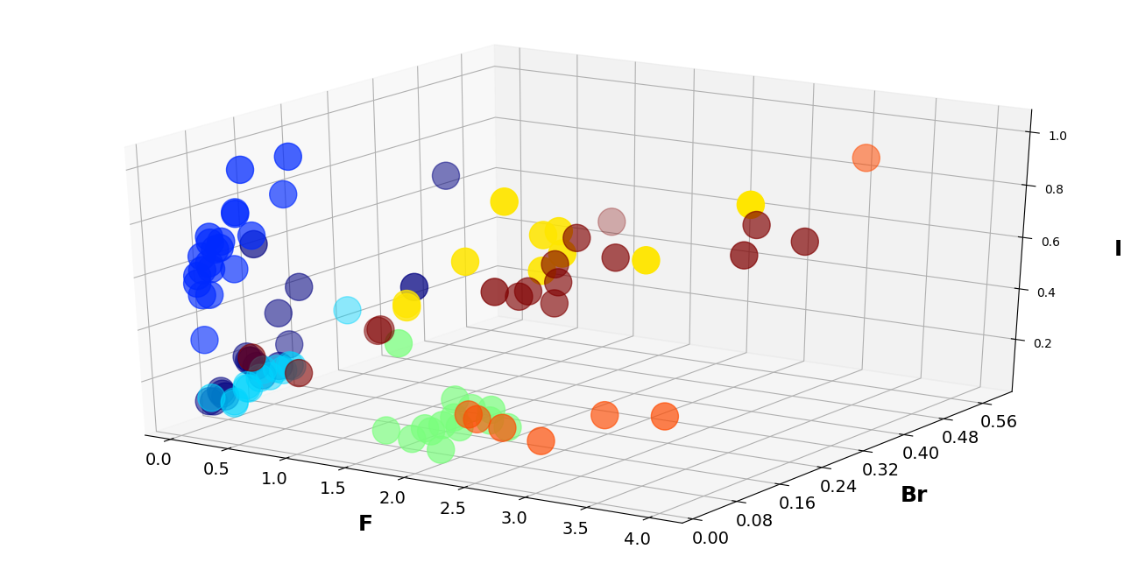

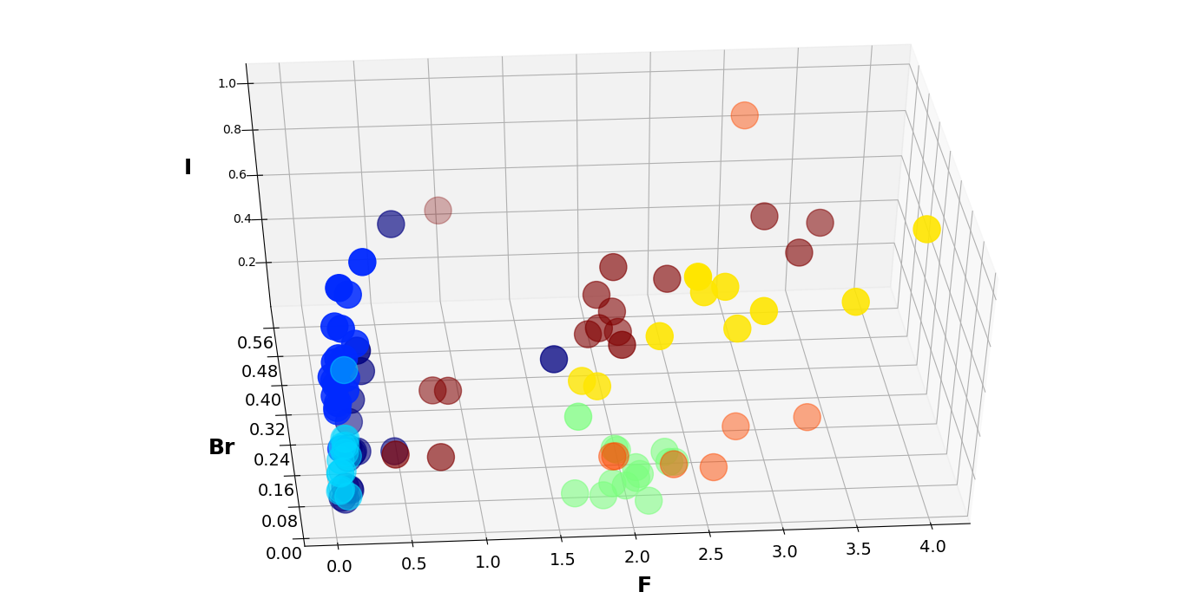

The original data of the nanotags is presented in the following table.

|  |  |  |  |  |  |
| --- | --- | --- | --- | --- | --- |
|  | **Si** | **F** | **Br** | **I** | **code** |
| **3** | 2079 | 1.536797 | 0.102557 | 0.594991 | 000 |
| **11** | 1941 | 0.086038 | 0.03325 | 0.106314 | 000 |
| **18** | 591 | 0.169205 | 0.100464 | 0.199369 | 000 |
| **19** | 109 | 0.449541 | 0.084285 | 0.231398 | 000 |
| **22** | 884 | 0.127828 | 0.053069 | 0.112887 | 000 |
| **30** | 206 | 0.252427 | 0.090409 | 0.682067 | 000 |
| **37** | 961 | 0.123829 | 0.048984 | 0.126264 | 000 |
| **46** | 499 | 0.202405 | 0.085395 | 0.234276 | 000 |
| **52** | 650 | 0.176923 | 0.156729 | 0.242843 | 000 |
| **73** | 772 | 0.17487 | 0.087157 | 0.231304 | 000 |
| **76** | 358 | 0.198324 | 0.136553 | 0.381357 | 000 |
| **78** | 2514 | 0.1428 | 0.114659 | 0.150025 | 000 |
| **81** | 376 | 0.284574 | 0.156786 | 0.47437 | 000 |
| **82** | 5011 | 0.070245 | 0.044158 | 0.095712 | 000 |
| **84** | 693 | 0.145743 | 0.08915 | 0.243408 | 000 |
| **86** | 1732 | 0.095843 | 0.052167 | 0.132567 | 000 |
| **92** | 194 | 0.603093 | 0.35538 | 0.787929 | 000 |
| **10** | 840 | 0.165476 | 0.072808 | 0.594025 | 001 |
| **15** | 980 | 0.084694 | 0.04501 | 0.510281 | 001 |
| **17** | 2281 | 0.088996 | 0.025107 | 0.56783 | 001 |
| **23** | 3512 | 0.086845 | 0.031786 | 0.346812 | 001 |
| **24** | 1548 | 0.082687 | 0.033058 | 0.517577 | 001 |
| **27** | 2997 | 0.143143 | 0.024318 | 0.622598 | 001 |
| **32** | 784 | 0.156888 | 0.055313 | 0.709943 | 001 |
| **45** | 622 | 0.090032 | 0.049162 | 0.606093 | 001 |
| **49** | 783 | 0.243934 | 0.089268 | 0.714592 | 001 |
| **57** | 2326 | 0.072657 | 0.029049 | 0.592738 | 001 |
| **59** | 1083 | 0.11819 | 0.043503 | 0.733092 | 001 |
| **60** | 1029 | 0.124393 | 0.050823 | 0.681062 | 001 |
| **66** | 1087 | 0.081877 | 0.047878 | 0.62791 | 001 |
| **67** | 1806 | 0.095792 | 0.048688 | 0.706362 | 001 |
| **74** | 778 | 0.169666 | 0.09058 | 0.954735 | 001 |
| **79** | 3158 | 0.064915 | 0.039588 | 0.658682 | 001 |
| **83** | 1506 | 0.120186 | 0.087811 | 0.795612 | 001 |
| **85** | 2553 | 0.135919 | 0.056331 | 0.683865 | 001 |
| **91** | 880 | 0.235227 | 0.147115 | 0.830637 | 001 |
| **97** | 2636 | 0.158953 | 0.080608 | 0.796936 | 001 |
| **98** | 1348 | 0.341246 | 0.137476 | 0.983541 | 001 |
| **6** | 1021 | 0.125367 | 0.11992 | 0.166844 | 010 |
| **12** | 2736 | 0.107822 | 0.033422 | 0.121284 | 010 |
| **31** | 1585 | 0.071924 | 0.078742 | 0.068821 | 010 |
| **38** | 964 | 0.078838 | 0.09916 | 0.106264 | 010 |
| **41** | 526 | 0.095057 | 0.096849 | 0.120862 | 010 |
| **43** | 440 | 0.193182 | 0.257072 | 0.305568 | 010 |
| **47** | 4664 | 0.063679 | 0.079883 | 0.059609 | 010 |
| **48** | 589 | 0.147708 | 0.165671 | 0.148352 | 010 |
| **50** | 840 | 0.080952 | 0.102659 | 0.102767 | 010 |
| **58** | 679 | 0.145803 | 0.12688 | 0.137454 | 010 |
| **69** | 956 | 0.118201 | 0.144645 | 0.151529 | 010 |
| **71** | 698 | 0.137536 | 0.163373 | 0.152847 | 010 |
| **72** | 2124 | 0.09275 | 0.11965 | 0.132112 | 010 |
| **75** | 987 | 0.139818 | 0.151239 | 0.142601 | 010 |
| **0** | 1572 | 2.052163 | 0.059322 | 0.16504 | 100 |
| **2** | 2523 | 1.968688 | 0.03608 | 0.12359 | 100 |
| **4** | 4815 | 2.338318 | 0.092799 | 0.121559 | 100 |
| **14** | 1355 | 1.884133 | 0.042984 | 0.123243 | 100 |
| **16** | 692 | 1.926301 | 0.087831 | 0.202561 | 100 |
| **28** | 1343 | 1.817573 | 0.033877 | 0.084635 | 100 |
| **36** | 410 | 1.660976 | 0.047544 | 0.430338 | 100 |
| **44** | 1089 | 1.623508 | 0.029457 | 0.1068 | 100 |
| **53** | 401 | 2.259352 | 0.081183 | 0.192514 | 100 |
| **54** | 801 | 2.042447 | 0.040796 | 0.149235 | 100 |
| **56** | 2312 | 2.115484 | 0.021886 | 0.074287 | 100 |
| **70** | 734 | 2.286104 | 0.072564 | 0.159689 | 100 |
| **88** | 1510 | 1.956954 | 0.110311 | 0.154286 | 100 |
| **90** | 2893 | 2.080539 | 0.062404 | 0.126287 | 100 |
| **7** | 144 | 3.979167 | 0.158327 | 1.0138 | 101 |
| **9** | 2132 | 1.781426 | 0.038681 | 0.580807 | 101 |
| **29** | 1470 | 1.692517 | 0.056774 | 0.574689 | 101 |
| **62** | 1311 | 2.194508 | 0.054065 | 0.766149 | 101 |
| **64** | 539 | 2.879406 | 0.074489 | 0.825732 | 101 |
| **68** | 1306 | 2.712864 | 0.075494 | 0.751369 | 101 |
| **80** | 1058 | 3.482987 | 0.087411 | 0.830915 | 101 |
| **94** | 752 | 2.444149 | 0.069528 | 0.989448 | 101 |
| **96** | 1231 | 2.523152 | 0.11869 | 0.840208 | 101 |
| **99** | 1788 | 2.657718 | 0.116781 | 0.863981 | 101 |
| **13** | 1849 | 1.943213 | 0.107398 | 0.130722 | 110 |
| **26** | 1739 | 2.326049 | 0.086003 | 0.123241 | 110 |
| **33** | 2498 | 1.933947 | 0.124291 | 0.098111 | 110 |
| **34** | 3077 | 2.603835 | 0.095006 | 0.085698 | 110 |
| **55** | 1576 | 2.802665 | 0.166823 | 0.143968 | 110 |
| **87** | 1726 | 3.289687 | 0.168146 | 0.173849 | 110 |
| **89** | 231 | 3.121212 | 0.580427 | 0.861454 | 110 |
| **1** | 1048 | 3.298664 | 0.30782 | 0.684914 | 111 |
| **5** | 24992 | 0.74912 | 0.058694 | 0.244284 | 111 |
| **8** | 27277 | 0.44367 | 0.040386 | 0.296691 | 111 |
| **20** | 1157 | 1.000864 | 0.577464 | 0.486388 | 111 |
| **21** | 5384 | 1.831538 | 0.223721 | 0.491724 | 111 |
| **25** | 1391 | 2.038821 | 0.283488 | 0.686907 | 111 |
| **35** | 2388 | 2.012982 | 0.255362 | 0.536272 | 111 |
| **39** | 3376 | 2.009182 | 0.14303 | 0.578873 | 111 |
| **40** | 3356 | 1.906138 | 0.224328 | 0.516557 | 111 |
| **42** | 1192 | 2.044463 | 0.241482 | 0.467393 | 111 |
| **51** | 1371 | 3.110868 | 0.373864 | 0.742043 | 111 |
| **61** | 2366 | 2.393914 | 0.275988 | 0.640108 | 111 |
| **65** | 3297 | 0.764331 | 0.194621 | 0.308549 | 111 |
| **77** | 1783 | 0.86203 | 0.179516 | 0.331535 | 111 |
| **93** | 1447 | 3.492053 | 0.37679 | 0.701297 | 111 |
| **95** | 5200 | 1.918077 | 0.270326 | 0.588173 | 111 |