TECH MAHINDRA

Solution Proposal
Prepared for: DiagTest
April 2026 | CONFIDENTIAL

Tech Mahindra – Solution Proposal

Executive Summary
- This is a test proposal.

Architecture
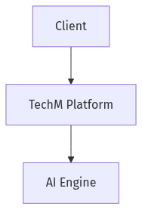
Figure: Solution Architecture Diagram

Commercials
Role | Rate
Architect | $120/hr

Appendix: Agent Analysis Details

Requirements Analysis
- Requirements
- Cloud migration
- 6-month delivery

Architecture Design
- Architecture
- Cloud-native solution.

Commercial Model
- Rate Card

