TARIFF TRACKER & IMPORT COST
INTELLIGENCE SYSTEM
Comprehensive Operational User Manual & Reference Guide
Prepared for: Supply Chain and Procurement Operations Teams
Version: 2.1 (MERN Edition) | Date: June 2026

1. Executive Overview & Logical Architecture
The Tariff Tracker & Import Cost Intelligence System is an enterprise-grade web platform designed to mitigate macroeconomic sourcing hazards. In an environment characterized by dynamic trade policy updates, tariffs, and geopolitical maritime corridor blockades, this system serves as a Decision Support System (DSS) for procurement executives. By integrating static Enterprise Resource Planning (ERP) records with live, real-time geopolitical data streams, it provides supply chain resilience metrics, predicts financial impacts, and optimizes procurement shares automatically.
Logical Architecture & Data Layers
The platform utilizes a decoupled, modern three-tier logical architecture designed to minimize latency while querying public REST API endpoints:
- Presentation Layer (Frontend): React.js client-side application compiled via Rollup/Vite. The client manages its own state and renders advanced analytical widgets.
- Application Layer (Backend Server): Express.js REST API server executing on Node.js. It manages calculation services, external API caches, and handles connection throttling.
- Database Layer: MongoDB Atlas Cloud Cluster hosting logical data collections for ERP configurations, supplier masters, and synchronization timestamps.
- Integration & AI Layer: Integrates live external endpoints including World Bank Logistics Performance Index (LPI) APIs, HMRC/WCO Trade Tariff classification APIs, GDELT geopolitical news feeds, and Amazon Bedrock Claude-3 Haiku models for executive risk analysis.
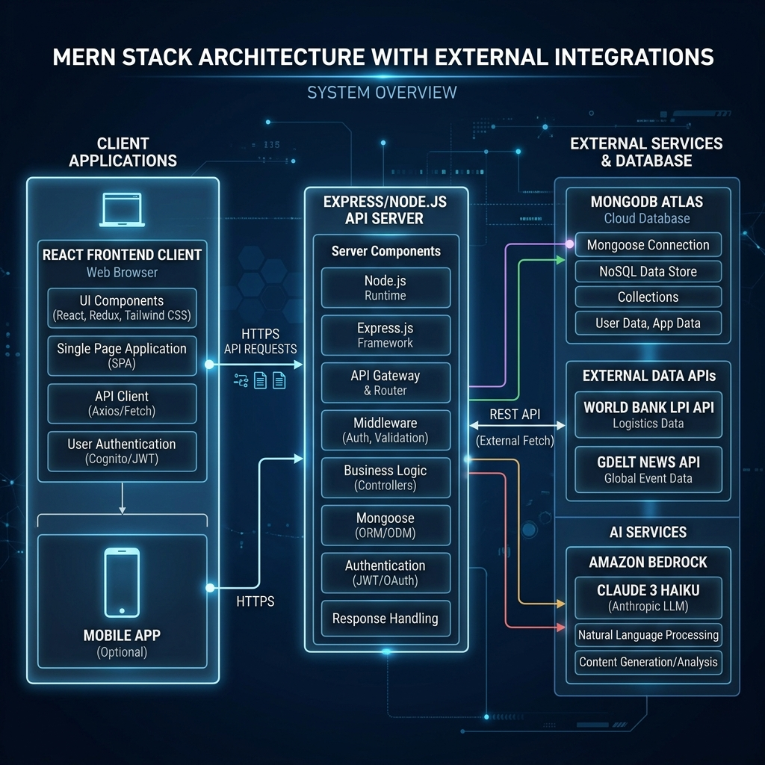
Figure: High-level logical network topology, decoupled MERN layers, and external service integrations.
Logical Data Segmentation
Data inside the system is organized into three distinct layers based on volatility and ingestion mode:
Data Segment | Ingestion Mode & Source | Description / Volatility
Product/Supplier Master | Automated Excel Ingestion from ERP (xlsx) | Ingested automatically upon boot by comparing OS filesystem timestamps. Volatility: Low (weekly/monthly).
External Geopolitical & News | Real-time GET API calls (World Bank, HMRC, GDELT) | Fetched on-demand with a 1-hour in-memory cache TTL to ensure quick page renders. Volatility: Medium (hourly).
Interactive Overrides | Direct Client User Input (Custom Inputs) | Allows immediate testing of tariff percentage adjustments, shipping corridors, and weight settings. Volatility: High (real-time simulation).

2. Technical Abbreviations & Glossary
To facilitate alignment across logistics, financial, and operations departments, the table below provides precise operational definitions for the technical terminology and jargon used throughout the platform:
Abbreviation / Term | Standard Meaning | Tariff Tracker Application Context
FOB | Free On Board | The base purchase price of the product at the origin port, excluding freight, insurance, tariffs, and customs duties.
CIF | Cost, Insurance, and Freight | Landed cost basis that includes the base price plus shipping ocean freight and marine cargo insurance.
VED | Vital, Essential, Desirable | Inventory criticality framework segmenting parts based on the severity of operational stoppage if out of stock.
SDE | Scarce, Difficult, Easy | Sourcing classification mapping supply lead times and supplier dependency (scarcity of supply routes).
HHI | Herfindahl-Hirschman Index | A mathematical measure of supplier concentration. High HHI indicates extreme reliance on a single supplier.
OTIF | On-Time, In-Full | Supplier reliability rating representing the percentage of shipments received on time and without shortfalls.
LPI | Logistics Performance Index | A World Bank rating (1.0 to 5.0) assessing a country's logistics competence, customs efficiency, and infrastructure quality.
HS Code | Harmonized System Code | A standardized numerical method of classifying traded products, used by customs to apply correct tariff rates.
MOQ | Minimum Order Quantity | The minimum quantity of units a supplier requires to accept a procurement purchase order.
ROQ | Reorder Quantity | The recommended standard purchase order size triggered when inventory levels hit the Reorder Point.

3. Executive KPI Dashboard Navigation
The Dashboard acts as the system landing page, serving as a command console. It aggregates key metrics and alert levels to give executives an immediate health check of the active sourcing and supply chain portfolio.
Key Visual Components & Functional Buttons
- KPI Summary Cards: Displays total SKUs, active suppliers, total inventory value, average portfolio risk score, and critical coverage items.
- Currency Switcher (Navbar): Allows switching the display currency between USD ($), INR (₹), and EUR (€) in real-time, pulling live conversion rates from exchange rate APIs.
- Sync Rates Button: Triggers a background fetch to retrieve the latest rates and refreshes the database cache.
- Inventory Risk Alerts Grid: Highlights products whose inventory levels are critically below their reorder points or safety stocks, providing a click-through link to the Tariff Impact Calculator.
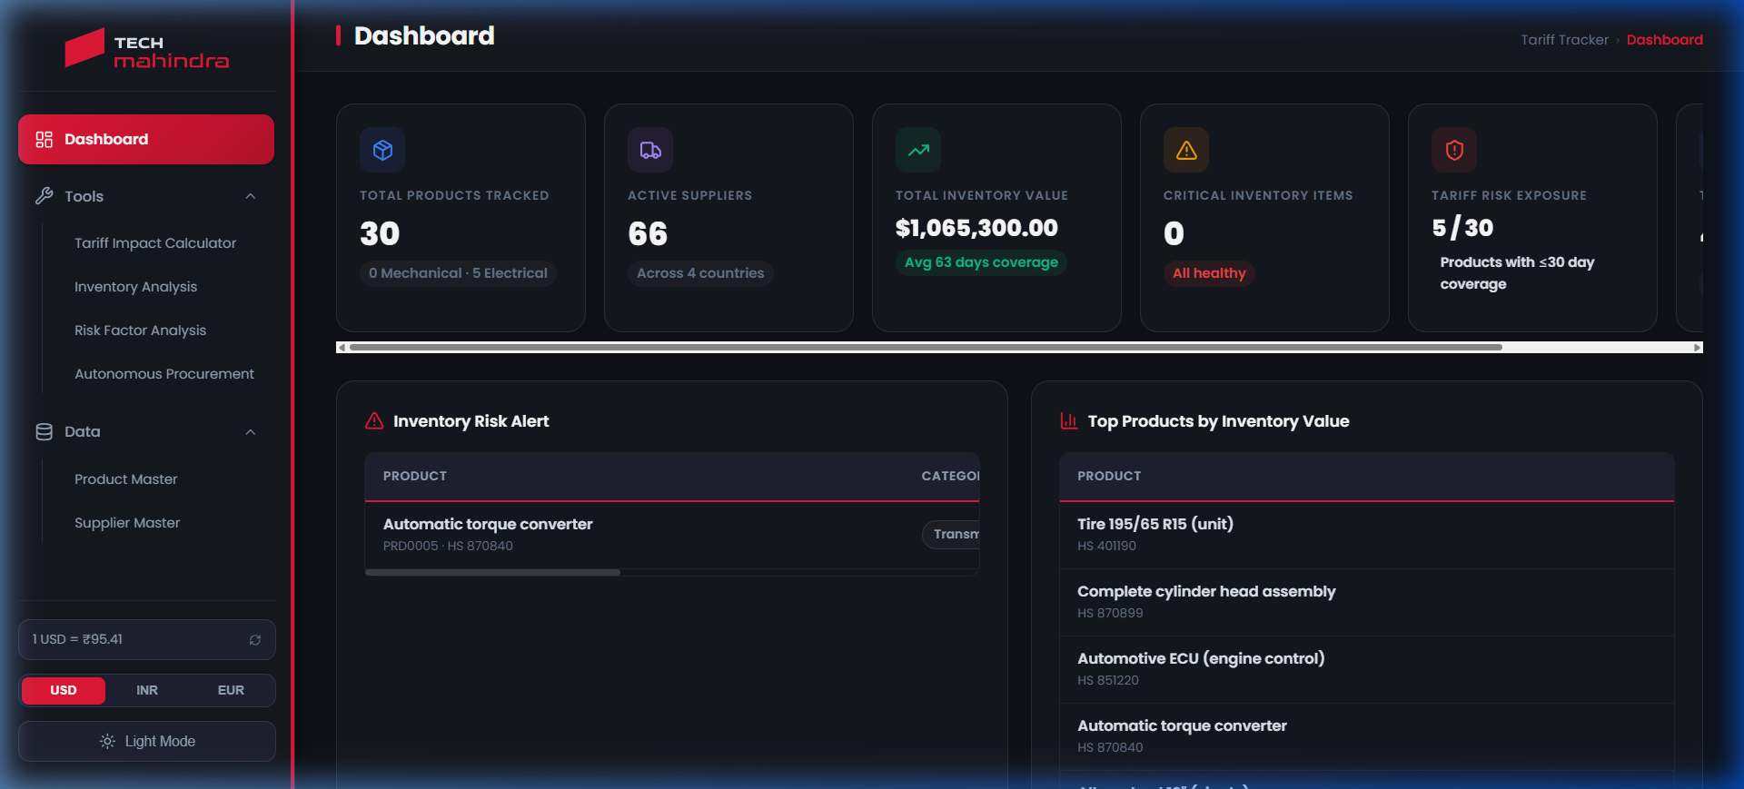
Figure: Executive Dashboard showing unified supply portfolio KPIs, interactive alerts grid, and currency options.

4. Step-by-Step User Guides for the 4 Core Tools
Tool 1: Tariff Impact Calculator
The Tariff Impact Calculator is a financial modeling tool designed to calculate the true Landed Cost of imported components, enabling comparisons between suppliers located in different tariff zones (e.g. FOB China vs. FOB Mexico).
Data Inputs & Modes
- Product Selection (Pre-fed): Retrieved automatically from Product Master when searching by erpCode.
- Supplier Selection (Pre-fed): Retrieves origin region, country, default transportation mode, reliability, and MOQ for all registered suppliers.
- Destination Country (User Input): The target destination country (e.g. United States, Germany, India) to establish the tariff corridor.
- Unit Base Price FOB (User Input): Base unit price (FOB) of the product at the origin port.
- Order Quantity (User Input): Size of the simulated order.
- Interactive Percentage Overrides: Allows overriding the default percentages for Tariff rates, Freight/Shipping costs, Insurance rates, other duties, and variable cost percentages.
System Outputs & Features
- Landed Cost Breakdown: Itemized listing of additional costs (Tariff value, Freight value, Insurance cost, and other taxes).
- Dual Supplier Comparison: A direct comparison table listing total landed cost differences, shipping time differences, and the cheapest alternative.
- Scenario Simulator: Simulates positive or negative tariff adjustments (e.g. +20% tariff spike) and displays the resulting unit cost shift.
- Sensitivity Matrix: A sensitivity table evaluating unit landed cost shifts across ten levels of tariff adjustments (-25% to +50%).
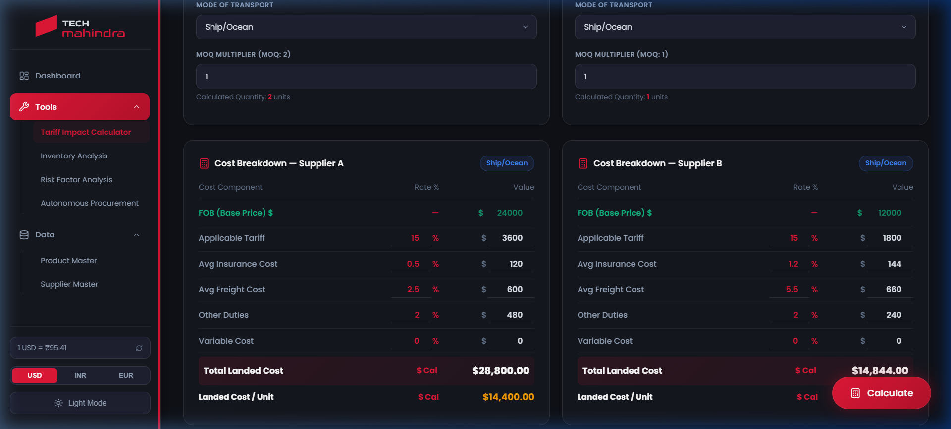
Figure: Tariff Impact Calculator showing comparative landed cost breakdowns, user inputs, and overrides.
Mathematical Modeling (Landed Cost & Sensitivity)
The system evaluates the Total Landed Cost ($TLC$) and Landed Cost Per Unit ($LCPU$) using the following equations:
Total Landed Cost = FOB + Tariff + Insurance + Freight + Other Duties + Variable Cost
Where:
* Tariff = FOB * (Tariff% / 100)
* Insurance = FOB * (Insurance% / 100)
* Freight = FOB * (Freight% / 100)
* Other Duties = FOB * (OtherDuties% / 100)
* Variable Cost = FOB * (VariableCost% / 100)
LCPU = Total Landed Cost / Order Quantity
The Scenario Simulator applies a percentage change ($c_{pct}$) to the base tariff percentage ($T_{base}$), deriving the new tariff rate ($T_{new} = T_{base} imes (1 + c_{pct} / 100)$), which is then used to recalculate the Total Landed Cost ($TLC_{new}$). The Sensitivity Matrix iterates this recalculation for $c_{pct} \in \{-25, -15, -10, -5, 0, 5, 10, 15, 25, 50\}$.

Tool 2: Inventory Analysis (Sourcing & Criticality)
The Inventory Analysis tool implements material criticality categorization, providing a proportional treemap visualization. The dashboard maps stock items by category, days of coverage, and current inventory value, making it easy to identify which high-value components are under-stocked.
Data Inputs & Modes
- Product Metrics: Category, Days of Coverage, In-Hand Inventory, and Inventory Value (Pre-fed).
- Supplier parameters: Lead Time Days, Reliability, and Number of Active Suppliers (Pre-fed).
- Dynamic Filter: Users can click on categories and filter records dynamically in the UI.
System Outputs & Features
- Visual Proportional Treemap: Displays proportional tiles sized by total inventory value and colored by material criticality classes (VED/SDE).
- Key Logistics Metrics: Displays lead times, Days of Coverage, and average supply reliability per category.
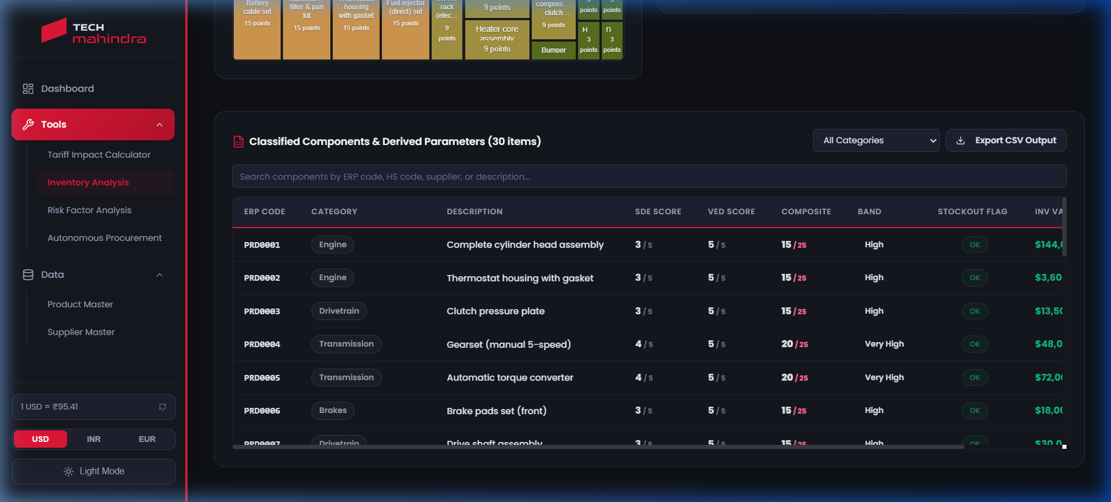
Figure: Inventory Analysis showing SKU coverage metrics, daily demand rates, and criticality classification tables.
Mathematical Modeling (VED & SDE Rules)
The system classifies each product into SDE (Sourcing) and VED (Operational Criticality) bands using logic codified in the backend:
1. SDE Classification Logic:
- S (Scarce): Max Lead Time > 30 days OR Number of Suppliers = 1. (Score: 5.0 if 1 supplier, 4.5 if multiple)
- D (Difficult): Max Lead Time > 20 days OR Number of Suppliers = 2. (Score: 3.5 if 2 suppliers, 3.0 if 1 supplier)
- E (Easy): Max Lead Time <= 20 days AND Number of Suppliers > 2. (Score: 1.0 if <= 12 days, 1.8 otherwise)
2. VED Classification Logic (Based on Category keyword & Days of Coverage):
- Base Score = 4.5 (Vital) for 'engine', 'transmission', 'drivetrain', 'brake', 'electrical'
- Base Score = 3.0 (Essential) for 'hvac', 'fuel', 'steering', 'suspension', 'wheel', 'tire'
- Base Score = 1.5 (Desirable) for general categories
- Adjustment: If Days of Coverage <= 20 days: Score = Base Score + 1.0
If Days of Coverage > 60 days: Score = Base Score - 1.0
- Clamping: Final VED Score is clamped between 1.0 and 5.0
- Category assignment: Score >= 4.0 -> Vital (V); Score >= 2.5 -> Essential (E); otherwise Desirable (D)
3. Criticality Score:
- Criticality Score = SDE Score * VED Score (Maximum Value = 25.0)

Tool 3: Risk Factor Analysis (Risk Engine)
The Risk Engine implements a double-scoring risk analysis matrix. By combining mathematical scoring models with live global API inputs (GDELT News and World Bank LPI) and Amazon Bedrock generative AI, it outputs a comprehensive, executive-ready threat overview for every SKU.
Data Inputs & Modes
- Risk Model Weights (Pre-fed): Standard weights for Model A (Weighted Sum) and Model B (Likelihood * Impact) are pre-loaded in the configuration.
- Operational Thresholds (Pre-fed): Thresholds for safety stocks and OTIF parameters are predefined.
- World Bank LPI (Live API): Retrieves live Logistics Performance Index (LPI) scores for supplier origin countries.
- GDELT News API (Live API): Queries global geopolitical news articles matching supplier origin and tariff keywords.
- Interactive Modals & Overrides: Users can click 'Calibrate SKU' to override weights, adjust tariff threat values, and modify corridor severity.
System Outputs & Features
- SDE * VED Heatmap Grid: A color-coded 3x3 SDE vs. VED matrix mapping the count and financial value of inventory items.
- Calculation Detail Modal: Provides step-by-step mathematical derivations of intermediate variables (ROP, daily consumption, sigma LT) when clicking 'View Math Details'.
- Amazon Bedrock AI Risk Analysis: Amazon Bedrock invokes Claude-3-Haiku to analyze LPI, news, and inventory levels, generating a concise narrative of the primary threat vectors and mitigation steps.
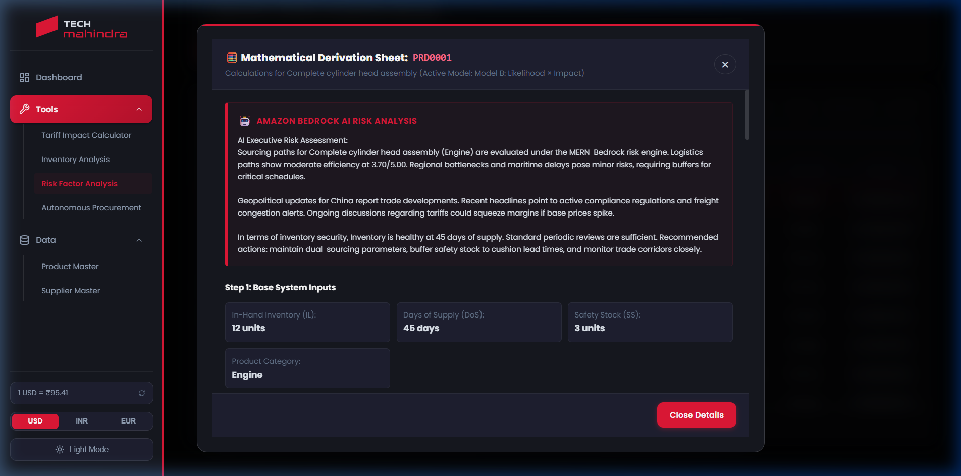
Figure: Risk Factor Analysis Details Modal displaying the Amazon Bedrock AI Analysis, intermediate variables, and calculations.
Mathematical Modeling (Risk Engine Score Models)
The Risk Engine computes eight subscores ($r_1$ to $r_8$, scaled $0.0$ to $1.0$) which represent threat vectors:
- r1 (Inventory Level): IL (In-Hand) compared to Reorder Point (ROP = DailyUse * LT_avg + SafetyStock). k = IL / ROP. r1 = clamp((1.2 - k) / (1.2 - 0.5)).
- r2 (Days of Supply): Days of Coverage compared to safety guidelines. r2 = clamp((dosSafe - DoS) / (dosSafe - dosCrit)) where dosSafe = 2.0 * LT_avg and dosCrit = 1.0 * LT_avg.
- r3 (Safety Stock Shortfall): Deviation of active safety stock from target. r3 = clamp((ssTarget - SafetyStock) / ssTarget) where ssTarget = max(SafetyStock * 1.5, 5).
- r4 (Effective Lead Time): Effective lead time including variability. r4 = clamp((ltEff - 15) / (45 - 15)) where ltEff = LT_avg + 1.65 * sigma_LT. Note: sigma_LT scales based on country LPI modifier and supplier reliability.
- r5 (Supplier Dependency): Combination of supplier concentration and shipment reliability. r5 = 0.5 * rConc + 0.5 * rOtif, where rConc is normalized HHI and rOtif scales OTIF reliability against target and floor values.
- r6 (Inventory Criticality): Category-based functional criticality base score (or override).
- r7 (Tariff News Threat): r7 = Severity * Probability * Relevance (Probability and Relevance are dynamically scaled by GDELT news sentiment).
- r8 (Corridor Threat): r8 = Relevance * (0.5 * Severity + 0.3 * Probability + 0.2 * Persistence) (scaled by region).
Using these subscores, the system evaluates two alternative risk models:
Model A (Weighted Additive):
Score_A = 100 * [Sum(w_i * r_i)]
(Utilizes weights: p1=8%, p2=15%, p3=12%, p4=15%, p5=18%, p6=12%, p7=10%, p8=10%)

Model B (Likelihood x Impact):
Score_B = 100 * Likelihood * Impact
* Likelihood = Sum(w_B_j * r_j) for j in {1, 2, 3, 4, 5, 7, 8} (Weights B normalize to 100%)
* Impact = 0.4 + 0.6 * r6 (Scales linearly from 0.4 to 1.0 based on operational criticality)

Floor Override Rule:
If Max(r2, r7, r8) >= 0.90, Final Score = Max(Score_B, 70.0) [Triggers Critical risk override]

Tool 4: Autonomous Procurement Optimizer
The Autonomous Procurement Optimizer is a mathematical solver designed to allocate purchasing quantities across multiple suppliers. It automatically respects minimum order quantities (MOQ) and concentration limits while seeking to minimize total landed cost, inventory holding costs, and risk penalties.
Data Inputs & Modes
- Product & Supplier Records (Pre-fed): Product parameters (erpCode, in-hand stock, average unit cost) and registered suppliers list (MOQs, lead times, reliability).
- Total Demand (User Input): The total number of units required to buy.
- Service Level Z (User Input): Safety factor multiplier representing target service level (standard default is 1.65, representing a 95% service level).
- Inventory Holding Cost Rate (User Input): The percentage used to calculate the annual holding cost (default is 15% of landed cost).
- Risk Penalty Weight (User Input): A sliding multiplier (0 to 10) representing the penalty weight applied to suppliers with high risk profiles.
- Dual Sourcing Constraint (Toggle): Enables the constraint requiring sourcing from at least two suppliers, preventing single-supplier bottlenecks.
- Max Supplier Share % (User Input): The maximum allocation share (e.g. 70%) allowed for any single supplier under dual sourcing.
System Outputs & Features
- Optimal Sourcing Share Allocation: The exact number of units to order from each supplier, rounded to nearest MOQ multiples.
- Total Allocation Cost Forecast: An itemized forecast of the total cost components (Landed cost sum, holding cost sum, safety stock cost, risk penalty, and total composite cost).
- Relaxation warning: If the solver cannot find a solution that satisfies both dual sourcing and MOQ limits (e.g., if MOQ totals exceed demand), it automatically relaxes constraints, allows single sourcing, and flags a warning.
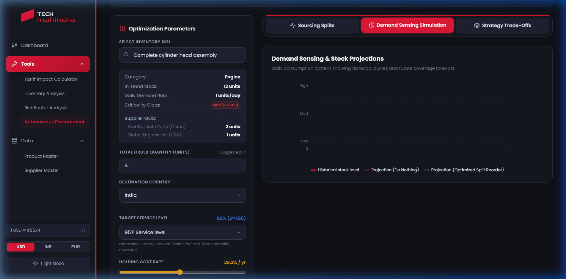
Figure: Procurement Optimizer view showing inputs, toggles, and optimizer run configurations.
Mathematical Modeling (Procurement Optimization Solver)
The solver models the allocation problem as an integer-constrained optimization program, solving over all active supplier subsets. The formulation is structured as follows:
Minimize: Total Composite Cost (W_total)
W_total = Sum_j [ Q_j * LandedCost_j ] + Sum_j [ (Q_j / 2) * HoldingCost_unit_j ]
+ Sum_j [ SafetyStock_Qty_j * HoldingCost_unit_j ] + Sum_j [ Q_j * LandedCost_j * RiskFactor_j ]
Where:
* Q_j = Quantity allocated to supplier j (Units)
* LandedCost_j = Total landed cost per unit from supplier j
* HoldingCost_unit_j = LandedCost_j * holdingCostRate
* SafetyStock_Qty_j = Z * sigma_LT_j * DailyUse
* RiskFactor_j = (RiskScore_j / 100) * RiskWeight * CriticalityFactor_j
Subject to the following constraints:
1. Demand Satisfaction: Sum_j [ Q_j ] >= Demand_total
2. MOQ Constraint: Q_j >= MOQ_j (for all active suppliers, i.e., where Q_j > 0)
3. MOQ Multiples: Q_j must be an integer multiple of MOQ_j (Q_j = m_j * MOQ_j, m_j >= 0)
4. Single Supplier Limit: Q_j <= MaxShare% * Demand_total (for all j, if dual sourcing enabled)
5. Dual Sourcing Count: Active supplier count >= 2 (if dual sourcing enabled and N >= 2)

5. Master Data Governance & Collections
The Tariff Tracker database utilizes two central master collections: Product Master and Supplier Master. These tables model the core parameters required for all financial, criticality, and optimization calculations. Any change in the physical files in `backend/data/` triggers an automatic delta synchronization upon server boot.
Product Master Data Structure
The Product Master collection stores part numbers, descriptions, HS classifications, and inventory statistics. The database fields are detailed below:
Mongoose Schema Field | Data Type | Operational Description
erpCode | String (Required, Unique) | The primary key identifier for the product, mapped to the ERP part number.
hsCode | String (Required) | The Harmonized System code used for looking up international customs tariff rates.
category | String | The component classification (e.g. Engine, Transmission, HVAC) used to establish base criticality (r6).
description | String | Text description of the part name and functional specifications.
inHandInventory | Number | The physical stock currently available inside the warehouse.
inventoryValue | Number | The book value of the current in-hand inventory in USD base currency.
inTransitInventory | Number | Quantity of units currently shipped and in route from suppliers.
daysOfCoverage | Number | Number of days the current in-hand stock will last before depletion based on demand history.
roq | Number | Reorder Quantity. The standard order size to place when triggering a new purchase order.
reviewType | String | The review model used (Perpetual vs. Periodic review cycles).
safetyStock | Number | The reserve inventory quantity held to buffer against lead time demand variability.
holdingCostPct | Number | The product-specific holding cost percentage applied annually.
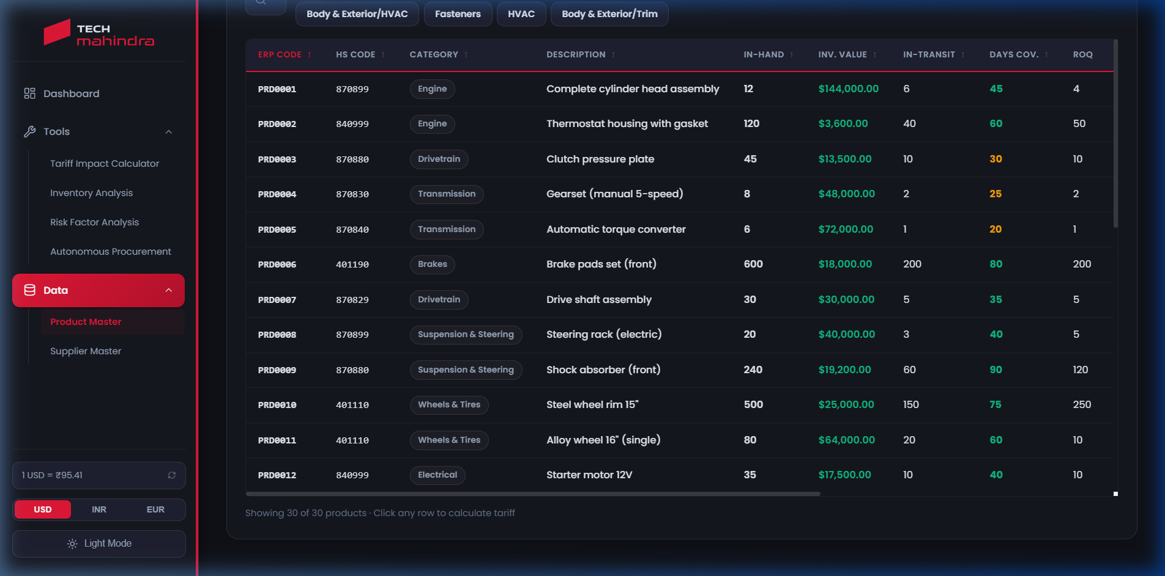
Figure: Product Master interface showing search filters, item lists, and details.

Supplier Master Data Structure
The Supplier Master collection stores supply-side parameters including supplier location, lead times, reliability rating, and MOQs. The database fields are detailed below:
Mongoose Schema Field | Data Type | Operational Description
productErpCode | String (Required) | Links the supplier record to the corresponding product erpCode. Maps one-to-many.
supplierId | String (Required) | The unique identifier of the supplier entity.
supplierName | String (Required) | The registered name of the supplier business.
country | String (Required) | The origin country of shipping, used for tariff lookups.
region | String | The geographical region (e.g. Asia, EU, NA) used to determine default shipping corridors.
countryCode | String | The ISO 2-letter country code (e.g. CN, MX, DE) used for World Bank LPI lookups.
supplyPct | Number | The percentage share of demand historically allocated to this supplier.
leadTimeDays | Number | The average time (in days) between placing an order and receiving the units.
defaultTransport | String | The default shipment mode (e.g., Ship/Ocean, Air, Road).
reliability | Number | The supplier OTIF rating (0 to 100) representing historical shipment accuracy.
moq | Number | The minimum order quantity required by this supplier to accept a purchase order.
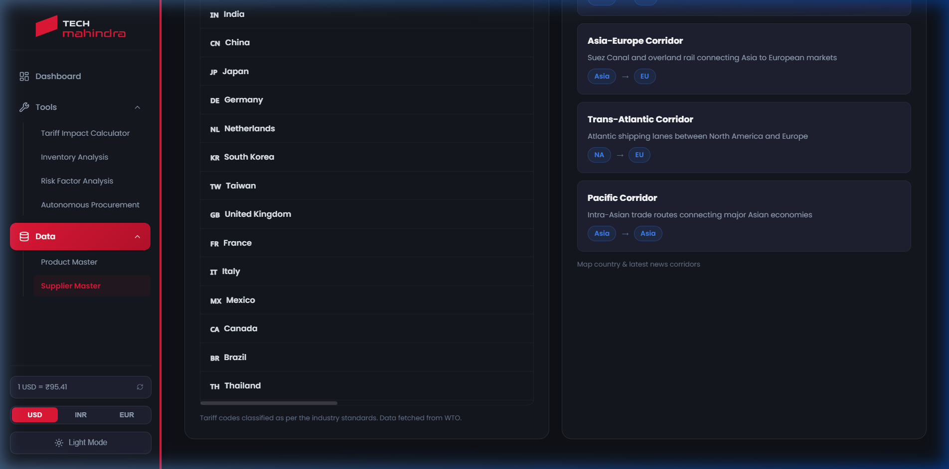
Figure: Supplier Master interface showing sourcing records, locations, and lead times.

6. Troubleshooting & FAQs
Q1: What happens if there is no internet connection to query World Bank LPI or GDELT News?
The system has a built-in fallback. If external REST services are unreachable, the backend calculations service will log a warning and apply standard regional defaults (e.g., LPI 3.5 for standard corridors) and default news scores (0.5), ensuring the user interface continues to run smoothly.
Q2: How is the Amazon Bedrock Claude-3 AI text generated?
When clicking 'View Math Details' in the Risk Engine, the system collects the specific product's inventory levels, supplier OTIF, country codes, and recent GDELT headline count. It sends this raw telemetry as a structured prompt to the Claude-3-Haiku model. If the AWS Bedrock credentials are not configured in the `.env` file, the server automatically switches to the Offline AI Risk Simulator fallback to compile the risk narrative locally.
Q3: How do I refresh the data shown on the website?
Data synchronization is automated. If you edit the values in the Product Master or Supplier Master Excel sheets inside the `backend/data/` folder, the Node.js server detects the file modification, wipes the outdated database collections, and synchronizes the new data within 2 seconds. Simply refresh your browser tab to see the updated figures.

