**FORMS**

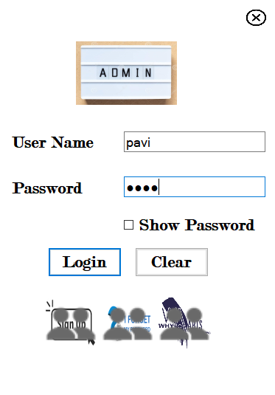**LOGIN PAGE**

**HOME PAGE**

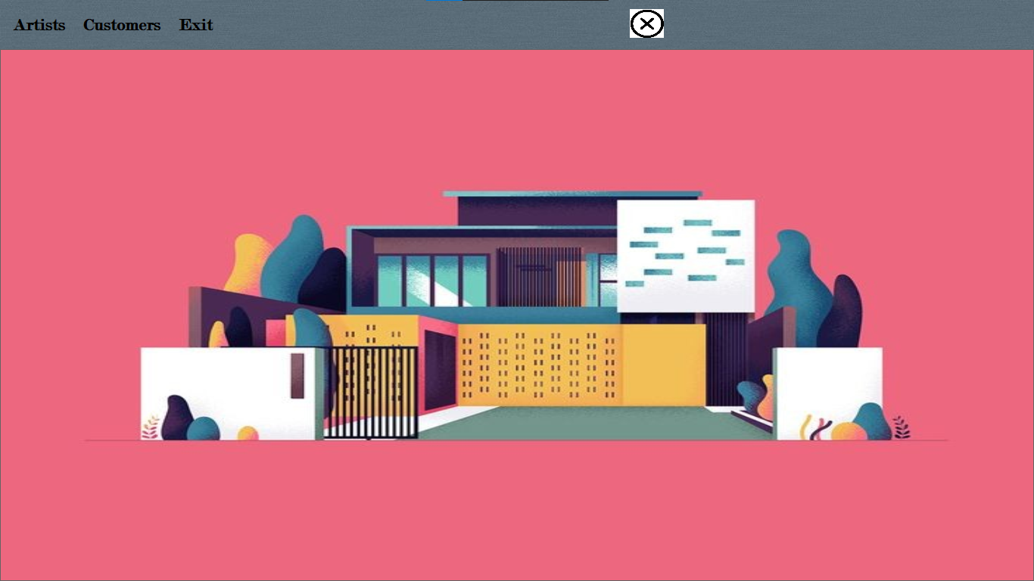

**ARTIST REGISTRATION**

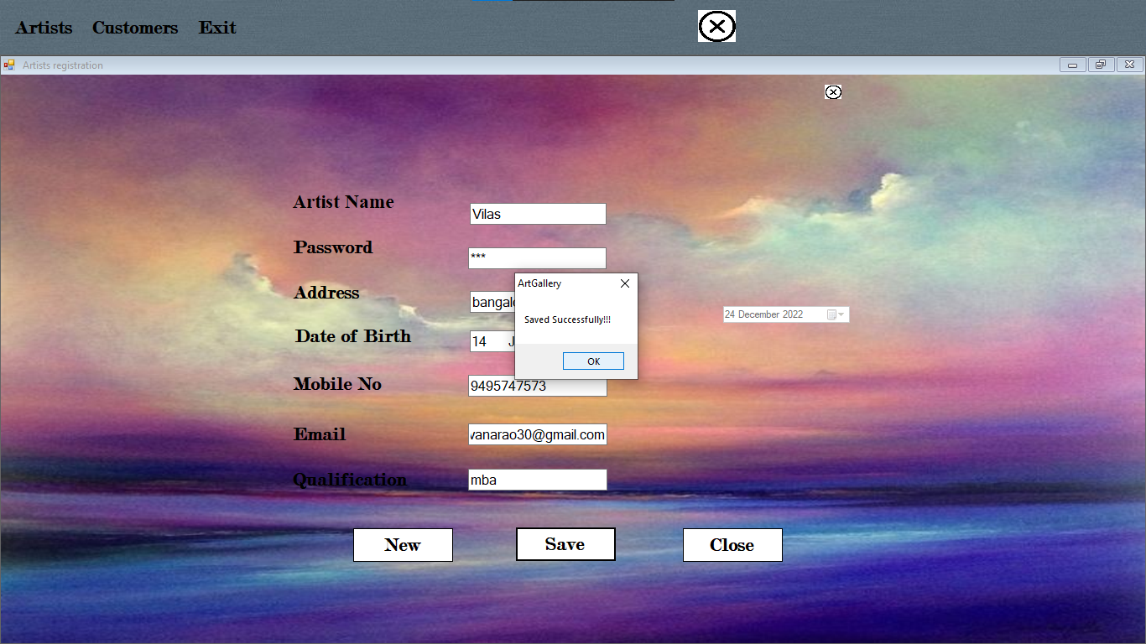

**ARTIST LOGIN**

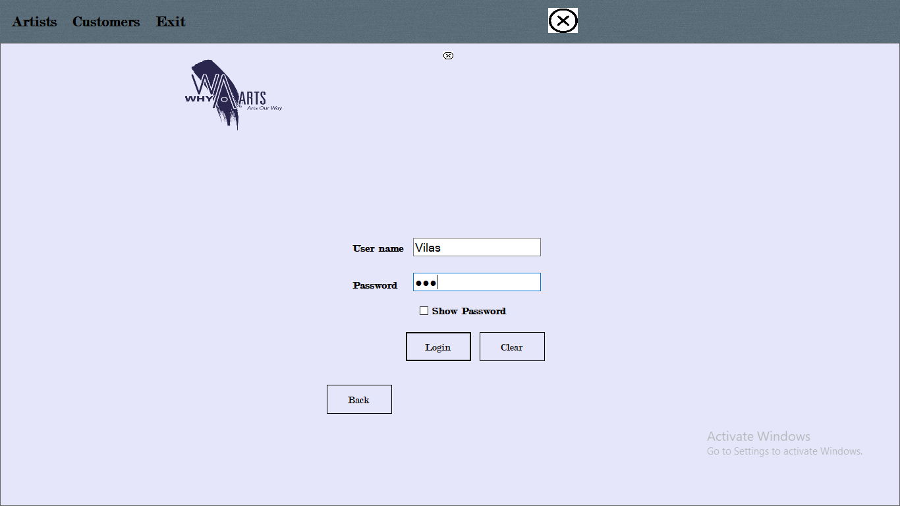

**ARTIST MAIN PAGE**



**ADD PAINTINGS**

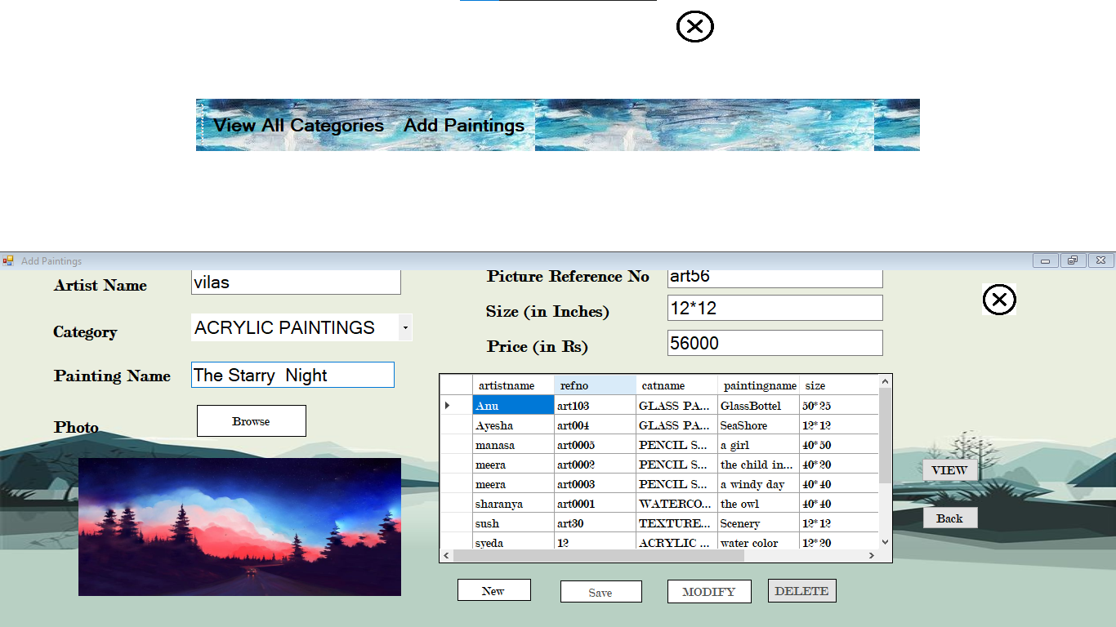

**CUSTOMER LOGIN** 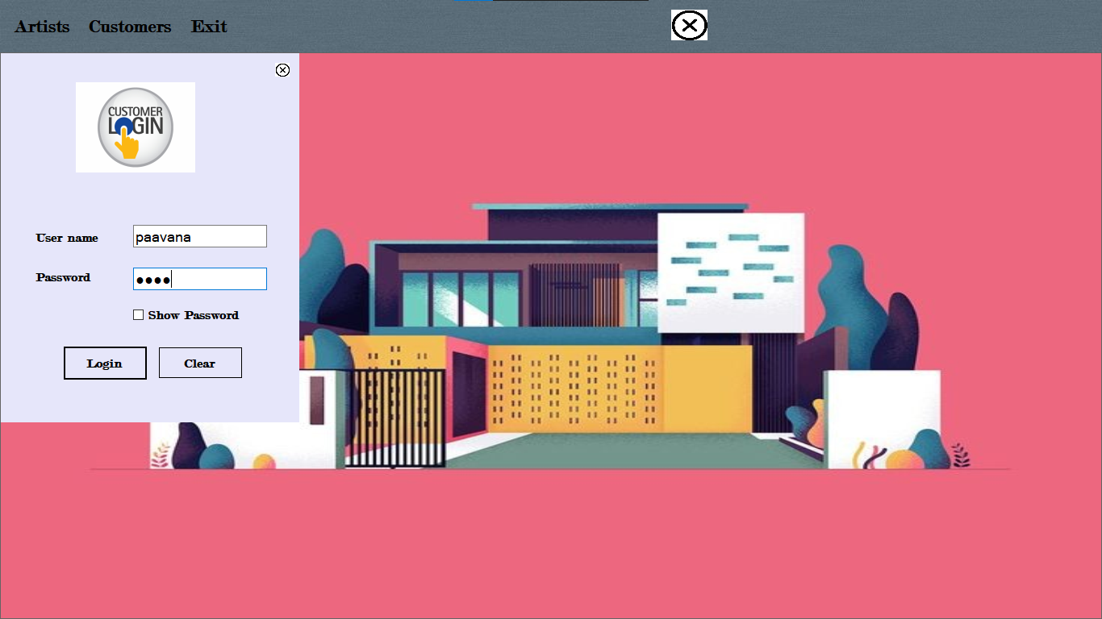

**SEARCH PAINTINGS**

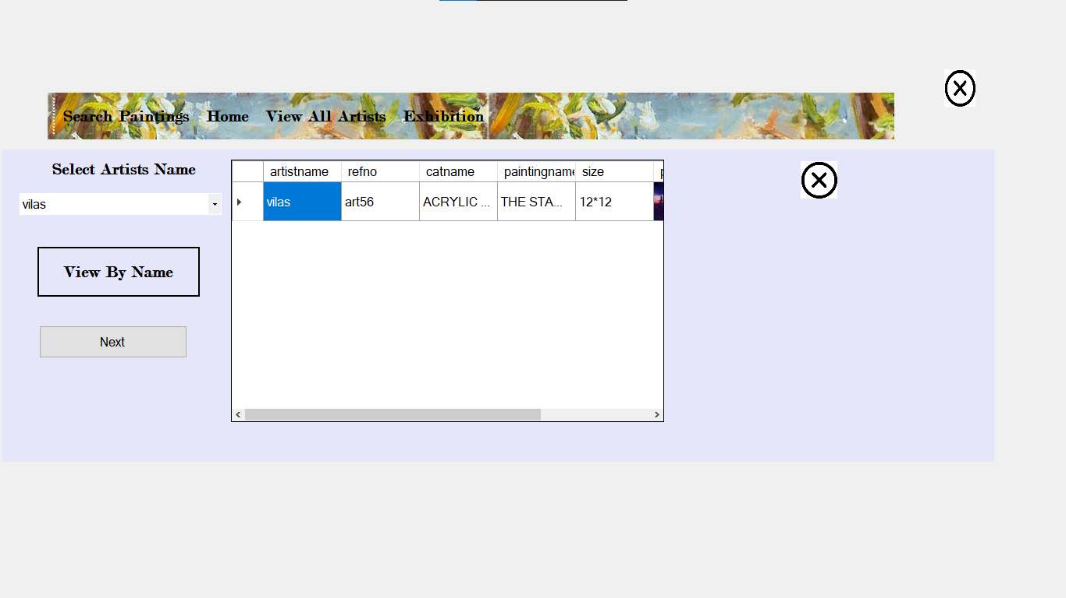

**SEARCH BY CATEGORY**



**VIEW ALL ARTISTS**

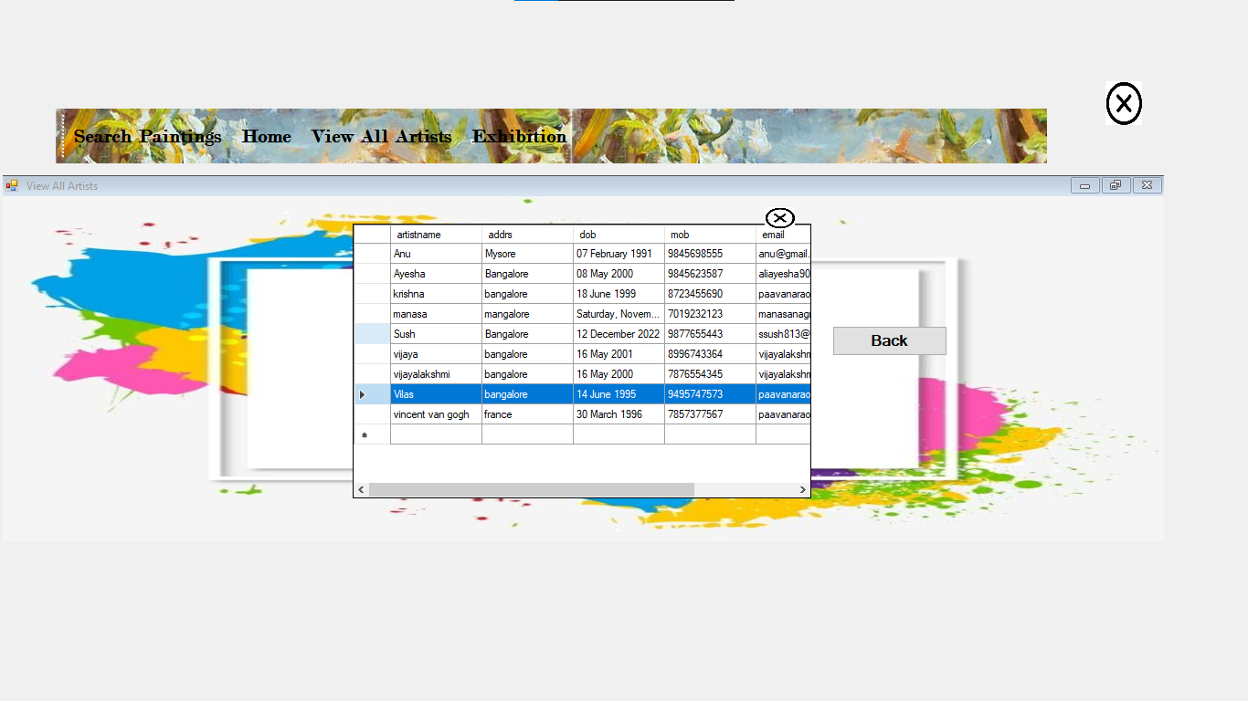

**EXHIBITION**

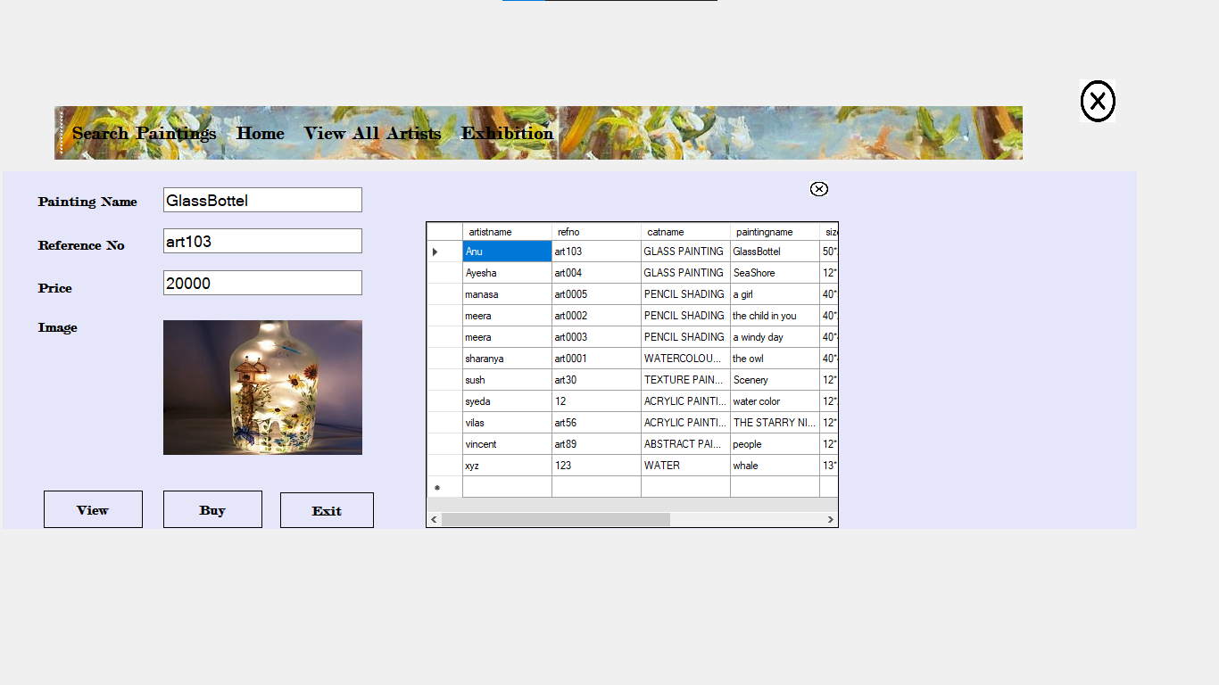

**BILLING**

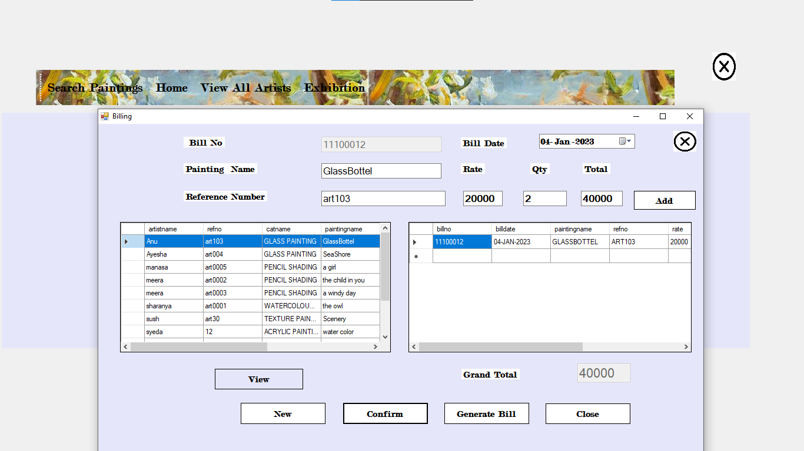

**BILL**

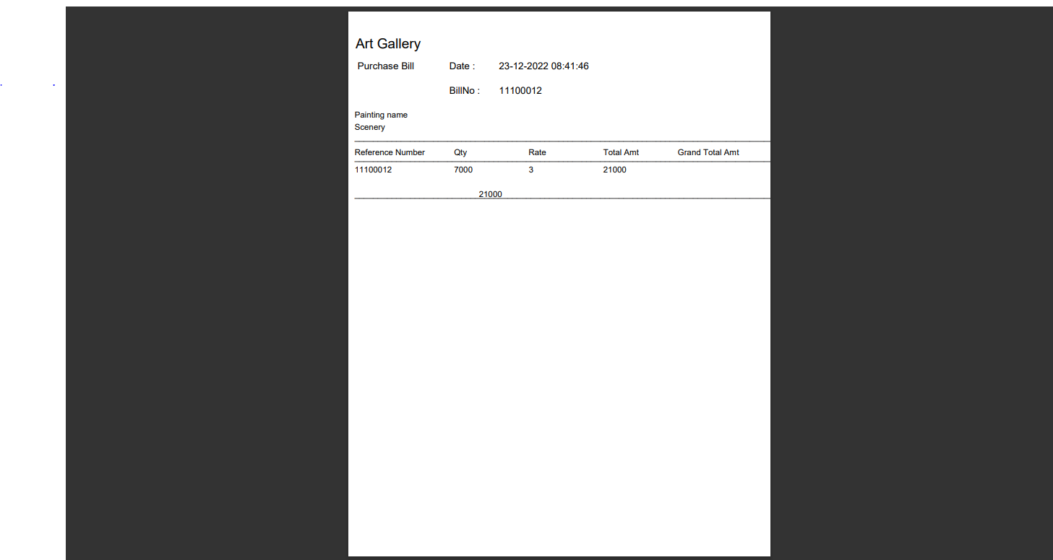

**ADMIN SIGN UP**

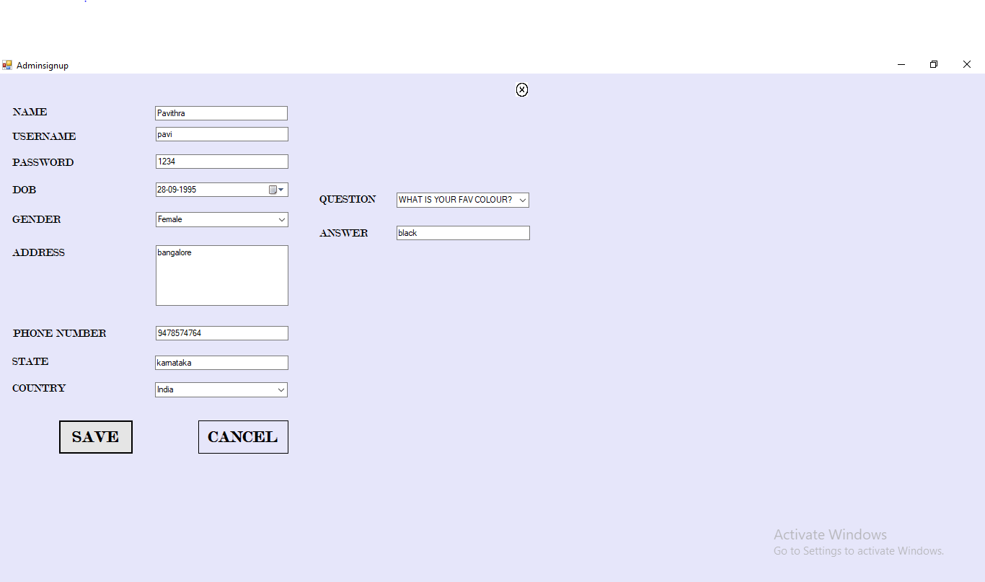

**CHECK PASSWORD**

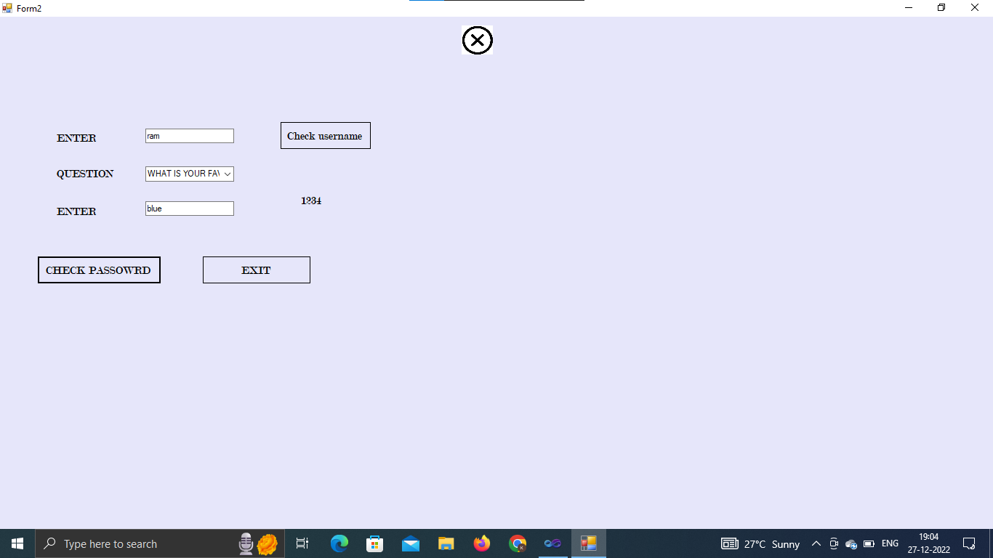

**ADMIN MAINPAGE**



**APPROVE ARTISTS**

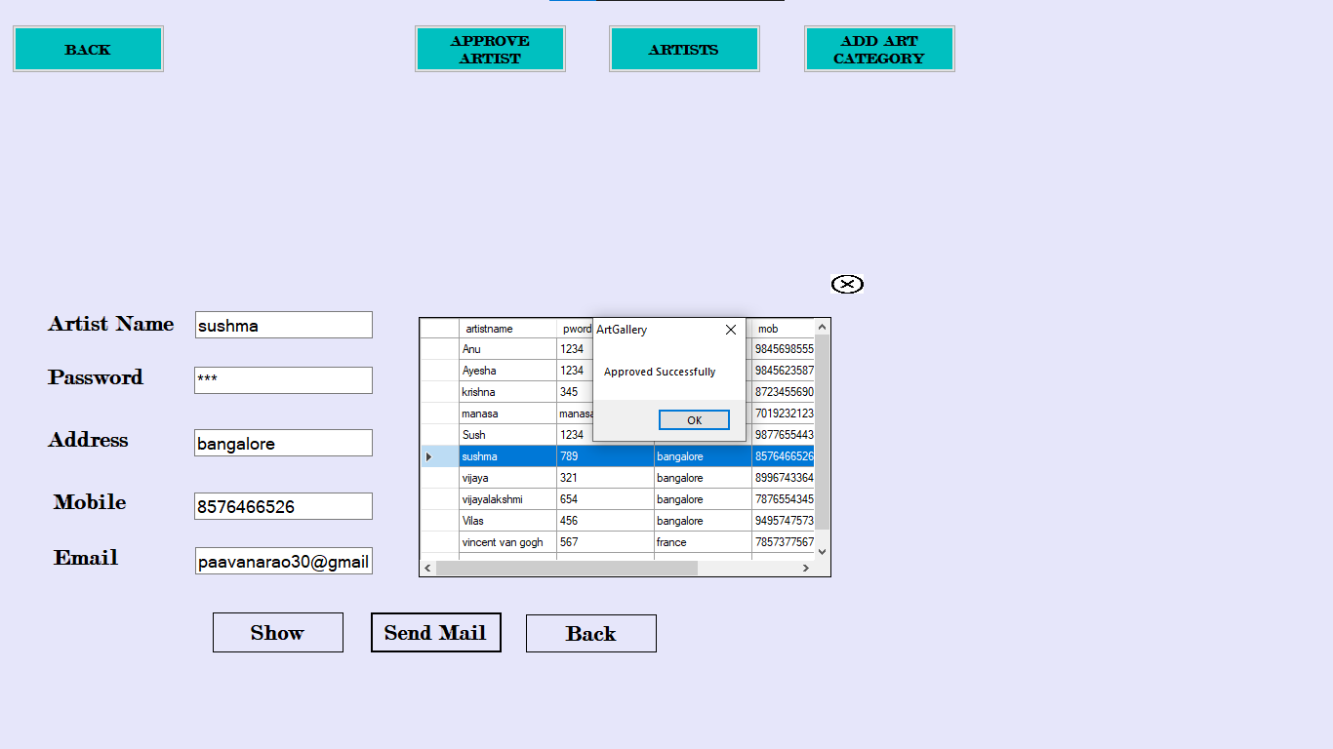

**VIEW ARTISTS**

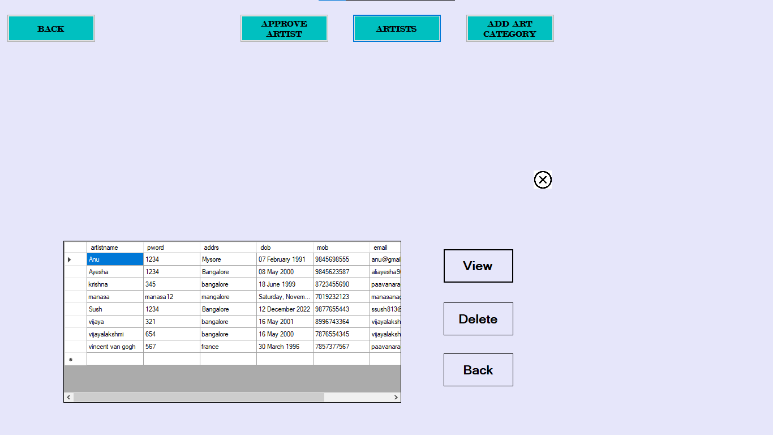

**ADD ART CATEGORY**

