PROJECT
  - on face recognition
By Paavana
Artificial Intelligence
April 23, 2024

Introduction

Machine learning is a subfield of artificial intelligence (AI) that focuses on developing algorithms and models that allow computers to learn from data and make predictions or decisions without being explicitly programmed. In other words, it enables computers to improve their performance over time by learning from experience or example data.
Types of Machine Learning
- Supervised Learning: Involves training a model on labeled data, where the model learns to make predictions based on input-output pairs.
- Unsupervised Learning: Trains a model on unlabeled data, aiming to discover patterns or groupings within the data.
- Reinforcement Learning: The model learns through trial and error, receiving feedback based on its actions.
Applications
- Image and speech recognition
- Natural language processing
- Recommender systems
- Financial predictions
- Medical diagnoses

Python is a popular programming language for machine learning due to its extensive libraries and frameworks

Use Cases
Web Development (Server-Side): Python can be used to create web applications running on servers.
Software Development: Python is suitable for building various software applications.
Mathematics: Python is used for scientific computing, data analysis, and mathematical modeling.
System Scripting: Python scripts automate tasks and system administration.
Big Data and Complex Mathematics: Python handles large datasets and performs complex calculations.
Rapid Prototyping and Production-Ready Software: Python is great for both quick prototypes and robust production code.

Why Python?
Platform Independence: Python runs on different platforms (Windows, Mac, Linux, Raspberry Pi, etc.).
Readable Syntax: Python’s syntax resembles the English language, making it easy to learn and understand.
Concise Code: Developers can express logical concepts with fewer lines of code compared to languages like C++ or Java.
Interpreted Execution: Python executes code immediately after writing, allowing quick prototyping.
Versatility: Python supports multiple programming paradigms (object-oriented, imperative, functional).

Objective
Implementation of PCA with ANN algorithm for Face recognition

Using the face dataset: Dataset: https://github.com/robaita/introduction_to_machine_learning/blob/main/dataset.zip design a face recognition system using Python.
Libraries /Modules Required
- scikit-learn: A powerful library that provides various machine learning algorithms, both supervised and unsupervised.
- TensorFlow: Developed by Google, it’s widely used for deep learning and complex tasks.
- Keras: A high-level neural networks API that runs on top of TensorFlow, CNTK
- Matplotlib is a powerful plotting library in Python that allows you to create static, animated, and interactive visualizations.
- NumPy is a powerful Python library that provides essential tools for scientific computing, numerical analysis, and working with arrays
Principal Component Analysis (PCA) is a statistical procedure that transforms a set of correlated variables (features) into a set of uncorrelated variables (principal components).
- The goal is to reduce the dimensionality of a dataset while retaining as much of the original information as possible.
- By finding a new set of variables (principal components), PCA captures the most important patterns or relationships between the original features.
- Covariance Matrix:
  - PCA starts by computing the covariance matrix of the original data.
  - The covariance matrix describes how features vary together.
- Eigenvalue Decomposition:
  - Next, PCA performs eigenvalue decomposition on the covariance matrix.
  - Eigenvalues represent the variance explained by each principal component.
  - Eigenvectors (principal components) are the directions of maximum variance.

- Selecting Principal Components:
  - Sort the eigenvalues in descending order.
  - Select the top k eigenvectors (principal components) corresponding to the largest eigenvalues.
Implementation
Step1: Import the required packages and modules
Step2: Load the Dataset
Step3: Convert the images into matrices and store them
Step4: Splitting the dataset
Step5: Input the components
- Apply PCA
- Generate Eigen Faces
- Compute LDA of reduced data
Step6: Train the model using Multilayer classifier
Step5: Test the model and check the accuracy

Outputs
Model Weights:[(8, 10), (10, 10), (10, 9)],
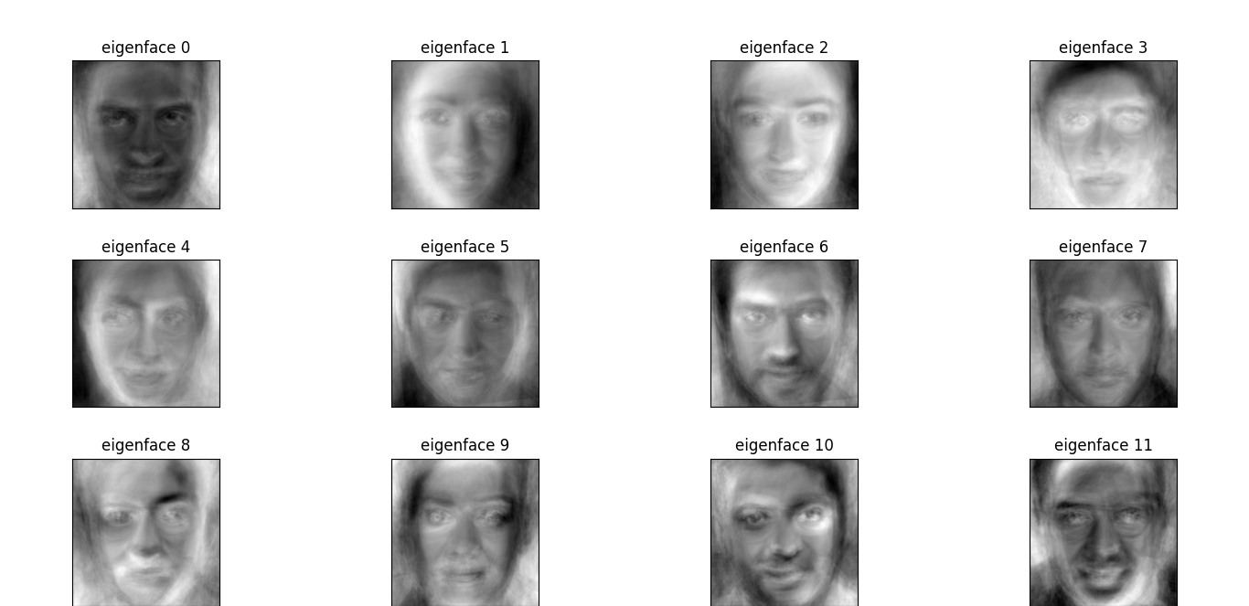
Accuracy: 69.02654867256638

