Sprint 2 Part 2
Self-Service Migration for SAP HANA Cloud
Structured study notes | Definitions | Key points | Demos | Exercises

Purpose: concise, structured study notes with definitions, explanations, key points, original diagrams, demo-style walkthroughs, practice exercises, and answer keys.
How to study: read each unit summary, memorize the definitions, walk through the demos using a sandbox or demo system, then complete the exercises without looking at the answer key.

Course map
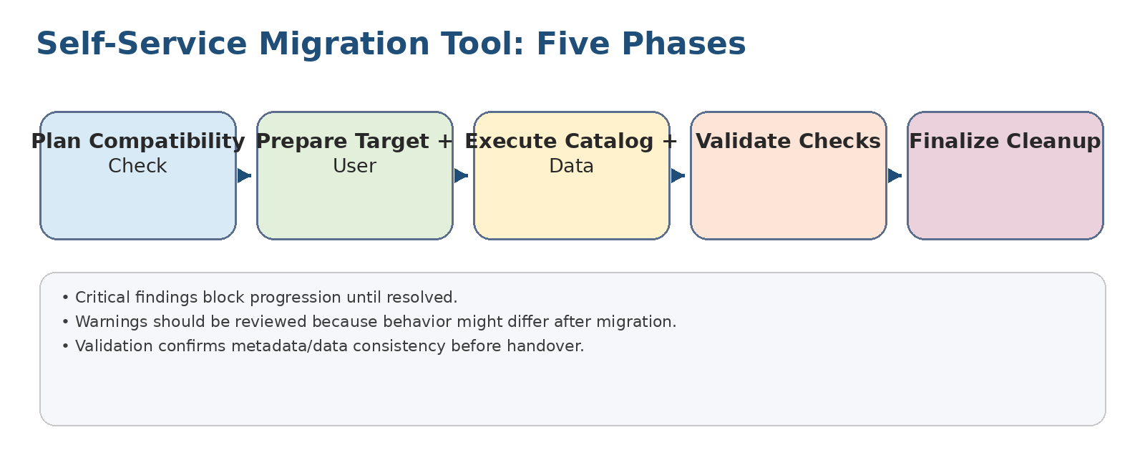
Original diagram: self-service migration phases.

High-yield overview
- The self-service migration tool is used from SAP HANA Cloud Central to move supported SAP HANA source databases to SAP HANA Cloud.
- The tool guides administrators through planning, preparation, execution, validation, and finalization.
- A compatibility check is performed early so blockers can be resolved before data movement begins.
- The migration can include catalog objects, table data, secure store content, and, depending on the scenario, schema/HDI container service instances.
- For on-premises sources, connectivity through SAP BTP and Cloud Connector must be prepared before the tool can reach the source system.
- SAP Alert Notification service can be configured to notify operations teams about migration progress and completion events.

Core definitions
Term | Definition
SAP HANA Cloud | SAP’s cloud database service that brings SAP HANA capabilities to SAP BTP with cloud provisioning, administration, and integration.
SAP BTP subaccount | A logical account area in SAP Business Technology Platform where services, entitlements, spaces, and subscriptions are assigned.
SAP HANA Cloud Central | The central web administration entry point used to create, manage, and monitor SAP HANA Cloud instances and migrations.
Self-Service Migration Tool | A guided migration wizard for supported SAP HANA sources moving to SAP HANA Cloud.
Compatibility check | A pre-migration analysis that reports issues by severity so administrators can determine what must be fixed.
Migration user | A dedicated source-database account granted the privileges needed to read and export migration content.
Cloud Connector | A secure connector that exposes an on-premises system to SAP BTP through virtual host and port mappings.
HDI container | An isolated design-time/runtime container model used by SAP HANA development artifacts.
Alert Notification service | An SAP BTP service that matches events with conditions and sends notifications through configured actions/subscriptions.
Condition / Action / Subscription | Alert Notification objects: condition filters events, action defines the delivery channel, and subscription links them together.

1. Discovering the Self-Service Migration Tool
Objective: Describe the purpose and value of the SAP HANA Cloud self-service migration tool.
Definitions
Term | Meaning
Critical | Must be resolved before migration can continue.
Error | Object will not be migrated because the target does not support the feature or behavior.
Warning | Object can migrate, but behavior might change and should be reviewed.
Info | Informational finding that does not require immediate correction.
Key points
- SAP HANA evolved from an on-premises in-memory database platform toward a cloud database service on SAP BTP.
- The tool reduces migration complexity by providing a guided wizard rather than a manually coordinated export/import project.
- Compatibility checks identify issues before execution, using severity levels that help prioritize remediation.
- Automated tasks can handle catalog migration, data migration, secure store migration, and supported service-instance migration.
- Temporary migration storage is SAP-managed, reducing the need for customers to provision separate interim storage.
Demo / lab practice: Open a mock migration project and identify which phase contains the compatibility check, user validation, data movement, consistency checks, and cleanup.
Exercise: Create a severity-response table: for Critical, Error, Warning, and Info, write what the administrator should do before migration.

2. Using the Self-Service Migration Tool
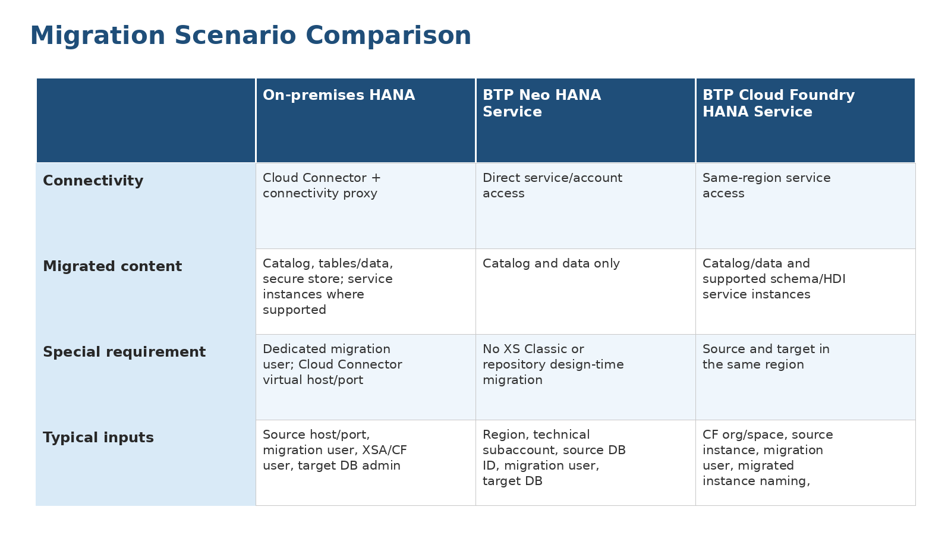
Original diagram: comparison of migration scenarios.

2.1 Preparing to Use the Tool
Objective: Perform the preparation steps before using the self-service migration tool.
Definitions
Term | Meaning
Subaccount Administrator role collection | Authorization bundle required for subaccount-level administration in SAP BTP.
connectivity_proxy | Service plan required for the on-premises migration scenario.
Virtual host/port | Cloud Connector mapping used by SAP BTP instead of exposing the real internal host.
Key points
- Confirm subaccount access and required administrator role collections before creating or administering SAP HANA Cloud databases.
- Ensure SAP HANA Cloud tools are available, including SAP HANA Cloud Central, SAP HANA cockpit, and database explorer.
- Navigate from SAP BTP cockpit to SAP HANA Cloud Central and the Migrations area to create or manage migration projects.
- Deploy the SAP HANA Cloud target database with correct memory, storage, performance class, hyperscaler, and region decisions.
- Create a dedicated migration user in the source database and grant the required privileges before starting migration.
- For on-premises sources, configure Cloud Connector and expose the virtual host and port that SAP BTP will use.
Demo / lab practice: In a sandbox plan, document the click path from SAP BTP cockpit to SAP HANA Cloud Central and then to the Migrations area.
Exercise: Prepare a migration readiness checklist with: access, tools, target database, source user, connectivity, and backup/rollback readiness.

2.2 Migrating an SAP HANA On-Premises Platform
Objective: Perform a migration from SAP HANA on-premises to SAP HANA Cloud.
Definitions
Term | Meaning
XSA | SAP HANA extended application services, advanced model; an application runtime based on Cloud Foundry concepts.
Location ID | Identifier used by Cloud Connector when more than one connector is registered to a subaccount.
Key points
- This scenario requires secure connectivity from SAP BTP to the on-premises source through Cloud Connector.
- The tool needs migration project metadata, source type, virtual host/port, Cloud Connector location ID, migration user credentials, XSA-related credentials where applicable, and target database credentials.
- Plan for networking, credential handling, source-system performance impact, and rollback before starting the execution phase.
- The demonstration pattern is: create project, enter source/target details, run compatibility checks, execute migration, validate, then finalize.
Demo / lab practice: Simulate the wizard inputs for an on-premises migration and mark which fields come from Cloud Connector, source HANA, XSA, BTP, and target HANA Cloud.
Exercise: Given a source system behind a firewall, list the exact data items the migration team must obtain from the network, HANA, XSA, and BTP administrators.

2.3 Migrating SAP HANA Service for SAP BTP, Neo Environment
Objective: Migrate an SAP HANA service for SAP BTP, Neo environment to SAP HANA Cloud.
Definitions
Term | Meaning
Technical subaccount name | Neo environment identifier used by the tool to locate the source service.
Catalog migration | Migration of database metadata such as schemas, tables, views, procedures, and related database objects.
Key points
- The Neo scenario focuses on catalog and data migration; XS Classic/repository design-time artifacts are not migrated by this scenario.
- Inputs include SAP BTP region, technical subaccount name, source database/schema ID, account credentials, source migration user credentials, and target database credentials.
- Weak demo passwords must not be reused in real projects; production migrations require controlled credential storage and rotation.
- Validate that the migrated database content behaves correctly in SAP HANA Cloud before finalizing operational cutover.
Demo / lab practice: Create a mock input sheet for Neo migration fields and label each item as project metadata, source locator, source credential, or target credential.
Exercise: Explain why repository design-time artifacts must be treated separately in a Neo migration.

2.4 Migrating SAP HANA Service for SAP BTP, Cloud Foundry Environment
Objective: Execute migration from SAP HANA Service for SAP BTP, Cloud Foundry to SAP HANA Cloud.
Definitions
Term | Meaning
Cloud Foundry space | Logical deployment space inside a Cloud Foundry organization where service instances and applications reside.
Migrated instance name | Naming pattern used when creating migrated service instances in the target landscape.
Key points
- The Cloud Foundry source and SAP HANA Cloud target must be planned with region alignment in mind.
- Inputs include Cloud Foundry user credentials, region, space, source service instance, migration user credentials, migrated instance naming, and target database credentials.
- For schema and HDI service instances, naming prefixes/suffixes help avoid collisions when creating migrated instances.
- The target validation phase should include application connection tests and record-count checks, not only wizard completion.
Demo / lab practice: Walk through a Cloud Foundry migration storyboard: select region, space, source instance, target, naming pattern, and notification preferences.
Exercise: Design a naming convention for migrated service instances that prevents collisions and still identifies the source environment.

3. SAP Alert Notification Service for Migration
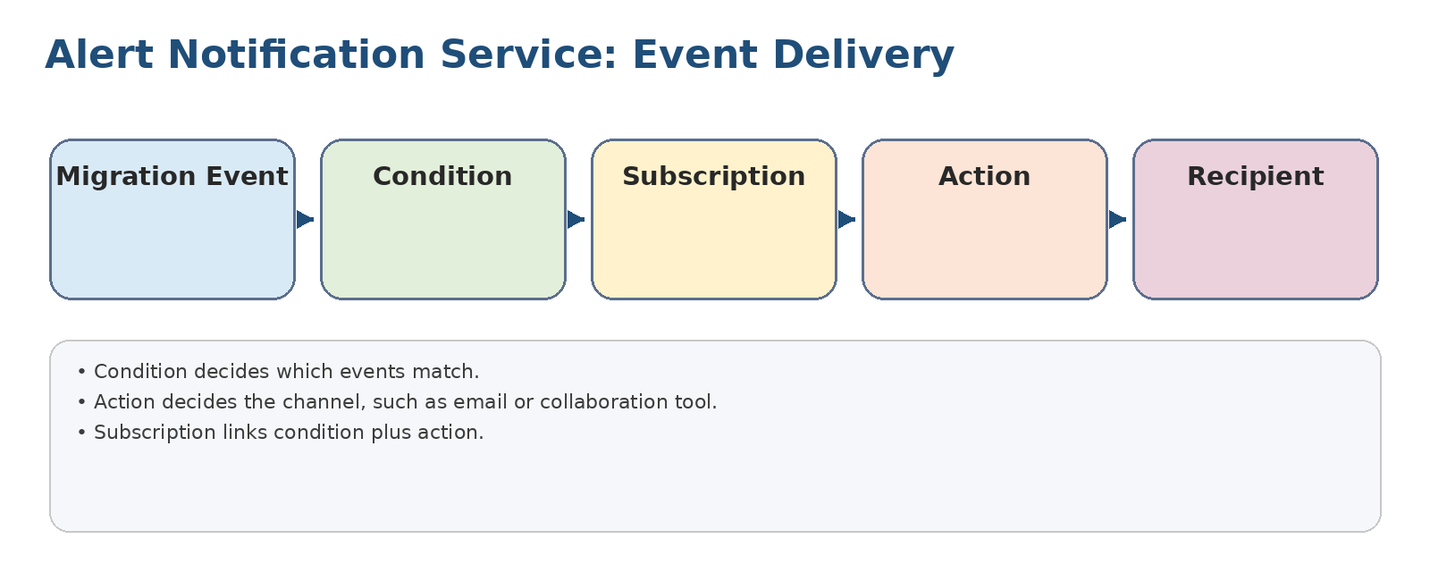
Original diagram: event-to-recipient alerting model.

3.1 Added Value of Alert Notification
Objective: Explain how Alert Notification helps during a migration to SAP HANA Cloud.
Definitions
Term | Meaning
HDB Migration Progress | Event type used to inform subscribers about migration step progress.
HDB Migration Finished | Event type used to indicate completion of a migration step or full migration.
HDB Migration Record Count Check Finished | Event type used when validation record-count checks complete.
Key points
- Long-running migrations need operational visibility without requiring administrators to continuously watch the wizard.
- Migration events can report progress, completion, and record-count check completion.
- Notifications can be delivered through configured channels such as email or team communication tools.
- Alerting is especially useful for large migrations, weekend cutovers, or migrations involving several technical teams.
Demo / lab practice: Create a notification design for a migration: who receives progress, who receives failures, and who approves finalization.
Exercise: Match each migration event to the operational question it answers: Is it still running? Did it finish? Did validation finish?

3.2 Activating Alert Notification
Objective: Activate the SAP Alert Notification service in the relevant SAP BTP subaccount.
Definitions
Term | Meaning
Entitlement | Permission/quota assignment that makes a service plan available in a subaccount.
Service instance | Concrete provisioned instance of a BTP service plan.
Key points
- Verify that the service entitlement and standard plan are assigned to the subaccount.
- Ensure a Cloud Foundry environment and space exist for the service instance.
- Create an Alert Notification service instance in Instances and Subscriptions.
- Wait until the instance status is created before building conditions, actions, and subscriptions.
Demo / lab practice: Mock the activation flow in a runbook: global account, subaccount, entitlements, Cloud Foundry space, service instance creation.
Exercise: Write a five-step activation checklist for Alert Notification from entitlement through created instance.

3.3 Configuring Alert Notification
Objective: Configure conditions, actions, and subscriptions for migration alerting.
Definitions
Term | Meaning
Condition | Rule that determines whether an incoming event matches.
Action | Notification delivery method and target.
Subscription | Mapping that connects one or more conditions with one or more actions.
Key points
- A condition filters which events are relevant for delivery.
- An action defines the delivery channel and destination.
- A subscription links conditions to actions and creates the actual delivery rule.
- Test notifications before the real migration window so routing, mailboxes, and team channels are verified.
Demo / lab practice: Create a dry-run subscription using a test action and validate that events reach the intended recipients.
Exercise: Build a subscription design with one progress notification, one completion notification, and one validation notification.

End-to-end demo walkthroughs

Demo A - On-premises migration
- Confirm target HANA Cloud instance exists.
- Confirm Cloud Connector mapping and connectivity_proxy entitlement.
- Create and grant a dedicated migration user.
- Start the migration project and enter virtual host/port, location ID, source credentials, and target credentials.
- Run compatibility check and resolve Critical findings.
- Execute migration, validate record counts/metadata, then finalize.

Demo B - Neo migration
- Collect Neo region, technical subaccount, DB/schema ID, account credentials, and migration user.
- Create migration project for the Neo source type.
- Review the scope limitation: catalog/data only.
- Run checks, execute migration, validate, and document unsupported artifacts separately.

Demo C - Cloud Foundry migration
- Confirm source and target region alignment.
- Collect Cloud Foundry org/space and source service instance details.
- Choose migrated instance naming prefix/suffix.
- Run checks, execute migration, validate service instances, and update app bindings if required.

Demo D - Migration alerting
- Activate Alert Notification service.
- Create condition for progress, finished, and validation-finished events.
- Create action for the chosen channel.
- Create subscriptions and test delivery before the migration window.

Practice exercises
- Explain the difference between the Plan and Prepare phases in one paragraph.
- A compatibility check returns Critical and Warning findings. Which ones block migration, and how should each be handled?
- List the prerequisites unique to the on-premises source scenario.
- Why is a dedicated migration user preferable to using a normal administrator account?
- Why should Alert Notification be configured before the execution phase starts?
- Design a validation checklist for migrated catalog, data, secure store, and application connectivity.
- Compare Neo and Cloud Foundry migration inputs. Which fields identify the source environment in each case?
- Create a cutover risk register with five risks and one mitigation for each.

Answer key / expected responses
- Plan selects the source and checks compatibility; Prepare selects the target and migration user and readies execution.
- Critical findings block continuation; Warnings do not necessarily block migration but require review and acceptance or remediation.
- On-premises needs Cloud Connector, virtual host/port, location ID, and connectivity_proxy entitlement.
- A dedicated user is auditable, scoped, removable, and avoids overusing personal or high-power administrator identities.
- Alerting must be tested before execution so long-running steps can be monitored without manual polling.
- Validation should include object counts, row counts, failed objects, application smoke tests, authorization checks, and cleanup confirmation.
- Neo uses region, technical subaccount, and source DB/schema ID; Cloud Foundry uses region, space, and service instance name.
- Typical risks include missing privileges, region mismatch, incompatible objects, network failure, insufficient target capacity, credential expiry, and inadequate rollback planning.

Final checklist
Check item | Owner | Done?
Access approved |  | ☐
Target instance sized and created |  | ☐
Source backup completed |  | ☐
Migration user created and tested |  | ☐
Connectivity tested |  | ☐
Compatibility findings reviewed |  | ☐
Alert Notification tested |  | ☐
Execution window approved |  | ☐
Validation evidence captured |  | ☐
Finalize and cleanup completed |  | ☐

