Sprint 2 Part 3
SAP HANA Installation and Administration - All Lessons
Structured study notes | Definitions | Key points | Demos | Exercises

Purpose: concise, structured study notes with definitions, explanations, key points, original diagrams, demo-style walkthroughs, practice exercises, and answer keys.
How to study: read each unit summary, memorize the definitions, walk through the demos using a sandbox or demo system, then complete the exercises without looking at the answer key.

Course-wide visual overview
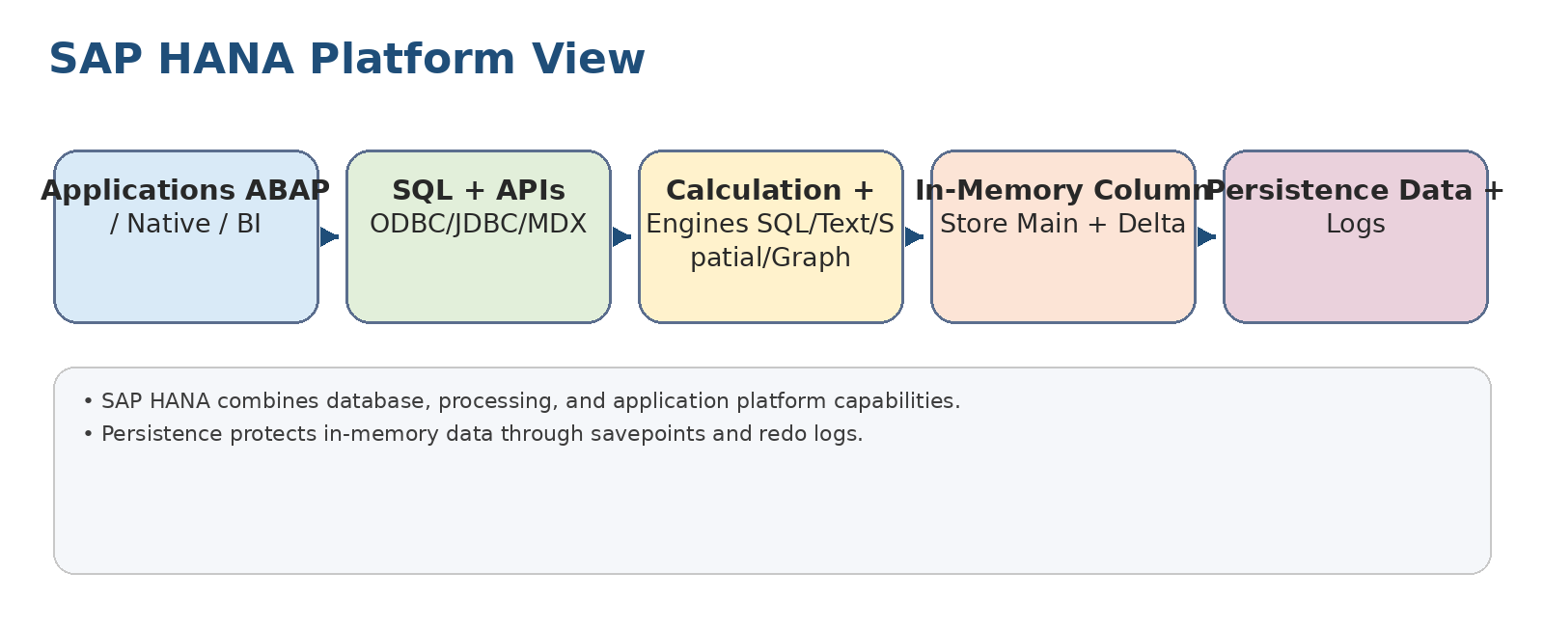
Original diagram: SAP HANA as a database and application platform.
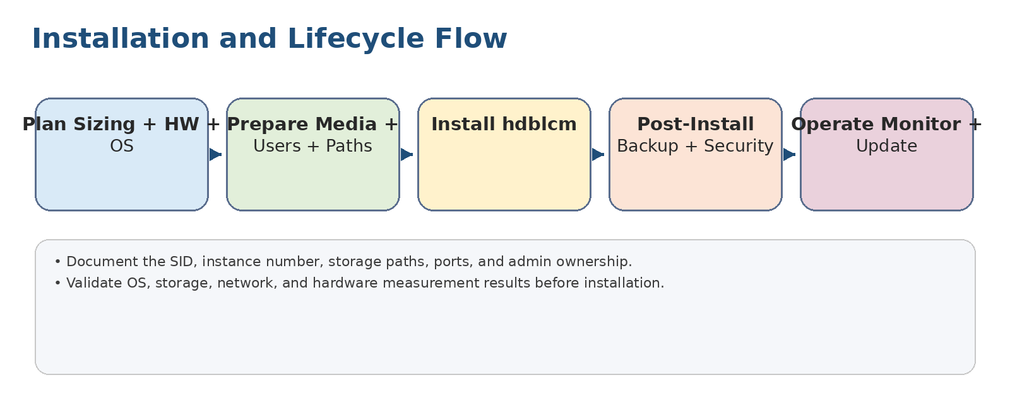
Original diagram: SAP HANA installation and lifecycle workflow.

How to use this pack
- Treat each lesson block as a checklist: objective, definitions, key points, and one practice task.
- Use the demos to turn theory into administration muscle memory.
- For commands and parameters, validate against your target SAP HANA revision and company standards before production use.
- Use the final exercises as a closed-book readiness test.

Core definitions across the course
Term | Definition
SAP HANA | In-memory database and application platform optimized for real-time transactional and analytical workloads.
SYSTEMDB | System database used to manage an MDC system.
Tenant database | Isolated database container that stores application data and users.
Cockpit | Web-based administration and monitoring tool for SAP HANA.
Database Explorer | Web tool for catalog browsing, SQL execution, and data import/export.
HDBLCM | Lifecycle manager for installing, updating, and configuring SAP HANA components.
HDBSQL | Command-line SQL client for SAP HANA.
Savepoint | Periodic persistence of changed data pages to disk.
Redo log | Persistent log of committed changes used during recovery.
Delta merge | Process that merges write-optimized delta storage into compressed main column storage.
Backup catalog | Record of backups and log backups used to select recovery options.
Role | Reusable bundle of privileges assigned to users or groups.
Audit policy | Rule defining which database activities are captured in the audit trail.

1. Discovering SAP HANA
Unit summary: Understand why SAP HANA exists, how it supports simplified SAP business applications, and why in-memory columnar processing changes application and administration design.
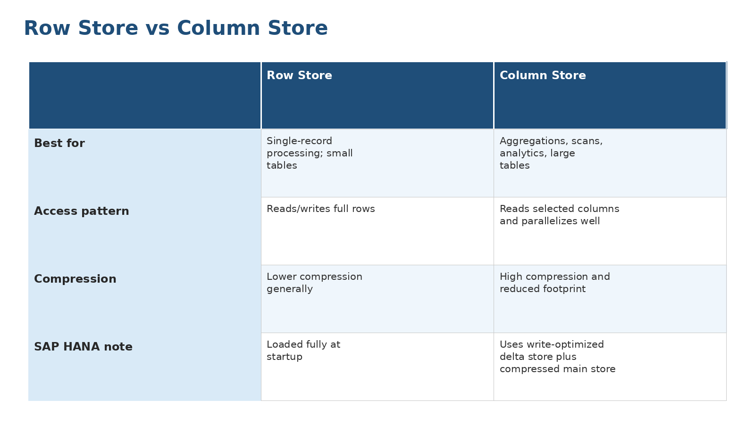
Original study diagram for 1. Discovering SAP HANA.

Identifying the Need for SAP HANA
Objective: Identify the business and technical reasons for SAP HANA.
Definitions
Term | Meaning
DMO | Database Migration Option of SUM; combines software update and database migration.
SWPM | Software Provisioning Manager used for system provisioning and heterogeneous system copy.
Key points
- SAP HANA enabled real-time applications and became the required foundation for SAP S/4HANA.
- SAP S/4HANA simplifies data models by reducing indices, aggregates, and redundant totals tables.
- Migration to SAP HANA is primarily a database migration while application servers can often remain separate.
- Common migration approaches include heterogeneous system copy with SWPM and DMO with SUM.
Exercise: Compare SWPM and DMO. When would a one-step SUM/DMO approach reduce risk?

Illustrating the Need for In-Memory Technology
Objective: Explain SAP HANA as an in-memory application platform.
Definitions
Term | Meaning
ACID | Atomicity, Consistency, Isolation, Durability; database reliability guarantees.
Column store | Storage format where values of each column are stored together.
Delta store | Write-optimized area used before changes are merged into compressed main storage.
MVCC | Multi-version concurrency control for consistent reads while updates occur.
Key points
- Disk-centric systems suffer from I/O bottlenecks as data volume grows.
- SAP HANA keeps operational data in memory while using persistence for durability.
- Column store improves scans, aggregations, compression, and parallel processing.
- Delta store makes column tables practical for writes as well as reads.
- SAP HANA supports application platform capabilities such as SQL, text, spatial, graph, and XSA scenarios.
Exercise: Choose row store or column store for five sample tables and justify each choice.

Unit demo practice
- Draw a row-store versus column-store decision table.
- Explain how S/4HANA simplification depends on SAP HANA.
- Describe a DMO migration flow in five steps.

2. Preparing the Installation
Unit summary: Plan capacity, hardware, operating system, and measurement validation before installing SAP HANA.

Performing SAP HANA Sizing
Objective: Estimate memory, CPU, disk, and throughput needs for SAP HANA.
Definitions
Term | Meaning
Quick Sizer | SAP tool/methodology used to estimate system requirements.
T-shirt sizing | Coarse early sizing method; useful for planning but not final procurement.
Key points
- Sizing determines whether the target system can handle data volume, workload, growth, and resilience requirements.
- Memory sizing must consider compressed data, working memory, row store, column store, and peak workload.
- Persistence sizing must include data volume, log volume, backups, and free space for operations.
- Use official sizing tools and customer workload evidence rather than guessing.
Exercise: Given a 3 TB source database and a 25% annual growth rate, list the sizing factors you must confirm before hardware selection.

Identifying Supported SAP HANA Hardware
Objective: Identify supported hardware models and deployment choices.
Definitions
Term | Meaning
Scale-up | One larger host carries the database workload.
Scale-out | Multiple hosts distribute storage, memory, and processing.
TDI | Tailored Data Center Integration; supported flexibility for customer data center components.
Key points
- SAP HANA must run on supported hardware, cloud, appliance, or Tailored Data Center Integration designs.
- Scale-up increases capacity on one host; scale-out distributes across multiple hosts.
- Certified hardware and virtualization support must be verified before installation.
- Storage and network design are as important as CPU and memory sizing.
Exercise: Create a hardware validation checklist: certification, memory, CPU, storage, network, OS, virtualization, and support status.

Identifying the Linux Operating System Requirements
Objective: Identify Linux prerequisites for SAP HANA.
Definitions
Term | Meaning
sidadm | Operating system administration user created for an SAP system ID.
NTP/chrony | Time synchronization services used to keep hosts aligned.
Key points
- Supported Linux distributions are mandatory for productive SAP HANA systems.
- OS packages, kernel settings, time synchronization, hostnames, filesystems, and users must be prepared consistently.
- Storage paths for data, log, shared, and backups must follow the design and performance requirements.
- Security patches and hardening should be coordinated with SAP HANA compatibility requirements.
Exercise: Write a pre-install OS checklist for a two-host SAP HANA landscape.

Outlining how to use the Hardware Measurement Tool
Objective: Use the hardware measurement tool to validate infrastructure.
Definitions
Term | Meaning
HWCCT | SAP HANA Hardware and Cloud Measurement Tools used to test performance characteristics.
Throughput | Amount of data transferred per time unit; critical for persistence and backup operations.
Key points
- The hardware measurement tool checks whether CPU, memory, disk, and network performance meet expected SAP HANA requirements.
- Measurement must run on the intended host configuration, not on a different or temporary setup.
- Poor storage or network results should be corrected before installing SAP HANA.
- Keep measurement evidence as part of installation sign-off.
Exercise: Interpret a hypothetical failed storage test and decide whether to tune, re-run, or block installation.

Unit demo practice
- Complete a sizing worksheet.
- Validate supported hardware/cloud status.
- Run a mock HWCCT result review and decide pass/fail.

3. Installing the SAP HANA Database System
Unit summary: Install SAP HANA using lifecycle tools and understand advanced and deployment choices.

Installing SAP HANA 2.0
Objective: Install an SAP HANA 2.0 database system.
Definitions
Term | Meaning
hdblcm | SAP HANA database lifecycle manager used to install, update, configure, and uninstall components.
SID | Three-character system identifier for an SAP system.
Key points
- Use installation media and hdblcm to install SAP HANA components.
- Key installation decisions include SID, instance number, hostnames, paths, passwords, components, and deployment topology.
- The installation creates operating-system users and database administrative users.
- Post-install validation should confirm services, ports, tenant/system database status, and license handling.
Exercise: Draft an install parameter sheet with SID, instance number, hosts, paths, passwords, and components.

Describing Advanced Installation Options
Objective: Describe installation options beyond a basic interactive install.
Definitions
Term | Meaning
Batch mode | Non-interactive installation method driven by parameters.
Parameter file | File containing installation values used by lifecycle tools.
Key points
- Advanced installs can use parameter files, command-line options, batch mode, and component selection.
- Additional hosts, XS advanced components, and automated installs require strict planning.
- Sensitive passwords should be handled securely rather than stored carelessly in scripts.
- Repeatable install parameters help standardize non-production and production landscapes.
Exercise: Identify which installation values may be standardized and which must remain environment-specific.

Illustrating Deployment Options
Objective: Illustrate SAP HANA deployment architectures.
Definitions
Term | Meaning
MDC | Multitenant database containers architecture with SYSTEMDB and tenant databases.
System replication | Replication technology used for high availability and disaster recovery scenarios.
Key points
- Single-host deployments are simpler; scale-out supports larger workloads and host distribution.
- Multi-tenant database containers separate SYSTEMDB from tenant databases.
- High availability can include host auto-failover and system replication depending on design.
- Deployment architecture affects administration, monitoring, backup, recovery, and security.
Exercise: Select a deployment pattern for a small development system and a large productive analytics system.

Unit demo practice
- Prepare an installation parameter sheet.
- Run through an hdblcm command/options checklist.
- Validate services, ports, users, and initial tenant status.

4. Installing the SAP HANA Cockpit
Unit summary: Use SAP HANA cockpit as the central web tool for administration and monitoring.
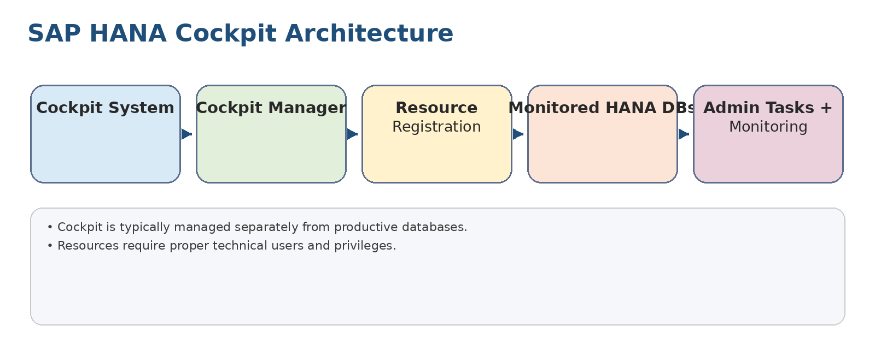
Original study diagram for 4. Installing the SAP HANA Cockpit.

Illustrating SAP HANA Administration Tools
Objective: Identify the main SAP HANA administration tools.
Definitions
Term | Meaning
SAPControl | Interface/tool for starting, stopping, and querying SAP system processes.
Database Explorer | Web tool for SQL, catalog, and data management tasks.
Key points
- SAP HANA cockpit provides browser-based monitoring and administration.
- Database Explorer supports catalog browsing, SQL execution, and data import/export tasks.
- HDBSQL provides command-line SQL access for automation and troubleshooting.
- HDBLCM and SAPControl support lifecycle and system control operations.
Exercise: Map five administration tasks to the best tool: cockpit, Database Explorer, HDBSQL, HDBLCM, or SAPControl.

Installing SAP HANA Cockpit
Objective: Install SAP HANA cockpit.
Definitions
Term | Meaning
Cockpit manager | Administrative component used to configure cockpit, users, and resources.
Resource | A database system or tenant registered for management in cockpit.
Key points
- Cockpit is installed as a dedicated administration system rather than directly inside each managed database.
- Plan cockpit sizing, ports, certificates, admin users, and lifecycle ownership.
- After installation, register resources and assign privileges before monitoring databases.
- Secure cockpit access because it centralizes administration capabilities.
Exercise: Prepare a cockpit installation checklist for a new administration landscape.

Describing the SAP HANA Cockpit Architecture
Objective: Describe cockpit components and resource model.
Definitions
Term | Meaning
Resource group | Logical grouping of cockpit resources for administration and authorization.
Technical user | Non-personal account used by tools or services to connect with controlled privileges.
Key points
- Cockpit has its own database and application components.
- Managed SAP HANA systems are registered as resources.
- Connections use technical users and secure communication.
- Resource groups help organize monitored systems and delegate access.
Exercise: Design cockpit resource groups for Development, Quality, and Production landscapes.

Configuring SAP HANA Cockpit
Objective: Configure cockpit for administration use.
Definitions
Term | Meaning
Registration | Process of adding a database resource to cockpit.
Monitoring user | Database user with privileges needed by cockpit to read operational metadata.
Key points
- Register SYSTEMDB and tenant resources as needed.
- Assign cockpit users and roles according to responsibilities.
- Configure secure connections, certificates, and required database privileges.
- Validate monitoring tiles and alerts after resource registration.
Exercise: Create a least-privilege model for cockpit users: viewer, operator, backup admin, and security admin.

Updating SAP HANA Cockpit
Objective: Update cockpit safely.
Definitions
Term | Meaning
Revision | Patch-level release of SAP HANA or cockpit software.
Rollback plan | Documented steps to restore service if the update fails.
Key points
- Check the supported cockpit revision and update path.
- Back up cockpit before update and document rollback options.
- Use lifecycle tools to update cockpit components.
- Validate resource registration, monitoring, and user access after update.
Exercise: Write a cockpit update runbook with preparation, execution, validation, and fallback steps.

Unit demo practice
- Register a database resource in cockpit.
- Create a cockpit resource group.
- Validate monitoring and user access.

5. Performing the Post-Installation Tasks
Unit summary: Harden, connect, update, and manage the system immediately after installation.

Illustrating Post-Installation Steps
Objective: Identify required post-installation activities.
Definitions
Term | Meaning
SAProuter | Component used to establish remote SAP support connectivity.
global_allocation_limit | Parameter that limits SAP HANA memory allocation.
Key points
- After installation, configure backup, security, monitoring, support connections, network settings, and administration users.
- Do not rely only on the installer success message; create a customer-specific post-install checklist.
- Create personal administrator accounts and reduce daily use of powerful default users.
- Register with monitoring/support tooling where required.
Exercise: Build a post-install checklist covering backup, security, monitoring, parameters, support, and documentation.

Updating SAP HANA
Objective: Update SAP HANA database revisions.
Definitions
Term | Meaning
SPS | Support Package Stack; release level containing features and maintenance content.
Maintenance window | Approved period for performing disruptive maintenance.
Key points
- Updates require compatibility checks, backups, maintenance windows, and validation plans.
- Lifecycle tools perform the technical update, but administrators manage risk and communication.
- Test updates in non-production before production rollout.
- After update, validate services, tenants, cockpit connectivity, backups, and application smoke tests.
Exercise: Plan an update window including stakeholders, backups, downtime, validation, and fallback.

Illustrating the Resident HDBLCM
Objective: Use resident lifecycle management on an installed system.
Definitions
Term | Meaning
Resident HDBLCM | Lifecycle manager installed with SAP HANA on the host.
Lifecycle operation | Install, update, configure, add, or remove system components.
Key points
- The resident HDBLCM is available on the installed system for lifecycle operations.
- It can update, add/remove components, rename hosts in supported contexts, and perform configuration tasks.
- Run lifecycle tasks as the proper operating-system user with sufficient privileges.
- Record tool output and logs as audit evidence.
Exercise: List which lifecycle tasks you would perform with resident HDBLCM versus cockpit.

Creating, Renaming, and Deleting a Tenant Database
Objective: Manage tenant database lifecycle.
Definitions
Term | Meaning
SYSTEMDB | System database used for overall system administration in MDC.
Tenant database | Isolated database container that stores application data and users.
Key points
- SYSTEMDB controls overall system administration; tenants contain business/application data.
- Tenant creation needs name, resources, credentials, and later backup/monitoring setup.
- Renaming or deleting tenants is disruptive and requires clear approval.
- Back up tenants before risky lifecycle operations.
Exercise: Write a tenant creation runbook and a separate delete-approval checklist.

Explaining the Revision Strategy of SAP HANA
Objective: Explain how to plan SAP HANA revisions.
Definitions
Term | Meaning
Revision strategy | Governed approach for choosing, testing, and deploying SAP HANA patch levels.
Regression test | Test that confirms existing processes still work after a change.
Key points
- A revision strategy balances stability, security, supportability, and access to fixes.
- Track dependencies between SAP HANA, cockpit, clients, application stacks, and operating systems.
- Avoid ad hoc patching without a tested path and rollback plan.
- Document standard revision levels for dev, QA, and production.
Exercise: Create a three-landscape revision rollout sequence: Dev, QA, Prod.

Using the SAP HANA HDBSQL Command-Line Tool
Objective: Use HDBSQL for SQL access and automation.
Definitions
Term | Meaning
hdbsql | SAP HANA command-line SQL client.
hdbuserstore | Secure store for connection keys and credentials used by SAP HANA clients.
Key points
- HDBSQL is useful for scripted administration, troubleshooting, and command-line SQL execution.
- Use secure user store to avoid exposing passwords in scripts.
- Connect to SYSTEMDB or tenant databases deliberately and verify context before running commands.
- Capture output for repeatable operational evidence.
Exercise: Create a secure-user-store based script outline that connects to a tenant and queries service status.

Unit demo practice
- Create a backup/security/support post-install checklist.
- Update a sandbox using resident HDBLCM.
- Create a mock tenant and document owner, backup, and monitoring settings.

6. Working with Database Explorer
Unit summary: Use Database Explorer for database object inspection, SQL execution, and lightweight data movement.

Using Database Explorer
Objective: Use the Database Explorer interface.
Definitions
Term | Meaning
Catalog | Metadata area containing schemas, tables, views, procedures, and other database objects.
Key points
- Database Explorer connects to SAP HANA databases and lets users browse catalog objects.
- Connections should use appropriate technical or personal users, not unrestricted accounts.
- It supports SQL execution, object inspection, and data management tasks.
- Use it carefully in production because SQL changes are executed directly against the database.
Exercise: Connect to a sandbox tenant and identify schemas, tables, and views without changing data.

Importing and Exporting Database Content
Objective: Import and export database content.
Definitions
Term | Meaning
CSV | Comma-separated values file format often used for simple data movement.
Key points
- Database Explorer can move data for small administrative or development tasks.
- For production-scale migration or backup, use purpose-built migration/backup tools instead.
- Check data types, delimiters, encoding, permissions, and target table definitions.
- Validate row counts after import/export.
Exercise: Export a sample table in a sandbox and compare source and exported row counts.

Displaying Table Information
Objective: Display table metadata and runtime information.
Definitions
Term | Meaning
Loaded status | Indicator of whether table data or columns are loaded into memory.
Key points
- Table details include columns, types, indexes, partitions, and runtime properties.
- Column-store tables may show memory, loaded status, and delta/main store indicators.
- Table inspection supports troubleshooting of performance and data issues.
- Do not infer business meaning from metadata alone; confirm with application owners.
Exercise: Inspect a table and identify columns, primary key, storage type, and loaded state.

Using the SQL Console
Objective: Run SQL statements in Database Explorer.
Definitions
Term | Meaning
DDL | Data Definition Language, such as CREATE or ALTER.
DML | Data Manipulation Language, such as INSERT, UPDATE, DELETE, or SELECT.
Key points
- The SQL console supports ad hoc queries, DDL, DML, and administration statements according to privileges.
- Always verify target connection and transaction impact before executing changes.
- Use explain plan or plan visualization for performance analysis where appropriate.
- Save useful SQL snippets only when they are safe and reviewed.
Exercise: Write a SELECT-only query to check row counts by schema, then explain why it is safe.

Using the SAP HANA Statement Library
Objective: Use prebuilt statements for administration.
Definitions
Term | Meaning
Statement library | Collection of reusable SQL statements for common SAP HANA analysis tasks.
Key points
- The statement library provides helpful SQL templates for system analysis and troubleshooting.
- Administrators should understand a statement before running it.
- Statement output often needs interpretation with context from workload, alerts, and configuration.
- Maintain a curated set of approved SQL checks for recurring operations.
Exercise: Pick three statement categories you would add to a weekly health-check pack.

Unit demo practice
- Connect to a tenant.
- Inspect table metadata.
- Run SELECT-only SQL and export a small result set.

7. Monitoring using SAP HANA Cockpit
Unit summary: Monitor services, memory, persistence, alerts, and SQL activity to maintain stability and performance.
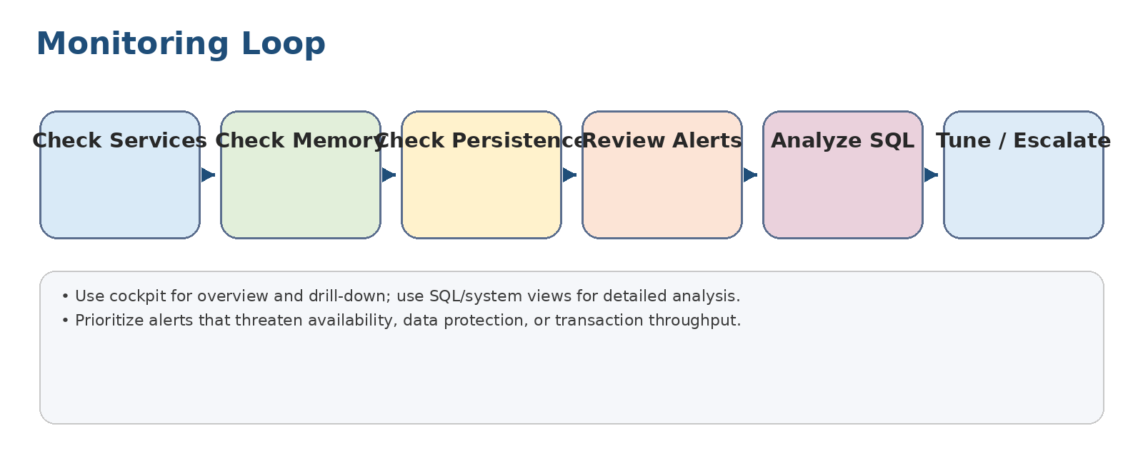
Original study diagram for 7. Monitoring using SAP HANA Cockpit.

Locating Databases in SAP HANA Cockpit
Objective: Locate registered systems and tenants.
Definitions
Term | Meaning
Resource inventory | List of databases and tenants available in cockpit.
Key points
- Cockpit presents registered database resources and resource groups.
- Administrators should distinguish SYSTEMDB, tenants, and hosts in the cockpit view.
- Resource organization supports delegation and operational focus.
- Missing resources usually indicate registration, privilege, or connectivity issues.
Exercise: Find a tenant resource in a mock cockpit inventory and identify its host and status.

Checking the SAP HANA Services
Objective: Check service status and health.
Definitions
Term | Meaning
indexserver | Core SAP HANA service handling SQL processing and data storage for tenant databases.
Key points
- Core services such as indexserver, nameserver, compile server, and other components must be running as expected.
- Service restarts, crashes, or memory pressure can indicate deeper issues.
- Scale-out systems require host-by-host service awareness.
- Use cockpit first for overview, then logs/traces/system views for detail.
Exercise: Investigate a stopped service: list first checks before restarting anything.

Checking the Memory Usage
Objective: Monitor SAP HANA memory usage.
Definitions
Term | Meaning
OOM | Out-of-memory condition where workload cannot obtain needed memory.
Key points
- SAP HANA memory includes used memory, allocated memory, peak memory, row store, column store, caches, and statement memory.
- High memory consumption is not always bad; the issue is whether allocation threatens workload stability.
- Investigate large tables, expensive statements, delta store growth, and memory limits.
- Avoid arbitrary parameter changes without evidence.
Exercise: Given high memory utilization, list five questions to ask before changing global_allocation_limit.

Checking the SAP HANA Persistence Storage
Objective: Monitor data and log volumes.
Definitions
Term | Meaning
Savepoint | Periodic persistence of changed data pages to the data volume.
Redo log | Log of committed changes used for recovery.
Key points
- Persistence protects committed data through savepoints and redo logs.
- Data and log volumes require sufficient space and performance.
- Log backup failure can fill log volumes and threaten database availability.
- Monitor savepoint duration, disk I/O, volume usage, and backup destinations.
Exercise: Explain why a full log volume can become an availability incident.

Checking for SAP HANA Alerts
Objective: Review and respond to alerts.
Definitions
Term | Meaning
Alert threshold | Configured boundary that triggers an alert when exceeded.
Key points
- Alerts summarize conditions that require administrative attention.
- Severity, category, affected object, and recommended action should guide prioritization.
- Acknowledge alerts only after understanding and documenting the response.
- Recurring alerts should become root-cause analysis tasks, not ignored noise.
Exercise: Classify five alerts into immediate action, schedule action, and monitor.

Checking the SQL Statements
Objective: Analyze SQL workload.
Definitions
Term | Meaning
Plan cache | Repository of compiled SQL execution plans and runtime statistics.
Key points
- SQL monitoring helps identify expensive statements, locks, blocked transactions, and plan-cache issues.
- Expensive statements should be evaluated for frequency, runtime, memory, records scanned, and application context.
- Use plan analysis to distinguish bad SQL design from missing statistics or abnormal workload.
- Work with developers before changing application SQL behavior.
Exercise: Create a triage checklist for one expensive SQL statement.

Unit demo practice
- Check services, memory, persistence, alerts, and SQL workload.
- Select one warning and document evidence.
- Propose a safe next action.

8. Administering using SAP HANA Cockpit
Unit summary: Perform common administration: start/stop, configuration, delta merge, and traces.
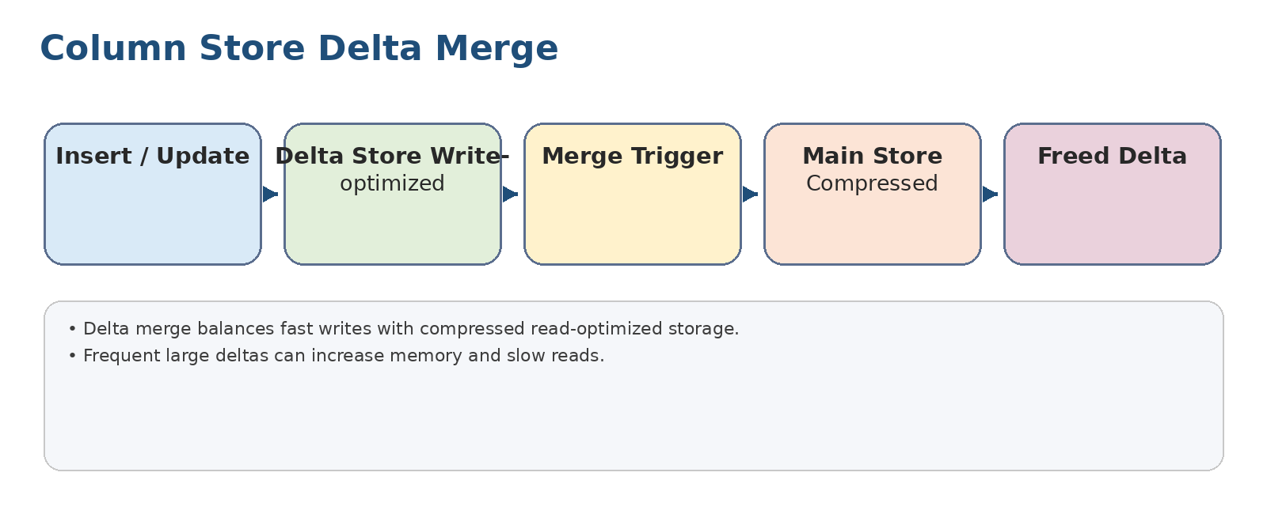
Original study diagram for 8. Administering using SAP HANA Cockpit.

Starting and Stopping SAP HANA
Objective: Use appropriate tools to start and stop systems, tenants, hosts, and services.
Definitions
Term | Meaning
Lazy loading | Column data is loaded on demand after restart rather than all at once.
Preload | Configuration that loads selected tables/columns into memory during startup.
Key points
- SAP HANA persists data with savepoints and redo logs so it can restart consistently.
- A normal shutdown writes a savepoint and reduces restart recovery work.
- Use the correct tool for the target scope: whole system, tenant, host, or service.
- Row store is loaded fully; column tables may be lazily loaded or preloaded based on configuration.
Exercise: Decide whether to use cockpit, SQL, HDB, or SAPControl for five start/stop scenarios.

Changing Database Configuration Parameters
Objective: Change SAP HANA configuration safely.
Definitions
Term | Meaning
ini file | Configuration file containing SAP HANA parameters.
Dynamic parameter | Parameter that can take effect without restart.
Key points
- Configuration is stored in .ini files with layers such as default, system, database, host, and service.
- Some parameters are dynamic; others require service or database restart.
- Changes should be documented with reason, owner, old value, new value, and rollback.
- Use cockpit or SQL with care and validate after changes.
Exercise: Create a configuration-change record for a memory-related parameter.

Describing Further Configuration Functions
Objective: Describe additional administration configuration functions.
Definitions
Term | Meaning
Workload management | Controls that help govern resource consumption by users, statements, or classes.
Key points
- Beyond basic parameters, administrators manage certificates, network/security settings, resource management, and workload-related configuration.
- Configuration must align with company standards and SAP supportability requirements.
- Avoid copying parameters blindly between systems without workload context.
- Review configuration after upgrades because defaults and recommendations may change.
Exercise: List three configuration areas that should be reviewed after system build.

Describing the Concept of Delta Merge
Objective: Explain delta merge in column-store tables.
Definitions
Term | Meaning
Main store | Compressed, read-optimized part of a column table.
Delta merge | Operation that moves changes from delta storage into main storage.
Key points
- Column-store writes land in the delta store, then merge into the compressed main store.
- Delta merge can be automatic, smart, or manually triggered in controlled cases.
- Large or delayed deltas can increase memory and slow reads.
- Monitor merge statistics before forcing manual merges.
Exercise: Diagnose a table with high delta size and decide whether to wait, tune, or merge.

Working with SAP HANA Traces
Objective: Use traces for diagnostics.
Definitions
Term | Meaning
Trace | Diagnostic output written by SAP HANA services.
Full system info dump | Diagnostic package containing system information for troubleshooting.
Key points
- Trace files provide detailed runtime and error information for SAP HANA services.
- Enable detailed traces only when needed because they can add overhead and generate large files.
- Use trace levels, diagnosis information, and full-system-info dumps for support cases.
- Disable or reduce trace levels after evidence is captured.
Exercise: Prepare a trace-capture plan for a reproducible error.

Unit demo practice
- Start/stop a sandbox tenant.
- Change a harmless test parameter and record rollback.
- Review delta merge status and trace settings.

9. Performing Backup and Recovery
Unit summary: Protect data through backup, log backup, recovery, retention, advanced techniques, snapshots, and copy scenarios.
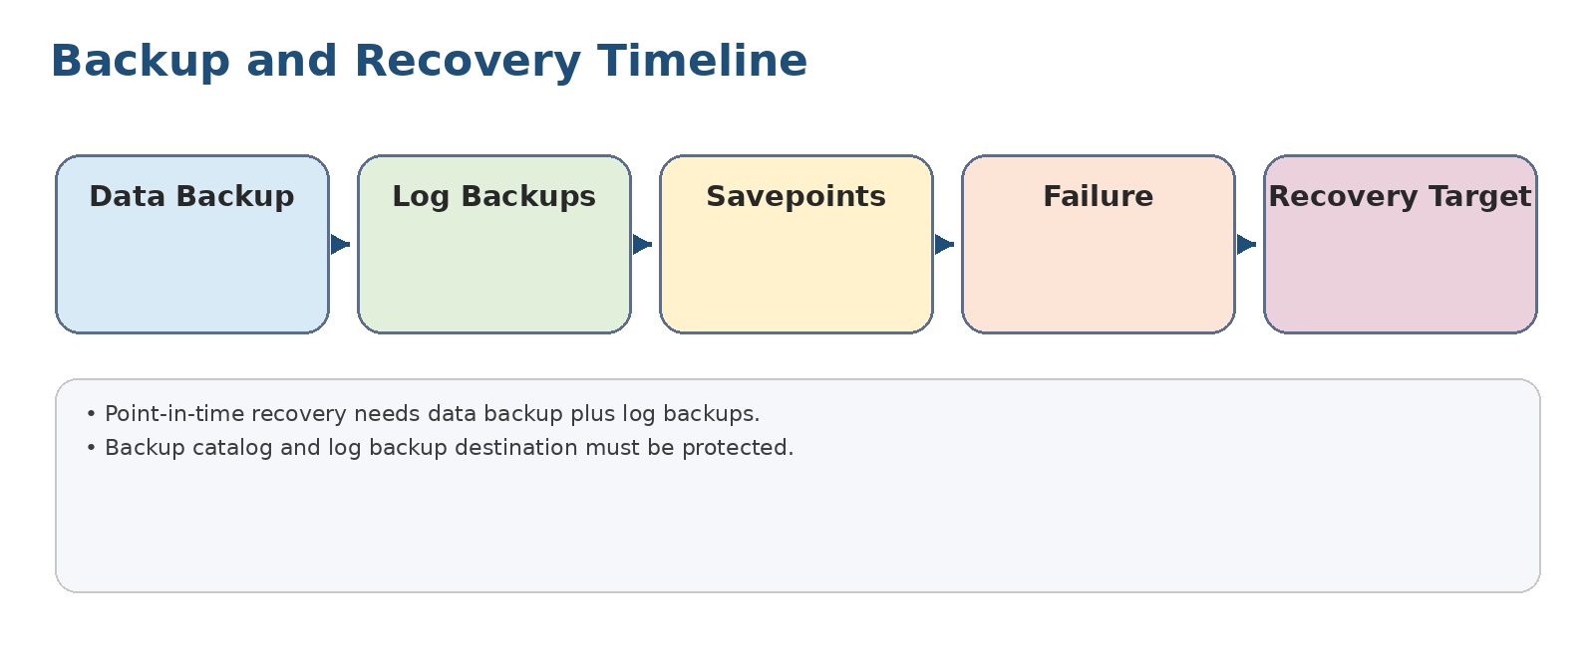
Original study diagram for 9. Performing Backup and Recovery.

Describing Backup and Recovery
Objective: Describe SAP HANA backup and recovery concepts.
Definitions
Term | Meaning
RPO | Recovery point objective; acceptable data loss window.
RTO | Recovery time objective; acceptable restore time.
Key points
- Backups protect against data loss, corruption, and operational mistakes.
- Data backups capture persisted data; log backups capture changes after data backups.
- Recovery options depend on available backups, logs, catalog, and target point.
- Backup strategy must be tested, not merely configured.
Exercise: Define RPO and RTO for a production tenant and explain backup implications.

Performing Data Backups
Objective: Perform a database data backup.
Definitions
Term | Meaning
Backup catalog | SAP HANA record of backups and log backups used for recovery.
Key points
- Data backups can be executed for SYSTEMDB and tenant databases.
- Backup destination, naming, encryption, and backup catalog entries must be verified.
- A successful backup should be checked for completion status and usability.
- Backups should not share the same failure domain as the database storage.
Exercise: Draft a data backup verification checklist.

Scheduling Data Backups
Objective: Schedule recurring data backups.
Definitions
Term | Meaning
Retention | Policy defining how long backups are kept.
Key points
- Scheduling reduces dependence on manual execution.
- Schedules should align with workload patterns and business recovery requirements.
- Retention must balance recovery needs, storage cost, and compliance.
- Monitor scheduled job success and failures.
Exercise: Design a weekly schedule for full backups and daily operational checks.

Configuring Log Backups
Objective: Configure automatic log backup.
Definitions
Term | Meaning
Log mode normal | Mode in which redo logs are backed up for recovery.
Point-in-time recovery | Recovery to a specific timestamp using data and log backups.
Key points
- Log backups are essential for point-in-time recovery.
- Log backup destination must have capacity and monitoring.
- Log mode and backup status directly affect recoverability.
- Failed log backups can create serious availability risk.
Exercise: Explain how log backup failure can lead to both data-protection and availability problems.

Performing Database Recovery
Objective: Perform recovery to a target state.
Definitions
Term | Meaning
Recovery target | The desired timestamp or backup state to which the database is restored.
Key points
- Recovery can use the most recent state, a specific point in time, or a specific data backup.
- Recovery requires compatible data backups, log backups, and access to the backup catalog or backup files.
- Recovery is disruptive and should follow an approved runbook.
- After recovery, validate services, users, data consistency, and application connectivity.
Exercise: Choose a recovery option for accidental table deletion discovered two hours later.

Describing Additional Backup Topics
Objective: Describe retention, Backint, catalog, encryption, and operational concerns.
Definitions
Term | Meaning
Backint | SAP-certified interface for third-party backup tools.
Catalog housekeeping | Management of old backup catalog entries and backup files.
Key points
- Backint integrates third-party backup tools with SAP HANA.
- Backup encryption and key management must be planned before relying on encrypted backups.
- Backup catalog housekeeping prevents uncontrolled growth while preserving recovery capability.
- Test restore drills should be scheduled regularly.
Exercise: Create a monthly backup governance checklist.

Illustrating Advanced Backup and Recovery Techniques
Objective: Illustrate advanced protection options.
Definitions
Term | Meaning
Storage snapshot | Storage-level consistent image used for fast fallback or backup acceleration.
Key points
- Advanced techniques include storage snapshots, system replication, tenant recovery, and cross-system restore scenarios.
- Snapshots can provide fast fallback but do not replace a full backup strategy.
- System replication helps availability but is not a substitute for recoverable backups.
- Cross-system restore requires careful handling of identifiers, encryption keys, and compatibility.
Exercise: Explain why system replication does not replace backups.

Creating a Fallback Snapshot
Objective: Create a fallback snapshot before risky maintenance.
Definitions
Term | Meaning
Fallback snapshot | Temporary recovery point used to revert after a failed change.
Key points
- A fallback snapshot is useful before upgrades or major changes when storage integration supports it.
- It should be coordinated with database consistency requirements.
- Snapshot existence, retention, and rollback procedure must be verified before maintenance starts.
- Fallback snapshots are time-bound operational safeguards, not long-term backups.
Exercise: Write a pre-upgrade fallback-snapshot checklist.

Identifying Database Copy Scenarios
Objective: Identify copy/refresh/clone scenarios.
Definitions
Term | Meaning
System refresh | Replacement of a non-production system with a recent copy of production data.
Key points
- Database copies support testing, training, troubleshooting, and system refreshes.
- Copy scenarios must protect sensitive data with masking or access controls where required.
- Target compatibility, backup availability, and post-copy configuration are key.
- After copy, update connections, users, schedules, and monitoring to avoid production conflicts.
Exercise: List post-copy tasks needed to prevent a refreshed QA system from sending production emails or jobs.

Unit demo practice
- Perform a sandbox data backup.
- Verify log backup configuration.
- Run a recovery drill and document RPO/RTO results.

10. Describing SAP HANA Security Features
Unit summary: Secure the platform through secure stores, encryption, auditing, and data-center integration.
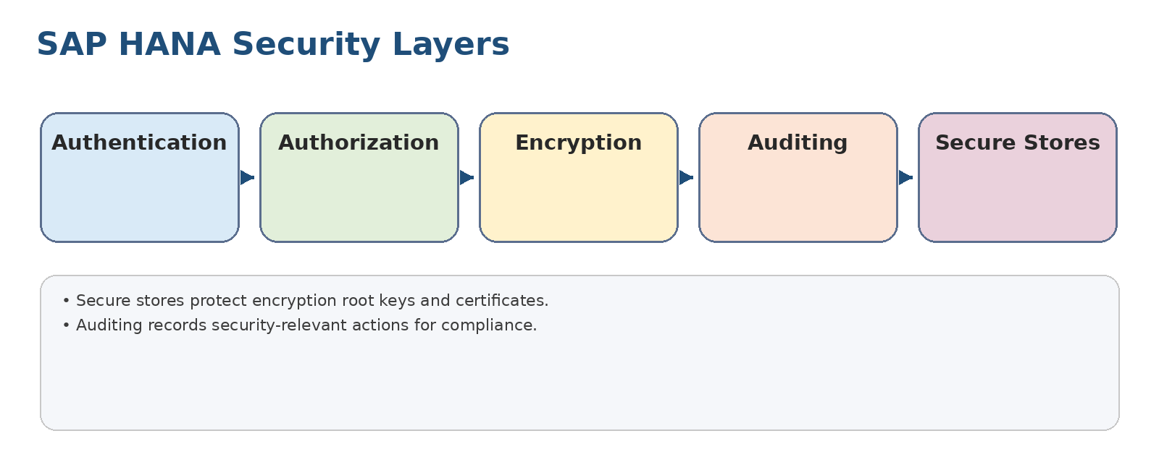
Original study diagram for 10. Describing SAP HANA Security Features.

Illustrating the SAP HANA Security Functions
Objective: Identify SAP HANA security capabilities.
Definitions
Term | Meaning
SSFS | Secure store in the file system; protects root keys and certificates.
LSS | Local secure store; separates sensitive key storage under a dedicated OS service/user.
Key points
- SAP HANA security covers authentication, authorization, encryption, auditing, and secure integration.
- Secure stores protect root keys and certificates required for encryption and internal communication.
- The security architecture integrates with identity management and logging infrastructure.
- Security features used depend on the scenario and surrounding architecture layers.
Exercise: Map each security function to the risk it reduces.

Describing Encryption
Objective: Describe encryption at rest and related key handling.
Definitions
Term | Meaning
Data-at-rest encryption | Encryption of persisted data such as volumes and backups.
Root key | Key used to protect lower-level encryption keys.
Key points
- SAP HANA can encrypt data volumes, redo logs, and backups.
- Encryption depends on root keys, secure stores, key backups, and operational procedures.
- Losing key material can make encrypted data inaccessible.
- Encryption design must include key rotation, backup, access control, and disaster recovery.
Exercise: Create an encryption operations checklist with key backup and recovery steps.

Setting Up Auditing
Objective: Set up audit policies and audit trail handling.
Definitions
Term | Meaning
Audit policy | Rule that defines which activities are recorded.
Audit trail | Stored record of audited events.
Key points
- Auditing records security-relevant actions for compliance and investigation.
- Audit policies must specify actions, users, objects, and severity carefully.
- Audit trails should be protected from tampering and reviewed regularly.
- Too much auditing creates noise and storage pressure; too little misses risk.
Exercise: Design an audit policy for failed logins, user changes, and privilege grants.

Unit demo practice
- Review secure store concepts.
- Create an encryption checklist.
- Draft three audit policies.

11. Performing User and Authorization Maintenance
Unit summary: Manage authentication, authorization, roles, users, groups, and administrator information sources.
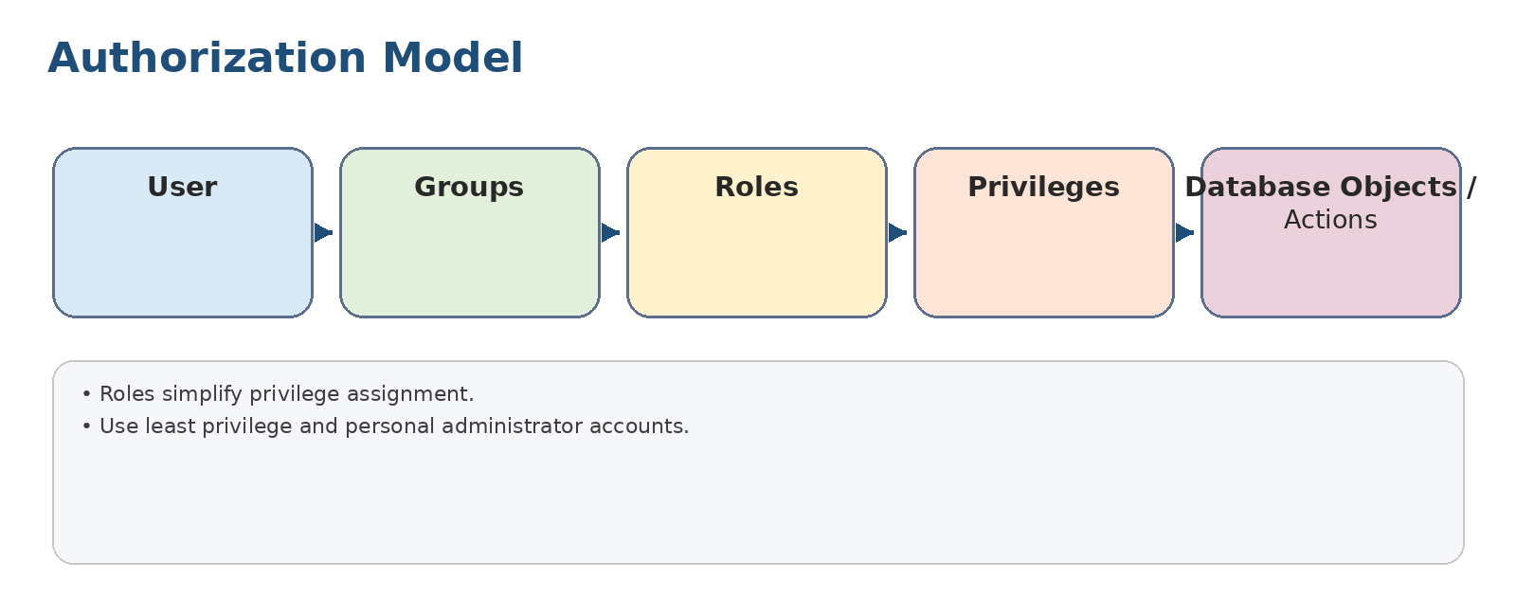
Original study diagram for 11. Performing User and Authorization Maintenance.

Describing SAP HANA Authentication and Authorization
Objective: Describe how users prove identity and receive permissions.
Definitions
Term | Meaning
Authentication | Process of verifying user identity.
Authorization | Process of determining permitted actions after authentication.
Key points
- Authentication confirms identity; authorization controls what authenticated users can do.
- SAP HANA can integrate with enterprise identity mechanisms depending on the scenario.
- User design should support personal accountability and least privilege.
- Authorization troubleshooting requires checking users, roles, privileges, object ownership, and analytic/application context.
Exercise: Explain the difference between authentication failure and authorization failure.

Describing SAP HANA Privileges and Roles
Objective: Describe privilege types and role-based design.
Definitions
Term | Meaning
System privilege | Privilege for administrative actions.
Object privilege | Privilege on a database object such as a table or view.
Role | Reusable container of privileges.
Key points
- Privileges can be system, object, analytic, package/application, or other context-specific privileges.
- Roles bundle privileges for easier assignment and review.
- Avoid direct privilege sprawl by using reviewed roles.
- Separation of duties should be reflected in role design.
Exercise: Design roles for backup operator, monitoring viewer, and security administrator.

Managing Users
Objective: Manage user lifecycle.
Definitions
Term | Meaning
User lifecycle | Creation, maintenance, review, locking, and deletion/deactivation of users.
Key points
- Create personal users for administrators instead of sharing powerful accounts.
- Apply password policy, lock/unlock processes, validity dates, and deactivation rules.
- The SYSTEM user should be protected and not used for everyday work.
- Review users and privileges regularly.
Exercise: Create a user offboarding checklist for a departing database administrator.

Managing Groups
Objective: Manage user groups.
Definitions
Term | Meaning
User group | Collection of users managed together for administration or assignment.
Key points
- Groups organize users for administration and can simplify assignment models.
- Group ownership and membership should be controlled.
- Groups should reflect operational responsibilities rather than informal convenience.
- Review group membership as part of access recertification.
Exercise: Define groups for operators, developers, security admins, and auditors.

Describing Information Sources for Administrators
Objective: Identify reliable administrator information sources.
Definitions
Term | Meaning
SAP Note | SAP support note containing corrections, recommendations, or release-specific guidance.
Key points
- Administrators use cockpit, database explorer, system views, traces, logs, SAP Notes, and official guides.
- Use current documentation for release-specific behavior.
- Keep internal runbooks aligned with actual system revision and company standards.
- When troubleshooting, preserve evidence before making changes.
Exercise: Build a troubleshooting evidence checklist: symptom, time, system, logs, alerts, SQL, recent changes, and impact.

Unit demo practice
- Create a test user and role.
- Assign least-privilege permissions.
- Review user/group membership and offboarding steps.

12. Describing SAP ABAP Systems on SAP HANA
Unit summary: Understand what changes when ABAP-based SAP systems run on SAP HANA.

Illustrating SAP ABAP Systems on SAP HANA
Objective: Illustrate how ABAP systems use SAP HANA as their database.
Definitions
Term | Meaning
Code pushdown | Design principle of moving data-intensive calculations closer to the database layer.
CDS | Core Data Services; semantic data modeling approach used in SAP applications.
Key points
- ABAP systems can run on SAP HANA as the primary database to gain performance and simplified data models.
- SAP HANA-optimized ABAP designs push appropriate computation closer to the database.
- Administrators must monitor both ABAP application behavior and SAP HANA database health.
- Migration and operation require coordination across Basis, database, application, and business teams.
Exercise: Identify three checks that require cooperation between the ABAP team and HANA database administrator.

Unit demo practice
- Map ABAP, Basis, and HANA administrator responsibilities.
- Identify HANA checks before and after ABAP migration.
- Explain code pushdown in a business scenario.

Consolidated demo runbook

Demo 1 - Pre-install readiness review
- Confirm sizing assumptions and growth.
- Verify supported hardware/cloud configuration.
- Check Linux OS packages, time sync, users, storage paths, and network.
- Run hardware measurement tests and archive results.

Demo 2 - Install and validate SAP HANA
- Prepare media and parameter sheet.
- Run hdblcm in planned mode.
- Confirm services and tenant status.
- Record ports, users, paths, and installation logs.

Demo 3 - Configure cockpit and register a tenant
- Install or access cockpit.
- Create users/resource groups.
- Register SYSTEMDB and tenant resources.
- Validate monitoring tiles and alerts.

Demo 4 - Tenant administration
- Create a sandbox tenant.
- Start/stop tenant using cockpit or SQL.
- Back up tenant.
- Rename/delete only in a sandbox with approval steps documented.

Demo 5 - HDBSQL secure access
- Create a secure user store key.
- Connect to the target tenant using hdbsql.
- Run SELECT-only health checks.
- Save output to an evidence file.

Demo 6 - Monitor and triage
- Check services, memory, persistence, alerts, and SQL workload.
- Pick one issue and gather evidence.
- Decide whether to tune, escalate, or monitor.

Demo 7 - Backup and point-in-time recovery drill
- Run or verify data backup.
- Confirm automatic log backups.
- Choose a recovery target.
- Restore in a sandbox and validate application connectivity.

Demo 8 - Security hardening drill
- Create personal admin users.
- Assign roles using least privilege.
- Enable a sample audit policy.
- Review encrypted backup/key-handling requirements.

Practice exercises
- Explain why SAP HANA still needs persistent data and log volumes even though it is in-memory.
- Choose row store or column store for: configuration table, fact table, session table, reporting aggregate, and lookup table.
- Create a pre-install checklist with at least ten items.
- Explain how sizing affects backup design and recovery objectives.
- Create a cockpit resource model for DEV, QA, and PROD.
- Write a tenant lifecycle runbook: create, backup, stop/start, rename, delete.
- Explain the relationship between savepoints, redo logs, data backups, and log backups.
- Describe how you would investigate high memory usage without immediately changing parameters.
- Explain the difference between a data backup, storage snapshot, fallback snapshot, and system replication.
- Design a least-privilege authorization model for monitoring, backup, and security administration.
- Create an audit policy plan for failed logins, privilege changes, and user administration.
- List post-copy tasks after refreshing QA from Production.

Answer key / expected responses
- Persistence provides durability. Savepoints persist changed pages, and redo logs persist committed transactions for crash recovery.
- Column store fits large analytical/fact data and aggregations; row store fits small, frequently updated, single-record tables.
- A strong checklist includes sizing, certified infrastructure, OS, users, storage, network, time sync, media, parameter sheet, passwords, backups, security, and support model.
- Bigger data and workload increase memory, persistence, backup storage, backup windows, and recovery time.
- Cockpit resources should be grouped by environment and access should be delegated through roles/resource groups.
- Tenant lifecycle requires approvals, backups, defined commands/tools, validation, monitoring update, and documentation.
- Data backups provide baseline restore points; log backups allow recovery after that baseline; savepoints and redo logs support consistency.
- Investigate tables, delta store, row store, expensive SQL, allocation limits, workload changes, and alerts before tuning.
- Backups recover data; snapshots can provide fast infrastructure fallback; system replication protects availability but can replicate corruption or user mistakes.
- Least privilege uses personal users, roles per task, no shared SYSTEM account, and regular recertification.
- Audit policies should be selective, protected, reviewed, and aligned with compliance needs.
- Post-copy includes masking, users, connections, jobs, emails, RFC destinations, monitoring registration, backup schedules, and documentation.

One-page final revision checklist
- ☐ I can explain why SAP HANA uses column store, delta store, and persistence.
- ☐ I can list pre-install requirements for sizing, hardware, Linux, storage, and network.
- ☐ I can explain the role of hdblcm, cockpit, Database Explorer, hdbsql, and SAPControl.
- ☐ I can describe SYSTEMDB versus tenant database administration.
- ☐ I can monitor services, memory, persistence, alerts, and SQL statements.
- ☐ I can explain start/stop recovery behavior, savepoints, redo logs, and preload/lazy loading.
- ☐ I can explain delta merge and when not to force it blindly.
- ☐ I can design data backup, log backup, retention, and recovery testing.
- ☐ I can explain encryption, secure stores, auditing, authentication, authorization, roles, and users.
- ☐ I can identify ABAP-on-HANA operational coordination points.

