**UZone**

The original design was initially set to create a graphical user interface system targeted at students to help organize and remember different tasks and events occuring in their lives. For this project, one of the main features was that the home page would transform into a news page with a Tasks and events side bar for students who successfully sign in. It was also set that there would be only 3 admins (which are the group members) that control the news page and can read any complaints that students can anonymously make. In terms of students, each was declared to have an array of Tasks and Events that they themselves can create, view, or delete.

Currently, the classes created by my group members and I have been split up and then overviewed. That is, the initial classes made and developed by each member were then checked by the two other group members to assure quality and resolve any observable errors.

The Person, Admin, and Student classes were generated by Tommy Salanski. After his first initial request to review his work, we found that it would be best to have Students have an ArrayList of Task and Event objects, which cut out the Info page we had initially proposed.

The Task, Event, and Complaint classes were created by Grayson Fleming. After his first initial request to review his work, we found that Task and Event classes should not contain an Info object, rather just a title string, info string, and calendar object keeping track of the time of the event by the year, month, day, and time of task or event.

The Driver1, Driver2, UZone, and UZoneGUI classes were developed by Justin Loera. After his first initial request to review his work, we found that we had only need to modify the GUI to fit the above mentioned modifications. Each dropdown JMenu has its own specific checks made to ensure that the textfield is satisfied. Within the Add Tasks and Add Events frames, a separate frame pops up for the storing of time information (which has its own checks verified and tested). The class UZone saves and loads all the data for both Students and Administrators.

The saving functionality works for Driver1, but has yet to be completed for Driver2. The View menus for both Task and Event must also be developed. A user can successfully register and sign in, however the main page must transform after doing so. The home menu must be implemented as well as the deletion and adding of tasks and events to the specific student. All are currently being worked on, and every function should be implemented very soon.

**Home**

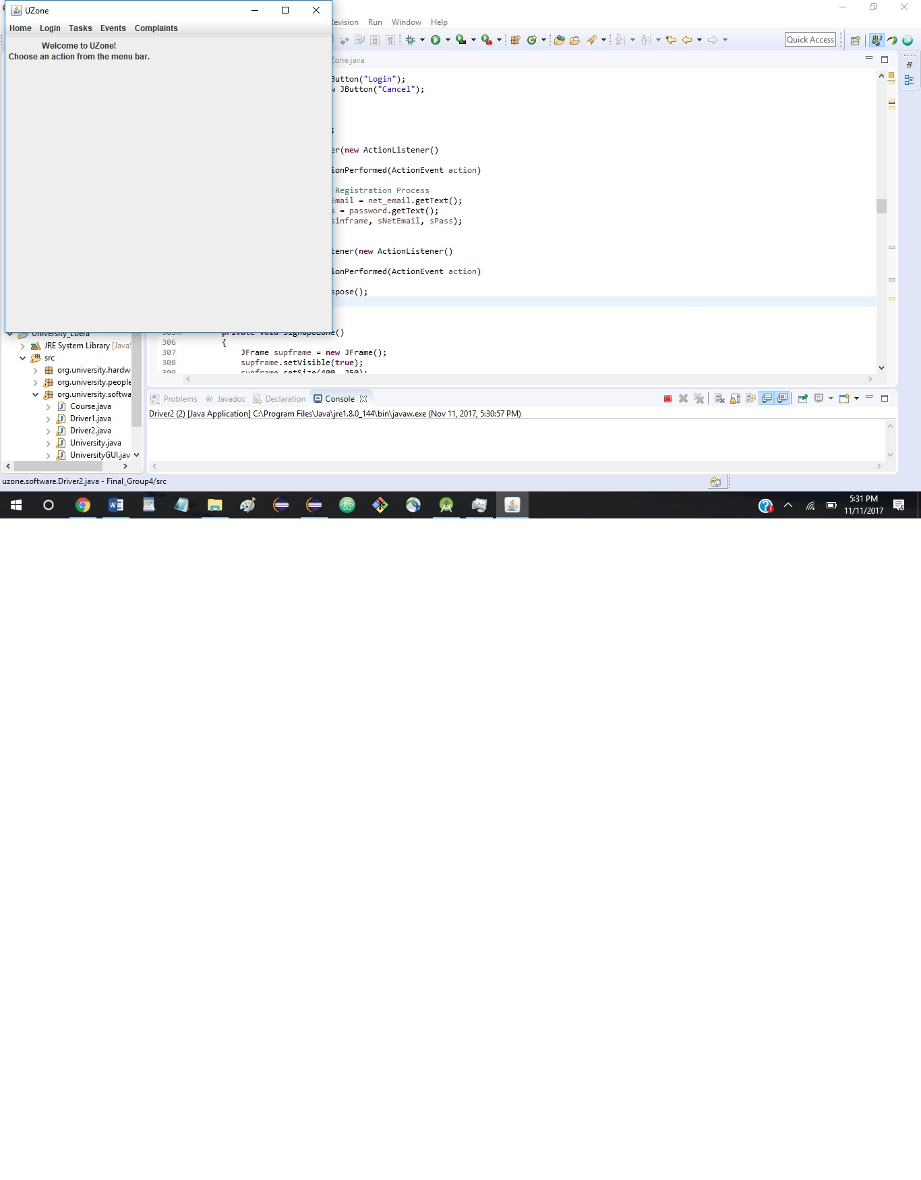

**Sign Up/Sign In**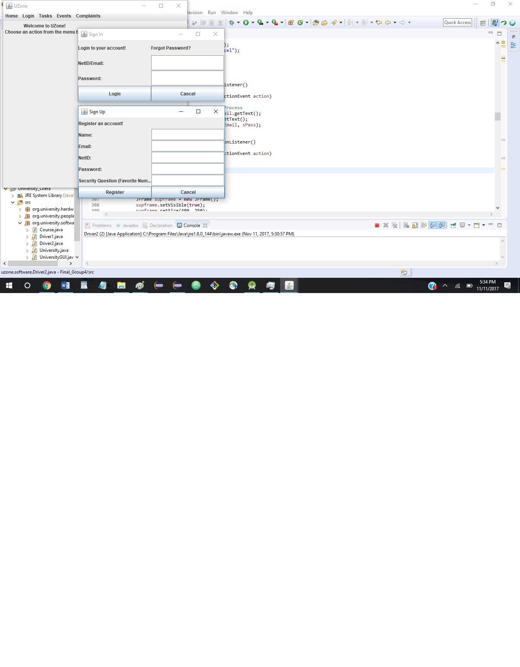

**Tasks**

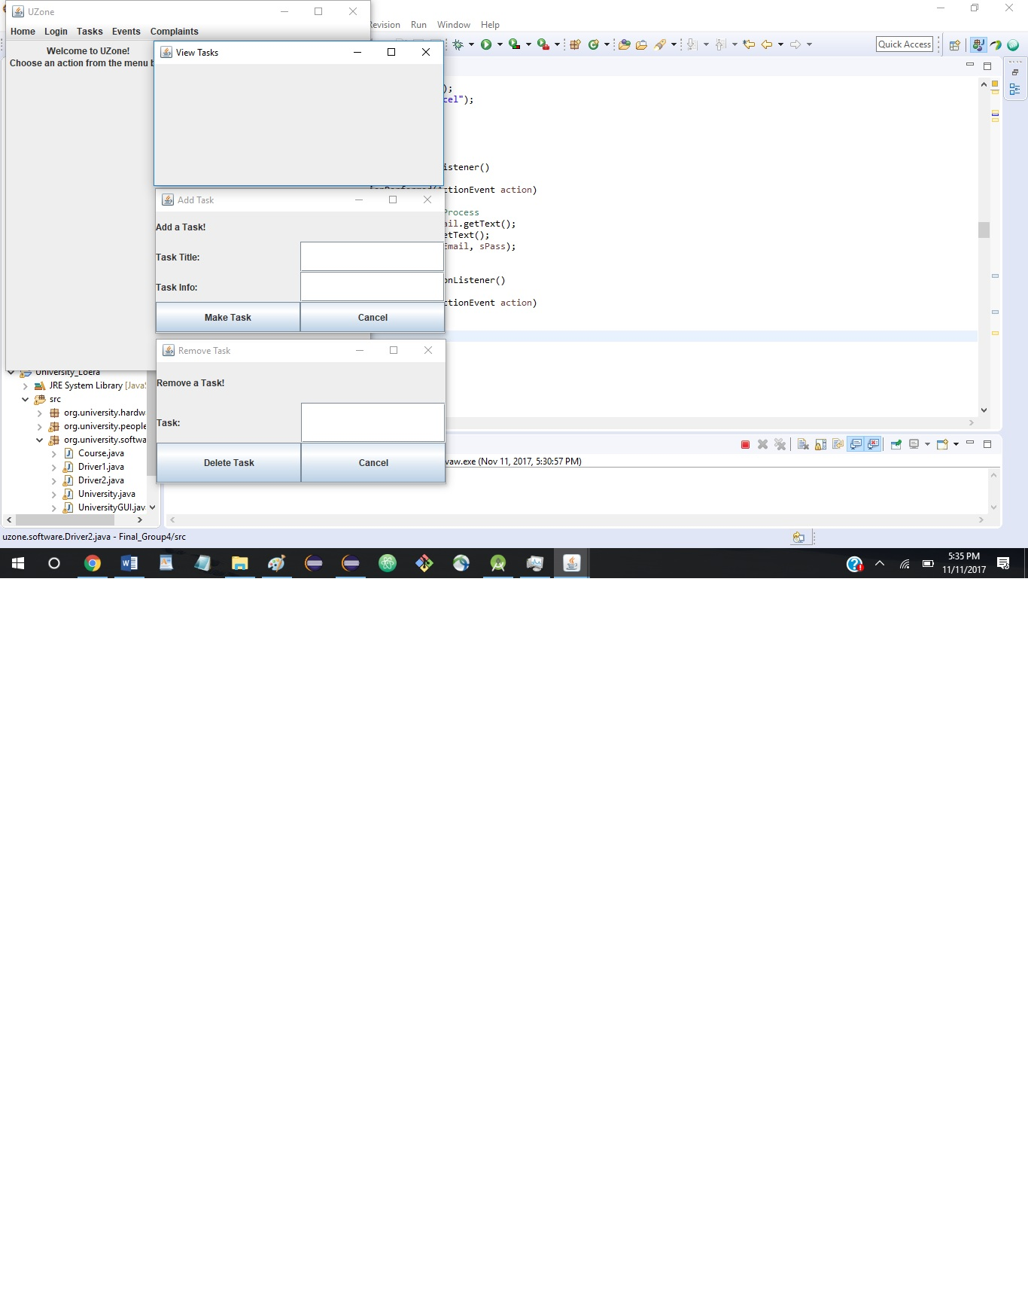

**Events**

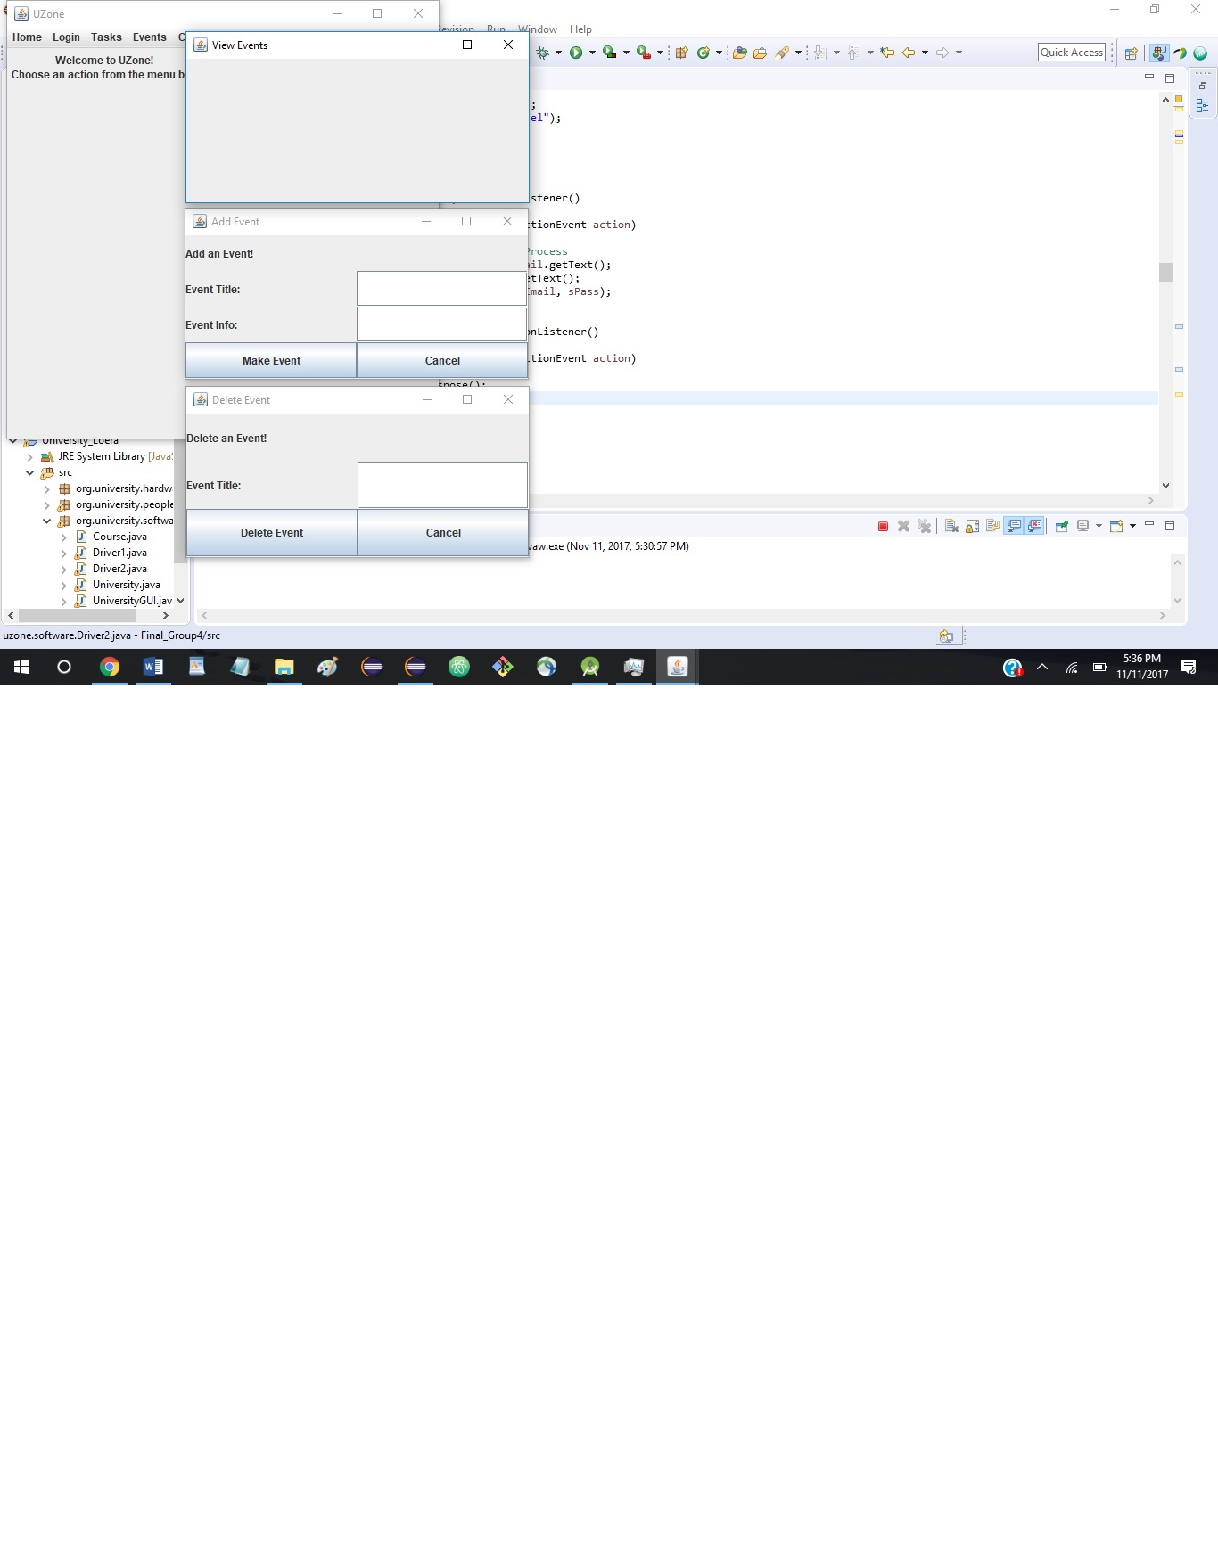

**Complaints**

