Table of Contents

User Accounts 2

Administrator User 2

Administrator Dashboard 2

Administrator Search 2

Administrator Wait-list detail 2

Advisor User 2

Advisor Dashboard 2

Advisor Search 2

Advisor Student Detail 2

Advisor Wait-list Detail 2

Scheduler User 2

Scheduler Dashboard 2

Scheduler Search 2

Scheduler Wait-list Detail 2

Student User 2

Student Dashboard 2

Student Search 2

Student Wait-list Sign Up 2

Visitor User 2

# User Accounts (Tony)

In this section we will explore what CORSICA users may do. The user types include: Administrator, Advisor, Scheduler, Student, and Guest. This manual will first examine the Administrator user. Upon the initial log on, the Admin is directed to their version of the CORSICA dashboard as shown in Figure 1.

## Administrator User

The Administrator User has the most abilities out of all the user types. They are able to do everything the Advisor and Scheduler users can do. In addition to these abilities, they are able to add and remove all user types from CORSICA.

### Administrator Dashboard

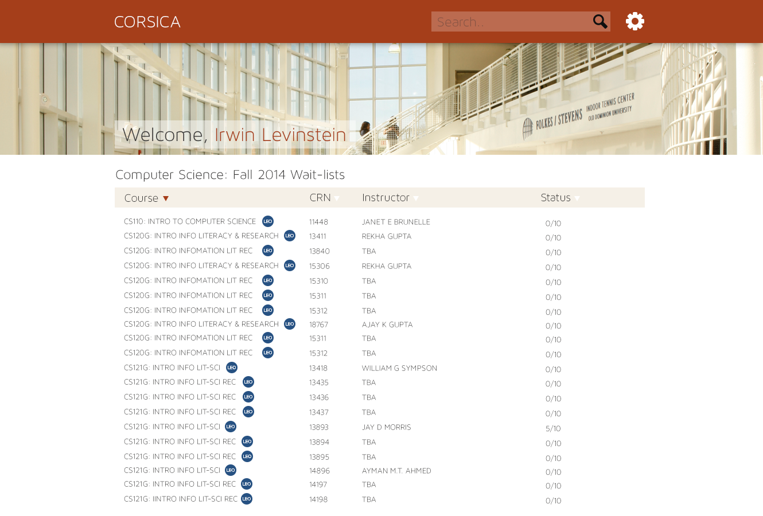

Figure - Administrator Dashboard

From the dashboard, the Admin will see a list of currently active wait-lists that display: course name, course CRN, the instructor, and the amount of students signed up on the wait-list. The admin may add a course to the currently active wait-lists by doing the following:

Step 1: Scroll to the bottom of their dashboard.  
 Step 2: Click the “Add Course” button that is shown in Figure 2.  
 Step 3: Fill out the requested information.

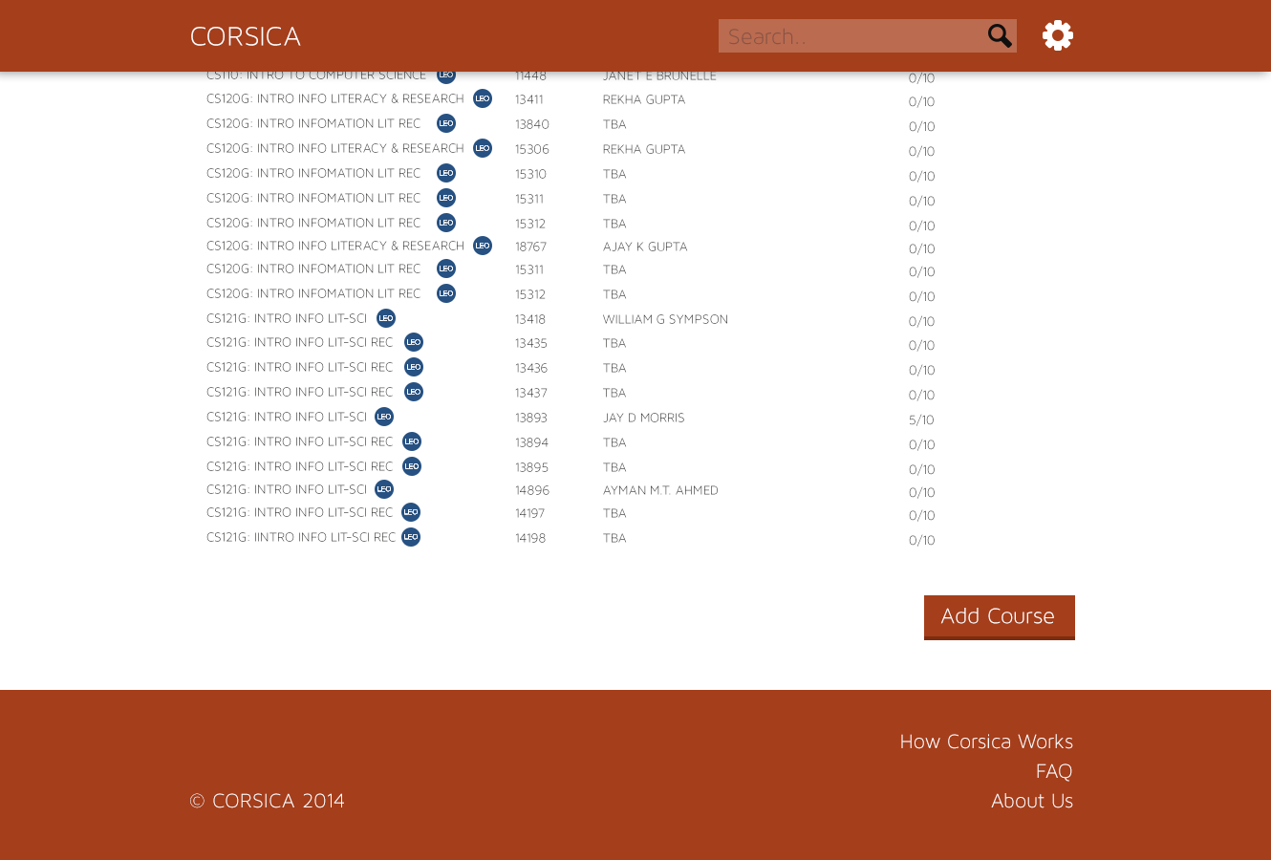

Figure - Admin Add Course

### Administrator Search

An admin user may search for a particular student by typing the name of the student in the search bar that is found in the top right corner of their dashboard.

### 

Figure - Search Bar

After the student search is performed the Admin may view any wait-lists the searched student is enrolled in. In the Figure 4 example, Latimer Gerle was searched and the wait-lists she is enrolled in are displayed.

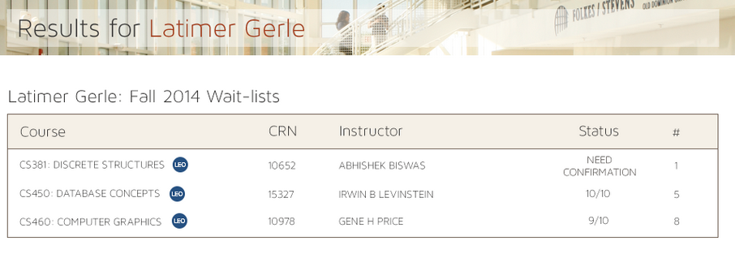

Figure - Search Result

An admin user may display the details about a course wait-list. The user will see the students that are enrolled in the wait-list. Students may be moved or deleted by the admin on this screen. In the Figure 5 example, CS 250 was searched.

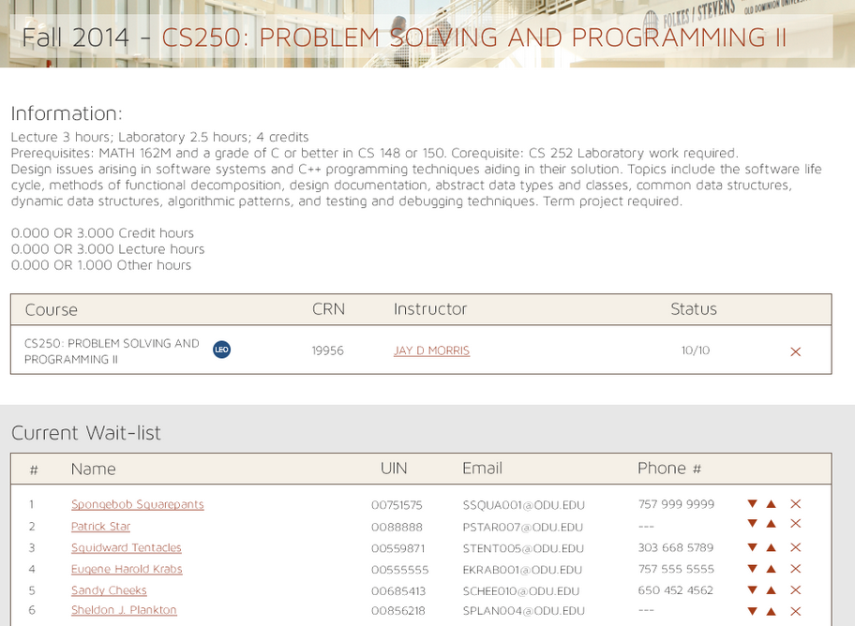

Figure - Course Search

## Advisor User

The Advisor User is responsible for leading students on the correct path throughout their academic career. They will have the ability to move students on the wait-list in a special case incident where a student needs one last course to graduate when compared to a freshman. They will also be able to delete students off of the wait-list.

### Advisor Dashboard

Same as Administrator User

### Advisor Search

Same as Administrator User

### Advisor Student Detail

Same as Administrator User

### Advisor Wait-list Detail

Same as Administrator User

## Scheduler User

The Scheduler User is in charge of setting up what courses are eligible to have wait-lists. They are able to add wait-lists and remove them.

### Scheduler Dashboard

Same as Administrator User

### Scheduler Search

Same as Administrator User

### Scheduler Wait-list Detail

Same as Administrator User

## Student User

The Student User will make up the majority of CORSICA’s user base. The student will be able to:

* Create account
* Search for a course
* Search for a keyword
* Search for a CRN
* Search for instructor
* Add to queue
* Remove from queue
* Can’t add yourself to queue because queue is filled
* Notification via email
* Notification via email and text

### Student Dashboard

Once a student user has logged into CORSICA, their dashboard will display all current wait-lists that student is enrolled in. Figure 6 shows a student who has logged in and is enrolled in three wait-lists.

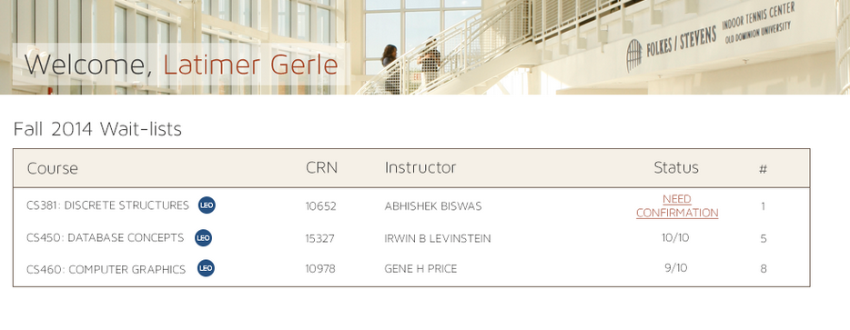

Figure - Student Dashboard

### Student Search

A student user may search for a particular professor by typing their last name into the search bar at the top right of their dashboard. Figure 7 shows an example of a student searching for Professor Brunelle. The course wait-lists that have the searched professor as the instructor are displayed.

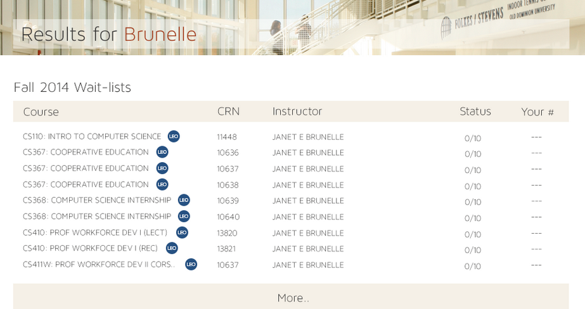

Figure - Student Search

### Student Wait-list Sign Up

In order for a student to queue for a course wait-list they must:

Step 1: Log into CORSICA

Step 2: Search for the course wait-list they wish to enroll in.

Step 3: If there is space available, they must click the “Queue” button as shown in Figure 8.

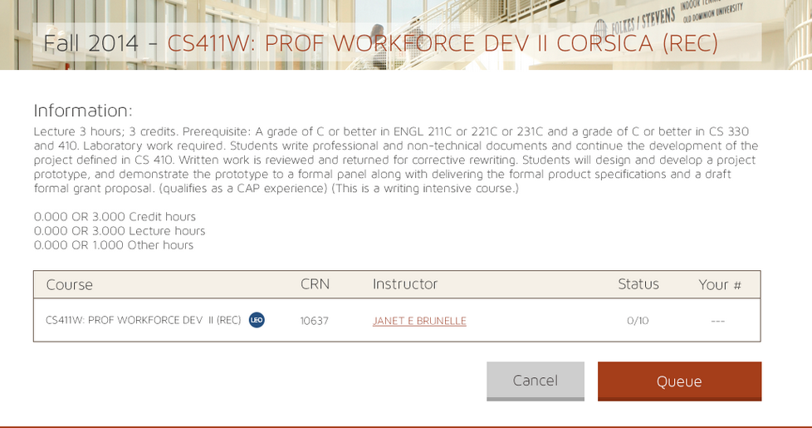

Figure - Student Wait-list sign up

Step 4: After pressing the queue button, the student will receive a confirmation pop up detailing their successful action and their position on the course wait-list as shown in Figure 9.

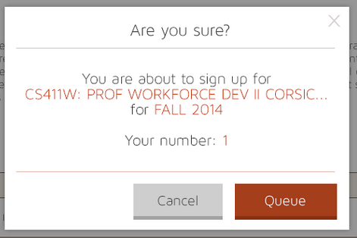

Figure - Student Confirmation

## Visitor User

The Visitor User will have the least amount of abilities. They will only be able to view the FAQs page and the About Us page in CORSICA.