# CORSICA Product Description

# Onapha Rattanachottiteepakorn

CS411W

# Janet Brunelle

September 21, 2014

# Table of Contents

1 INTRODUCTION.............................................................................................................. 3

2 CORSICA PRODUCT DESCRIPTION............................................................................ 4

2.1 Key Product Features and Capabilities .................................................................. 5

2.2 Major Components (Hardware/Software).............................................................. 6

3 IDENTIFICATION OF CASE STUDY............................................................................. 8

4 CORSICA PRODUCT PROTOTYPE DESCRIPTION.................................................... 9

4.1 Prototype Architecture (Hardware/Software) ...................................................... 10

4.2 Prototype Features and Capabilities .................................................................... 14

4.3 Prototype Development Challenges .....................................................................17

Glossary ...................................................................................................................................... 19

References ................................................................................................................................... 21

List of Figures

Figure 1 - Hardware Components ................................................................................................ 7

Figure 2 - Major Functional Components Diagram ..................................................................... 10

List of Tables

Table 1 - Real World Product and Prototype Comparison Table ................................................ 11

Table 2 - Algorithms Description Table ...................................................................................... 12

1. **INTRODUCTION**

When the amount of wages boosted by a bachelor’s degree proved to be worth the initial investment, it is no wonder that the amount of freshman admission increases over the year (Barrow and Rouse). The headcount statistic from Old Dominion University shows that from the year 2002, the amount of first year students admitted increased from 2,481 to 4,550 in 2013 (Old Dominion University Student Headcount). While the rising in number of students entering the college is good for the economy and the technological advancement, it also presents a capacity challenge to universities across the nation (Fry). When a university failed to address the course capacity issue, the admitted students would be deprived of the opportunity to graduate in a 4 years timeline. This has led to the problem of the current class enrollment system becoming insufficient for handling course overflow.

Old Dominion University currently relies on the Ellucian’s ERP, Banner, for handling the enrollment system. The school implemented Leo Online as the interface for accessing the information from Banner. While the current system provides a relatively stable services, it still underrepresents a way for student to get wait-listed into a full class online. This issue directly increases the amount of unnecessary communication between the students and the faculty. Going from students to professors to advisors and then to the enrollment staff, the long winded process of entering a full class proves to be an avoidable problem with an efficient online wait-list process.

CORSICA is a part of Old Dominion University’s Computer Science Department’s professional workforce development course. The creation of the prototype of a new online wait-list process will be a good sample that such system can be implement within the Computer Science classes. The prototype will allow student users to login to the CORSICA website with their ODU credential. The user will be able to enlist his/herself to a full CS class. Once the class becomes available to enroll, CORSICA will automatically send a notification to the enlisted students through email and/or text message. While the prototype will not directly communicate with ODU’s database, it will serve as a good proof of concept for an online wait-list process implementation.

1. **CORSICA PRODUCT DESCRIPTION**

**2.1 Key Product Feature and Capabilities**

CORSICA is a an online wait-list management system. The product’s main features include the ability for students to enlist themselves into a wait-list of a full class and receive notification of the class’s availability. CORSICA also will also provide centralized services for Advisors, Professors, as well as Schedulers. Such services include increasing class capacity, manual adding/dropping students in a wait-list, and manual opening/closing of certain classes.

Student users will be able to log in to CORSICA with their ODU credential. Once the user has been authenticate, the user will be able to search for a specific class and see its status. Once a full class becomes available, CORSICA will lock the course enrollment in order to prevent students not on the wait-list to register for the seat. The server would send out notification, through email and/or text message, that the class has become available to the users on the wait-list. The first user on the wait-list has 24 hours to register or refuse class before the seat is offered to the next student on the list. Once the user respond to the notification, he/she will be automatically removed from the wait-list.

Advisors and Professors will also have access to CORSICA. In order for CORSICA to be a fully centralized automate wait-list system, faculty will have the ability to manually add or drop a student from the wait-list through the site. Scheduler user will be a special type of user provided for the department’s classes scheduler. The Scheduler will have the ability to manually close or open a wait-list for classes.

CORSICA will also provide analyses for future class scheduling. The overall information will be only be accessible for the faculty users. This feature will display general statistic of students enrollment as well as providing prediction for course capacity in the proceeding semester. This tool should prove to be useful for scheduler to make sure that the university will be able to provide seats for its students equally.

One of the major capabilities for CORSICA is the ability to handle classes that require labs and recitations. When a student enlists his/herself to a class that needs lab/recitation, CORSICA would alert the user to also list his/herself on to the desirable and available additional classes. Student will not be able to enroll into a class through CORSICA if he/she has not enlist in the required classes respective wait-lists.

**2.2 Major Components (Software/Hardware)**

Since CORSICA is an online service provided to ODU authenticated users, the product require little hardwares. The user should have a computer with internet connection in order to connect to CORSICA server to be able to access the site’s services.

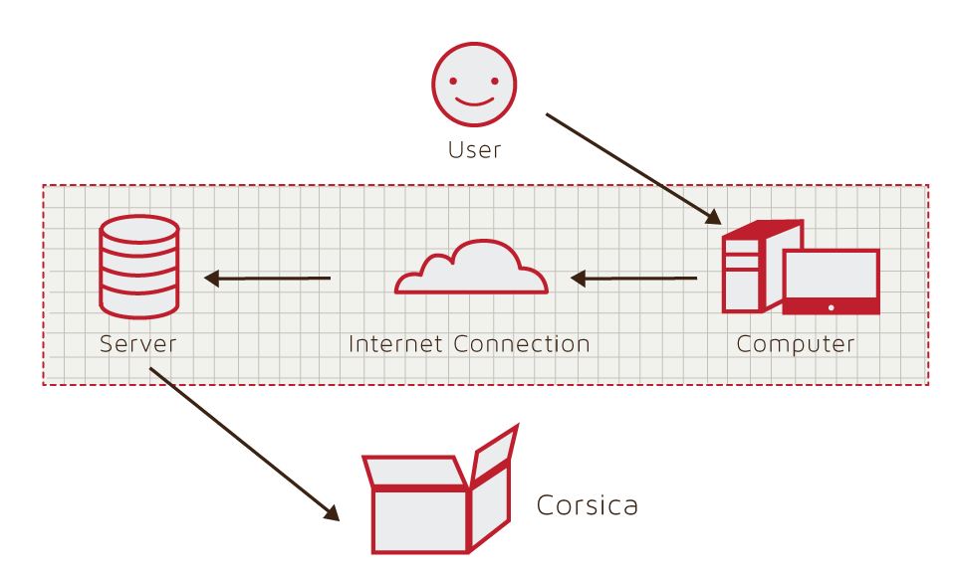

Figure 1: Hardware Components

For the software counterpart, CORSICA’s main structure includes backend server using NoSQL database MongoDB with Node.JS as the tool to communicate between the backend and frontend. MongoDB uses the NoSQL database structure which accommodates data from the already existed CS classes information in JSON format (Mardan). CORSICA will utilize Backbone.JS as its main scaffold for the site’s structure. Backbone.JS “gives structure to web applications by providing models with key-value binding and custom events, collections with a rich API of enumerable functions, views with declarative event handling, and connects it all to [the project] existing API over a RESTful JSON interface” (Backbone.js).

1. **IDENTIFICATION OF CASE STUDY**

CORSICA is being developed as a solution to the course overflow problem within the CS Department at ODU. The problem was brought to attention by Dr. Irwin Levinstein, the department’s associate professor and the classes scheduler. The current wait-list system shows potential for an online wait-list system, but it underperforms in term of handling the enrollment process. With the current process, once a seat becomes available to enroll, it does not obey the wait-list rule and allows any student to register his/herself into the class. This leads to the problem of miscommunication between students and faculty and proves that the current process is not efficient to handle the school’s class capacity issue. As a solution to this problem, CORSICA centralizes the enrollment and notification services as well as provides the wait-list’s visibility for any users.

1. **CORSICA PRODUCT PROTOTYPE DESCRIPTION**

The prototype version of the envision product will be developed throughout the Fall 2014 semester at ODU. Since the time allotted to this project is only 18 weeks, CORSICA will not be able to ship as a real wait-list product to be used in real class enrollment process. The final prototype will simulate the way an online wait-list process operates as well as providing an example for a future wait-list process implementation.

Since CORSICA does not have access to the Banner database, a simulation of students data will be created. CORSICA will receive CS classes information from the department’s scheduler in a form of JSON file. The data provides information on the classes’ overall status, such as total enrolled and capacity, as well as basic information, such as instructor information and the course reference number. With these information and the simulated students data, the prototype will demonstrates the key features of the envision wait-list system including: login functionality, customized dashboard for each of the user types, enlisting in different wait-lists and enrolling into available class for student users, manual adding/dropping of students from wait-lists and manual closing/opening of wait-lists by faculty users, and providing a guide to use the website effectively for every users. CORSICA will also automatically send out notifications through email and text messages to the students to inform them of a class’s availability. Table 1 illustrates the difference of the prototype and the envisioned product design.

|  |  |  |
| --- | --- | --- |
|  | **Real World Product** | **Prototype** |
| **Environments for all Users** | Yes | Will only demonstrate student, admin, and scheduler users |
| **Notification System** | Yes | Yes |
| **Check for available seats** | Yes | Yes |
| **Add Student to Wait-list** | Yes | Yes |
| **Drop Student from Wait-list** | Yes | Yes |
| **Mostly Automated** | Yes | Will rely heavily on user interaction |
| **Link to Banner** | Yes | Will be loaded with data.txt files instead |
| **Link to Leo-Online** | Yes | No |
| **Frontend Interface** | Yes | Yes |
| **Seat Analysis System** | Yes | No |

Table 1: Real World Product and Prototype Comparison Table

**4.1 Prototype Architecture (Hardware/Software)**

CORSICA will receive the current semester’s CS classes from the scheduler’s JSON file. The file will provide necessary information to be input into the classes database via javascript code. The simulated users data will also be stored manually into the users database for testing purposes. The data will provide different types of user including: an administrator, advisor users, a scheduler user, and student users. Once all of the data have been stored into the databases, CORSICA will allow for interaction via a webapp interface created by the Backbone.JS framework. The development for the frontend of the websites will be utilizing the basic knowledge of HTML, SASS (Ruby based pre-processor for CSS), Javascript and jQuery (a client-side Javascript library), as well as graphical creation software (e.g. Adobe Photoshop or Adobe Illustrator) for basic image assets. Figure 2 illustrates the major functional components for the envision product.

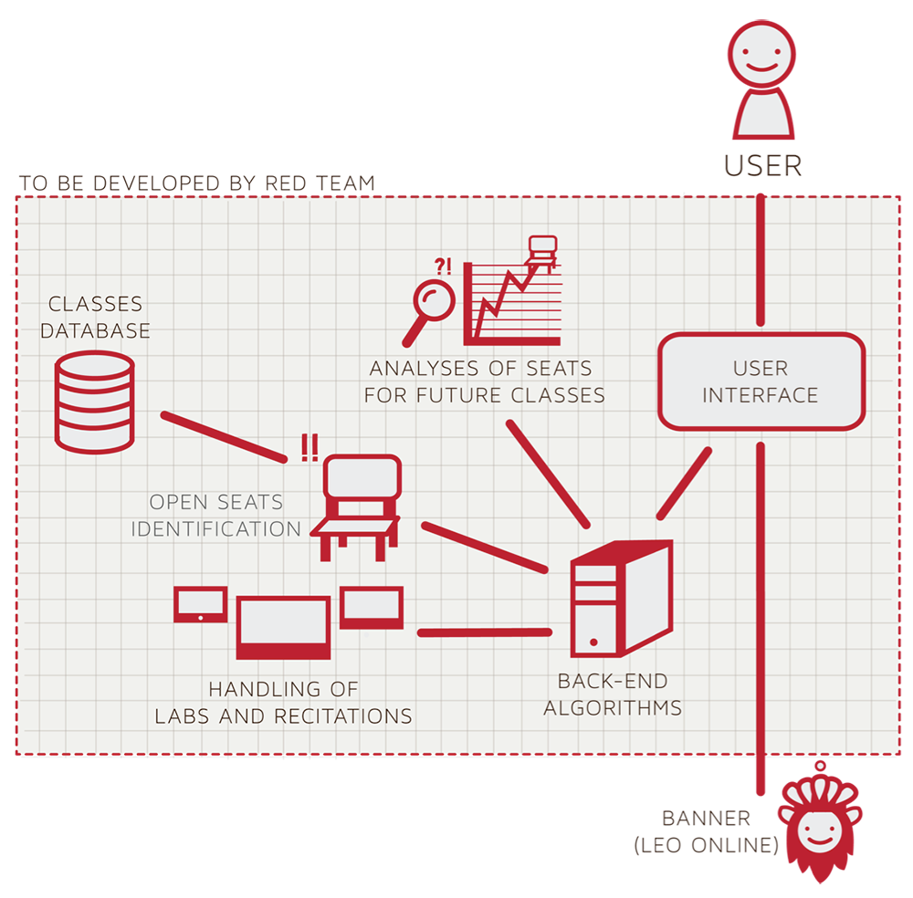

Figure 2: Major Functional Components Diagram: a Test Harness

**4.2 Prototype Features and Capabilities**

For CORSICA to be fully functional for the final prototype shipment, the application will have eight majors algorithms. Table 2 illustrates the full usage of each of the algorithms to be included in CORSICA prototype.

|  |  |
| --- | --- |
| **Algorithm** | **How it functions** |
| **Load Enrollment Data Files** | * Course data files are loaded into CORSICA. * Files contain class’s capacity, number of enrollments, and available seats. |
| **Open Course** | * An administrator or scheduler user logs into CORSICA and opens a course for students to enroll in. |
| **Check for Open Seats** | * Once a course becomes full, a wait-list is activated for it by CORSICA * CORSICA will continually reference the current course capacity and amount of students enrolled. * If the amount of students enrolled is less than course capacity, a seat has become available. * Calls notification algorithm |
| **Add Student to Wait-list** | * Student X wishes to enroll in Course Y’s wait-list * CORSICA receives this request and adds Students X to wait-list queue * Course Y’s wait-list is updated |
| **Notification** | * The check for open seats algorithm completes and returns true for an available seat * All students on the wait-list queue are notified of opening * Students respond |
| **Drop Student from Wait-list** | * Student X wishes to be dropped from Course Y’s wait-list or the time window for that student has expired * CORSICA receives this request and removes Student X from the wait-list queue * Course Y’s wait-list is updated |
| **Increase Course Capacity** | * Administrator logs into CORSICA and increases course capacity for Course Y |
| **Close Course** | * An Administrator or Scheduler user logs into CORSICA and closes the wait-list for the course |

Table 2: Algorithms Description Table

The user roles in the prototype will only include an administrator, advisor users, a scheduler user, and student users. While the initial product design aims to automatically grab the user authentication through the university’s MIDAS ID (ODU’s login and password management system), the prototype will be getting the users data through manual insertion.

Once a user is logged in, CORSICA will display a specific dashboard customized the the specific user’s role. The administrator, advisor, and scheduler will be able to see the current semester’s wait-list, both active and inactive, as well as having the ability to click through for a detailed view of a specific wait-list. The faculty users will have the ability to customize the wait-list in their own way. Advisor will be able to move, add, or drop a student into a wait-list, while scheduler will able to completely close the wait-list or open a new one. The administrator will have the access to both advisor’s and scheduler’s abilities.

The dashboard for a student user will only display the user’s enlisted wait-list. From the dashboard, the user will be able to search for a specific class through class’s name, instructors, or the course reference number. If the wait-list is available (opened and not full), the student will be able to click through to the class’s detailed page, which will display the number of students currently in the list as well as providing basic information about the class. The student may join the wait-list if he/she met the requirement as well as opt for a notification of available seat through email and/or text message. CORSICA will automatically email the users on the list of the seat’s availability and give the first user a 24 hours period to respond. The user will be removed from the list once responded or if the 24 hours have passed since the sending of the notification.

CORSICA’s prototype will also give the ability for a nonessential personnel such as parents or any interested party to read about the project. The static pages will be created for people without the ability to log in to see CORSICA’s product description, FAQ, and the developers’ about page.

One of the major capabilities that will be implemented into the prototype product is the ability for CORSICA to link wait-lists of requisite classes such as the lecture, recitation, and lab requirement for many of the programming classes. As the information will be provided by the scheduler’s classes data, CORSICA will only have to connect the classes together and create restriction rule for students wait-list enlisting process.

**4.3 Prototype Development Challenges**

Creating a working prototype require a considerable amount of teamwork, learning experiences, and the ability to foresee arising challenges. With only 18 weeks development time, many of the functionalities from the initial design was cut in order for the team to complete key features for an online wait-list system. While the algorithms will be developed in C++, the language that the project’s developers are most familiar with, the basic knowledge of databases, javascript, its libraries, and an established framework will be required to create a complete web application prototype. Not only will the developers have to create a stable backend server and a good API connection, they will also have to create a professional frontend design to represent ODU as an established institution. While the prototype will open up a new opportunities to learn new languages, it will also come with the double edge of completing a shippable product by the end of the semester without major bugs and issues. Even though there will be many challenges toward a completed product, CORSICA should, in the end, proves that an efficient wait-list system is capable to be implemented into the university’s enrollment system.

**GLOSSARY**

**Algorithm**:A set of instructions that is carried out in order to solve a problem; typically used in the context of Computer Science.

**Banner**: The centralized academic and administrative records system used by Old Dominion University.

**C++**:An object-oriented computer programming language.

**CSS**:Cascading Style Sheets. A style sheet language used for formatting a document; typically used in conjunction with HTML for websites.

**Computer**: An electronic device that can store information and carry out programmed instructions.

**CORSICA**: Computer Science Class Waitlist. A piece of software developed for the Old Dominion University Computer Science department.

**Database**:A collection of (usually related) information.

**Email**: A method of sending messages from one computer to another on a network.

**GUI**: Graphical User Interface. A program that allows a user to interact with a computer by means of graphical icons such as buttons and text boxes.

**HTML**: Hypertext Markup Language. A markup language that is used for creating websites.

**Internet**: A worldwide system of interconnected computer networks.

**JavaScript**:A dynamic computer programming language, typically used in web browsers.

**Lab**:A section of a college class that commonly involves hands-on work.

**Lecture**: An oral presentation given by a college professor within a university setting.

**MySQL**:A relational database management system.

**Notification**:The act of informing someone of something.

**ODU**: Old Dominion University. A public post-secondary institution in Norfolk, Virginia.

**PHP**:A scripting language commonly used for web development.

**Prototype**: A preliminary model of something.

**Recitation**: A college class section where small groups of students from the corresponding lecture meet to review weekly material.

**Server**: A computer that provides information and services to other computers.

**SQL**:Structured Query Language.A programming language designed for managing data held in a relational database management system.

**Text Message**: An electronic message that is sent between cell phones.

**UIN**:University Identification Number. A unique identification number provided to students at Old Dominion University.

**Wait-list**: A list of people who are waiting for something.

**REFERENCES**

"MySql vs MongoDB Performance Benchmark." *MoreDevs*. N.p., March 14, 2013. Web. Retrieved September 21, 2014 from http://www.moredevs.ro/mysql-vs-mongodb-performance-benchmark.

*Old Dominion University Student Headcount*. Rep. Old Dominion University, n.d. Web. September 21, 2014 from http://www.odu.edu/content/odu/about/facts-and-figures/factbook.htm[l](http://www.odu.edu/content/odu/about/facts-and-figures/factbook.html)

Barrow, Lisa, and Cecilia Elena Rouse. "Does College Still Pay?" *The Economists' Voice* 2.4 (2005): n. pag. Web. Retrieved September 21, 2014. http://transitions.s410.sureserver.com/wp-content/uploads/2011/09/barrow-rouse.pdf.

Fry, Richard. "The Growing Economic Clout of the College Educated." *Pew Research Center*. Pew Research Center, September 24, 2013. Web. Retrieved Septmeber 21, 2014. http://www.pewresearch.org/fact-tank/2013/09/24/the-growing-economic-clout-of-the-college-educated/.

Mardan, Azat. "PHP vs. Node.js." *Webapplog [programming Weblog]*. N.p., September 9, 2014. Web. Retrieved September 21, 2014 from http://webapplog.com/php-vs-node-js.

National Center for Education Statistics, U.S. Department of Education. (2001). Postsecondary Education. In *Digest of* education statistics 2001 (chap. 3). Retrieved September 6, 2014, from http://nces.ed.gov/programs/digest/d12/ch_3.asp.

National Center for Education Statistics, U.S. Department of Education. (2001). Table 5: Number of education Institutions, by level and control of institution: Selected years, 1980-81 through 2010-11. In *Digest of* education statistics 2001 (chap. 3). Retrieved September 6, 2014, from http://nces.ed.gov/programs/digest/d12/tables/dt12_005.asp.

National Center for Education Statistics, U.S. Department of Education. (2013). *Digest of Education Statistics: 2012*. Retrieved September 18, 2014.

Shaked, Uri. "AngularJS vs. Backbone.js vs. Ember.js - Choosing Your JS Framework." *Airpair*. N.p., August 21, 2014. Web. Retrieved September 21, 2014 from http://www.airpair.com/js/javascript-framework-comparison.