**CORSICA Product Description**

**Red Team**

**Patrick DeBerry**

**Old Dominion University**

**September 21, 2014**

**CS 411 Lab 1**

# 

# **Table of Contents**

**1 INTRODUCTION ...........................................................................................................3**

**2 CORSICA PRODUCT DESCRIPTION ………........................................................... 4**

**2.1 Key Product Features and Capabilities ………................................................. 5**

**2.2 Major Components (Hardware/Software) …………….................................... 6**

**3 IDENTIFICATION OF CASE STUDY …………….................................................... 8**

**4 CORSICA PRODUCT PROTOTYPE DESCRIPTION ………................................. 9**

**4.1 Prototype Architecture (Hardware/Software) ……….................................... 10**

**4.2 Prototype Features and Capabilities ………………........................................ 14**

**4.3 Prototype Development Challenges ……………….......................................... 17**

**Glossary……………………………………………………………………………….……….. 19**

**References……………………………………………………………………………….…….. 21**

**List of Figures and Tables**

**Figure 1 - Hardware Components…………………………………………...…………...…. 7**

**Table 1 - Real World Product and Prototype Comparison…………………...…………. 10**

**Figure 2 - Major Functional Components Diagram……………………………...….....… 11**

**Table 2 - Description of Algorithms…………………………..………………………...…. 12**

**Figure 3 - Risk Table and Matrix……….……………………………...………….……..... 16**

**Table 3 - Prototype Challenges………………………………………...………….……...... 17**

# **CS 411W LAB I - PRODUCT DOCUMENT**

# **1** **INTRODUCTION**

Attending a university has become an important step in obtaining a successful job. The

Bureau of Labor Statistics has shown that citizens with a higher education not only earned a higher salary, but also increase their chances of getting a job, lowering the unemployment rate (2014). Universities have become more desirable, increasing enrollment over the past years. Universities, such as Old Dominion University (ODU), have the issue of courses reaching capacity due to their student population. An increase in the student admission has led to the problem of the current course enrollment system becoming insufficient for handling course overflow.

The current enrollment system used by ODU is Banner and Leo Online. While most of the management system works well; it lacks an efficient wait-list process. The wait-list causes problems for ODU’s Administration, students, faculty, advisors, and schedulers. The current course wait-list implementation can cause excess student communication with faculty and Administration in order to facilitate the student's desire to be enrolled in a specific course when it has reached capacity. While the student and faculty are attempting to resolve this issue, they are unable to complete their other tasks. Implementing an improved wait-list feature in the current course add/drop system, will greatly reduce the number avoidable communications.

A new wait-list system needs to be implemented. CORSICA, or COmputeR ScIenCe wAit-list, will be the solution to these issues. A student wishing to take a Computer Science (CS) course at ODU will be put on a new wait-list which they can monitor its status and get notifications. This will assist students in joining a class if a space becomes available. CORSICA is only for the CS department; however, it can be adapted to any department.

# **2** **CORSICA PRODUCT DESCRIPTION**

CORSICA is a wait-list addition to the current enrollment system. The wait-list process will be a more effective way for students to register for classes that have reached capacity, providing a simple and fair setup. CORSICA will be made available online for Administrators, Advisors, Schedulers, Students, and Visitors. When a course reaches capacity CORSICA will take over, locking the class so only students on the wait-list may join the course. If a student wants to join the course, they must first join the wait-list for a course that has no more available seats. A seat may become available through two ways, either a student drops the course of the capacity of the course is raised. Once the course has an opening, the student will receive a notification through an e-mail and/or text message. E-mails and text messages are the fastest and most efficient in delivering messages. The notification system will reduce the attention students would use constantly checking to see if an available seat has opened. . CORSICA allows the student at the top of the list to have priority, allowing them to register first. The list will then move the rest of the students up on the list, opening more sections on the wait-list. CORSICA’s notification process will speed up the wait-list process.

## 2.1 Key Product Features and Capabilities

CORSICA is designed to maintain a course’s wait-list when it has reached capacity. CORSICA notifies students on available seat openings. Students are required to take certain classes necessary to graduate with a CS degree. When a student gets to their senior year, they could face the issue of not being able to take a necessary class to graduate due to the class reaching capacity. This would force the student to postpone their graduation. CORSICA would allow the student a more effective way of joining the course they needed.

CORSICA’s notification system will be one of the key features. The notification system will notify students in a timely manner when a seat becomes available. The student will have the option to receive the notification through e-mail, text message or both. CORSICA will only notify the students during the add and drop period for course enrollment. The student is given a 24 hour window, after receiving the message, to register for the course. The 24 hour window gives any student ample time to register for the course is they still need the course. If the student does not register for the course within 24 hours, they will be removed from the wait-list and the next student will be notified. The process continues till the seat is filled. This will allow other students on the list to move up in the list quickly. A student may also respond to the notification asking to be removed from the wait-list, which would also notify the next student. CORSICA would also notify students if the wait-list was closed by the Scheduler.

CORSICA will be provided over the Internet, using a Graphical User Interface (GUI) that is easy to use. This will give users all the same abilities, despite their web browser. Students will be limited to 6 course waitlists, preventing students from abusing this privilege. CORSICA’s website will allow students to view their position on the wait-list. They will be able to add and remove themselves from any waitlist, as long as the meet the course requirements. The easily to use GUI will allow students to easily be able to join and track their wait-lists.

A key feature in CORSICA will be the ability to handle courses that have labs and/or recitations with a lecture. When a lecture with a lab and/or recitation reaches capacity, CORSICA will close all three. Each lecture will be linked to the lab and/or recitation that it is associated with. The courses will be linked by their CRNs. If a student joins the wait-list for the lecture, they must also join the wait-list for the lab and/recitation that are linked to the course. The student will be given an error message and will not be added to the wait-list, unless they join all courses linked to the lecture. The student will then be placed on all wait-lists associated with the course.

Another feature of CORSICA will be the ability to track statistics of courses. The statistics can be used to see if a course needs to have the capacity raised in the future. CORSICA will track how many students join a wait-list. The reports will show how many students add and drop the course. CORSICA will show how long it takes to establish a wait-list, this will show how desired the class is for students.

CORSICA also allows different levels of access for users. When a user logs in, they are established an administrator, an advisor, a scheduler or a student. Administrators will be given full access over the system. The administrator’s main task is to oversee all the other uses. They will be able to delete or add any user. CORSICA’s statistics can be used by schedulers to decide if a course’s capacity show be raised or decreased. Schedulers will have the ability to manually open and close courses. Advisors will be able to view a student’s position on a wait-list. The advisor will also be able to alter the wait-list by changing a student’s position, adding students and removing them. Students will be able to view the courses that all courses with wait-lists. The courses will show how many students are on the waitlist. Students will also be able to see the wait-lists they are on. CORSICA will also have user section for visitors. Visitors will not be able to log-in. They will able to view static pages, the CORSICA home page, an about section, a contact page and the FAQS page.

## 2.2 Major Components (Hardware/Software)

CORSICA will require hardware and software components in order to complete the tasks it is designed to do. Figure 1 shows the setup of the three main hardware components needed in the implantation on CORSICA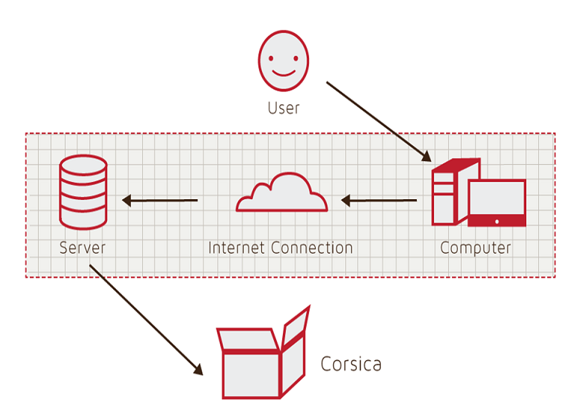

Figure 1, Hardware Components

A computer with a web browser is required in order to access the Internet. Through the Internet, the user will access CORSICA’s servers. The server will hold a web server, as well as a database server. Multiple servers can be used in order to better maintain the databases and also perform backups on all of CORSICA’s data. The web server will display web pages for the user to access from their home computers. The database server will manage all CORSICA information that is gathered.

Software components will consist of database software that will maintain all information the CORSICA needs, such as course CRN, course capacity, student information, etc. The database will use the student’s information to send out the notifications. The database will be created using MySQL. PHP, SQL, javascript and HTML will be used to manipulate the database. The alterations to the MySQL database will increase its capabilities. The different users would require use to develop different GUIs. HTML, CSS, and JavaScript will be used to maximize the efficiency of CORSICA’s GUI. Algorithms will be developed using C++ that will maintain course that have labs and/or recitations. Algorithms will also be implemented to identify open seats, loading enrollment data, increase course capacity, close/open course and add/drop student from waitlist.

# **3** **IDENTIFICATION OF CASE STUDY**

CORSICA will be developed for Old Dominion University’s Computer Science department. The development in CS411W and will be overseen by faculty mentor Dr. Irwin Levinstein. Dr. Levinstein, an Associate Professor, is the course scheduler for the CS department. Since Dr. Levinstein is the course scheduler, the reports and analysis feature of CORSICA would assist in setting up the capacity size for CS courses for future semesters. Advisors and faculty will also benefit from the development of CORSICA. During registration periods when classes reach capacity, students will email the professor of the course and their advisor asking to be added to the course. Students would instead be able to just be able to join the wait-list and be able to monitor their position. CORSICA would save advisors and faculty time. They would no longer have to constantly e-mail students back.

The Computer Science department is not the only department that faces these issues. The successful development of CORSICA could be adapted to maintain any department at Old Dominion University. CORSICA could also have the potential to assist other universities that face the same problems.

# **4** **CORSICA PRODUCT PROTOTYPE DESCRIPTION**

CORSICA will be start out as a prototype. The prototype will not have all the capabilities the real world product would. CORSICA will work with Banner’s database. Since access to Banner is restricted, the student and course information will be simulated. The prototype will not use the Seat Analysis System functionality. Instead the prototype will show the capabilities and features that the users will have access to. The users that will be demonstrated are the administrator, advisor, scheduler, student and visitor.

A demonstration for CORSICA’s prototype will show its abilities to operate as an automated system and the effectiveness of the notification system. The prototype will also demonstrate the fair enrollment process, the alert process if an error occurs and the ability to reserve seats for students on the wait-list. CORSICA will be setup as an automated system that can be overridden by certain users. Developing CORSICA to be an automated system prevents administration from having to constantly maintain it. The notification system will assisted by Old Dominion University’s current alert system. The alert system is use by ODU to contact students about important information such as school closures. CORSICA will close a course when the class reaches capacity, preventing students to enroll unless they are on the wait-list. This will ensure the fairness of CORSICA’s process. Alert triggers will use pop up textboxes in order to notify the user if the changes they are making are correct. Table 1 shows features that the prototype and real world product will have.

|  |  |  |
| --- | --- | --- |
|  | **Real World Product** | **Prototype** |
| **Environments for all Users:** | **Yes** | **No**  · **Will demonstrate student, admin, and scheduler users** |
| **Notification System** | **Yes** | **No**  · **Will be simulated with text box** |
| **Check for available seats** | **Yes** | **Yes** |
| **Add Student to Wait-list** | **Yes** | **Yes** |
| **Drop Student from Wait-list** | **Yes** | **Yes** |
| **Fair process** | **Yes** | **Yes** |
| **Alert System** | **Yes** | **No**  · **Will be simulated with text box** |
| **Mostly automated** | **Yes** | **No**  · **Will rely heavily on user interaction** |
| **Link to Banner** | **Yes** | **No**  · **Will be loaded with data.txt files instead** |
| **Link to Leo-Online** | **Yes** | **No**  · **Will be simulated with command box menu** |
| **GUI** | **Yes** | **Very Basic (Text System)** |
| **Seat Analysis System** | **Yes** | **No** |

Table 1

Real World Product and Prototype Comparison

## 4.1 Prototype Architecture (Hardware/Software)

The CORSICA prototype will consist of four major components: course database, notification system, user interface, and back-end algorithms. Figure 3 shows the connection of these four components.

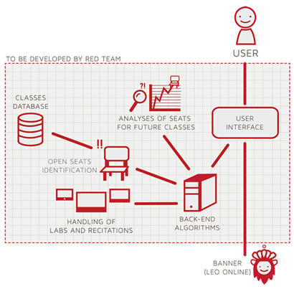

Figure 2

Prototype Major Functional Components Diagram

Users will use basic comments in the user interface to interact with the prototype. All data for the database will be simulated text files in the prototype. Simulated data will consist of: course sections, course name, course capacity, available seats and number of students enrolled in course. CORSICA’s prototype will simulate the notification process instead of using ODU’s current notification system. The notification process will access the student’s phone number and/or e-mail to send a message and then notify the administrator that the student has been notified. Back-end algorithms for the prototype include: loading enrollment data, checking for available seats, adding/dropping students to a wait-list, changing course capacity, and opening/ closing courses. Table 2 provides the functionality of the algorithms.

|  |  |
| --- | --- |
| **Algorithm** | **How it functions** |
| **Load Enrollment Data Files** | **Course data files are loaded into CORSICA.**    **Files contain course: Capacity, Number of Enrollments, and Available seats.** |
| **Open Course** | **An Administrator or Scheduler user logs into Banner and opens a course for students to enroll in.**    **Banner database is updated**    **CORSICA database is notified of change and is updated** |
| **Check for Open Seats** | **Once a course becomes full, a wait-list is activated for it by CORSICA**    **CORSICA will continually reference the current course capacity and amount of students enrolled.**    **If the amount of students enrolled is less than course capacity, a seat has become available.**    **CORSICA database updates**    **Calls notification algorithm** |
| **Add Student to Wait-list** | **Student X wishes to enroll in Course Y’s wait-list**    **CORSICA receives this request and adds Students X to wait-list queue**  **Course Y’s wait-list is updated** |
| **Notification** | **The check for open seats algorithm completes and returns true for an available seat**  **All students on the wait-list queue are notified of opening**    **Students respond** |
| **Drop Student from Wait-list** | **Student X wishes to be dropped from Course Y’s wait-list or the time window for that student has expired**    **CORSICA receives this request and removes Student X from the wait-list queue**    **Course Y’s wait-list is updated** |
| **Change Course Capacity** | **Administrator logs into Banner and increases course capacity for Course Y**    **Banner database is updated**    **CORSICA database is notified of change and is updated** |
| **Close Course** | **An Administrator or Scheduler user logs into Banner and closes a course as an available option for students to enroll in**    **Banner database is updated**    **CORSICA database is notified of change is updated** |

Table 2

Description of Algorithms

## 4.2 Prototype Features and Capabilities

CORSICA’s prototype will show a sample of the products capabilities. The users demonstrated include: administrator, advisor, scheduler, student and visitor. The prototype will provide example uses of the different types of users.

The administrator has full control over CORSICA and other users. When an administrator logs into the system, they will be giving all courses for the term and their wait-lists. The administrator has the ability to search for a student using their name or University Identification Number (UIN). Searching for a student will pull up courses they are enrolled in and their wait-list history. The administrator can also search courses by their name or section number. The search would display the course information, number of students enrolled in the course, seats available, and number of students on the wait-list. The administrator could then look through the wait-list and make alterations if needed. The administrator could change a student’s position, add/remove them for the list or close the wait-list. The administrator’s main purpose would be maintaining the other users. Administrators would be able to add/delete users and also change their capabilities.

An advisors main task is to oversee the students enrolling in the courses. They would be able to look through all course and wait-list data, as well as student information in CORSICA. They would have the ability to search for a course or a student. While they cannot change the capabilities of other users they would be able to change a course’s wait-list. The advisor would also be able to alter the wait-list like the administrator. The advisor is limited to only being to change courses, students, and wait-list.

The scheduler would only need access to the courses and their wait-lists. A scheduler could sort courses that have wait-lists and courses without wait-lists. Previous course wait-lists would also be provided for the scheduler. A scheduler could search a course and view a wait-list from a previous semester. The scheduler could also look up the statistics and analytical data for any course. If a course needs to be altered, the scheduler could just search the course then easily add, delete or alter the capacity size.

A student logging in would be able to view all the courses they enrolled in and any wait-list they are currently on. The student would be able to search a course by the course name, course section or the instructor’s last name. If the course is full they would be able to join the wait-list. CORSICA would use an alter box to inform the student of the course name, semester and the position the student would be on the wait-list. If the user confirms that they want to be on the wait-list, they will be added to the list.

The visitor will not be provided in the prototype, because they are an outside user. They will only have access to examples of the site as well as contact information and FAQs section. CORSICA’s prototype will give potential users the chance to view the different user capabilities. The prototype could be the deciding factor for potential customers as to whether or not the product would be able to solve their issues.

## 4.3 Prototype Development Challenges

CORSICA’s prototype will have some risks in developing. The risks CORSICA faces are divided into 2 catagories: customer risk and technical risk. The customer risks are issues that the developers face with the customers, such as cost and interest. Technical risks are problems the developer would face in creating the product. Figure 3 shows some of the risks CORSICA would face in its development.

|  |  |
| --- | --- |
| **Customer Risks** | **Technical Risks** |
| C1: Department Use Rejection | T1: Ability to Integrate with Banner |
| C2: Transition to New GUI | T2: Software Upgrades |
| C3: Cost of Product | T3: Availability of Server Storage |
| C4: Product Interest | T4: Security Vulnerability |

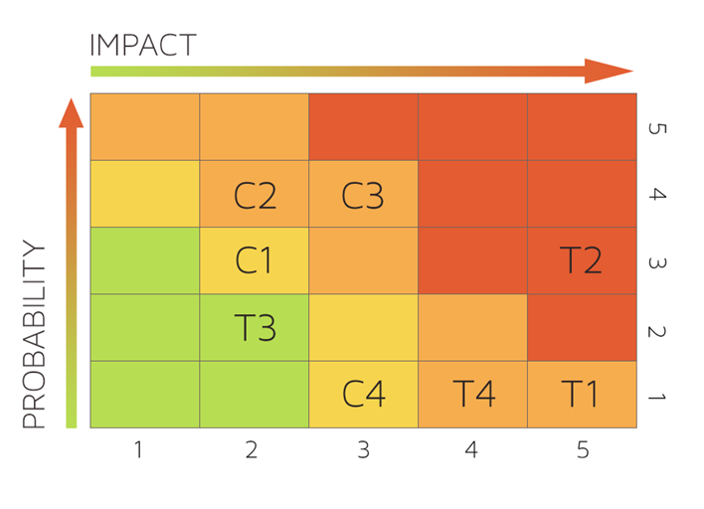

Figure 3  
Risk Table and Matrix

CORSICA will also face challenges in the development of the prototype. The prototype will be limited to its capabilities and features. The challenges CORSICA faces will be dealt with in a variety of ways. Table 3 provides a list of challenges and solutions.

|  |  |  |
| --- | --- | --- |
| **Objectives** | **Prototype** | **Challenges** |
| **Environments for all Users:** | **No**  · **Will demonstrate student, admin, and scheduler users** | **Working out all the bugs in CORSICA to allow all users to use CORSICA as intended** |
| **Notification System** | **No**  · **Will be simulated with text box** | **Allowing CORSICA to sync EXACTLY with the University’s Clock** |
| **Alert System** | **No**  · **Will be simulated with text box** | **Making the Alert System actually recognize each change to help ensure intentional changes** |
| **Mostly automated** | **No**  · **Will rely heavily on user interaction** | **Users need to be knowledgeable of CORSICA** |
| **Link to Banner** | **No**  · **Will be loaded with data.txt files instead** | **Using Black Box Testing to certify the text file compatibility** |
| **Link to LEO Online** | **No**  · **Will be simulated with command box menu** | **Maintaining LEO Online’s layout while appending the CORSICA option on the course registration screen** |
| **GUI** | **Very Basic (Text System)** | **Coding a GUI that looks professional and is simple to navigate** |

Table 3  
Prototype Challenges

Glossary

**\*Algorithm -** A set of steps that are followed in order to solve a mathematical problem or to complete a computer process.

**\*\*\*Banner -** Old Dominion University's centralized academic and administrative records system.

**\*Browser -** A computer program that is used to find and look at information on the Internet.

**\*\*C++ -** A general purpose programming language that is free-form and compiled.

**\*\*Cascading Style Sheets (CSS) -** A style sheet language used for describing the look and formatting of a document written in a markup language.

**\*Computer -** An electronic machine that can store and work with large amounts of information.

**\*Database -** A collection of pieces of information that is organized and used on a computer.

**\*E-mail -** A system for sending messages from one computer to another computer.

**\*Graphical User Interface (GUI) -** A program that allows a person to work easily with a computer by using a mouse to point to small pictures and other elements on the screen.

**HyperText Markup Language (HTML) -** A computer language that is used to create documents or Web sites on the Internet.

**\*Internet -** An electronic communications network that connects computer networks and organizational computer facilities around the world.

**\*\*Javascript -** A dynamic computer programming language, used as part of web browsers, whose implementations allow client-side scripts to interact with the user.

**\*Laboratory -** A room or building with special equipment for doing scientific experiments and tests.

**\*Lecture -** A talk or speech given to a group of people to teach them about a particular subject.

**\*\*MySQL -** A database management system.

**\*Notification -** The act of notifying someone.

**\*ODU** - Old Dominion University, a public 4-year university in Norfolk, Virginia.

**\*\*PHP -** A server-side scripting language designed for web development.

**\*Prototype -**  An original or first model of something from which other forms are copied or developed.

**\*Recitation -** A class period especially in association with and for review of a lecture.

**\*Server -** The main computer in a network which provides files and services that are used by the other computers.

**\*\*SQL -** A programming language designed for managing data held in a relational database management system.

**\*Text Message -** A short message that is sent electronically to a cell phone or other device.

**\*\*\*University Identification Number (UIN) -** A unique identification number given out to students at Old Dominion University.

**\*Wait-list -** To be put on a waiting list.

**\***Found at http://www.merriam-webster.com/

**\*\*** Found at <http://en.wikipedia.org/wiki/>

**\*\*\*** Found at https://www.odu.edu

References

National Center for Education Statistics, U.S. Department of Education. (2001). Postsecondary Education. In *Digest of* education statistics 2001 (chap. 3). Retrieved September 6, 2014, from http://nces.ed.gov/programs/digest/d12/ch_3.asp.

National Center for Education Statistics, U.S. Department of Education. (2001). Table 5: Number of education Institutions, by level and control of institution: Selected years, 1980-81 through 2010-11. In *Digest of* education statistics 2001 (chap. 3). Retrieved September 6, 2014, from http://nces.ed.gov/programs/digest/d12/tables/dt12_005.asp.

National Center for Education Statistics, U.S. Department of Education. (2013). *Digest of      Education Statistics: 2012*. Retrieved September 18, 2014.