Ron and Victoria Friedman, Co-Founders of Vistar Foundation,
with Ashok Gangadean,
Professor of Philosophy at Haverford College, Founder of the Global Dialogue Institute
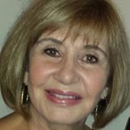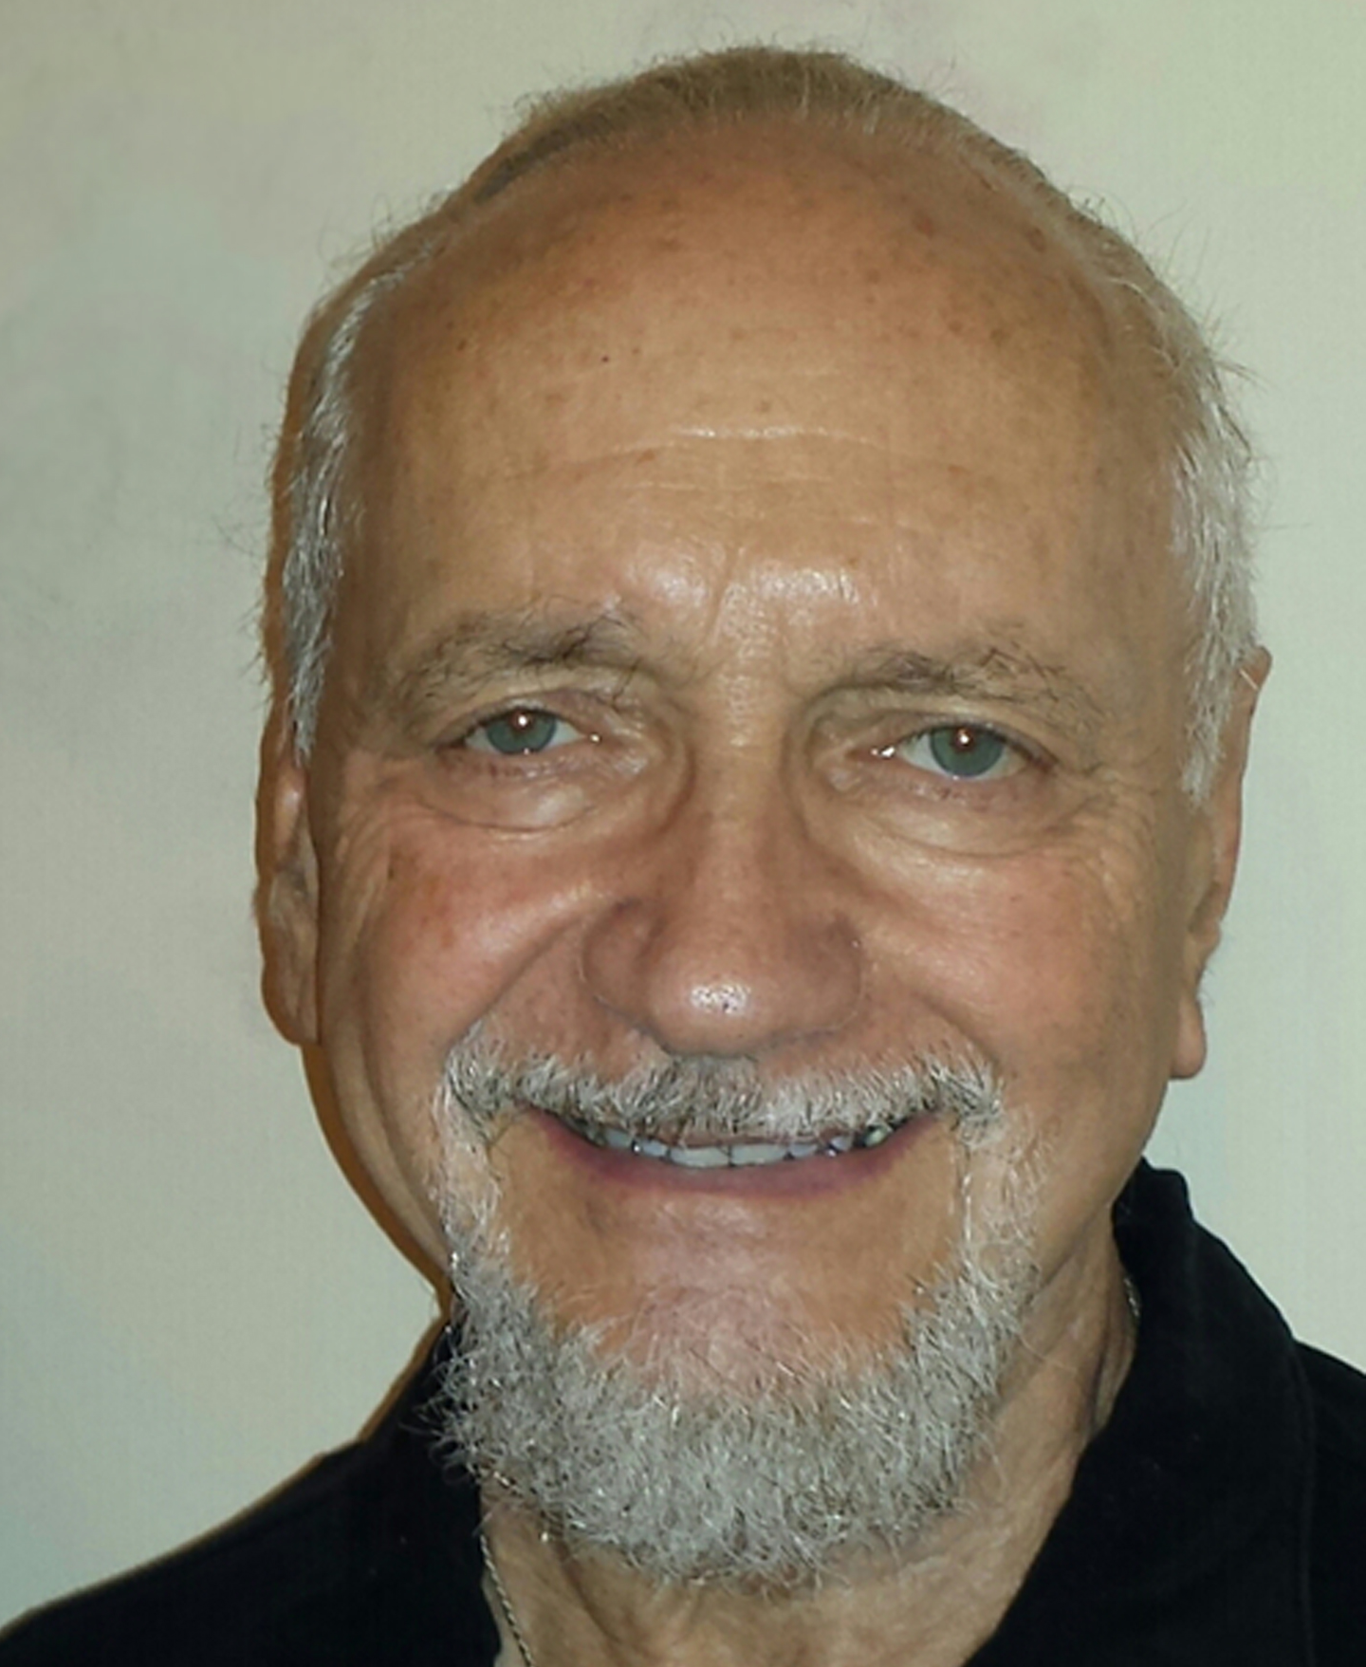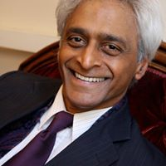

invite you to participate in a Vistar Circle dialogue on
“THE POWER OF Collective Consciousness for CO-CREATION”
at the Spiritual Summit for Social Change

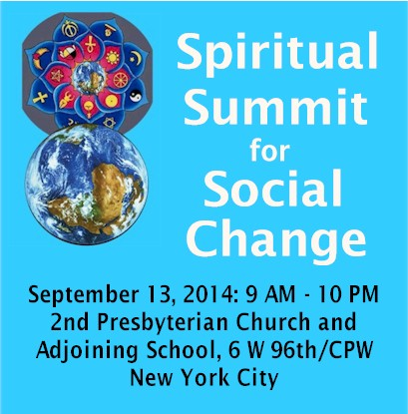
The Summit is part of the 11 days of Global Unity leading up to the United Nations International Day of Peace on Sept 21

Take part in our presentation at the Summit by participating in the Vistar Working Session. We will be exploring the power of Collective Consciousness for Co-Creation and seeing what possibilities emerge for new co-creative ventures. Find out about the FIONS New York Circle and more…

You will be receiving time of Session and more info.
Let us know you are joining us by REGISTERING on: info@vistarfoundation.org
More info - Call Victoria at 203.322.8974

ALSO…join other groups working on various initiatives (listed below). This event will give us a big picture perspective on social change and provide an opportunity to network with many people creating on that evolutionary frontier. Come for the whole day or for whatever sessions you wish to attend.

FACEBOOK EVENT PAGE
https://www.facebook.com/events/1462123247371311/
______________________________________________________________________

SCHEDULE: Day-- 10 AM -- Welcome, AM Ceremony and Plenary, AM Working Session-- Lunch (nearby café’s)-- Short PM Re-gather Ceremony, Two Afternoon Working Sessions & Plenary -- Supper (café’s). Working Sessions: 80-90 min.
--$5 (or donation) for required NYC city services--

EVENING SACRED CELEBRATION — 8:15 PM

WORKING SESSIONS: Eco-Spirituality -- Eco-Ministry -- Global Climate Issues -- Upcoming Peoples Climate March -- Contemplative Voice and Sacred Activism -- Integral Vision and Future of Religion -- Future of Religions -- New Community/ New Monasticism – Youth -- Interspiritual Education for Children -- The Arts and Transformation -- Future Scientific Thresholds -- Collective Consciousness -- Global Meta-Networks, and also the Internet, for World Transformation -- Indigenous Traditions, Shamanism, Ceremony, Ritual and Its Global Importance -- Healthy Relationships -- Healing and Energy -- Alternative Energy – and more!
______________________________________________________________________

--SPONSORS—
The Global Interspiritual Network
Forum 21 Institute
Friends of the Institute of Noetic Sciences
The Guild for Spiritual Guidance

