Gesture controlled Media Player using Arduino and Ultrasonic sensors

Sumeet Jirwankar
Bachelor of Computer Applications
Symbiosis Institute of Computer Studies and Research, Pune, India
sumitjirwankar22@gmail.com

Abstract— The purpose of this project is to build a tool which can control pc using ultrasonic sensors. Using Arduino to interact between ultrasonic senor and computer. The Arduino can be connected to the Laptop for powering the module and also for Serial communication. Once the connections are done place them on your monitor as shown below. The concept behind the project is simple. Two sensors will be placed on top level of the laptop which will measure or read the distance between the monitor and hand. Based on this distance we will perform various actions.
Keywords— Hand gestures, Ultrasonic sensor, Arduino, Python, Human Computer Interaction, Computer Vision. (key words)

Introduction (Heading 1)
Gestures are used in human lifestyle and have an importance in day-to-day life. Human have been interacting with each other or within the physical world with five senses. During the era of technology and machines which are influencing human lifestyle thus its an objective to make use of gestures in technology as well.
Since this dissertation deals with gesture-controlled computer, the primary focus is going to be utilization of hand gestures on media application.
The concept behind this project is very simple, two ultrasonic sensors will be placed on top of the laptop which will scan the gap between the monitor and hands. Arduino will support and measure this distance which will perform the actions. Use of Pyautogui library will be taken and the commands from Arduino will be sent to the laptop through port. This information will be scanned by python that is running on the laptop and the actions will be performed.

Objectives
The main objectives are to minimize the use of keyboard and mouse in computer, to use ultrasonic sensors to recognize gestures, to integrate gesture recognition features to any computer at low cost, To help in the development of touch less displays.

Literature Review

Project Profile
This research project mainly emphasizes on the aspects of human computer interaction advancement making it better than normal interaction with keyboard and mouse etc.
This new way of interaction can be useful in gaming industry, making touchless displays and in virtual reality controls as well. The following researches are similar to use this technology and thus this project gets inspiration from them.

Existing System Projects and Research
- Research Paper No.1: (William T. Freeman, December 1994)
This research paper describes how a viewer can control a television set remotely with the help of hand gestures. This paper focuses on issue of gesture–based human–computer interaction: How can one communicate with a set of commands without any user training and memorization of gestures?
- Research Paper No.2:
( Piyush Kumar ; Jyoti Verma and Shitala Prasad, June 2012)
In this research paper a real-time HCI based data glove and KNN classifier is used. In this research data is extracted with the help of gloves. The results shown in this project are used for interaction better than a keyboard and mouse interaction.
- Research Paper No.3:
(Suat Akyol, Ulrich Canzler Dept. of Technical Computer Science University of Technology (RWTH) Aachen, Germany; Bengler, Klaus Wolfgang Hahn BMW AG Munich, Germany, Nov. 28-30. 2000)
This paper describes a real-time gesture recognition in automobiles generally cars, reducing the use of physical buttons is shown in this paper.
- Research Paper No.4: -
(Harish Kumar Kaura, Vipul Honrao , Sayali Patil , Pravish Shetty , Nov 5 2013)
This research paper tells about a feasible solution, the project is tells us about how a robot can be controlled.

- Research Paper No.5: -
(Zivkovic, Sept 2006)
This research talks about using an ir sensor to use for hand gestures recognition. To minimize the costs, the system does not include any additional optical elements but an innovative approach is used where the directionality of the movements is estimated by using shadows of the existing enclosure of the chip.

Problem Formulation

Objective of Proposed System
The purpose of gesture recognition in laptop is used to minimize the distance between physical and digital world. The kind of way that humans interact with machines could be solved by implementing gestures via mathematical algorithm.

Scope of Proposed System:
Hand gesture technique is not only limited to gaming, using basic function of computer it can be useful for medical applications as well. Hand gesture technique can work as input method between medical instruments and hand gestures as proposed. It can be used for operating all functions of a computer.

Feasibility Study:

Operational Feasibility:
Operational feasibility includes number of staff members allocated for the project as well as the responsibilities given to different staff members based on their expertise area.
Table.1
Staff ID | Staff Member Name | Responsibilities | Area
01 | Sumeet | Identify and resolve system level bugs | Resolving system and unit level bugs.
 |  | Quality Testing of the system | Analysing the functions and features of the system
 |  | Preparation of test summary report (Identification of pass/fail test cases). | Quality Assurance Testing
 |  | Execution of all test cases. | Unit and System level Programming

Technical Feasibility:
Technical feasibility includes identification of hardware as well as the software requirements.

- Hardware Requirements:
- HC-SR04 Ultrasonic Sensor
- Arduino Uno
- Laptop (Windows/MacOS/Linux)

- Software Requirements:
- Arduino IDE
- Python 2.7.14
- VLC Media Player

Economic Feasibility
Economic Feasibility includes development cost, employee salary, maintenance cost and miscellaneous.
Table.2
Product | Cost
Arduino Uno | 330 ₹ / original- 1,750₹
HCSR04 Ultrasonic Sensor 2pcs | 160₹

Proposed Methodology
The following are the gestures and corresponding functions that are executed in the current project:
Table.3
Gesture Motion | Function
Placing both hands | Play/Pause
Left hand Towards Movement | Volume increase/ Decrease
Left hand Movement | Rewind

Research Design
The circuit diagram of Arduino part of the model is shown in the figure 1. It consists of an Arduino UNO board and two Ultrasonic Sensors. We can power up all these components from the laptop’s USB Port.

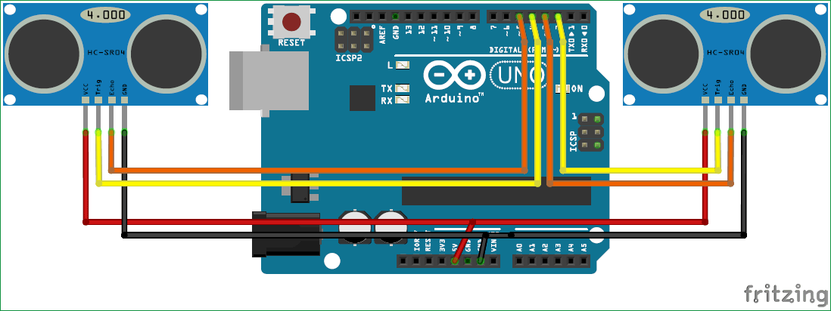
Fig.1. Circuit diagram of system

Result and Analysis

The project is designed fully for the purpose of reducing use of physical buttons and using hand gestures to control the computer. The project is reliable and sustainable the features of project are volume up and volume down, video forward and rewind. User can use hand gesture like keep hand near the sensors to rewind the video and vice versa to forward the video. This will work with sending the distance to the sensors which will be supported by Arduino and Pyautogui library.

Conclusion
In this project to control laptop hand gestures uses an Arduino Uno board, Two Ultrasonic sensors and a computer to carry perform the operations of controlling media playback and volume. Its main focus is to reduce the operations of controlling media player. Its other focus is to reduce efforts of interacting with a computer through input devices. This kind of technology can be used in gaming as well as classrooms for interactive learning for hologram developed technology can also be taken in use. More applications exist in medical applications, in case a medical the user may not be within reach of the display and yet can operate with hand gestures. Gestures such as swipe using finger as a virtual mouse, are a safer and faster way to control the device..

References
Akyol, S., & Canzler, U. (2000, Nov 28-30). Gesture Control for use in Automobiles. Dept. of Technical Computer Science University of Technology (RWTH) Aachen,Germany; Bengler, Klaus Wolfgang Hahn BMW AG Munich, Germany.
Freeman, T. W. (1994, December). Television Control by Hand Gestures. Mitsubishi Electric Research Laboratories.
Kaura, H. K., Vipul, H., Sayali, P., & Pravish, S. (2013, Nov 5). Gesture Controlled Robot using Image Processing. Department of Computer Engineering Fr. C. Rodrigues Institute of Technology,.
Piyush, K., Jyoti, V., & Shitala, P. (2012, June). Hand Data Glove: A Wearable Real-Time Device for Human Computer Interaction. Department of Information Technology, Indian Institute of Information Technology, Deoghat, Khalwa, Allahabad, India.
Zivkovic, Z. (2006, Sept). Air Gesture Control Using 5-Pixel Light Sensor. NXP Semiconductors.

