# 1.Fișa de proces

## *1.1.Denumirea procesului*:

Verificarea valabilitatii politei

## 1.2.Necesitatea automatizării prin RPA

Volum mare de date care necesită muncă manuală repetitivă.

# **2.Input**

Inputul va fi preluat dintr-un mail structurat care contine toate datele necesare pentru a incepe procesarea.

Exemplu:

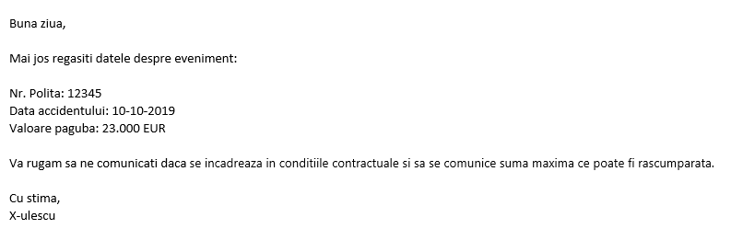

# 3. Fișier intermediar pentru procesare

Baza de date in care sunt stocate politele asiguratilor se regaseste intr-un fisier .xlsx

Exemplu:



# 4. Output

Outputul este reprezentat printr-un mail de raspuns catre persoana care a trimis input-ul, mentionand daca polita mai este activa si daca rezerva acopera valoarea daunei.

Exemplul 1:

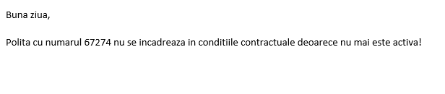

Exemplul 2:

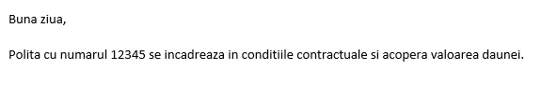

Exemplul 3:

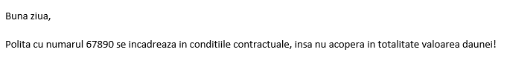

# 4.Flow process

## 4.1. Read mails and verify if a request was made

## 4.2. Save mails and get data from them

## 4.3. Search the database for requested policy

## 4.4. Verify if the policy is still active, based on policy start date and end date

## 4.5. Verify if the assured amount can cover the damage (!Bonus points: For differences between currencies, compare after conversion to same currency between values)

## 4.6. Create the mail and send the data requested:

**4.6.1. Case 1: Inactive policy**

**4.6.2. Case 2: Active policy, damage covered**

**4.6.3. Case 3: Active policy, damage not covered (!Bonus points: Mention the difference between the sums in the mail body)**

## 5. Best Practices to be respected

* Save all posible constants in the Config file ex: a path to a folder, a credential, the name of a file
* In arguments should have the prefix ‚in_’
* Out arguments should have the prefix ‚out_’
* In/Out arguments should have the prefix ‚io_’
* Variables should use the camelCase format ex: myInt, myValueExists
* Your workflows should start with „Start” + WorkflowName
* Don’t let commented code
* No more than two nested ifs

# 6. Tips

* To create a new Workflow you can press Ctrl + N
* To create a new variable while inside a variable field of any activity press Ctrl + K
* To create a new In Argument while inside a variable field of any activity press Ctrl + M
* To create a new Out Argument while inside a variable field of any activity press Ctrl + Shift + M
* To comment a sequence or activity press Ctrl + D while its selected
* To uncomment a sequnce or activity press Ctrl + E while selecting the comment window
* If you have an activity with an output, if you create a variable using the shortcut inside that field, the variable will have been created with the correct type necessary for the activity output field