Proiect IBM Summer School

WebDev

Team – Bytes

1. **Team Details**

|  |  |  |  |
| --- | --- | --- | --- |
| Team – Bytes | | | |
| Lead | Dev | Dev | Ops |
| Lavric Cosmin | Chelaru Alexandru | Bobeică Teodor | Ciubuc Vlad |

LEAD: Lavric Cosmin

Lavric Cosmin was chosen as the LEAD due to his professionalism and strong organizational skills. He has a comprehensive understanding of the project requirements and is adept at coordinating efforts among team members. Cosmin is capable of presenting complex information clearly and confidently, making him an ideal candidate to lead the presentation of the homework. His ability to defer technical questions to the appropriate team members ensures that the presentation remains accurate and thorough.

DEV: Chelaru Alexandru

Chelaru Alexandru was selected as the DEV because of his experience and proficiency in software development. He has a talent of writing clean, optimized, and efficient code. Alexandru is skilled in problem-solving and implementing requests accurately. His technical expertise and ability to collaborate effectively with other developers make him a valuable asset to the team.

DEV: Bobeică Teodor

Bobeică Teodor is another DEV chosen for his strong programming skills and attention to detail. Teodor excels in developing robust code and is known for his innovative solutions to complex problems. His ability to work closely with Alexandru ensures that the development process is smooth and that any challenges are promptly addressed. Teodor’s contribution to the project is critical in maintaining high standards of code quality and functionality.

OPS: Ciubuc Vlad

Ciubuc Vlad is an OPS known for his creativity and passion for design. He excels in managing and optimizing operational processes while bringing a unique, designed-focused perspective to problem-solving. His innovative approach ensures efficient workflows and enhances the overall user experience. Vlad is friendly and sociable, always striving to ensure the well-being of the entire team.

1. **Changelog**

**The Ops Manual was written by the entire team, and revised by lead, Lavric Cosmin.**

|  |  |  |
| --- | --- | --- |
| CHANGELOG | | |
| DATE – [DATA CURSULUI] | LIST OF CHANGES | AUTHOR |
| [10/07/24] | Implementation for MapBase based in a 10x10 table with the implementation of PlayerController for the red square placed in the middle of the table built in .js and .css file.  I contributed to the creation of the documentation. | Bobeică Teodor |
| [10/07/24] | Added a new font in order to improve the design of the website.  Import of the font in the index.css file  Design changes to the buttons so that they resemble an actual keypad  Added animations to the text and the moving cube so that it looks more like an vintage arcade game.  I contributed to the creation of the documentation. | Lavric Cosmin |
| [10/07/24] | Change the position of the red cell based on the player controller actions.Set an upper and lower bound for how much the player X and Y coordinates can change(never less than 0, never more than 9. I contributed to the creation of the documentation | Chelaru Alexandru |
| [12/07/24] | I designed the main character’s appearance, the textures for the edges and created vintage-style arcade buttons for the on-screen arrow keys using Piskel. I also replaced the old buttons, positioning, centering and adjusting the new ones. I contributed to the creation of the documentation. | Ciubuc Vlad |
| [12/07/24] | Add variables for HP and Strength, and display them on the screen. I contributed to the creation of the documentation. | Chelaru Alexandru |
| [12/07/24] | I added the statistics in a frame and styled them and placed them on the page. I contributed to the creation of the documentation. | Bobeică Teodor |
| [12/07/24]  [18/07/2024] | Added a new font in order to improve the design of the website.  Import of the font in the index.css file  Design changes to the buttons so that they resemble an actual keypad  Added animations to the text and the moving cube so that it looks more like an vintage arcade game.  I contributed to the creation of the documentation, and also revised it.  Created the Stats component.  Added a new component, Header, in order to make the code clearer.  Made changes to the main header, added a new animation for it in order to add to the „arcade” feeling.  Implemented the following functionality: when the player presses a key, the character model will change it’s direction based on the input.  New components added, Modal, NPCStats.  New styles added.  Added the following feature: when enemy and player are on the same tile, the Modal component will render and all inputs and movements are frozen until player presses run.When the modal closes, the enemy will spawn in a random cell, in order to avoid an infinite loop of rendering the modal.  Enemy attacks at random intervals, modal will first turn orange and then it will turn red. | Lavric Cosmin  Lavric Cosmin |
| [20/07/2024] | Created the design of stats label for both player and the NPC. Created the GIF for the enemy with animations.  I updated this document with the latest changes and features. | Ciubuc Vlad |
| [23/07/2024]  [23/07/2024] | Implemented the following combat system: At the beginning of each battle, there is a delay, if the player decides to attack he will lose hp as a penalty. There is a 3 second time frame for the player to attack and parry. (1)If the player successfully paries an attack, he will get back 1 health and the enemy will lose 0.1% of his health scalling with his own strength.  If the player slightly defends the attack he will recover 1HP but he will get attacked a second time.( (1) applies in this context too)  When the player HP goes to 0, the game over component renders and the player will have the option to reset the game.  When enemy HP goes to 0, he will respawn back to full health and increase strength by 1.  Created GameOver component.  Added a battle theme when the modal is open.  Added an animation for when the player/enemy are attacked. | Lavric Cosmin  Lavric Cosmin |
| [24/07/2024] | Created the cards for the characters when the modal is activated. Created the frame of the modal with the light animation. Updated the document with the latest features. | Ciubuc Vlad |
| [26/07/2024] | Created the floor and the border of the second map plus drawing the teleporter tile with the on/off animation. | Ciubuc Vlad |
| [28/07/2024]  [28/07/2024] | The drawings of the third map are made by me, including the xenomorph character, the hatched egg and the towers as a decoration.  I have created the final version of the document and formatted it.  Created the following components: SafeArea,BossArena, TypeWritter.  Created the useTypewritter hook.  Added dynamic blocks, dialogue for npc modal. | Ciubuc Vlad  Lavric Cosmin |

1. **Deep Dive**

For the first course on [10/07/24], our team focused on several enhancements to our React project, which are detailed below:

Implementation of MapBase Component

Author: Bobeică Teodor

We began by introducing a new component named MapBase, which features a 10x10 table where each cell maintains equal width and height, ensuring they are perfect squares. This component replaces the previously used spinning React element. In this implementation, the middle cell of the table is initially highlighted in red. The component was built using both JavaScript and CSS files to ensure that the structure and styling were well-defined. This foundational change was crucial as it set the stage for further interactive elements in our project.

Player Controller and Boundary Implementation

Author: Chelaru Alexandru

The functionality of the MapBase component was extended to include player controller actions, allowing the red cell to be moved around the table based on user inputs. This dynamic interaction was complemented by setting strict upper and lower bounds for the player's coordinates, ensuring they stay within the grid's limits (from 0 to 9). This implementation required careful handling of state changes and event listeners in React to maintain a smooth and responsive control system. Despite the complexity, this feature was successfully integrated, providing a foundational interactive element for future enhancements.

Design Enhancements

Author: Lavric Cosmin

To improve the overall design aesthetics of the website, a new font was added and imported into the index.css file. Additionally, significant design changes were made to the buttons, giving them the appearance of a classic keypad, enhancing the user interface to be more intuitive and visually appealing. Furthermore, animations were added to the text and the moving cube, aiming to evoke a vintage arcade game feel. These animations not only improved the visual appeal but also contributed to a more engaging user experience.

Dependencies and Challenges

During this session, no additional dependencies were introduced beyond the standard React library and CSS. One major challenge we faced was ensuring the cells remained perfectly square across various screen sizes, which required precise CSS adjustments and testing. Additionally, implementing smooth and responsive player controls in React posed its own set of difficulties, particularly in managing state changes and event listeners efficiently. However, through collaborative effort and iterative testing, these challenges were overcome.

Here is a screenshot showcasing the current state of the project, highlighting the MapBase component with the movable red cell in the middle of the grid:

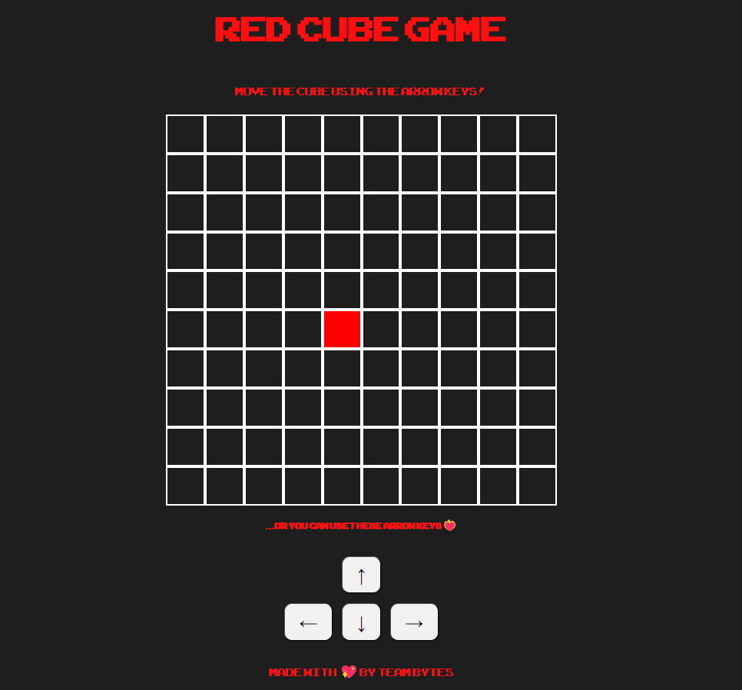

For the second course on [12/07/24], our team focused on several enhancements to our React project, which are detailed below:

We made the border of the 10x10 grid by adding spikes with collider on the edges so that the player could not pass through them, also we set the spikes to be pointed in an appropriate direction (toward the center of the square) for a more pleasant appearance.

In addition, we added the green square that represents the NPC which moves randomly on the X and Y axis every second through the moveNPC() function.

Then we created the new on-screen arrow keys in Piskel, followed by designing the stats label:

Our main character’s name is BitBlip, he is a pixelated extraterrestrial mysterious figure. Born from the old arcades and the captivating charm of retro gaming, BitBlip navigates through realms where nostalgia meets innovation.

Before adding him in the game we changed the edges of the map creating original textures for the borders and adding floor textures too.

After that we made a wavy animation for the title of the game too get the feeling of a real vintage arcade game.

Furthermore, we added an 8-bit main theme that plays in the background, with the option to turn it on or off.

We introduced the new enemy GIF:

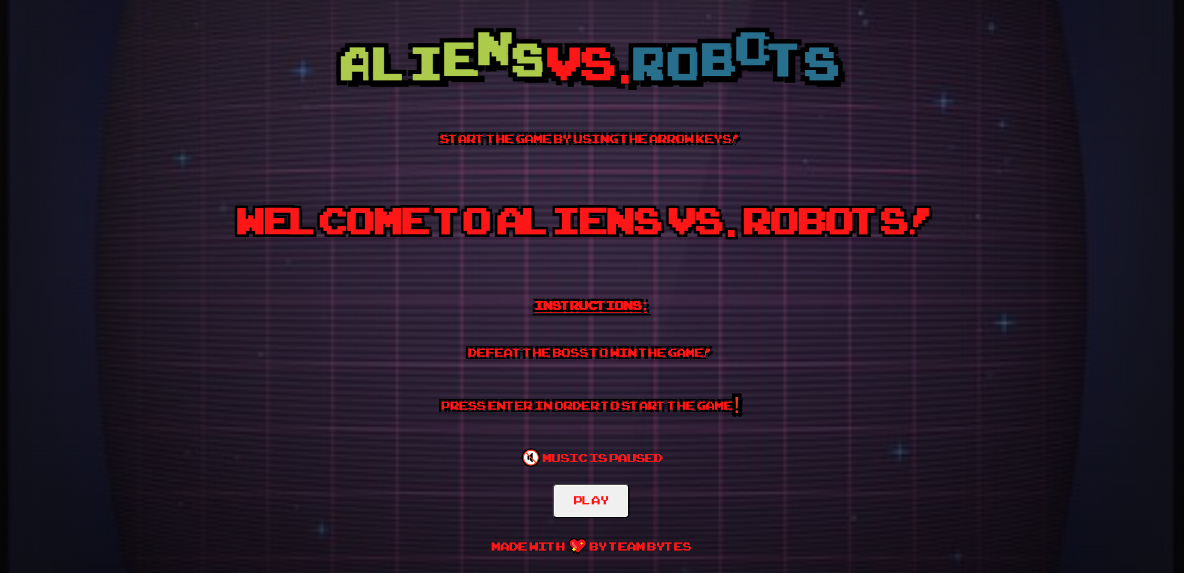

This is the starter screen. Upon pressing enter, the game will start.

We added the modal window that appears when the player and the enemy are on the same tile. This window shows three actions you can take, each with specific sound effects. Additionally, when you are in a fight with an enemy, the music changes to a more dynamic rhythm, enhancing the intensity of the battle.

The fighting system works like this: you have to wait for the timer to start before you can take any action. Clicking attack or parry before the timer has started will result in you taking damage based on the enemy’s strength. So, be careful and pay attention.

Following the tasks we’ve had, we added spike obstacles on the map to increase the game's difficulty. The enemy can hide behind the spikes, making it harder to reach them.

As you can see in the image, there is a tile with a teleporter on it. The teleporter activates when you defeat the first enemy, allowing you to progress to the next level of the game when you step on it.

Moving on to the next level, you will face a mini-boss, which is a more powerful enemy than those on the first map.

We wanted to change the theme of the map to make it look more challenging, transporting the player to a more apocalyptic world.

As you can see on this map as well, there is a teleporter that takes you to the end of the game. It activates once you defeat the boss. Additionally, a message saying “You defeated the boss!” will appear on your screen.



On the last level of our game, you will encounter an NPC that you can interact with. He is a xenomorph who was captured by the robots, and your mission is to save him and his egg, which is ready to hatch.

To interact with the xenomorph, you need to stand in front of him and press the spacebar. A window will then open, and Alien General Xeno will chat with you.

You will also notice a message on the enemy monitor congratulating you for defeating the game.

In case you lose the game, the following messages will appear on the screen:

Thank you for reviewing the documentation for our arcade game! We hope the information provided has given you a clear understanding of the mechanics, theme, and challenges you will encounter in our adventure.

We have put a lot of effort and creativity into developing this game, and we are excited to offer you an engaging and action-packed experience. We encourage you to explore every corner of our world, face enemies with courage, and take advantage of every opportunity to tackle the challenges you encounter.

We look forward to your feedback and are eager to hear about your adventure. We wish you enjoyable gameplay and success in achieving all your goals!

For any questions or suggestions, please do not hesitate to contact us.

Goodbye and have fun playing!