Course overview
https://github.com/sidpalas/devops-directive-kubernetes-course

Part 1

1 Technology Overview
2. Installation Set Up
3. Built-in Kubernetes Resource Types
4. Helm

Part 2

1. Demo Application
2. Deploying Demo Application to Kubernetes
3. Extending the Kubernetes API
4. Deploying Auxiliary Tooling
5. Developer Experience
6. Debugging
7. Deploying to multiple Environments
8. Cluster/Node Upgrades
9. CI/CD

Technology Overview

Terms we’re going to use:
- Cluster → Set of resources that make up the Kube System
- Node → A server (a VM or Bare Metal)
- Control Plane → System components run here
- Data Plane → Our end user applications run here on the Worker Nodes
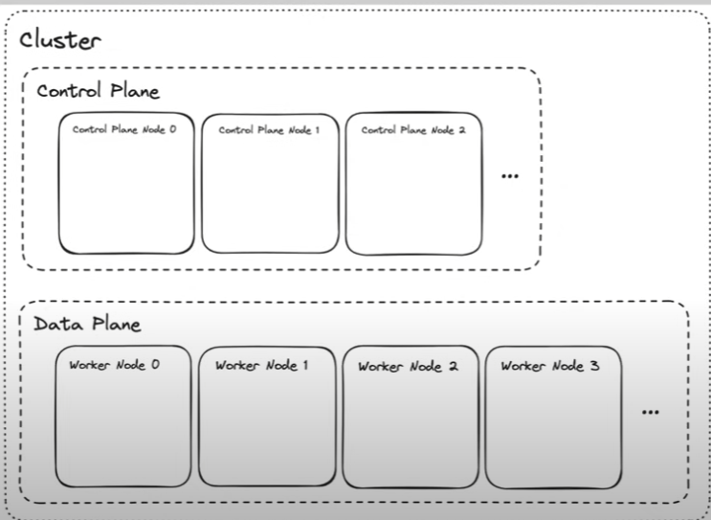
You could run a Kube with a single node, on a single plane but most production systems use this notion of 2 planes.

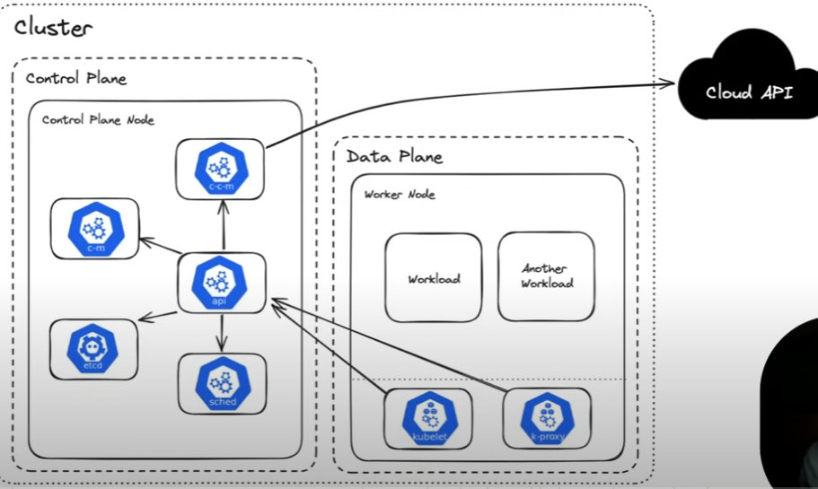

- Cloud controller manager → Interface between Kube and the Cloud Provider, logic for resources lives here, like Load Balancers on the Cloud Provider
- Controller Manager → Runs the various controllers that regulate the state of the cluster (matches desired state with current state of a an element)
- API → This is how we interact with the Kube Cluster, and makes calls to other components
- Data Store (ETCD) → Highly available key-value store that stores information regarding components
- Scheduler → Assigns Pods to new nodes based on current usage
There are 2 Kube System components that live on the worker nodes:
- Kubelet → Spawns and Manages the Workloads, performs Health Checks, relays the info to the API panel
- Kube Proxy → Sets up and maintains the networking between the different workloads (Not every cluster use Kube Proxies)
We’re going to focus on Workloads and not managing the cluster itself in this course

Kube Standard Interfaces

1. Container Runtime Interface (CRI)
2. Container Network Interface (CNI)
3. Container Storage Interface (CSI)

These are used to handle the container runtime, the container networking and the container storage.
These have been moved out of the core Kube so we can have a pluggable implementation.

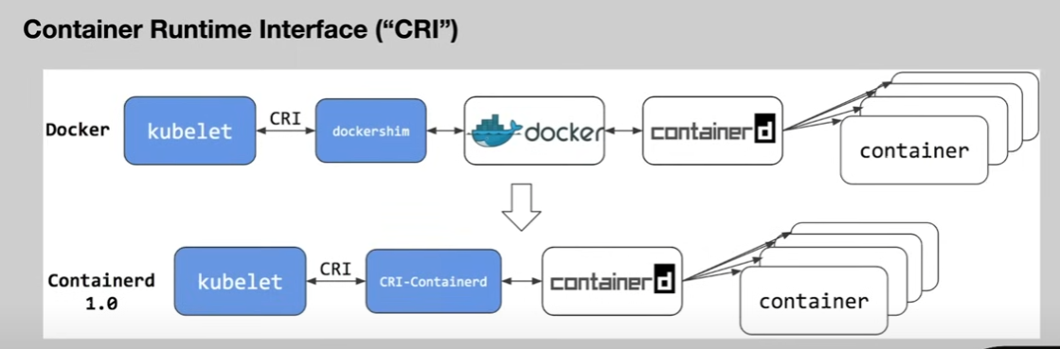

CRI is the standard interface Kube uses to run Container processes (Popular today is Container D, Docker was used as a container runtime but it had issues due to difference between it and CRI, so that dockershim interface was used. Kube in 1.0 no longer uses Docker as a runtime)

CNI defines how the networking should be set up for the containers that are running within kube. There are many different implementations of the CNI like:
- Calico
- Flannel
- Cilium
- Cloud specific CNI Plugins (Amazon VPC CNI, Azure CNI, Google Cloud CNI)
Not all these CNIs use KubeProxies (Cilium uses Psylium)

CSI is the interface through which we provide storage to the containers.
- Cloud Specific CSI Driver (Amazon EBS, Compute Engine persistent disk, Azure Disk Container)
- Cert Manager CSI (can load a certificate at runtime into the file system storage of container)
- Secrets Store CSI

https://landscape.cncf.io
A landscape of different projects at different levels in combination with Kube

Installation and Set Up
WE’RE USING UBUNTU ON A VIRTUAL MACHINE YOU PLEB
https://stackoverflow.com/questions/54251855/virtualbox-enable-nested-vtx-amd-v-greyed-out
https://github.com/sickcodes/Docker-OSX/issues/127
dism.exe /Online /Disable-Feature:Microsoft-Hyper-V

Tools:
- Docker Desktop
- Helm: Package manager / Template Engine
- Kubectl: Kubernetes Client
- Kubectx: kubectl add-on to make cluster switching easier
- Kubectl: improving Kubernetes configuration management
- KinD: Deploy Kubernets within Docker
- ko: Containerizing go applications
- k9s: TUI for observing Kubernetes clusters
- oras: OCI registry client
- yq: Parsing and manipulating Yaml

We will grab the project from the Repo first then install Docker Desktop.
Then manually install Devbox (jetify.com/devbox/docs/quickstart)
- After installing devbox on your Ubuntu distribution, we will also clone the repo there
- Then devbox shell, devbox list will also list the deps you have in the current session

Course helper , in any folder step of the course, in the devbox shell running task –list-all will list all of the commands used in that course step based on the taskfile.yaml

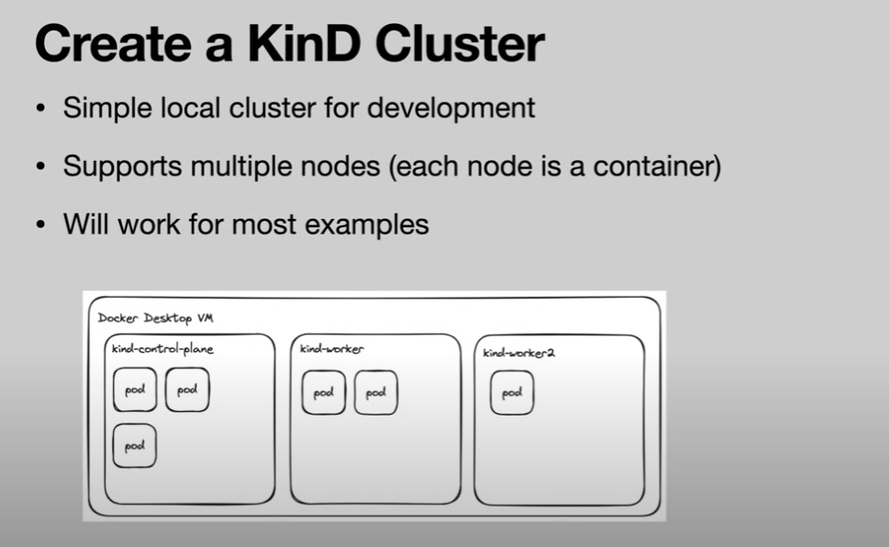

One of the tasks is the kind:01-generate-config, which will generate the kind configuration file to deploy our cluster. We are generating instead of using one we find online because we want 2 extra mounts
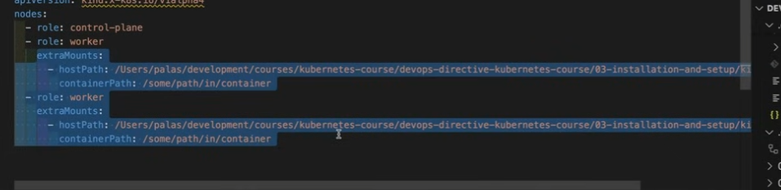
And it’s going to use absolute paths on your system
We can run task kind:01-generate-config (We can autocomplete if you make your taks yaml following to go-task guide)
We can now run the kind:02-create-cluster
kubectl get nodes will return the nodes you have active

The last step is the Cloud Provider Kind, that will allow us to run Load Balancers in the kind cluster that will be accesible from the host, but for now we don’t do it until deployment
Once we’re done we have the 04:delete-cluster

kubectl get pods -A will list all the pods, which will show the types we’ve discussed.

It’s also educational to deploy remote clusters, we’re going to use CIVO for free (fazBj54!MJMN#Uk password)
Let’s provision a cluster with CIVO, we have 6 tasks civo in the task list, which set up your cluster in CIVO with firewall rules for ingress/egress and the network.

Built-in Kubernetes Resources

Our goal is to present here the basis of the resources, and while we build the demo application we can revisit the resources to get more in-depth.

Namespace
Provides a mechanism to group resourcers within a cluster
There are 4 initial namespaces: default, kube-system, kube-node-lease, kube-public
By default namespaces DO NOT act as a network/security-boundary

Within the module 4 directory, there is a folder for each resource type, with a taskfile for each one.
We’ll use the kind local cluster, but the results are identical between local and remote clusters.
Kubectl explain will list properties and details regarding concepts like namespace.

It is recommended to store your resource definitions in yamls instead of doing them all in command line, in the project we have yaml for each resource definition.

Pod
The smallest deployable unit
You will almost never create a pod directly (we are only doing so for educational purposes)
A pod can contain multiple containers and containers within a pod share networking and storage.
There are:
- Init Containers → A container that runs before the startup of other containers, that does things like preparing files, injecting dependencies, etc
- Sidecar containers → Containers that run alongside the primary container, serving as network proxies
More configurations (Listening Ports, Health Probes, Resource requests/limits, Security Context, Environment Variables, Volumes, DNS Policies)

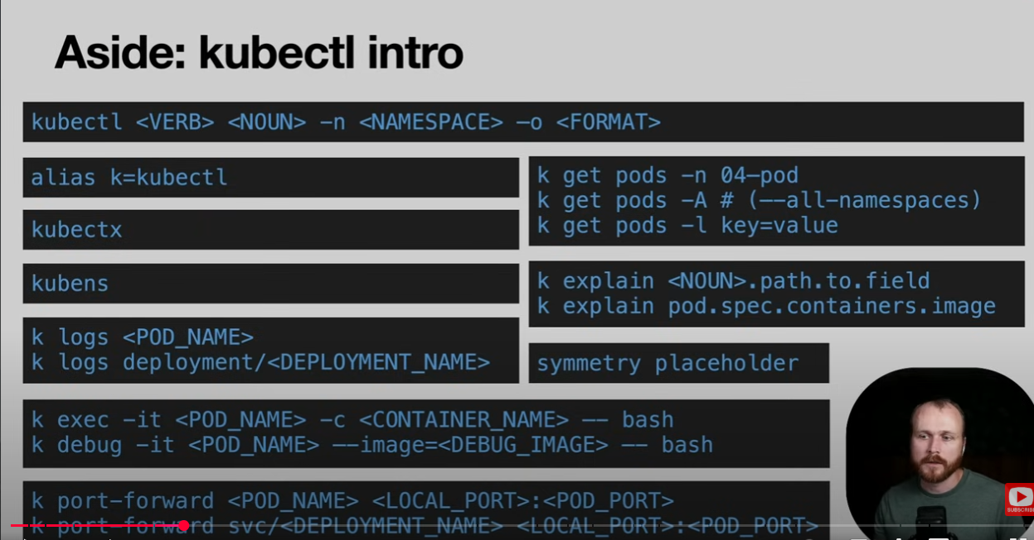
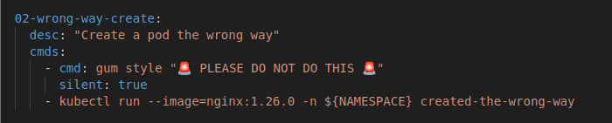
A task to create a pod was given

But this is really not the way to create pods, there is no record, and it will probably remain orphaned
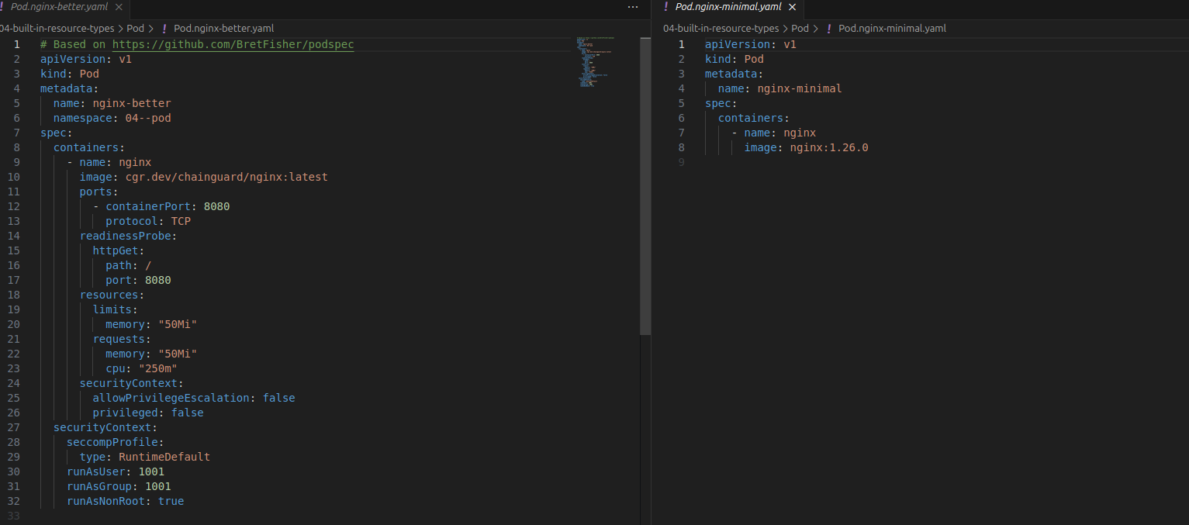
We are given two configurations for pods, a minimal and a better one, for an nginx server:

This time at least we have the resource yaml in the source code and we can figure out why it exists
There is also a task that exposes the nginx server for port forward
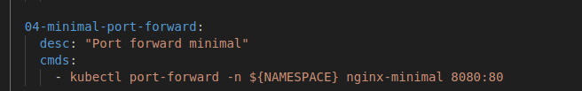

The differences to the better resource are:
- A clear namespace so it does not get deployed to default
- We are specifying a lot more regardiong the ports, limits, memory security of the pod
- The image is grabbed from chainguard which is a secure image of nginx
- We are specifying the readinessProbe to just hit the route “/” at port 8080 to check it

ReplicaSet
Adds the concept of replicas
You will almost never create a ReplicaSet directly
Labels are the link between ReplicaSets and Pods
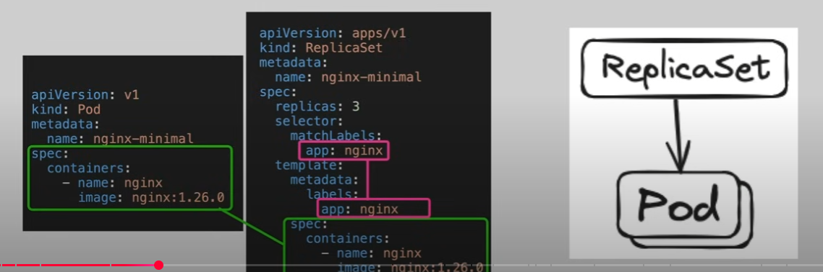

The kube controller based on this value ensures we have that many replicas running of that pod at all times.
But again, we’ll never deploy a ReplicaSet Directly, we’ll cover more in the next sections.

Deployment
Adds the concept of rollouts and rollbacks
Used for long-running stateless applications
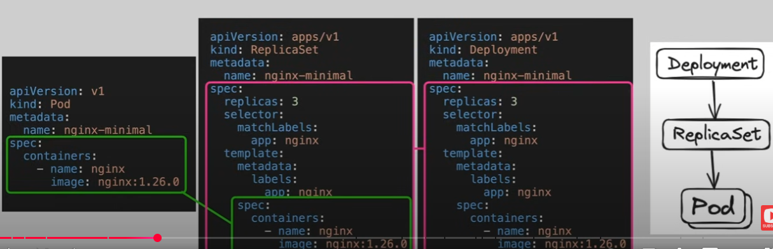
For example if we update the image tag of the application, you can specify with rollouts, if you want it to happen 1 pod at a time, how many pods you are okay being unhealthy at a time.

Service
DEMO IS DONE ON THE REMOTE CLUSTER
Serves as an internal load balancer across replicas
Uses pod labels to determine which pods to serve
Types:
- ClusterIP: Internal to cluster
- NodePort: Listens to each node in cluster
- LoadBalancer: Provisions external load balancer

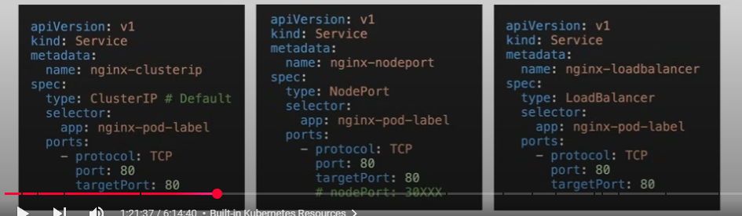

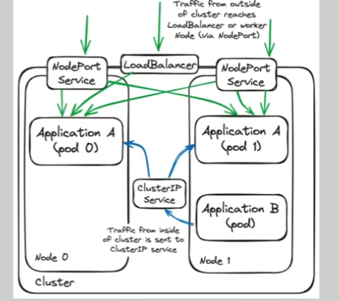

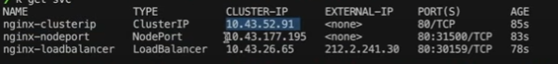
If we access that external IP in the browser, we can get to the service, having a public IP means we can also set up a DNS.
There is also another tpye of internal service DNS that if you are within the same namespace you can call services like curl nginx-clusterip:80, and that will route to the CLUSTER-IP, can only be done in the same namespace.
(kubectl run curl-pod -it –rm –image=curlimages/curl –command – sh)
We can however make calls across namespaces, with the fully qualified domain name
curl nginx-clusterip.04—service.svc.cluster.local

We can however also do something with the Kind Cluster, even if running the commands for running a load balancer just leave it in a pending state, since kind does not support it by default.
Back in lesson 3, we have the task 03, where we can run the cloud provider kind

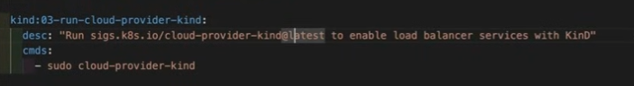
Opening a new terminal, running that command as sudo, our load balancer service is now running with an External IP, but it’s not really external, it’s only accesible from your host system.

Job
Adds the concept of tracking completions
Used for the execution of workloads that run to completion
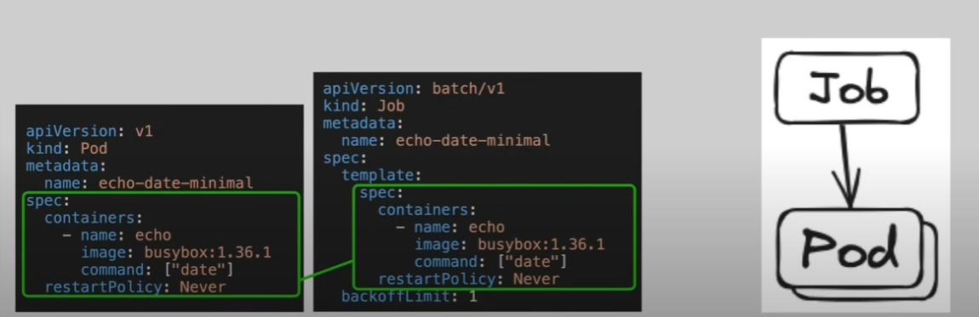
Instead of nginx which is a long running task, busybox is a cluster of UNIX tools, it starts it runs the date command, then stops. There is also a backoff limit, how many times it should retry in case it fails on the first run.
There are some resource configs to note:

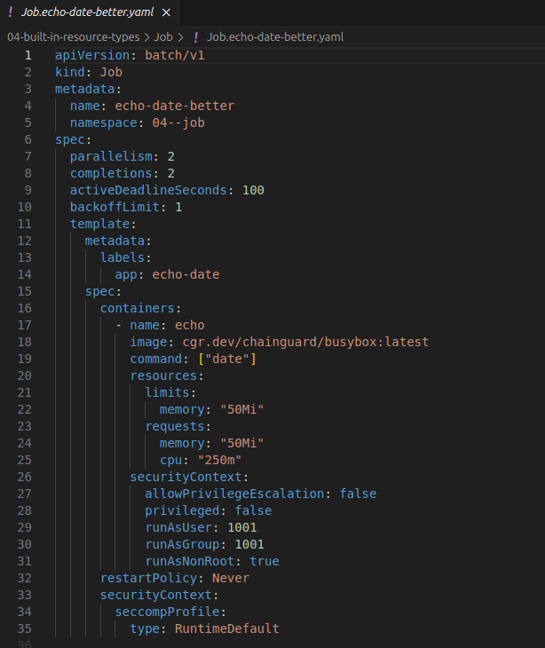

Parallelism tells how many jobs it can run in parallel, completions how many times this job must be completed before it stops, active deadlines.

CronJob
Adds the concept of a Schedule, used for period execution of workloads that run to completion.
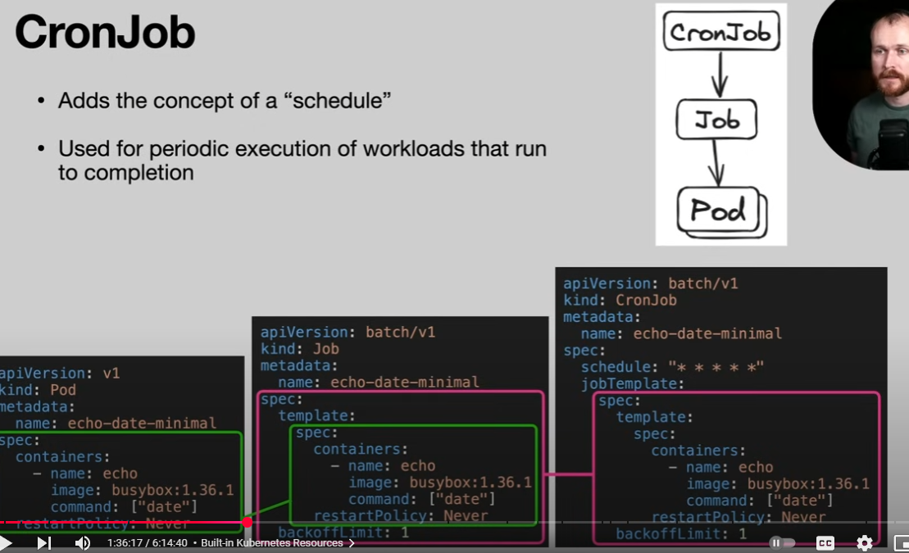

DaemonSet
Runs a copy of the specificed pof on all (or a specified subset of) nodes in the cluster
Useful for applications such as:
- Cluster storage daemon
- Log Aggregation
- Node Monitoring
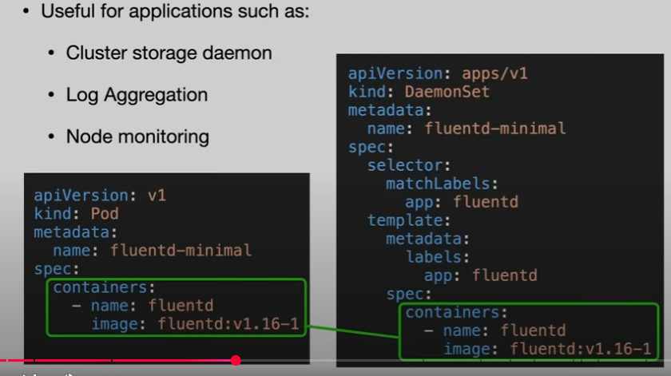

In this example we have fluentd, which is a log shipping agent, not configured to send it anywhere.

StatefulSet
Similar to Deployment, except:
- Pods get sticky identity (pod-0, pod-1…)
- Each pod mounts separate volumes
- Rollout behavior is ordered\
It enables configuring workloads that require state management (eg primary vs read replica for a database)
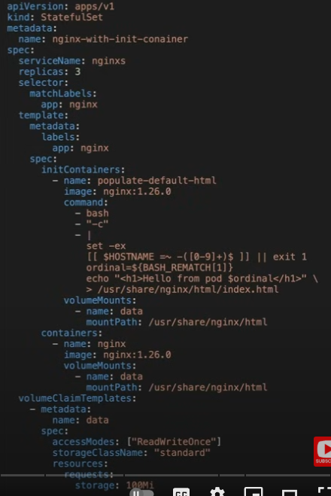

The init container there runs a bash script that stores an html snippet in a file system, and that system is in a volume that is shared between the primary and init container.

ConfigMap
Enables environment specific configuration to be decoupled from container images
Two primary styles:
- Property like (MY_ENV_VAR = “MY_VALUE”)
- File like (conf.yml = <multi-line-string>)

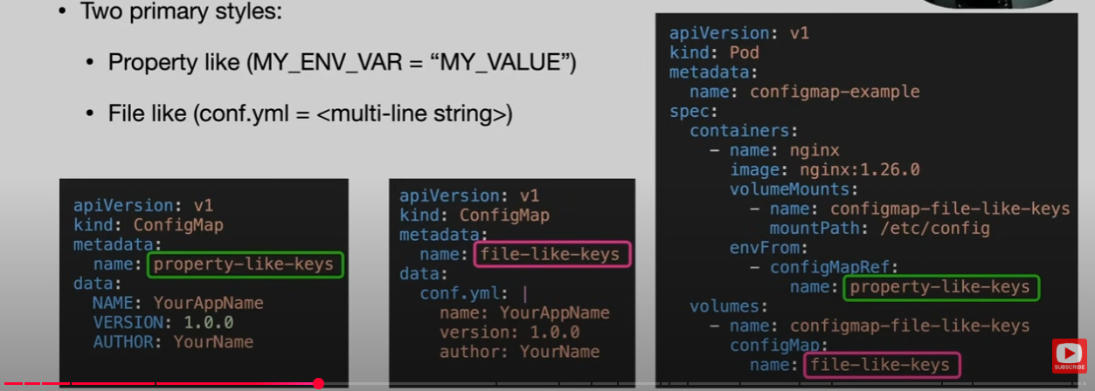
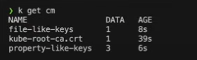
After applying both type tasks:

The kube root certificate is created by the system.
To show that the file was loaded in the pod, we’re going to use a cat command in that container:
- kubectl exec configmap-example -c nginx – cat /etc/config/conf.yml
To showcase the environment variable variant, we use this command for the pod:
- kubectl exec configmap-example -c nginx – printenv

Secrets
Similar to ConfigMaps with one main difference:
- Data is base64 encoded (this is to support binary data and is NOT a security mechanism)
Because they are separate resource type, they can be managed/controller with specific authorization policies
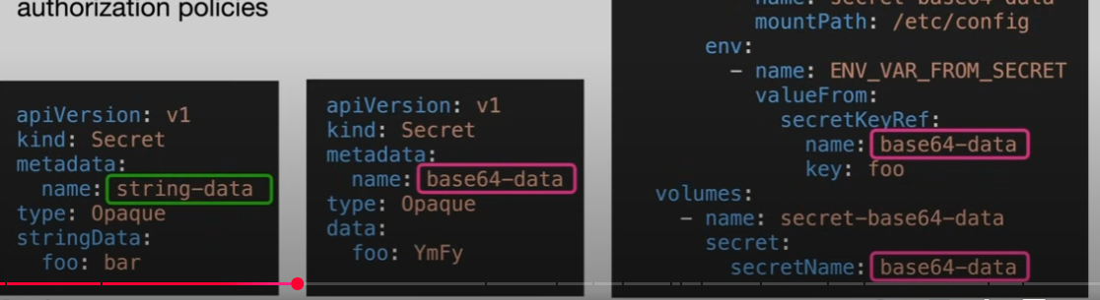

Ingress

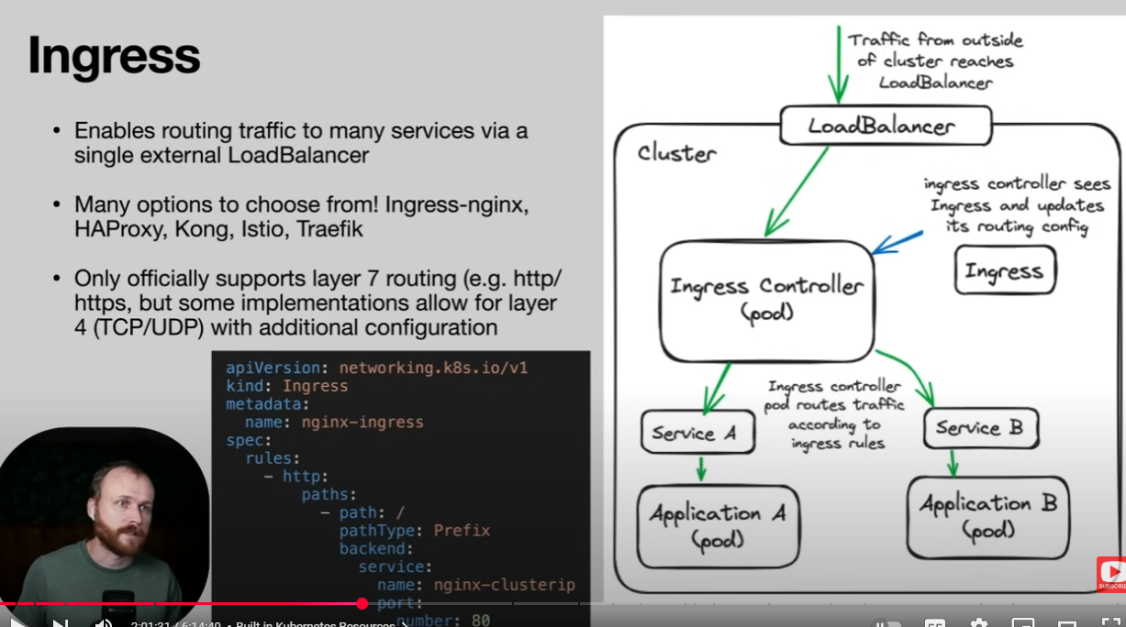

GatewayAPI
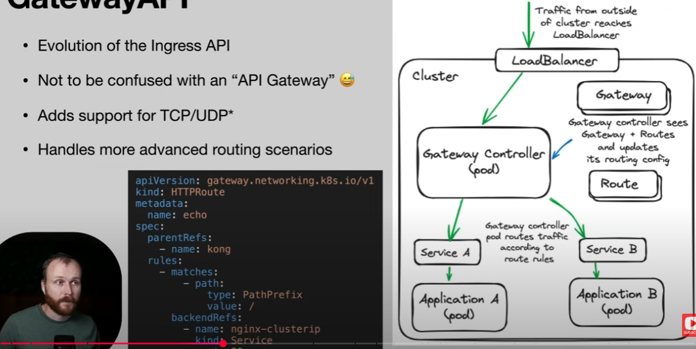

PersistentVolume & PersistentVolumeClaim
Provides API for creating, managing and consuming storage that lives beyond the live of an individual pod
Access Modes:
- ReadWriteOnce(and new ReadWriteOncePod)
- ReadOnlyMany
- ReadWrite Many
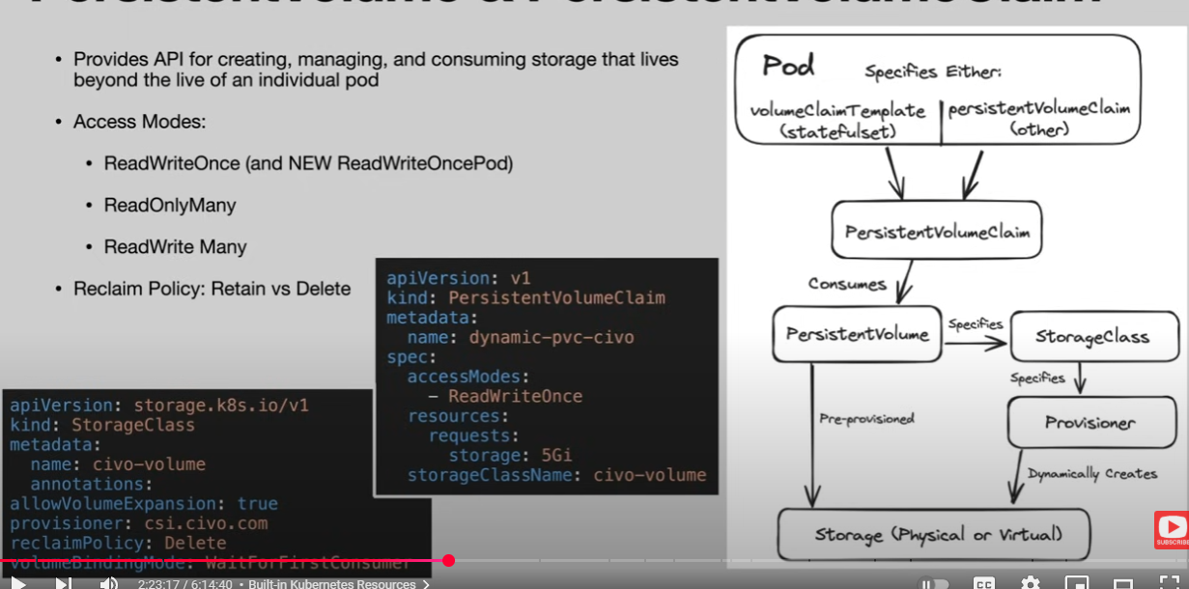
Reclaim Policy: Reatin vs Delete

Containers are great by themselves, a fresh new system, but if we want data to persist between restarts, we need a persistent volume.
For cloud provides they have specific solutions, network file shares, and these are Kube’s solution for persistent storage.
ReadWriteOnce you can mount this storage with a single pod, so a second one would fail. (In the past you could mount multiple pods from the same node, but with the new one it has per pod)
The reclaim policy is what happens when the persistent volume claim gets deleted.

RBAC (ServiceAccount, Role, RoleBinding)
Provides applications (or users) access to the Kubernetes API
Access can be granted by namespace or cluster wide
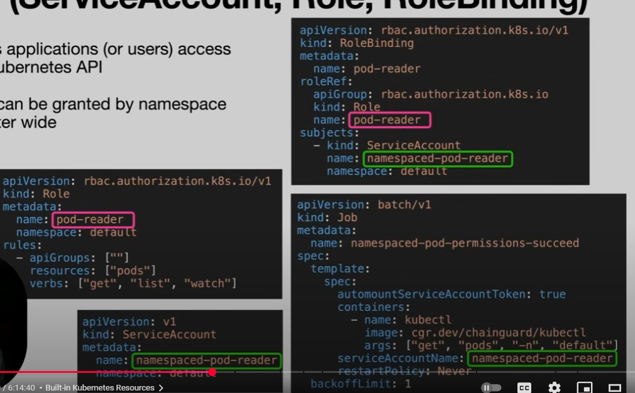

Labels and Annotations

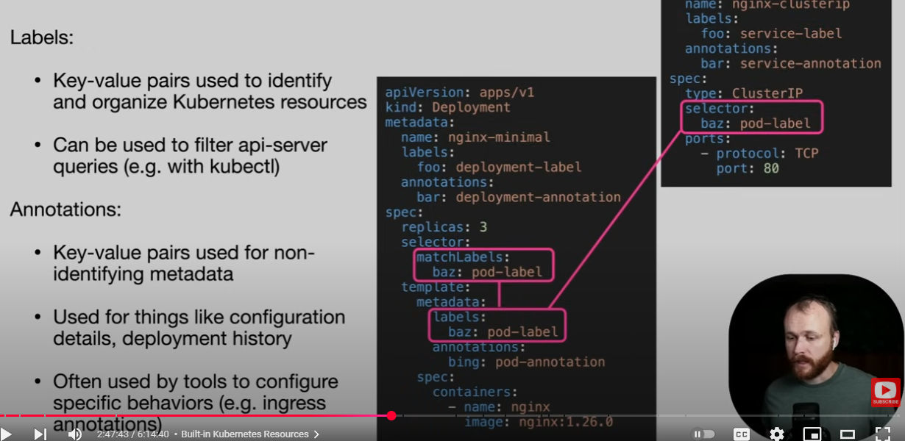

Out of scope
LimitRange – Govern the number of resources an object can manage
NetworkPolicy – Mechanism to control access from a network standpoint across boundaries
MutatingWebhookConfiguration – Changes to the pod on the fly
ValidatingWebhookConfiguration – For example validates that all configuration specifies memory specs
HorizontalPodScaler – Changes the number of replicas based on specific conditions and metrics
CustomResourceDefinition (covered in later section)

Helm

De-facto standard for distributing software for Kube
Combination of: Package Manager and Template Engine
Primary use cases: Application Deployment and Environment Management
Commands: helm install / helm upgrade / helm rollbacks
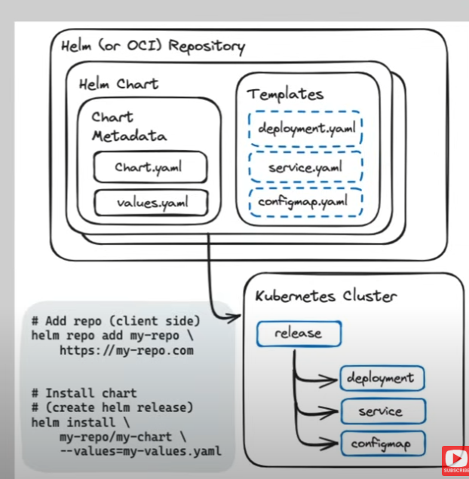

Templates can become complicated:
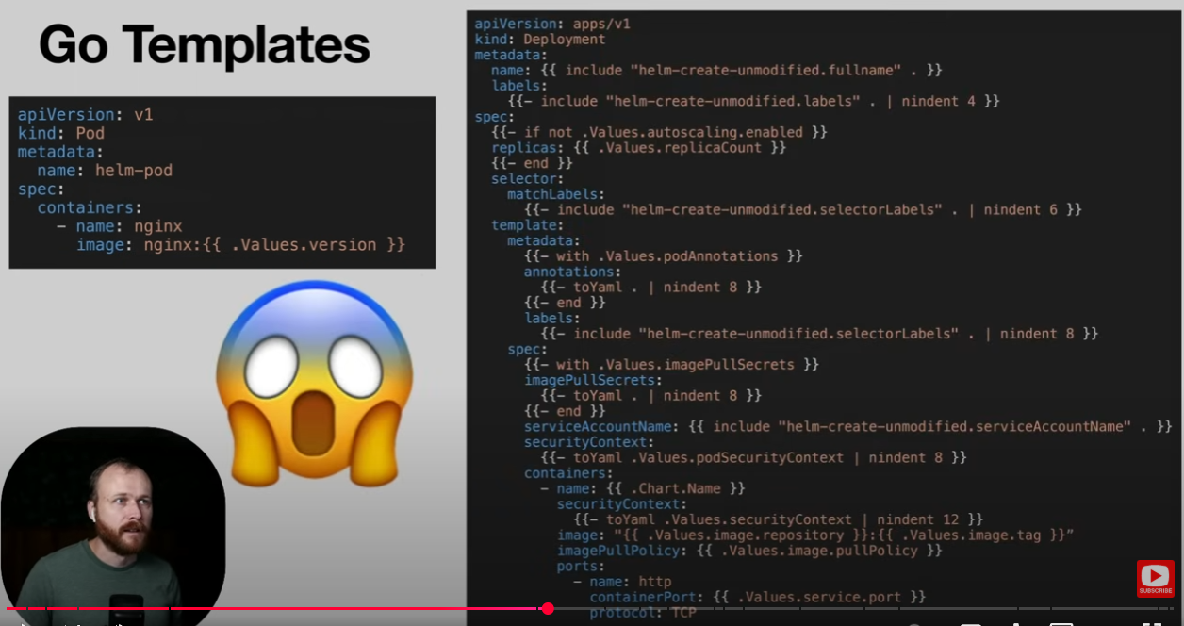

This is a sequence from the SQL helm chart, there are a lot of conditions and scenarios.
There are features that matter:
- Metadata (Chart/Release/Values)
- Variables
- Conditionals (if)
- Loops (range)

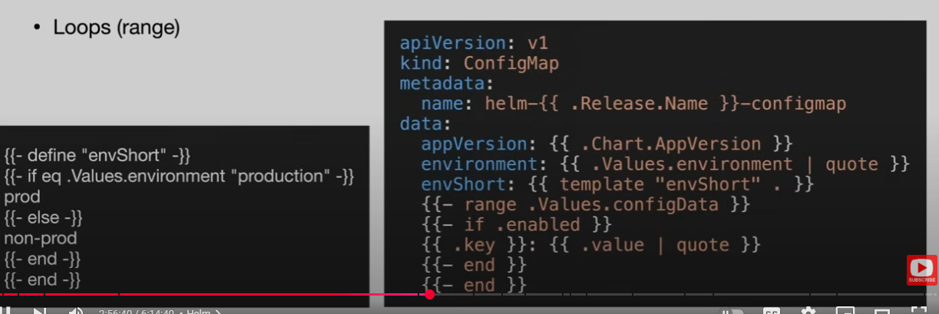
In our Helm Folder, there are 2 subfolder, we’ll start with the postgres one, where we will consume an external helm chart
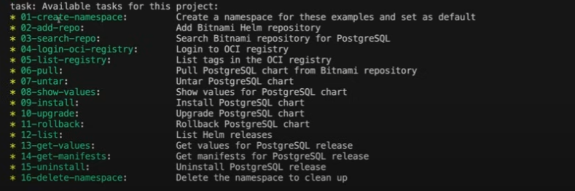
helm repo add adds a repo to the current helm environment to be able to request from it.
Helm search repo will search for the postgre, then we log in, list the tags and grabs the postgresql chart.

There are also OCI repositories, dockerhub for example is an OCI repo.
Grabbing the chart from bitnami gives us a tar which we will unzip, giving us a postgres directory with Chart.Yaml, Chart.lock, values.yamls, locks, templates, .helmignore.

We can also create our own chart, in the other folder called charts we can run helm create foo, which will create a basic chart.

Demo Application

This will be a Minimal 3 Tier Web application:
- React Frontend
- Two API implementations (Node.js – interpreted, Go – Compiled)
- Python load generator
- PostgreSQL Database

We have everything ready in our Module 6 directory.
- task postgresql:run-postgres this is gonna spin up docker run -e POSTGRES_PASSWORD=foobarbaz -v pgdata:/var/lib/postgresql/data -p 5432:5432 postgres:16.3-alpine
- Then we initalizae the tables with the next task while leaving that terminal running the server
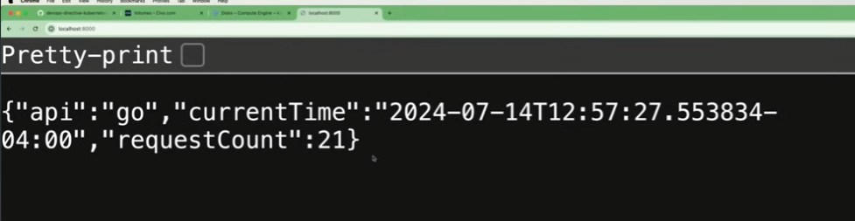
- Now we can spin the 2 backend applications, starting with go, the task will install deps, then we can do the run task, which starts the GO application

- Let’s start the node app, same stuff by installing the deps, then the npm run dev task with the same structure shown
- For the react app, we have simillar tasks, with npm run, which shows a simple interface

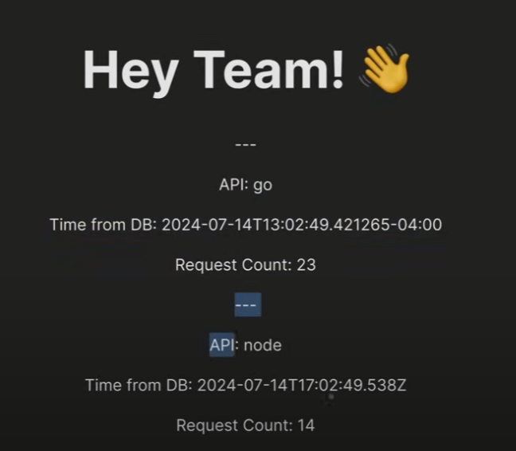

Each refresh will make a single request to node and go apis.
- The python part will simply make repeated calls to the apis for a quick update

Building the Demo Application Images

A container image is detailed in a dockerfile, start with an OS, install language runtime, install deps, copy source cope, set up execution commands
Then we store it somewhere like a containe regsitry (dockerhub, github, cloud providers)
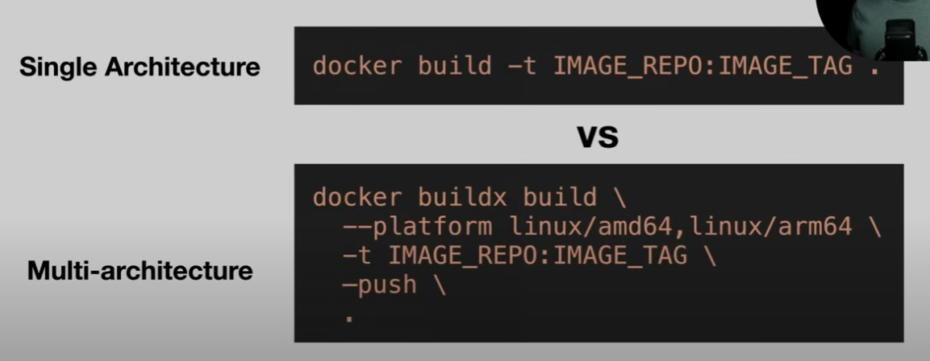
The multi-architeture approach is made to make sure that the machine you’re deploying on is not a mismatch to what you’ve built the application on.

Debugging
https://learnk8s.io/troubleshooting-deployments

