Course overview
https://www.youtube.com/watch?v=7xngnjfIlK4
https://github.com/sidpalas/devops-directive-terraform-course

1. Terraform Overview + Setup
2. Basic Terraform Usage
3. Variables and Outputs
4. Language Features
5. Project Organization and Modules
6. Managing Multiple Environments
7. Testing Terraform Code
8. Developer Workflows

Terraform Overview + Setup

Terraform is a tool for building, changing, and versioning infrastructure safely and efficiently
Enables application software best practices to infrastructure
Compabile with many clouds and services.

Common Patterns

Provisioning + Config Management
Terraform is the provisioning a number of virtual machines and take a tool like Ansible which installs the necessary tools on the machines.

Provisioning + Server Templating
A tool like Packer, Terraform provisions the services, but the template comes before provisioning, and the machine image comes with all the deps

Provisioning + Orchestration
Like Kubernetes, we have the clusters from Terraform, defined cloud resources, and Kube defines how the application is deployed and managed on the clusters

Terraform Architecture
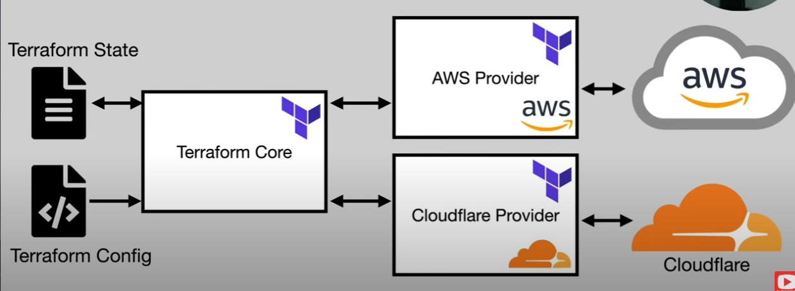

Let’s do the setup
- Install Terraform
sudo apt get terraform

- Authenticate to AWS
We need a simple user, with: AmazonRDSFullAccess, AmazonEC2FullAccess, IAMFullAccess, AmazonS3FullAccess, AmazonDynamoDBFullAccess, AmazonRoute53FullAccess
We need the command line installed: aws cli,

- Hello World tf Config
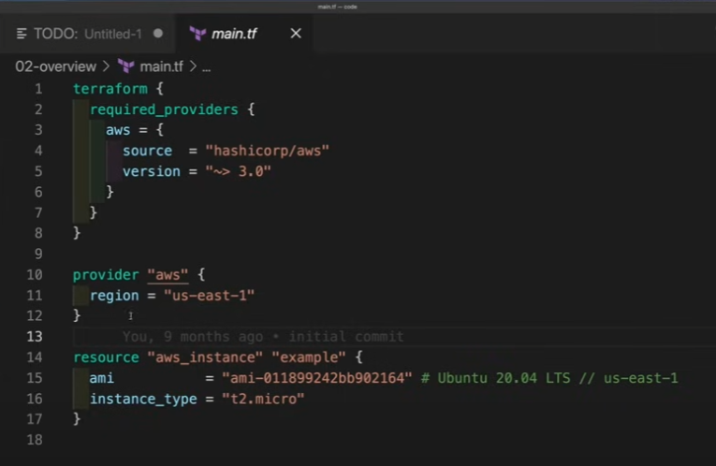
- Init, Plan, Apply, Destroy
We run terraform init, it’s going to state locally
The terraform plan, it’s going to query the aws api to compare to what is currently deployed and the resources specified in the .tf we have locally
Then terraform apply to actually launch it
The terraform destroy we should run so we don’t pay =)

Terraform Usage

We have seen the basic usage sequence in the first step.
Each provider will have it’s own set of rules that declare what you can pass in the terraform.

What happens in terraform init?
It’s going to get the code from the aws provider, puts it in the working directory. The next thing that it does is, if you used any modules (ways to bunlde Terraform Code) it will go get that as well and slides them into the directory.
The State File is a json file that is a representation of the world for Terraform, containing information about every resource and data object, contains also SENSITIVE INFO like passwords.
It can be stored locally or remotely, the default is locally, but within a company you store it remotely like in an S3 Bucket, or Google Cloud.

Basic Usage
The simplest way is to have a local backend, with a terraform state file which is stored right alongside the code. (It’s going to have sensitive values in plain text on your local system). It’s also uncollaborative in this case and it’s very manual.

A remote backend can separate the developer from the state file. Terraform has Terraform Cloud which manages that, or we can use a provider like S3 or Google Cloud, in which case, sensitive data is encrypted, it’s collaborative, it allows for automation but it increases complexity

What about terraform plan?
It’s taking the terraform config (Desired State), and compares it to the Terraform State (Actual State if you did not modify something dynamic outside the terraform)
If we get a network config, 4 servers and a db, and on the Actual state we only have 3 servers. So the plan command says I need 1 virtual machine, which gets fed to the AWS provider to provision that VM.

Terraform apply will do as the plan says. (The destroy command gets rid of everything within that configuration and project)

Remote Backend
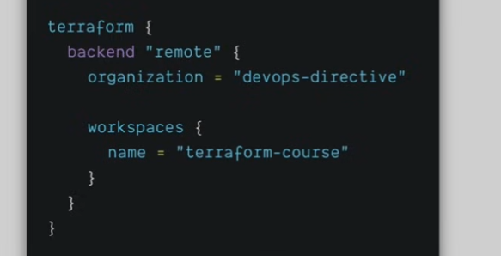
Terraform Cloud is a free offering up to 5 users, you would put the following:

We have a self managed option backend AWS with S3 bucked and a DynamoDB used for locking
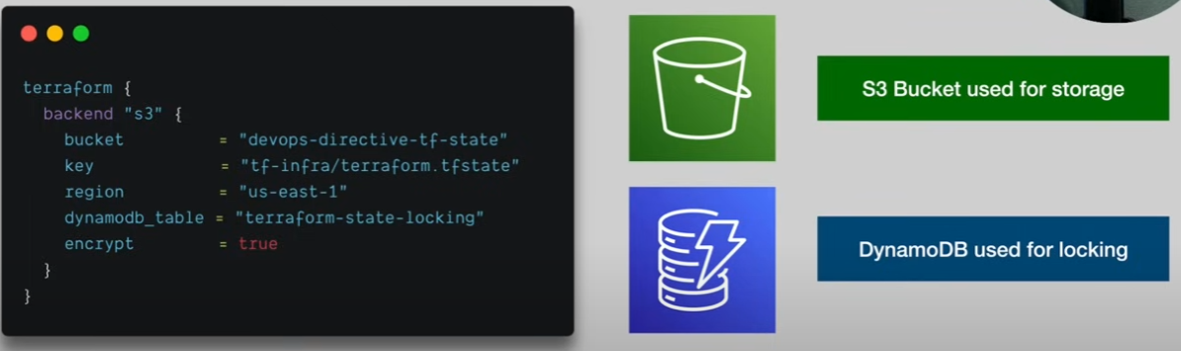
But in this case you’re setting up infrastructure for a project that sets up infrastructure, chicken and egg. There is a bootstrapping process.

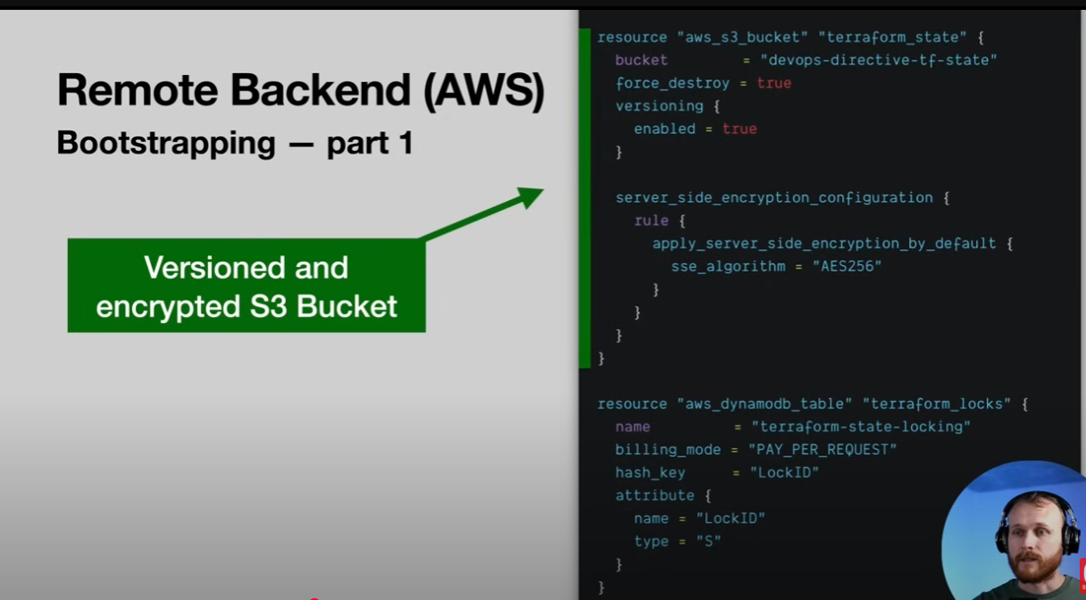

Variables and Outputs

Variable Types
- Input Variables var.<name>
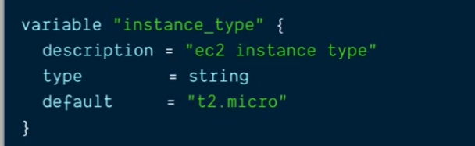

- Local Variables: local.<name>
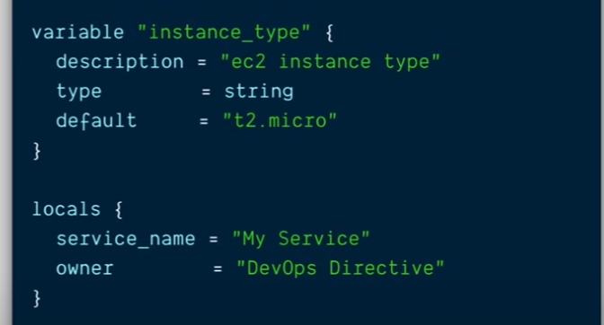

- Output Variables
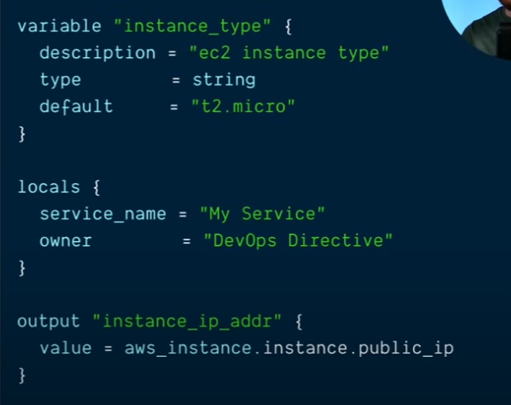

Setting Input Variables
(In order of precedence // lowest → highest)
- Manual entry during plan/apply
- Default value in declaration block
- TF_VAR_<name> environment variables
- terraform.tfvars file
- *.auto.tfvars file
- Command line -var or -var-file

Types and Validation
Primitive Types: string, number, bool
Complex Types: list, set, map, object, tuple
Validation: Type checking happens automatically, Custom conditions can be enforced

Sensitive Data
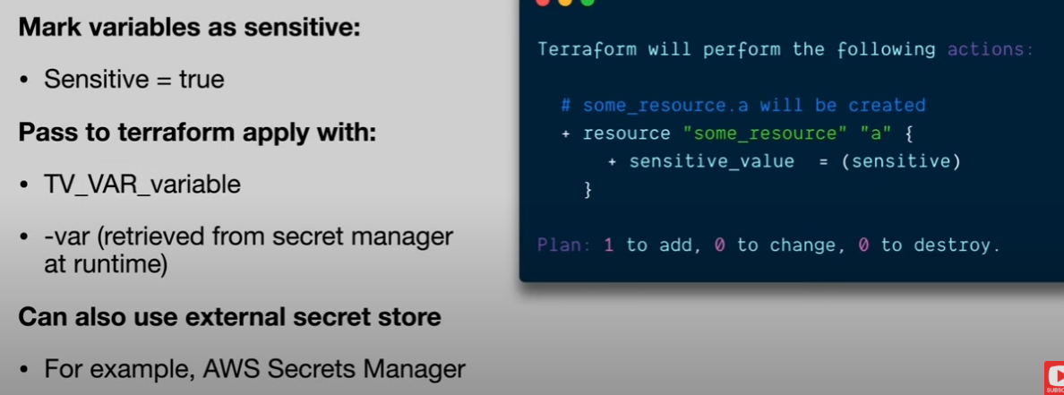

Additional Language Features
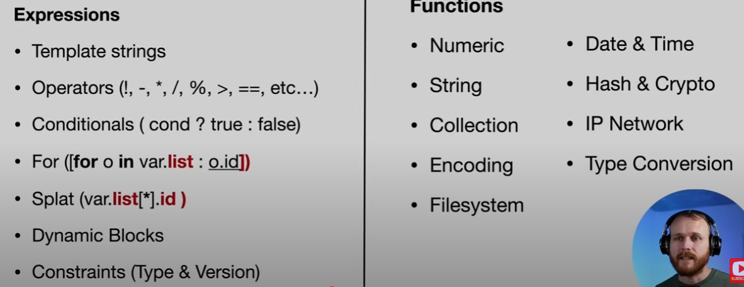
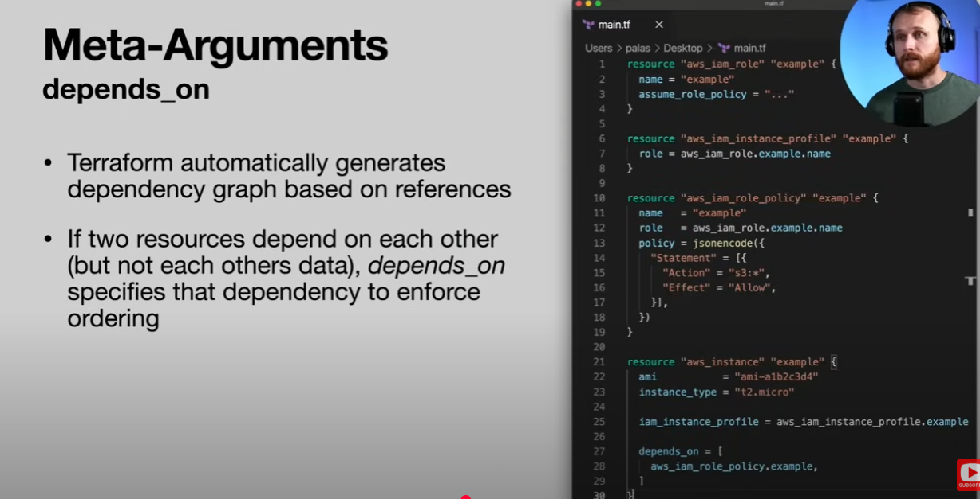

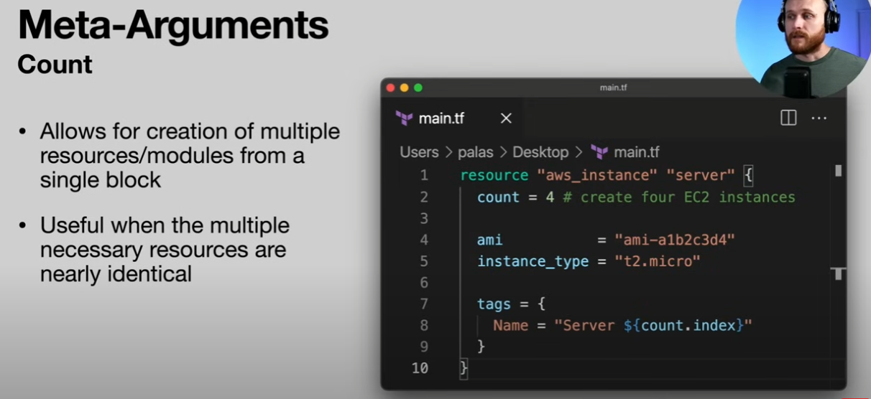

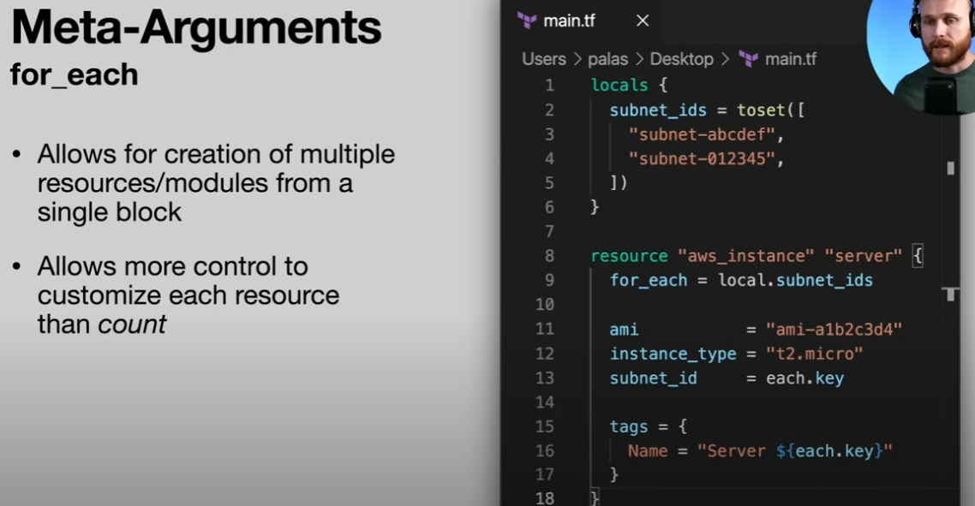

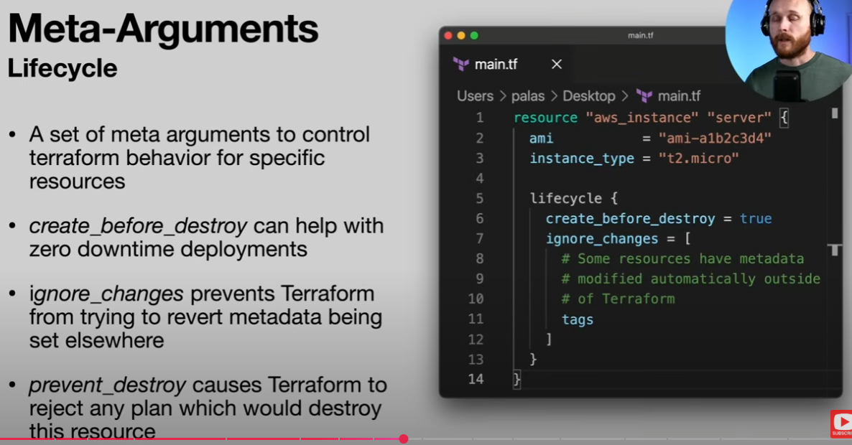

Project Organization + Modules

What is a module?
It’s a container for multiple resources that are used together. A module consists of a collection of .tf and/or .tf.json files kept together in a directory.
Modules are the main way to package and reuses resource configurations with Terraform.

Types of modules
Root Module: Default module containing all .tf files in main working directory
Child module: A separate module reffered from a .tf file
Module sources:
- Local paths
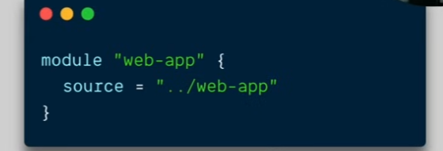

- Terraform Registry
- Github
- Bitbucket and other gits
- Http URLs
- S3 Buckets or other storage
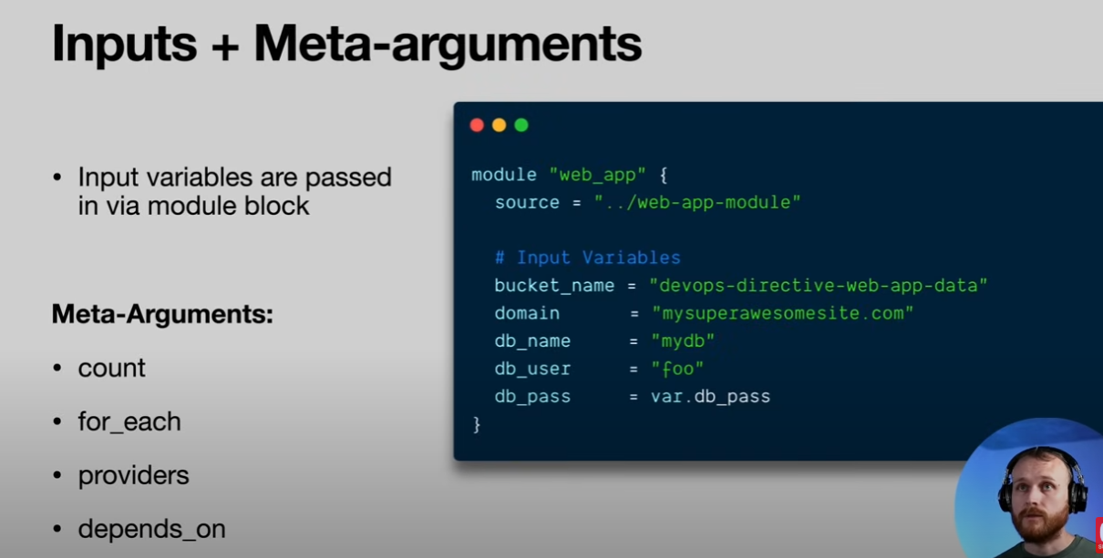

Managing Multiple Environments

Apps usually don’t have 1 environment, we have dev, staging, production, so we want to stage and deploy our terraform infra.
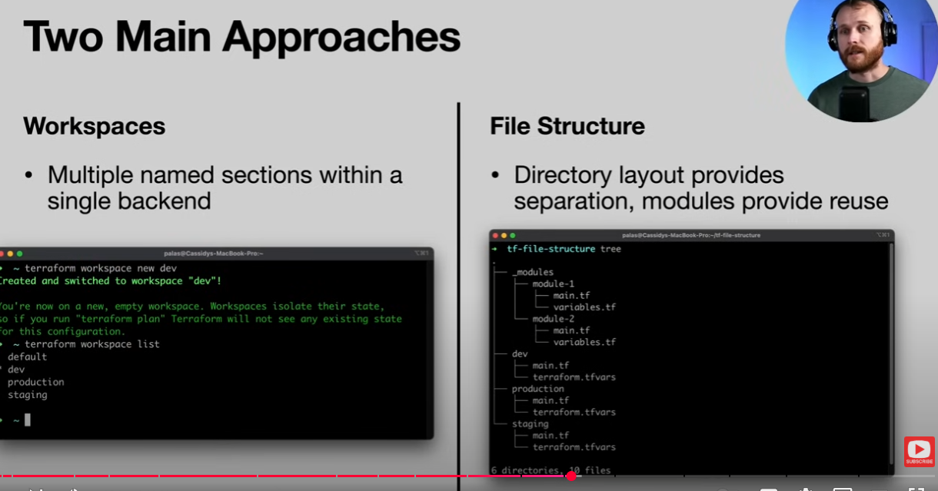
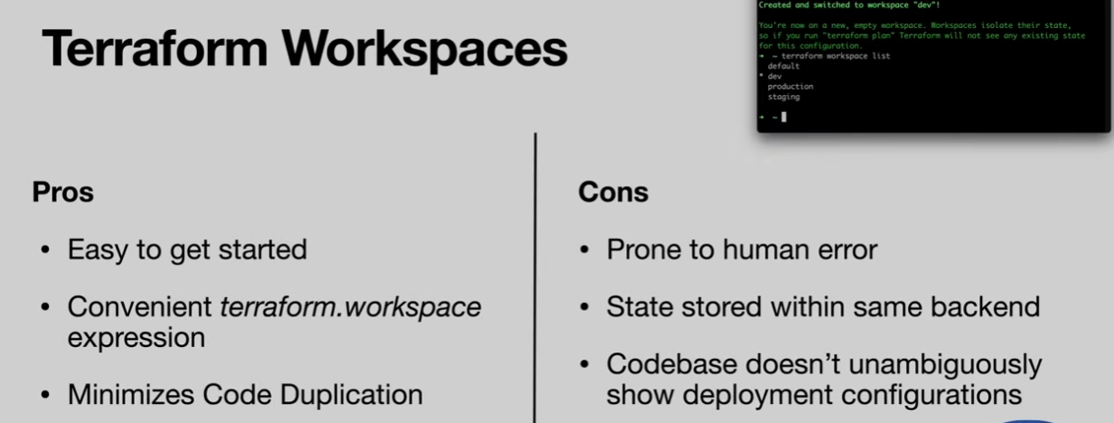

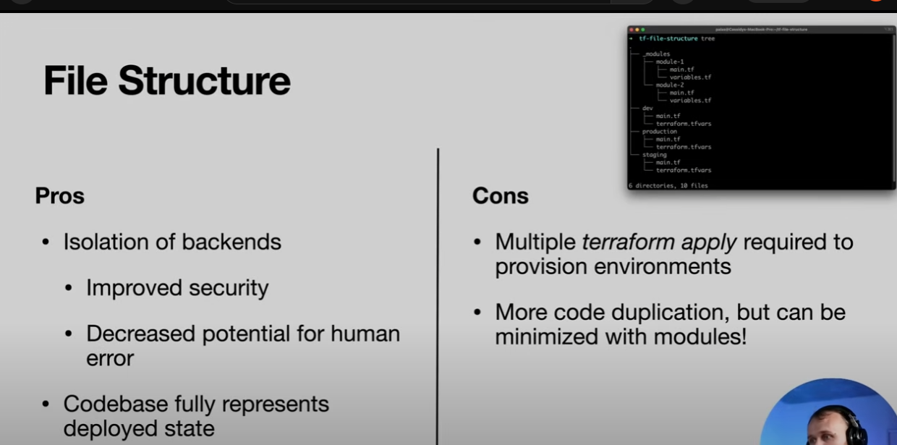
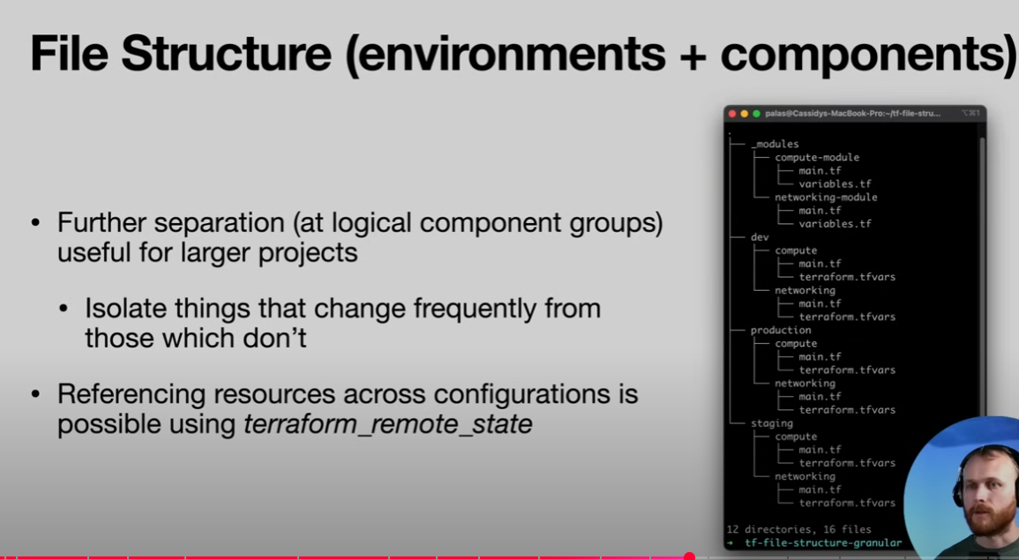

Testing Terraform Code

Code Rot
- Out of Band Changes
- Unpinned versions
- Deprecated deps
- Unapplied changes

Static checks


