Efficient localization methods for mobile devices

Introduction
Related Work
FenceIT – The mobile Application
Theoretical aspects
Locations
Geographical Coordinates Location
Connected Wifi Location
Wifis Detected Location
Cell Network Location
Other aspects
Localization Optimizations
Actions
System Architecture
The Application Interface
Background Service
Implementation
Android Operating System
Libraries Used
Log4J / Android-Logging-Log4J
AndroWrapee - a side-result of FenceIt development
General design
Alarms
Triggers
Locations
Wifi Connected Location
Wifis Detected Location
Cell Network Location
Geographical Coordinates Location
Actions
Context Data Providers
Wifi Context Data Provider
Cell Network Data Provider
Geographical Coordinates Data Provider
Application Interface
Conclusions
References

Abstract— Location-Based Services have become some of the most important and used applications of the mobile devices and people are in constant search of tools that make their life easier and more efficient. Yet, the main technology used for locating a device is still the Global Positioning System, which has high battery consumption and requires special hardware. However, there are situations, such as the case of Location-Based Reminder applications, when an exact localization is not required. We developed FenceIt, an Android application that allows users to define location-based reminders and actions and which uses alternative methods to GPS positioning and different data processing algorithms in order to preserve both the battery level and the data connection.

Introduction
The society is moving faster than ever before, yet slower than anytime in the future. And the human body and mind have to keep up with this always accelerating world, in which information is everything and in which, for most of the situations, there is only one right moment to do something. This has made people start to use more and more tools to help them in their daily life.

One of the most important needs for people in today’s society is the need to remember that they need to do something, sometimes, somewhere, with somebody. And for this, people have been using various methods to help them remember things: write to-do lists, stick post-its on the fridge or next to the door, use an alarm, set up an email reminder, ask a friend to remind and many more.

The problem with these solutions is that, most of the time, they might not be available or may not be appropriate. For instance, sticking a post-it at home in the evening to remind you to do something when you get at work in the morning has a small success rate, as you don’t have the required information when and where it is needed -- at work, in the morning. Or, to exemplify more, setting a timed-based alarm to remind one to do something right as he/she gets home or just before leaving will most likely not work, as few people can always know exactly when this happens.

We can easily conclude that some reminders or some actions would be more effective if they would be triggered based on more contextual information. These types of systems, that use different types of information are usually called “context-aware systems”. For instance, an action to automatically set one’s mobile device on ‘Silent’ when he/she gets at school is much more helpful if it’s not triggered 20 minutes before he/she reaches school or half an hour after the class has started. Meanwhile, a solution that would take into account the person’s location would fix this problem perfectly.

In the category of the context aware systems we can include Location Based Services (LBS), which have the ability to make use of location information to provide better services to users. A great example of such a LBS is a system that would allow users to set location-based reminders and actions. And, as in today’s society almost everyone has a mobile device in possession almost at any moment, the mobile platforms are excellent deployment targets for these kinds of systems. The development of mobile devices has been exponential in the recent years and their performance is now comparable to full-scale computers, while their size and usefulness allows them to be carried by people all the time. Thus, they give the owners the capability of having permanently available solutions for defining location-based reminders and actions.

The domain of location-based reminders and actions applications has recently started to get the attention of a growing number of developers, but the existing solutions are still in an incipient stage. Some of the problems that most of the developers have encountered so far include: high battery consumption due to the use of location-sensing hardware (GPS), necessity to use the data connection which increases costs for some users or is unavailable for others. Moreover, some situations have certain defining factors that should be taken into consideration, allow applications of this type to be improved. For instance, special algorithms that increase the time interval between updates and/or location-data acquisitions in certain cases can be used. All these aspects have motivated us to further study this field and look for alternative solutions. Our goal is to design a system that is not dependent on location-sensing hardware and does not need the device to have permanent Internet connectivity, all while making use of any conditions and contextual information that might improve the performance of the algorithms.

In the following sections we will get into the details regarding all of the factors that influence a location-based reminder application and the architecture, design and implementation of the FenceIt application. This is being implemented for the Android mobile operating systems, thus having a huge market and being accessible to numerous people, and allows the users to create, manage and use reminders and actions which are based on location -- it is part of the Location Based Services (LBS) category of applications. Multiple methods of defining and triggering reminders/actions will be implemented and analyzed, the expected results being presented in the following sections.

Related Work
Implementation of location-based reminder applications for mobile devices is not a brand new idea, as many developers have started to develop such applications. However, as mentioned before, different problems have been encountered.

One of the first experiments in this field is the work of Dey and Abowd (2000) [1], who developed Cybre-Minder, a context-aware application that allows users to send and receive reminders, based on complex contextual information, such as time, location and other available data. The application supported various types of reminder delivery, such as simple audio & visual reminder, SMS on a mobile phone, email or printing on a local printer. For detection of the available context information, it used Context Toolkit.

Other initial papers explored this domain, for example comMotion, by Marmasse and Schmandt (2003) [3]. These incipient applications were mainly using GPS positioning. However, some studies by Barbeau et al. (2008) [4] and Gasinski (2009) [5], showed that the use of the GPS interface and the continuous access to a data connection cause the battery level to decrease quickly. Thus, solutions based only on GPS hardware were proven to be less practical for large-scale use in daily life of mobile users.

Various papers started to explore alternative methods for locating a device without requiring GPS hardware. LaMarca et al. (2005) [2] developed PlaceLab, which was one of the first solutions to position a device using radio beacons, such as 802.11 wireless access points and GSM beacons. The study manages to achieve a median accuracy of 20-30 meters with almost perfect coverage measured by availability in people’s daily lives.

Other studies, such as Sohn et al (2005) [6], which developed Place-Its, Ludford et al. (2005) [7], which worked on PlaceMail, Meeuwissen et al. (2007) [8] and Hedin and Noren (2009) [9] explored various methods for locating a device using alternative methods, including Tower Cell Ids.

Regarding existing implementations of Location-Based Reminder (LBR) applications for the modern mobile operating systems, in the past couple of years there have been some developers that explored this domain.

In autumn 2011, for the iOS5 [10], Apple provided a LBR application for the user. However, the biggest issue is that it works only on devices that have GPS capabilities. The fact that it is only based on GPS positioning is a huge drawback, as this system consumes a great amount of electricity, draining the battery relatively fast.

One of the most popular similar applications for Android is Spoty Location Reminder [12]. Initially, it started as an application that allowed the user to specify a location by positioning a marker on a map and used GPS and Coarse positioning. However, the latest version provides the users with the possibility to define locations also using connected Wifi networks or WiFi/Cell Towers in Range, although the feature is still in development and isn’t very reliable at this point.

Another popular LBR Android application is ePythia To Do List [11]. Although it doesn’t provide advanced methods for location acquisition, mainly using GPS and Coarse positioning, it brings some new concepts to LBR applications. For instance, it allows the users to use the Google Points–Of–Interests database (Google Places) to easy find close public locations -- restaurants, markets, banks, etc--- and to set a task with a location reminder at these points.

Even though some research has been done in the field of Location-Based Reminder systems, most of the lack an integration of multiple methods for locating the device and thus lack the capacity of an active comparison of the benefits and disadvantages of the available methods.

FenceIT – The mobile Application
To evaluate and study different methods of acquiring the location data and various algorithms that drive the process, we have started the development of FenceIT for the Android operating system.

FenceIT is an application that allows the users to define different reminders and actions to be executed and use positioning information to get triggered. Basically, the use scenario consists of:
- the user defines Locations or Fences and give them a descriptive name. The Locations can be defined using: GPS Coordinates, the Wifi Network the device is Connected to, the Telephony Cell Tower the device is Connected to, Wifi Networks in range, or a combination of these. More details regarding how these information types trigger the alarms are given in the next sections.
- the user creates the Alarms, defining Triggers using the already set up Locations/Fences and defining reminders or various other types of actions to be executed or, as they will be referred to from this point forward, Actions. Actions examples may include: pop up of a reminder, changing the phone status to Silent/Normal, sending a SMS to a contact.
- the application scans for conditions that could trigger any of the defined Alarms and then shows the reminder or performs the action, notifying the user..

FenceIT is developed to study both the methods of checking if one of the alarms should be triggered and when and how often should the device use the hardware to check for location updates.

Theoretical aspects
When discussing the problem of efficiently localizing a mobile device in a particular area, multiple methods can be used, each based on some particularities or characteristics of that location. This chapter presents four methods of localizing a mobile device in an area and some optimization algorithms.

In this paper, we will call a Location a particular environment state TODO

Locations
As mentioned before, FenceIT will basically allow the user to define four types of Locations, each containing enough information about a particular place so that the device has the possibility to identify when it enters, leaves or is at that particular Location. This variety of possibilities has the advantage of offering a possible “best-choice” for most of the situations the user would such an application.

As mentioned before, the Locations can be defined using:
- the Geographical Coordinates of the particular place (Geographical Coordinates Location)
- the Wifi Network the device is Connected to (Connected Wifi Location)
- the Wifi Networks in range (Wifis Detected Location)
- the Telephony Cell Tower the device is Connected to (Cell Network Location)

In the following sub-sections, the details of each of the four location types are given.

Geographical Coordinates Location
The first type of Location is based on the geographical coordinates of a given point in space (GPS coordinates). What the application does in this case is that it queries the Location Provider of the device for the current coordinates (acquired either using the GPS hardware or using the Coarse method -- localization using the known coordinates of Wifis and Cell Towers – [15] p.15) or allows the user to select a point on a map. To completely define the Location, a triggering distance from the central point is set-up. Thus, the key elements necessary to set up such a type of Location are: geographical coordinates, triggering distance.

For instance, to set a Location at ones house, the application gets the coordinates of the house and sets a radius of, to exemplify, 200m around it. Anytime the device gets closer than 200m to this point it is said that it has “entered the fence”, when it is within 200m it is “in the fence” and when it gets farther than 200m from that point it has “left the fence”.

The problem with this type of Location is that, for the Alarm to be triggered, the device has to have GPS hardware/capabilities and has to use it as often as needed, which has the drawback of big battery consumption. The alternative, of using the Coarse method, requires permanent Internet connectivity and is not always precise.

Analyzing the goal of the Location-Based Reminder and Actions application, it has to be noticed that the exact coordinates of a given location are not required for the alarms to be triggered. Instead, just a method that can say whether the device is or is not in a given area is needed. The next three Location types are based exactly on this concept. The application does not know the global geographical position of that particular Location. It just uses available contextual information that can place the device inside the target area.

Connected Wifi Location
This second type of Location is based on the connected Wifi network. This method relies on the fact that every Wifi Access Point has a unique or semi-unique identification number, called Basic Service Set Identifier (BSSID).

The BSSID is a 48-bit number which has the same format as an IEEE 802 MAC address. This field uniquely identifies each Basic Server Set (BSS). The value of this field in an Independent BSS (IBSS) is a locally administered IEEE MAC address formed from a 46-bit random number. More details can be found in [18] (IEEE 802.11 Specifications) and in [14] (Melville G., 2004).

When a user wants to define a Location using the connected Wifi network, the BSSID of this network is stored. When the alarm is checked if it should trigger, the BSSID of the currently connected network is compared with the stored BSSID. Thus, the key element for this Location type is this unique identification number for a Wireless network, which accurately identifies a place.

The main advantage of this method is that it does only require the wireless interface to be activated. Besides this, it has a very high accuracy and is easy to be checked. Some of the main disadvantages are that sometimes the BSSID of the Wifi network the device can get changed -- for instance, when the access point hardware malfunctions and it is manually changed by the administrator -- and that the device has to be connected to that particular network, not just have it in range. This latter disadvantage is the most important and can cause some issues on devices that do not auto-connect to (previously set-up) Wireless Networks or do not store required authentication credentials during the previous connection process.

Wifis Detected Location
The third possible Location type is the one that is based on the Wifi networks in range of the device or, also called, Wifi networks detected by the Wireless-capable device.

Similarly to the second method (Connected Wifi Location), it is also based on the unique identification number of Wireless Networks (BSSID). More details regarding it can be read in the previous section. This method relies on the acquisition of the BSSIDs of the networks in range of the device and stores them so that, at a later moment, they can be compared with the networks in range at that particular time. Besides this, a ratio of the number of Wifi networks that have to be detected can be set up. This introduces a degree of flexibility in the analysis process and allows some errors (e.g. one of the networks is temporarily down) to be overcome.

One advantage compared to the second network is that the device does not have to connect to that particular Wifi network, which solves the issues presented before. However, the problem is that, depending on what ratio of the number of original networks’ BSSIDs have to match, it might not always trigger if the signal from some networks is dampened -- therefore they are not detectable. Another considerable downside to using this method is that the battery consumption of a Wifi Scan is usually relatively large compared to just getting information about the connected Wifi network and takes a significantly larger amount of time.

Cell Network Location
The last type of Location is the one that relies on the data provided by the environment, when the device is connected to a Telephony Network (Cellular Network) [19]. At any point, a device which is connected to a cellular network, is registered to a Cell Site, which can be uniquely identified using a sequence of numbers.

In the case of GSM (Global System for Mobile Communication) networks, each of the cell sites can be uniquely identified using 4 values (Sohn et al, 2006) [13]:
- MCC - Mobile country code (fixed code and available online)
- MNC - Mobile network code (fixed code and available online)
- LAC - Local Area Code (dynamic and obtained from the device)
- CID - Cell ID (dynamic and obtained from the device)
In the case of CDMA (Code-Division Multiple Access) cellular networks, each of the cell sites can by uniquely identified using:
- BID - base station identification number
- SID - system identification number
- NID - network identification number
Between these numbers a correspondence can be made: CID < - > BID, LAC <-> NID, MNC & MCC -> SID. From this point forward I will refer only to the GSM cellular network identification numbers for cell sites and, using the correspondence mentioned above, the same characteristics apply to CDMA cellular networks.

This location type is based on the fact that using the uniquely identifiable cell sites, plus information regarding the strength of the signal, a device can be located in an area around one Cell Site. The accuracy varies depending on conditions, but can range from a few tens or hundreds of meters in densely populated areas, to even kilometers in unpopulated areas, where the density of Cell Sites per surface unit is smaller. A better accuracy can be obtained if identification data can be obtained about all the detectable Cell Sites in range. In this particular case, using interpolation algorithms, a better fix on the location can be made.

When discussing disadvantages, the accuracy is not the best for this method and in certain situations it cannot be used (e.g. when trying to locate the device in two areas very close to each-other). However, the biggest advantage is that it does not require any additional interface (such as GPS or Wireless) to be activated, besides the normal telephony interface. This has a great importance on the battery consumption of the device in long-case use scenarios.

Other aspects
One more important disadvantage has to be stated regarding all the last three Location Types (Connected Wifi Location, Wifis Detected Location, Cell Network Location) compared to the first one (Geographical Coordinates Location). While picking a point by its geographical position can be done from anywhere, for example setting a pinpoint on a map – though it might need internet connectivity –, for the last three methods the device has to be in that particular location/area, so it can collect the required contextual data. This is sometimes not possible, thus making the first method the only available one. A good example for this case is a person who is travelling by train and wants to be awaken by an alarm when he/she reaches his train destination.

Moreover, as it was stated during the description of each of the Location Types, some of them cannot be applied in certain locations or require some specific hardware capabilities that could not always be present (e.g. GPS sensor or Wifi interface). Thus, the decision of which Location Types to use in which situation is a very important one and has to be studied more.

Considering these, FenceIt was developed so that it allows users to define any of these types of Locations and even use combinations of them when creating Triggers for alarms. For instance, an user can define a Trigger for an alarm that gets fired either when the device connects to a particular Wifi Network or when it gets in range of a Cell Tower. Thus, depending on the conditions and the available hardware, the application can detect if the device is in an area in various cases and scenarios.

Localization Optimizations
While most of the existing applications in this field use a straightforward approach regarding when to check for updates, acquiring information at regular time intervals and checking if any conditions have been met, this is not the optimal behaviour. In some cases, more information from the context can be used to make the querying algorithm more efficient.

An important type of optimization is only applicable to the first type of alarm (using the geographic coordinates system) and considers the distance of the target location to the current position. For instance, if there is only one Type 1 alarm active in the system and the target location is far from the current position of the device (for example a few kilometers), querying for GPS location every second is inefficient, as it is not practically possible to get to that location in that short amount of time. In such a case, an approximation algorithm that takes into consideration the current speed, direction and distance to target and estimates the arrival moment at the location can be used to dynamically change the frequency of data acquisition from the GPS hardware.

Another optimization considers the inactivity of the device. If it hasn’t moved for a considerable amount of time, the frequency at which any type of data acquisition should be done can be smaller, improving the battery consumption. This can prove highly efficient, as it considers cases when, for instance, the user is at work or at home and the mobile device is stationary on a table. If this happens for a predefined amount of time, it’s inefficient to acquire location information every second and an algorithm can be used to compute a dynamic waiting time between data gatherings.

As shown, there are various methods for optimizing the localization process and all of them will be combined in a complex algorithm that computes a variable duration between context information gathering. The effect is that less battery is consumed and, in certain cases, the data connection use is reduced.

Actions
As mentioned before, when creating an alarm, the user can define various Actions that can be performed when the alarm is triggered. As the Actions are outside the scope of this paper, only some basic ones will be implemented. However the architecture of the application is designed so it supports easy addition of other actions.

The basic Actions which will be developed for FenceIt include:
- reminder - a message pops up that will remind the users of something

- changing the profile of the device - for instance, change the device’s profile to “Silent”

- sending an SMS to a friend - when the alarm is triggered, a short text message is sent to a predefined contact.

System Architecture
The architecture of the system has to consider a number of factors, that are important for an application of this size:
- operating system particularities - each operating system has a set of characteristics that impose some limitations on the process of developing applications. In the particular case of a mobile operating system (such as Android) the architecture of the system has to take the characteristics of the mobile devices into consideration.
- modularity - any subsequent upgrade to the application has to be done with minor interference with the existing and working modules. This allows modules later developed (e.g. new Actions or Location types) to be added with minimal impact on the existing structure.
- easy to maintain - in high connection with the previous point, an application of this size has to be easy maintainable and whenever some changes are required, they have to be done as easy as possible
- usability - the application has to be designed in such a way that allows inexperienced users (with minimal technical knowledge) to use it and perform as many steps and background actions as possible, without requiring user interaction
- intuitive - the interaction of components and the user interface have to be intuitive, allowing a new user to get acquainted with the features as easy as possible.

With the factors presented above in mind, the main architecture of FenceIt was developed highly-modular. The architecture of the application can be described using the diagram presented in Figure 1.

The functionality was split into two large components/sections of the application, i.e. the Application Interface and the Background Service, that will communicate with each-other and with the SQLite database. Both of them are composed of multiple modules for performing their respective tasks. They are more thoroughly presented in the following sub-sections.

The Application Interface
This component is the one that the users will be most aware of and the one that allows them to manage their settings, alarms, triggers, locations and actions. In other words, this is the main interaction point of users with the application. The tasks that this component of the application handles are:
- shows information to the user regarding existing alarms, triggers, locations and any other settings that have been previously made
- offers the user the possibility to create, edit and manage new or existing alarms, triggers, locations, actions or the application settings.
- informs the user regarding any events that show up, including when an alarm was triggered and the user has to be notified.

The application interface is composed of a multitude of modules, each handling different tasks and are presented in Figure 2.

Fig2. Application Interface design modules

Besides the main module, which is the main interface, there are mainly four big sections:

- the Database Wrapper, which handles the interaction with the SQLite Database, handling all the operations, including concurrency issues
- the Location definition, which has a module for each type of Location that the user can define. Every module requires some information from the user (e.g. pinpointing on a map for the geographical location or which of the Wifi Networks in range should be used to define the Location) and gathers other contextual data from the surrounding environment (e.g. connected Wifi network or identification details for the Cell Sites in range). All the processing done by each module is done specifically for that particular type of Location.
- the Action Setup, which has a module for each type of Action that the user can define. As above, every module allows the users to completely define the Action that should be executed when the associated Alarm is triggered. The user interface for each of these modules is particular to the specific type of Action.
- the Application Settings module allows the user to specify application wide settings that affect all other modules and components or the background services.

The design is adapted to small-screen devices and all the factors that influence interaction with an application on mobile devices.

Background Service
This component is where the main logic of the application is located. It’s constructed using Android background services and Broadcast Receivers, which run even when the main application activity is not started, and constantly scan the environment for the contextual information that is required to check if any of the enabled Alarms should be triggered.

The information gathering is done on a “need-to” basis, which means that only what is needed is gathered only when it is needed. For instance, if there are no enabled alarms that use information about the Wifi Networks, the wireless interface will not queried for information. Or, as another example, the frequency at which the positioning system is queried for location data depends on the current speed, direction and distance to target and other factors. More details regarding this will be provided in the Implementation Chapter.

The modules that compose the Background service are presented in Figure 3.
Fig. 3 - Background Service design modules

Besides the main block, which contains the main logic of the service, three sections can be identified:
- the Database Wrapper - as before, handles the connection with the SQLite database
- the Context Information Provider - provides the background service with the required information gathered about the surrounding environment and is formed of multiple modules, each for a type of context information that can be gathered. The GPS and the Network Location modules use either the GPS interface or the the Coarse Network Location service provided by Android to obtain the current geographical position of the device. The Wifi module provides information gathered from the wireless interface, while the Telephony Cell module queries the operating system for information regarding surrounding Cell Towers.

- the Alarm Executor - the module that handles the execution of the Actions defined for an Alarm that was triggered.

Another important aspect regarding the background service is that it will display a notification in the Android bar, showing users details about the active alarms.

Implementation
FenceIt was developed in order to make an accurate study and analysis of the previously presented methods for locating a mobile device and all the related aspect.

Android Operating System
Android is an open source mobile OS platform, which is based on the Linux operating system, on Apache harmony and the Dalvik Virtual machine. Initially developed by Google it was later backed by the Open Handset Alliance and is the fastest growing operating system for mobile devices [19].

The development in Android is done using its Java-like language based on Google-developed Java libraries and offers the developers a very large amount of possibilities and tools when developing application for this operating system. The Android SDK is offering support for the majority of the Java SE (Java Standard Edition), with the exception of the Abstract Window Toolkit (AWT) and Swing. Instead of using AWT and Swing, the Android SDK has its own framework for designing UI. In order to develop and run applications for Android, a developer only requires the SDK, which also includes an emulator and advanced tools that can aid the process.

Being an open-source OS for mobile devices which offers an extensive documentation, Android allows the developers to start developing with ease and simplicity and the advanced facilities it offers make it an excellent target platform for an extremely wide range of application. This has made us choose Android as the development platform for FenceIt.

Before the details of the FenceIt implementation are offered, we will make a short description of the four component types that represent the building blocks in Android. They are used throughout the implementation and their understanding is essential to the understanding of how FenceIt was developed:
- Activity - this component is used by developers to define the user interface and represents a “screen” of the application. At any one point, only one Activity can be active (and accept input from user) and Android offers very powerful tools for controlling the behaviour of this component.
- Service - this component allows the application to do background service and offers the possibility to execute code even after all the UI Activities have disappeared. The user cannot interact specifically with a Service, all the required settings being made using the UI (Activities).
- Broadcast Receiver - this component is used to respond to asynchronous messages received by the application either from other applications, from the operating system or even from inside the application.
- Content Provider - this component is used by the Android system to abstract data sources and is a wrapper around the implementation of data storage (which can be local, in a database or files, or remote, for example on a web server).
More details regarding how the Android OS is working and how components interact with each-other can be found in [21].

Libraries Used

Log4J / Android-Logging-Log4J
Log4J is a Java-based logging framework, currently developed by the Apache Software Foundation, that allows developers to easily control the logging process in their application. Log4J is based on the concepts of Loggers (logical log names), Appenders (handle the output) and Layouts (that format the output) and is easily configurable, either from a configuration file or programmatically. More details can be found at [22]

Android-Logging-Log4J is an Open Source project that offers a wrapper of Log4J for the Android OS. Besides this, it offers some Android-specific features, such as an appender to LogCat (the Android Logging system). This project can be found at [23].

While working on FenceIt, Log4J and Android-Logging-Log4J were used to ease the development process and to easily handle the logging process after the final version was released.

AndroWrapee - a side-result of FenceIt development
While developing FenceIt, a considerable amount of Java Objects had to be stored in Android SQLite Database to be later restored into Java Objects. This has created the need to use a wrapper for the basic operations with the Database (table creation, the CRUD operations, etc).

We initially developed a sub-component of FenceIt that would act as a wrapper between the database and the rest of the application, easing the development process. However, after a considerable amount of time and work was dedicated to this, it was decided to break this code from the FenceIt project and implement it as a separate library, which could also be used by other Android developers. This has lead to the creation of AndroWrapee open-source project, which can now be found at [24].

As it is out of the scope of this paper, we will only make a short presentation of the facilities developed and the simple use scenario.

The main purpose of AndroWrapee is to allow developers to easily store entries in the database (and restore them later), without interacting with the database directly and without writing any SQL queries. The library automatically handles the transformation of Java Objects into the appropriate parameters for a SQL query to insert, update, delete an entry in the database or parses the query results, creating a corresponding Java Object, in the case of a Get (SELECT) operation. In order to aid the library as to how to make the transformations (correlations), the developer has to add some Java Annotations to the Java classes that should be stored in the database. They will be presented later this section.

The three important classes of this implementation are DefaultDAO, DefaultDatabaseHelper and ReflectionManager, which are generic classes and offer the basic operations/features necessary for managing the database tables and creating, reading, updating and deleting entries from tables.

The DefaultDatabaseHelper is an extension of SQLiteOpenHelper and handles the automatic manipulation of SQLite tables (creation, upgrade). Besides other parameters, initialization of the DefaultDatabaseHelper requires the classes that should be stored in the database and the table names for each class. A basic usage example is:

SQLiteOpenHelper dbHelper = new DefaultDatabaseHelper(context, DATABASE_NAME, DATABASE_VERSION,
new Class[] { Alarm.class, ... }, //The classes to store in the database
new String[] { "alarms", ... }); // The table names for the classes in the database

The ReflectionManager is used to handle the Java Reflection operations on the objects. It is initialized with the required class and goes through every field in a Java Class, checks whether it should be in the Database and any other conditions and speeds up the Reflection process by caching some results. In order to get an instantiated ReflectionManager, the following code is used:

ReflectionManager rm = new ReflectionManager(Car.class);

As mentioned before, to allow the library to handle the correspondence between the Java Objects and the corresponding columns in the SQLite Database, the library user has to annotate the classes he wants to store in the Database. For this, the following Annotations can be used:

@DatabaseClass // marks a class as corresponding to a Database Table
@DatabaseField // marks a field that will be stored in the table and which corresponds to a column
@IdField // marks a field that is considered to be the id (primary key) in the Table
@ReferenceField // marks a field that stores an entity which forms a relationship with this one

An example of a basic class that is annotated is:

@DatabaseClass //required annotation for classed stored in database
public class Car {
@IdField
public long id; //will be stored in the database as the primary key of the table

@DatabaseField
private String name; //will be stored in the database

@DatabaseField
protected Date producedOn; //will be stored in the database

public ArrayList<Color> availableColors; //will not be stored in the database, as it doesn't have the required annotation
...
}

The DefaultDAO<T> is the class that actually handles the CRUD operations with the database. When constructed it requires a ReflectionManager, a table name and other required parameters. The ReflectionManager is not instantiated in the DefaultDAO implementation to allow developers to make some caching (for example singletons), as the Reflection step in the construction of a ReflectionManager is computational expensive. In order to instantiate and use a DefaultDAO, similar code can be used:

DefaultDao<Car> dao = new DefaultDAO<Car>(Car.class, // the class it handles
dbHelper, // a SQLiteOpenHelper to manage the database
rm, // the reflection manager
"cars"); // the table name
Car newCar=new Car();
...
dao.open();
long id=dao.insert(newCar);
newCar.id=id;
dao.close();
...
dao.open();
dao.update(newCar, newCar.id);

long carID=...
Car otherCar=dao.fetch(carID);
dao.close();
...

As described, the usage of AndroWrapee library for handling operations with the Android SQLite Database is simple and intuitive and helps speed up the development process. More details regarding the implementation and usage can be found in the source code, provided at [24].

General design
The implementation of the application was done with modularity, extensibility and ease of maintenance in mind. The project is broken into multiple modules, each of them handling a sub-section of the entire application.

In this section the details regarding the general aspects of the application are given, while in the following sections the paper will go into the details regarding the application graphical interface and the background service.

As mentioned in the previous chapters, there are a couple of concepts the application is working with. A brief description is provided below, after which the paper will get into the implementation details for each of them:
- Alarm - the entity which contains TODO
- Trigger - stores information regarding a condition that has to be valid for an alarm to go off
- Location/Fence - entity that stores information regarding a specific place, so that the application can identify when the device is in that area and when it is not
- Action - defines how the application should behave when an alarm is triggered.
A class diagram with the most important fields and methods and the relationships between classes is provided in <Figure>. It has to be mentioned that the diagram provides a simplified view, with getters, setters or other non-relevant fields and methods not being shown.
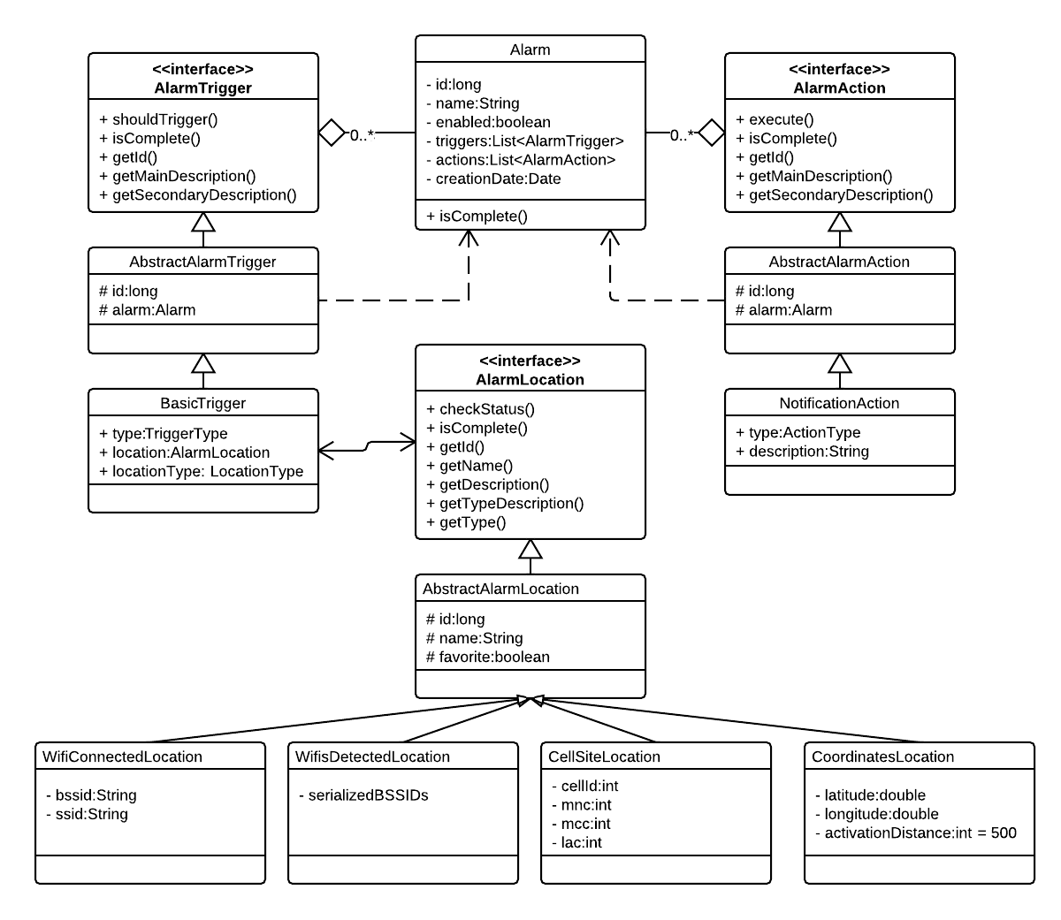

Alarms
In FenceIt, an Alarm corresponds to the Alarm class (com.;;fenceit.Alarm) and stores all the required information about how it should be shown, when it should be triggered and what happens when the alarm is triggered.

The name is added by the user and has the purpose of easing the identification process between alarms. The enabled field marks if the alarm is active and its triggers should be checked for matching conditions. The triggers that implement AlarmTrigger and which need to be checked with context information if they should go off are stored as a list. The actions list stores the actions which are executed (performed) when the alarm is triggered. The creationDate field only has the purpose of storing the exact moment when this alarm was created and is used in various algorithms for sorting the alarms and also for the UI.

Alarms are stored in the database, in the table “alarms”, so the class has an id field and is annotated with @DatabaseClass. All the other fields that should be stored in the database are also, as required, annotated with either @DatabaseField or @ReferenceField. As the triggers and the actions are Lists, they will not be stored in the Database in the ‘alarms’ table, but in their own separate tables and a reference will be kept to the corresponding alarm.

Triggers
In our application, a Trigger is an implementation of the AlarmTrigger (com.fenceit.alarm.triggers.*) interface and is the entity that stores everything that is required to check if an alarm should be triggered, given some contextual information.

To ease the implementations of various types of triggers, an AbstractAlarmTrigger was implemented, which stores the trigger id, the corresponding alarm of this trigger and also implements some methods.

The only implementation for an AlarmTrigger used in FenceIt (in the current version) is the BasicTrigger, which is based on when (e.g. enters, leaves) the alarm should go off. The possible moments when a trigger can be set off are defined in the TriggerType enumeration:

public enum TriggerType {
/** The triggering occurs when entering the Location. */
ON_ENTER,
/** The triggering occurs when exiting the Location. */
ON_EXIT
};

Thus, a BasicTrigger holds a reference to a Location (which will be presented in the following section), in the location field and a type of triggering, in the type field. Besides these, the BasicTrigger also hold a LocationType field (locationType), which is used to distinguish the different types of Locations and optimize the fetching process (more details in the next section). In the shouldTrigger method it checks, using the provided contextual information, if it should be triggered or not.

The BasicTriggers are stored in the database, in the table “triggers”, so the class has an id field and is annotated with @DatabaseClass. All the other fields that should be stored in the database are, as required, annotated with either @DatabaseField or @ReferenceField. As the Location is a custom object (and, as we will see, with multiple implementations), only its reference (the id) is stored in the triggers table, all the other details being stored in separate tables (as we will see in the following section).

Locations
Locations are implementations of the AlarmLocation (com.fenceit.alarm.locations.*) interface and, as presented before, are of four different types. An AlarmLocation object stores all the required data so that, when appropriate contextual data is provided, it can decide whether the device is or is not in that particular Location/Fence.

As mentioned, in FenceIt there are multiple Location types used and all the theoretical aspects regarding them was presented in previous chapters. When talking about implementation, the LocationType enumeration, containing each of the four location types (Wifi Connected Location, Wifis Detected Location, Cell Network Location and Geographical Coordinates Location), was defined:
public enum LocationType {
/** The Geo Coordinates location, based on geographical coordinates. */
GeoCoordinatesLocation(0),
/** A location based on the connected Wifi. */
WifiConnectedLocation(1),
/** A location based on the detected Wifi(s) network(s). */
WifisDetectedLocation(2),
/** A location based on the visible Cell Network Sites and the Cell Site connected to. */
CellNetworkLocation(3);
...
}
To ease the implementations of various types of locations, the AbstractAlarmLocation was implemented, which stores the name of the location, in case it has one, if it is a favorite and should be persisted even after the corresponding trigger is deleted and the id of the location. Besides this, it and also implements some methods.

All the classes that extend the AbstractAlarmLocation (thus implementing AlarmLocation) are stored in the database, in a corresponding table, so the abstract class has an id field and is annotated with @DatabaseClass. Each of the extending classes also is annotated with @DatabaseClass and all the other fields that should be stored in the database are, as required, annotated with @DatabaseField. Regarding the storing of AlarmLocations in the database, as mentioned in the previous sub-section, each BasicTrigger has a reference to the id of the corresponding alarm and a LocationType. The location type is used to identify in which table the AlarmLocation is stored and the reference field is used to identify the particular location in that table. This abstraction allows the BasicTrigger implementation to be completely independent of the AlarmLocation implementations, thus the addition of a new location type is easy. For fetching an AlarmLocation from the database, to fill in a BasicTrigger, the class AlarmLocationBroker is used, which handles the correspondence between the location id and type and the corresponding table and entity in the database.

Now, the paper will go into the implementation details for each of the four Location types, shortly describing what each AlarmLocation stores and how it checks if the device is or is not at the Location.

Wifi Connected Location
This location type is implemented in the WifiConnectedLocation class and corresponds to a Location based on the Wifi Network to which the device is connected. As described in Chapter 3, it is based on the unique BSSID of the connected Wifi Network. Thus, it stores the BSSID of the Wifi to which it was connected when the alarm was defined and the SSID, for a human-readable name for the user. In the database, it is stored in the table “wificonn_locations”.

When the application needs to check whether it is or it’s not at the Location, it compares the stored BSSID to the BSSID provided by the Context Data Provider (now or at the previous query). A diagram depicting the process is presented in <Figure>
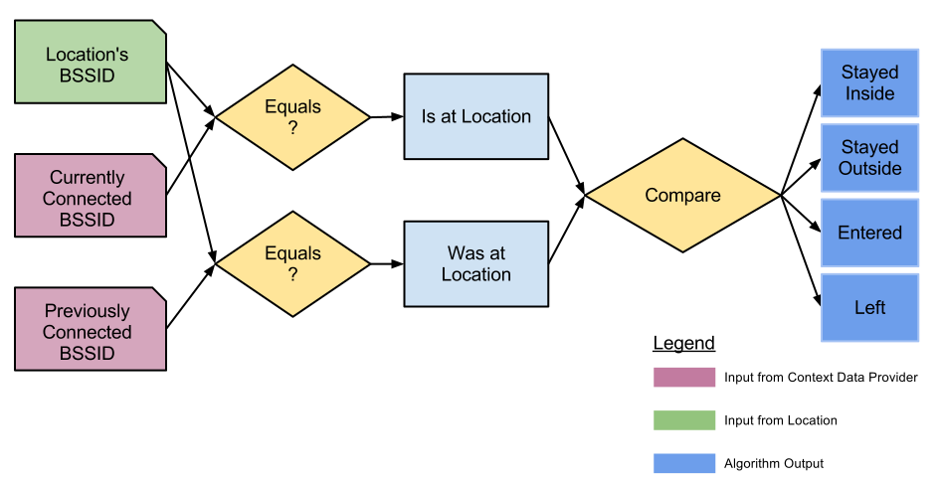

Wifis Detected Location
This location type is implemented in the WifisDetectedLocation class and corresponds to a Location based on the Wifi Networks which are detected by the Wireless interface of the device. As the paper describes in Chapter 3, it relies on the unique BSSID of all the Wifi Networks that can be detected. Thus, it stores the BSSIDs of all the Wifi Networks in range when the alarm was defined. In the database, it is stored in the table “wifisdetec_locations”.

When FenceIt checks whether it is or it’s not at the Location, it compares the stored BSSIDs to the BSSIDs provided by the Context Data Provider (now or at the previous query). In order to accommodate a certain degree of errors, a MATCH_PERCENT constant is used, which defines the percent of the Wifi Networks in the Location that have to match the Wifi Networks provided by the Context Data Provider. A diagram showing the process is presented in <Figure>
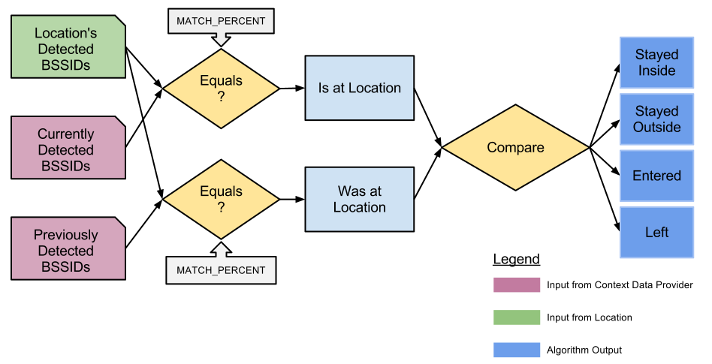

Cell Network Location
This location type is implemented in the CellNetworkLocation class and corresponds to a Location based on the identification details received from the Cellular Network. As it was detailed, it uses four unique values provided by the GSM network: Mobile Country Code, Mobile Network Code, Location Area Code and Cell Id (or three similar ones in the case of CDMA mobile networks). Therefore, it stores these four values as they are obtained when the alarm was defined. In the database, it is stored in the table “cell_locations”.

When the application needs to check whether it is or it’s not at the Location, it compares the stored the four values with the values provided by the Context Data Provider (now or at the previous query). A diagram depicting the process is presented in <Figure>
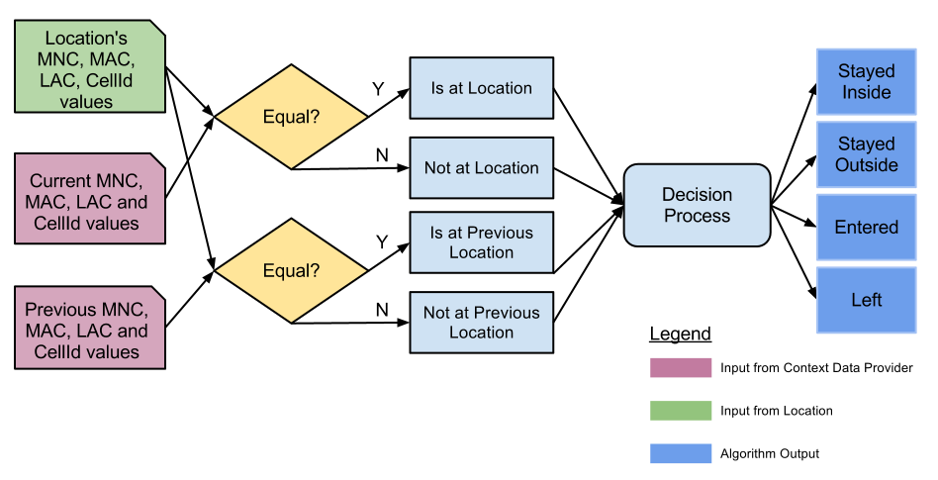

Geographical Coordinates Location
This location type is implemented in the CoordinatesLocation class and corresponds to a Location based on the current geographical position of the device. As described in Chapter 3, it uses the latitude and the longitude obtained from the Android’s LocationManager to position the device within a certain radius of a point. Therefore, it stores both the latitude and the longitude of the definition point and a radius (in meters), which is used to check if the device is or is not within range of that point. In the database, it is stored in the table “coordinates_locations”.

In Fenceit, when it is needed to check whether the device is or is not at the Location, it computes the distance between the stored geographical point and the one provided by the Context Data Provider (now or at the previous query). A diagram depicting the process is presented in <Figure>

Actions
In FenceIt, an Action is an implementation of the AlarmAction (com.fenceit.alarm.actions.*) interface and is the entity that stores all the details that are required to execute an already set of operations, when an Alarm is triggered. Each alarm can have multiple Actions, each of them being executed when the alarm is set off because of one of its triggers.

To ease the implementations of various types of actions, an AbstractAlarmAction was implemented, which stores the action’s id, the corresponding alarm and also implements some methods.

As the actions are out of the scope of this paper, the only implementation for an AlarmAction used in the current version of FenceIt is the NotificationAction, which, when executed, shows a new Activity to the user with a pre-set message (stored in the description field) and notifies the user with a specific sound.

All the classes that extend the AbstractAlarmAction (hence implementing AlarmAction) are stored in the database, in a corresponding table, so the abstract class has an id field and is annotated with @DatabaseClass. Each of the extending classes also is annotated with @DatabaseClass and all the other fields that should be stored in the database are, as required, annotated with @DatabaseField or @ReferenceField.

Context Data Providers
As mentioned in Chapter 4, an important component of FenceIt is the one that handles gathering of contextual information from the surrounding environment, with the purpose of checking if any of the Alarms (more precisely any of the triggers) should be set off or not. The component that handles this in FenceIt is built of Context Data Providers which are implemented in the classes of the com.fenceit.providers package.

One of the most important characteristic of these Context Data Providers is that they have to gather the required data as quickly as possible and with a minimum battery consumption, as they will be used extensively by both the Application Interface (UI) and the Background Service which is constantly analyzing whether any of the alarms should be triggered.

To get into the details of how Context Data Providers work, we’ll use the diagram in <Figure>, which depicts the general process of gathering data.
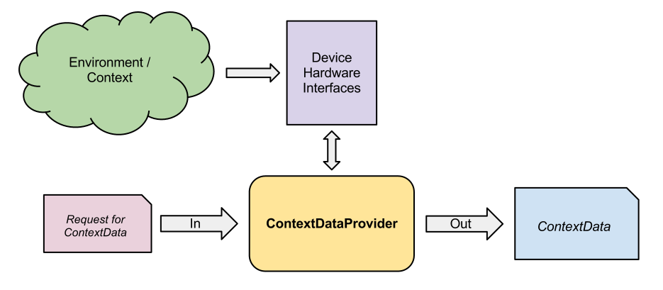
As it can be noticed from the diagram, the process of gathering Contextual Data from the surrounding environment starts with a request to the ContextDataProvider for information regarding the current environment (i.e. a method call). Then, the Provider queries the device Hardware and the Android OS for the necessary information from the environment. When the Interfaces/OS reply, a ContextData object is returned, which is then used by the application. In most cases, it is given to the BasicTriggers and the AlarmLocation implementations which use it to check if the device is or is not currently at some Locations. The ContextData is, in FenceIt, an interface which is implemented by the classes that want to store contextual data.

In FenceIt, there are three Context Data Providers, namely WifiDataProvider, CoordinatesDataProvider and CellDataProvider and four Context Data implementations, concretely WifiConnectedContextData, WifisDetectedContextData, CoordinatesContextData, CellContextData.

Wifi Context Data Provider
The WifiDataProvider is used for gathering contextual information using the Wireless Interface, and is used for getting data regarding both the Connected Wifi (a WifiConnectedContextData is returned) and the Detected Wifis (a WifisDetectedContextData is returned). The Android Manager that is used is the WifiManager.

In the case of detected Wifi networks, the newest Wifi Scan Results are only available after a Wifi Scan is completed. Thus, in order to get the most accurate results, for a proper use of the provider, a startScan() must be issued before the contextual data is actually requested. After the startScan() method is used, the Android OS starts a scan and, when the results are available, a WifiManager.SCAN_RESULTS_AVAILABLE_ACTION broadcast intent is sent in the system. In order to catch and process such an intent, a BroadcastReceiver can be registered, which could be used to query the Context Data Provider for the results, using getWifisDetectedContextData(). An example of such a receiver is:
private class WifiScanReceiver extends BroadcastReceiver {
@Override
public void onReceive(Context context, Intent intent) {
log.info("Wifi Scan Finished Broadcast received.");
ContextData c=WifiDataProvider.getWifisDetectedContextData();
//use c ...
}
}
A method to dynamically register such a Broadcast Receiver (for example in the UI), is by using intent filters:
BroadcastReceiver receiver = new WifiScanReceiver();
IntentFilter filter = new IntentFilter();
filter.addAction(WifiManager.SCAN_RESULTS_AVAILABLE_ACTION);
registerReceiver(receiver, filter);
As another solution, this registration could also be done at compile time, using the Android Manifest.

Cell Network Data Provider
The CellDataProvider is the Context Data Provider that is used for gathering information from the environment regarding the Cell Network and the Cell Site to which the device is currently connected to. In order to do this, it uses the Android TelephonyManager, and, depending on the PhoneType (GSM or CDMA), uses either GsmCellLocation or CdmaCellLocation. Using the information from these, it fills in a CellContextData object that is returned to the provider caller.

Geographical Coordinates Data Provider
The Context Data Provider handling the geographical coordinates is the CoordinatesDataProvider. As it uses Android’s Location Manager, which is asynchronous, using this provider is also done in an asynchronous mode. For this, This provider is using the concept of listeners/observers and the CoordinatesLocationDataListener interface is used:
public interface CoordinatesLocationDataListener {
public void onLocationUpdate(Location location);
}
The components that require data gathered from the environment have to first register themselves as a listener to the provider, using:
public void addCoordinatesLocationDataListener(CoordinatesLocationDataListener listener, Context context)

When the first listener is added, the provider automatically starts listening for location updates and as soon as it receives a good location, is notifies all the listeners using the onLocationUpdate() method. When the component that started listening is no longer interested in location updates, it has to remove itself, using:
public void removeCoordinatesLocationDataListener(CoordinatesLocationDataListener listener)

To provide an accurate response to queries, the provider is using all the available Android Location Providers (if possible, both the GPS_PROVIDER and the NETWORK_PROVIDER), with dynamic values between updates for each of them. To provide the best possible solution the CoordinatesDataProvider stores the best Location found so far and, when a new Location is provided by the Android system, it compares it with the existing one, storing the more accurate one. The code for comparing two Locations can be found in <Annex>. At any request for Context Data, a CoordinatesContextData object is built using the most accurate Location found so far, if any was found at all.

Application Interface
The application interface of FenceIt was developed in a consistent way, while trying to be as intuitive and as easy-to use as possible. In this way, an inexperienced user, who is encountering the application for the first time, should have no problem in easily and quickly learning to use it.

A diagram showing all the available activities and the interactions between them can be seen in <Figure>. The diagram also shows, besides the Activities (shown in blue), the Context Data Providers (in violet), the Brokers for LocationType and ActionType (in green), the Broadcast Receivers implemented for UI (in yellow) and the Notification activity shown when a Notification action is triggered (in red).

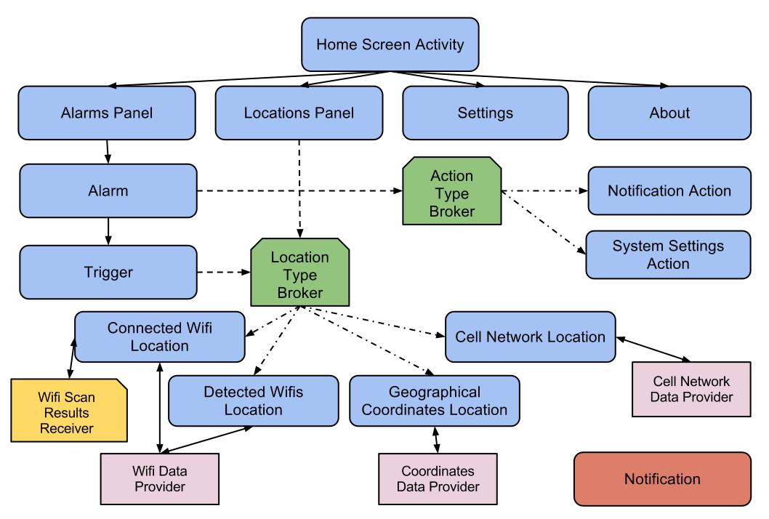

Conclusions
In this paper we have discussed the main considerations that have to be taken into account when trying to locate a mobile device in a particular area. We have shown that using only the geographical position is not always the right solution for a mobile location-based application and that there are more methods which can be used to place a device in an area, namely using the connected Wifi, the Wifi networks in range or using the connection to the current Cell Tower. Using any of the four methods has advantages and disadvantages and each one should be used when it is most appropriate. Besides this, other contextual information, such as distance to target or inactivity period, can be used by the algorithms to improve the battery consumption and data connection usage.

Moreover, we described the architecture of FenceIt, an Android application that allows users to create reminders and define actions to be shown/ executed when the device is enters, leaves or is in a given Location. The application will be further developed and will allow us to make a complete and accurate study of the methods that can be used to effectively determine if a mobile device is or is not at a given location.

References
- Dey, A. and Abowd, G., 2000. CybreMinder: A Context-Aware System for Supporting Reminders

- LaMarca, A. et al., 2005. Place lab: Device positioning using radio beacons in the wild.

- Marmasse, N. and Schmandt, C., 2003. Location-Aware Information Delivery with ComMotion

- Barbeau, S. J. et al., 2008. Dynamic Management of Real-Time Location Data on GPS-enabled Mobile Phones.

- Gasinski, D., 2009. Location-Based Services inom undervisningen på Broängsskolan

- Sohn et al., 2005. Place-Its: A Study of Location-Based Reminders on Mobile Phones

- Ludford, J. et al., 2006. Because I carry my cell phone anyway: functional location-based reminder applications

- Meeuwissen, E. et al., 2007. Inferring and Predicting Context of Mobile Users

- Hedin, B. and Noren, J., 2009. Mobile Location-Based Learning Reminders using GSM Cell Identification

- iOS5, Location Reminders, Apple Inc. http://www.apple.com/ios/features.html

- ePythia To Do List, ePythia Corporation. http://www.epythia.com

- Spoty Location Reminder, Incorporate Apps. http://www.incorporateapps.com/

- Sohn T. et al, 2006. Mobility Detection Using Everyday GSM Traces

- Melville A., 2004. IEEE P802.11 Wireless LANs. Virtual Access Point Definition.

- Millete. G and Stroud A., 2010. Professional Android Sensor Programming

18. IEEE 802.11: Wireless LAN Medium Access Control (MAC) and Physical Layer (PHY) Specifications
19. J. E. Flood. Telecommunication Networks. Institution of Electrical Engineers, London, UK, 1997. chapter 12.
20. Dot Com Infoway - Position Paper. 2012. A study on present and future of Google's Android.
21. S. Komatineni, D. MacLean, 2011. Pro Android 4.
22. http://logging.apache.org/log4j/1.2/index.html
23. http://code.google.com/p/android-logging-log4j/
24. http://code.google.com/p/andro-wrapee/

