DOCUMENTATION

ASSIGNMENT 1

STUDENT NAME: Tianu Cosmin-Nicolae
GROUP: 30425

CONTENTS

1. Assignment Objective 3
2. Problem Analysis, Modeling, Scenarios, Use Cases 3
3. Design 3
4. Implementation 3
5. Results 3
6. Conclusions 3
7. Bibliography 3

Assignment Objective
The main objective of the first assignment is to design and implement a polynomial calculator using Java, with a dedicated graphical interface through which the user can insert polynomials, select mathematical operations and view the result. This involves the following sub-objectives:

- Analyze the problem and identify requirements.
- Design the polynomial calculator.
- Implement the polynomials calculator.
- Test the polynomial calculator.

Problem Analysis, Modeling, Scenarios, Use Cases
The polynomial calculator has the following functional requirements. It should allow the user to insert the needed polynomials for the wanted operation. Also, the user should be able to select what operation he wants to do out of the following: addition, subtraction, multiplying, division of 2 polynomials and the derivative and integration of 1 polynomial. Finally, the calculator should correctly display the result.

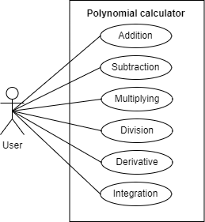

Figure 1: Use case diagram
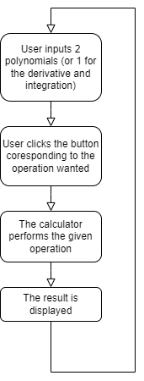
Figure 2: Flow-chart of use case descriptors

As for the non-functional requirements the polynomial calculator should be easy and intuitive to use by the user.

Design
The polynomial calculator’s structure follows a MVC structure. The model of the polynomial calculator would represent the core functionality and data handling, therefore here are present the Operations and Polynomial classes. The view handles the presentation of the user interface, it also contains graphical elements such as buttons, text fields, etc. Additionally, it incorporates logic for sending the user input to the controller and setting the result. The controller acts as the intermediary between the model and view, it takes the given input from the view, processes it does the operation given also by the view using the polynomial and operations classes from the model. Its job is to coordinate user input, trigger events and update the view along the way.

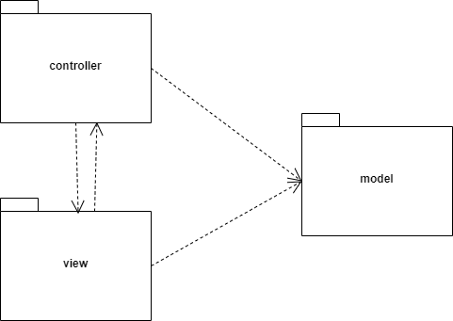
Figure 3: UML package diagram

Implementation

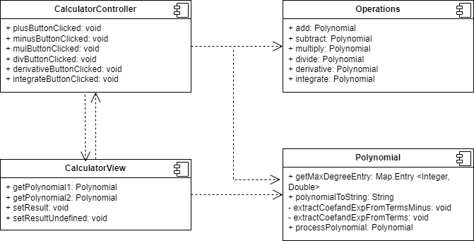
Figure 4: UML class diagram

The Polynomial has a single field, the TreeMap which represents the terms of the polynomial. Besides the classic getters, setters and constructors it has also a method to get the highest degree entry, a method to convert the polynomial correctly to a string for displaying the result and the process method to create the polynomials from a string give by the user as input. This last method uses regex to get the term separated by the plus sign then further separates them by the minus sign if needed, as we now have the terms of the form ax^b, only one more separation is needed by the “x^” to get the exponents and coefficients.

The essence of the polynomial class is its implementation using a TreeMap which sorts the terms of the polynomial by its exponent in descending order. This way no further sorting is needed and it is easier and more intuitive to implement the operations, especially the division because the highest power term is needed at each point of the polynomial division.

The Operations contains all the mathematical operations using the Polynomial class. Here it is the code for the division method that turned out to be the most complex.
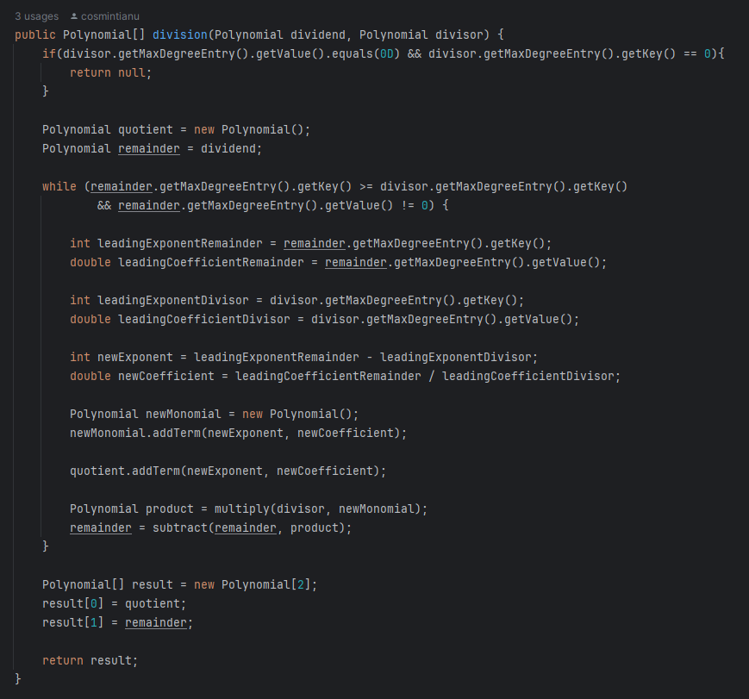
Figure 5: Division implementation.

For the CalculatorView class it is important to note that it contains all the GUI elements, it is divided in 3 panels for a cleaner organization. Also, it has method for sending the input polynomials after calling the method for processing them and setting the result after conversion of the polynomial to String.
.
Figure 6: Panel 1
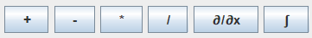

Figure 7: Panel 2

Figure 8: Panel 3
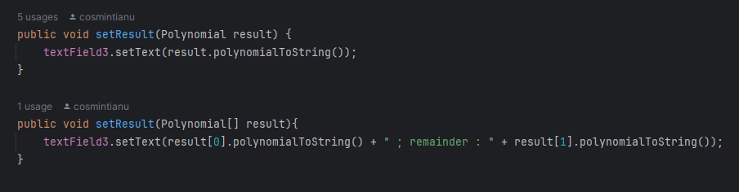
Figure 9: Set Result method
In the above picture we can see the overloading the implementation for the setResult method, used for the division.
Also, it is trivial to underline how the actions are performed, by adding an action listener on each button and in case of pressing a method from the controller is called.

The Calculator controller contains methods that take the polynomial from the view, uses the operations from the Operation class, this is possible with the help of the Polynomial class.
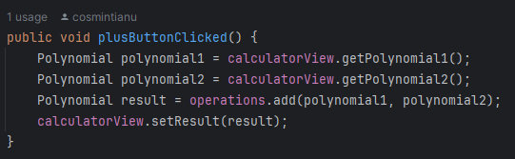
Figure 10: Controller example method

And as for the Main class, it puts everything together, declaring a new instance for the Operation, CalculatorView and CalculatorController.

Results
The results of the Polynomial Calculator have been achieved and it working accordingly, backed up even with the testing made with Junit.
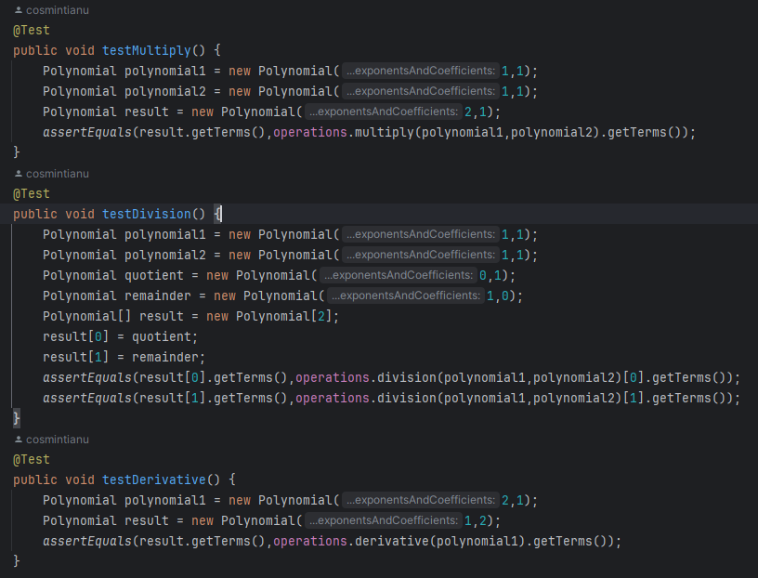
Figure 11: Junit testing sample

In the figure above we can see the multiplying x and x we get x^2, while dividing them we get the quotient 1 and 0 as the remainder. The tests successfully passed.

Conclusions
In conclusion the polynomial calculator is a very good tool to have at your disposal, but also creating it was a process that I enjoyed. Personally, I learned to use the TreeMap, to better use regex and provided me with coding experience and a new project under in my portfolio.
For further developments, the GUI could use a make over but its functionality it is important.

Bibliography
- https://dsrl.eu/courses/pt/materials/PT2024_A1.pdf
- https://dsrl.eu/courses/pt/materials/PT_2024_A1_S1.pdf
- https://dsrl.eu/courses/pt/materials/PT_2024_A1_S2.pdf
- https://dsrl.eu/courses/pt/materials/PT_2024_A1_S3.pdf

