DOCUMENTATION

ASSIGNMENT 2

STUDENT NAME: Tianu Cosmin-Nicolae
GROUP: 30425

CONTENTS

1. Assignment Objective 3
2. Problem Analysis, Modeling, Scenarios, Use Cases 3
3. Design 3
4. Implementation 3
5. Conclusions 3
6. Bibliography 3

Assignment Objective
Design and implement an application aiming to analyze queuing-based systems by (1) simulating a series of N clients arriving for service, entering Q queues, waiting, being served and finally leaving the queues, and (2) computing the average waiting time, average service time and peak hour.
- Analyze the problem and identify requirements.
- Design the simulation application.
- Implement the simulation application.
- Test the simulation application.

Problem Analysis, Modeling, Scenarios, Use Cases
The queue management application has the following functional requirements. It should enable the user to start the simulation, and closely observe the evolution of the simulation. Also, the user has the ability to set the simulation parameters, such as the number of clients (N) and of queues (Q), the maximum simulation time and the bounds of the client parameters: arrival time and service time, through the application. Moreover, at the end of the simulation the app should inform the user about the average waiting time, average service time and the peak hour of the simulation. Finally, all the app needs to log all the simulation information in a .txt file.
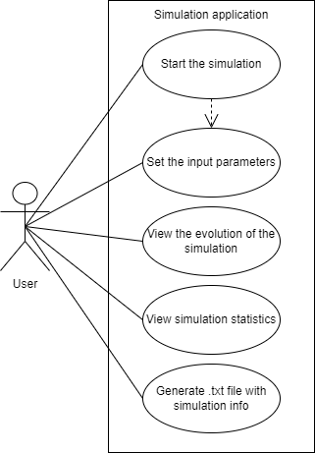
Figure 1: Use case diagram.

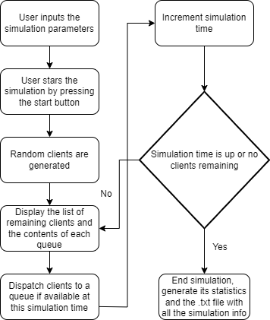

Figure 2: Flow-chart of the application.

As for the non-functional requirements the queue management app should be easy and intuitive to use by the user.

Design
The queue management app’s structure follows a MVC structure. The model of the app would represent the core functionality and data handling, therefore here are present the Task and Server classes and also, the SelectionPolicy enumeration. The Server class represents one queue that are usually found in supermarkets or every other store, the Task class symbolizes a person that wants to purchase anything from that store and needs to pay, while the SelectionPolicy is just an enumeration that contains the strategy that the app could use .The view handles the presentation of the user interface, it also contains graphical elements such as buttons and text fields. Additionally, it has only one class: SimulationFrame that incorporates logic for sending the user input to the controller and updating the GUI with the simulation info at each time of the simulation. The controller acts as the intermediary between the model and view, it takes the given input from the view, processes it, sends each task to the appropriate time using the SimulationManager, and to the appropriate server through the Scheduler using one of the possible Strategies. Its job is to coordinate user input, trigger events and update the view along the way.
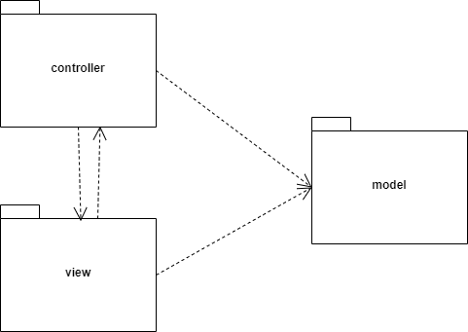
Figure 3: UML package diagram

Implementation
Starting with model package it contains the Task class, as already mentioned it represents a person. Therefore, each person has an id, an arrival time ( the time the person is ready for check out ) and the service time ( the time necessary for the person to finish the paying process ). An important thing to mention is the overriding of the toString method for an easier understanding of the output or debugging.

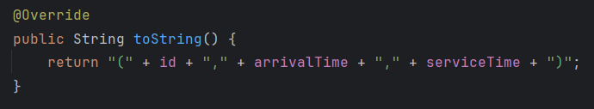
Figure 9: toString method

As for the Server class, it represents a queue where a task can be processed and works on a separate thread, thus implementing the Runnable interface. Since the main and gui updating thread can access the contents of the server class at the same time, the tasks field which represents the current tasks in the queue is of type BlockingQueue and the waiting period is of type AtomicInteger, these types are known and were created to support multi-threading in a safe way. Moreover, the same applies to the field running which is an AtomicBoolean which is used as the stop condition for the servers’ threads. Finally, the totalWaitingTime field stores the amount of time that each task has spent in the queue until its time to be processed started, using the currentTime ( which is passed down from the main thread in the SimulationManager, through the Scheduler ) and the task’s arrival time.
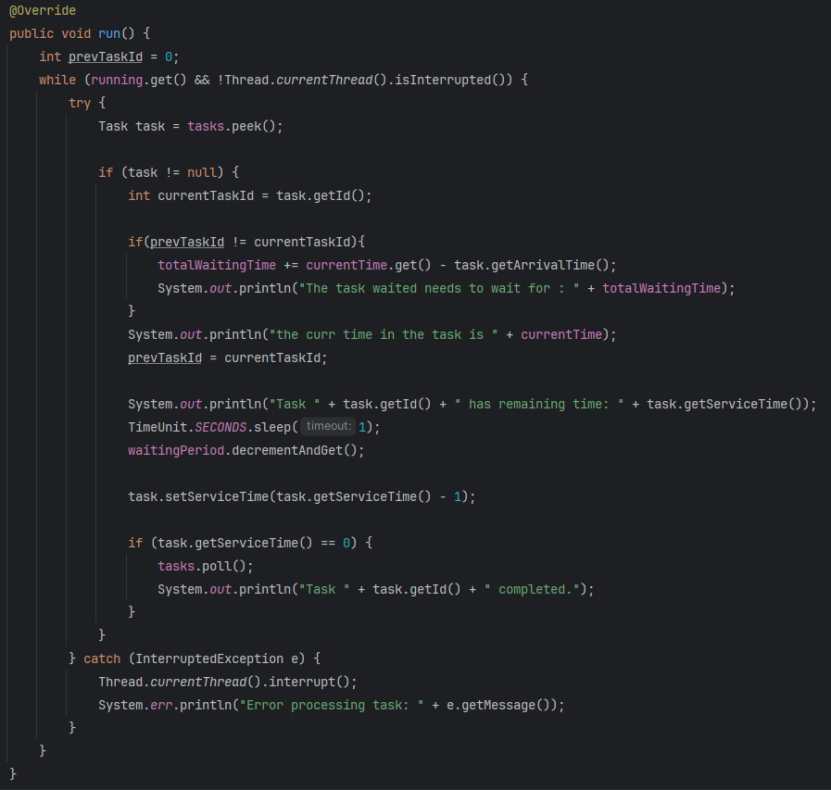
Figure 4: run method of the Server Class

The picture above shows the run method of the Server class that checks if there is any task in the queue, if there is it sleeps for 1 second to sync with the main thread, updates the time of the current task to match the new time. Also, if the time of a task is up, it is eliminated from the list of tasks of the server and if a new task arrives at the front of the queue if calcultes the time it has waited in the queue until then.

Finally, the last class of the model package is the SelectionPolicy enum which stores the available strategies of the queue management app.
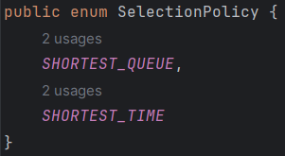
Figure 4: SelectionPolicy enum

The view package has only one class, the simulationFrame class which extends Jframe and it represent the GUI thus, using Swing the user can communicate with the logic of the application.
This JFrame consists of the input panel that has JLabels and JTextFields that allows the user to input the following: the maximum simulation time, the number of servers, the number of tasks, the minimum and maximum time that a task can arrive at, the minimum and maximum time that a task can be processed in and also a JComboBox that enables the user to switch between the queue management strategies. Also, it contains a JButton that has the scope to start the simulation, thus sending the data from the GUI to the SimulationManager through an ActionListener. Finally, the important methods here are: updateSimulationInfo which is called at every time of the simulation in the main thread and appends the current time information to the past simulation information, appendStats that is called at the end of the simulation to append the statistics and writeContentsToFile which has the role to take everything that has been output ( the whole simulation information and it’s statistics ) and write them intro a .txt file.

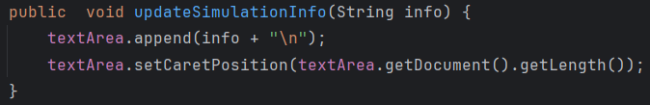
Figure 4: updateSimulationInfo method

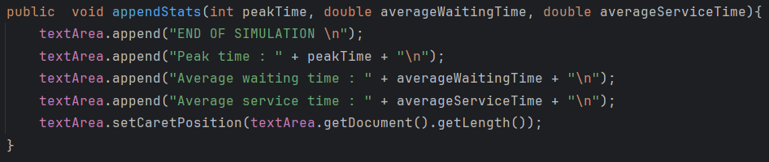
Figure 4: appendStats method
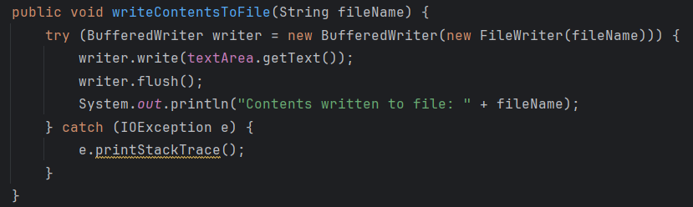
Figure 4: writeContentsToFile method

As for the controller package, it contains the core functionality of the queue management app. This functionality resides in the SimulationManager class. In this class also resides the main method but it just creates an object of type SimulationManager. This class implements besides Runnable also the SimulationManagerListener interface that has just one method: startSimulation, its implementation sets the user’s input as the simulation parameters, it creates a scheduler object, generates the random tasks, computes the average service time and starts the main, all the server and the GUI threads.

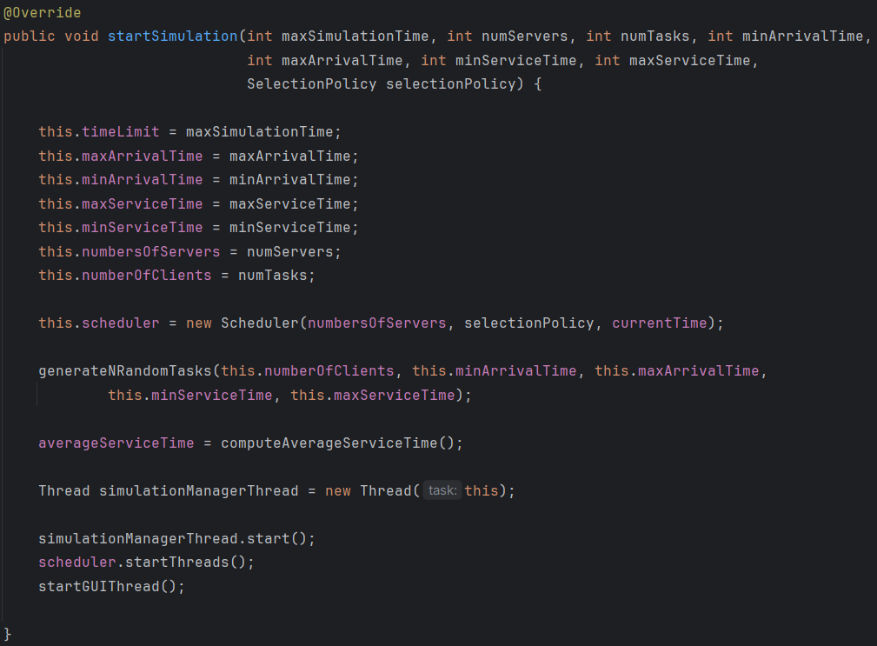
Figure 4: startSimulation method
The main thread only sleeps for 1 seconds and increments the current time, simulating a real time queue. It also sends any available tasks at the current time to a server according to the selected startetgy, computes the peak time by checking the number of tasks at each time and exits the simulation if the time is up or if there are no more tasks coming up or being processed. After the simulation is over the statistics are added to the GUI, the simulation info is written in the .txt file and the gui and sever threads are stopped.

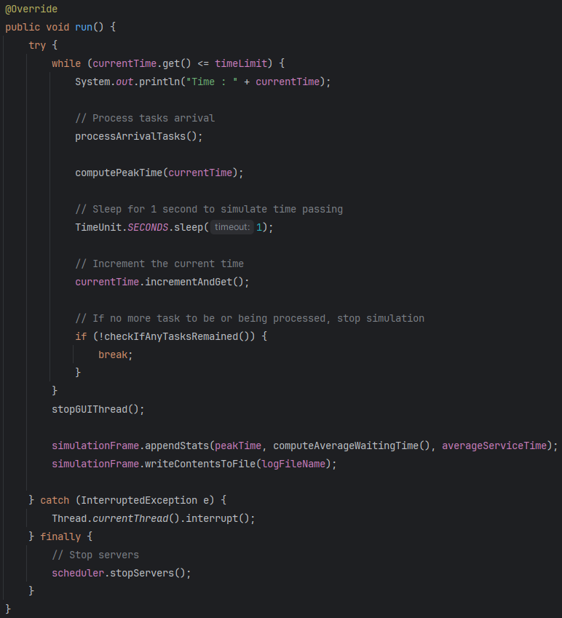

Figure 4: run method of the SimulationManager class

The statistics are calculted using their own methods :
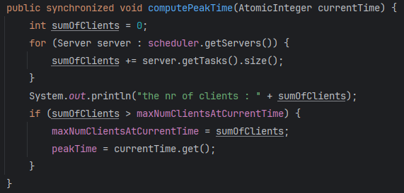
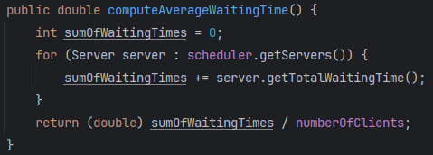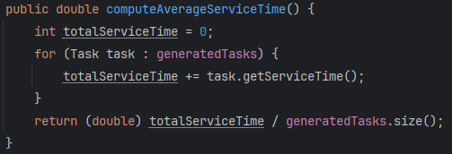

Figure 4: statistics methods

The last thing to be noted about this class is the way the GUI thread works. Basically it uses the updateGUI then waits for 1 second to be in sync with the main thread until it is stopped using a flag guiThreadRunning.

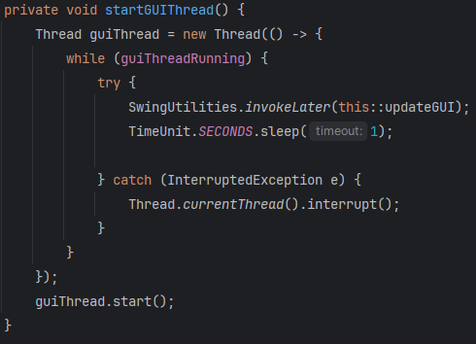
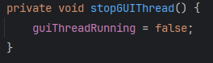
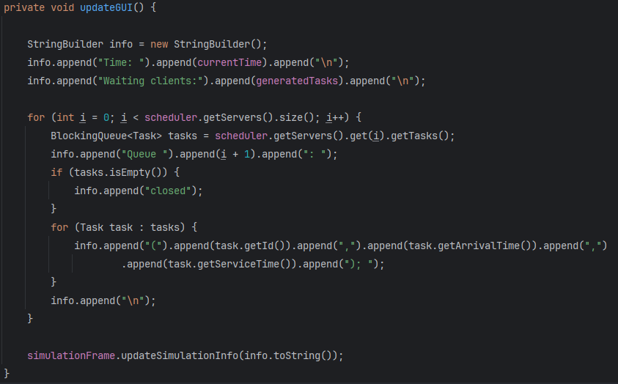

Figure 4: GUI Thread operation methods
The second most significant class of this package is the Scheduler. In this class the strategy is set and the tasks are dispacthed also here according to it. More importantly, in its constructor the Server objects and their Threads are created and added to a list for ease of use.

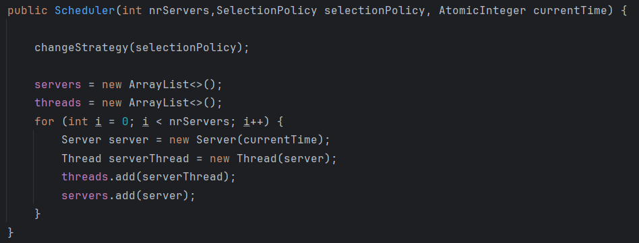

Figure 4: GUI Thread operation methods

The rest of the controller package consists of the 2 strategies: ShortestQueueStrategy and ShortestTimeStrategy classes that both implement the Strategy interface.

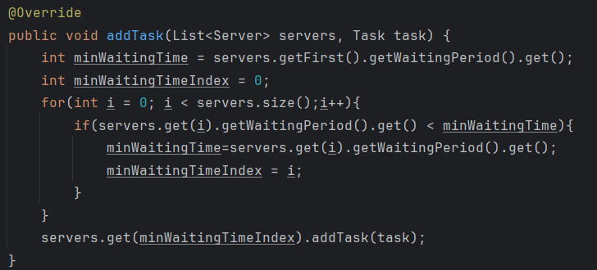

Figure 4: ShortestTimeStrategy addTask method
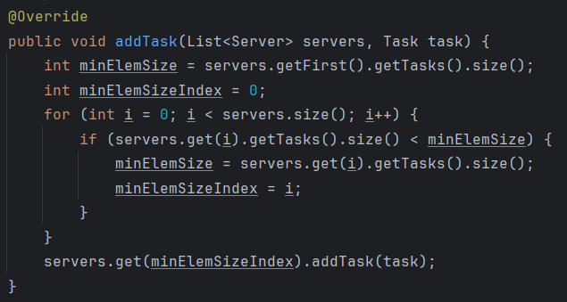

Figure 4: ShortestQueueStrategy addTask method

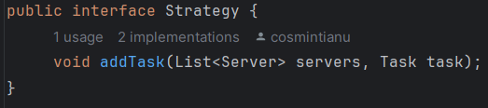

Figure 4: Strategy interface

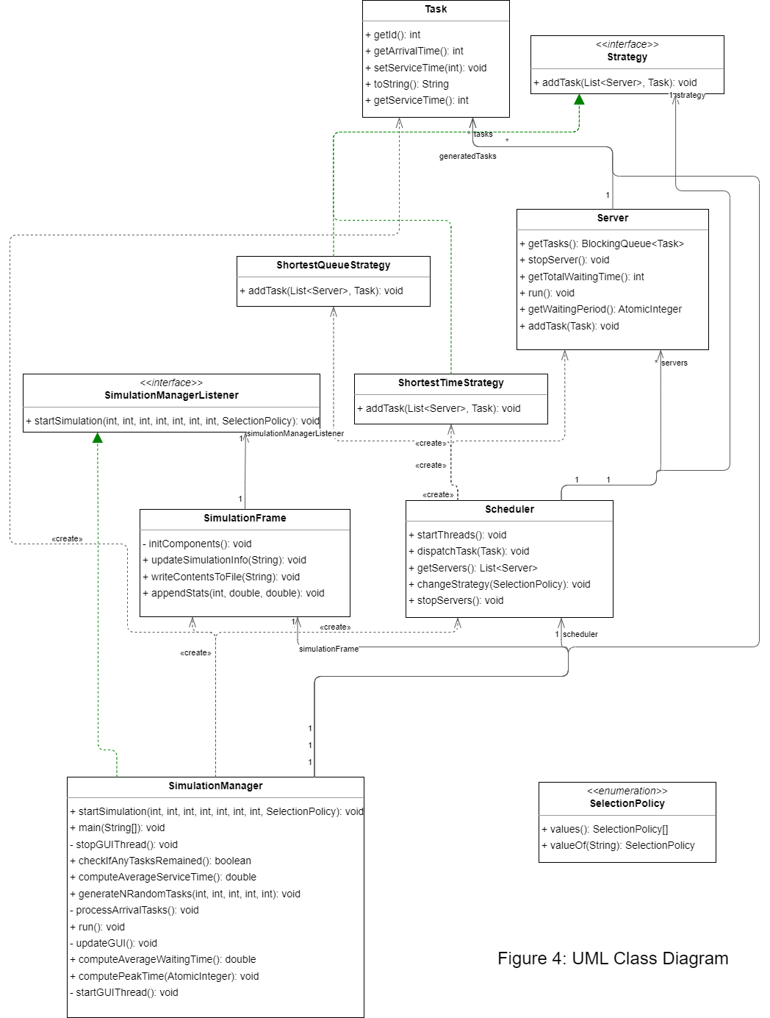

Conclusions
In conclusion, a queue management system exists at almost supermarket we go to and it is interesting to know how one works. Personally, I learned to use Threads, to create a multi-thread environment, synchronize them and use them in the most efficient way, also this opportunity provided me with extra coding experience and a new project in my portfolio.

For further developments, the GUI could use a make over.

Bibliography
- https://dsrl.eu/courses/pt/materials/PT2024_A2.pdf
- https://dsrl.eu/courses/pt/materials/PT_2024_A2_S1.pdf
- https://dsrl.eu/courses/pt/materials/PT_2024_A2_S2.pdf
- https://www.geeksforgeeks.org/multithreading-in-java/
- https://www.geeksforgeeks.org/synchronization-in-java/

