DOCUMENTATION

ASSIGNMENT 3

STUDENT NAME: Tianu Cosmin-Nicolae
GROUP: 30425

CONTENTS

1. Assignment Objective 3
2. Problem Analysis, Modeling, Scenarios, Use Cases 3
3. Design 4
4. Implementation 5
5. Conclusions 15
6. Bibliography 15

Assignment Objective
Design and implement an application for managing the client orders for a warehouse.

- Analyze the problem and identify requirements.
- Design the the orders management application.
- Implement the orders management application.
- Test the orders management application.

Problem Analysis, Modeling, Scenarios, Use Cases
The warehouse management application has the following functional requirements. It should enable the user to manage client orders efficiently by providing functionality for viewing, adding, updating, and removing clients, as well as generating bills for their orders. Additionally, the application should allow the user to view the current inventory, add or remove products, and update product details. The user can also view the orders and bills generated.
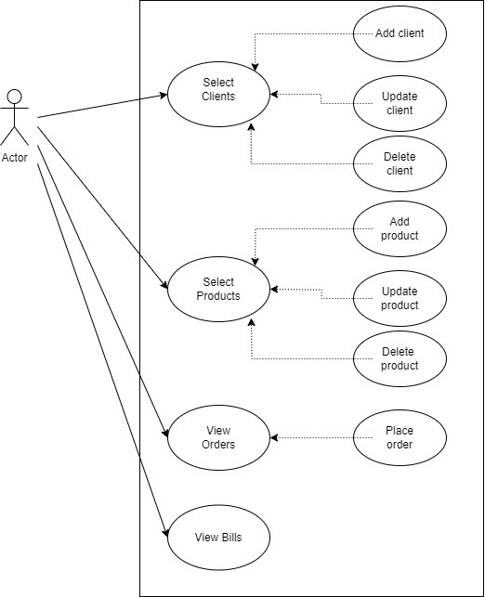
Figure 1: Use case diagram.
As for the non-functional requirements, the order management app of an warehouse should be easy and intuitive to use by the user.

Design
The warehouse management application follows a 4-layer architecture, consisting of the following layers:
Data Access Layer (DAO): Responsible for handling data persistence and database operations. Uses DAO design pattern to abstract the interaction with the database. Utilizes DAO classes to perform CRUD (Create, Read, Update, Delete) operations on entities.
Model Layer: Represents the domain model or business entities of the application. Consists of classes representing clients, products, orders, bills. Contains business logic methods specific to each entity and their own constructors, getters and setters.
Business Logic Layer (BLL): Acts as an intermediary between the data access layer and the presentation layer. Implements business logic and rules governing the interactions between different entities. Ensures data integrity, consistency, and validation before data is persisted in the database.
Presentation Layer: Handles the user interface and interaction with the end-user. Utilizes Swing library to create graphical user interface (GUI) elements such as buttons, tables, and frames. Responds to user inputs, triggers appropriate actions, and updates the view based on changes in the model.
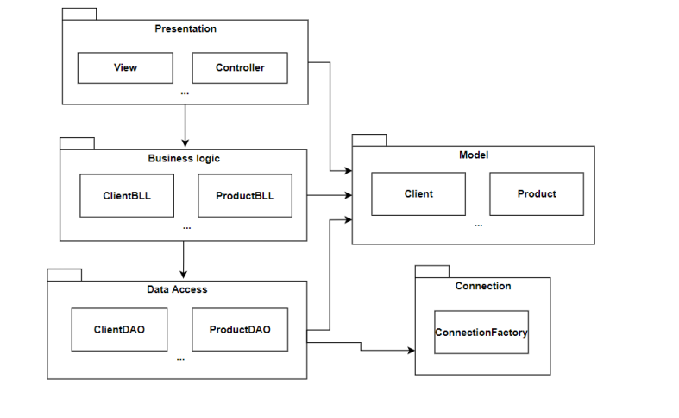 Figure 2: UML package diagram
The architecture promotes separation of concerns and modularity, allowing each layer to focus on its specific responsibilities. This design facilitates easier maintenance, testing, and scalability of the warehouse management application.

Implementation
The ConnectionFactory class provides methods for establishing, managing, and closing database connections in a Java application. Let's discuss the responsibilities and functionality of this class:
- Establishes database connections using JDBC (Java Database Connectivity).
- Provides methods to create, retrieve, and close database connections, SQL statements, and result sets.
- Handles exceptions related to database connection and resource management.
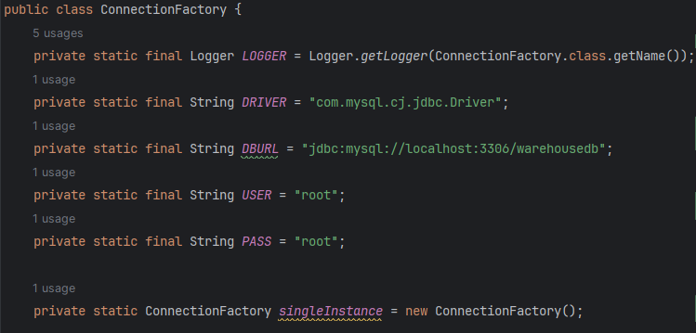
Figure 3: Connection details

Functionality:
- createConnection(): Private method responsible for creating a new database connection using the JDBC driver, URL, username, and password specified in the class constants.
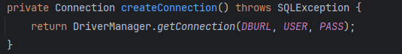
Figure 4: method example

- getConnection(): Public static method that clients can call to retrieve a database connection. It delegates the creation of the connection to the private createConnection() method
- 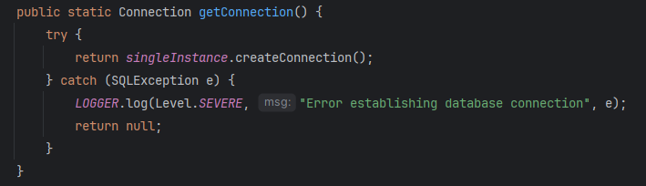
- close(Connection connection): Public static method for closing a database connection. It handles any SQLException that may occur during the closing process.
- close(Statement statement): Public static method for closing a SQL statement. It ensures that the statement is properly closed and handles any SQLException that may occur. 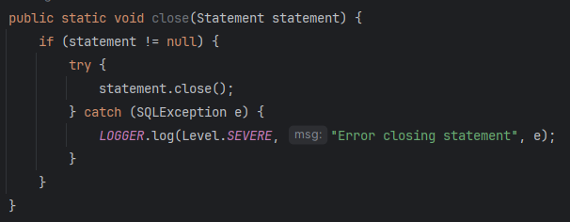
Figure 5: method example

- close(ResultSet resultSet): Public static method for closing a ResultSet. It ensures that the result set is properly closed and handles any SQLException that may occur.
Additional Information:
- The class follows the Singleton design pattern, ensuring that only one instance of ConnectionFactory is created.

In the DAO (Data Access Object) layer, the AbstractDao class serves as a foundational class providing common methods and functionality for interacting with the database. Let's discuss its role and how other DAO classes extend it:
AbstractDao Class:
  - Abstracts away common database operations such as CRUD (Create, Read, Update, Delete) operations.
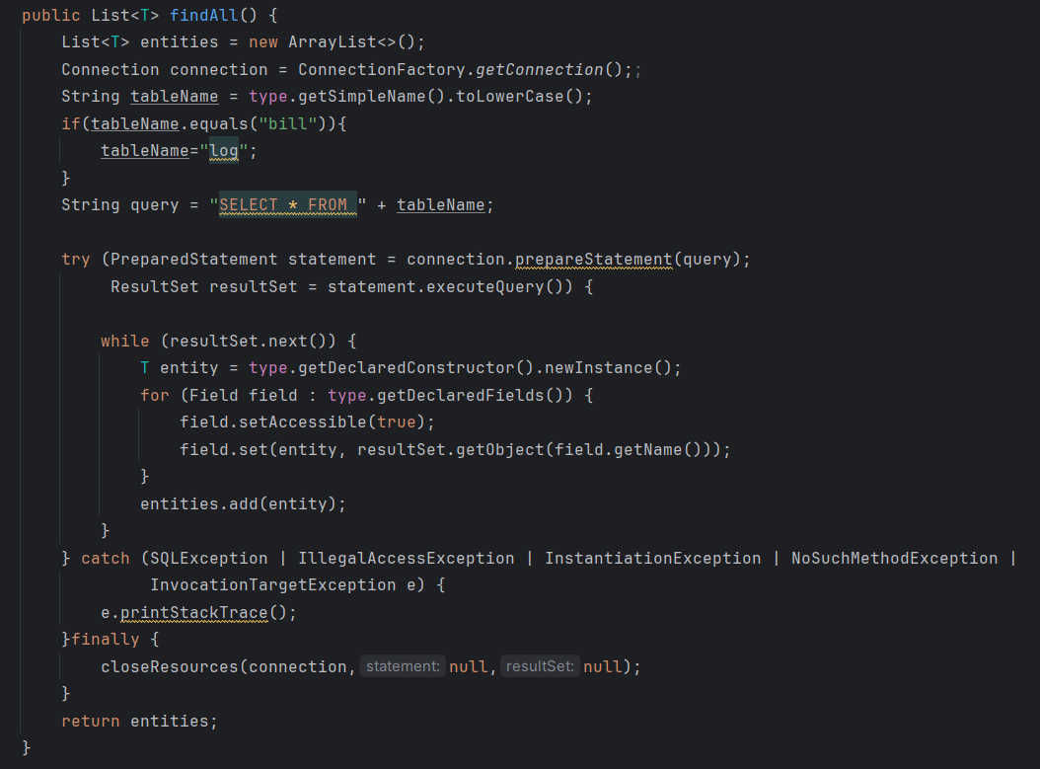
Figure 6: method example

  - Provides methods for executing SQL queries and handling database connections.
  - Encapsulates the interaction with database entities and shields clients from low-level database details.

  - Majority DAO classes in the application extend the AbstractDao class to inherit its common functionality and structure.

  - By extending AbstractDao, specific DAO classes can focus on implementing entity-specific logic and custom queries without duplicating boilerplate code for database interaction.

  - Only the bill DAO class overrides abstract methods defined in AbstractDao to provide entity-specific implementations such as reading it from database, it’s model being a record.
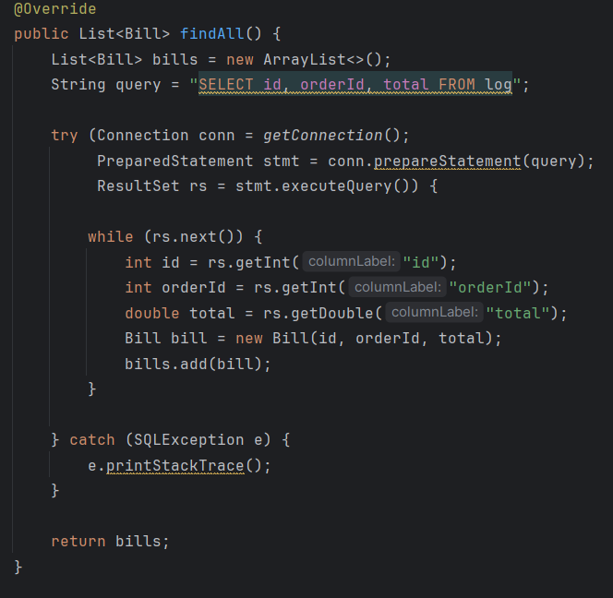
Figure 7: method example

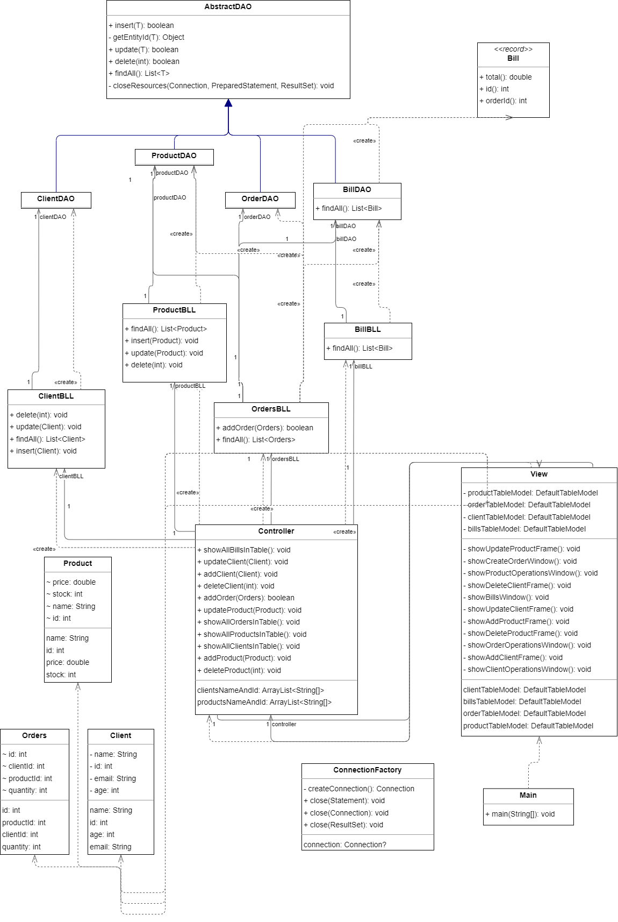
Figure 8: Use case diagram.

In the model layer, the Bill class represents a record of a bill in the system. It encapsulates information about a bill, such as its ID, client ID, total amount, and date.
The model classes serve as plain Java objects (POJOs) that hold data and provide getters and setters to access and manipulate that data. In this context, the Bill class acts as a data structure to organize bill-related information.
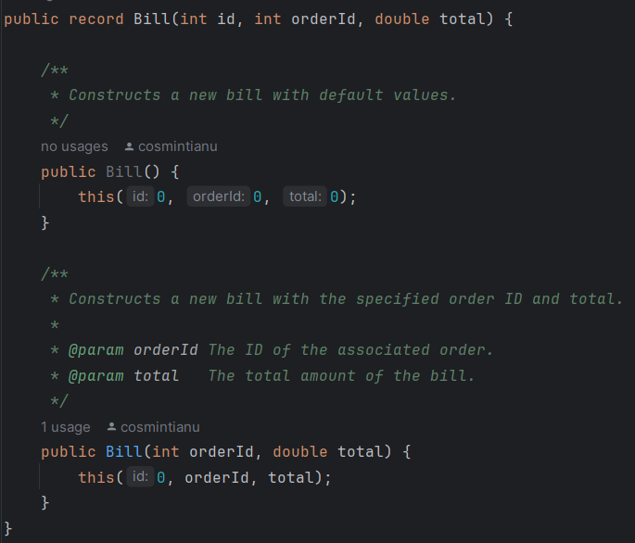
Figure 9: method example

The presentation layer has the Controller class in the presentation layer acts as the bridge between the graphical user interface (GUI) and the business logic layer. It manages user interactions, coordinating actions between the view and business logic, and updating the GUI components accordingly.
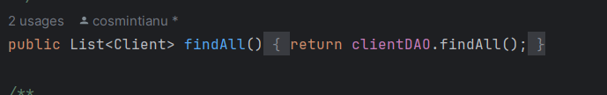
Figure 10: method example
For client operations, methods like showAllClientsInTable(), addClient(), updateClient(), and deleteClient() handle fetching, adding, updating, and deleting clients in the database using the BLL layer, which has not a lot of functionality just check if there is available stock. These methods ensure the client table in the GUI is updated with the latest data using reflection.
Similarly, showAllProductsInTable(), addProduct(), updateProduct(), and deleteProduct() manage product-related operations, updating the product table in the GUI with data retrieved from ProductBLL.
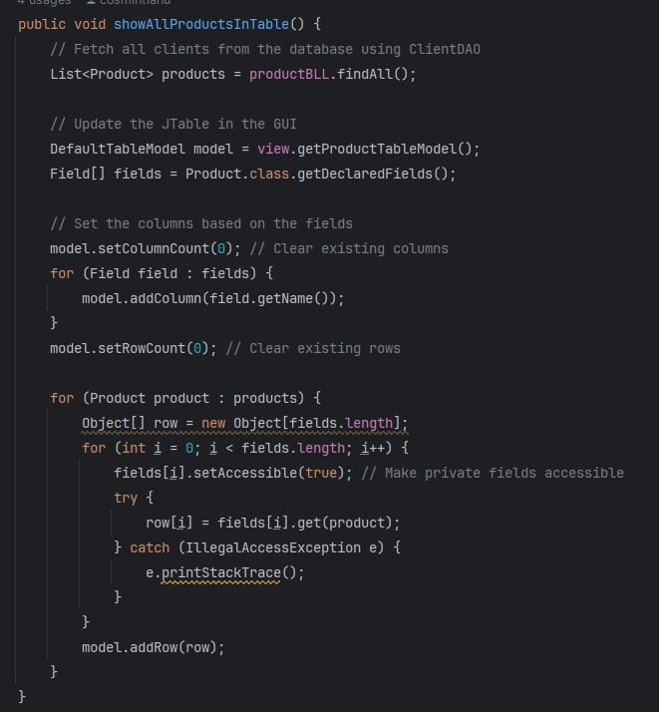
Figure 11: method example

The Controller also manages orders and bills. Methods like showAllOrdersInTable() and showAllBillsInTable() update the orders and bills tables in the GUI with data from OrdersBLL and BillBLL.
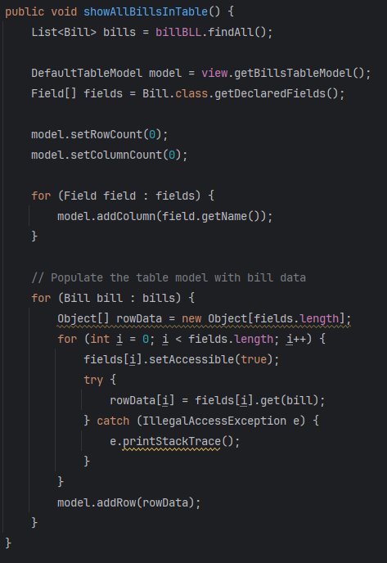
Figure 12: method example

Additionally, methods like getClientsNameAndId() and getProductsNameAndId() retrieve client and product names and IDs for use in the GUI for selecting the wanted product and client when creating an order.

Also here is present the View class creates and manages the graphical interface of the warehouse management system. It constructs windows for tasks like adding, updating, and deleting clients and products, managing orders, and viewing bills. Using Java Swing components, it facilitates user interaction by displaying buttons, text fields, tables, and frames. Interfacing with the Controller class, it updates the GUI with data fetched from the database, enabling efficient warehouse resource management.

Conclusions
In conclusion, the order warehouse management system plays a crucial role in streamlining inventory operations, facilitating client management, and ensuring efficient order processing. This project has provided invaluable insights into database management, GUI development using Java Swing, and the MVC architecture. Personally, I've gained hands-on experience in implementing CRUD operations, handling user interactions, and maintaining data integrity. Moving forward, potential enhancements could focus on refining the GUI to enhance user experience and incorporating additional features for more comprehensive warehouse management capabilities.

Bibliography
- https://dsrl.eu/courses/pt/materials/PT2024_A3.pdf
- https://dsrl.eu/courses/pt/materials/PT_2024_A3_S1.pdf
- https://dsrl.eu/courses/pt/materials/PT_2024_A3_S2.pdf

