Digital communication principles

Bibliography: 1. Robert Gallager, Principals of Digital Communication, 2008.
2. Andrea Goldsmiths, Wireless Communications, 2005.
3. Andreas Molisch, Wireless Communications, 2nd ed., 2011.

The architecture of a digital communication system (wired or wireless) can be best described using Fig. 1. The system consists of:
- the source: produces data in the analog or digital form, data which is fed to the source encoder
- the source encoder: encodes the analog and digital data as a sequence of bits and also compresses the data
- the channel encoder: takes the bitstream from the source encoder and encodes this bitstream in an analog waveform suitable to be transmitted on a specific channel (i.e. an electromagnetic wave
- channel: the transmission channel (either wired or wireless) which is a physical channel; this physical channel can still be modelled mathematically in order to incorporate noise in the received signal; for example the received waveform can be modelled as R(t) = S(t) + GN(t) where R(t) is the received waveform, S(t) is the send waveform and GN(t) is a Gaussian noise (i.e. a function with a bell/Gaussian shape) and t is time; or the received signal can be modelled as a linear Gaussian channel R(t) = S(t)*h(t) + GN(t) where the components have the same meaning as previously explained, but h(t) is a linear filter with the impulse response (i.e. impulse response is the output of a filter function when presented with a brief input pulse) and “*” is the convolution operator. Convolution: if f and g are mathematical functions, the convolution f*g is a new function defined as the integral of the product of the two functions, after one of them is reversed and shifted, $\left(f*g\right)\left(t\right)= \int_{-∞}^{∞}{f\left(τ\right)g\left(t-τ\right)dτ}$; note that g(-τ) is the reversed of g(τ) and g(t-τ) is the time shifted version of g(-τ) and also note that the t parameter usually means time, but is not necessary; simply said, the convolution is the weighted sum of f(τ) where the weights are given by g(t-τ); if f(t) is a unit impulse (i.e. f(t) = 1 for t=0 and f(t) = 0 for t≠0), then (f*g)(t) is equal to g(t).

Viewing the whole system as being formed from different, separate layers with clear data interfaces between them indeed helps as it allows the independent treatment of each layer (in a way similar to the OSI layered model for computer networks). We will now take each layer and detail it, the layer which we will not discuss anymore is the channel because this is the closest to physical phenomenon.

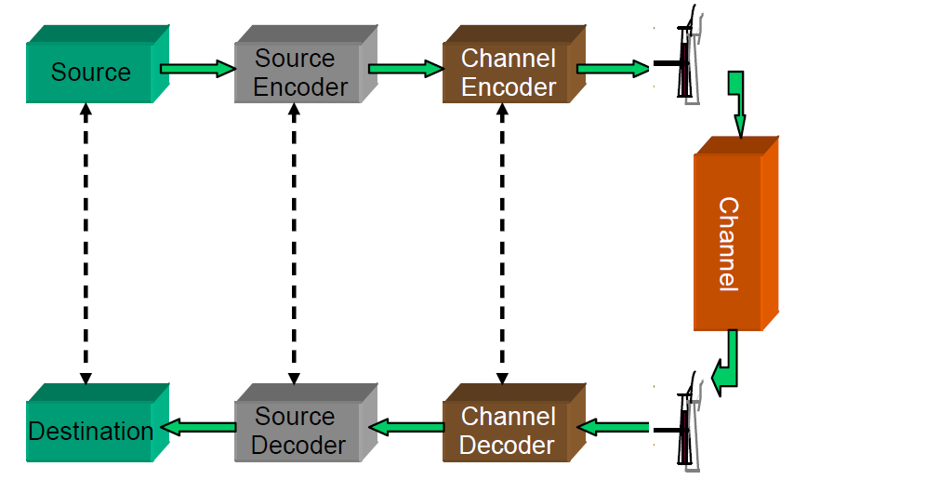

Fig. 1. The architecture of a digital communication system

The source encoder

The source encoder encodes the data produced by the source and outputs a sequence of bits. The sequence of bits will be the input of the channel encoder/modulator. The source encoder can be discrete (encoder’s input is a sequence of symbols from a discrete alphabet like the latin alphabet; e.g. email message, web page) or analog (encoder’s input is a waveform like a speech waveform; e.g. speech, video). The goals of the source encoder are:
- represent data as binary sequence
- compress data
The structure of the source encoder, still layered, is depicted in Fig. 2. Discrete source encoders require only the inner layer above (i.e. discrete encoder, discrete decoder), while analog source encoders use all three layers.

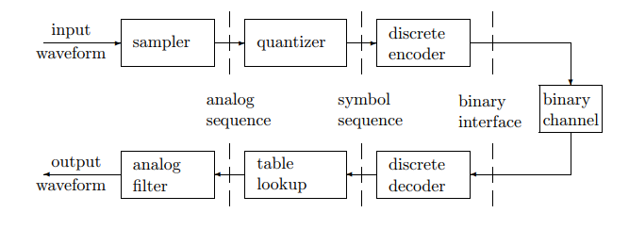
Fig. 2. The structure of the source encoder [1]
The sampler and quantizer

An analog data like speech or other sounds has an oscillating nature. For example, look in Fig. 3 which depicts a recording of a couple of seconds of speech. This figure depicts sound samples of a couple of seconds, recorded with 2 channels (i.e. stereo sound) with a sampling rate of 44100Hz. Sound is air movement or air pressure created in the vicinity of the sound emitting device (i.e. speaker, human vocal cords) or existent in the proximity of the sound recording device (i.e. microphone, ear drums). Ideally, if we had a device that measures this air pressure with infinite resolution (i.e. it could take an uncountable number of measurements per time unit/second) and we represent all these measurements on a time axis, this chart would look like the chart in Fig. 3. It will definitely have an oscillating shape – we call such a function a waveform (note that the values of the waveform function are normalized between -1 and 1 in Fig. 3, they are not real air pressure values). Any oscillating function may be periodical, in which case it has a frequency(i.e. the number of cycles per second) and a wavelength (i.e. the time duration until the waveform completes one cycle) or aperiodical. Mathematically, a waveform is just a real function $u\left(t\right):R→R$. Of course, we can not represent such a continuous function (i.e. continuous in the sense that there is an infinity of values between any two values of the input parameter t) in systems with finite memory like computer systems. We first need to make the function discrete and then we need to be able to represent the discrete function values on a limited number of bits.

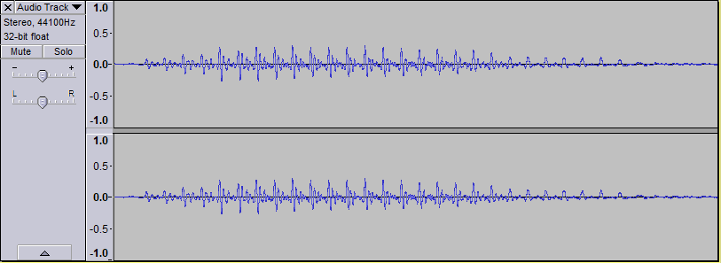
Fig. 3 A simple speech waveform recorded in Audacity

The most common form of sampler and quantizer is depicted in Fig. 4. In the graph from 4 a) we can see an ideal waveform (sin(t) function with the period T). The result of the sampler on this waveform is depicted in subfigure 4 b) which shows the sampled waveform; samples are values of the original waveform taken at regular intervals; we can see the shape of the waveform is maintained in subfigure 4 b), but important information is lost through the sampling process. The graph from 4 c) shows the result of quantisizing the sampled values from the graph 4 b) on 3 bits. The quantization process just approximates samples so that they can be represented on a fixed number of bits. If we look at the graph from 4 b) we can see there are 16 distinct values of the waveform (let’s ignore the value zero for now). On 3 bits we can represent only 2^3 = 8 distinct values/levels, so we approximate the 16 different values from graph 4 b) into 8 different values from graph 4 c). The quantization process further reduces the quality of the waveform. The larger the sampling rate, the better the quality of the represented waveform/signal; the sampling rate is the number of samples per second. The more bits we use for quantization the better the quality of the represented waveform/signal, but also this means a larger memory space (in bytes) is required.

Another way of converting (i.e. approximating) a continuous waveform function into a discrete function (i.e. a set of numerical values) will be shown later in this text after we introduce the Fourier series and implies the following 2 processes:
- expand the waveform u(t) into an orthonormal expansion
- quantize the coefficients in that expansion

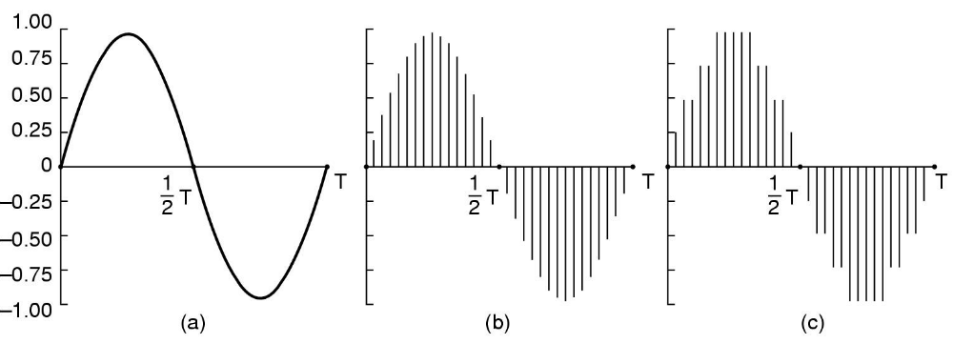
Fig. 4 Analog to digital conversion: the sampler and quantizer

Some examples of sample rates and quantization schemes used for different applications are:
- Telephone voice: telephone voice is sampled at 8.000 samples per second and each sample is quantisized on 8 bits in Europe and 7 bits in USA and Japan. This leads to 64 Kb/s for the Europe standard and 56 Kb/s for the USA, Japan standard. These facts are for PCM (Pulse Code Modulation – which means each sample is encoded independently of other samples), but there are other techniques like Differential PCM which achieve lower bitrates and will be discussed shortly
- Audio CDs: sound recorded on audio compact discs is sampled at 44.100 samples per second and uses 16 bits per sample quantization, PCM. This technique requires 705.6 Kb/s for mono sound (i.e. 1 audio channel) or 1.411 Mb/s for stereo sound (i.e. 2 audio channels). Using the 44.100 Hz = 44KHz sampling rate we can encode sounds that are formed from frequency components up to 22 KHz without aliasing distortion (i.e. 44KHz sampling rate is the Nyquist sampling rate for signals made of frequency components in the interval [0, 22.000]). In order to explain the Nyquist sampling rate we need to briefly introduce the Fourier transform and the idea of decomposing a waveform into a set of frequency components. As you will see later in this text, a waveform or any oscillating function can be decomposed into a weighted sum of sinus or cosinus functions using the Discrete Fourier Transform. The input parameter of these sine and cosine functions is called frequency. Nyquist sampling rate says that we can encode a signal (i.e. waveform) without aliasing distortion if we use a sampling rate that is at least twice the maximum frequency of its sine or cosine components. The human ear is able to perceive sound with the frequency in the interval [0 Hz, 22000 Hz], so doubling the maximum frequency of 22KHz, we get 44KHz which is approximately the sampling rate used for recording sound on audio compact disks.

Predictive coding techniques for sound
We have talked above about Pulse Code Modulation (PCM) where samples are encoded independently, but there is also LCP (Linear Code Prediction), Differential PCM (DPCM) or Adaptive DPCM where samples are encoded as difference from other samples. In Pulse Code Modulation we have the classic encoding design as depicted in Fig. 2, first we have the sampler, then the quantizer and finally, the discrete encoder. The predictive coding techniques (LCP, DPCM, ADPCM) however add another transformation step between the sampler and the quantization (this step is not depicted in Fig. 2). This transformation step is based on the observation that adjacent samples are often similar in a sound waveform. Consequently, predictive coding predicts the current sample from previous samples, quantize and code only the prediction error, instead of the original sample. If the prediction is accurate most of the time, the prediction error is concentrated near zeros and can be coded with fewer bits than the original signal. Usually a linear predictor like this one is used (linear predictive coding) :

$$x_{p}\left(n\right)= \sum_{k=1}^{p}{a_{k}x(n-k)}$$
where $x_{p}\left(n\right)$ is the predicted n-th sample and $x\left(.\right)$ is the original signal and $a_{k}$ are coefficients. For the n-th sample only the prediction error, $d\left(n\right)= x_{p}\left(n\right)-x(n)$, is quantisized and then binary encoded using the discrete encoder. A diagram of the predictive encoder can be seen in Fig. 5 and a diagram of the predictive decoder can be seen in Fig. 6.

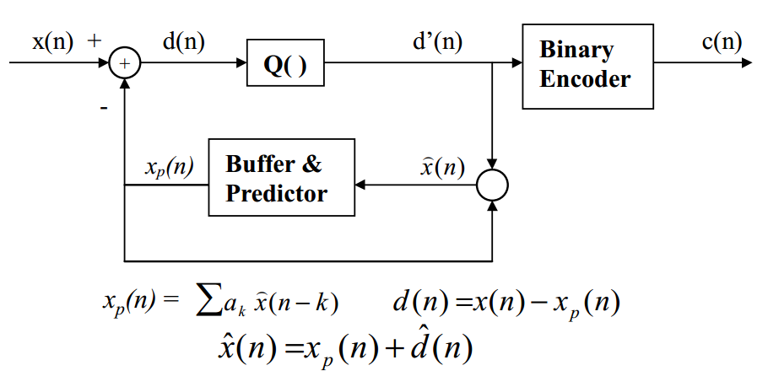

Fig. 5. The predictive encoder
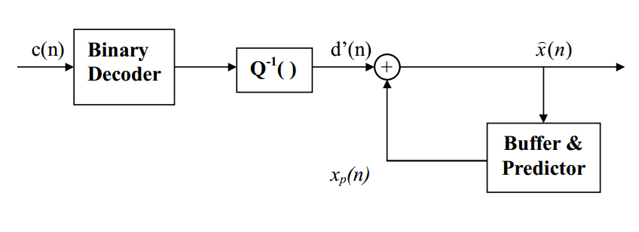
Fig. 6. The predictive decoder

The quantization performed by the quantizer can be uniform quantization or non-uniform quantization (i.e companding). Uniform quantization can be explained by looking at Fig. 7. Simply said, it has constant distance between successive quantization layers (depicted with Δ, 2Δ, ... in the figure). On the left side you can also see the binary values associated with each quantization level. The waveform that will be sampled prior to applying the quantization is depicted with red and is a function of time.
Δ

2Δ

3Δ

4Δ

5Δ

6Δ

7Δ

8Δ

000
001
010

011

100

101

110

111

Quantization levels
Time

Fig. 7. Uniform quantization

Although uniform quantization is the most used one in practice, for some type of applications like telephony system, non-uniform quantization may be more appropriate. For telephony applications Δ may be too large for quiet voices, ok for slightly louder ones and too small (risking overflow) for much louder voices. This is visible in Fig. 8.

000
111
001
OK
Δ too big for quiet voice
Δ too small for loud voice
Δ
Δ

Fig. 8 Setting the distance between quantization levels (i.e. Δ) is not so easy

In non-uniform quantization, the distance between quantization levels is not constant as can be seen in Fig. 9. A non-uniform quantizer like the one in Fig. 9 would increase smaller amplitudes and reduce larger ones. Examples of non-uniform quantization algorithms are A-law & Mu-law (G711).

0001

-001
0111
-111
0110
-110
0101
-101
0100

Fig. 9 Non-uniform quantization

The discrete encoder

The goal of the discrete encoder is to compress input data and to represent input data in binary. The input data is a sequence of symbols from a finite alphabet (e.g. latin alphabet, tuples from the binary alphabet) and the output is a sequence of binary digits. The discrete encoder assigns a codeword made from bits to each input symbol. The code should be uniquely decodable. There are two type of encoding algorithms:
- fixed code length algorithms: ASCII
- variable code length algorithms: Huffman, LZW

A variable-length code C maps each source symbol a_{j} in a source alphabet X = {a₁, . . . , a_{M}} to a binary string C(a_{j}), called a codeword. The number of bits in C(a_{j}) is called the length l(a_{j}) of C(a_{j}). For example, a variable-length code for the alphabet X = {a, b, c} and its lengths might be given by:
C(a) = 0 l(a) = 1
C(b) = 10 l(b) = 2
C(c) = 11 l(c) = 2

A code C for a discrete source is uniquely decodable if, for any string of source symbols, say x₁, x₂, … , x_{n}, the concatenation of the corresponding codewords, C(x₁)C(x₂) … C(x_{n}), differs from the concatenation of the codewords C(x₁)C(x₂) … C(x_{m}) for any other string x₁, x₂, … , x_{m} of source symbols. A prefix of a string y₁ … y_{l} is any initial substring y₁… y_{m}, m ≤ l of that string. The prefix is proper if m < l. A code is prefix-free if no codeword is a prefix of any other
codeword. A prefix-free code is uniquely decodable.

Kraft inequality for prefix-free codes: Every prefix-free code for an alphabet X = {a₁, . . . , a_{M}} with codeword lengths {l(a_{j}) | 1 ≤ j ≤ M} satisfies the relation:
$$\sum_{j=1}^{M}{2^{-l(a_{j})} ≤1}$$

In case of fixed length coding every codeword has the same number of bits. N distinct symbols can be represented with (int) log₂(N) bits and on L bits we can represent 2^{L} distinct symbols using fixed length coding. In variable length coding more frequently appearing symbols are represented by shorter codewords (Huffman, arithmetic, LZW=zip). The minimum number of bits required to represent a source is bounded by its entropy. If we have a source with a finite source symbol alphabet {a₁, . . . , a_{M}} and symbol a_{i} has the probability of occurrence (frequency) P(a_{i}) = p_{i} and if symbol a_{i} is given a codeword with l_{i} bits, the average bitrate (bits/symbol) would be:
$$l_{avg}= \sum_{i=1}^{M}{p_{i}l_{i}}$$
Average bitrate is bounded by the entropy of the source (H):
$$H≤l_{avg}≤H+1$$
H = $-\sum_{i=1}^{M}{p_{i}{\log_{2}(l}_{i})}$
For this reason, variable length coding is also known as entropy coding.
The Huffman variable length encoding algorithm

Huffman coding achieves an average bitrate (bits/symbol) very close to the entropy bound. If the probability distribution is known and accurate, Huffman coding is very good (off from the entropy by 1 bit at most). One can code one symbol at a time (scalar coding) or a group of symbols at a time (vector coding). The basic idea of Huffman encoding is to compute the probability of occurrence (i.e. occurrence frequency) of each symbol and assign a codeword with the smallest bit length to the symbol having the largest probability. The Huffman coding algorithm works in the following way:
- Step 1: arrange the symbol probabilities in a decreasing order and consider them as leaf nodes of a tree
- Step 2: while there are more than one node:
  - Find the two nodes with the smallest probability and assign the one with the lowest probability a “0” label, and the other one a “1” label (or the other way, but be consistent)
  - Merge the two nodes to form a new node whose probability is the sum of the two merged nodes.
  - Go back to Step 1 (but consider the new, merged node instead of the two nodes with the smallest probability considered above)
- Step 3: For each symbol, determine its codeword by tracing the assigned bits from the corresponding leaf node to the top of the tree. The bit at the leaf node is the last bit of the codeword.

In order to ease the understanding of Huffman encoding, you can look at an example in Fig. 10 which shows how we compute Huffman codewords for the symbol sequence: {3,2,2,0,1,1,2,3,2,2}. The occurrence probability for these symbols are:
P(3) = 8/49
P(2) = 36/49
P(1) = 4/49
P(0) = 1/49
We start by placing these symbols with their corresponding probability on the vertical, left side of Fig. 10 and then start with the leaf nodes having the smallest probabilities (1/49 and 4/49), merge them into a new node (with the merged probability 5/49), then merge the node with probability 5/49 with the next smallest probability leaf node (i.e. leaf node with probability 8/49) and so on. Next we assign 0 or 1 labels on each edge spanning from an intermediary node to its children and keep this consistent: for example, we can label the upper edge “1” and the lower edge “0” for each intermediary node as is done in Fig. 10. After we have added all the initial symbols to this tree of probabilities and labeled all the edges, we can read the codeword for each symbol by reading the labels on the path from the root node of the tree to that specific symbol leaf node. The codewords are specified on the right side of Fig. 10 and are summarized in the next table:
Symbol | Codeword
0 | 000
1 | 001
2 | 1
3 | 01

The input sequence 3,2,2,0,1,1,2,3,2,2 will be encoded using the above Huffman codes into the bitstream: 01,1,1,000,001,001,1,01,1,1 (I kept the comma (‘,’) symbol for better viewing).
We obtain an average bitrate per encoded symbol of 18 bits/10=1.8 bits/symbol. Using a fixed length coding we would have obtained an average bitrate per symbol of 2 bits/symbol. Saving is more obvious for a longer sequence of symbols.

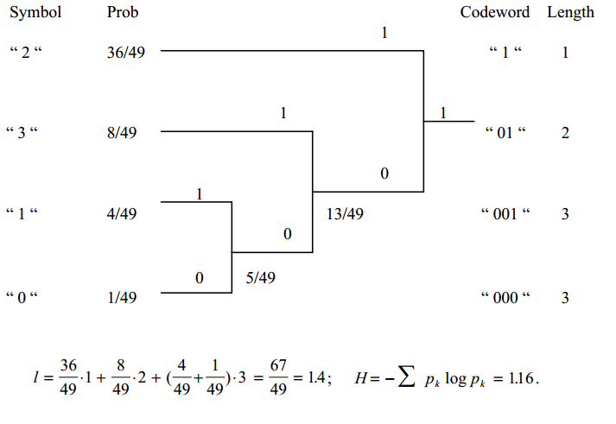
Fig. 10. Basic Huffman encoding example

The LZW variable length encoding algorithm

Another similar algorithm that compresses a list of characters by encoding them into a bitstream is the LZW algorithm. The LZW is interesting because the encoder and decoder dynamically build a dictionary of (symbol-code) pairs, they do not have a predefined one. However, this dictionary is initialized with the ASCII extended codes set (codes 1-255 are already occupied). The encoder always tries to add an unknown, long, symbol sequence to this dictionary and sends only the code for this sequence to the decoder (not the actual sequence). As larger and larger subsequences of symbol keep repeating in the input data, they are encoded as one symbol (not many symbols).

The LZW encoding algorithm is the following:
Initialize dictionary with single character strings
P = first input character
WHILE not end of input stream
C = next input character
IF P + C is in the string table
P = P + C
ELSE
output the code for P
add P + C to the string table
P = C
END WHILE
output code for P

The LZW decoding algorithm is the following:
Initialize dictionary with single character strings
OLD = first input code
output translation of OLD
WHILE not end of input stream
NEW = next input code
IF NEW is not in the string table
S = translation of OLD
S = S + C
ELSE
S = translation of NEW
output S
C = first character of S
OLD + C to the string table
OLD = NEW
END WHILE

In the following example, we detail the LZW encoding process of the sequence BABAAB, step by step:
2.
Input: BABAAB Output: 66,65
P = A B
C = B

Dictionary:
… | …
255
256 | BA
257 | AB

1.
Input: BABAAB Output: 66
P = B A
C = A

Dictionary:
… | …
255
256 | BA

3.
Input: BABAAB Output: 66,65
P = B BA
C = A

Dictionary:
… | …
255
256 | BA
257 | AB

4.
Input: BABAAB Output: 66,65,256
P = BA A
C = A

Dictionary:
… | …
255
256 | BA
257 | AB
258 | BAA

6.
Input: BABAAB Output: 66,65,256.257
P = AB
C =

Dictionary:
… | …
255
256 | BA
257 | AB
258 | BAA

5.
Input: BABAAB Output: 66,65,256
P = A AB
C = B

Dictionary:
… | …
255
256 | BA
257 | AB
258 | BAA

So, the encoded sequence will be: 66,65,256,257.
Now, we do the reverse process, the decoding, step by step.
2.
Input: 66,65,256,257 Output: BABA
Old = 65 256
New = 256
S = BA
C = B

Dictionary:
… | …
255
256 | BA
257 | AB

1.
Input: 66,65,256,257 Output: BA
Old = 66 65
New = 65
S = A
C = A

Dictionary:
… | …
255
256 | BA

3.
Input: 66,65,256,257 Output: BABAAB
Old = 256 257
New = 257
S = AB
C = A

Dictionary:
… | …
255
256 | BA
257 | AB
258 | BAA

The channel encoder (modulator)

The channel encoder has as input a binary sequence produced by the source encoder and it produces a waveform signal suitable for being transmitted over a (wireless) channel. We need to introduce some concepts first:

Channel Capacity: the maximum data rate (in bits/second) at which data can be transmitted over a channel; Claude Shannon showed that data can be sent over a channel with arbitrary low error probability as long as the transmission rate does not surpass the channel capacity value; Shannon also gave a formula for channel capacity depending on the transmission power, the bandwidth of the transmitted signal and the noise power per unit of bandwidth.

Bandwidth: the bandwidth of the transmitted signal (measured in Hertz); it is the difference between the maximum frequency and the minimum frequency between the frequency components that make this signal (see Fourier series to understand how a signal can be decomposed into frequency components). Please note that the above definition is given in the context of signal processing and this is the meaning of bandwidth that we will use throughout this document. But also note there is another meaning of bandwidth in the context of data networks where it means a data transmission rate given in bits per second.

Data rate: the actual data rate at which data is transmitted from sender to the receiver; it is measured in bps (i.e. bits per second) and is always below the channel capacity value for that channel.

Bit error rate (BER): the number of bits erroneously received (i.e. 1 instead of 0 or 0 instead of 1) divided to the total number of bits received.

Modulation is the technique of adding information to a carrier signal (i.e. modulating data over an electromagnetic wave). The waveform (i.e. ‘electromagnetic wave’ if it is considered from an engineering/electric point of view or ‘mathematical waveform’ if it is considered from an abstract/mathematical point of view) on which the characteristics of the information signal are modulated is called a carrier signal. A modulator would modify characteristics of the carrier waveform so that their variations match the variation of the information content in the information signal. A demodulator would detect any reliable detectable changes in the received signal and would “demodulate” the carrier signal in order to obtain the original information signal that was transmitted. A system that performs modulation and demodulation functionality is usually called modem. The input information signal can be analog data (e.g. voice data or video data represented as variation in electric current intensity) or digital (e.g. data represented in a computer like text, image, video, sound), but the carrier signal is always analog (i.e. it is not a discrete vector – digital representation -, but a continuous waveform – analog representation). Depending on the type of the information signal that is modulated on the carrier signal, we talk about analog modulation or digital modulation. Please note that there may be systems where the information signal is recorded first analog and then converted to a digital signal using an ADC (Analog to Digital Converter) and then modulated over an analog waveform in order to be transmitted wirelessly – this modulation is digital modulation (because digital data is modulated over the carrier signal). In order to understand the concept of modulation we present a brief example of analog modulation in Fig. 11 and then move to the most common ones which are digital modulation techniques. The black signal curve is an ideal information signal (i.e. like a voice segment) that needs to be modulated on a carrier signal. The AM modulation changes the amplitude of the carrier signal according to the values of the information signal (the frequency of the red curve is constant). The FM modulation depicted in the blue curve changes the frequency of the carrier signal according to the values of the information signal (the amplitude of the blue curve is constant).

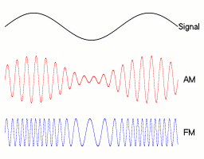
Fig. 11. Analog modulation: Amplitude modulation (AM) and Frequency modulation (FM)

Mathematically speaking a carrier signal or carrier wave is just an oscillating, periodical function and we only have 3 characteristics that we can change (i.e. modulate) for it : amplitude, frequency and phase. Let’s consider a typical cosine oscillating carrier signal (a sine waveform can be used analogously, havin the same 3 characteristics):
x(t) = A cos(2πft + Φ)
This waveform function has the following defining characteristics:
  - A – amplitude (the maximum and minimum value of the signal)
  - f – frequency (the number of cycles per second)
  - Φ – phase (initial angle of the sinusoidal function at its origin)
So, depending on which of the above 3 parameters are changed in the carrier wave, we have different types of simple digital modulation technologies:
- Amplitude Shift Keying (ASK) – a finite number of amplitude levels are used to modulate information
- Frequency Shift Keying (FSK) – a finite number of frequency values are used to modulate information
- Phase Shift Keying (PSK) – a finite number of phase values are used to modulate information
- Modulation using more than one parameter: two or three parameters are changed in order to modulate information; for example in QAM (Quadrature Amplitude Information) an in-phase cosine waveform is amplitude modulated and summed to a quadrature phase cosine waveform that is also amplitude modulated; so the phase and amplitude are used together for modulation.
Some more complex digital modulation techniques that use multiple carrier signals are:
- OFDM (Orthogonal Frequency Division Multiplexing) : transmit data on multiple carrier frequencies in parallel
- FHSS (Frequency Hopping Spread Spectrum) : jump between different frequency subbands when transmitting
- DSSS (Direct Sequence Spread Spectrum) : widen the frequency spectrum of the transmitted data so that it reseamples noise and is less prone to noise interference.
We will discuss these multi carrier modulation techniques later on when we talk about IEEE 802.11 wireless LANs (i.e. Wi-Fi networks).

We will present in the following paragraphs simple binary digital modulation techniques from the above categories (BASK – Binary Amplitude Shift Keying; BPSK – Binary Phase Shift Keying; BFSK – Binary Frequency Shift Keying) that encode each bit (0 or 1) into a separate waveform which is transmitted for a finite time interval T (i.e. the symbol duration interval). However, these binary shift keying schemes are rather inefficient, usually a block of b consecutive bits (not one single bit) is mapped onto a symbol (also called a signal), all symbols generated are then transformed into a real waveform function which is then shifted up to the passband frequency band and transmitted (to be discussed in the following paragraphs).

Binary digital modulation techniques

In BASK (Binary Amplitude Shift Keying) the frequency is kept constant and the amplitude has 2 levels (for bit 1 and for bit 0) and given a bitstream str=b₀b₁b_{2…} the modulated waveform is:
$x\left(t\right)=s\left(t\right)sin⁡(2πft)$
where f is the carrier frequency and s(t) is a function of rectangular pulses s(t)=b_{i} for iT ≤ t ≤ (i+1)T, i≥0 where T is the symbol duration interval. Instead of the sine oscillating function, the cosine could also be used in the above formula for x(t). In figure 12 we see the rectangular pulses function s(t) for the bitstream 0010110010 and in Fig. 13 we see the modulated signal x(t) for this bitstream.

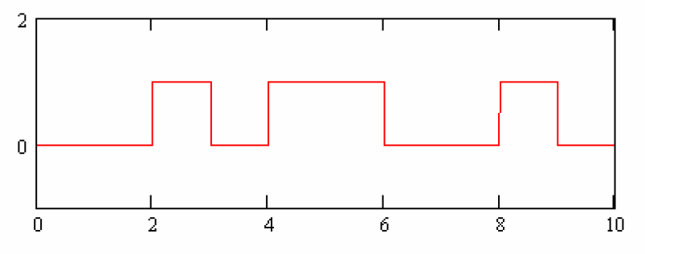
Fig. 12. The function of rectangular pulses s(t) corresponding to the bistream 0010110010
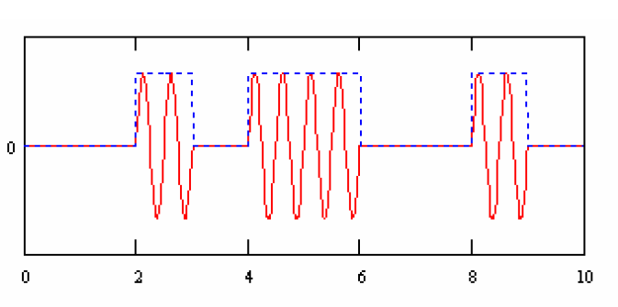
Fig. 13. The BASK modulated signal x(t) for the bitstream 0010110010

We define BFSK (Binary Frequency Shift Keying) in a similar way. The amplitude is kept constant this time and there are two frequencies f₁ and f₂ for the two values of a bit, 0 and 1. Being given a bitstream str=b₀b₁b_{2…} the modulated waveform is:
$$x\left(t\right)=\left\{\begin{aligned}sin⁡(2πf_{1}t), & if s\left(t\right)=1 \\ sin⁡(2πf_{2}t), & if s\left(t\right)=0\end{aligned}\right.$$
where s(t) is, the same as for BASK, a function of rectangular pulses s(t)=b_{i} for iT ≤ t ≤ (i+1)T, i≥0 where T is the symbol duration interval. Instead of the sine oscillating function, the cosine could also be used in the above formula for x(t). The rectangular pulses function s(t) for the bitstream 0010110010 is already displayed in Fig. 12 and in Fig. 14 we see the modulated signal x(t) for this bitstream.
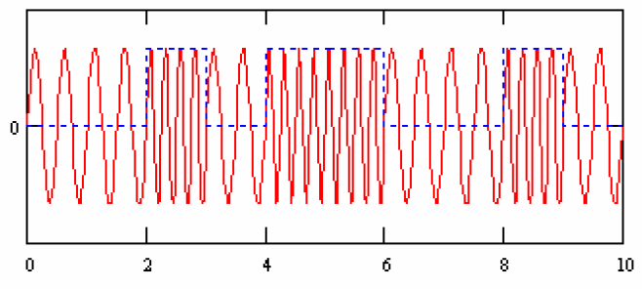
Fig. 14. The BFSK modulated signal x(t) for the bitstream 0010110010

Finally, we have BPSK (Binary Phase Shift Keying). The amplitude and frequency is kept constant this time and there are two phases, for example 0 and π, for the two values of a bit, 0 and 1. Being given a bitstream str=b₀b₁b_{2…} the modulated waveform is:
$$x\left(t\right)=\left\{\begin{aligned}sin⁡(2πft), & if s\left(t\right)=1 \\ sin⁡(2πft+π), & if s\left(t\right)=0\end{aligned}\right.$$
where s(t) is, the same as for BFSK, a function of rectangular pulses s(t)=b_{i} for iT ≤ t ≤ (i+1)T, i≥0 where T is the symbol duration interval. Instead of the sine oscillating function, the cosine could also be used in the above formula for x(t). The rectangular pulses function s(t) for the bitstream 0010110010 is already displayed in Fig. 12 and in Fig. 15 we see the modulated signal x(t) for this bitstream.

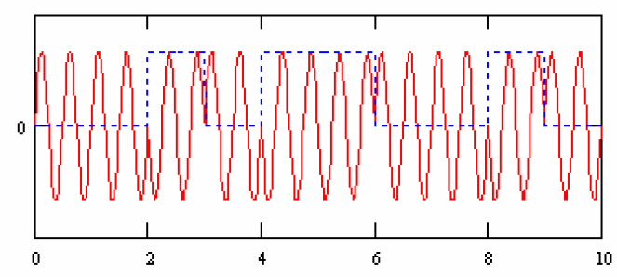
Fig. 15. The BPSK modulated signal x(t) for the bitstream 0010110010

Non-binary (i.e. multilevel) digital modulation techniques and bandpass signals

In the previous section we introduced BASK, BFSK and BPSK, but they are rather bandwidth inefficient schemes (on their own) because the bitrate is equal to the symbol rate for them. Instead, more complicated multilevel digital modulation techniques are used and their structure is depicted in Fig. 16. The steps of converting a sequence of bits to a passband waveform detailed in Fig. 16 are:
- The binary input (from the source encoder) is converted to signals (i.e. vectors of real/complex numbers or vectors of real/complex tuples from ℝ^{n})
- The signals are transformed/expanded into a waveform – continuous function of time (this waveform is computed using an orthonormal/orthogonal expansion, e.g. using values from the signals vector as coefficients of a Fourier Series waveform (computed using the Discrete Fourier Transform))
- The resulted baseband waveform (i.e. centered around zero frequency) is then transformed into a passband waveform (i.e. a waveform centered around a higher frequency due to national and international regulations) – continuous function of time .

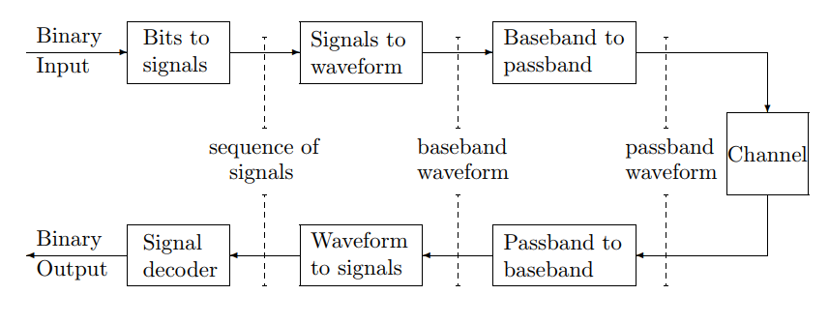
Fig. 16. The architecture of a multilevel digital modulation technique [1]

Each of the above steps are detailed below.

1. Bits to signals

In this phase the incoming bits are segmented into b-bit blocks and then b-bit blocks are mapped to a signal constellation A = {a₁, a₂, … a_{M}} where M=2^{b} possible blocks; each value of the signal constellation is called a signal(it is just a real/complex number). You can see examples of 1 dimension constellations in Fig. 17. Examples of constellations with 2 dimensions are visible in Fig. 18.

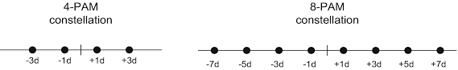
Fig.17. Examples of 1D signal constellations; the left constellation has
4 signals and the right constellation has 8 signals; d is just a parameter

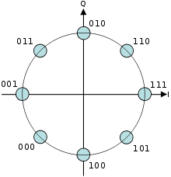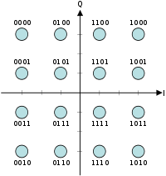
Fig.17. Examples of 2D signal constellations (each signal has 2 components)

2. Signals to waveform

The obtained sequence of signals u₁, u₂, u₃, … is then mapped to a waveform u(t) (i.e. a continuous time function) using an orthogonal/orthonormal expansion p(t):
$$u\left(t\right)= \sum_{k}{u_{k}p(t-kT)}$$
where T is the interval between successive signals. Fourier series are an example of orthonormal/orthogonal expansion and are summarized in the following lines. Although in the above sentence I said p(t) should be an orthogonal/orthonormal expansion, you can just consider p(t) to be any waveform (i.e. oscillating function).

Fourier series and Fourier Transform

In this section we briefly introduce Fourier series and Fourier transforms. We can not spend too much time on Fourier analysis because the required math machinery is quite complex and this is not a mathematical course. Fourier transforms are used a lot in digital communication and the most important usages are the following:
- using Fourier Transform (i.e. the modulation theorem of Fourier transform) we can compute the lowpass equivalent or the complex envelope of a real-valued, bandpass signal. Any real-valued, narrowband, high frequency, bandpass signal (i.e. waveform) can be represented in terms of a complex-valued, low frequency signal (i.e. waveform) called the lowpass equivalent of the original bandpass signal. This allows us to work with the low frequency signal and not directly with the high frequency, bandpass signal, thus simplifying the treatment of bandpass signals. This is because applying signal processing algorithms to low frequency signals is much easier due to the lower required sampling rate (see John Proakis, Masoud Salehi, Digital Communications, 5th edition, 2008, pp. 18-23)
- because Fourier transform allows us to determine the frequency spectrum of a time domain signal, we can study the signal better, its energy etc.
- any low pass filtering or any other kind of filtering done at the receiver is usually easier implemented in the frequency domain using Fourier transforms that in the time domain
- an important multicarrier modulation technique used in Wi-Fi communication (IEEE 802.11 family of wireless standards to be discussed in a following course) is Orthogonal Frequency Division Multiplexing (OFDM) which is implemented at the sender and receiver using Fourier Transform and Inverse Fourier Transform.
Fourier series are the simplest way of representing a waveform (continuous function of time) as a vector of values (i.e. Fourier coefficients). Fourier series represent a real/complex waveform (i.e. oscillating function of time) as a weighted sum of sinusoids (sin() and cos() functions). Each weight (i.e. Fourier coefficient) is determined by the function and the function expression is determined by the set of weights (so a continuous math function can be approximated by a computer vector of coefficients).
Let $u\left(t\right): R→R$ a continuous function of time, integrable and periodic on the interval [-T/2, T/2] with period T. The Fourier series of function u(t) is:
$u\left(t\right)= \sum_{k=-∞}^{∞}{\hat{u_{k}} e^{2πikt/T}}$ for t in [-T/2,T/2] and u(t)=0 elsewhere
where the Fourier coefficients are:
$$\hat{u_{k}}=\frac{1}{T}\int_{-T/2}^{T/2}{u(t)e^{-2πikt/T}dt}$$
At this point it’s important to remember Euler’s formula which relates trigonometry with complex numbers $e^{ix}=\cos\left(x\right)+i sin⁡(x)$. Using Euler’s formula, we can write:
$$u\left(t\right)= \sum_{k=-∞}^{∞}{\hat{u_{k}} e^{2πikt/T}}= \sum_{k=-∞}^{∞}{\hat{u_{k}} [\cos\left(\frac{2πkt}{T}\right)+i\sin\left(\frac{2πkt}{T}\right)]}$$
In the above equation it is visible that Fourier series decompose a continuous function of time into a weighted average of sin() and cos() complex functions with different frequencies (kt/T for
-∞≤k≤∞).

Fourier transform maps a function of time $u\left(t\right): R→ C$ into a function of frequency $\hat{u}\left(f\right): R→ C$. The Inverse Fourier transform maps $\hat{u}\left(f\right)$ back to $u\left(t\right)$.
$$\hat{u}\left(f\right)=\int_{-∞}^{∞}{u(t)e^{-2πift}dt}$$
$$u\left(t\right)=\int_{-∞}^{∞}{\hat{u}\left(f\right)e^{2πift}df}$$
There are theorems (Plancherel) that say that given any function integrable u(t), there exist its Fourier transform, $\hat{u}\left(f\right)$. Also, given the Fourier transform $\hat{u}\left(f\right)$, there exist the function u(t). Similar to Fourier series, the Fourier transform describes a continuous function of time u(t) in term of sin() and cos() complex functions with different frequencies. The complex number $\hat{u}\left(f_{0}\right)$
describes the component with frequency f₀. The magnitude of this complex number (i.e. $\sqrt{{Re\{\hat{u}\left(f_{0}\right)\}}^{2}+{Im\{\hat{u}\left(f_{0}\right)\}}^{2}}$) specifies the weight or the amplitude of the component with frequency f₀ into the function u(t). Although, the Fourier series is an infinite sum (i.e. a sum with an infinity of components) and the Fourier transform is defined for an infinity of frequency values (i.e. it is defined on $R$) the majority of waveforms encountered in nature are bandwidth-limited, meaning that the value of $\hat{u}\left(f_{0}\right)$ is zero everywhere except on a closed, finite interval. We can see in Fig. 18 a small sound sample recorded in Audacity (the sound has a couple of seconds duration). And in Fig. 19, you can see the magnitude of the Fourier transform for each frequency (measured in Hertz) for which the magnitude is different than zero (for the aforementioned recorded sound sample).
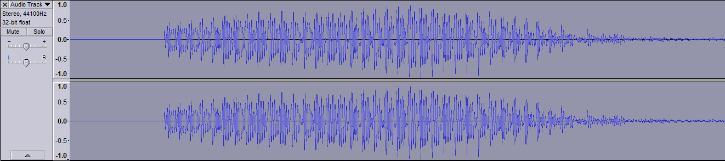
Fig. 18. A sound sample of a couple of seconds recorded in Audacity
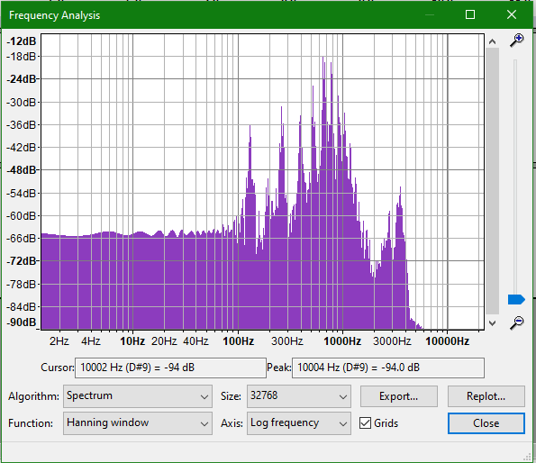
Fig. 19. The magnitude of the Fourier transform function for each frequency value

Although the Fourier transform uses an infinity of Fourier coefficients, there are theorems that prove the function u(t) is also approximated by a finite number of Fourier coefficients ($\hat{u}\left(f_{1}\right)$, $\hat{u}\left(f_{2}\right)$, $\hat{u}\left(f_{3}\right)$…). Using Fourier transform, we can approximate a waveform as a vector of real numbers and having a vector of samples (real numbers) we can approximate/interpolate a waveform (continuous, oscillating function).

3. Baseband to passband

The baseband waveform is shifted up to a passband waveform (by increasing its frequency to be around a central carrier frequency f_{c}). The baseband waveform u(t) is made of frequency components centered at 0 frequency; i.e. its Fourier transform $\hat{u}(f)$ is zero except for the frequencies $-B≤f≤B$. The passband waveform x(t) will be made of frequency components centered around the carrier frequency f_{c}; i.e. its Fourier transform $\hat{x}(f)$ is zero except for $f_{c}-B≤f≤f_{c}+B$. The baseband waveform u(t) is shifted up to frequency f_{c} by multiplying it with $e^{2πif_{c}t}$. Depending if u(t) is real or complex, it may be necessary to apply additional transformation in order to get to a real (not complex) passband waveform.

Examples of multilevel digital modulation techniques

Example 1. The following example is actually binary (i.e. it has only 2 signals in the constellation), but it is useful in order to understand all the steps from Fig. 16.
A sequence of binary symbols (bits) enters the modulator at T-spaced instants of time. These symbols can be mapped into real numbers using the mapping: 0 $→$+1 and 1 $→-$1. The resulted sequence of real numbers u₁, u₂, u₃, … is then mapped into a baseband waveform given by:
$u\left(t\right)=\sum_{k}{u_{k}sinc(\frac{t}{T} -k)}$ where $sinc\left(x\right)=\frac{sin⁡(πx)}{πx}$
Then, this baseband waveform is transformed into a passband waveform centered around a carrier frequency. In the absence of noise, the receiver can sample u(t) at times T, 2T, 3T, … to retrieve u₁, u₂, u₃, … which can then be decoded into the original binary symbols. Each pulse waveform component $u_{k}sinc\left(\frac{t}{T}-k\right)$ is time limited (i.e. is transmitted on a limited period of time) to T (i.e. the duration of a symbol). The receiver (in the absence of noise) just samples the received signal $u\left(t\right)=\sum_{k}{u_{k}sinc(\frac{t}{T} -k)}$ at times T, 2T, 3T, … in order to retrieve the sent signals u₁, u₂, u₃, … ; remember that $sinc\left(x\right)=\frac{sin⁡(πx)}{πx}$ is 1 when x=0 and is zero for the other integer values of x (i.e. it is ideal Nyquist):
$$u\left(T\right)= u_{1}sinc\left(0\right)+ u_{2}\left(-1\right)+ u_{3}\left(-2\right)+ …+ u_{n}\left(-\left(n-1\right)\right)= u_{1}$$
$$u\left(2T\right)= u_{1}sinc\left(1\right)+ u_{2}\left(0\right)+ u_{3}\left(-1\right)+ …+ u_{n}\left(-\left(n-2\right)\right)= u_{2}$$
$u\left(3T\right)= u_{1}sinc\left(2\right)+ u_{2}\left(1\right)+ u_{3}\left(0\right)+ …+ u_{n}\left(-\left(n-3\right)\right)= u_{3}$
….

Example 2. PAM (Pulse Amplitude Modulation)

Incoming bits are segmented into b-bit blocks. The b-bit blocks are mapped to a signal constellation A = {a₁, a₂, … a_{M}} where M=2^{b} possible blocks; each value of the signal constellation is called a signal(it is just a real/complex number). The obtained sequence of signals u₁, u₂, u₃, … is then mapped to a waveform u(t) (i.e. a continuous time function) by the use of time shifts of a basic pulse waveform p(t):
$$u\left(t\right)= \sum_{k}{u_{k}p(t-kT)}$$
where T is the interval between successive signals
Finally, baseband waveform u(t) is transformed to passband waveform. In order to shift the u(t) signal waveform to a higher frequency band and make it a passband signal, the signal is multiplied with $e^{2πif_{c}t}$, which makes the Fourier transform $\hat{u}\left(f\right)$ zero except for $f_{c}-B≤f≤f_{c}+B$ where B is the frequency bandwidth of the original signal. The resulted waveform ${u(t)e}^{2πif_{c}t}$ is now a complex one which can not be transmitted (only real waveforms can be transmitted). So, u(t) is also multiplied with the complex conjugate of $e^{2πif_{c}t}$, i.e. $e^{-2πif_{c}t}$, so the transmitted signal becomes:
$$x\left(t\right)=u\left(t\right)\left[e^{2πif_{c}t}+e^{-2πif_{c}t}\right]=2u\left(t\right)\cos\left(2πf_{c}t\right)$$
which is a real signal centered at frequency f_{c}.

1D constellation examples for PAM:
- for 2 signals (bit blocks: 0 and 1):
-1, 1
- for 4 signals (bit blocks: 00, 01, 10 and 11):
-3,-1,1,3
- for 8 signals (bit blocks: 000, 001, 010, 011, 100, 101, 110, 111):
-7,-5,-3-1,1,3,5,7
- the distance between 2 signals in a signal constellation does not necessary need to be 2, but it should be a constant; for example, this is also a signal constellation with 4 signals:
-9,-3,3,9
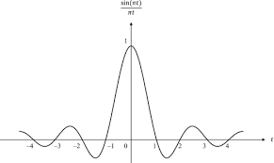
p(t) function examples for PAM:
- $p\left(t\right)=sinc\left(\frac{t}{T}\right)$

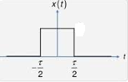
- $p\left(t\right)=\left\{\begin{aligned}1 ,if-\frac{T}{2}≤t≤\frac{T}{2} \\ 0 ,otherwise \end{aligned}\right.$

- raised cosine function
- Gaussian basis pulse

Example 3. QAM (Quadrature Amplitude Modulation)

Incoming bits are segmented into b-bit blocks. The b-bit blocks are mapped to a signal constellation A = {a₁, a₂, … a_{M}} where M=2^{b} possible blocks; a_{i} is a complex number and A = {(a+bi) | aϵ𝕽, bϵ𝕽}; each signal can be considered a tuple of two real numbers. The obtained sequence of signals (i.e. complex numbers) u₁, u₂, u₃, … is then mapped to a waveform u(t) (i.e. a continuous time function) by the use of time shifts of a basic pulse waveform p(t) (the same as for PAM, ideal Nyquist):
$$u\left(t\right)= \sum_{k}{u_{k}p(t-kT)}$$
where T is the interval between successive signals.
Finally, the baseband waveform u(t) is transformed to passband waveform. In order to shift the u(t) signal waveform to a higher frequency band, the signal is multiplied with $e^{2πif_{c}t}$, which makes the Fourier transform $\hat{u}\left(f\right)$ zero except for $f_{c}-B≤f≤f_{c}+B$ where B is the frequency bandwidth of the original signal. The resulted waveform ${u(t)e}^{2πif_{c}t}$ is complex which can not be transmitted (only real waveforms can be transmitted). So, the complex conjugate is added to ${u(t)e}^{2πif_{c}t}$, so the transmitted signal becomes:
$$x\left(t\right)={u(t)e}^{2πif_{c}t}+{u^{*}(t)e}^{-2πif_{c}t}=2Re\left\{{u(t)e}^{2πif_{c}t}\right\}=2Re\left\{u\left(t\right)\right\}\cos\left(2πf_{c}t\right) -2Im\{u\left(t\right)\}sin⁡(2πf_{c}t)$$
which is a real signal centered at frequency f_{c}. (Re{x} is the real part of complex number x and Im{x} is the imaginary part of complex number x).

In Fig. 20, we can see a constellation example for 16-QAM (i.e. QAM with 16 signals). One axis represents the in-phase component and the other represents the quadrature component. The two components are phase shifted (i.e. they have different phase).

Fig. 20. Signal constellation for 16-QAM

Now let’s briefly describe the QAM decoder. In the absence of noise, the received signal is
$r\left(t\right)={u(t)e}^{2πif_{c}t}+{u^{*}(t)e}^{-2πif_{c}t}$
$=2Re\left\{u\left(t\right)\right\}\cos\left(2πf_{c}t\right) -2Im\{u\left(t\right)\}\sin\left(2πf_{c}t\right)$
$=I\left(t\right)cos\left(2πf_{c}t\right)-Q\left(t\right)sin⁡(2πf_{c}t)$
where I(t) is the in-phase component and the Q(t) is the quadrature component; they are our of phase by 90º (i.e. they are orthogonal).
The received signal r(t) is multiplied separately by $cos\left(2πf_{c}t\right)$ and by $sin(2πf_{c}t)$ so we get:
$r\left(t\right)cos(2πf_{c}t)=I\left(t\right)cos(2πf_{c}t)cos\left(2πf_{c}t\right)-Q\left(t\right)cos⁡(2πf_{c}t)sin⁡(2πf_{c}t)$
and respectively
$r\left(t\right)sin(2πf_{c}t)=I\left(t\right)sin(2πf_{c}t)cos\left(2πf_{c}t\right)-Q\left(t\right)sin⁡(2πf_{c}t)sin⁡(2πf_{c}t)$
We have:
$$r\left(t\right)cos\left(2πf_{c}t\right)=I\left(t\right)cos\left(2πf_{c}t\right)cos\left(2πf_{c}t\right)-Q\left(t\right)\cos\left(2πf_{c}t\right)\sin\left(2πf_{c}t\right)=\frac{1}{2}I\left(t\right)\left[1+\cos\left(4πf_{c}t\right)\right]-\frac{1}{2}Q\left(t\right)\sin\left(4πf_{c}t\right)=\frac{1}{2}I\left(t\right)+ \frac{1}{2}[I\left(t\right)\cos\left(4πf_{c}t\right)-Q\left(t\right)\sin\left(4πf_{c}t\right)]$$
The high frequency terms (containing $4πf_{c}t$) can be eliminated using a low-pass filter, leaving only the in-phase component I(t).
Similarly for the quadrature component:
$r\left(t\right)sin(2πf_{c}t)=I\left(t\right)sin(2πf_{c}t)cos\left(2πf_{c}t\right)-Q\left(t\right)sin⁡(2πf_{c}t)sin⁡(2πf_{c}t)$ $=\frac{1}{2}I\left(t\right)\sin\left(4πf_{c}t\right)-\frac{1}{2}Q\left(t\right)[1-cos\left(4πf_{c}t\right)]$
$=-\frac{1}{2}Q\left(t\right)+ \frac{1}{2}[I\left(t\right)\sin\left(4πf_{c}t\right)+Q\left(t\right)\cos\left(4πf_{c}t\right)]$
Similarly, the high frequency terms (containing $4πf_{c}t$) can be eliminated using a low-pass filter, leaving only the in-phase component Q(t).

