Software Technology 2 - Week 5 Lab Report

Task 1: Recursion vs Iteration
Screenshots:
Comments:
The recursive functions worked correctly for all three cases, but the iterative versions generally performed faster. This is because iteration avoids the repetition of function calls. The recursive Fibonacci implementation was much slower for larger values because it recalculates the same smaller Fibonacci values many times. This shows that recursion is easier to read, but iteration is often more efficient for repeated computations.

Task 2: Merge Sort vs Insertion Sort
Screenshots:
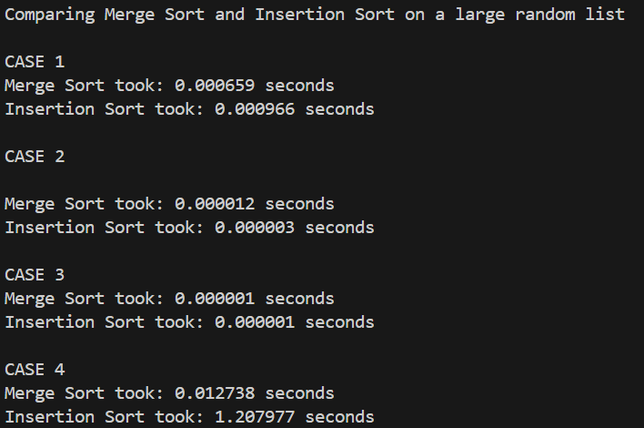
Comments:
Merge sort is more efficient for larger datasets. This is because merge sort uses a divide and conquer method, which is much more efficient than insertion sort. In smaller datasets the difference is minimal, but as the datasets grow, the difference is significant.

Task 3: Tower of Hanoi
Code with move count feature:
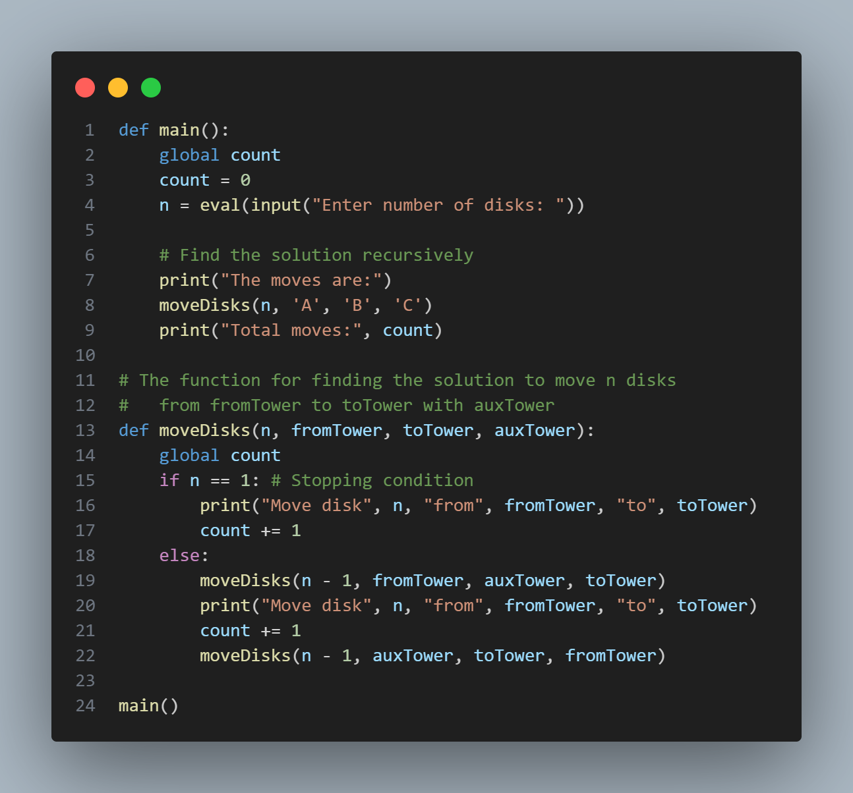

Screenshots:
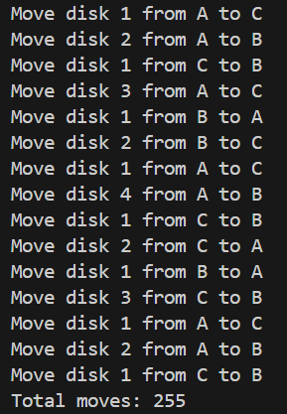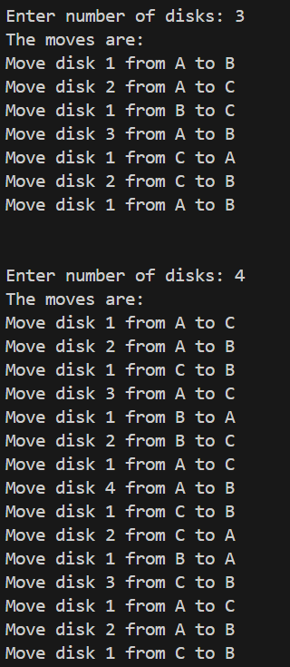

Task 4: Fractals (Sierpinski Triangle & Koch Snowflake)
Screenshots:
Sierpinski Triangle
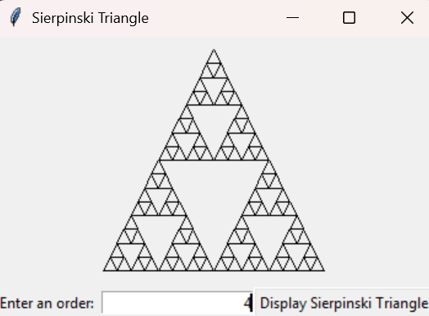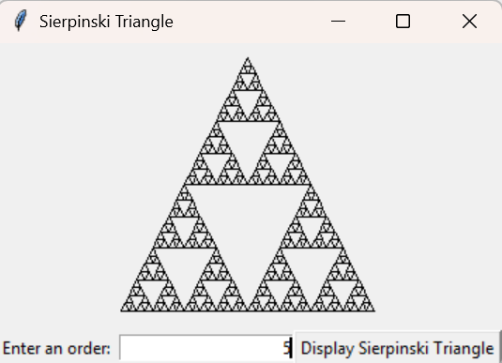

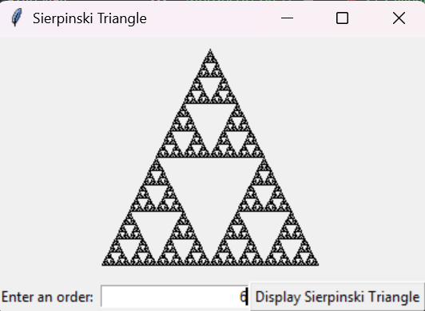

Koch Snowflake
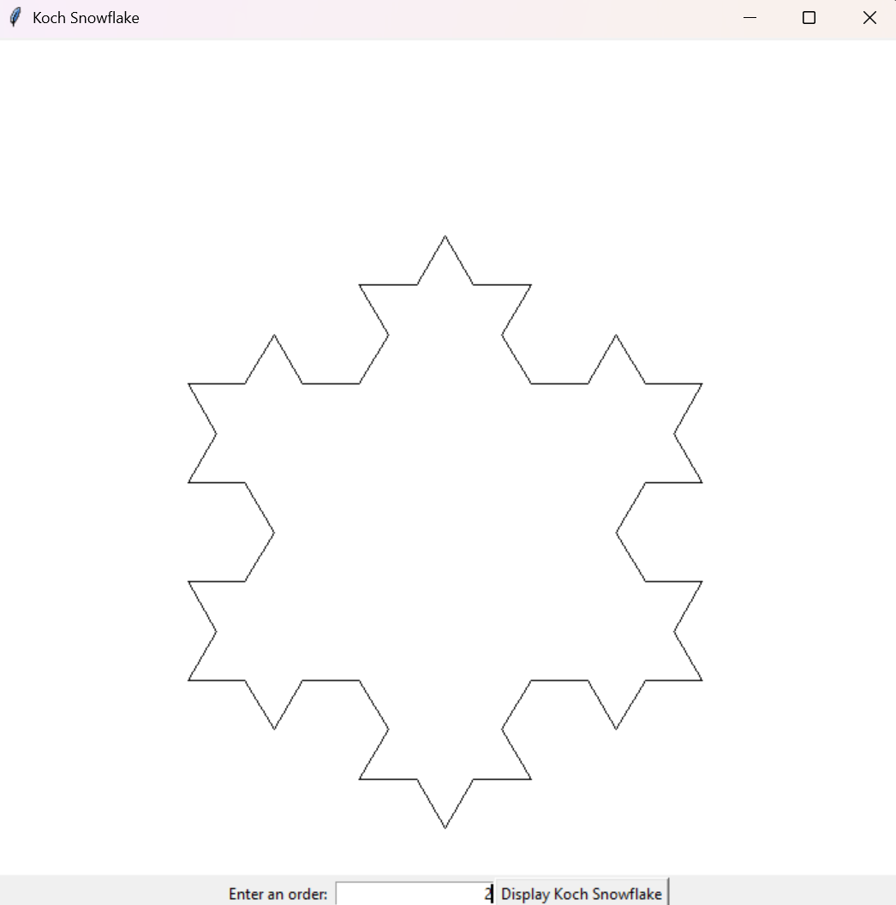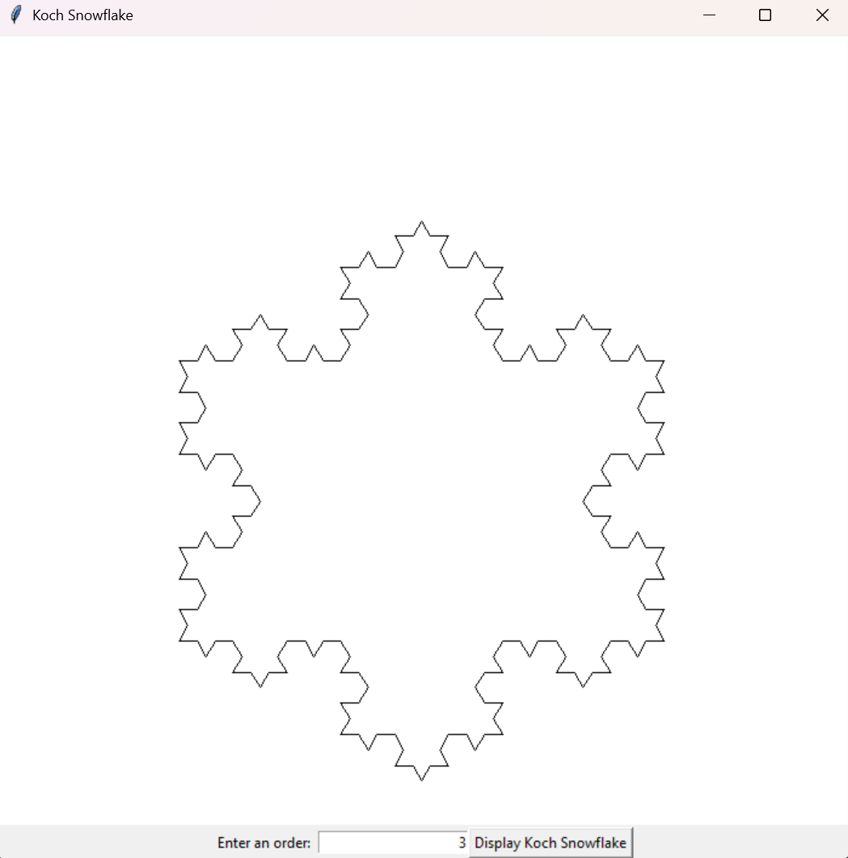

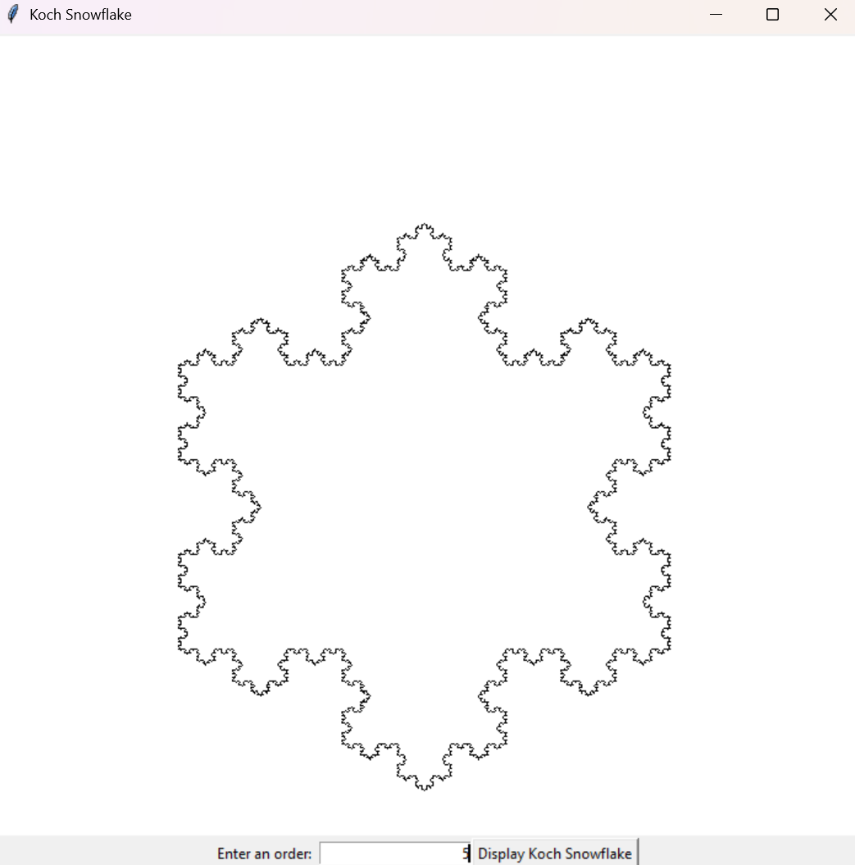
Note:
The code for both the Koch Snowflake and Sierpinski Triangle implementations are included in the submitted files.

