# Welcome to Mighty Oak Acorn Workbook

## Overview

As part of CSE 170 Technical Teamwork, you will work in teams of 3-4 on four different Acorn projects. This workbook is to assist you in forming those projects.

## Purpose

The purpose of working on projects is to help you better understand the complexity and practicality of the elements you learned in class. You and your team create the projects through careful preparation, guidance by the Spirit, and teamwork using inspiration, collaboration, and innovation.

## Background

 Please read and watch the following information

* <https://www.byui.edu/president/past-presidents/jacob-spori>
* <https://www.byui.edu/devotionals/justin-hodges>

## Requirements

Each project will focus on the Influence model and the Institutional Learning Outcomes.

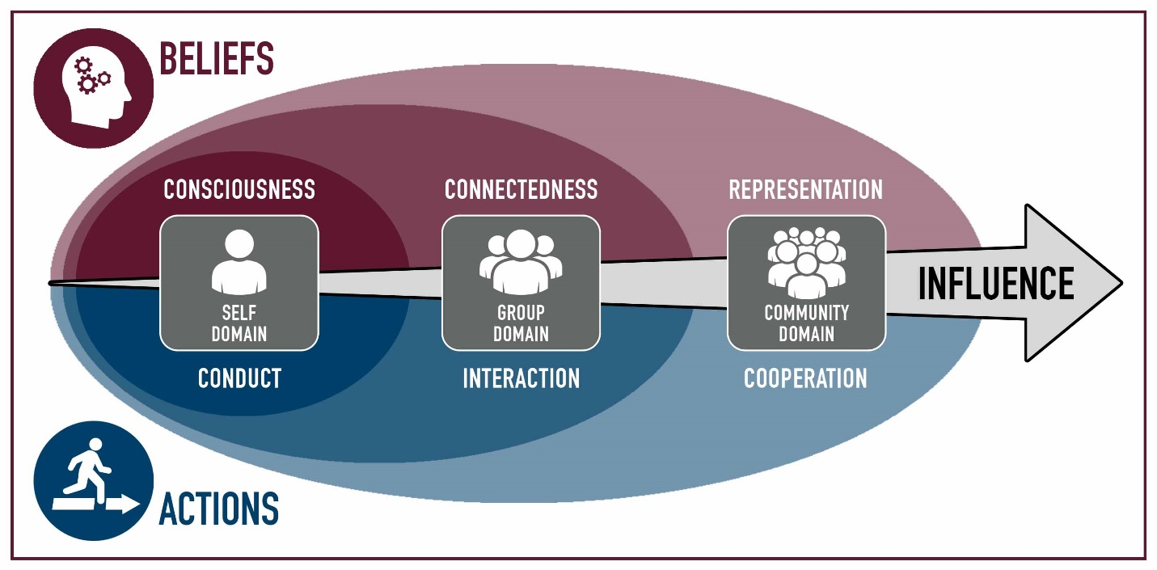

Each project will focus on the Self, the Group, or the Community. Tying in the Belief or Action attributes associated in the Model of Consciousness: Conduct, Connectedness, Interaction, Representation, and Cooperation.

The university has four Institutional Learning Outcomes.

Each of your Acorn Projects will be assigned one of these learning outcomes.

* 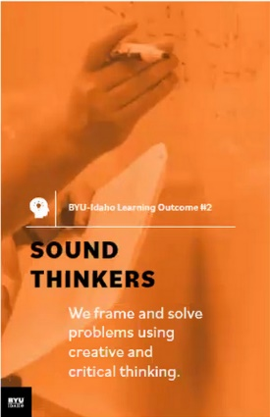A Disciple of Jesus Christ
  + We believe in Jesus Christ as the Son of God and strive to follow Him.
* Sound Thinkers
  + We frame and solve problems using creative and critical thinking.
* Effective Communicators
  + We develop and express ideas that are purposeful, organized, and clear
* 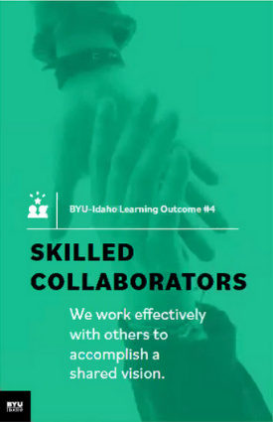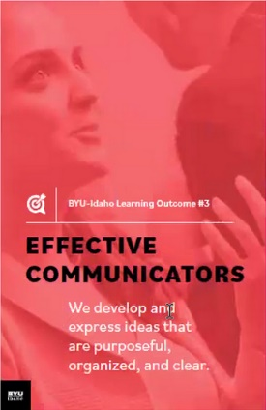Skilled Collaborators
  + We work effectively with others to accomplish a shared vision.

**NOTE: All I.L.O.s need a project.**

# Four Project Breakdown:

A project will consist of the following parts

* List the values associated with the project & a statement of the project vision
* Describe each of your roles
* A statement of your vision of success
* Each project must be a minimum of 10-20 hours.
* The project will have a Specific, Measurable, Achievable, Realistic, Timely Goal.
* Definition of the Goal: Who, What, Where, When, How & Why
* List of Milestone, Achievements, Checkpoints, and Deliverables.

What should you do for your project? That is up to you and your team. You and your team will have to have some brainstorming ideas. Research some ideas, have backup ideas, and work together to synergize to come up with an innovative project.

## Types of Projects

Acorn projects are small; they are smaller than class projects and bigger than individual and team assignments. You work on the Acorn Projects as a team.

Examples of Acorn project:

Rules: You may use one of these examples as is. You may modify another. The other two you must come up with as a team.

* Attend a [Career Services](https://www.byui.edu/career/preparation) event as a team and work on a deliverable
* Participate in “[Get Involved](https://www.byui.edu/get-involved)”: Recreation, Ushering, Get Connected, I-Serve, Peer Mentoring, Rep Council, Tutoring
* Participate in a service project, service information, training that will help other students at BYU-Idaho.
* Create a program together, use a collaborative tool and resource repository.
* Join a Department Society and work together to contribute to a project
* Attend a Society Event such as a Hack-A-Thon, participate as a team
* Participate in a Sport, Sporting Event, or Team activity
* Attend a Leadership conference/activity produced by Student Services
* Participate in an Escape Room, Rope Course, or similar activity
* Discover 4+ campus building activities: for example Geology, Animal, Garden tour, Planetarium
* Plan three group date, with at least 3 activities
* Play 5 different players vs the board, 2-3 times, or an RPG game

# Participation

Each project should be a significant effort. It will require some brainstorming, planning, execution, and reflections.

Each project should for the team be about 10-20 hours cumulative, with multiple sessions. If there are four in a group, this breaks down to 2-4 hours each. I suspect that you will be around 3-5 hours each.

You work together as a team and do not split up the projects individually among yourselves.

# Brainstorming

The following are tools and concepts you should know about brainstorming and managing your team’s project and members. We will be covering each of these throughout the semester in detail and are here for reference and reminders.

* 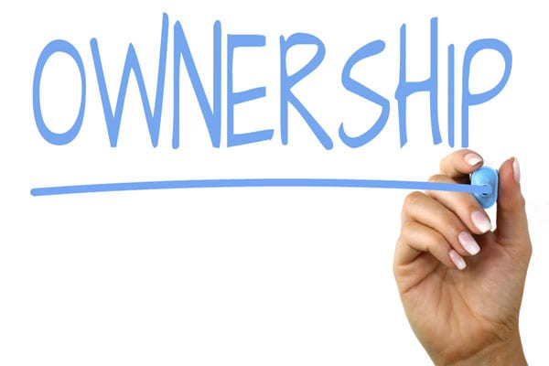Ownership
  + Ownership is one of the hardest things to learn. Ownership is taking the goal of the team and making it yours. It goes along with the scripture, “Be One.” You put your whole might, mind, heart, and soul into it.
* Listening
  + Listening is a key element in brainstorming. We have two ears and one mouth. For some reason, our ear does not hear when our mouth is moving and making sounds. Lord intended us to listen twice as much as we talk. If it became a problem, use the tool “the Talking stick,” which the person holding the stick gets to talk about, then pass it along.
  + “Seek first to understand, then to be understood” – Steven R. Covey
* Brainstorming
  + This process is where you through ideas on the wall and vote on them. It is best to come prepared with 4-5 ideas, accept other ideas, and be prepared to have your ideas merge with others to be better ideas.
  + A couple of questions to ask to help with the process
    - If you had unlimited finances, what would you do?
    - If you had magic, what would you do?
    - If you had unlimited time, what would you do?
* Problem Solving
  + We are problem solvers. For thousands of years, your ancestors solved problems. You can solve problems. The problem sometimes is making a choice and committing to it.
  + Steps: Describe the problem, gather information, determine important factors, visualize the solution, create action steps.
* Decision making
  + Do not get stuck in the analysis paralysis loop, which is thinking about a solution and not taking any action. Pick a solution and go with it. A boat never sails if it does not get in the water.
  + Sort, Rank, and Vote on the solution. And then do it. The change will happen along the way that will make it better.
* Conflict Management
  + 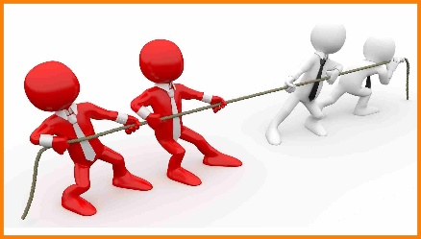 Everyone has different experiences and opinions based on those experiences. Everyone has different backgrounds and values-based on those backgrounds. That is ok and is necessary. Without conflict, a boat does not sail, and planes don’t fly. We do not strengthen our muscles, bones, and tendons. Good Conflict Management creates a space where ideas can share, discuss, analyze, poked at, torn apart, and put back together better, without insults, put-downs, or negative feels.
  + “You can empower yourself, but can only encourage others.”
  + Tools: Negotiate with rules and limits, be cooperative, be direct, be aware of yourself and others, establish trust, be open.
* Communication
  + Oh, communication. Say what you mean. Say what you are going to say, say it, and say what you said. Keeping your thoughts back does not work with brainstorming. Letting everyone participate is also just as important. Being present is also needful.
    - Form of Communication: Nonverbal, Oral, and Written
    - Blueprint of Communication: Message, Sender, and Receiver
    - Assure good communication: Common ground, Sincerity, Authority (to act, not be acted upon), and clarity.
    - Barriers of Communication: lack of receptiveness and a good environment.
* 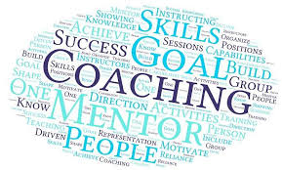Coaching and Mentoring
  + Ask for help is necessary. Ask to have some to report to also necessary. You don’t think you need a coach; you can do it on your own. Think again. Every professional has a coach; that is how they got to be a professional—sports, Business, C.E.O., etc.
* Change
  +  Things are going to change; plan on it. The first plan never works out. The original idea will not be the final product. Being adaptable is necessary. Ask a carpenter if every cut is exact or is just close enough. Ask an artist if all lines are straight. An Engineer is there no tolerances. Build in the wiggle room.
    - When change is needed, leading change can make it happen
    - How to lead change: recognize the change, empower others to make the change, base change on value, mission, and vision, establish urgency, move ahead with the unknowns (manage and mitigate the risks, don’t get stuck in analysis paralysis),
* 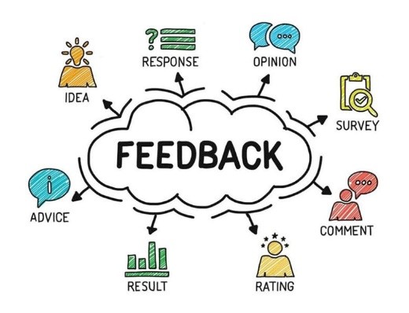Feedback
  + You are going to receive feedback. Prepare for it. That is how you learn. Make sure you go in without your eye wide shut, seeing but not seeing. Other perspectives allow you to see what you forgot you saw. Remember, the feedback is not you. It is reality. It is you being looked at through someone else’s eyes and mind, repeated back to you through your eyes and mind. It is like taking a photograph, making a drawing of it, and then you are describing what you saw from the drawing. Receiving feedback is like receiving the word at the end of the play, the game Telestrations.
  + “Consider feedback to be a gift. It truly is.”

# Acorn Project Worksheet Explanation

Record the summary of your brainstorming activities.

## Project Influence

Pick one of the following:

* Self
  + 🞏Belief: Consciousness
  + 🞏Actions: Conduct
* Group
  + 🞏Belief: Connectedness
  + 🞏Action: Interaction
* Community
  + 🞏Belief: Representation
  + oAction: Cooperation

Explain how this project will Influence you, your team/group, or the community.

## Project Mission Focus:

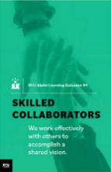Identify 1 of the following for this Project Goal. Must have one project goal for each I.L.O.

* 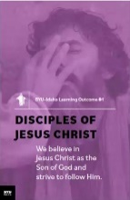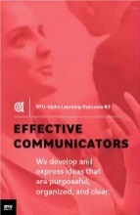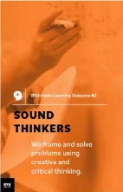oDisciple of Jesus Christ
* 🞏Sound Thinkers
* 🞏Effective Communicators
* 🞏Skilled Collaborators

## Personal Values

Values are our core beliefs or desires that guide or motivate our attitudes and actions. List your values and the forms that they take; principles, standards, personal qualities, character traits, or ethics codes.

## Vision Statement

A vision is a picture of future success. Our vision is when we think far enough to realize that there will be challenges for which we can prepare.

## S.M.A.R.T. Goals

*“A Goal Without a Deadline is Only a Dream!”*

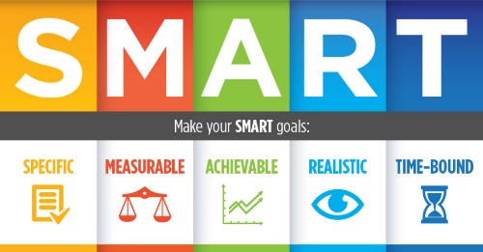Define your Acorn project as a “SMART” (**S**pecific, **M**easurable, **A**ttainable, **R**elevant, and **T**imely) goal.

* **Specific** - Describe this Acorn Project Goal in enough detail so that you, your teammates, and the instructor know specifically what you are going to do, how it is important, or how it will impact you. Is it challenging?
* **Measurable** - Describe how this Acorn Project Goal is Measurable**.** How will you know when the goal is completed? What is your exit strategy? What are the milestones?
* **Attainable** - Describe how this Acorn Project Goal is Attainable**.** Can it be accomplished? You have 10-12 weeks to complete the project with four people.
* **Relevant** – Describe how this Acorn Project Goal is Relevant. How does it relate to BYU-Idaho I.L.O.s? How will it help grow your Acorn into a might oak?
* **Timely** - Describe how this Acorn Project Goal is Timely**.** Can it be accomplished in a reasonable amount of time? Ten cumulative hrs. minimum per project

Re-write the SMART goal as a single sentence.

## Milestones

It takes more than one step to complete goals. List up to 10-12 milestones, achievements, checkpoints, or deliverables for your goal. Following the network of high-level objectives, break down each objective into separate activities necessary to accomplish it. Order and prioritize the activities by the longest and plan.

# Approval of Project

You will submit your projects for review & approval to your instructor. Expect a week for feedback. You can continue as if it was approved; meanwhile, your instructor will give you additional tasks and ideas to improve the projects. Submit a final revision with changes for approval.

# Update Software Concept. Upgrade System Icon. Application Status.. Royalty Free Cliparts, Vectors, And Stock Illustration. Image 126610927.Bi-Weekly Status of Project

As mentioned in the brainstorming, you will have changes, conflicts, decision making. Change is normal. Each week you need to meet with your team to discuss the progress of your Acorn Projects. You can complete them in sequence or parallel.

You will be required to provide the status of your Acorn projects every other week. You will need to indicate the **percentage done**.

# Stages of Team Development

As you move with your Acorn project, you and your team will hit some challenges and accomplish some breakthroughs. Here is a guide to let you know what you will face as your team pulls together. It is expected that each goal has multiple sessions/milestones, to show these phases.

The first stage in a team’s development is **Forming** (“Pickup Sticks,” “Polite”).

Most team members are eager to be on the team. However, they often come with high, unrealistic expectations. These expectations come with some anxiety about how they will fit in, how much they can trust others, and how much time to set aside. Team members are also unclear about norms, roles, goals, and timelines. In this stage, there is a high dependence on the leading figure for purpose and direction. Behavior is usually tentative and polite. The major issues are personal well-being, acceptance, and trust.



The second stage in a team’s development is **Storming** (“At Odds,” “Testing”).

As the team gets some experience working together under their belt, there is a dip in morale as team members experience discrepancies between their initial expectations and reality. The difficulties in accomplishing the task and working together lead to confusion and frustration, and growing dissatisfaction. Negative reactions to each other develop, and subgroups form, which polarize the team. The breakdown of communication and the inability to problem-solve result in lowered trust. The primary issues in this stage concern power. Control and conflict.

The third stage in a team’s development is **Norming** (“Coming Around,” “Valuing”).

As the issues encountered in the second stage are addressed and resolved, morale begins to rise. Task accomplishment and technical skills increase, contributing to a positive, even euphoric feeling—clarity and commitment increase on purpose, values, norms, roles, and goals. Trust and cohesion grow as communication becomes more open and task-oriented. There is a willingness to share responsibility and control. Team members value the differences among themselves. The team starts thinking in terms of “we” rather than “1.1! Because the newly developed feelings of trust and cohesion are fragile, team members avoid conflict for fear of losing the positive climate. This reluctance to deal with conflict can slow progress and lead to less effective decisions. Issues at this stage concern the sharing of control and avoidance of conflict.

The fourth stage in a team’s development is **Performing** (“As One,” “Trusting”).

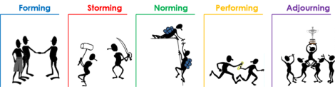At this stage, both productivity and morale are high, and they reinforce one another. There is a sense of pride and excitement in being part of a high-performing team. The primary focus is on performance. The purpose of roles and goals are clear. Standards are high, and there is a commitment to meeting standards and continuous improvement. Team members are confident in their ability to perform and overcome obstacles. They are proud of their work and enjoy working together. Communication is open, and leadership is shared. Mutual respect and trust are the norms. Issues include continued refinements and growth.

## Pushing Through

As mentioned in the brainstorming, you will have changes, conflicts, decision-making. Each week you need to meet with your team to discuss the progress of your Acorn Projects. You can complete them in sequence or parallel.

You will be required to provide the status of your Acorn projects every other week. You will need to indicate the **percentage done**.

## The finish line

No runner stops exactly at the finish line; No athlete walks straight to the car and goes home; No engineer throws away all the equipment after an experiment. After camping, what do you keep and what do you throw away. There is clean up, reflection, lessons learned, and preparing to do it again.

You will need to complete the following for each Acorn:

1. Presentation
   1. Your team will be required to present a 3-5 minute briefing of your Acorn Project to the class.
2. Lessons Learned
   1. You need to reflect on the vision and goal of the project. Think if you were to do each of the projects again, how would you do better. What advice would you give someone?
   2. You need to have at least two lessons learned for each of the 4 Acorn Projects.
   3. Also, additional lesson learned on your team dynamics.
3. S.T.A.R
   1. Write up a summary of your experience in the following format
      1. 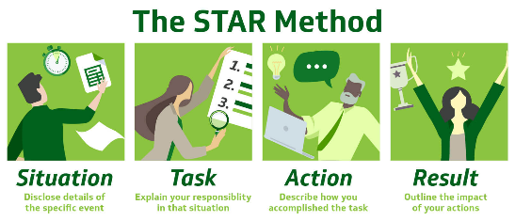S. Situation
      2. T. Task
      3. A. Achievement
      4. R. Results
4. Participation
   1. Each of you will provide a report on how you participated and
   2. Each of you will report on how each member of the team participated.
   3. As a team, you will determine how many hours you spend on each project.
5. Stop, Start, and Continue
   1. As a team and as an individual, you need to reflect on three things:
      * Stop: List an item that your team and yourself that you need to stop doing that hindered the team and project.
      * Start: List an item that would improve and innovate the project.
      * Continue: List items that went well and is necessary for the success of the project
   * Complete Stop, Start, and Continue for each of your projects.

# Presentation of Acorns Ceremony

On the Last of Class, we will have a ceremony where I will present you with four Acorns, one for each project that you completed.



## Other Resources

* <https://www.byui.edu/mighty-oaks>

**Acorn Project Worksheet**

**Project Mission Focus:** Disciple of Jesus Christ

* **Team Name: Flamming Kumquate**
* **Team member’s Names: Parker Jackman, Braxton Medeiros, Silas Carlos, Luke Warner**
* 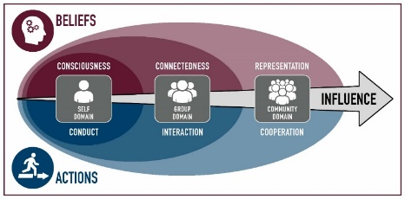**Project Title:** Come Follow Me
* **Project Influences:**

|  |  |  |
| --- | --- | --- |
|  | **Belief** | **Actions** |
| **Self** | oConsciousness | oConduct |
| **Group** | oConnectedness | oInteraction |
| **Community** | oRepresentation | oCooperation |

**Explain:** When we are going to discuss a topic that is potentially sensitive having good conduct that is respectful is important, interaction is the what the whole project is. A form of communication is important. We will have to share a connection in sharing our ideas and testimonies.

* f**Project Values:** Spiritual reliance, gospel learning, educational, personal improvement, testimony building, idea sharing, communication.
* **Description:** We are going to discuss Come Follow Me for two weeks. It will require each member to take time to study and meet as a group once for each week.
* **Vision Statement:**  To help us come closer to Jesus Christ and share ideas and beliefs with each other.
* **SMART Goal:** To spend two hours studying Come Follow Me by meeting twice and discuss the weekly Come Follow Me that we studied on our own and sharing our ideas and insights.
  + Specific: Spend an hour discussing come follow me twice over two weeks with personal study
  + Measurable: We did meet up, and for how long
  + Attainable: It is easily doable and all can participate in the meetings
  + Relevant: It will help develop faith in Christ while letting us practice working as a team
  + Timely: It is over two weeks and that is plenty feasible

***Summary***: To spend adequate time discussing the gospel as a group

* **Audience (*Who, What, Where, When, Why, How*):**
  + **Who:** us
  + **What: the gospel**
  + **Where: STC**
  + **When: weekly**
  + **How: Sharing ideas**
* **Roles and Responsibilities:**

**Role Responsibilities**

* + **1:Lead Prepare questions and lead discussions**
  + **2:Standard Read the scriptures and come with ideas and insights to share**
  + **3: “”**
  + **N: “”**
* **Milestones**
  + 1. Preparedness week 1
  + 2.First meeting
  + 3.Preparedness week 2
  + 4.Second meeting
* **Instructor Improvements Suggestions**:
  + _________________________________________________________
  + __________________________________________________________

[ ] **Approved** Date: __________________

**Acorn Project Worksheet**

**Project Mission Focus:** Sound Thinkers

* **Team Name: Flamming Kumquate**
* **Team member’s Names: Parker Jackman, Braxton Medeiros, Silas Carlos, Luke Warner**
* **Project Title:** Crafting with the bois
* **Project Influences:**

|  |  |  |
| --- | --- | --- |
|  | **Belief** | **Actions** |
| **Self** | oConsciousness | oConduct |
| **Group** | oConnectedness | oInteraction |
| **Community** | oRepresentation | oCooperation |

**Explain:** We all must know what we are doing and contributing to the group. We have to take on roles assigned to us to complete specific tasks. We must share resources. We must act towards common goal and not be distracted.

* **Project Values:** Teamwork, Resourcefulness, self-control, game/rule knowledge, survival skills, spatial awareness
* **Description:** We will be creating a world in the game Minecraft in which we will build a base, acquire resources, and ultimately defeat the Ender Dragon.
* **Vision Statement:** We want to hone in our teamwork skills and coming up with strategies to quickly and efficiently defeat the end-game boss in Minecraft.



* **SMART Goal:** To successfully build a base, acquire hardware, and defeat the Ender dragon within a total of 20 hours or less.
  + Specific: Our milestones are clear
  + Measurable: The completion of tasks are y/n and the time limit is measurable
  + Attainable: This goal is very attainable and some of us have experience in this game
  + Relevant: To defeat the dragon quickly, it will require skill and cooperative teamwork
  + Timely: This will be accomplished in the time restraint set

***Summary***: To successfully build a base, acquire hardware, and defeat the Ender dragon within a total of 20 hours or less.

* **Audience (*Who, What, Where, When, Why, How*):**
* **Who: us**
* **What: The video game Minecraft**
* **Where: STC study room**
* **When: Two 2 hour sessions after classes on Monday and Wednesday**
* **Why: It’s a fun way to work on team building skills and it peaks all our interests**
* **How: On our laptops connected via local network**
* **Roles and Responsibilities:**

**Role Responsibilities**

* + **1: Leader To assign tasks to be accomplished as a team and individually**
  + **2: Player To complete the tasks given in order to further the game with better resources**
  + **3: “”**
  + **N: “”**
* **Milestones**
  + 1. HQ built
  + 2. Acquiring diamonds
  + 3. Portal located and activated
  + 4. Defeating the dragon
* **Instructor Improvements Suggestions**:
  + _________________________________________________________
  + __________________________________________________________

[ ] **Approved** Date: __________________

**Acorn Project Worksheet**

**Project Mission Focus:** Effective Communicator

* **Team Name: Flamming Kumquate**
* **Team member’s Names: Parker Jackman, Braxton Medeiros, Silas Carlos, Luke Warner**
* **Project Title:** Dungeons & Dragons
* **Project Influences:**

|  |  |  |
| --- | --- | --- |
|  | **Belief** | **Actions** |
| **Self** | oConsciousness | oConduct |
| **Group** | oConnectedness | oInteraction |
| **Community** | oRepresentation | oCooperation |

**Explain:** When playing dungeons and dragons we have to be self-conscious and properly conduct ourselves. As a group we need to make sure we are connecting and interacting with each other. We need to work together to accomplish our goal while the dungeon master will facilitate our actions and make sure we are in line. In our journey we will have to cooperate with each other.

* **Project Values:** Teamwork, communication, a little bit of luck, self-control, cooperation, and helpfulness
* **Description:** We will need to first take time to create our different characters while the dungeon master creates the campaign. We then will get together and play the campaign. We will need to work together and try our best to complete the campaign.
* **Vision Statement:** We will work together to complete the adventure ahead of us. We will deal with problems that arise.



* **SMART Goal:** To build our characters successfully. We also want to successfully work together to accomplish the adventure set up for us by the dungeon master in under 15 hours.
  + Specific: Yes, it is
  + Measurable: The tasks are measurable and there is a time limit.
  + Attainable: It is possible to accomplish it given all the information
  + Relevant: To accomplish the task, we will need to be effective communicators.
  + Timely: This will be accomplished in the time restraint given.

***Summary***: We will spend an hour building our character sheets. We will then use the rest of the time to accomplish our adventure.

* **Audience (*Who, What, Where, When, Why, How*):**
* **Who: The Flamming Kumquate’s**
* **What: The role-playing game Dungeons and Dragons**
* **Where: STC study rooms**
* **When: Two hour sessions after class Monday and Wednesday**
* **Why: It accomplishes the requirements and it is our groups interest**
* **How: By working together**
* **Roles and Responsibilities:**

**Role Responsibilities**

* + **1: Dungeon Master- To set up and facilitate the adventure**
  + **2: Tank- To be the person to take the majority of damage in fights**
  + **3: Support- To support the party in fights**
  + **N: Fighter- To do a lot of damage in fights**
* **Milestones**
  + 1. Create our characters and adventure
  + 2. Start the adventure
  + 3. Use D&D mechanics to see what happens
  + 4. Accomplish the adventure
* **Instructor Improvements Suggestions**:
  + _________________________________________________________
  + __________________________________________________________

[ ] **Approved** Date: __________________

**Acorn Project Worksheet**

**Project Mission Focus:** Skill Collaborators

* **Team Name: Flamming Kumquate**
* **Team member’s Names: Parker Jackman, Braxton Medeiros, Silas Carlos, Luke Warner**
* **Project Title:** Cooking the heat or something
* **Project Influences:**

|  |  |  |
| --- | --- | --- |
|  | **Belief** | **Actions** |
| **Self** | oConsciousness | oConduct |
| **Group** | oConnectedness | oInteraction |
| **Community** | oRepresentation | oCooperation |

**Explain: We must plan and cook a meal together. Therefore, we must plan and coordinate on what we like to eat, what we can realistically cook, and any allergies. As a group we will plan a meal using ingredients that can be purchased from a local grocery store and then assemble and cook those ingredients in a specified order outlined by a recipe that was previously selected by all members of the group.**

* **Project Values: Teamwork, communication, reading, corporation, patience, reading recipes, critical thinking skills.**
* **Description: As a group we will plan and prepare a meal that is determined sufficient by the group.**
* **Vision Statement: Our goal is to create a delicious meal that is edible by human beings. Furthermore, our goal is to hone our critical thinking and teamwork skills to plan and cook a meal together.**
* **SMART Goal:**
  + Specific: Plan and cook a meal
  + Measurable: The food
  + Attainable: We were successfully able to make a meal
  + Relevant: To successfully able to make a meal we must home in our teamwork skills and work together as a team
  + Timely: This will be accomplished on a date set by the team

***Summary***: As a team we will plan and cook a meal, which will be accomplished once we successfully make a meal, on a date set by the team to home in our teamwork skills and work together as a team.

* **Audience (*Who, What, Where, When, Why, How*):** 
  + **Who: Our team**
  + **What: Plan and cook a meal**
  + **Where: Probably someone’s house/apartment**
  + **When: A date determined by the team**
  + **Why: To practice our insane cooking skill and to better ourselves as a team**
  + **How: Using our brains?**
* **Roles and Responsibilities:**

**Role Responsibilities**

* + **1: Head Chef or something (leader) Be able to tell everyone what to do and how to do it**
  + **2: Cook Listen to the leader and do what they say**
  + **3: Cook Listen to the leader and do what they say**
  + **N: Cook Listen to the leader and do what they say**
* **Milestones**
  + 1. Prepare and choose what recipes
  + 2. Get ingredients
  + 3. Meet up
  + 4. Cook the meal
  + 5. Eat the meal
  + 6. Enjoy
* **Instructor Improvements Suggestions**:
  + _________________________________________________________
  + __________________________________________________________

[ ] **Approved** Date: __________________