CL Tutorial 4

# Exercise 1

Assuming $c⊨¬b, c⊨¬a$

By contraposition, $a⊨¬c, b⊨¬c$

$$\frac{a⊨¬c b⊨¬c}{a∧b⊨¬c}$$

$$\frac{a∧b⊨¬c}{c⊨¬(a∧b)}$$

Also,

$$\frac{c⊨¬a c⊨¬b}{c⊨¬a∨¬b}$$

Both of these proofs involve only equivalences, and both of them start from the same two premises. It follows that they can be combined to give the equivalence

$$\frac{c⊨¬(a∧b)}{c⊨¬a∨¬b}$$

Now, we can use this equivalence in the following proofs:

$$\frac{ }{\frac{¬a∨¬b⊨¬a∨¬b}{¬a∨¬b⊨¬(a∧b) }}$$

$$\frac{ }{\frac{¬(a∧b)⊨¬(a∧b)}{¬(a∧b)⊨¬a∨¬b}}$$

Interpreting $⊨$ as set inclusion, this means that $¬a∨¬b⊆¬(a∧b)$ and $¬(a∧b)⊆¬a∨¬b$, that is,

$$¬(a∧b)=¬a∨¬b$$

which is the second of De Morgan’s laws.

# Exercise 2

Write a proof which reduces the conclusion $(x∧y)∨(x∧z)⊨x∧(y∨z)$ to premises that can’t be reduced further.

1. (the intersection of $x$ and $y$) conjoined with (the intersection of $x$ and $z$) looks like  
   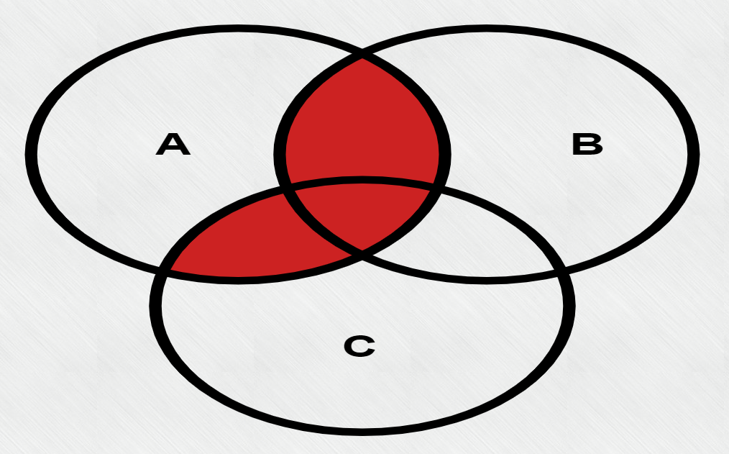  
   where $x$ = A, $y$ = B, $z$ = C.
2. The intersection of $x$ and (the conjunction of $y$ and $z$) looks like  
   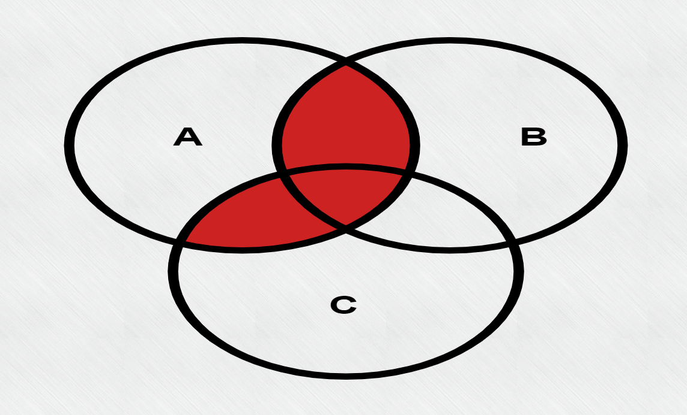  
   where $x$ = A, $y$ = B, $z$ = C.

A set of reduced premises would be $z⊨x, y⊨x$.

The set is not universally valid, as a universe with no $y$ would not fill the intersection of $x$ and $y$, so the existential assumption is required.

# Exercise 3

Write a proof which reduces the conclusion $⊨ (x ∧ ¬y) ∨ (¬(x ∨ z) ∨ (y ∨ z))$ to premises that can’t be reduced further.

1. (X and not Y) or (not (X or Z) or (Y or Z))
2. If X or Z are false, truth propagates from $¬(x ∨ z)$ all the way out.
3. For the other two cases (X & Z are true, Y is true or false),
   1. if Y is false, $(x ∧ ¬y)$ makes the statement true.
   2. if Y is true, $(y ∨ z)$ makes the statement true.
4. The statement is always true.

The statement is a tautology as it is true by necessity.

# Exercise 4

The second cannot be reduced as it is invalid, $¬\left(a ∧ b\right)$ is a superset of $¬a ∧ ¬b.$

Neither one is universally valid, and the counterexample for the first is a universe with no examples of $¬a$ and $¬b$ and $¬c$.

The counterexample for the second is an example within $a$ but not within the intersection of $a$ and $b$.