CL Tutorial 6

# Exercise 1

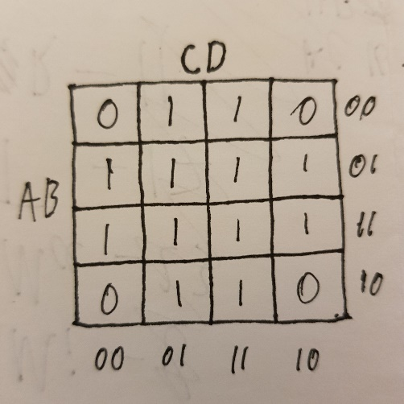

There are two clauses in this expression, B and D.

The Karnaugh map of this expression is on the right:

The block of zeros for D is in orange, the block of zeros for B is blue.

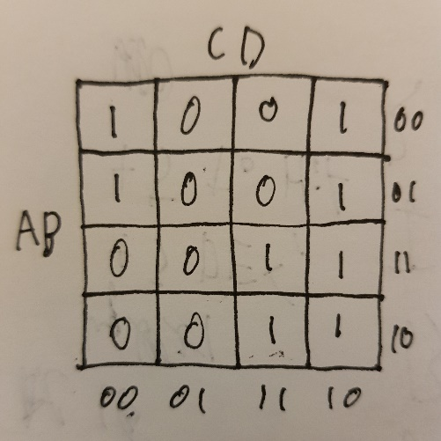

$(¬A∨C)∧(A∨¬D)$

There are two clauses in this expression, $(¬A∨C)$ and $(A∨¬D)$.

The Karnaugh map of this expression is on the right:

The block of zeros for $(¬A∨C)$ is in orange, the block of zeros for $(A∨¬D)$ is blue.

# Exercise 2

X1: $¬D\bigvee{¬A}$

Y1: $D⋁A$

X2: $\left(C⋁B\right)⋁A$

Y2: $(¬C\bigwedge{¬B)⋀(¬A)}$

# Exercise 3

$r↔(a∧b)$

Karnaugh map:

CNF from map: $\left(¬B⋁R\bigvee{¬A}\right)⋀(¬B\bigvee{¬R}⋁A)⋀(B\bigvee{¬R})$

$r↔(a→b)$

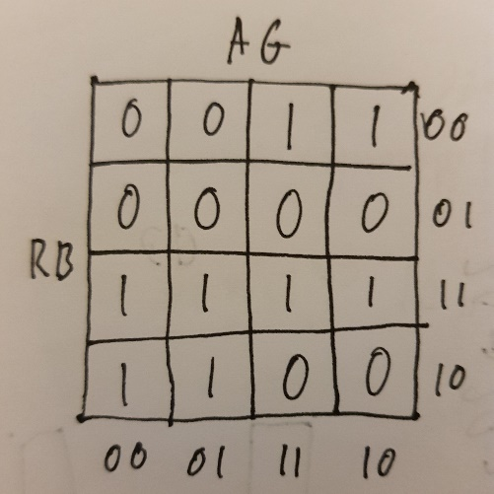Karnaugh map:

CNF from map: $\left(R⋁A\right)⋀(¬A\bigvee{¬R}⋁B)⋀(¬A⋁R\bigvee{¬B})$

# Exercise 4

For each of the following pairs of clauses, draw a Karnaugh map and show the two blocks of zero states corresponding to the two clauses:

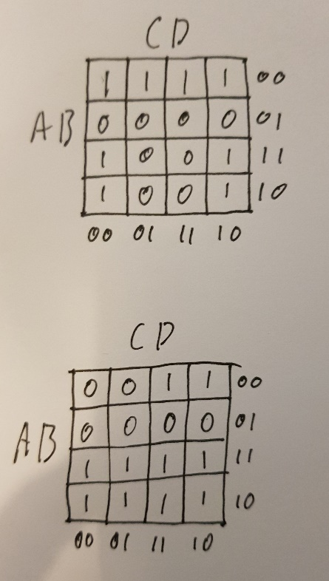

1. 𝐴 ∨ ¬𝐵, ¬𝐴 ∨ ¬𝐷

2. 𝐴 ∨ ¬𝐵, 𝐴 ∨ 𝐵 ∨ 𝐶

Use these Karnaugh maps to identify new clauses Δ1 and Δ2, different from both premises, such that the following sequents are valid:

1. 𝐴 ∨ ¬𝐵, ¬𝐴 ∨ ¬𝐷 ⊧ Δ1

Δ1 = ¬𝐵 ∨ ¬𝐷

1. 𝐴 ∨ ¬𝐵, 𝐴 ∨ 𝐵 ∨ 𝐶 ⊧ Δ2

Δ2 = 𝐴 ∨ 𝐶

How many different solutions can you find for clauses Δ1 and Δ2?

As solutions will always form contiguous blocks of zeroes in the shapes [1x1, 1x2, 2x1, 2x2, 4x1, 1x4, 2x4, 4x2, 4x4], 1. has 19 valid clauses total, of which two are already excluded, so there are 17. For 2. there are 14, of which two are already excluded, so there are 12.