Cl Tutorial 8

# Exercise 1

Convert $r↔\left(s↔t\right)$ to CNF

$a ↔ b = (a → b) ∧ (b → a)$, so

$$(r→\left(s↔t\right)) ∧ (\left(s↔t\right) → r)$$

And again

$$(r→(\left(s → t\right)∧ \left(t → s\right))) ∧ ((\left(s → t\right)∧ \left(t → s\right)) → r)$$

$a→b=¬a∨b$, so

$$(¬r∨(\left(¬s∨t\right)∧ \left(¬t∨s\right))) ∧ (¬(\left(¬s∨t\right)∧ \left(¬t∨s\right))∨r)$$

$(a∧b)∨c=(a∨c)∧(b∨c),$ so

$$(\left(\left(¬s∨t\right)∨¬r\right)∧\left(\left(¬t∨s\right)∨¬r\right)) ∧ (¬\left(\left(¬s∨t\right)∨r\right)∧\left(\left(¬t∨s\right)∨r\right))$$

Removing brackets,

$$\left(¬s∨t∨¬r\right)∧\left(¬t∨s∨¬r\right) ∧ (¬\left(¬s∨t∨r\right)∧\left(¬t∨s∨r\right))$$

# Exercise 2

Give an equivalent logical expression:

$$\left(¬a ⋀ b\right) ⋁ (a ⋀ ¬b)$$

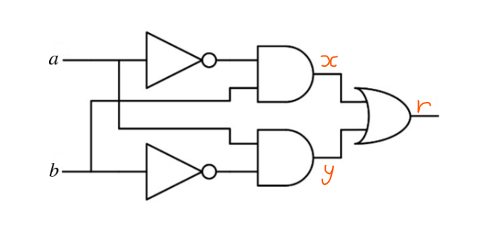Apply the Tseytin transformation to give an equisatisfiable CNF expression:

$$y↔a ⋀ ¬b$$

$$\left(y ⋁ ¬a ⋁ b\right) ⋀ \left(¬y ⋁ a\right) ⋀ (¬y ⋁ ¬b)$$

$$x↔¬a ⋀ b$$

$$\left(x ⋁ a ⋁ ¬b\right) ⋀ \left(¬x ⋁ ¬a\right) ⋀ (¬x ⋁ b)$$

$$r↔x ⋁ y$$

$$\left(¬r ⋁ x ⋁ y\right) ⋀ \left(r ⋁ ¬x\right) ⋀ (r ⋁ ¬y)$$

Assume r is true:

$$\left(x ⋁ y\right) ⋀ 1 ⋀ 1$$

Merge:

$$\left(x ⋁ y\right) ⋀ \left(y ⋁ ¬a ⋁ b\right) ⋀ \left(¬y ⋁ a\right) ⋀ (¬y ⋁ ¬b) ⋀ \left(x ⋁ a ⋁ ¬b\right) ⋀ \left(¬x ⋁ ¬a\right) ⋀ (¬x ⋁ b)$$

# Exercise 3

Apply the Tseytin transformation to the expression

$$(¬a∨c)∧(b→((a∨c)↔d))$$

to give an equisatisfiable CNF expression.

$$\left(¬a ⋁ c\right) ⋀ (¬b ⋁ (\left(¬d ⋁ a ⋁ c\right) ⋀ \left(d ⋁ ¬a\right) ⋀ (d ⋁ ¬c))$$

$(a∧b)∨c=(a∨c)∧(b∨c)$, so

$$(¬a ⋁ c) ⋀ ((¬d ⋁ a ⋁ c) ⋁ ¬b) ⋀ (((d ⋁ ¬a) ⋀ (d ⋁ ¬c)) ⋁ ¬b))$$

Again,

$$(¬a ⋁ c) ⋀ ((¬d ⋁ a ⋁ c) ⋁ ¬b) ⋀ ((d ⋁ ¬a)∨¬b)∧((d ⋁ ¬c)∨¬b)$$

Removing brackets:

$$(¬a ⋁ c) ⋀ (¬d ⋁ a ⋁ c ⋁ ¬b) ⋀ (d ⋁ ¬a∨¬b)∧(d ⋁ ¬c∨¬b)$$

# Exercise 4

1. 2
2. 6
3. 3

# Exercise 5

1. 3
2. 5