Pramod Sivaram Kaushik(201407538)
Mohd Salman Khan(201305513)
Sajal Sharma(201305526)

Project 2 : Data Classification

Datasets:

Yale Dataset
The dataset is taken from Original Yale Face Dataset (http://vision.ucsd.edu/content/yale-
face-database). The Yale Face Database (size 6.4MB) contains 165 grayscale images in GIF
format of 15 individuals. There are 11 images per subject, one per different facial expression
or configuration: center-light, w/glasses, happy, left-light, w/no glasses, normal, right-light,
sad, sleepy, surprised, and wink.

Some of the images are given below :

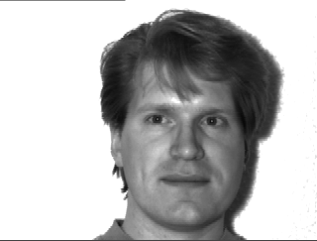
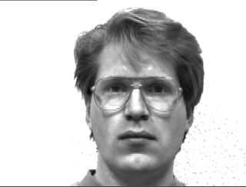
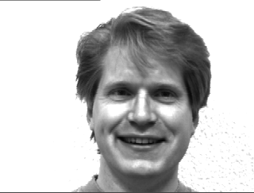

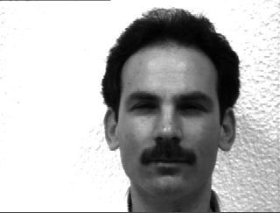
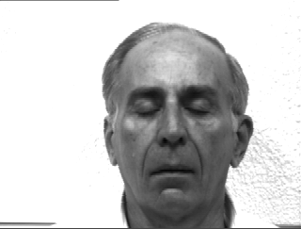

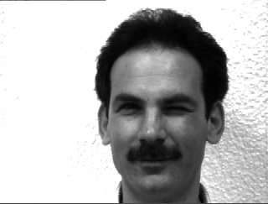

Handwriting Recognition Dataset(MNIST)
The MNIST database of handwritten digits, available from this page, has a training set of 60,000 examples, and a test set of 10,000 examples. It is a subset of a larger set available from NIST. The digits have been size-normalized and centered in a fixed-size image.
It is a good database for people who want to try learning techniques and pattern recognition methods on real-world data while spending minimal efforts on preprocessing and formatting.

Four files are available on this site:
train-images-idx3-ubyte.gz: training set images (9912422 bytes)
train-labels-idx1-ubyte.gz: training set labels (28881 bytes)
t10k-images-idx3-ubyte.gz: test set images (1648877 bytes)
t10k-labels-idx1-ubyte.gz: test set labels (4542 bytes)

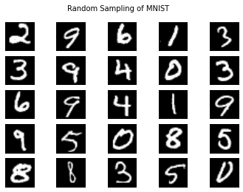
Source Codes & their respective Results:

K-Nearest Neighbours (K = 3) :
(for Yale Dataset)

import os
import sys
import pdb
import glob
import math
import numpy
import random
import operator
from sets import Set
import scipy as scipy
from scipy.misc import *
from scipy import linalg

# This function loads the images, divides the data intro training and test set
def getNeighbors(trainingSet, testInstance, trainingLabels, k):
distances = []
length = len(testInstance)-1

for x in range(len(trainingSet)):
#print(trainingSet[x])
dist = EuclideanDistance(testInstance, trainingSet[x], length)
distances.append((trainingSet[x], dist, trainingLabels[x]))
distances.sort(key=operator.itemgetter(1))
neighbors = []
for x in range(k):
#neighbors.append(distances[x][0])
neighbors.append(distances[x][2])
return neighbors

def getResponse(neighbors):
classVotes = {}
for x in range(len(neighbors)):
response = neighbors[x]
#print('response'+response)
if response in classVotes:
classVotes[response] += 1
else:
classVotes[response] = 1
sortedVotes = sorted(classVotes.items(), key=operator.itemgetter(1), reverse=True)
return sortedVotes[0][0]

def LoadImages(directory, split):
# get a list of all the picture filenames
gifs = glob.glob(directory + '/*.gif')
# uncomment the below line when trying an unknown file
#extraGif = glob.glob("/media/cosmos/Data/College Notes/M.Tech/Semester 4/Statistical Methods in AI/Project - Face Recognition/2.gif")
classMap = {}
testGIF = []
allLabels = []
testLabels = []
trainingGIF = []
trainingLabels = []
for i in range(len(gifs)):
if random.random() < split:
trainingGIF.append(gifs[i])
l = gifs[i].split("/");
labelName = l[len(l)-1].split(".")[0][-2:]
trainingLabels.append(labelName)
allLabels.append(labelName)
else:
testGIF.append(gifs[i])
l = gifs[i].split("/");
labelName = l[len(l)-1].split(".")[0][-2:]
testLabels.append(labelName)
allLabels.append(labelName)
# uncomment the below 2 lines when trying an unknown file
#testGIF.append(extraGif[0])
#testLabels.append("un")
#allLabels.append("un")
trainingImgs = numpy.array([imread(i, True).flatten() for i in trainingGIF])
testImgs = numpy.array([imread(i, True).flatten() for i in testGIF])
# creating a list of class labels
allLabels = set(allLabels)
noOfClasses = len(allLabels)
sortedLabels = []
for i in allLabels:
sortedLabels.append(i)
sortedLabels = sorted(sortedLabels)
# creating a mapping for confusion matrix
j = 0
for i in sortedLabels:
classMap[i] = j
j = j + 1
return trainingImgs,testImgs,trainingLabels,testLabels,noOfClasses,classMap

def EuclideanDistance(instance1, instance2, length):
distance = 0
for x in range(length):
distance += pow((instance1[x] - instance2[x]), 2)
return math.sqrt(distance)

def Mahanalobis(x, y):
return scipy.spatial.distance.mahalanobis(x,y,np.linalg.inv(np.cov(x,y)))

# Run Principal Component Analysis on the input data.
# INPUT : data - an n x p matrix
# OUTPUT : e_faces -
# weights -
# mu -
def PCA(data):
# mean
mu = numpy.mean(data, 0)
# mean adjust the data
ma_data = data - mu
# run SVD
e_faces, sigma, v = linalg.svd(ma_data.transpose(), full_matrices=False)
# compute weights for each image
weights = numpy.dot(ma_data, e_faces)
return e_faces, weights, mu

# This function calculates the weight of the test data
def InputWeight(testData, mu, e_faces):
ma_data = testData - mu
weights = numpy.dot(ma_data, e_faces)
return weights

# Reconstruct an image using the given number of principal components.
def Reconstruct(imgIDx, e_faces, weights, mu, npcs):
# dot weights with the eigenfaces and add to mean
recon = mu + numpy.dot(weights[imgIDx, 0:npcs], e_faces[:, 0:npcs].T)
return recon

# Saves the image in the given directory
def SaveImage(outDIR, subdir, imgID, imgDims, data):
directory = outDIR + "/" + subdir
if not os.path.exists(directory): os.makedirs(directory)
imsave(directory + "/image_" + str(imgID) + ".jpg", data.reshape(imgDims))

# Prints the final results
def PrintResults(wrongPredictedClassCount, unknownLabels, accuracy, correctlyClassifiedDistances, maxDist, confusionMatrix):
print "Number of Wrongly Predicted Labels:",wrongPredictedClassCount
print "Number of Unknown Labels:",unknownLabels
print "Accuracy:",accuracy,"%"
print "Max Distances among correcltly classified:",correctlyClassifiedDistances[len(correctlyClassifiedDistances) - 1]
print "Max Distances among all:",maxDist
PrintConfusionMatrix(confusionMatrix)

# Prints the confustion matrix
def PrintConfusionMatrix(confusionMatrix):
print "Confusion Matrix:"
for i in range(0, len(confusionMatrix)):
print confusionMatrix[i]

# Predicts the class of test data
def PredictLabelsFromTestData(testData, noOfClasses, mu, e_faces, trainingWeights, testLabels, trainingLabels, classMap, thresholdDistance, noOfDimensions, k):
correctlyClassifiedDistances = []
confusionMatrix = [[0 for i in xrange(noOfClasses)] for i in xrange(noOfClasses)]
wrongPredictedClassCount = 0
unknownLabels = 0
for i in range(len(testData)):
testWeight=InputWeight(testData[i],mu,e_faces)
distances = []
for x in range(len(trainingWeights)):
dist = EuclideanDistance(testWeight, trainingWeights[x], noOfDimensions)

#dist = Mahanalobis(testWeight, trainingWeights[x])
distances.append(dist)
neighbors = getNeighbors(trainingWeights,testWeight, trainingLabels, k)
result = getResponse(neighbors)
predictedLabel = result
actualLabel = testLabels[i]
#predictedLabel = ""
minDist = sys.maxint
maxDist = -sys.maxint
for j in range(len(distances)):
if minDist > distances[j]:
minDist = distances[j]
predictedLabel = trainingLabels[j]
if maxDist < distances[j]:
maxDist = distances[j]
confusionMatrix[classMap[actualLabel]][classMap[predictedLabel]] = confusionMatrix[classMap[actualLabel]][classMap[predictedLabel]] + 1
#print "Actual class:",actualLabel
#print "Predicted class:",predictedLabel
#print "Min Dist:",minDist
#print "---------"
if minDist >= thresholdDistance:
predictedLabel = "Unknown"
unknownLabels = unknownLabels + 1
elif predictedLabel != actualLabel:
wrongPredictedClassCount = wrongPredictedClassCount + 1
else:
correctlyClassifiedDistances.append(minDist)
# calculate accuracy
accuracy = (1 - wrongPredictedClassCount / float(len(testData))) * 100
correctlyClassifiedDistances.sort()
PrintResults(wrongPredictedClassCount, unknownLabels, accuracy, correctlyClassifiedDistances, maxDist, confusionMatrix)
return accuracy

def main(arg):
inDIR = "/home/cosmos/CSStuff/SMAI/Project 2 - Classification/input/yalefaces"
outDIR = "/home/cosmos/CSStuff/SMAI/Project 2 - Classification/output/Yalefaces Output"
k = int(arg[0])
imgDims = (243, 320)
split = 0.8
noOfDimensions = 100
thresholdDistance = 18000.0
trainingData, testData, trainingLabels, testLabels, noOfClasses, classMap = LoadImages(inDIR, split)
e_faces, trainingWeights, mu = PCA(trainingData)
# save mean photo
imsave(outDIR + "/mean.gif", mu.reshape(imgDims))
# save each eigenface as an image
for i in range(e_faces.shape[1]):
SaveImage(outDIR, "eigenfaces", i, imgDims, e_faces[:,i])
# reconstruct each face image using an increasing number of principal components
reconstructed = []
for p in range(trainingData.shape[0]):
reconstructed.append(Reconstruct(p, e_faces, trainingWeights, mu, noOfDimensions))
imgID = p
SaveImage(outDIR, "reconstructed/" + str(p), imgID,imgDims, reconstructed[p])
# Predicting Classes for test data
accuracy = PredictLabelsFromTestData(testData, noOfClasses, mu, e_faces, trainingWeights, testLabels, trainingLabels, classMap, thresholdDistance, noOfDimensions, k)
return accuracy

total = 0.0
for i in range(0, 5):
total = total + main(sys.argv[1:])
print "_____________________________________________"
print "Mean Accuracy:",total / 5,"%"

Results:

Number of Wrongly Predicted Labels: 5
Number of Unknown Labels: 0
Accuracy: 84.8484848485 %
Max Distances among correcltly classified: 13029.804586
Max Distances among all: 44376.4745935
Confusion Matrix:
[2, 0, 0, 0, 0, 0, 0, 0, 0, 0, 0, 0, 0, 0, 0]
[0, 4, 0, 0, 0, 0, 0, 0, 0, 0, 0, 1, 0, 0, 0]
[0, 0, 1, 0, 0, 0, 0, 0, 0, 0, 0, 0, 0, 0, 0]
[0, 0, 0, 0, 0, 0, 0, 0, 0, 0, 0, 0, 0, 0, 0]
[0, 0, 0, 0, 2, 0, 0, 0, 0, 0, 0, 0, 0, 0, 0]
[0, 0, 0, 0, 0, 2, 0, 1, 0, 0, 0, 0, 0, 0, 0]
[0, 0, 0, 0, 0, 0, 2, 0, 0, 0, 0, 0, 0, 0, 1]
[0, 0, 0, 0, 0, 0, 0, 1, 0, 0, 0, 0, 1, 0, 0]
[0, 0, 0, 0, 0, 0, 0, 0, 4, 0, 0, 0, 0, 0, 0]
[0, 0, 0, 0, 0, 0, 0, 0, 0, 0, 0, 0, 0, 0, 0]
[0, 0, 0, 0, 0, 0, 0, 0, 0, 0, 1, 0, 0, 0, 0]
[0, 0, 0, 0, 1, 0, 0, 0, 0, 0, 0, 3, 0, 0, 0]
[0, 0, 0, 0, 0, 0, 0, 0, 0, 0, 0, 0, 2, 0, 0]
[0, 0, 0, 0, 0, 0, 0, 0, 0, 0, 0, 0, 0, 2, 0]
[0, 0, 0, 0, 0, 0, 0, 0, 0, 0, 0, 0, 0, 0, 2]
_____________________________________________
Number of Wrongly Predicted Labels: 3
Number of Unknown Labels: 0
Accuracy: 90.3225806452 %
Max Distances among correcltly classified: 14559.4523311
Max Distances among all: 37696.4649247
Confusion Matrix:
[0, 0, 0, 0, 0, 0, 0, 0, 0, 0, 0, 0, 0, 0, 0]
[0, 3, 0, 0, 0, 0, 0, 0, 0, 0, 0, 0, 0, 0, 0]
[0, 0, 1, 0, 0, 0, 0, 0, 0, 0, 0, 0, 0, 0, 0]
[0, 0, 0, 4, 0, 0, 0, 0, 0, 0, 0, 0, 0, 0, 0]
[0, 0, 0, 0, 2, 0, 0, 0, 0, 0, 0, 0, 0, 0, 0]
[0, 0, 0, 0, 0, 2, 0, 0, 0, 0, 0, 0, 0, 0, 0]
[0, 0, 0, 0, 0, 0, 1, 0, 0, 0, 0, 0, 0, 0, 2]
[0, 0, 0, 0, 0, 0, 0, 1, 0, 0, 0, 0, 0, 0, 0]
[0, 0, 0, 0, 0, 0, 0, 0, 0, 0, 0, 0, 0, 0, 0]
[0, 0, 0, 0, 0, 0, 0, 0, 0, 2, 0, 0, 0, 0, 0]
[0, 0, 0, 0, 0, 0, 0, 0, 0, 0, 2, 0, 0, 0, 0]
[0, 0, 0, 0, 0, 0, 0, 0, 0, 0, 0, 2, 0, 0, 0]
[0, 0, 0, 0, 0, 0, 0, 0, 1, 0, 0, 0, 3, 0, 0]
[0, 0, 0, 0, 0, 0, 0, 0, 0, 0, 0, 0, 0, 2, 0]
[0, 0, 0, 0, 0, 0, 0, 0, 0, 0, 0, 0, 0, 0, 3]
_____________________________________________
Number of Wrongly Predicted Labels: 4
Number of Unknown Labels: 0
Accuracy: 88.2352941176 %
Max Distances among correcltly classified: 17670.4641544
Max Distances among all: 37367.8789651
Confusion Matrix:
[2, 0, 0, 1, 0, 0, 0, 0, 0, 0, 0, 0, 0, 0, 0]
[0, 3, 0, 0, 0, 0, 0, 0, 0, 0, 0, 1, 0, 0, 0]
[0, 0, 0, 0, 0, 0, 0, 0, 0, 0, 0, 0, 0, 0, 0]
[0, 0, 0, 4, 0, 0, 0, 0, 0, 0, 0, 0, 0, 0, 0]
[0, 0, 0, 0, 0, 0, 0, 0, 0, 0, 0, 0, 0, 0, 0]
[0, 0, 0, 0, 0, 2, 0, 0, 0, 0, 0, 0, 0, 0, 0]
[0, 0, 0, 0, 0, 0, 1, 0, 0, 0, 0, 0, 0, 0, 0]
[0, 0, 0, 0, 0, 0, 0, 1, 0, 0, 0, 0, 0, 0, 0]
[0, 0, 0, 0, 0, 0, 0, 1, 2, 0, 0, 0, 0, 0, 1]
[0, 0, 0, 0, 0, 0, 0, 0, 0, 3, 0, 0, 0, 0, 0]
[0, 0, 0, 0, 0, 0, 0, 0, 0, 0, 4, 0, 0, 0, 0]
[0, 0, 0, 0, 0, 0, 0, 0, 0, 0, 0, 1, 0, 0, 0]
[0, 0, 0, 0, 0, 0, 0, 0, 0, 0, 0, 0, 2, 0, 0]
[0, 0, 0, 0, 0, 0, 0, 0, 0, 0, 0, 0, 0, 2, 0]
[0, 0, 0, 0, 0, 0, 0, 0, 0, 0, 0, 0, 0, 0, 3]
_____________________________________________
Number of Wrongly Predicted Labels: 5
Number of Unknown Labels: 0
Accuracy: 83.8709677419 %
Max Distances among correcltly classified: 10415.4792513
Max Distances among all: 37176.1344234
Confusion Matrix:
[4, 0, 0, 0, 0, 0, 0, 0, 0, 0, 0, 0, 0, 0, 0]
[0, 1, 0, 0, 0, 0, 0, 0, 0, 0, 0, 0, 0, 0, 0]
[0, 0, 0, 0, 0, 0, 0, 0, 0, 0, 0, 0, 0, 0, 0]
[1, 0, 0, 2, 0, 0, 0, 0, 0, 0, 0, 0, 0, 0, 0]
[0, 0, 0, 0, 0, 0, 0, 0, 0, 0, 0, 0, 0, 0, 0]
[0, 0, 0, 0, 0, 1, 0, 0, 0, 0, 0, 0, 0, 0, 0]
[0, 0, 0, 0, 0, 0, 2, 0, 0, 0, 0, 0, 0, 0, 0]
[0, 0, 0, 0, 0, 0, 1, 1, 0, 1, 0, 0, 0, 0, 0]
[0, 0, 0, 0, 0, 0, 0, 0, 0, 0, 0, 0, 0, 0, 0]
[0, 0, 0, 0, 0, 0, 0, 0, 0, 0, 0, 0, 0, 0, 0]
[0, 0, 0, 0, 0, 0, 0, 0, 0, 0, 4, 0, 0, 0, 0]
[0, 1, 0, 0, 0, 0, 0, 0, 0, 0, 0, 3, 0, 0, 0]
[0, 0, 0, 0, 0, 0, 1, 0, 0, 0, 0, 0, 2, 0, 0]
[0, 0, 0, 0, 0, 0, 0, 0, 0, 0, 0, 0, 0, 3, 0]
[0, 0, 0, 0, 0, 0, 0, 0, 0, 0, 0, 0, 0, 0, 3]
_____________________________________________
Number of Wrongly Predicted Labels: 6
Number of Unknown Labels: 0
Accuracy: 83.3333333333 %
Max Distances among correcltly classified: 12768.2245175
Max Distances among all: 35078.1754419
Confusion Matrix:
[3, 0, 0, 1, 0, 0, 0, 0, 0, 0, 0, 0, 0, 0, 0]
[0, 1, 0, 0, 0, 0, 0, 0, 0, 0, 0, 0, 0, 0, 0]
[0, 0, 2, 0, 0, 0, 0, 0, 0, 0, 0, 0, 0, 0, 0]
[0, 0, 0, 4, 0, 0, 0, 0, 0, 0, 0, 0, 0, 0, 0]
[0, 0, 0, 0, 4, 0, 0, 0, 1, 0, 0, 0, 0, 0, 0]
[0, 0, 0, 0, 0, 2, 0, 0, 0, 0, 0, 0, 0, 0, 0]
[0, 0, 0, 0, 0, 0, 2, 0, 0, 0, 0, 0, 0, 0, 0]
[0, 0, 0, 0, 0, 0, 0, 3, 0, 1, 0, 0, 0, 0, 0]
[0, 0, 0, 0, 0, 0, 0, 0, 3, 0, 0, 0, 0, 0, 1]
[1, 0, 0, 0, 0, 0, 0, 0, 0, 0, 0, 0, 0, 0, 0]
[0, 0, 0, 0, 0, 0, 0, 0, 0, 0, 2, 0, 0, 0, 0]
[0, 0, 0, 0, 0, 0, 0, 0, 0, 0, 0, 0, 0, 0, 0]
[0, 0, 0, 0, 0, 0, 0, 0, 0, 0, 0, 0, 1, 0, 0]
[0, 0, 0, 0, 0, 0, 0, 0, 0, 0, 0, 0, 0, 1, 1]
[0, 0, 0, 0, 0, 0, 0, 0, 0, 0, 0, 0, 0, 0, 2]
_____________________________________________
Mean Accuracy: 86.1221321373 %

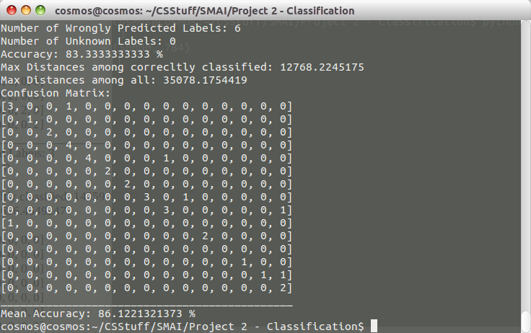

For MNIST Dataset:

import mnist_loader
import os
import sys
import pdb
import glob
import math
import numpy
import random
import operator
from sets import Set
import scipy as scipy
from scipy.misc import *
from scipy import linalg

# Prints the confustion matrix
def getNeighbors(trainingSet, testInstance, trainingLabels, k):
distances = []
length = len(testInstance)-1

for x in range(len(trainingSet)):
#print(trainingSet[x])
dist = EuclideanDistance(testInstance, trainingSet[x], length)
distances.append((trainingSet[x], dist, trainingLabels[x]))
distances.sort(key=operator.itemgetter(1))
neighbors = []
for x in range(k):
neighbors.append(distances[x][2])
return neighbors

def getResponse(neighbors):
classVotes = {}
for x in range(len(neighbors)):
response = neighbors[x]
#print('response'+response)
if response in classVotes:
classVotes[response] += 1
else:
classVotes[response] = 1
sortedVotes = sorted(classVotes.items(), key=operator.itemgetter(1), reverse=True)
return sortedVotes[0][0]

def CreateConfusionMatrix(predictions, testSet):
noOfClasses = 10
confusionMatrix = [[0 for i in xrange(noOfClasses)] for i in xrange(noOfClasses)]
s=set()
for i in testSet:
s.add(i)
l=list(s)
d={}
for x in range(len(l)):
d[l[x]]=x

for x in range(len(testSet)):
if predictions[x]==testSet[x]:
confusionMatrix[d[testSet[x]]][d[testSet[x]]] = confusionMatrix[d[testSet[x]]][d[testSet[x]]] + 1
else:
confusionMatrix[d[testSet[x]]][d[predictions[x]]] = confusionMatrix[d[testSet[x]]][d[predictions[x]]] + 1
return confusionMatrix

def CalculatePrecisionAndRecall(confusionMatrix, noOfClasses, noOfTestSamples):
totalRecall = 0.0
totalPrecision = 0.0
totalSpecificity = 0.0
recall = []
precision = []
specificity = []
#print "Precisions for Different Classes"
#print "________________________________"
for i in range(0, len(confusionMatrix[0])):
classPrecision = 0.0
for j in range(0, len(confusionMatrix)):
classPrecision = classPrecision + confusionMatrix[j][i]
if classPrecision != 0.0:
classPrecision = (confusionMatrix[i][i] / float(classPrecision)) * 100
else:
classPrecision = 0.0
precision.append(classPrecision)
#print "Class Precision for class", i + 1,":", classPrecision
totalPrecision = totalPrecision + classPrecision
#print "Recalls for Different Classes"
#print "________________________________"
for i in range(0, len(confusionMatrix)):
classRecall = 0.0
for j in range(0, len(confusionMatrix[i])):
classRecall = classRecall + confusionMatrix[i][j]
if classRecall != 0.0:
classRecall = (confusionMatrix[i][i] / float(classRecall)) * 100
else:
classRecall = 0.0
recall.append(classRecall)
#print "Class Recall for class", i + 1,":", classRecall
totalRecall = totalRecall + classRecall
for i in range(0, len(confusionMatrix[0])):
numerator = noOfTestSamples - confusionMatrix[i][i]
denominator = numerator
for j in range(0, len(confusionMatrix)):
if i != j:
denominator = denominator + confusionMatrix[j][i]
classSpecificity = (numerator / float(denominator)) * 100
totalSpecificity = totalSpecificity + classSpecificity
specificity.append(classSpecificity)

avgRecall = (totalRecall / float(noOfClasses))
avgPrecision = (totalPrecision / float(noOfClasses))
avgSpecificity = (totalSpecificity / float(noOfClasses))
return avgPrecision, avgRecall, avgSpecificity, precision, recall, specificity

def PrintResults(confusionMatrix, avgPrecision, avgRecall, avgSpecificity, precision, recall, specificity):
print "Confusion Matrix:"
for i in range(0, len(confusionMatrix)):
print confusionMatrix[i]
for i in range(0, len(precision)):
print "Class", i + 1
print "--------"
print "Precision :", precision[i]
print "Recall :", recall[i]
print "Specificity :", specificity[i]
print "\n"
print "-------------------"
print "Average Recall:", avgRecall
print "Average Precision:", avgPrecision
print "Average Specificity:", avgSpecificity

def EuclideanDistance(instance1, instance2, length):
distance = 0
for x in range(length):
distance += pow((instance1[x] - instance2[x]), 2)
return math.sqrt(distance)

def GetAccuracy(testLabels, predictions):
correct = 0

for x in range(len(testLabels)):
if testLabels[x] == predictions[x]:
correct += 1

return (correct/float(len(testLabels))) * 100.0

def main(k):
training_data, validation_data, test_data = mnist_loader.load_data()
k = int(k[0])
predictions=[]
for i in range( len(test_data[0])):
neighbors=getNeighbors(training_data[0],test_data[0][i],training_data[1],k)
result=getResponse(neighbors)
predictions.append(result)
confusionMatrix = CreateConfusionMatrix(predictions,test_data[1])
avgPrecision, avgRecall, avgSpecificity, precision, recall, specificity = CalculatePrecisionAndRecall(confusionMatrix, 10, len(test_data[1]))
PrintResults(confusionMatrix, avgPrecision, avgRecall, avgSpecificity, precision, recall, specificity)
accuracy = GetAccuracy(test_data[1], predictions)
print "Accuracy :", accuracy

main(sys.argv[1:])

Results:

Confusion Matrix:
[967, 0, 1, 0, 0, 5, 4, 1, 2, 0]
[0, 1120, 2, 3, 0, 1, 3, 1, 5, 0]
[9, 1, 962, 7, 10, 1, 13, 11, 16, 2]
[1, 1, 14, 950, 1, 17, 1, 10, 11, 4]
[1, 1, 7, 0, 937, 0, 7, 2, 2, 25]
[7, 4, 5, 33, 7, 808, 11, 2, 10, 5]
[10, 3, 4, 1, 5, 10, 924, 0, 1, 0]
[2, 13, 22, 5, 7, 1, 0, 954, 4, 20]
[4, 6, 6, 14, 8, 24, 10, 8, 891, 3]
[10, 6, 0, 12, 33, 5, 1, 14, 6, 922]
Class 1
--------
Precision : 95.6478733927
Recall : 98.6734693878
Specificity : 99.5152583453

Class 2
--------
Precision : 96.9696969697
Recall : 98.6784140969
Specificity : 99.6074032529

Class 3
--------
Precision : 94.03714565
Recall : 93.2170542636
Specificity : 99.329596659

Class 4
--------
Precision : 92.6829268293
Recall : 94.0594059406
Specificity : 99.1780821918

Class 5
--------
Precision : 92.9563492063
Recall : 95.4175152749
Specificity : 99.2226844756

Class 6
--------
Precision : 92.6605504587
Recall : 90.5829596413
Specificity : 99.3085566119

Class 7
--------
Precision : 94.8665297741
Recall : 96.4509394572
Specificity : 99.4521148367

Class 8
--------
Precision : 95.1146560319
Recall : 92.8015564202
Specificity : 99.4612424409

Class 9
--------
Precision : 93.9873417722
Recall : 91.4784394251
Specificity : 99.3781365918

Class 10
--------
Precision : 93.9857288481
Recall : 91.3776015857
Specificity : 99.3542738317

-------------------
Average Recall: 94.2737355493
Average Precision: 94.2908798933
Average Specificity: 99.3807349238
Accuracy : 82.15
SVM:

For Yale Dataset:
1. Source Code

import sys
import glob
import numpy
import random
from scipy.misc import *
from scipy import linalg
from subprocess import call

def SplitData(directory):
split = 0.8
gifs = glob.glob(directory + '/*.gif')
classMap = {}
testGIF = []
allLabels = []
testLabels = []
trainingGIF = []
trainingLabels = []
for i in range(len(gifs)):
if random.random() < split:
trainingGIF.append(gifs[i])
l = gifs[i].split("/");
labelName = l[len(l)-1].split(".")[0][-2:]
trainingLabels.append(labelName)
allLabels.append(labelName)
else:
testGIF.append(gifs[i])
l = gifs[i].split("/");
labelName = l[len(l)-1].split(".")[0][-2:]
testLabels.append(labelName)
allLabels.append(labelName)
trainingImgs = numpy.array([imread(i, True).flatten() for i in trainingGIF])
testImgs = numpy.array([imread(i, True).flatten() for i in testGIF])
allLabels = set(allLabels)
noOfClasses = len(allLabels)
sortedLabels = []
for i in allLabels:
sortedLabels.append(i)
sortedLabels = sorted(sortedLabels)
# creating a mapping for confusion matrix
j = 0
for i in sortedLabels:
if i[0] == '0':
i = i[1 : ]
classMap[i] = j
j = j + 1
return trainingImgs, testImgs, trainingLabels, testLabels, noOfClasses, classMap

def PCA(data):
# mean
mu = numpy.mean(data, 0)
# mean adjust the data
ma_data = data - mu
# run SVD
e_faces, sigma, v = linalg.svd(ma_data.transpose(), full_matrices=False)
# compute weights for each image
weights = numpy.dot(ma_data, e_faces)
return e_faces, weights, mu

def WriteIntoFile(data, labels, directory, fileType):
if fileType == "train":
fd = open(directory + "/training.txt", 'w+')
else:
fd = open(directory + "/test.txt", 'w+')
for i in range(0, len(data)):
line = labels[i]
for j in range(0, len(data[i])):
line = line + " " + str(j + 1) + ":" + str(data[i][j])
fd.write(line + "\n")
fd.close()

def TrainUsingSVM(directory):
filePath = directory + "/training.txt"
command = directory + "/svm-train"
call([command, "-t", "0", filePath])

def InputWeight(testData, mu, e_faces):
ma_data = testData - mu
weights = numpy.dot(ma_data, e_faces)
return weights

def PredictLabels(directory):
command = directory + "output/svm-predict"
testFilePath = directory + "output/test.txt"
modelPath = directory + "/training.txt.model"
fd = open(directory + "/output/result", 'w+')
resultFilePath = directory + "output/result"
call([command, testFilePath, modelPath, resultFilePath])
fd.close()

def CalculateAccuracy(directory, actualLabels):
noOfCorrectlyClassifiedSamples = 0
fd = open(directory + "/result", "r")
predictedLabels = []
for line in fd:
predictedLabels.append(line)
for i in range(0, len(predictedLabels)):
predictedLabels[i] = predictedLabels[i][0 : len(predictedLabels[i]) - 1]
for i in range(0, len(actualLabels)):
if actualLabels[i][0] == '0':
actualLabels[i] = actualLabels[i][1 : ]
for i in range(0, len(actualLabels)):
if actualLabels[i] == predictedLabels[i]:
noOfCorrectlyClassifiedSamples = noOfCorrectlyClassifiedSamples + 1
accuracy = (noOfCorrectlyClassifiedSamples / float(len(actualLabels))) * 100
return actualLabels, predictedLabels, accuracy

def CalculateConfusionMatrix(actualLabels, predictedLabels, classMap, noOfClasses):
confusionMatrix = [[0 for i in xrange(noOfClasses)] for i in xrange(noOfClasses)]
for i in range(0, len(actualLabels)):
confusionMatrix[classMap[actualLabels[i]]][classMap[predictedLabels[i]]] = confusionMatrix[classMap[actualLabels[i]]][classMap[predictedLabels[i]]] + 1
return confusionMatrix

def CalculatePrecisionAndRecall(confusionMatrix, noOfClasses, noOfTestSamples):
totalRecall = 0.0
totalPrecision = 0.0
totalSpecificity = 0.0
recall = []
precision = []
specificity = []
#print "Precisions for Different Classes"
#print "________________________________"
for i in range(0, len(confusionMatrix[0])):
classPrecision = 0.0
for j in range(0, len(confusionMatrix)):
classPrecision = classPrecision + confusionMatrix[j][i]
if classPrecision != 0.0:
classPrecision = (confusionMatrix[i][i] / float(classPrecision)) * 100
else:
classPrecision = 0.0
precision.append(classPrecision)
#print "Class Precision for class", i + 1,":", classPrecision
totalPrecision = totalPrecision + classPrecision
#print "Recalls for Different Classes"
#print "________________________________"
for i in range(0, len(confusionMatrix)):
classRecall = 0.0
for j in range(0, len(confusionMatrix[i])):
classRecall = classRecall + confusionMatrix[i][j]
if classRecall != 0.0:
classRecall = (confusionMatrix[i][i] / float(classRecall)) * 100
else:
classRecall = 0.0
recall.append(classRecall)
#print "Class Recall for class", i + 1,":", classRecall
totalRecall = totalRecall + classRecall
for i in range(0, len(confusionMatrix[0])):
numerator = noOfTestSamples - confusionMatrix[i][i]
denominator = numerator
for j in range(0, len(confusionMatrix)):
if i != j:
denominator = denominator + confusionMatrix[j][i]
classSpecificity = (numerator / float(denominator)) * 100
totalSpecificity = totalSpecificity + classSpecificity
specificity.append(classSpecificity)

avgRecall = (totalRecall / float(noOfClasses))
avgPrecision = (totalPrecision / float(noOfClasses))
avgSpecificity = (totalSpecificity / float(noOfClasses))
return avgPrecision, avgRecall, avgSpecificity, precision, recall, specificity

def PrintResults(confusionMatrix, avgPrecision, avgRecall, avgSpecificity, precision, recall, specificity, accuracy, iterationNo):
print "Confusion Matrix:"
for i in range(0, len(confusionMatrix)):
print confusionMatrix[i]
for i in range(0, len(precision)):
print "Class", i + 1
print "--------"
print "Precision :", precision[i]
print "Recall :", recall[i]
print "Specificity :", specificity[i]
print "\n"
print "-------------------"
print "Average Recall:", avgRecall
print "Average Precision:", avgPrecision
print "Average Specificity:", avgSpecificity
print "Accuracy for iteration number", iterationNo + 1,":", accuracy

def main(argv, iterationNo):
directory = argv[0]
inDIR = directory + "input/yalefaces"
outDIR = directory + "output"
trainingData, testData, trainingLabels, testLabels, noOfClasses, classMap = SplitData(inDIR)
e_faces, trainingWeights, mu = PCA(trainingData)
WriteIntoFile(trainingWeights, trainingLabels, outDIR, "train")
TrainUsingSVM(outDIR)
testWeights = InputWeight(testData, mu, e_faces)
WriteIntoFile(testWeights, testLabels, outDIR, "test")
PredictLabels(directory)
actualLabels, predictedLabels, accuracy = CalculateAccuracy(outDIR, testLabels)
confusionMatrix = CalculateConfusionMatrix(actualLabels, predictedLabels, classMap, noOfClasses)
avgPrecision, avgRecall, avgSpecificity, precision, recall, specificity = CalculatePrecisionAndRecall(confusionMatrix, noOfClasses, len(testData))
PrintResults(confusionMatrix, avgPrecision, avgRecall, avgSpecificity, precision, recall, specificity, accuracy, iterationNo)
return accuracy

total = 0.0
for i in range(0, 5):
accuracy = main(sys.argv[1:], i)
total = total + accuracy
print "________________________________________________"
print "Average Accuracy : ",total / 5.0,"%"

2. Results

Accuracy = 92.1053% (35/38) (classification)
Confusion Matrix:
[5, 0, 0, 0, 0, 0, 0, 0, 0, 0, 0, 0, 0, 0, 0]
[0, 2, 0, 0, 0, 0, 0, 0, 0, 0, 0, 0, 0, 0, 0]
[0, 0, 2, 0, 0, 0, 0, 0, 0, 0, 0, 0, 0, 0, 0]
[0, 0, 0, 3, 0, 0, 0, 0, 0, 0, 0, 0, 0, 0, 0]
[0, 0, 1, 0, 1, 0, 0, 0, 0, 0, 0, 1, 0, 0, 0]
[0, 0, 0, 0, 0, 1, 0, 0, 0, 0, 0, 0, 0, 0, 0]
[0, 0, 0, 0, 0, 0, 1, 0, 0, 0, 0, 0, 0, 0, 0]
[0, 0, 0, 0, 0, 0, 0, 2, 0, 0, 0, 0, 0, 0, 0]
[0, 0, 0, 0, 0, 0, 0, 0, 1, 0, 0, 0, 0, 0, 0]
[0, 0, 0, 0, 0, 0, 0, 0, 0, 5, 0, 0, 0, 0, 0]
[0, 0, 0, 0, 0, 0, 0, 0, 0, 0, 5, 0, 0, 0, 0]
[0, 0, 0, 0, 0, 0, 0, 0, 0, 0, 0, 1, 0, 0, 0]
[0, 0, 0, 0, 0, 0, 1, 0, 0, 0, 0, 0, 2, 0, 0]
[0, 0, 0, 0, 0, 0, 0, 0, 0, 0, 0, 0, 0, 2, 0]
[0, 0, 0, 0, 0, 0, 0, 0, 0, 0, 0, 0, 0, 0, 2]
Class 1
--------
Precision : 100.0
Recall : 100.0
Specificity : 100.0

Class 2
--------
Precision : 100.0
Recall : 100.0
Specificity : 100.0

Class 3
--------
Precision : 66.6666666667
Recall : 100.0
Specificity : 97.2972972973

Class 4
--------
Precision : 100.0
Recall : 100.0
Specificity : 100.0

Class 5
--------
Precision : 100.0
Recall : 33.3333333333
Specificity : 100.0

Class 6
--------
Precision : 100.0
Recall : 100.0
Specificity : 100.0

Class 7
--------
Precision : 50.0
Recall : 100.0
Specificity : 97.3684210526

Class 8
--------
Precision : 100.0
Recall : 100.0
Specificity : 100.0

Class 9
--------
Precision : 100.0
Recall : 100.0
Specificity : 100.0

Class 10
--------
Precision : 100.0
Recall : 100.0
Specificity : 100.0

Class 11
--------
Precision : 100.0
Recall : 100.0
Specificity : 100.0

Class 12
--------
Precision : 50.0
Recall : 100.0
Specificity : 97.3684210526

Class 13
--------
Precision : 100.0
Recall : 66.6666666667
Specificity : 100.0

Class 14
--------
Precision : 100.0
Recall : 100.0
Specificity : 100.0

Class 15
--------
Precision : 100.0
Recall : 100.0
Specificity : 100.0

-------------------
Average Recall: 93.3333333333
Average Precision: 91.1111111111
Average Specificity: 99.4689426268
Accuracy for iteration number 5 : 92.1052631579
________________________________________________
Average Accuracy : 90.0948621554 %

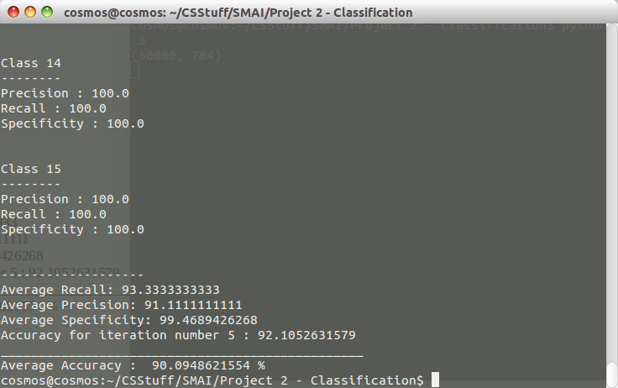

For MNIST Dataset:

1. Source Code

"""
mnist_svm
~~~~~~~~~

A classifier program for recognizing handwritten digits from the MNIST
data set, using an SVM classifier."""

#### Libraries
# My libraries
import mnist_loader

# Third-party libraries
from sklearn import svm

def CreateConfusionMatrix(predictions, testSet):
noOfClasses = 10
confusionMatrix = [[0 for i in xrange(noOfClasses)] for i in xrange(noOfClasses)]
s=set()
for i in testSet:
s.add(i)
l=list(s)
d={}
for x in range(len(l)):
d[l[x]]=x

for x in range(len(testSet)):
if predictions[x]==testSet[x]:
confusionMatrix[d[testSet[x]]][d[testSet[x]]] = confusionMatrix[d[testSet[x]]][d[testSet[x]]] + 1
else:
confusionMatrix[d[testSet[x]]][d[predictions[x]]] = confusionMatrix[d[testSet[x]]][d[predictions[x]]] + 1
return confusionMatrix

def CalculatePrecisionAndRecall(confusionMatrix, noOfClasses, noOfTestSamples):
totalRecall = 0.0
totalPrecision = 0.0
totalSpecificity = 0.0
recall = []
precision = []
specificity = []
#print "Precisions for Different Classes"
#print "________________________________"
for i in range(0, len(confusionMatrix[0])):
classPrecision = 0.0
for j in range(0, len(confusionMatrix)):
classPrecision = classPrecision + confusionMatrix[j][i]
if classPrecision != 0.0:
classPrecision = (confusionMatrix[i][i] / float(classPrecision)) * 100
else:
classPrecision = 0.0
precision.append(classPrecision)
#print "Class Precision for class", i + 1,":", classPrecision
totalPrecision = totalPrecision + classPrecision
#print "Recalls for Different Classes"
#print "________________________________"
for i in range(0, len(confusionMatrix)):
classRecall = 0.0
for j in range(0, len(confusionMatrix[i])):
classRecall = classRecall + confusionMatrix[i][j]
if classRecall != 0.0:
classRecall = (confusionMatrix[i][i] / float(classRecall)) * 100
else:
classRecall = 0.0
recall.append(classRecall)
#print "Class Recall for class", i + 1,":", classRecall
totalRecall = totalRecall + classRecall
for i in range(0, len(confusionMatrix[0])):
numerator = noOfTestSamples - confusionMatrix[i][i]
denominator = numerator
for j in range(0, len(confusionMatrix)):
if i != j:
denominator = denominator + confusionMatrix[j][i]
classSpecificity = (numerator / float(denominator)) * 100
totalSpecificity = totalSpecificity + classSpecificity
specificity.append(classSpecificity)

avgRecall = (totalRecall / float(noOfClasses))
avgPrecision = (totalPrecision / float(noOfClasses))
avgSpecificity = (totalSpecificity / float(noOfClasses))
return avgPrecision, avgRecall, avgSpecificity, precision, recall, specificity

def PrintResults(confusionMatrix, avgPrecision, avgRecall, avgSpecificity, precision, recall, specificity):
print "Confusion Matrix:"
for i in range(0, len(confusionMatrix)):
print confusionMatrix[i]
for i in range(0, len(precision)):
print "Class", i + 1
print "--------"
print "Precision :", precision[i]
print "Recall :", recall[i]
print "Specificity :", specificity[i]
print "\n"
print "-------------------"
print "Average Recall:", avgRecall
print "Average Precision:", avgPrecision
print "Average Specificity:", avgSpecificity

def svm_baseline():
training_data, validation_data, test_data = mnist_loader.load_data()

# train
clf = svm.SVC()
clf.fit(training_data[0], training_data[1])
# test
predictions = [int(a) for a in clf.predict(test_data[0])]
num_correct = sum(int(a == y) for a, y in zip(predictions, test_data[1]))
confusionMatrix = CreateConfusionMatrix(predictions, test_data[1])
avgPrecision, avgRecall, avgSpecificity, precision, recall, specificity = CalculatePrecisionAndRecall(confusionMatrix, 10, len(test_data[1]))
PrintResults(confusionMatrix, avgPrecision, avgRecall, avgSpecificity, precision, recall, specificity)
print "Baseline classifier using an SVM."
print "%s of %s values correct." % (num_correct, len(test_data[1]))

if __name__ == "__main__":
svm_baseline()
2. Results

Confusion Matrix:
[967, 0, 1, 0, 0, 5, 4, 1, 2, 0]
[0, 1120, 2, 3, 0, 1, 3, 1, 5, 0]
[9, 1, 962, 7, 10, 1, 13, 11, 16, 2]
[1, 1, 14, 950, 1, 17, 1, 10, 11, 4]
[1, 1, 7, 0, 937, 0, 7, 2, 2, 25]
[7, 4, 5, 33, 7, 808, 11, 2, 10, 5]
[10, 3, 4, 1, 5, 10, 924, 0, 1, 0]
[2, 13, 22, 5, 7, 1, 0, 954, 4, 20]
[4, 6, 6, 14, 8, 24, 10, 8, 891, 3]
[10, 6, 0, 12, 33, 5, 1, 14, 6, 922]
Class 1
--------
Precision : 95.6478733927
Recall : 98.6734693878
Specificity : 99.5152583453

Class 2
--------
Precision : 96.9696969697
Recall : 98.6784140969
Specificity : 99.6074032529

Class 3
--------
Precision : 94.03714565
Recall : 93.2170542636
Specificity : 99.329596659

Class 4
--------
Precision : 92.6829268293
Recall : 94.0594059406
Specificity : 99.1780821918

Class 5
--------
Precision : 92.9563492063
Recall : 95.4175152749
Specificity : 99.2226844756

Class 6
--------
Precision : 92.6605504587
Recall : 90.5829596413
Specificity : 99.3085566119

Class 7
--------
Precision : 94.8665297741
Recall : 96.4509394572
Specificity : 99.4521148367

Class 8
--------
Precision : 95.1146560319
Recall : 92.8015564202
Specificity : 99.4612424409

Class 9
--------
Precision : 93.9873417722
Recall : 91.4784394251
Specificity : 99.3781365918

Class 10
--------
Precision : 93.9857288481
Recall : 91.3776015857
Specificity : 99.3542738317

-------------------
Average Recall: 94.2737355493
Average Precision: 94.2908798933
Average Specificity: 99.3807349238
Baseline classifier using an SVM.
9435 of 10000 values correct.

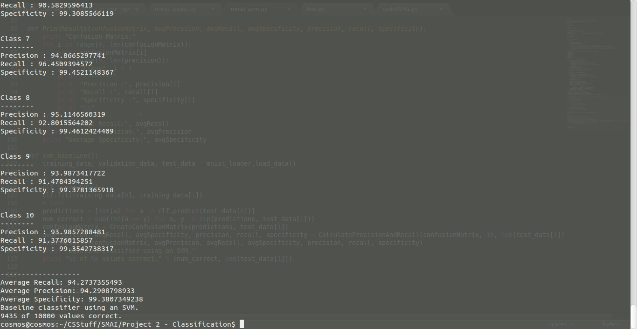
Multilayer Feedforward Neural Network

For Yale Dataset:
1. Source Code

eigen_face_loader
# -*- coding: utf-8 -*-
"""
Created on Thu Apr 9 22:59:21 2015

@author: pramod
"""
import numpy as numpy
import random
import glob
from scipy.misc import *

def LoadImages(directory, split):
# get a list of all the picture filenames
gifs = glob.glob(directory + '/*.gif')
# uncomment the below line when trying an unknown file
#extraGif = glob.glob("/media/cosmos/Data/College Notes/M.Tech/Semester 4/Statistical Methods in AI/Project - Face Recognition/2.gif")
classMap = {}
testGIF = []
allLabels = []
testLabels = []
trainingGIF = []
trainingLabels = []
for i in range(len(gifs)):
if random.random() < split:
trainingGIF.append(gifs[i])
l = gifs[i].split("/");
labelName = l[len(l)-1].split(".")[0][-2:]
trainingLabels.append(labelName)
allLabels.append(labelName)
else:
testGIF.append(gifs[i])
l = gifs[i].split("/");
labelName = l[len(l)-1].split(".")[0][-2:]
testLabels.append(labelName)
allLabels.append(labelName)
# uncomment the below 2 lines when trying an unknown file
#testGIF.append(extraGif[0])
#testLabels.append("un")
#allLabels.append("un")
trainingImgs = numpy.array([imread(i, True).flatten() for i in trainingGIF])
testImgs = numpy.array([imread(i, True).flatten() for i in testGIF])
# creating a list of class labels
allLabels = set(allLabels)
noOfClasses = len(allLabels)
sortedLabels = []
for i in allLabels:
sortedLabels.append(i)
sortedLabels = sorted(sortedLabels)
# creating a mapping for confusion matrix
j = 0
for i in sortedLabels:
classMap[i] = j
j = j + 1
return trainingImgs,testImgs,trainingLabels,testLabels,noOfClasses,classMap
# mean
mu = numpy.mean(data, 0)
# mean adjust the data
ma_data = data - mu
# run SVD
e_faces, sigma, v = numpy.linalg.svd(ma_data.transpose(), full_matrices=False)
# compute weights for each image
weights = numpy.dot(ma_data, e_faces)
return e_faces, weights, mu
def PCA(data):
# mean
mu = numpy.mean(data, 0)
# mean adjust the data
ma_data = data - mu
# run SVD
e_faces, sigma, v = numpy.linalg.svd(ma_data.transpose(), full_matrices=False)
# compute weights for each image
weights = numpy.dot(ma_data, e_faces)
return e_faces, weights, mu
def InputWeight(testData, mu, e_faces):
ma_data = testData - mu
weights = numpy.dot(ma_data, e_faces)
return weights
def load_data():
inDIR = "/home/cosmos/CSStuff/SMAI/Project 2 - Classification/input/yalefaces"
outDIR = "/home/cosmos/CSStuff/SMAI/Project 2 - Classification/output"
imgDims = (243, 320)

split = 0.8
trainingData, testData, trainingLabels, testLabels, noOfClasses, classMap = LoadImages(inDIR, split)
e_faces, trainingWeights, mu = PCA(trainingData)
#print trainingWeights.shape[0]
#print trainingWeights.shape
#print mu.shape
#print e_faces.shape
'''
tr_d, va_d, te_d = load_data()
training_inputs = [np.reshape(x, (784, 1)) for x in tr_d[0]]
print tr_d[0].shape
training_results = [vectorized_result(y) for y in tr_d[1]]
training_data = zip(training_inputs, training_results)
validation_inputs = [np.reshape(x, (784, 1)) for x in va_d[0]]
validation_data = zip(validation_inputs, va_d[1])
test_inputs = [np.reshape(x, (784, 1)) for x in te_d[0]]
test_data = zip(test_inputs, te_d[1])
return (training_data, validation_data, test_data)
'''
testWeights=numpy.zeros((len(testData),trainingWeights.shape[1]))
#print testWeights.shape
#print trainingWeights.shape
#print len(testWeights)
for i in range(len(testWeights)):
#testWeight =InputWeight(testData[i],mu,e_faces)
testWeights[i]=InputWeight(testData[i],mu,e_faces)

#formatting weights
training_inputs = [numpy.reshape(x, (len(trainingWeights), 1)) for x in trainingWeights]
test_inputs= [numpy.reshape(x,(len(trainingWeights) , 1)) for x in testWeights]
#Convert training labels to vectors
trainingLabels=numpy.asarray(trainingLabels)
trainingLabels=trainingLabels.astype(numpy.float)
testLabels=numpy.asarray(testLabels)
testLabels=testLabels.astype(numpy.float)
#decrementing subject labels
for i in range(len(trainingLabels)):
trainingLabels[i]=trainingLabels[i]-1
for i in range(len(testLabels)):
testLabels[i]=testLabels[i]-1
#print testLabels
#print vectorized_result(trainingLabels[0])
#print trainingWeights.shape
training_results = [vectorized_result(y) for y in trainingLabels]
#test_results= [vectorized_result(y) for y in testLabels]

tr_d=zip(training_inputs, training_results)
te_d=zip(test_inputs,testLabels)
#print te_d
return (tr_d,te_d)
def vectorized_result(j):
"""Return a 10-dimensional unit vector with a 1.0 in the jth
position and zeroes elsewhere. This is used to convert a digit
(0...9) into a corresponding desired output from the neural
network."""
e = numpy.zeros((15, 1))
e[j-1] = 1.0
return e
#load_data()

# -*- coding: utf-8 -*-
"""
Created on Thu Apr 9 22:59:21 2015

@author: pramod
"""
import numpy as numpy
import random
import glob
from scipy.misc import *

def LoadImages(directory, split):
# get a list of all the picture filenames
gifs = glob.glob(directory + '/*.gif')
# uncomment the below line when trying an unknown file
#extraGif = glob.glob("/media/cosmos/Data/College Notes/M.Tech/Semester 4/Statistical Methods in AI/Project - Face Recognition/2.gif")
classMap = {}
testGIF = []
allLabels = []
testLabels = []
trainingGIF = []
trainingLabels = []
for i in range(len(gifs)):
if random.random() < split:
trainingGIF.append(gifs[i])
l = gifs[i].split("/");
labelName = l[len(l)-1].split(".")[0][-2:]
trainingLabels.append(labelName)
allLabels.append(labelName)
else:
testGIF.append(gifs[i])
l = gifs[i].split("/");
labelName = l[len(l)-1].split(".")[0][-2:]
testLabels.append(labelName)
allLabels.append(labelName)
# uncomment the below 2 lines when trying an unknown file
#testGIF.append(extraGif[0])
#testLabels.append("un")
#allLabels.append("un")
trainingImgs = numpy.array([imread(i, True).flatten() for i in trainingGIF])
testImgs = numpy.array([imread(i, True).flatten() for i in testGIF])
# creating a list of class labels
allLabels = set(allLabels)
noOfClasses = len(allLabels)
sortedLabels = []
for i in allLabels:
sortedLabels.append(i)
sortedLabels = sorted(sortedLabels)
# creating a mapping for confusion matrix
j = 0
for i in sortedLabels:
classMap[i] = j
j = j + 1
return trainingImgs,testImgs,trainingLabels,testLabels,noOfClasses,classMap
# mean
mu = numpy.mean(data, 0)
# mean adjust the data
ma_data = data - mu
# run SVD
e_faces, sigma, v = numpy.linalg.svd(ma_data.transpose(), full_matrices=False)
# compute weights for each image
weights = numpy.dot(ma_data, e_faces)
return e_faces, weights, mu
def PCA(data):
# mean
mu = numpy.mean(data, 0)
# mean adjust the data
ma_data = data - mu
# run SVD
e_faces, sigma, v = numpy.linalg.svd(ma_data.transpose(), full_matrices=False)
# compute weights for each image
weights = numpy.dot(ma_data, e_faces)
return e_faces, weights, mu
def InputWeight(testData, mu, e_faces):
ma_data = testData - mu
weights = numpy.dot(ma_data, e_faces)
return weights
def load_data():
inDIR = "/home/cosmos/CSStuff/SMAI/Project 2 - Classification/input/yalefaces"
outDIR = "/home/cosmos/CSStuff/SMAI/Project 2 - Classification/output"
imgDims = (243, 320)

split = 0.8
trainingData, testData, trainingLabels, testLabels, noOfClasses, classMap = LoadImages(inDIR, split)
e_faces, trainingWeights, mu = PCA(trainingData)
#print trainingWeights.shape[0]
#print trainingWeights.shape
#print mu.shape
#print e_faces.shape
'''
tr_d, va_d, te_d = load_data()
training_inputs = [np.reshape(x, (784, 1)) for x in tr_d[0]]
print tr_d[0].shape
training_results = [vectorized_result(y) for y in tr_d[1]]
training_data = zip(training_inputs, training_results)
validation_inputs = [np.reshape(x, (784, 1)) for x in va_d[0]]
validation_data = zip(validation_inputs, va_d[1])
test_inputs = [np.reshape(x, (784, 1)) for x in te_d[0]]
test_data = zip(test_inputs, te_d[1])
return (training_data, validation_data, test_data)
'''
testWeights=numpy.zeros((len(testData),trainingWeights.shape[1]))
#print testWeights.shape
#print trainingWeights.shape
#print len(testWeights)
for i in range(len(testWeights)):
#testWeight =InputWeight(testData[i],mu,e_faces)
testWeights[i]=InputWeight(testData[i],mu,e_faces)

#formatting weights
training_inputs = [numpy.reshape(x, (len(trainingWeights), 1)) for x in trainingWeights]
test_inputs= [numpy.reshape(x,(len(trainingWeights) , 1)) for x in testWeights]
#Convert training labels to vectors
trainingLabels=numpy.asarray(trainingLabels)
trainingLabels=trainingLabels.astype(numpy.float)
testLabels=numpy.asarray(testLabels)
testLabels=testLabels.astype(numpy.float)
#decrementing subject labels
for i in range(len(trainingLabels)):
trainingLabels[i]=trainingLabels[i]-1
for i in range(len(testLabels)):
testLabels[i]=testLabels[i]-1
#print testLabels
#print vectorized_result(trainingLabels[0])
#print trainingWeights.shape
training_results = [vectorized_result(y) for y in trainingLabels]
#test_results= [vectorized_result(y) for y in testLabels]

tr_d=zip(training_inputs, training_results)
te_d=zip(test_inputs,testLabels)
#print te_d
return (tr_d,te_d)
def vectorized_result(j):
"""Return a 10-dimensional unit vector with a 1.0 in the jth
position and zeroes elsewhere. This is used to convert a digit
(0...9) into a corresponding desired output from the neural
network."""
e = numpy.zeros((15, 1))
e[j-1] = 1.0
return e
#load_data()

Neural Network Eigen Utility Code:

import eigen_face_loader
trainingData, testData = eigen_face_loader.load_data()
import neuralnetwork
net = neuralnetwork.Network([len(trainingData), 200, 15])
net.SGD(trainingData, 50, 5, .09, 15, test_data = testData)

2. Results:

Epoch 0: 3 / 27
Epoch 1: 2 / 27
Epoch 2: 2 / 27
Epoch 3: 3 / 27
Epoch 4: 4 / 27
Epoch 5: 4 / 27
Epoch 6: 4 / 27
Epoch 7: 4 / 27
Epoch 8: 3 / 27
Epoch 9: 3 / 27
Epoch 10: 3 / 27
Epoch 11: 3 / 27
Epoch 12: 3 / 27
Epoch 13: 3 / 27
Epoch 14: 3 / 27
Epoch 15: 3 / 27
Epoch 16: 4 / 27
Epoch 17: 4 / 27
Epoch 18: 4 / 27
Epoch 19: 4 / 27
Epoch 20: 4 / 27
Epoch 21: 4 / 27
Epoch 22: 4 / 27
Epoch 23: 4 / 27
Epoch 24: 4 / 27
Epoch 25: 4 / 27
Epoch 26: 4 / 27
Epoch 27: 4 / 27
Epoch 28: 4 / 27
Epoch 29: 4 / 27
Epoch 30: 4 / 27
Epoch 31: 4 / 27
Epoch 32: 4 / 27
Epoch 33: 4 / 27
Epoch 34: 4 / 27
Epoch 35: 4 / 27
Epoch 36: 3 / 27
Epoch 37: 3 / 27
Epoch 38: 3 / 27
Epoch 39: 3 / 27
Epoch 40: 3 / 27
Epoch 41: 3 / 27
Epoch 42: 3 / 27
Epoch 43: 3 / 27
Epoch 44: 3 / 27
Epoch 45: 3 / 27
Epoch 46: 3 / 27
Epoch 47: 3 / 27
Epoch 48: 3 / 27
Epoch 49: 3 / 27
Confusion Matrix:
[0, 0, 0, 1, 0, 0, 0, 0, 0, 0, 0, 1, 0, 0, 0]
[1, 0, 0, 0, 0, 0, 0, 0, 0, 0, 0, 0, 0, 0, 0]
[0, 0, 0, 1, 0, 0, 0, 0, 0, 0, 0, 1, 0, 0, 0]
[0, 0, 0, 1, 1, 0, 0, 0, 0, 0, 0, 1, 0, 0, 0]
[0, 0, 0, 1, 0, 0, 0, 0, 1, 0, 0, 0, 1, 0, 0]
[0, 0, 0, 0, 0, 0, 0, 0, 0, 1, 0, 0, 0, 0, 0]
[0, 0, 0, 0, 0, 0, 1, 0, 0, 0, 2, 0, 0, 0, 0]
[0, 0, 0, 0, 0, 0, 0, 0, 0, 0, 0, 0, 0, 0, 0]
[0, 0, 0, 0, 0, 0, 0, 0, 1, 1, 0, 0, 0, 0, 0]
[0, 0, 0, 0, 0, 0, 0, 0, 0, 0, 0, 0, 0, 0, 0]
[0, 0, 0, 0, 0, 0, 0, 0, 0, 0, 0, 0, 0, 0, 0]
[1, 0, 0, 0, 0, 0, 2, 0, 0, 0, 0, 0, 0, 0, 1]
[0, 0, 0, 0, 0, 1, 0, 1, 0, 0, 0, 0, 0, 1, 1]
[0, 0, 1, 0, 0, 0, 0, 0, 0, 0, 0, 0, 0, 0, 0]
[0, 0, 0, 0, 0, 1, 0, 0, 0, 0, 0, 0, 0, 0, 0]
Class 1
--------
Precision : 0.0
Recall : 0.0
Specificity : 93.1034482759

Class 2
--------
Precision : 0.0
Recall : 0.0
Specificity : 100.0

Class 3
--------
Precision : 0.0
Recall : 0.0
Specificity : 96.4285714286

Class 4
--------
Precision : 25.0
Recall : 33.3333333333
Specificity : 89.6551724138

Class 5
--------
Precision : 0.0
Recall : 0.0
Specificity : 96.4285714286

Class 6
--------
Precision : 0.0
Recall : 0.0
Specificity : 93.1034482759

Class 7
--------
Precision : 33.3333333333
Recall : 33.3333333333
Specificity : 92.8571428571

Class 8
--------
Precision : 0.0
Recall : 0.0
Specificity : 96.4285714286

Class 9
--------
Precision : 50.0
Recall : 50.0
Specificity : 96.2962962963

Class 10
--------
Precision : 0.0
Recall : 0.0
Specificity : 93.1034482759

Class 11
--------
Precision : 0.0
Recall : 0.0
Specificity : 93.1034482759

Class 12
--------
Precision : 0.0
Recall : 0.0
Specificity : 90.0

Class 13
--------
Precision : 0.0
Recall : 0.0
Specificity : 96.4285714286

Class 14
--------
Precision : 0.0
Recall : 0.0
Specificity : 96.4285714286

Class 15
--------
Precision : 0.0
Recall : 0.0
Specificity : 93.1034482759

-------------------
Average Recall: 7.77777777778
Average Precision: 7.22222222222
Average Specificity: 94.4312473393
Accuracy : 11.1111111111
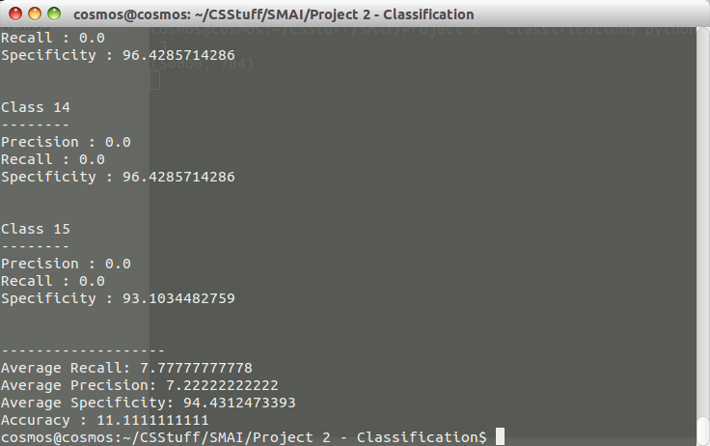

For MNIST Dataset:

1. Souce Code

mnist_loader :
# -*- coding: utf-8 -*-
"""
Created on Thu Apr 9 21:09:06 2015

@author: pramod
"""

"""
mnist_loader
~~~~~~~~~~~~

A library to load the MNIST image data. For details of the data
structures that are returned, see the doc strings for ``load_data``
and ``load_data_wrapper``. In practice, ``load_data_wrapper`` is the
function usually called by our neural network code.
"""

#### Libraries
# Standard library
import cPickle
import gzip

# Third-party libraries
import numpy as np

def load_data():
"""Return the MNIST data as a tuple containing the training data,
the validation data, and the test data.

The ``training_data`` is returned as a tuple with two entries.
The first entry contains the actual training images. This is a
numpy ndarray with 50,000 entries. Each entry is, in turn, a
numpy ndarray with 784 values, representing the 28 * 28 = 784
pixels in a single MNIST image.

The second entry in the ``training_data`` tuple is a numpy ndarray
containing 50,000 entries. Those entries are just the digit
values (0...9) for the corresponding images contained in the first
entry of the tuple.

The ``validation_data`` and ``test_data`` are similar, except
each contains only 10,000 images.

This is a nice data format, but for use in neural networks it's
helpful to modify the format of the ``training_data`` a little.
That's done in the wrapper function ``load_data_wrapper()``, see
below.
"""
f = gzip.open('/home/cosmos/CSStuff/SMAI/Project 2 - Classification/input/mnist.pkl.gz', 'rb')
training_data, validation_data, test_data = cPickle.load(f)
f.close()
return (training_data, validation_data, test_data)

def load_data_wrapper():
"""Return a tuple containing ``(training_data, validation_data,
test_data)``. Based on ``load_data``, but the format is more
convenient for use in our implementation of neural networks.

In particular, ``training_data`` is a list containing 50,000
2-tuples ``(x, y)``. ``x`` is a 784-dimensional numpy.ndarray
containing the input image. ``y`` is a 10-dimensional
numpy.ndarray representing the unit vector corresponding to the
correct digit for ``x``.

``validation_data`` and ``test_data`` are lists containing 10,000
2-tuples ``(x, y)``. In each case, ``x`` is a 784-dimensional
numpy.ndarry containing the input image, and ``y`` is the
corresponding classification, i.e., the digit values (integers)
corresponding to ``x``.

Obviously, this means we're using slightly different formats for
the training data and the validation / test data. These formats
turn out to be the most convenient for use in our neural network
code."""
tr_d, va_d, te_d = load_data()
training_inputs = [np.reshape(x, (784, 1)) for x in tr_d[0]]

training_results = [vectorized_result(y) for y in tr_d[1]]
training_data = zip(training_inputs, training_results)
validation_inputs = [np.reshape(x, (784, 1)) for x in va_d[0]]
validation_data = zip(validation_inputs, va_d[1])
test_inputs = [np.reshape(x, (784, 1)) for x in te_d[0]]
test_data = zip(test_inputs, te_d[1])
return (training_data, test_data)

def vectorized_result(j):
"""Return a 10-dimensional unit vector with a 1.0 in the jth
position and zeroes elsewhere. This is used to convert a digit
(0...9) into a corresponding desired output from the neural
network."""
e = np.zeros((10, 1))
e[j] = 1.0
return e

MNIST Utility Function Source Code:

import mnist_loader
trainingData, test_data = mnist_loader.load_data_wrapper()
import copyCode
net = copyCode.Network([784, 30, 10])
net.SGD(trainingData, 30, 10, 3.0, 10, test_data)

2. Results

Epoch 0: 9104 / 10000
Epoch 1: 9211 / 10000
Epoch 2: 9262 / 10000
Epoch 3: 9321 / 10000
Epoch 4: 9358 / 10000
Epoch 5: 9370 / 10000
Epoch 6: 9375 / 10000
Epoch 7: 9395 / 10000
Epoch 8: 9390 / 10000
Epoch 9: 9399 / 10000

Confusion Matrix:
[932, 0, 5, 0, 1, 4, 6, 1, 1, 8]
[0, 1108, 0, 1, 2, 3, 1, 5, 1, 4]
[4, 3, 959, 12, 2, 2, 2, 27, 7, 1]
[5, 2, 9, 939, 2, 23, 4, 10, 12, 15]
[2, 0, 7, 1, 927, 3, 7, 9, 4, 27]
[7, 1, 5, 22, 2, 822, 9, 1, 9, 8]
[11, 7, 12, 3, 12, 7, 913, 1, 3, 0]
[1, 1, 12, 7, 2, 1, 0, 956, 7, 15]
[13, 13, 19, 19, 8, 25, 16, 6, 928, 16]
[5, 0, 4, 6, 24, 2, 0, 12, 2, 915]
Class 1
--------
Precision : 95.1020408163
Recall : 97.2860125261
Specificity : 99.473453269

Class 2
--------
Precision : 97.6211453744
Recall : 98.4888888889
Specificity : 99.6972754793

Class 3
--------
Precision : 92.9263565891
Recall : 94.1118743867
Specificity : 99.1990344525

Class 4
--------
Precision : 92.9702970297
Recall : 91.9686581783
Specificity : 99.2225142357

Class 5
--------
Precision : 94.399185336
Recall : 93.9209726444
Specificity : 99.3974583699

Class 6
--------
Precision : 92.1524663677
Recall : 92.776523702
Specificity : 99.2430795848

Class 7
--------
Precision : 95.3027139875
Recall : 94.2208462332
Specificity : 99.5072273325

Class 8
--------
Precision : 92.9961089494
Recall : 95.4091816367
Specificity : 99.2101799035

Class 9
--------
Precision : 95.2772073922
Recall : 87.3000940734
Specificity : 99.4955033999

Class 10
--------
Precision : 90.6838453915
Recall : 94.3298969072
Specificity : 98.9759233032

-------------------
Average Recall: 93.9812949177
Average Precision: 93.9431367234
Average Specificity: 99.342164933
Accuracy : 93.99

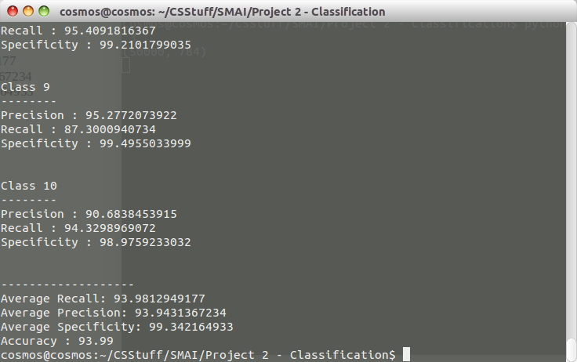

Comparisons Between Different Methods:

Dataset / Methods | K- Nearest Neighbours | SVM | Multilayer Feedforwards Neural Network
Yale Dataset | 86.1221321373 % | 90.0948621554 % | 11.11 %
MNIST Dataset | 82.15 % | 94.35 % | 93.99%

